FFA@CEBAF Working Group|Minutes

Meeting date | time 08/23/2024 | 11 AM EST | Meeting location https://jlab-org.zoomgov.com/j/1614898082?pwd=TnUzMS81M2sxbDZIbERJU01tYkJCQT09
Meeting called by Alex B  Type of meeting Weekly Meeting  Facilitator Alex B  Note taker Ryan  Timekeeper Alex B | Attendees  Alex B, Ryan, Donish, Dejan, Alex C, Edith, Salim, Stephen, Donish, Vasiliy, Roger, Nick

Intro Discussion
- Discussion of some other design (Ryan missed start of conversation).
  - EIC linac – 3 GeV multipass linac
- CEBAF $320M for 12 GeV Upgrade
  - Today’s money is “Billion Dollar Machine”
- Donish officially made Staff Scientist I
  - Will be more involved

Agenda topics

Time allotted | 25 mins | Agenda topic SBIR| Presenter Alex/Stephen/Dejan
- SABR – discussion from Stephen/Dejan to manufacture our magnets.
- Letter of intent to build ~1.2 m magnet – tech demo
- Dejan – Stephen did everything – let’s hear from him
- Stephen – didn’t even know what SBIR was, but hopefully got LOI in correctly
- Phase 1 is ~$200K over 1 year, then phase 2 is about a million
  - Phase 1 is about right for a prototype building
- LOI – is a one-pager that allows you to tell if worth doing full proposal
- 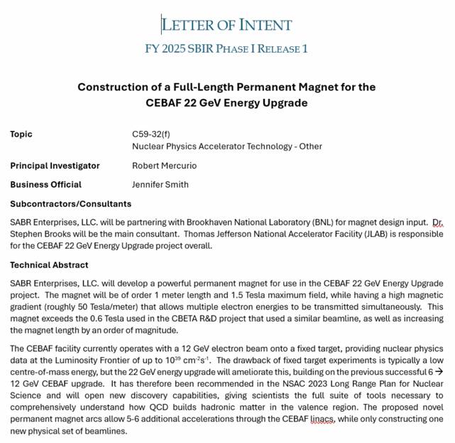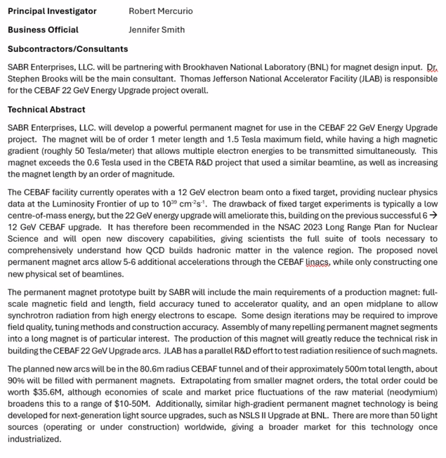
- October 8 for full proposal
- Discussion of letter (above)
- Most of money to SABR, some to BNL
- Discussion of costs, relevance, etc…
- Applicability to wide range of places (light sources, etc…)
- Ryan – tangent about Adam Steinberg’s paper: https://journals.aps.org/prab/abstract/10.1103/PhysRevAccelBeams.27.071601
  - Stephen actually helped a lot with input on that paper
  - Roger – what’s new with this?
    - Ryan – using cuboids instead of wedges
    - Roger – Volker Ziemann tried something similar, likely not published – maybe on ArXiv
- Geoff retiring – Volker coming
- Alex B – this could be great as a reduction in price!
- Stephen – likely not good for our use, too tight radius. Pushing ours to the limit
- Alex B – will wait for green light to see if the proposal moves forward.
  - SBIR should mostly go to company (2/3) and rest to lab as needed.
- Stephen – do you know Timur?
  - Yes, he’s part of the JLAAC committee
  - He gave a talk with the collab a few months ago
  - Looking at both hybrid and Halbach magnets in parallel
- Stephen – Ryan going to FFA?
  - No, travel problems
Action Items | Person responsible | Deadline

Time allotted | 25 mins | Agenda topic Alternative Splitters| Presenter Donish
- Need preconceptual design withing two years
  - Have to start tying things together.
- Dejan – might be able to write a white paper first
  - Can put a lot of things that have been done so far: Alex C thesis, splitters, transition
  - Alex – let’s talk separately offline to see what we can put in
- Alex – Pre-CDR will have physics motivation, but our part would be the technical design parts
  - Already a white paper for the physics case
- Dejan – that’s what we did with CBETA – just put things in ArXiv
- Long delays in papers at times.
- Donish presents:
- 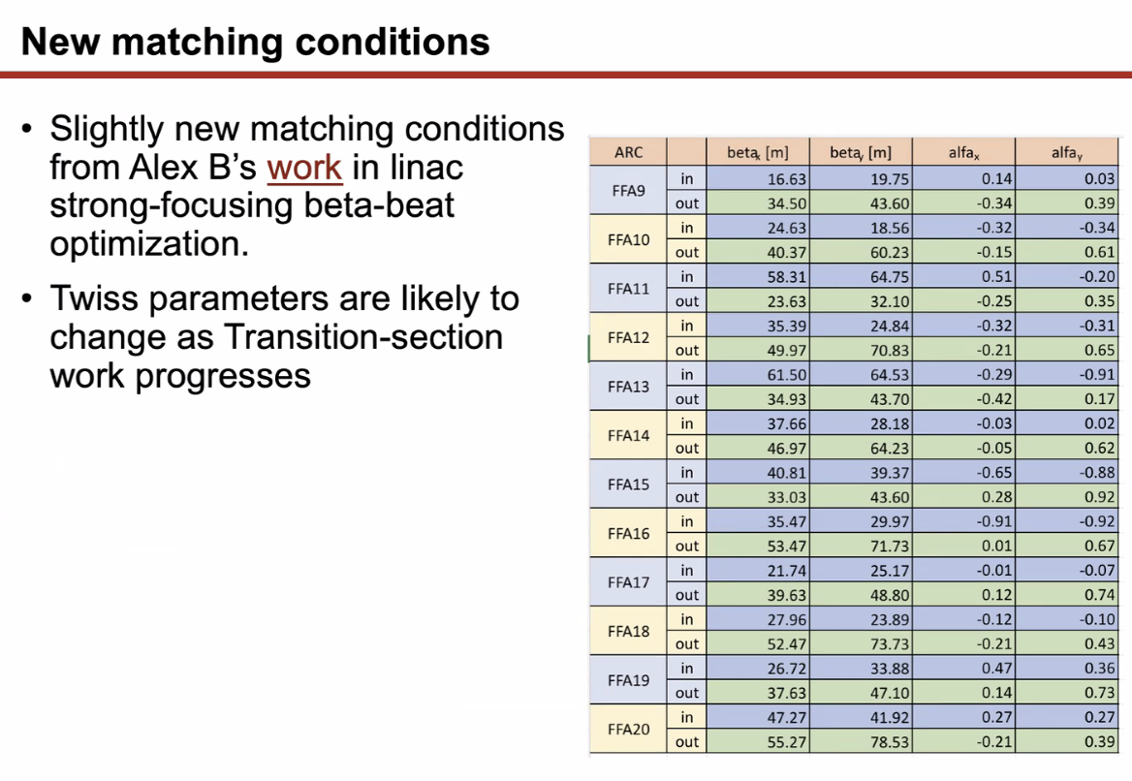
  - Twiss into splitters changed a lot after Alex B’s new SFLs
  - These Twiss are going to change as Randy keeps working on transition section – values will evolve
- 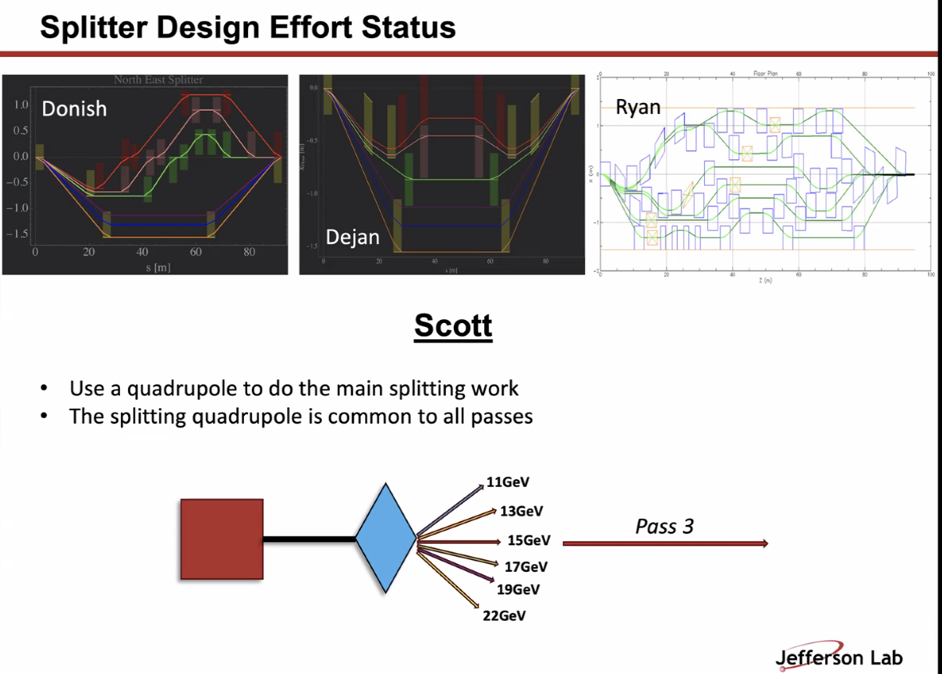
  - 4th design! Similar to Dejan, but Scott said split all 6 passes with a quad
    - Might make more symmetric splitter design
    - First split at dipole, then hit quad, split transversely
    - Quad must be centered at one pass (3rd here)
- 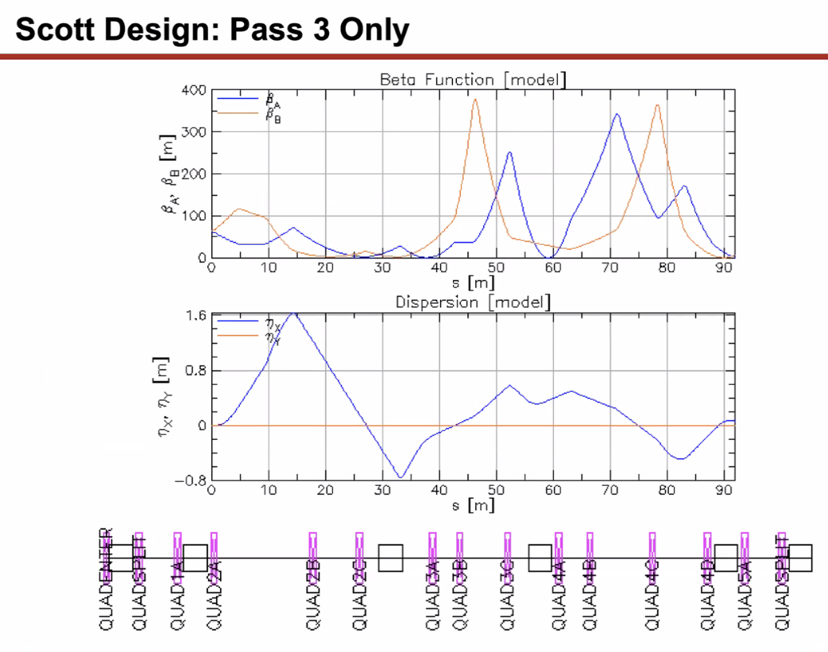
  - 3rd pass – betas ok
  - Match all parameters (Twiss plus R56)
  - Alex B – is this Bmad?
    - Yes
    - Shows cartoon on floor
- 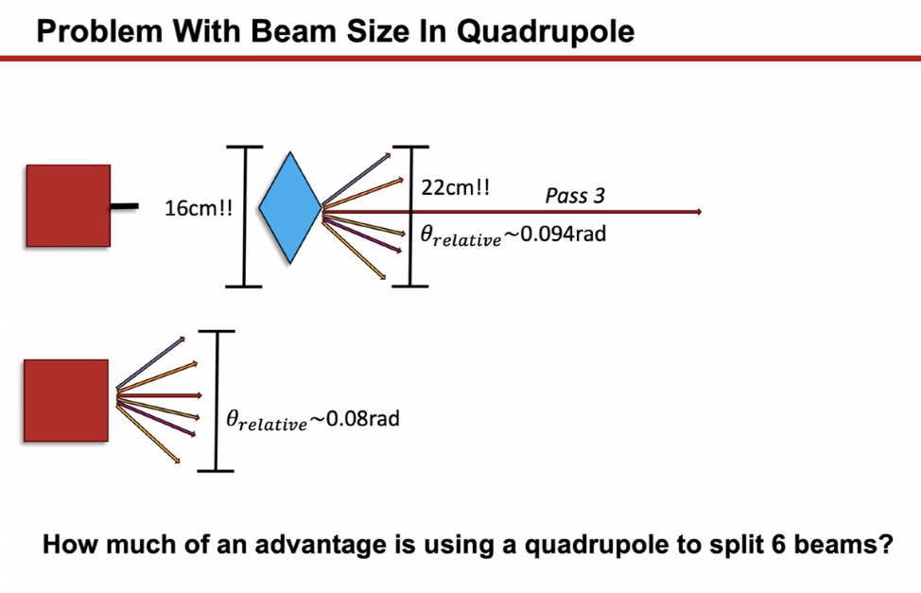
  - Hiccup – incoming beam has a 16 cm spread, and 22 cm on output
  - Ryan/Scott gave feedback – likely not quads that can have that sort of gap
  - Use just dipole with same amount of drift space, you see you don’t get much gain
    - 0.08 vs 0.094 rad
    - This begs the question – is this really that advantageous?
- Only completed 3rd pass, but didn’t want to keep going until figure out if that quad is realizable
- Next update: improving Dejan’s design:
  - 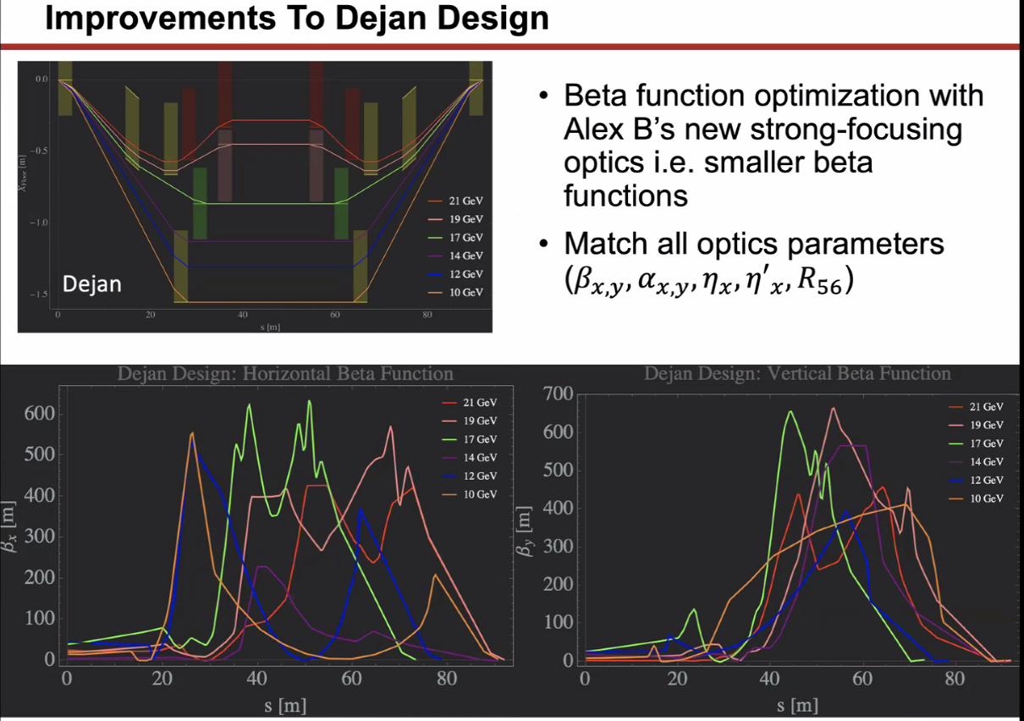
  - Changes:
    - New Twiss
    - Implementing new optimizer strategies
      - Got some big beta improvements
    - Ryan said likely to just get that large beta function b/c of the amount of drift space coming into the FFA
    - Alex B - ~600 m not so bad
  - Dejan – did I have quads at all?
    - Yes, you assumed they’d be put somewhere
    - Dejan – didn’t add any, have to add multiple
- 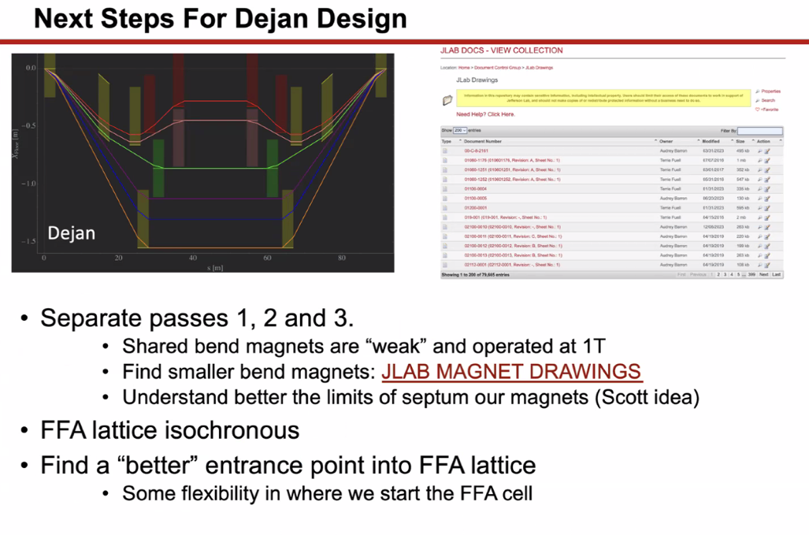
  - Ryan/Kirsten said need to separate out all the lines, not just a few
    - Try not to share magnets/passes
  - Positive: shared magnets are pretty weak
    - 3 m but only 1 T
  - Maybe shrink magnets
  - Jay sent Donish to magnet drawings
- Not using any septa here, but think it’ll add flexibility if you can add them
  - Ryan – the one’s I’m using in my design are septa
    - Also, look at the ZA magnets, etc…
  - Alex B – yes, those are a good place to start.
- Ryan – you have to pay attention to cooling of magnets as well
- LDRD update:
  - Some “future work” we’re anticipating making an isochronous FFA lattice
    - Would have implications on spitter design
  - Not starting now, but might be next step
- Stephen – is the R56 good or bad if it shrinks?
  - Donish – right now, would help
  - Stephen – have another option that reduces that (IPAC24 idea)
- LDRD sent for approval
- Ryan – Yves pointed out that we may not *want* to zero-out our R56. Might need nonzero R56, and that needs to be looked at.
- Alex – yes, may want to chirp
  - This is being looked at in PERLE
- Ryan – Yves also said we haven’t looked much into longitudinal dynamics yet
  - Donish – you mean bunch compression?
  - Ryan – yes, and operationally
  - Alex B – yes, but we only do it in the injector right now
- Alex B – flexible momentum compaction gives options
- Dejan – it would be fantastic to make work: need 5-6 variables, much harder in FFAs to do what Alex B is describing.
  - Easy in a single line by varying quads. In FFAs, if you do it for all the energies, that would be a Nobel prize result!
- Some flexibility choosing FFA lattice entrance. Spoke with Ryan and Alex C about this
  - Basically find different betas that ease matching conditions
  - Have lattice, need to cut
  - Stephen: can sort of start wherever you like, but be careful with apertures, etc…
    - Can stop anywhere in cell
  - Dejan – keep in mind that we have presently a FODO, but you should switch one magnet as a half a magnet, for example (alphas are zero), use power law to move cells away from each other, betas will rise, still things will match
- Ryan – what we’re talking about is that each magnet has 6 segments, so 12 in a cell, and we can match into the different parts of each magnet in each cell, for example
- Dejan – yes, you can do this exactly as described.
- Donish – yes, segment current lattice
  - If still having problems, then start moving magnets. But first, keep it simple
- Alex B – putting together different people ideas and designs might be helping.
  - September is coming. In the Fall, it’ll be busy. We’ll see if we can have this meeting between travels/conferences
Action Items | Person responsible | Deadline

Time allotted | 10 mins | Agenda topic AOB | Presenter All

Action Items | Person responsible | Deadline

Special notes

Pathway to Repository: https://jeffersonlab-my.sharepoint.com/:f:/g/personal/tristan_jlab_org/EqZ5MeS-nipCgPfZB5p0oS4B9Is67d3nQb9sLJI3Zyev9g

Next meeting in two weeks. This will persist for summer (every other week).

