FFA@CEBAF Working Group|Minutes

Meeting date | time 09/20/2024 | 11 AM EST | Meeting location https://jlab-org.zoomgov.com/j/1614898082?pwd=TnUzMS81M2sxbDZIbERJU01tYkJCQT09
Meeting called by Alex B  Type of meeting Weekly Meeting  Facilitator Alex B  Note taker Ryan  Timekeeper Alex B | Attendees  Alex B, Ryan, Salim, Edith, Scott, Randy, Donish, Dejan, Stephen, Kirsten, Reza, Andrei, Tim, Alex C,

Intro Discussion
- Travel to Japan – ERL coming up
- SBIR with SABR didn’t go through – “not on the books”
  - Stephen - Sounds like JLab said positrons happen first, so possibly interpreted as only positrons “eligible”
  - Non-responsive
  - Ryan – perhaps partially due to govt budget outlook?
  - Stephen – “applied too early – not close enough to building yet” – maybe try again later

Agenda topics

Time allotted | 25 mins | Agenda topic Mag. LDRD| Presenter Ryan/Edy/Kirsten/Randy
- 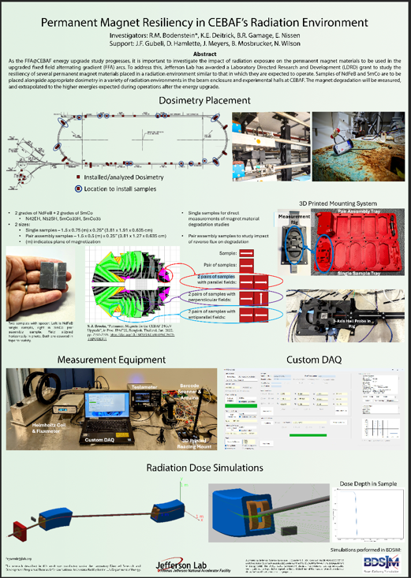
- Talking at ERL24
- 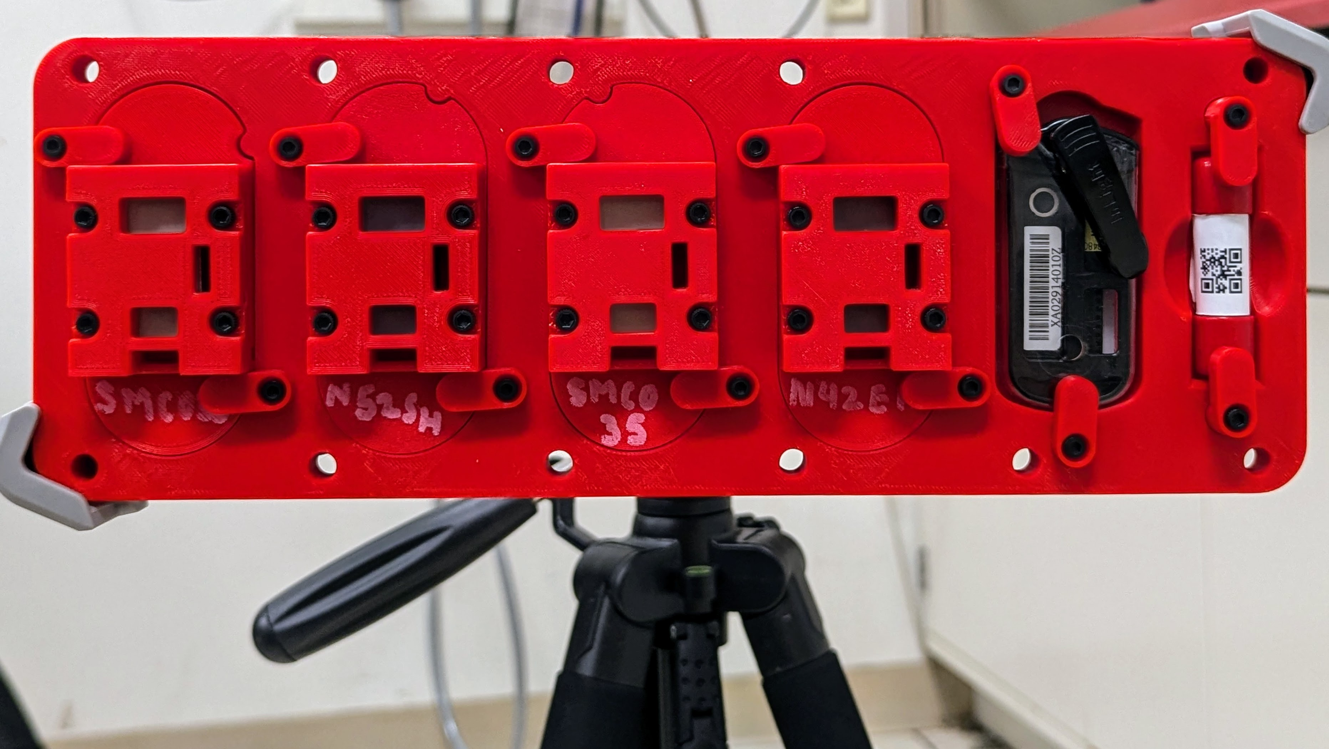
- 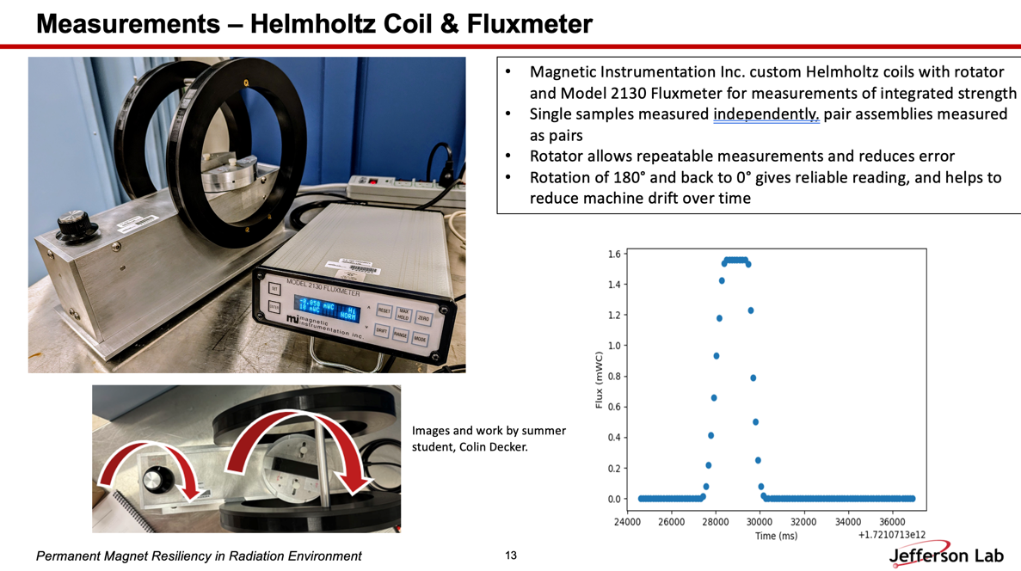
- 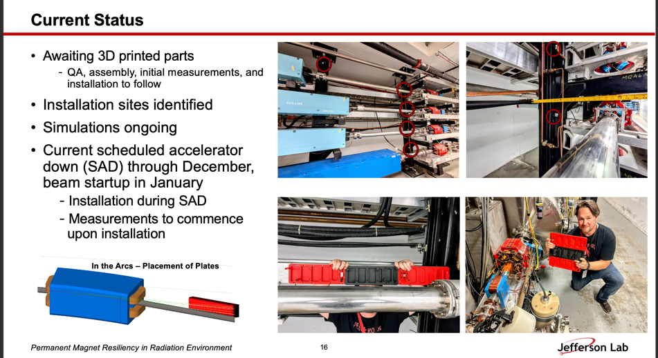
- 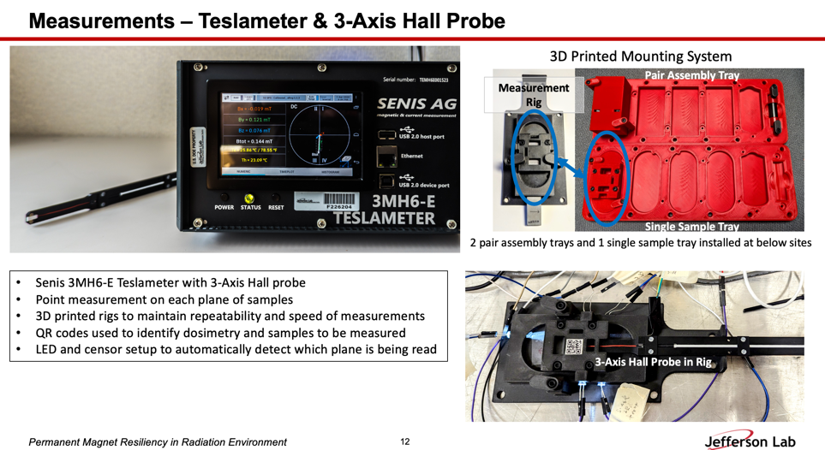
Action Items | Person responsible | Deadline

Time allotted | 25 mins | Agenda topic LERF2NL Line| Presenter Salim
- Dual-purpose e+ (123 MeV) and FFA (650 MeV) beamline from LERF to NL
- Dennis took early look, Salim went into details
- 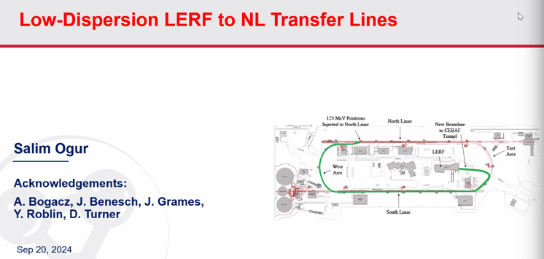
- Need low dispersion and Beta
- 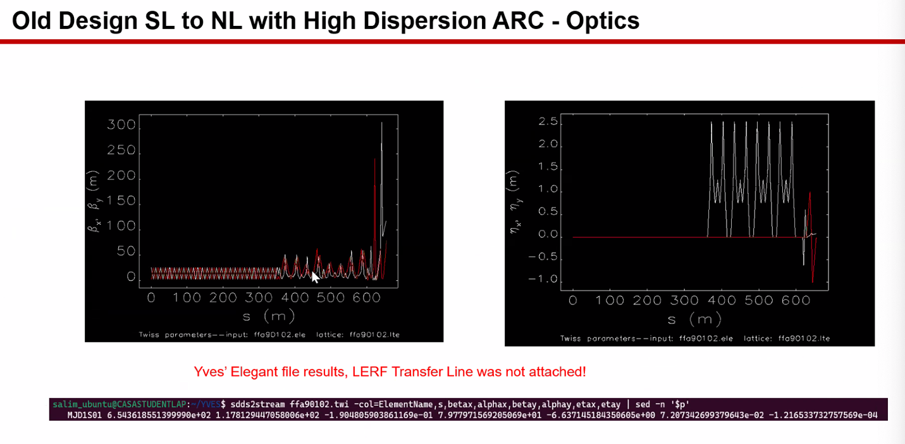
- 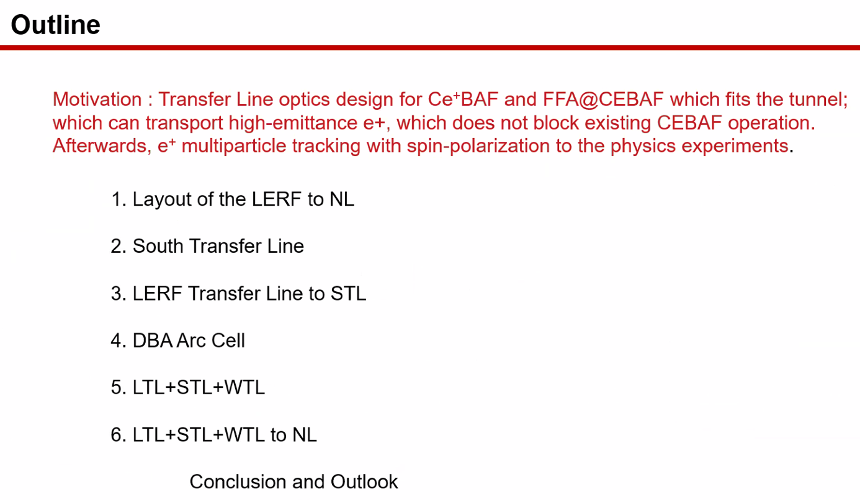
- 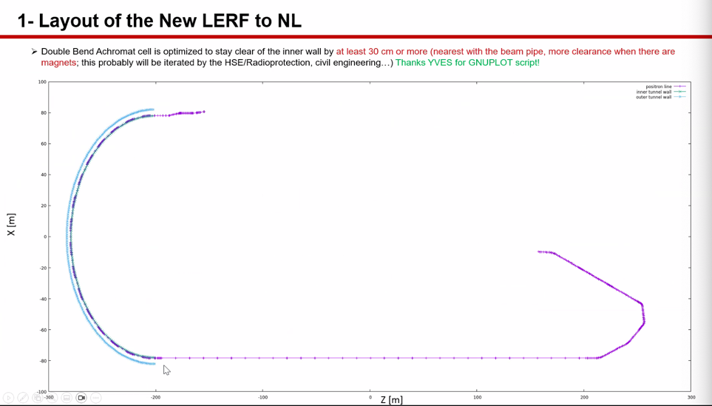
  - Blue is outer wall
  - Green inner wall
  - Line suspended from ceiling
- 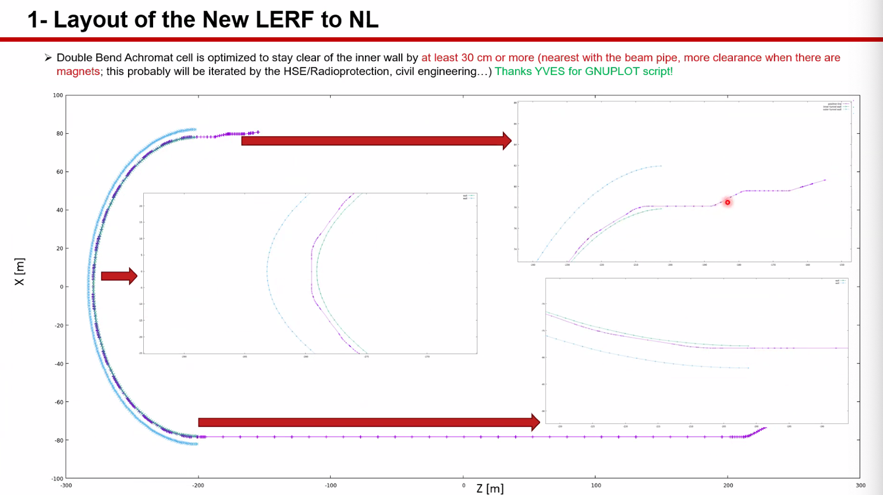
  - Don’t touch walls
- 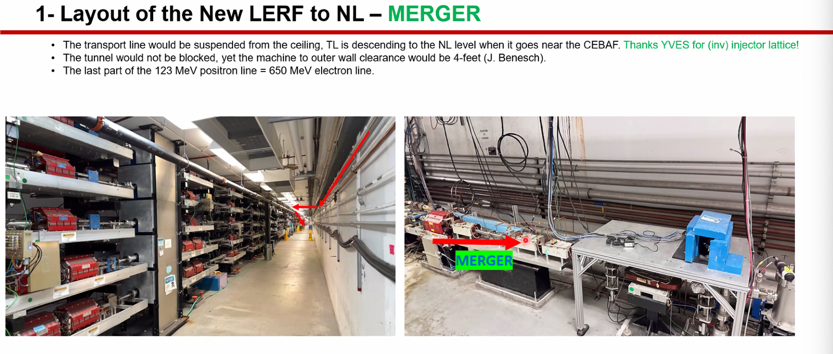
- 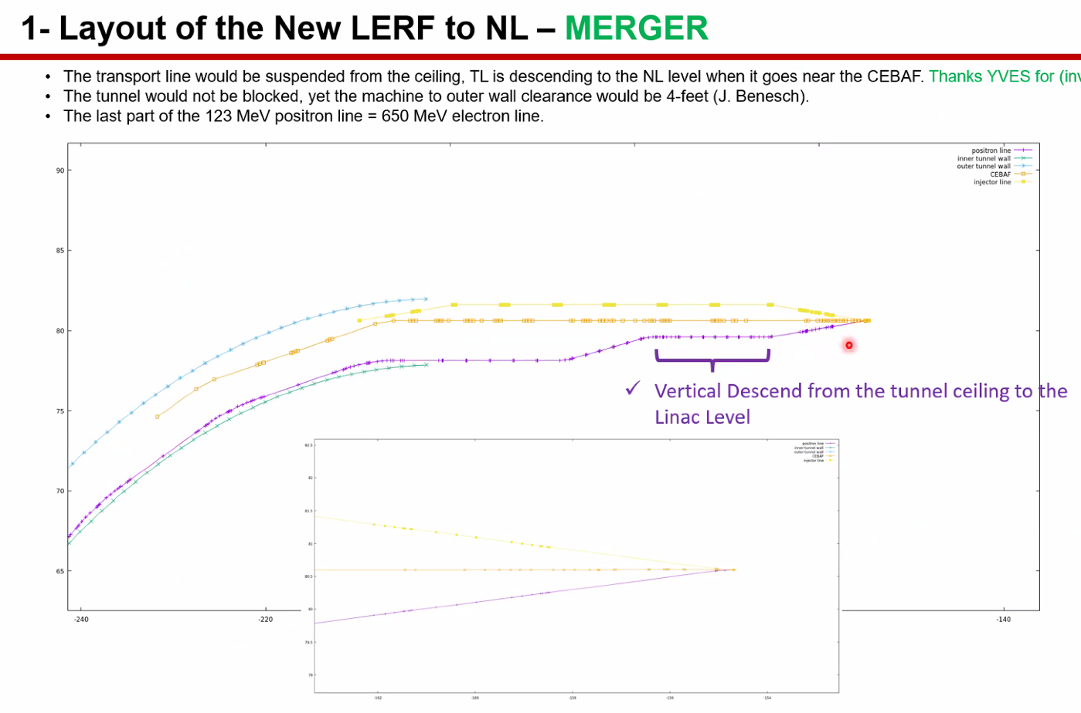
  - 4 ft of clearance for carts/magnet access
  - Near spectrometer dump
- 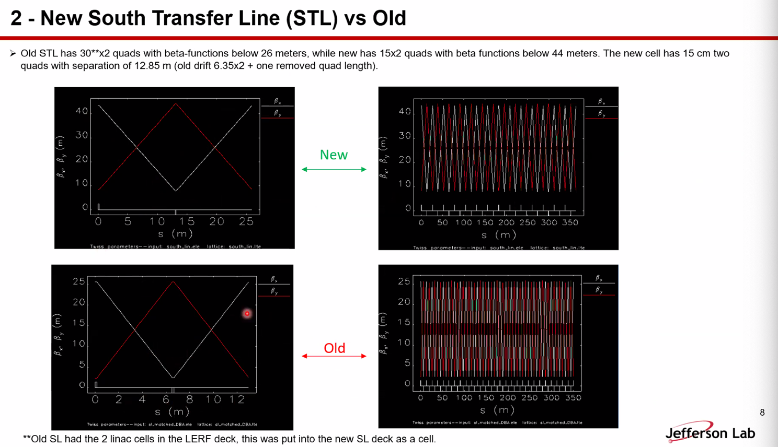
- 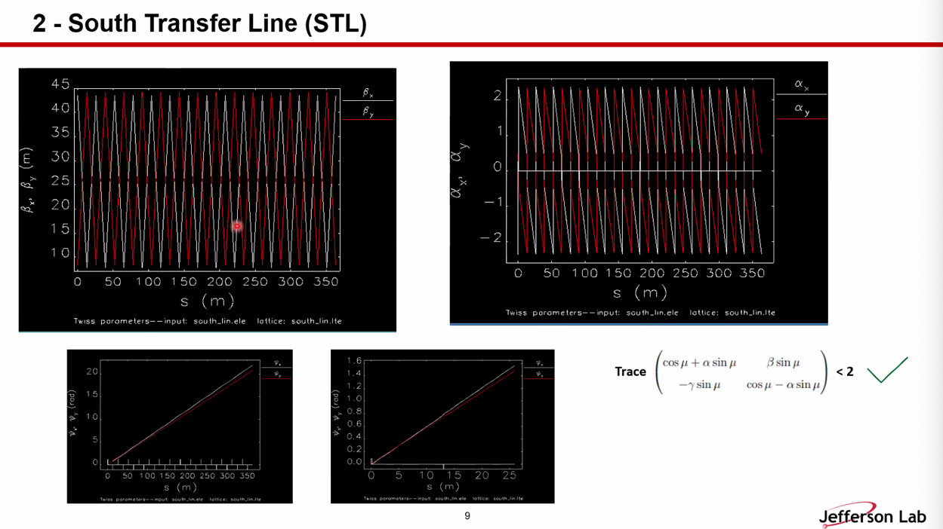
- 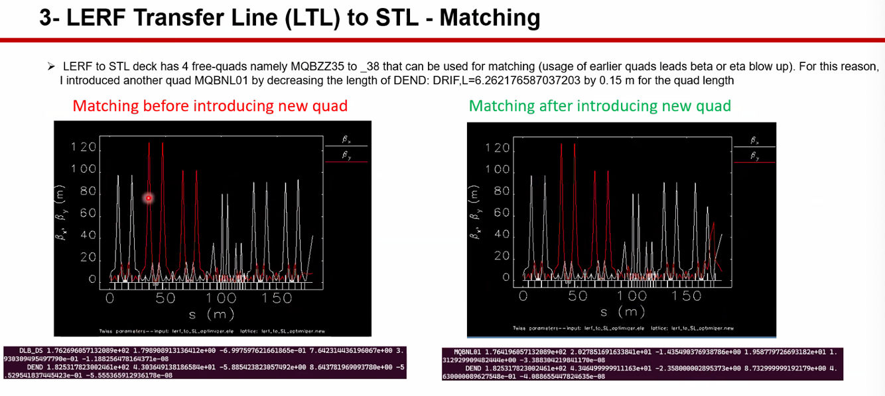
  - Started with Dennis’ and adjusted to right plot
  - 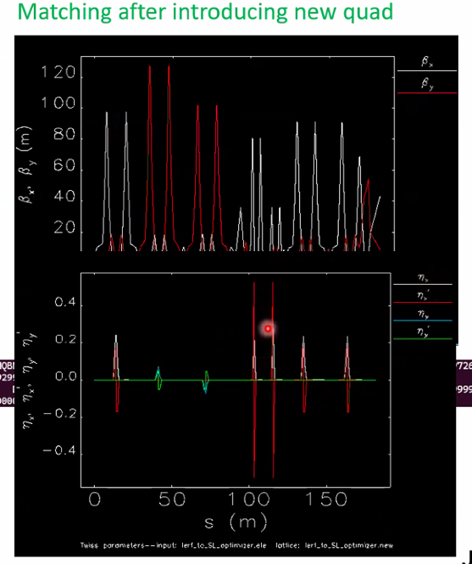
- 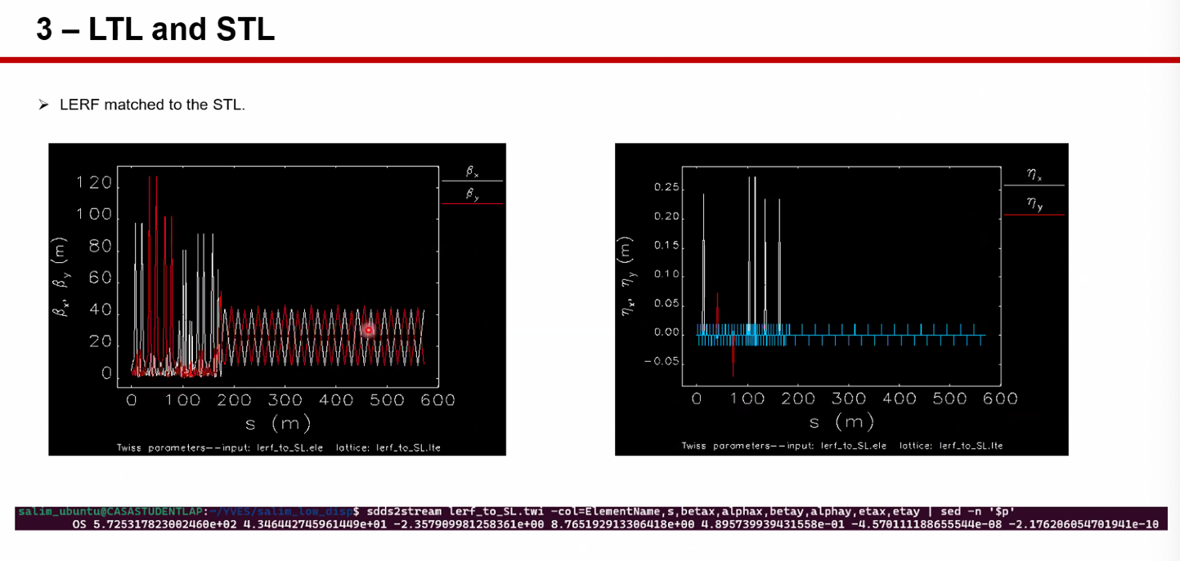
  - LERF and south transfer linac matching
- 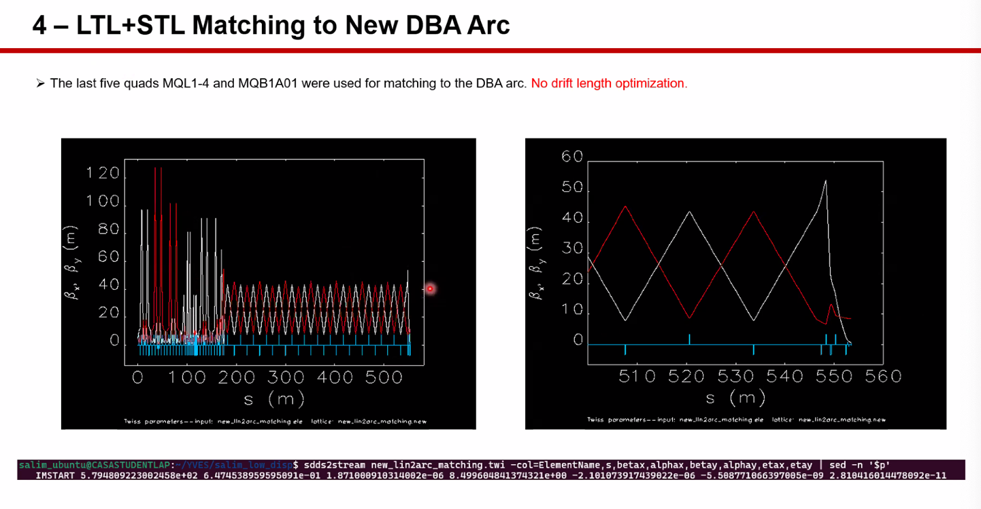
- 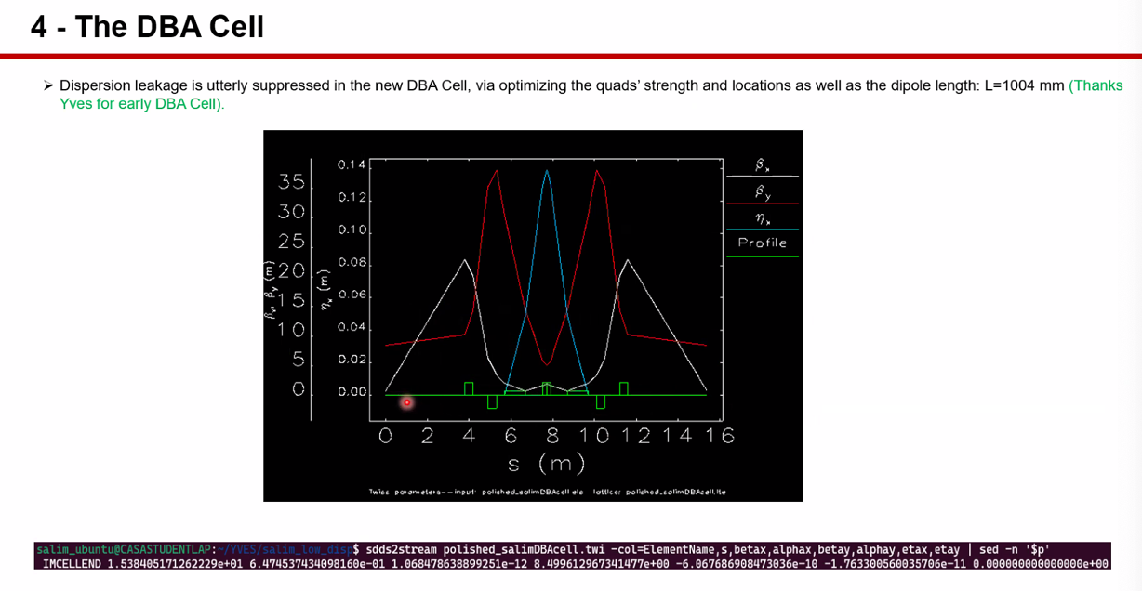
- 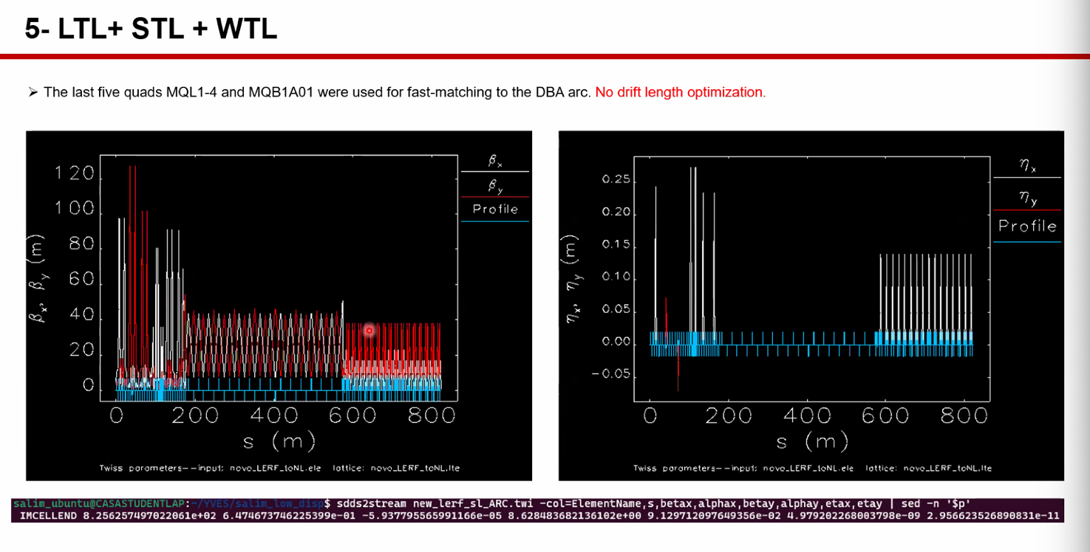
- 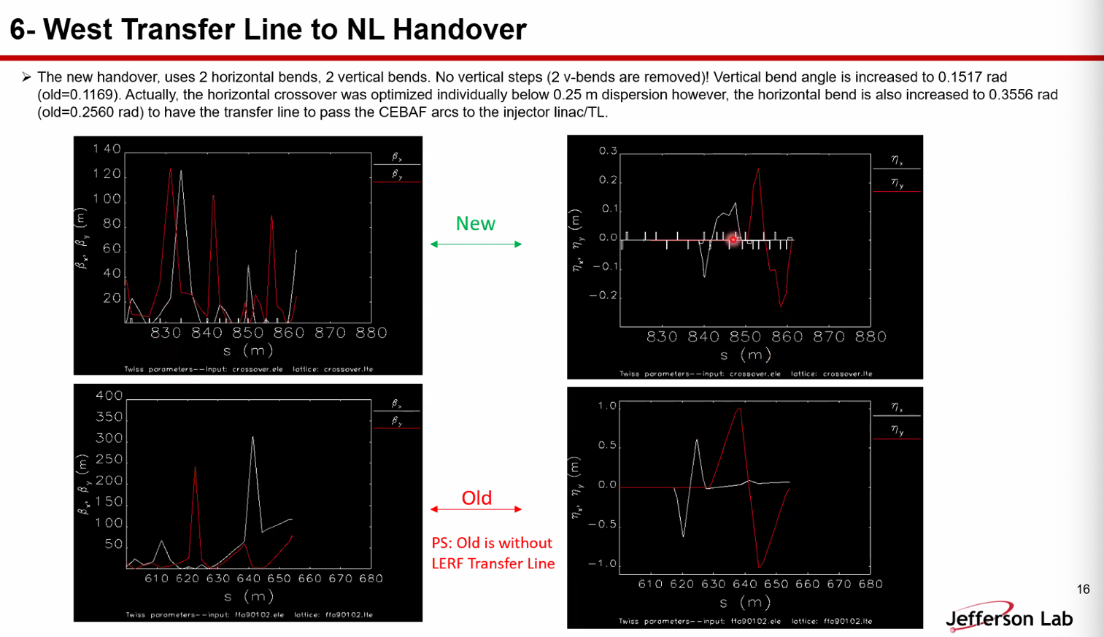
  - 1 step instead of 2 steps
  - If the beam dies, it’ll die in the LERF transfer line
- Currently optimizing (matching) into the NL
  - Will then connect them up and start tracking with multiparticle and spin tracking
- 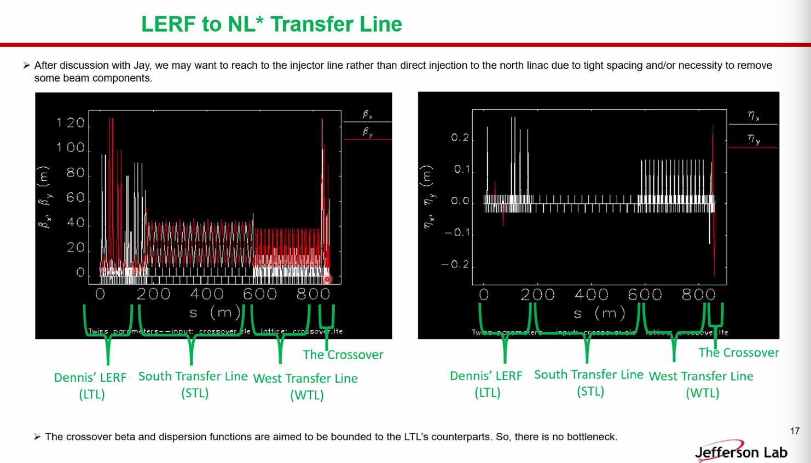
- 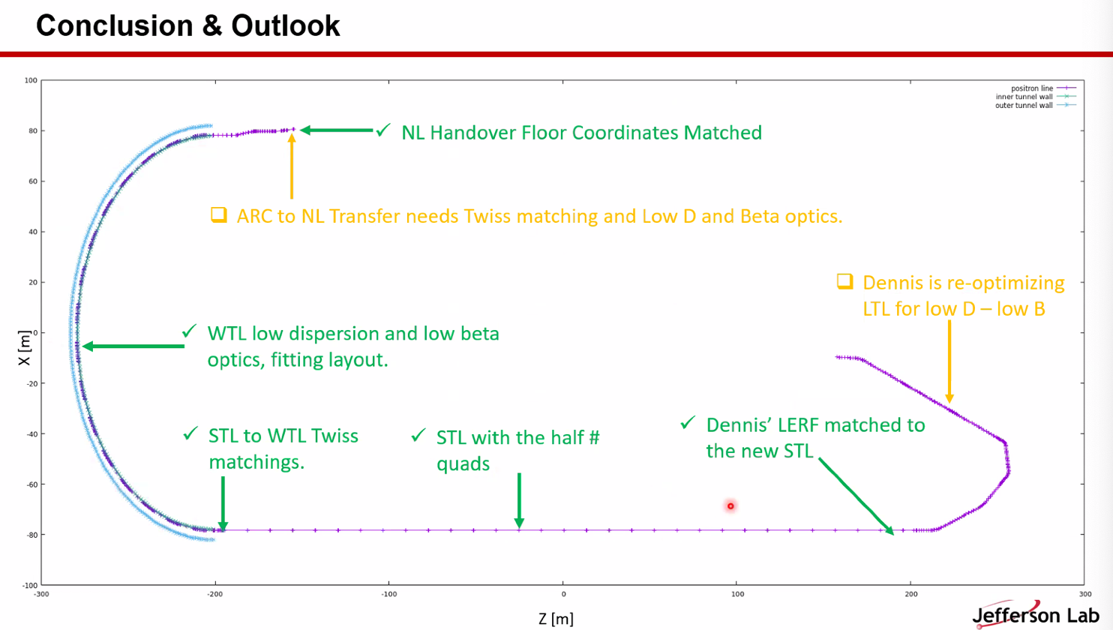
  - Status
- Dejan – maybe Salim should work on splitters
  - Ryan – maybe extraction would be smarter
- This is for electrons only now
- Ryan – please push these to the GitHub when ready
  - Salim – will translate and upload when ready
- Working with Jay to make sure things are clear, etc…
- Reza – you’re powering the same number of quads for positrons and FFA?
  - Told that during commissioning, they’ll use electrons, then flip polarities
  - Can decrease number of quads – but told not to yet
Action Items | Person responsible | Deadline

Time allotted | 10 mins | Agenda topic AOB | Presenter All

Action Items | Person responsible | Deadline

Special notes

Pathway to Repository: https://jeffersonlab-my.sharepoint.com/:f:/g/personal/tristan_jlab_org/EqZ5MeS-nipCgPfZB5p0oS4B9Is67d3nQb9sLJI3Zyev9g

Next meeting in two weeks. This will persist for summer (every other week).

