FFA@CEBAF Working Group|Minutes

Meeting date | time 10/4/2024 | 11 AM EST | Meeting location https://jlab-org.zoomgov.com/j/1614898082?pwd=TnUzMS81M2sxbDZIbERJU01tYkJCQT09
Meeting called by Alex B  Type of meeting Weekly Meeting  Facilitator Alex B  Note taker Ryan  Timekeeper Alex B | Attendees  Alex B, Ryan, Donish, Alex C, Dejan, Salim, Scott, Stephen, Tim, Randy, Vasiliy

Intro Discussion
- Alex C wrapping up very soon & giving CAS seminar.
  - Pre-defense revisions, clarifying, then hopefully scheduling defense soon
- Alex B – budget is non-existent (CR), so the modest support sent to BNL (0.45 FTE/year) has been delayed but not forgotten
- Dejan – in the olden days, when working on muon collider, there was no “different budgets” for different things. This new organization with DOE is basically screwing up intellectual development in many different fields
  - Ryan – yes, had to pause work on magnet LDRD b/c of this
- Slimmer attendance – Edy is part of “national guard” (CAP) – unit deployed to help hurricane victims
- Summer is over – moving back to weekly schedule
  - Will be more regimented for design

Agenda topics

Time allotted | 50 mins | Agenda topic Sextupoles in FFA| Presenter Donish
- Alex B – exploratory study for different optics and magnet design. Donish followed up
- 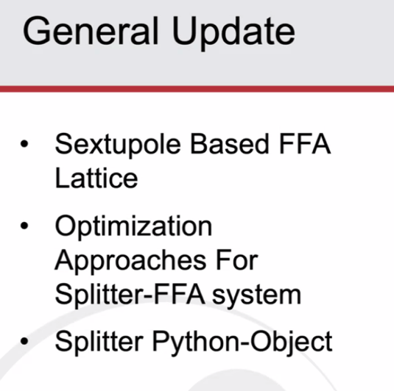
  - In progress for sextupoles – not a lot of slides
- 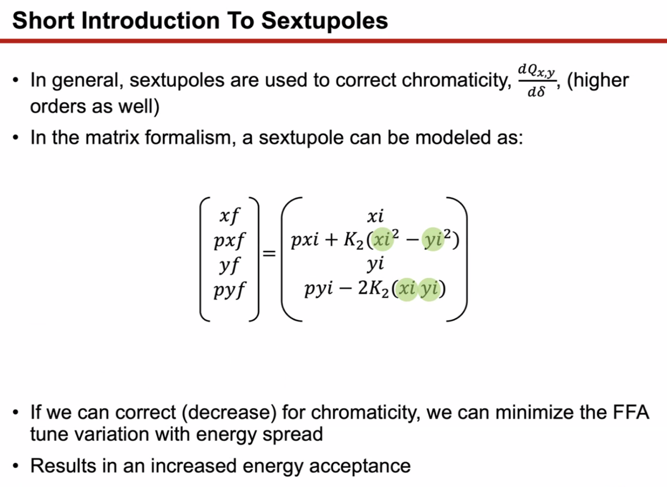
  - Second-order dependence on transverse coord gives transverse kick
  - General big picture idea – if you can correct for chromaticity, minimize tune variation, improve energy acceptance
- 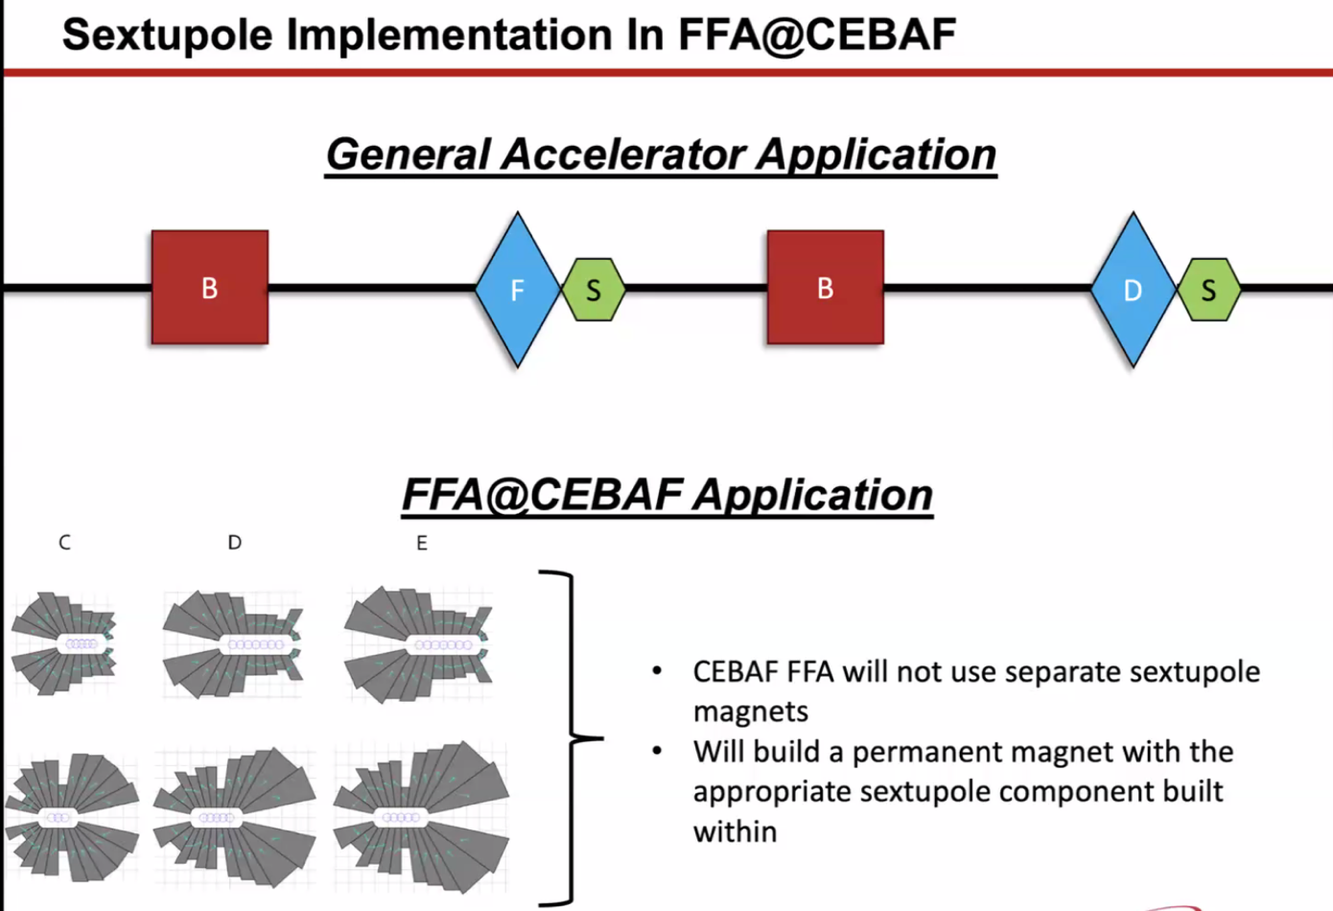
  - Basic FODO with setupoles next to quads so that they can interact with high-beta areas
  - Different for us – including sextupole component into FFA magnets
- 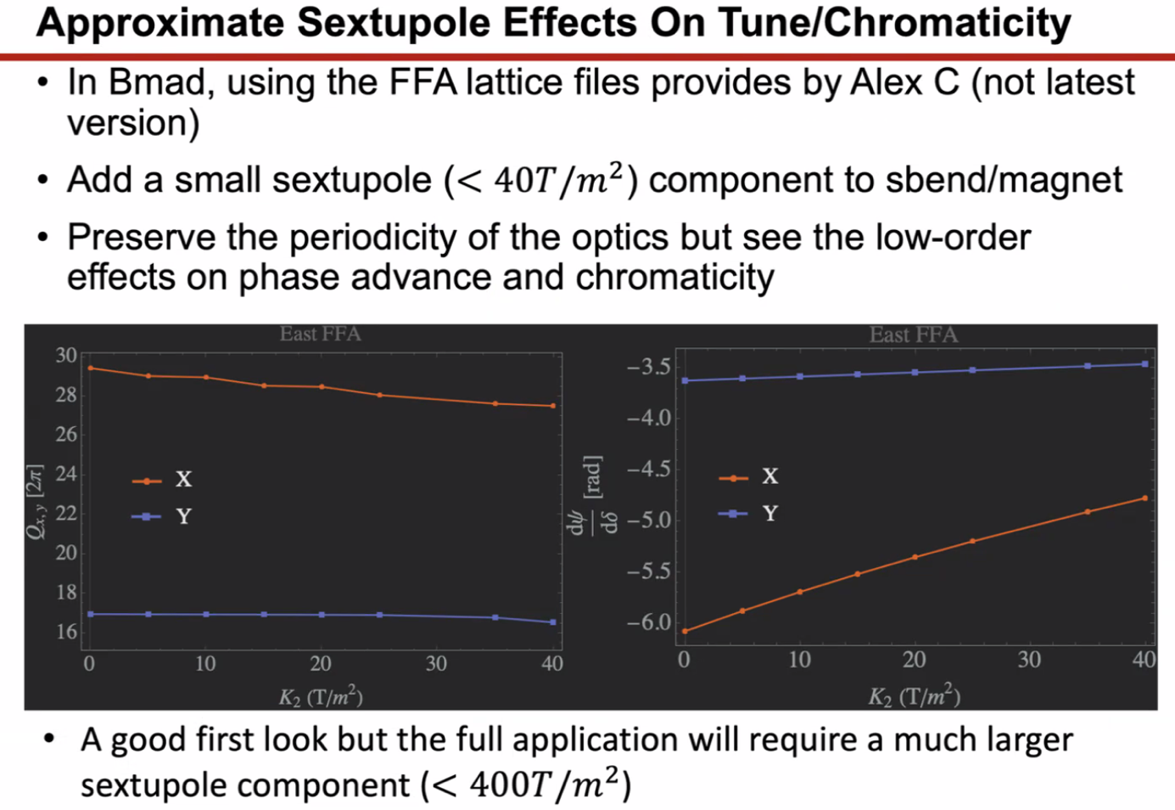
  - These are from FFA lattice from AC
    - Not the latest, but based on a slightly older version
    - Assuming lattice optics should be pretty similar
  - Took lattice, added small sextupole component to bending magnets instead of adding separate magnets or zero-length magnets
  - Just for a rough feel of what’s happening
  - Kept small to maintain periodicity of optics
  - See what sextupoles do to optics
  - Left plot is tune variation with sextupole added
    - 0 on x axis means no sextupole
  - Right plot is chromaticity
- In LDRD proposal – look at 400 T/m^2 – that’ll be very different from the 40 shown above
  - Need to ramp up and see how the optics changes
  - Need to preserve periodicity, can’t just ramp up
    - Expect that other magnet components will change
- 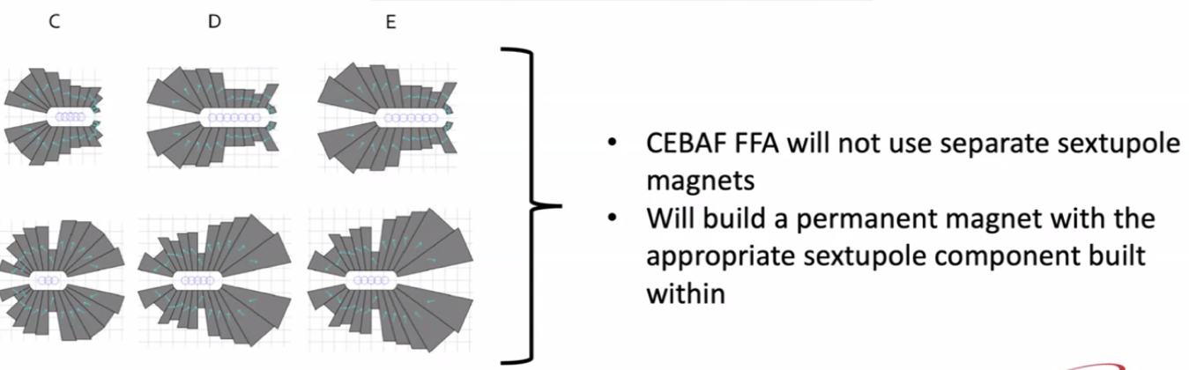
  - Didn’t show A and B options without sextupole components
  - Difference in cross-sectional area
- 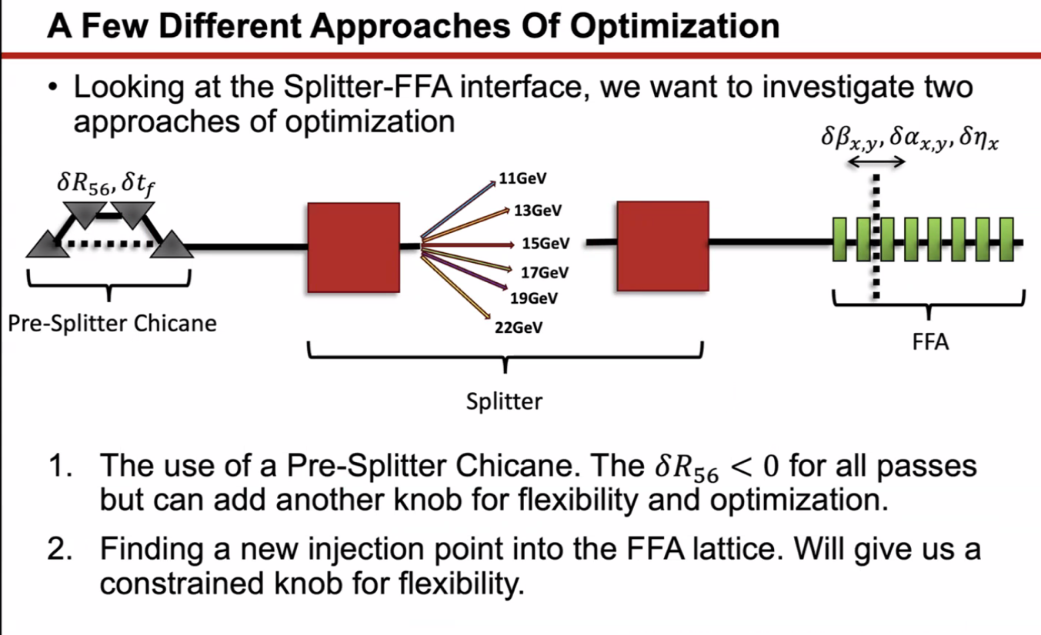
  - Looking at pre-splitter chicane to vary R56 and ToF
  - Looking at new injection point into FFA lattice – spoke with Ryan about this
  - Change where you go into FFA cell
- 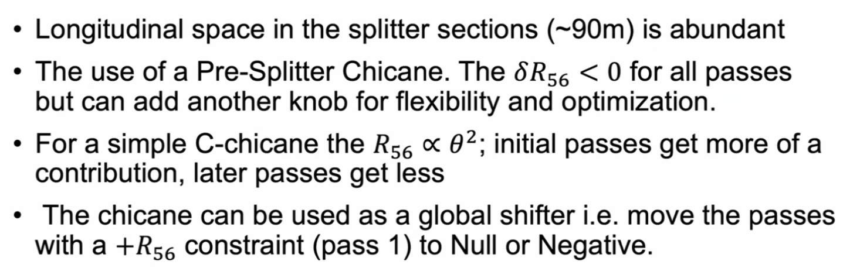
  - Problem matching all conditions while maintaining transverse space
  - Cut splitter length without problem
  - First pass has positive R56 – introduces some complexities due to needing to add quads early before second bend
  - Idea is to put a pre-splitter chicane
    - R56 is prop to square of bend angle – will impact each pass separately but proportionally – higher energy gets less variation
  - Easier to work with negative than positive
- Scott – interesting idea. Will say that in practice (at least in CBETA) it wasn’t so much the sign of R56 that was the problem, but the magnitude.
  - R56 on extremes were so large, so hard to manage
  - Sign not so much an issue
- Stephen – Design B has smaller R56, might be good to go with that
- Donish – this chicane has problems – can only push in one direction (pushes negative)
  - Need quads to tune
- Another avenue (not sure good or bad): don’t have to build chicane and put into simulation as a deviation of R56 to target in optimization
  - Instead of a chicane, can go dogleg route
  - Push down higher energy passes
  - Haven’t really taken this idea anywhere yet – wants to test out
  - “Just another knob” for R56
- If you’re having trouble tuning R56 for CBETA, probably much harder here b/c we’re higher energy
- Scott – yes and no – in a sense that we’re able to generate larger angles that’s true. Our biggest issue revolved around compact nature of the splitter lines
  - The more phase advance you can generate through the line, the more flexibility you have for generating/creating R56 you want without extreme beta function (large and small) problems
    - Don’t want huge OR small (cm level) betas
  - If you can get phase advance without IP-style optics, will be good
- Donish – how large is too large?
  - Ryan – has to do with beam pipe
    - Scott – yes, but also too many “bads” should come together
  - Wouldn’t expect betas more than 100 m
  - Entering at ~50ish m
  - 100 m probably wrong number – need maybe more, but not km-scale betas
    - However, whenever bad things happen, you’ll also usually get small betas as well
  - Seeing a large S region with some large beta, need to be tougher with beta
- Dejan – what Scott is saying – in the longitudinal distance available, if the betas are more than 100 m large, you’ll have small betas as well – very bad to have
  - Suggest not going above 70 m
  - Previous designs had 60 m and min was 10 m
  - Ryan – previous efforts above 600 m
  - Stephen – sextupoles don’t change
    - Shorter cells may have helped
    - If make larger beampipe, then you’ll get larger magnets
  - Dejan managed half of 16 m required
    - Maybe when you add others, it’ll be just fine?
    - Lattice I showed – files are loaded somewhere
- Scott – if you want, I can show you how “not” to do it
- Dejan takes screen:
  - 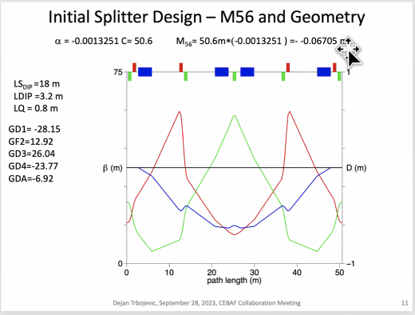
  - 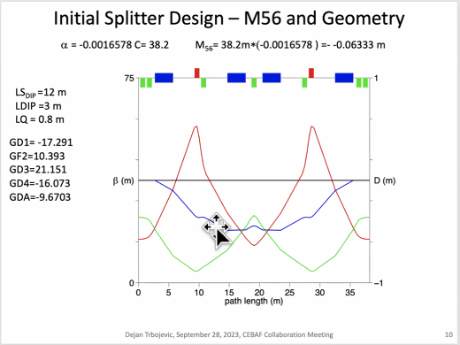
  - Betas were very small
- Dejan – playing with isochronous lattice
  - With 5 circuits of sextupoles, dispersion oscillates with + and – values
  - Making R56 zero without zero
  - Still need ToF correction
  - Might need many more magnets than shown
  - Maybe changing cell length, can get a better starting R56
- Scott shares screen:
  - Don’t do this!!
  - 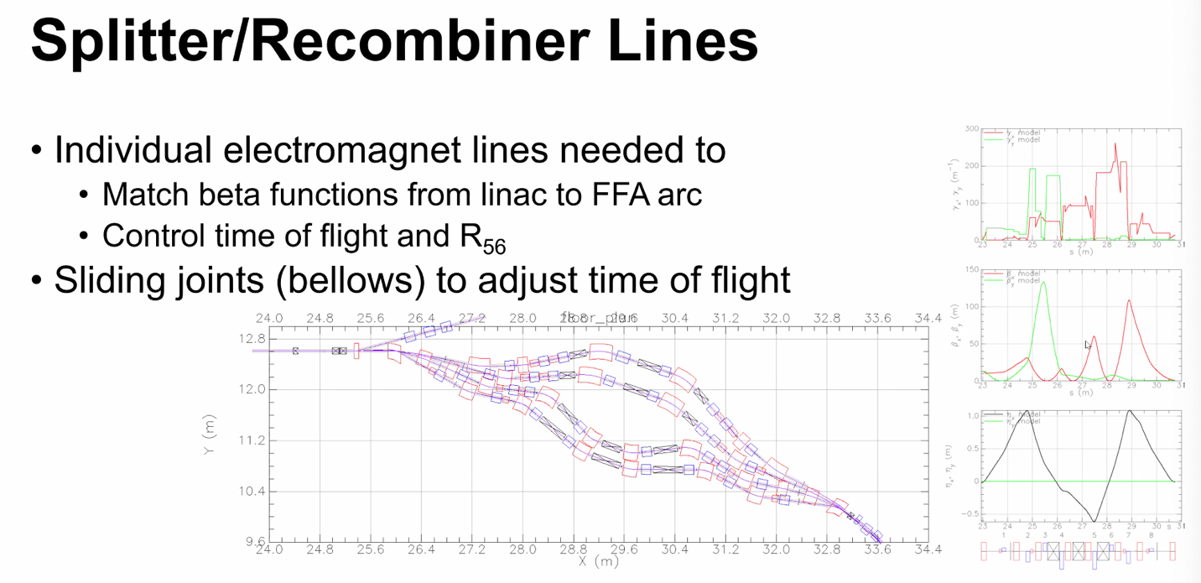
  - Beta in middle plot
  - To get R56, needed to make a phase advance in 3pi range
  - Did it the bad way – very low beta functions
  - Minima is cm-scale
  - Lots of chromaticity created
  - Donish - Gamma plot at top?:
    - This is CS gamma – proportional to chromaticity
    - At min beta – about half a cm – very bad b/c massive chromaticity
    - Useful to see
  - Ryan – how did you improve that?
    - Didn’t – this is what we were forced into with constraints
  - Donish – why create phase advance?
    - Think about normalized dispersion plane plot – without a dipole you go around a circle
    - Dipoles give you vertical displacement in plot
    - Trying to time things on that diagram so that the vertical displacement from dipole does the right thing in terms of dispersion
    - More phase advance you have, the more control of it you have
    - Dipoles dictated by geometry – we don’t have a green field
      - In GF – can put dipoles wherever you want
- Dejan take screen back again:
  - 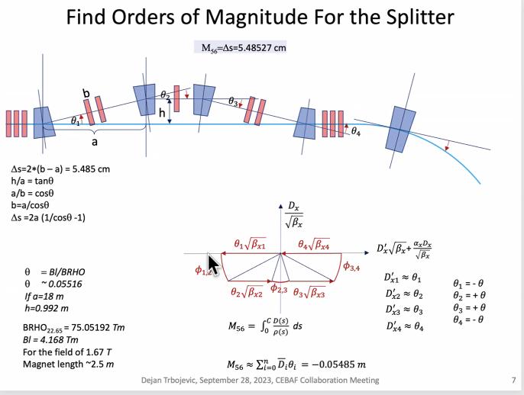
    - Look at diagram on plot here
    - Dipole bends left first
    - Phase provided by quads in picture – they drop the red down at first
  - Scott – that’s basically it
    - Reason I talk about phase advance: basically going from 0 dispersion amplitude to 0 – very little by design in FFA
    - There are solution classes – around 3Pi, can make a range of R56s by making continuous changes to a specific design
    - Let’s say have Pi phase advance through system – will then be able to make a range of values by changing parameters
      - At some point, run out of range
      - If R56 is out of that range, then start with new solution class
    - Phase advances usually vary less than Pi
    - CBETA usually had odd multiple of pi that work
    - This is why large R56 was so hard to deal with – limited quads and limited space limit solutions
- Donish – didn’t mean to laugh about 100 m betas, just not getting anywhere near that
  - Stephen – don’t forget that the splitters at CEBAF are much larger, so relevant number might be 10x bigger
    - CBETA was much shorter
  - Stephen – 800 might be problematic
  - Plot gamma
- Donish – started with Dejan’s initial designs. Problem is trying to match all parameters together
  - Has nice parameters inside. But when you try to match to FFA, it blows up optics
  - Can try normalized dispersion technique
  - Donish – ask Ryan what betas getting
    - Ryan – hundreds, depending on solution
- Scott – when trying to close the lattices, you can only get so far with normalized dispersion plane
  - Other trick is looking at dispersion. That’s what’s causing trouble
  - Basically, match the line where trying to nail dispersion and put a minimum on max beta
  - Betas won’t match, but the driving term for beta is twice the phase. Easier to fix than dispersion
  - So, get dispersion right, then get betas down, then match betas, then get R56
- 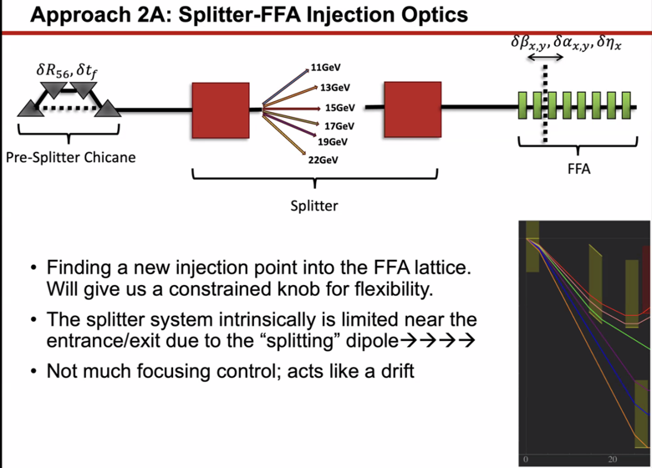
  - Can change where we inject into FFA lattice. That changes Twiss and dispersion we need to match into.
  - Another flexibility knob
  - Splitters is limited near entrance and exits b/c splitting dipoles – no space for quads
    - Basically a drift
    - One of reasons beta blows up in splitter is b/c this
- 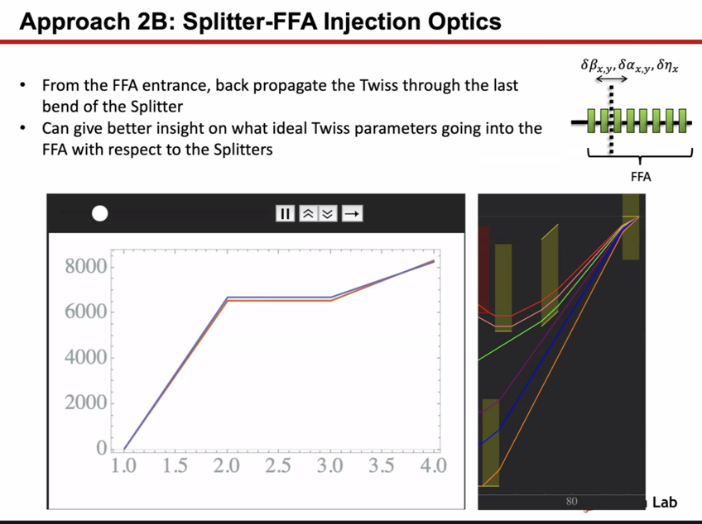
  - If you back propagate from last dipole to first quad
  - Left plot is video
  - Scott – bend to drift? Varying initial point in FFA lattice and propagating back?
    - In CBETA, cut a quad in half. Surprised not doing better
  - Stephen – as long as things stable, can adjust/cut these magnets pretty much wherever
  - Dejan – go adiabatically from FFA cells and get betas of order of 50 m – 70 m and merge orbits at same time
    - Stephen – do we have the space for that?
    - Ryan – nope
    - Dejan – never used 180 degrees, etc…
      - Similar to eRHIC
    - Ryan – we don’t have that space though
- 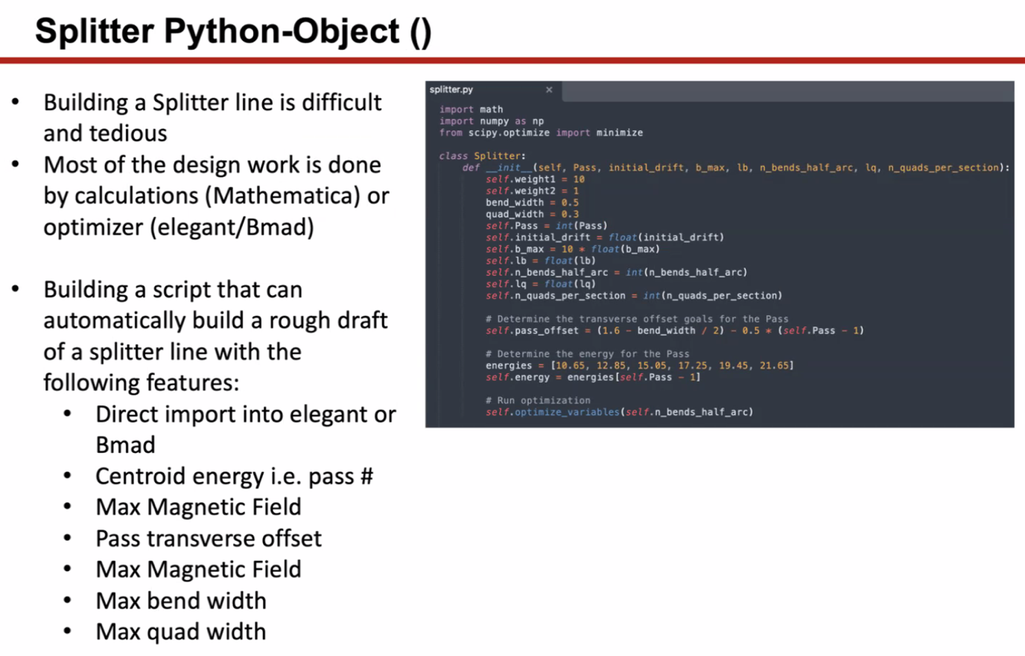
  - Make a splitter in python automatically
  - Making b/c people have good ideas, but creating initial file and piecing it together is painful, so this is a way for people to drop in ideas and it’ll start the process
Action Items | Person responsible | Deadline

Time allotted | 10 mins | Agenda topic AOB | Presenter All
- Next week talking about Transition section (Randy)
- Congrats to Alex B for becoming an APS Fellow!
Action Items | Person responsible | Deadline

Special notes

Pathway to Repository: https://jeffersonlab-my.sharepoint.com/:f:/g/personal/tristan_jlab_org/EqZ5MeS-nipCgPfZB5p0oS4B9Is67d3nQb9sLJI3Zyev9g

