FFA@CEBAF Working Group|Minutes

Meeting date | time 10/11/2024 | 11 AM EST | Meeting location https://jlab-org.zoomgov.com/j/1614898082?pwd=TnUzMS81M2sxbDZIbERJU01tYkJCQT09
Meeting called by Alex B  Type of meeting Weekly Meeting  Facilitator Alex B  Note taker Ryan  Timekeeper Alex B | Attendees  Alex B, Ryan, Randy, Vasiliy, Nick, Scott, Salim, Dejan, Reza, Donish, Stephen, Edy, Andrei, Tim

Intro Discussion
- Weather talk
- Nick Sereno joins

Agenda topics

Time allotted | 50 mins | Agenda topic Transition| Presenter Randy/Vasiliy
- 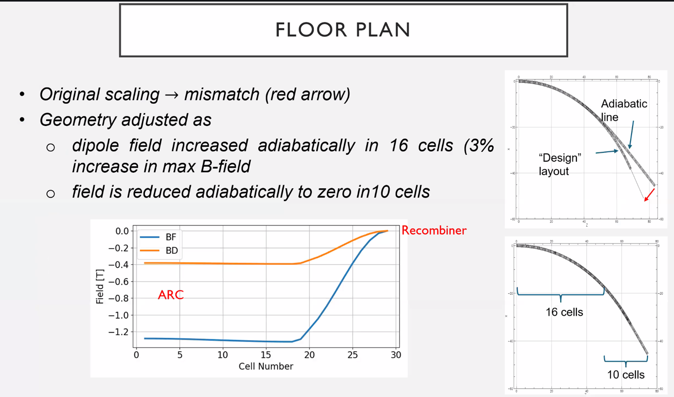
  - This is from just before IPAC
  - Was gone for about a month – not much change since then
  - After the last ARC dipole, have about 15 m before the recombiner
  - If you only use the adiabatic match, it doesn’t work – moves outward toward wall (top right plot)
  - 16 cells to bring them together, 10 cells to adiabatically match
    - Rough – doesn’t quite match or hit, but good start
- 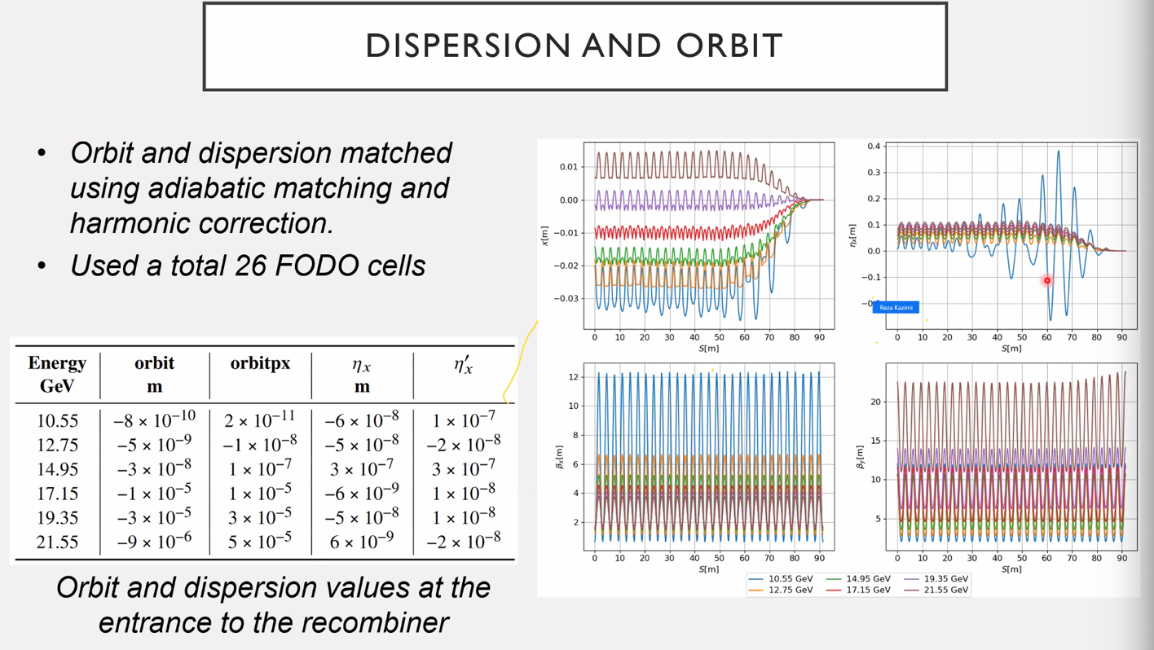
  - Not enough space to only use adiabatic matching – can’t get orbit and dispersion to close dispersion
  - Adiabatic first, then harmonic to get them to match
- 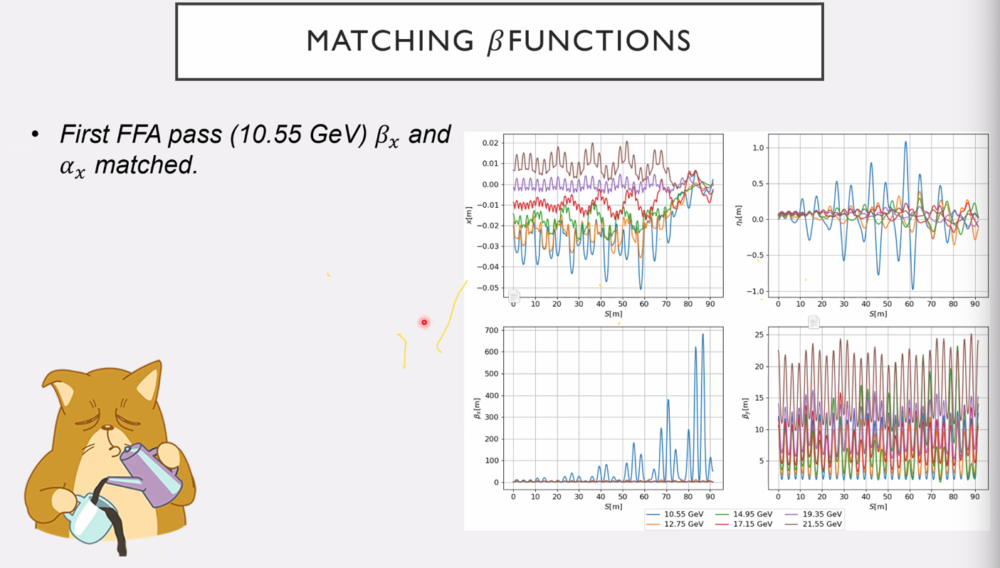
  - Sort of got Beta_x, but dispersion is being pushed back up and the orbits are hitting apertures
- 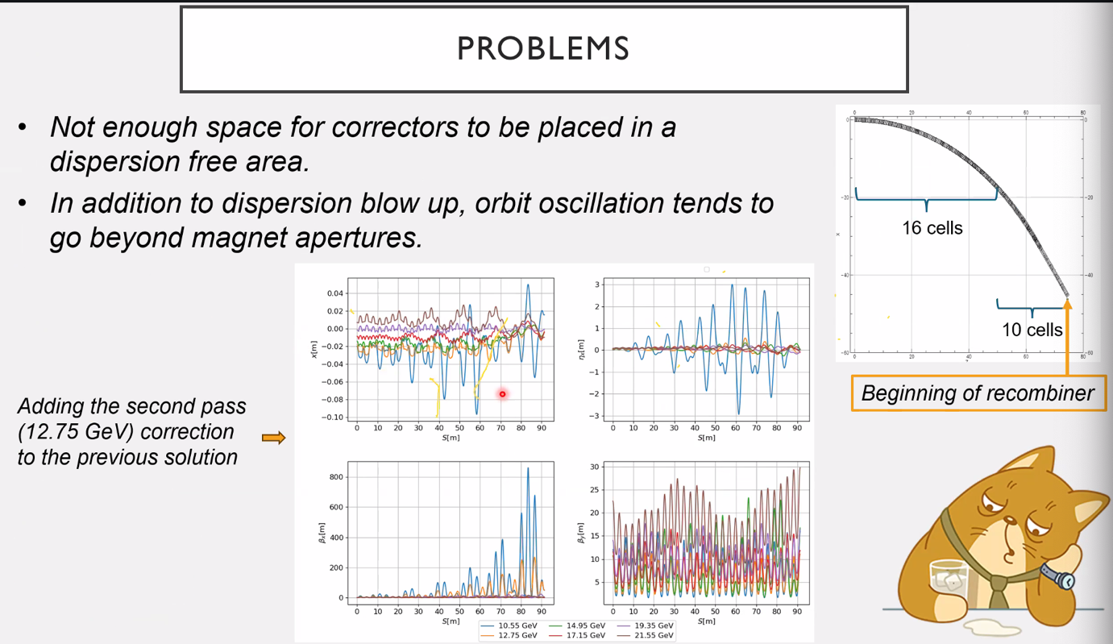
  - Adding in 2nd pass makes this worse
  - One issue: if we had correctors in non-dispersive area it would work better
    - If no bending, it might work – but no choice
    - Only last cell has no bending
  - Orbits are crossing over the apertures
- 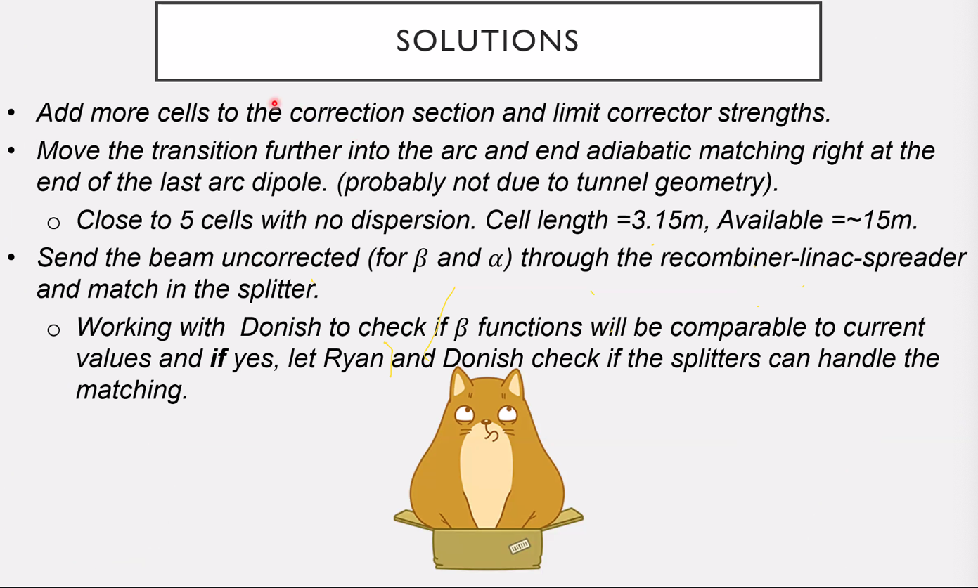
  - Second method might not work b/c geometry
    - Basically move things upstream to get a 15 m straight section – but this only gives about 5 cells
  - Maybe only send orbits and dispersion set, and allow Twiss to just go through LINACs uncorrected
    - See if splitters can handle the re-matching then
- Stephen – what was the correctors used?
  - Just a thin corrector in between FODO cells
  - So weak quad?
    - Yes – dipole for orbit and disp, quad for betas
  - Beta – normally you have to change the cell lengths
    - So make magnets longer with weaker magnets – will give higher betas
    - If using only the strong magnets we have now, you’ll probably get betas oscillating rapidly
  - Randy – yes, that would work. But the matching into very specific betas is hard.
    - Matching to 6 specific betas/alphas is very hard, but your method would help
    - It might be helpful to let splitters do the matching, and allow the Twiss transport “as is” in LINACs
  - Stephen – tiny area and sensitive match
- Dejan shares:
  - 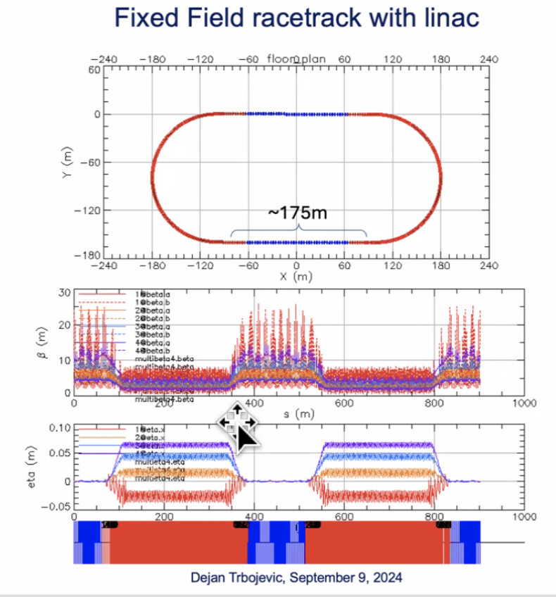
    - Problem with betas
    - Red arcs show space required for this
  - 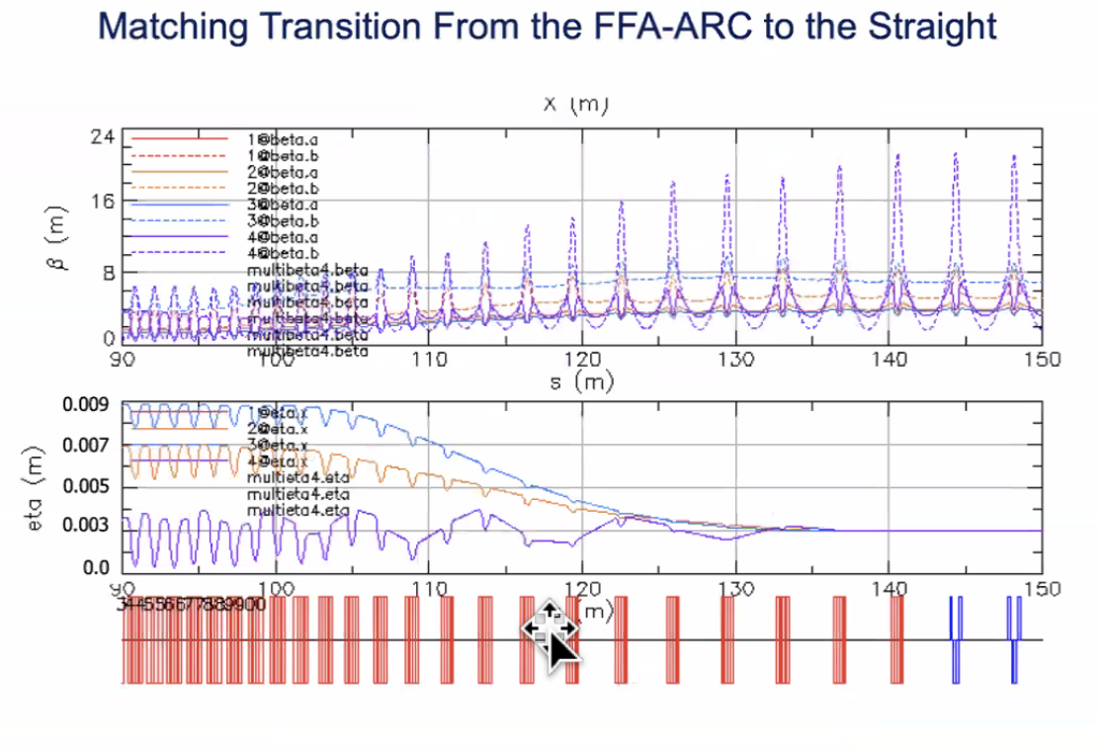
    - This uses power law – lots of space taken here
    - Our betas are ~120 m – need sells probably almost twice of this size
    - Maybe need something other than power law so it can go faster on merging orbits
- Alex B – 5 cell transition doesn’t give enough DoF
  - So if you need to go back into the arc, that’s doable.
  - Randy – no, 5 cells isn’t the transition itself.
  - 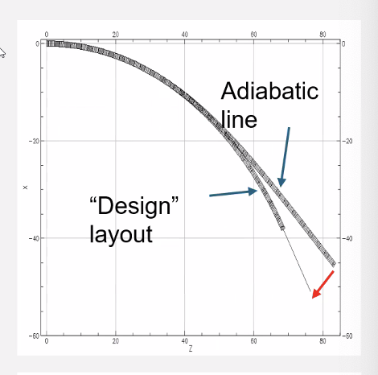
    - So start adiabatic part earlier and have the ~15 m length to bring down the Twiss
    - However, there’s no space left
- Dejan – cut from 90 degrees to 83 to allow for adiabatic
  - Randy – yes, but if you’re not straight at the end, can’t align with recombiner – MUST BE STRAIGHT
  - Yes but maybe go to 75 degrees instead of 83
  - Stephen – that’s what he’s done already
  - Narrow line is only the free space available
- Stephen – longer is tricky b/c dispersion and orbits wander
  - Can put less focusing in the cells – just add in less magnet
  - Reduce F and D in them
- Dejan – can’t merge without reducing bending
  - Go back to first picture:
  - Instead of using same cell length, make the cells longer and repeat like below
  - 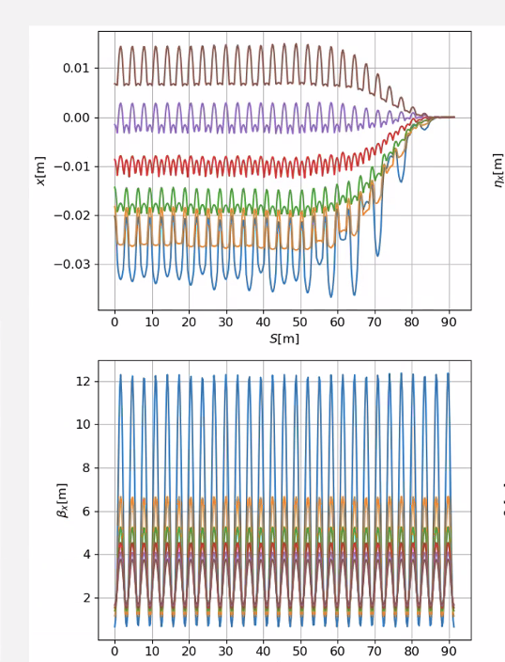
  - Randy – will try
- Stephen – but we don’t have much space to lengthen cells. But maybe smarter to reduce fields in them
- Vasiliy – cell length changing only works if phase advance per cell is roughly fixed
  - 20 m beta cell has very little phase advance
  - When going from short to long cell, can’t keep phase advance
  - Stephen – get too much focusing – need to reduce field too
  - Vasiliy – tried this but didn’t work
    - Used large number of cells – didn’t work. Shouldn’t abandon yet, but will likely require a large amount of space to go from several meters up to over 100 m
- Dejan – changed bend, length, and gradients
- Vasiliy – gradients have to be strong enough to keep phase advance constant
  - Stephen – don’t want PA to go up and become unstable, but maybe can send it down
    - Might get bigger betas for optimizer
  - But that’s not systematic – think tried in past and wasn’t successful
    - Dropping PA requires brute force optimizing
- Dejan – main law used was power law – but maybe there’s a third order or some other way to reduce length of matching and still be adiabatic
- Vasiliy – only two options for systematic match:
  - Adiabatic with cell length
  - Harmonic match – might need to go through several focal points
- Vasiliy shares:
- 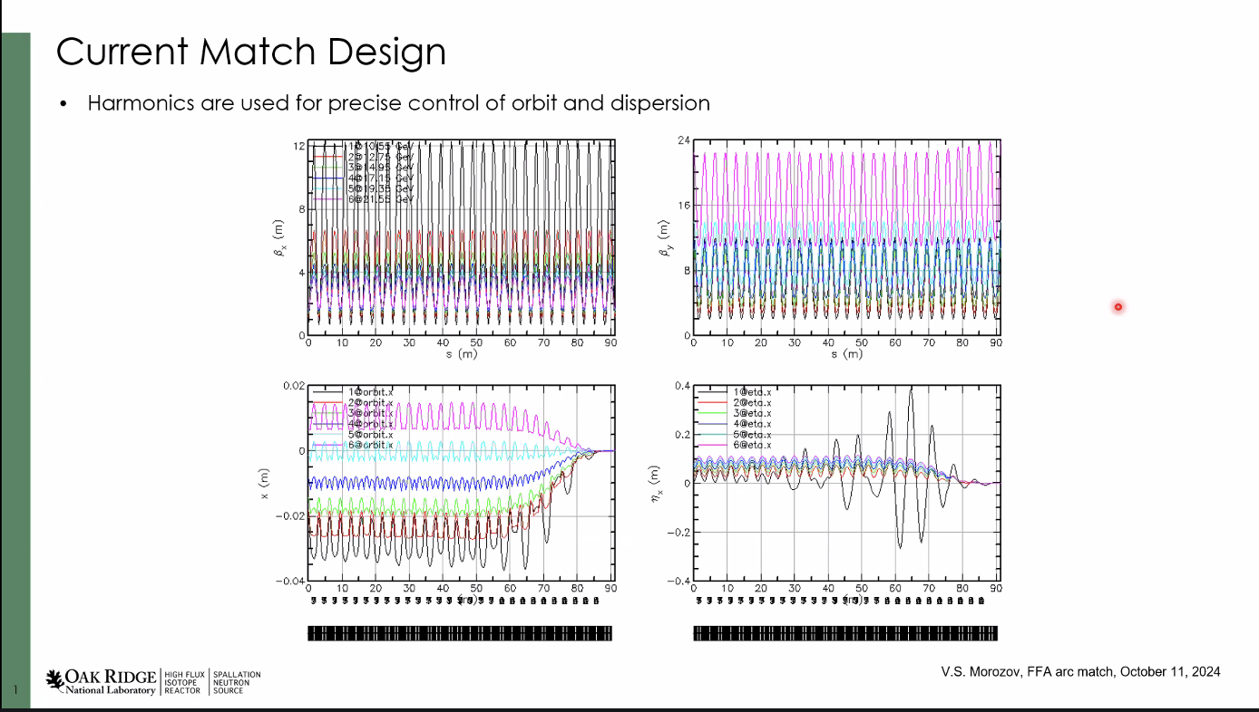
  - Limited space, adiabatic suppression of orbits and dispersion need to be done in a small number of cells (10ish)
  - You get close, but low E orbit not suppressed perfectly (lower left plot)
  - Harmonics used for quad and dipole components at the betatron tune frequencies
    - Each family controls only its own energy
    - Magnets modulated at frequency of betatron tune
  - Lowest E dispersion is concerning (lower right) – way to improve?
- 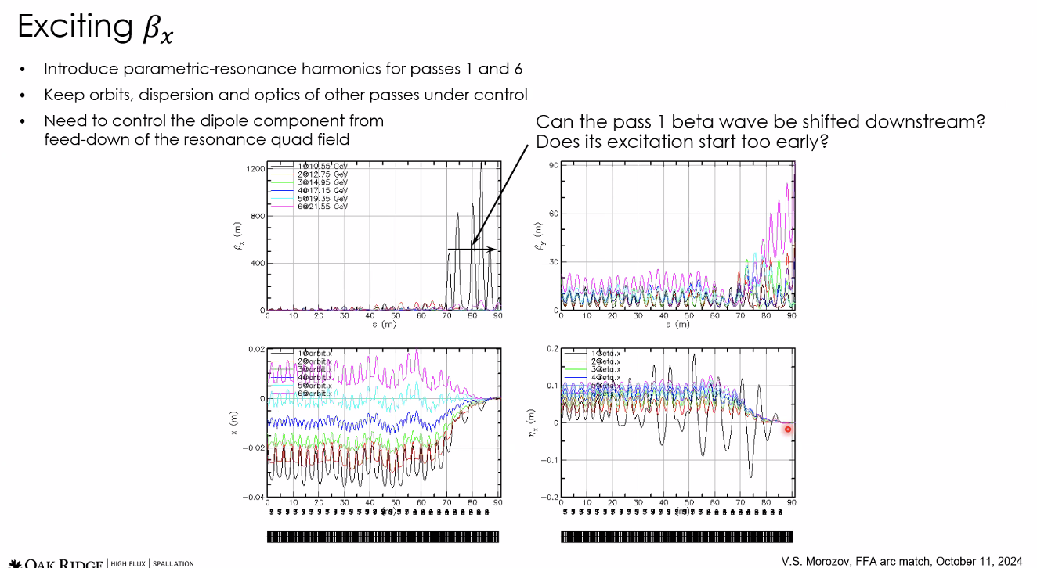
  - Tried resonant harmonics for passes 1 and 6
  - Able to generate 50 m betas at the end of the matching for passes 1 and 6
  - Kept control of the rest of the passes mostly
  - Pass 6 look OK, but pass 1 really starts oscillating heavily (top left plot)
- Any way to move beta wave later (downstream)?
- Is resonance throughout all of matching section for quads right?
  - When they’re introduced, they make a dipole component on all passes from feed-down of quad field
- Introduced dipole component at the same frequency and tune as the modulation of the parametric resonance quad harmonic
  - This may have been why controlled a little better
- 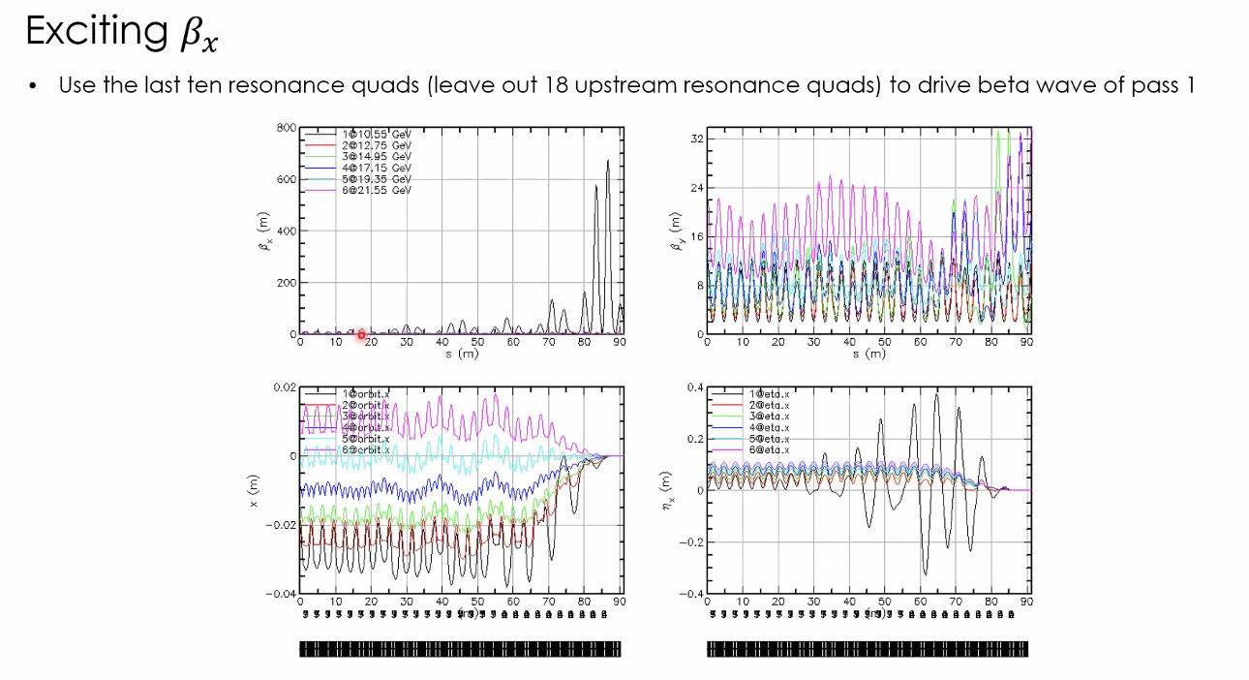
  - Tried using only the last 10 resonance quads and look at lowest E pass
  - Get modulated beta wave (top left plot)
  - Not sure why modulation is happening
- 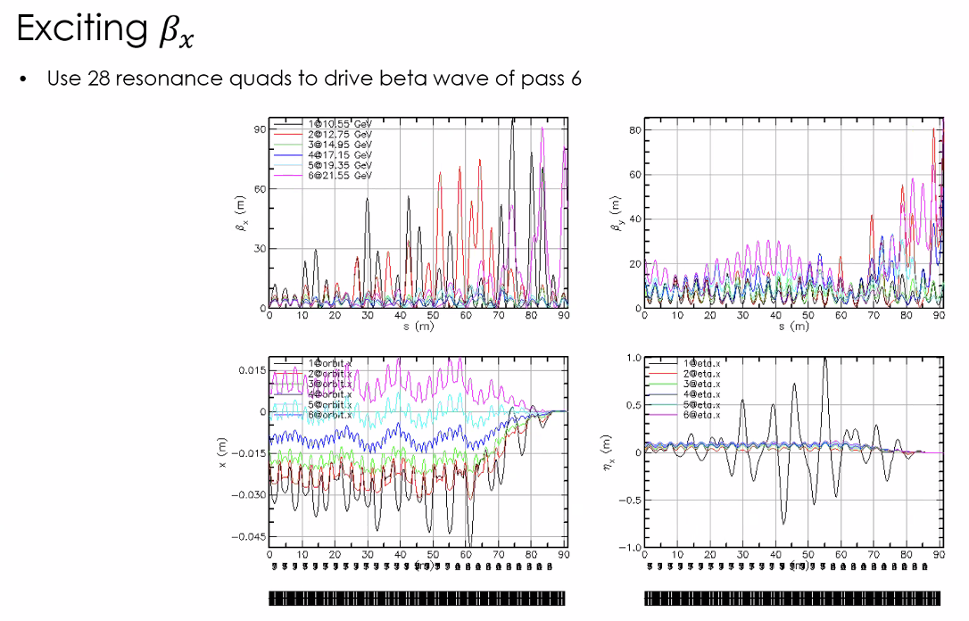
  - Looking at highest E pass, used all 28 quads and dipoles of same harmonic
  - Able to excite betas for highest E up to 50 m, but it also impacts lower E passes
- 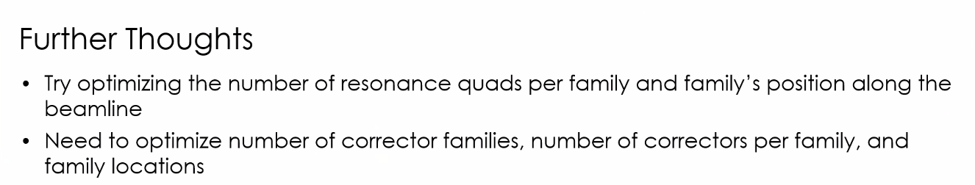
  - Maybe power every few cells for certain energies?
  - Corrector families have non-trivial interactions with resonant harmonics
    - Right now 1 family per energy, maybe change that
- Stephen – have you assumed any limits on quad correctors?
  - No, not yet. Looking for any solution first
  - Stephen – can go downwards a lot if you take magnet away, though you also remove dipole then
- Easy way to change quad a lot in the last few cells, reduce length (but also then lose dipole)
- Can also play with lengths and positions
- So can play with strengths of main magnets – change drifts between, and change lengths pretty freely
  - Vasiliy: For the model, keep the length the same and alter the strength
  - Stephen – might not want to do that b/c interplay
- Vasiliy – if we squeeze things upstream a bit, maybe gain some real estate
  - All for increasing cell length, but maybe not space
- Stephen – your corrector is in a fixed position in the cell?
  - Yes
  - Introduce more drifts and shift magnets back and forth on the cell?
- Vasiliy – more considering positioning of the entire family of magnets
  - Stephen – but yes, what if you change where in the cell these corrections take place?
- Vasiliy – maybe let correctors vary independently based on betatron tune
  - Stephen – b/c it’s so short, you’ll need to optimize all the variables you can – adiabatic only rough approx. at this point.
- Ryan – how many magnets per cell?
  - Vasiliy – one Y and one X (one on the F or D mags)
- Alex B – steering/modulation?
  - Tried to compensate steering by introducing dipole at the same frequency as quad component
- Dejan shares:
- 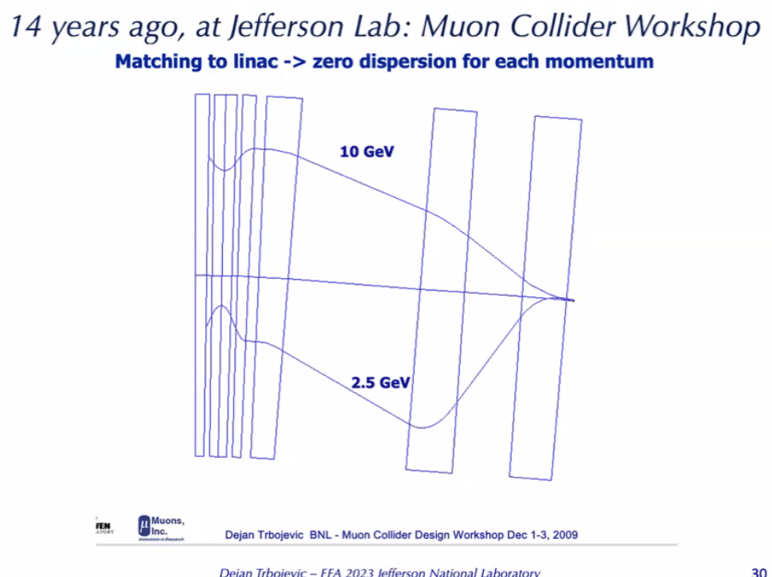
  - FFA in end.
  - With only 2 magnets (combined function) can merge – can be done analytically
- 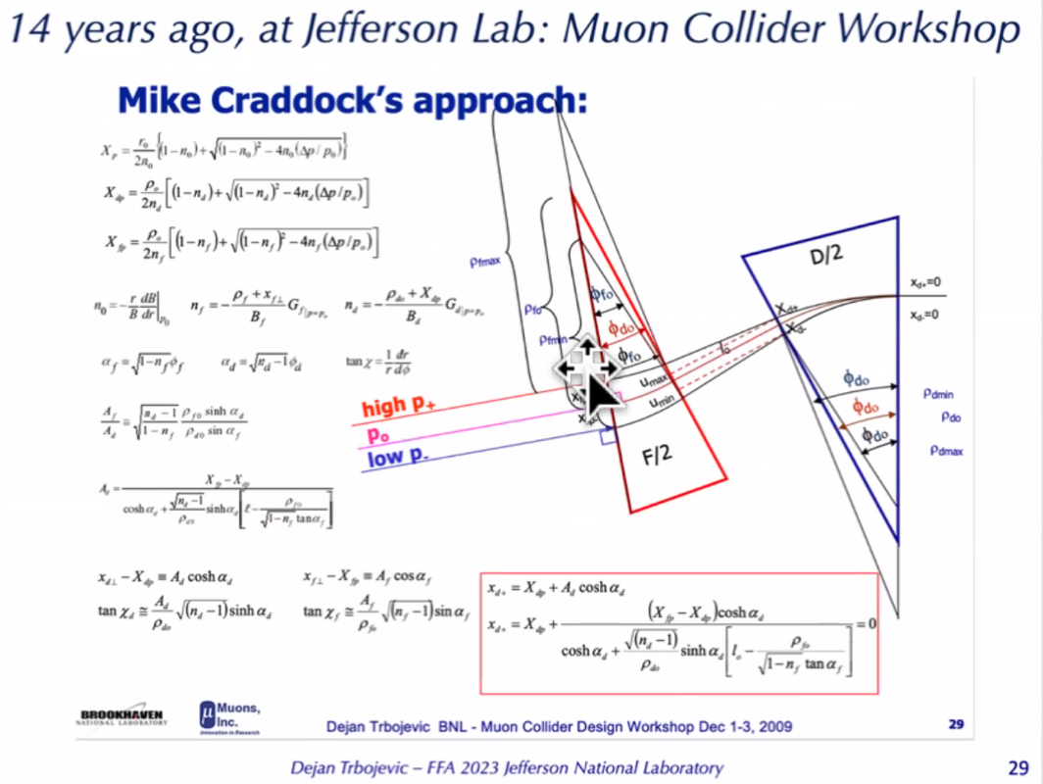
- Vasiliy – we tried the short-quick
  - Worked for orbits and dispersion, but not beta
  - Maybe combine?
  - Use short section at end for orbit and dispersion and use several cells before final cell to get betas?
- Alex B – optimizers from linac optimized some way
  - If you find a more preferred configuration of the Twiss, can redo things for multipass optics for linacs
  - Probably need to give us a hint in which direction to go
- Dejan – if I raise the linac and start with the first module
  - Keep tunes same in every module, then raise gradients as accelerate, then need higher gradients for phase difference
    - Track multiple turns – have you done it?
  - Alex B – yes, we’ve done this. Only visible for first linac – not detrimental
    - Keep phase advance constant – but regulate end field focusing with quads
    - Optics – transparent – same PA
  - If LINAC is drift, get 150 m beta
  - Must be optimum value by using the LINAC as the IR
    - Alex B – can have multipass optics to have quasiperiodic solution for all passes
      - But betas gradually increases (thinking 167 m for top pass)
  - Dejan – I got 110 m – depends what beta you choose in the middle
  - Alex B – if you have the whole chain and not just a single cell, changes
    - At the 22 GeV, getting elevated to ~160 m
    - Dejan – we should revisit
    - We did this, then went back to strong focusing to get Betas and Alphas right
- Dejan – because the quads inside of the LINAC don’t do much at higher Es, can play with triplets at end, focusing with low and high E optics
- Alex B – Donish made the code a bit modular so we can drop in different versions of things.
- Please put slides in the folder!
Action Items | Person responsible | Deadline

Time allotted | 10 mins | Agenda topic AOB | Presenter All

Action Items | Person responsible | Deadline

Special notes

Pathway to Repository: https://jeffersonlab-my.sharepoint.com/:f:/g/personal/tristan_jlab_org/EqZ5MeS-nipCgPfZB5p0oS4B9Is67d3nQb9sLJI3Zyev9g

