FFA@CEBAF Working Group|Minutes

## Meeting date | time 10/25/2024 | 11 AM EST | Meeting location <https://jlab-org.zoomgov.com/j/1614898082?pwd=TnUzMS81M2sxbDZIbERJU01tYkJCQT09>

|  |  |  |  |  |  |  |  |  |  |  |  |
| --- | --- | --- | --- | --- | --- | --- | --- | --- | --- | --- | --- |
| |  |  | | --- | --- | | Meeting called by | Alex B | | Type of meeting | Weekly Meeting | | Facilitator | Alex B | | Note taker | Ryan | | Timekeeper | Alex B | | Attendees  Alex B, Ryan, Donish, Scott, Edy, Dejan, Kirsten, Stephen, Vasiliy, Reza, Alex C, Roger, Salim, Tim, |

# Intro Discussion

* DOE Tour at JLab today
  + Posters from Salim and Donish
* EIC review at BNL
* Jim Fast retiring
* JLab having lots of retirements in general
* EIC injector decision needs to be made

# Agenda topics

## Time allotted | 50 mins | Agenda topic Splitter Mag Tolerance| Presenter Donish

* JLAAC: 5th time presented FFA@CEBAF
  + Oliver wanted more insights into “crowded” splitters
  + “What is the field and magnet tolerances in the congested beamlines.”
* Donish presents
* Diagram

  Description automatically generated
  + Stephen – what about vertical spreader?
    - This is different
    - Ryan – spreader is to split off all lines, even EM. This would come after, but before splitters
  + Did this for pass 1 – make isochronous
  + Neg R56 – center has to be positive x2
  + Work in progress
  + Difficulty seeing – global shift in R56 will impact other passes, maybe negatively
  + Not sure good or bad yet
* Ryan – where would ToF take place, in this chicane, or in the splitter itself?
  + Donish – splitter
* A picture containing diagram

  Description automatically generated
  + Sampled from gaussian, 10K runs
  + Designs are more complicated, can’t just look at orbit. Need Twiss matching, eta, R56 at end
  + Preliminary study
  + Shifted dipoles spatially and angularly
  + 1% error, not 0.01%
* Dejan – some of these dipoles are common for 3 lines – how would this work?
  + Donish – splitters are so early stage, there’s no correction scheme associated with it
  + Dejan – can always adjust fields if there’s an error. But if you adjust it for one it’ll hit all others wrong
  + Ryan – but you’re trying to separate these out further so they’re independent anyway, right?
    - Dejan – yes, good sentence
    - Donish – yes, working on finding magnets that can separate them out
* Donish – first two yellow bends are weak – only ~1T at 3 m long
  + Use of septa, and other magnets
  + Ryan – side note – you’re going to have to start pushing the higher E passes “up” in that plot to make them fit. This will change the geometry significantly
  + Design is in flux – magnet strengths, etc… are changing frequently
* Dejan – what’s the deadline for the review?
  + Feb 4-6, 2025
  + Still have time, but it’s coming soon
  + Dejan – need to help Donish with this work
    - Plan to make this “white paper”
* Chart, scatter chart

  Description automatically generated
  + Top is spatial, bottom is angular misalignments
  + Ran independently
  + 10K runs
  + Alex B – so you ran a Monte Carlo?
    - Donish – gaussian distribution of errors
      * Take stats of error, plot, and then calculate RMS of gaussian
      * 10K roughly enough.
  + High spread has larger effect
* Chart, histogram

  Description automatically generated
  + Running with 1% field strength error
  + Spread inside the splitters – will amount to large spot size in beam in either direction – could be beam loss in pipe
    - Top left plot in particular – beta goes over 1000 m
      * 500 m is nominal beta function there
* Ryan – is this dipoles or quads or both?
  + Donish – both
  + At the very end, the spread is important – are you matching at the end into the FFA cells?
    - Lots of spread in the Bx and By and D – will affect matching into FFA arcs
    - Eta matching will also impact R56
  + Stephen – this sensitivity is what Scott warned us about in the Splitters!
  + Donish – the current design is very sensitive. If you tweak one quad to fix R56, destroy matching
    - When first started and looked at Spreaders, error studies are very sensitive b/c lots of load on each bend
      * One way to alleviate is to include more magnets and/or bends with smaller angles
      * More quads to share load
  + Stephen – what about each individual magnet? See which are most sensitive?
    - Good idea, one at a time
* Scott – your idea has merit in principle. Issue is that to make that work, you can’t just put in more quads.
  + Quads have to be “doing something”
    - If you just slap a bunch of quads together in basically the same lattice design, not going to help anything
  + Trick is actually phase advance.
  + Imagine that every time you add a quad, increase PA by Pi/10 (for example – random choice)
    - Quad doublet needs to add “another FODO cell” (not really FODO, but that idea)
  + It’ll bring Betas down – not bad in absolute sense
  + Imagine a long FODO chain with Pi/2 in each compact cell, easy to control
    - Catch – just made something with very high gradients – very difficult object to create
  + Apertures go down, but go as sqrt(beta) – not as fast as mags go up
  + So basically, implement in a reasonable way
* Alex B – adding more quads in this way, you have to do it deliberately so you can create orthogonality of different groups of quads?
  + Scott – that’s part of what’s going on. But really, trying to solve the problem that showed previously
    - Essentially creating the phase advance needed to do the matching by doing horrible things (like making IRs in lattice, etc…)
    - Try to make enough PA and independent control to have some sensible cells so betas don’t go as high or low
    - Avoid extremes to avoid chromaticity
    - “Easier said than done” often
      * Quads get longer, etc…
* Dejan – from CBETA – difficult to tune splitters as long as the beam was not in the middle of the quads, b/c the quads would then also bend and mess with operation
  + Must have beam in middle of quads
* Donish – tried following orange line (low E)
  + Very simple, only 4 dipoles.
  + 3 quads in first and last drift
  + Tried to make repeatable cell in middle – lots of difficulty to make a cell structure in middle to play around with
    - Beta going into second bend is nice without quads, but high D
  + Suggestions?
    - Ryan – you can do sets of doublets with alternating polarity, but not “pure” doublets. You make the quads independent, but flipped signs. This way they can group together in ways to control different terms
    - Alex B – that’s a good idea, maybe start with 2 doublets
    - Chart, line chart

      Description automatically generatedDejan shares old work
    - Alex B – yes, but doing it cleverly, you can essentially make is a triplet
  + Scott – that picture is a good example to look at.
    - Donish’s lattice will look similar with R56 matching
    - R56 comes mostly from central 2 dipoles. Almost nothing from end dipoles
    - Basically, controlling dispersion and betas at the two dipoles
    - Just try to control D at two central dipoles
      * With symmetric lattice you have (which may not be reality), you basically have it.
      * Use quads between two outer dipoles to make the dispersion what you need
      * With more space in center quads, you have all the time to bring things to 0 in the center.
      * Need enough quads between first two dipoles to set dispersion to what you want
      * Dejan – and keep betas low
        + Scott – problematic is below a meter for beta
      * Keep beta max and beta min not too great
* Donish – worked with lattices like this from the start – definitely easier said than done
  + Doublet between first two bends – might not fit in that space. Shift closer to second magnet
  + Dejan – but there are many solutions
  + Scott – Donish is brining up an important point. Talking about section right after separation. Take space to find a place to fit a quad. Need to wait until you have enough space to fit a quad
* Kirsten – sensitivity is important. But if we can’t actually measure the beam parameters after EM passes, doesn’t matter how stable the transport is, the small errors will add up. We’ll have to send it and hope. This is a bigger part of the problem of not repeating CBETA problems
  + Need to know what you have!
  + Scott – partially where put screens
  + Kirsten – but if they want to bang on about not doing the same problem, maybe we make sure we can diagnose the beams
* Dejan – zigzag might help instead of chicane as well! Not sure how it’ll impact things
  + Ryan – like Donish’s other design.
  + Dejan – but I like the chicane b/c it’s symmetric and simple
* Scott – net bend?
  + Ryan – no, if you keep it under 95 meters
  + CBETA had net bend
  + Here, nothing stopping from having common dipoles bending the other way
  + Imagine 2 common dipoles pinning the ends – one side maybe more free?
  + Ryan – have under 3 m of transverse, 95 m length
    - Donish looked at this – it’s his idea
  + Donish - Central dipoles always give the same R56 – need to use quads to flip it
* Dejan – be careful for rho and D, but zigzag might be OK
* Donish – plot that Dejan showed with complete symmetry – one difference: 3rd bend is quite difference – no control
  + Finding that 2nd and 3rd dipoles don’t have same control
* Ryan – have to remember, we’re not closing dispersion into FFA arc. Each pass has a different D and D’
  + Scott – dispersion amplitude is ~0 at FFA end and 0 at LINAC end
    - Big difference is beta – issue there is that b/c of large beta coming from LINAC side, make a large dispersion amplitude at LINAC side than at FFA side
      * Basically will generate big dispersion amplitude on left side, small on right side – way we imagine things is that we have this symmetric dispersion going through, where you really don’t b/c you generate a large one on one side, and small on other, and having very different betas.
      * Also hard to control phase advance with large betas b/c need to bring them down first
      * Diagram, schematic

        Description automatically generated
* Ryan makes aside about how we already operate with very tight beamlines:
  + 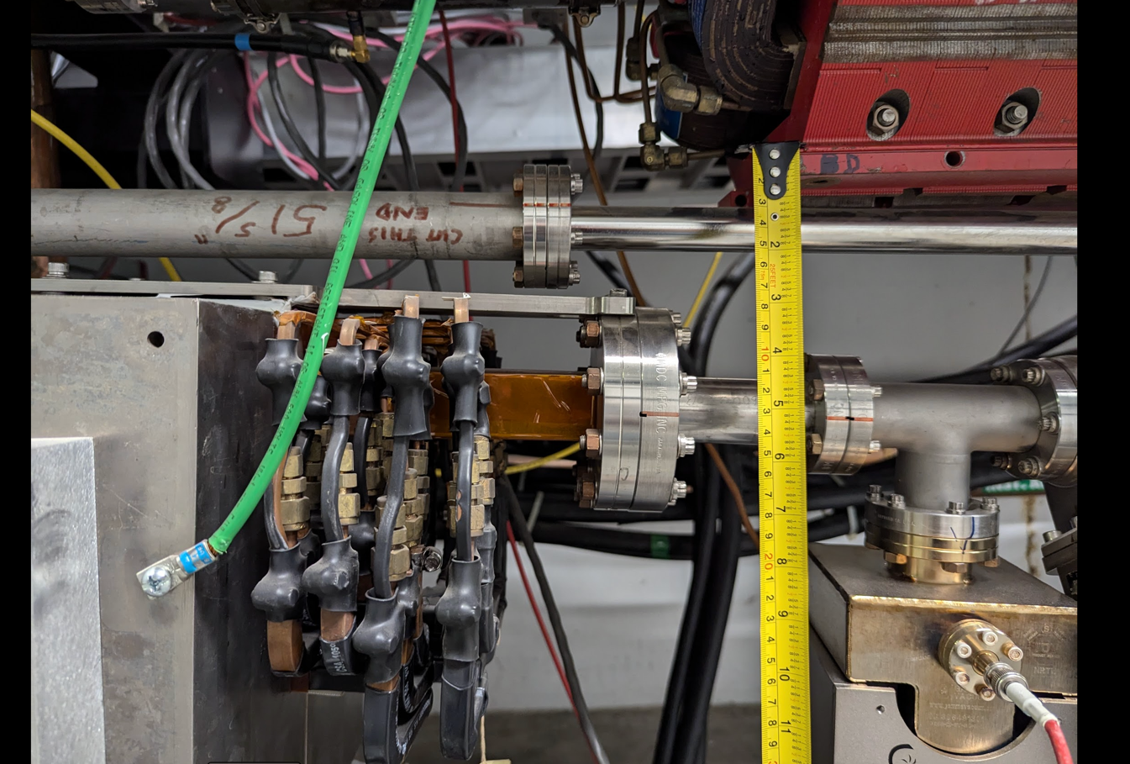
  + A picture containing text

    Description automatically generated
  + A picture containing text, indoor

    Description automatically generated
  + Suggest complimenting Donish’s simulations with an argument that this is already how we operate the machine.
  + Scott – be careful, you can do this gently, but if you have to do it too hard, it won’t work (CBETA)
    - Ryan – I agree, with the caveat that CBETA was low energy, and ours are much higher E beams with more rigidity
      * Scott – It might be that way
* Alex B – this is all-important. If you have an idea, he needs all the suggestions. We need to do this collectively.
  + To keep the momentum going, we’ll probably revisit every other meeting.

|  |  |  |
| --- | --- | --- |
| Action Items | Person responsible | Deadline |
|  |  |  |
|  |  |  |

## Time allotted | 50 mins | Agenda topic “White Paper”| Presenter All

|  |  |  |
| --- | --- | --- |
| Action Items | Person responsible | Deadline |
|  |  |  |
|  |  |  |

## Time allotted | 10 mins | Agenda topic AOB | Presenter All

|  |  |  |
| --- | --- | --- |
| Action Items | Person responsible | Deadline |
|  |  |  |
|  |  |  |

## Special notes

Pathway to Repository: <https://jeffersonlab-my.sharepoint.com/:f:/g/personal/tristan_jlab_org/EqZ5MeS-nipCgPfZB5p0oS4B9Is67d3nQb9sLJI3Zyev9g>