FFA@CEBAF Working Group|Minutes

Meeting date | time 11/08/2024 | 11 AM EST | Meeting location https://jlab-org.zoomgov.com/j/1614898082?pwd=TnUzMS81M2sxbDZIbERJU01tYkJCQT09
Meeting called by Alex B  Type of meeting Weekly Meeting  Facilitator Alex B  Note taker Ryan  Timekeeper Alex B | Attendees  Alex B, Ryan, Donish, Scott, Alex C, Nick, Edith, Kirsten, Randy, Salim, Stephen, Dejan,

Intro Discussion
- Scott – what about a paper?
  - Alex B – Dejan recommended making an internal white paper
    - JLab management wants a TDR in 2ish years
      - Ryan – doesn’t CDR come first?
      - Alex – apparently, no (according to Alison Lung)
      - Ryan – odd, overseas, it was CDR then TDR – might be JLab specific
  - White paper for now is for us – Donish is leading the Overleaf part
  - Ryan shares link in chat: https://www.geeksforgeeks.org/difference-between-technical-design-and-conceptual-design-in-software-engineering/
- SBIR?
  - Looks bleak
  - What was BNL’s response?
    - DOE rejected as something to do in the future
  - Short version of discussion: rejected (“non-responsive”)
- Long aside about funding, etc…
  - Muon cooling/collider, etc

Agenda topics

Time allotted | 50 mins | Agenda topic Splitters| Presenter Donish
- 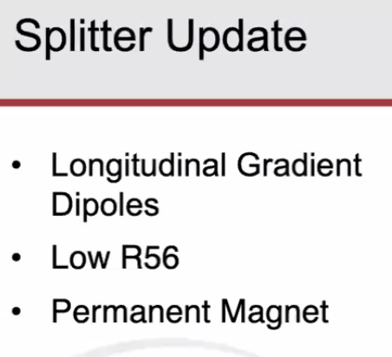
- Lots of talk/good ideas – explored a few this week.
- Not enough time to do anything finalized. Initial impressions
- 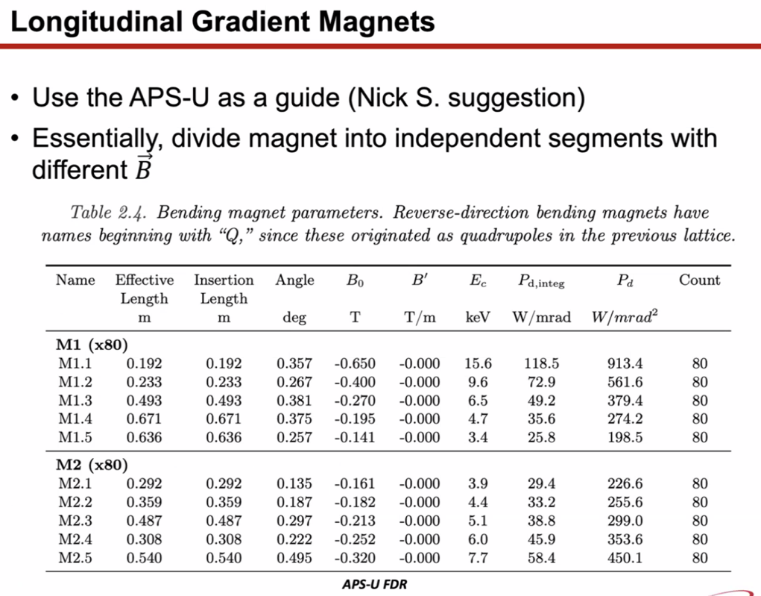
  - Longitudinal gradient magnets divided into M1 and M2 – split into 5 pieces
    - Each different length/strength associated with it
  - No linear tapering – operated independently
  - Nick in chat: They have a complex coil structure with varying numbers of coil turns along the magnet.
- Tried this with our magnets
- 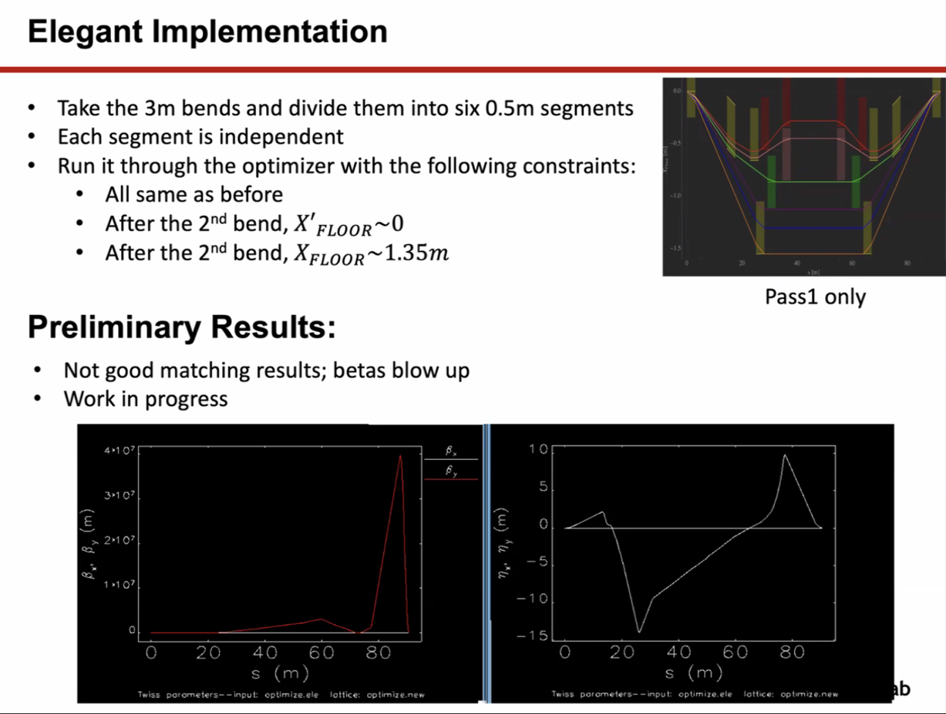
  - 3 m bends, divided into six, 0.5 m segments
  - Only first pass on this run
  - Kept all the other constraints from before
  - After second bend, wanted x’ of floor to be 0
  - Wanted x at floor to be at 1.35 m
  - Prelim at bottom – bad for matching
  - Betas blow up – work in progress
  - Feeling getting – this introduces quite a lot of complexity to the system
    - Thought it would give more freedom (6 knobs for dipole field) – but it’s too much for the optimizer (ran a long time)
  - Ryan – remind me to send you the paper from Andrei: https://journals.aps.org/prab/pdf/10.1103/PhysRevAccelBeams.26.021601
- Tried using alternative magnets:
  - 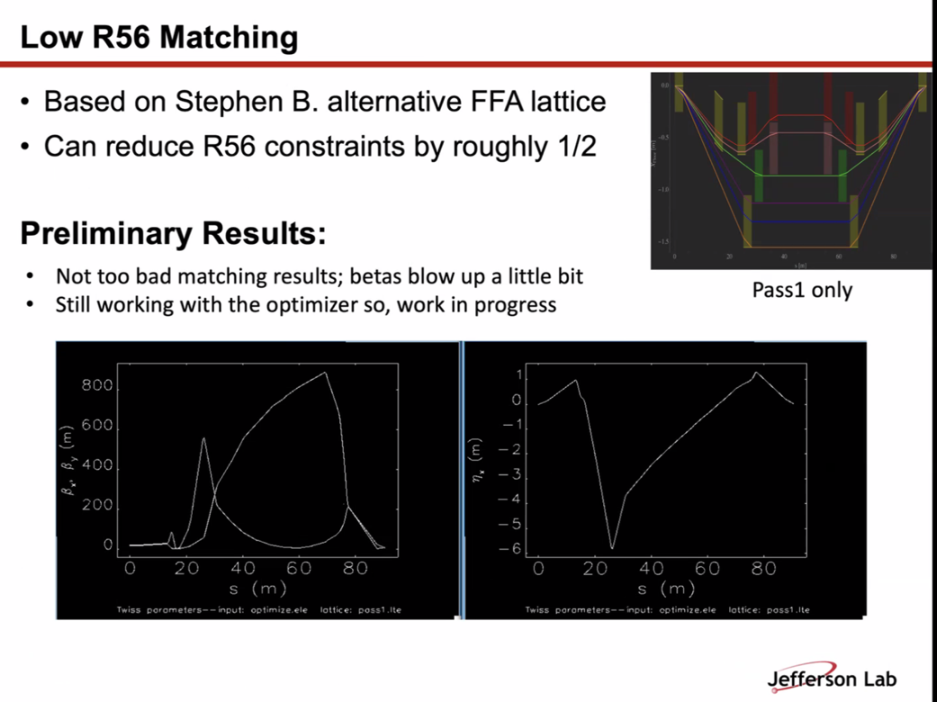
  - Helps matching, but still running
  - Basically just reduced R56 and tried matching
- Stephen – should be about 5/6 for option B. Sextupoles reduce it more
- Donish – if you have more specific numbers, this is promising
- Permanent magnets suggestion:
  - 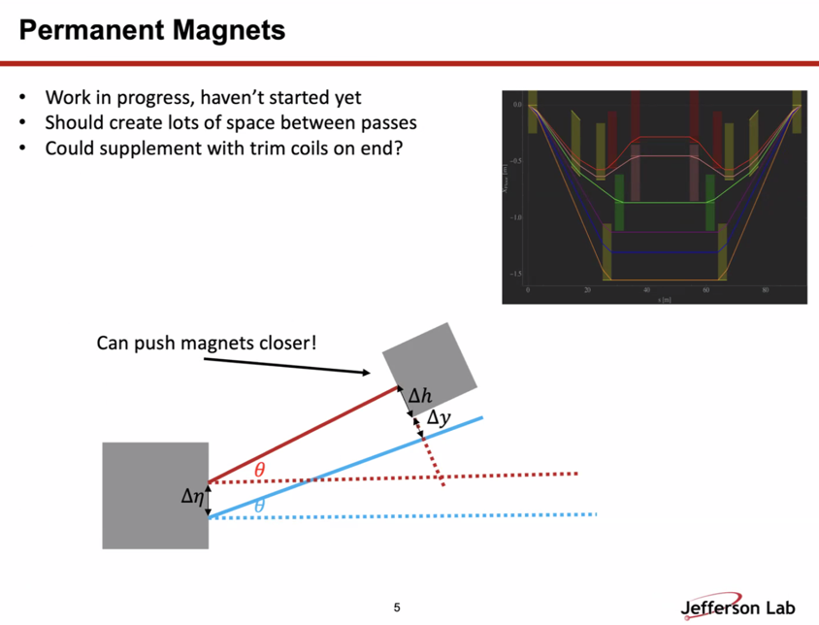
  - Ryan – we spoke about this previously – sort of sandwiching between EM magnets
  - Scott – might make sense to put permanent magnets on one end and adjust at the other
    - You need the adjustment at a corrector level, but also to handle varying energy
    - If you say permanent on one end, EM on the other, get angle right but not position
    - Can probably do this – maybe have permanent, adjustable, permanent (sandwich)
  - Alex B – Hybrid promising, but what about different energy linacs?
    - Ryan – that’s why you need the adjustable
  - Scott – could also have PM C-magnet in Halbach style sort of
  - Stephen – if R56 isn’t as big, can use higher gradient in smaller periods
    - Can’t change bending, but can adjust optics more to improve emittance growth
  - Scott – lower R56 will help emittance, which should help emittance
  - Stephen – looking to optimize
  - Ryan – in favor of trying not to add sextupoles, b/c it would complicate things. If you need them, so be it, but I’d prefer operationally not to add them in
    - Stephen – been looking with Sextupoles, but might try to look at linear magnets and different cell designs
- Alex B – use PMs with quad components, Curly H improve if we have focusing and bending
  - Kirsten – B/c the PMs are smaller, optics smaller?
  - Alex B – b/c D and D’ smaller and varying less
    - FFA arc, having the gradient distributed inside bend helps the variation of D and D’ more gentle
    - Not quantitative
  - Kirsten – can get smaller optics and curly-H
  - Stephen – The FFA does it, high field but works
  - Kirsten – looking at table, it says some is I3, some is massive amount of bending
    - Bend a lot in the FFA, but not bend hard
    - Ryan – it’s more constant, not going up and down, just bending
    - Kirsten – right, it’s gentle, etc…
  - Alex B – my suggesting is look at Curly-H, D might be better
  - Stephen – even in the FFA, the beams are going through over 1 T throughout
    - FFA is doing something right that’s not screwing up the emittance
  - Kirsten – Curly H is extremely small in the FFA arc. Betas are small in the FFA arc, can’t reach that in the splitters
    - Going to be a problem no matter what
  - Alex B – won’t be as low b/c of the larger betas, so we should look at Curly-H and betas
  - Dejan – The main problem is, in the ARCs, the radius is much greater than in the splitters
    - D is cm, Beta smaller
    - When you bend more than 1 m, D is equivalent to the size of the bend, roughly
    - In the splitters, you just get a large B b/c you need to bend greater
    - If one can make a step-wise bending and changing phases between bends, might work
      - Not enough room
    - Looked at dimentions of ring when visiting - Distance is ~2.74 m from beam to wall
      - Ryan – no, the distance is ~2.9 m from wall to walkway, beam is almost in the middle
      - Ryan has pictures
      - Alex B – I’m sure Ryan has the right dimensions
- Donish – will have small optimization term for Curly-H, but it’s basically minimizing max beta
  - Problem is that there are so many constraints at the end – adding another will make the other constraints suffer
  - No clear way to have everything match up and get Curly-H right
  - Difficulty of Splitters is all the constraints – too many on one system
    - Other machines split apart sections to meet requirements. Here, we’re trying to do everything – can’t match all
    - Not clear how to do all of it together
  - For PMs – wanted to make it generic – just to detail what it’ll involve
    - Change size of magnets would help design
    - Would allow magnets closer to each other – would change geometry
    - Smaller would decrease delta-H parameter (essentially width of magnets), etc…
    - Problem is space and getting small enough magnets
- Alex B – Donish, thanks – please share the Overleaf link for the paper
- Scott – Donish, you’re facing the same issues with CBETA and EIC – desperation matches
  - It doesn’t get to look nice. Have to get from Point A to Point B
  - The one trick used in CBETA, which might help here, is to match all of these things at once, get the basic match
    - Don’t worry about R56 at first, worry about just the Beta and D matched
      - Then, you have “two loops” – outer is beta, D match, etc…
      - Inner loop – take remaining variables and vary them and redo the inner match
      - Essentially walk the R56 back
    - Essentially go back and forth between matches
    - Ryan – agree – essentially what I’ve had to do too – iterate to get things matched
- Dejan – for higher Es, need to produce 5.X cm ToF distance – not a big deal
  - Can even get H small
  - Lower energies not as important – gamma smaller so everything is less critical
    - Energy gamma
  - ToF largest at highest E – not true, have to pick up what you’re comparing with.
  - Need to adjust ToF, but depending on which bucket you come back to the LINAC, ToF should be close to zero
  - Ryan – on the order of cm for ToF correction throughout the day/year
  - Small chicane (dogleg) in CEBAF arcs now
- Stephen – optimization right now have ToF variation of 2.2 cm difference from low to hight E is what is running
- Dejan – then reduce R56 by reducing D in arcs
- Ryan and Dejan agree that you need independent ToF for each pass
- Ryan Shares:
  - 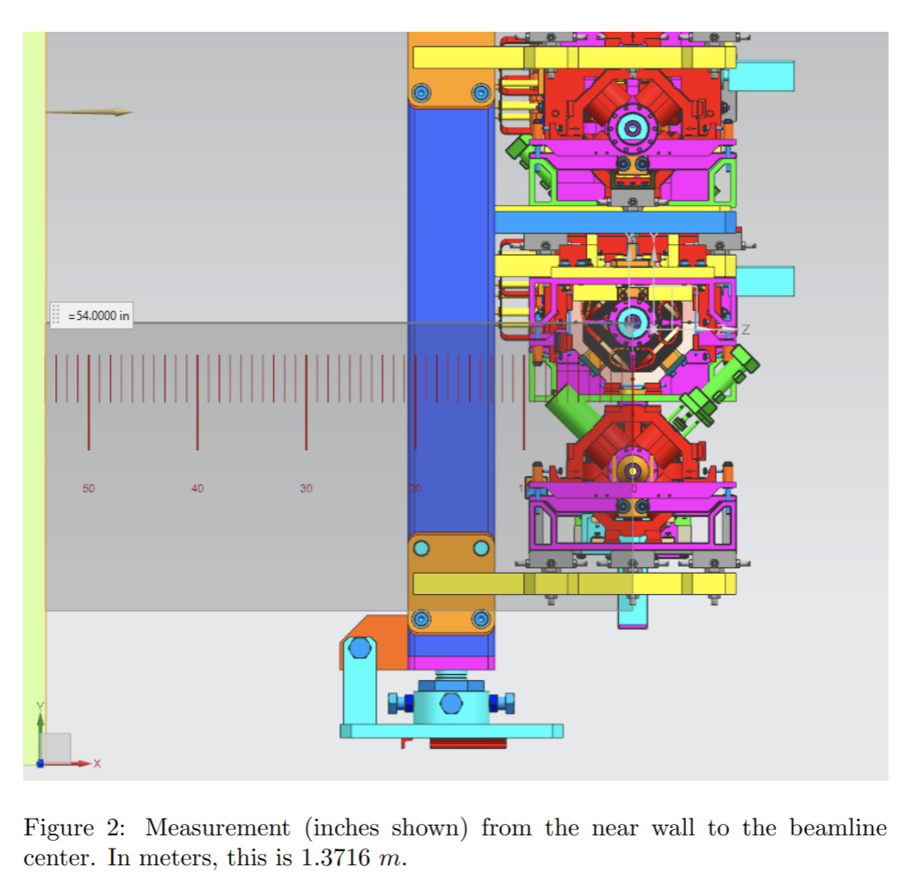
  - 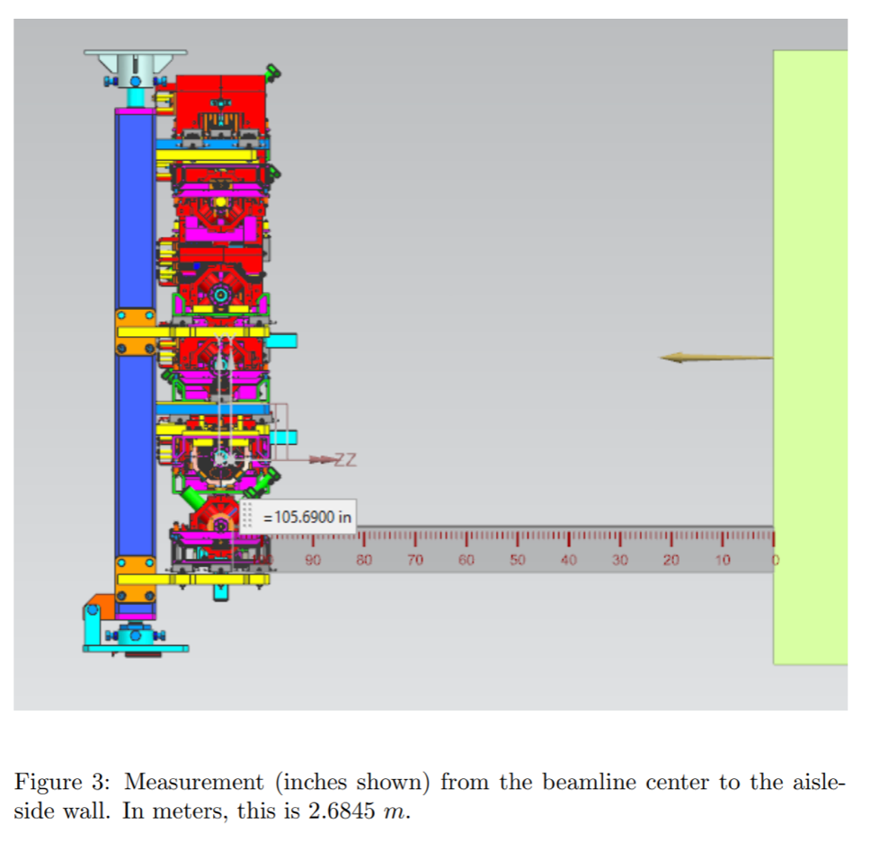
  - 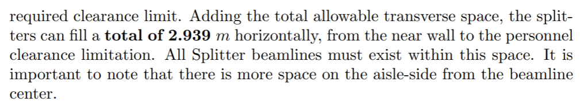
  - 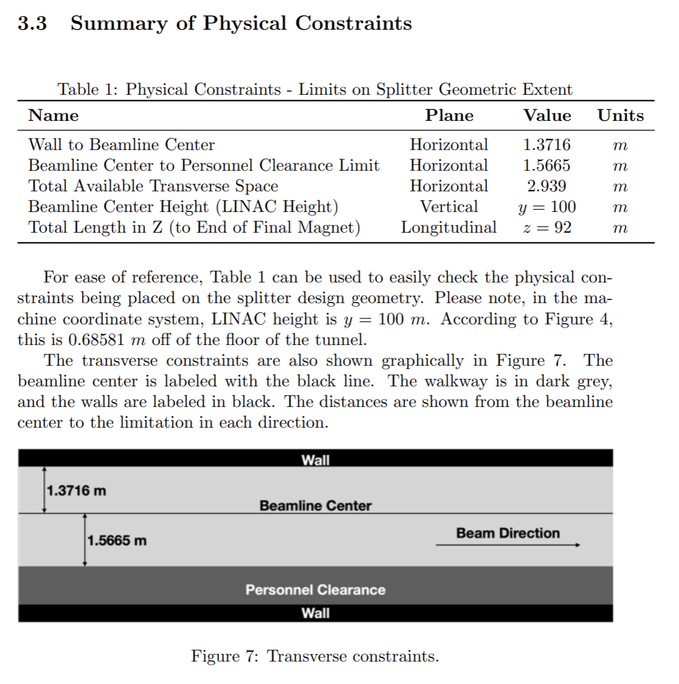
- Edith – need to keep room for Hall D extraction in NE
  - Vertical chicane?
  - Will be tight, need a way to get the top energy beam into Hall D
- Dejan shares a picture from the visit
  - Picture shows the walkway, top picture is in the arc
  - Dejan – this is where the recombination happens
  - Kirsten – that’s not the same place as where we’re putting the splitters
  - Ryan - Walls are also not smooth in the arcs
- Stephen – where is this file?
  - Ryan – this is in the tech note sent out in October 2023
    - All parameters, constraints are in here
  - Alex B – is it in the presentations?
    - No, in the tech notes folder
    - Also what Donish is using for constraints
  - Describe all the limitations, match requirements, etc…, why which magnets are chosen, previous tries, etc…
- Stephen – also a req documents folder to keep up to date with matching etc…
  - Ryan – agree. Some got wrapped into the GitHub, but should keep up with it there too
- Ryan – current FFA Arc cell needs to be optimized. Hard to match into. R56 is hard, match parameters are hard
- Alex B – we have a thread, we’re merging three cells to make FMC cell – should aleiviate this
  - Salim is working on that
- Salim – trying to replicate option C and make it an FFA cell just to see
  - Questions coming up on the way – want to discuss how to put it together
  - 170 degrees? Trying to bend 180 with Option C magnets
  - Have a cell, working on it
- Ryan – recommend working with Alex C before it’s too late. He has a lot of this automated, and can help you build the arcs and cells properly
  - Would speed things up
- Alex B – doing 180 degree bend at first is probably OK for now, but will need to change later
- Salim – trying to get same length as what’s in there
  - 179.3 degrees is working
  - Trying to find a way
  - Discussion with Alex C would be useful
- Needs to happen soon – he’s defending on Wednesday
- Alex B – hoping Alex C’s departure will be “soft” and not ending on Wed
- Stephen – where are you getting data from? B/c not always up to date
  - Email Stephen – Option A and C are on sharepoint, B isn’t
  - Might need more parameters
  - Salim – using July data
- Ryan – might help to not reinvent the wheel – just ask
- Salim – idea was to see how to manage to get things together
  - Need to get idea of what we’re trying to do, so can grasp things, and understand
  - Way of understanding is “learning through suffering” (HA!)
- Stephen – that July presentation is probably good
- Alex C – happy to share his process!
Action Items | Person responsible | Deadline

Time allotted | 10 mins | Agenda topic AOB | Presenter All
- Alex C is defending Wednesday!
- Alex C remarks:
  - Been an honor
  - Modular correction protocol can likely be used on pretty much any non-scaling FFA you might develop
- Lots of applause!
- Defense is taking place at ODU in the Physics Conference Room (and zoom)
- Dejan – hope you can keep working with us!
- Alex C – might have some CASA/VCU collab
Action Items | Person responsible | Deadline

Special notes

Pathway to Repository: https://jeffersonlab-my.sharepoint.com/:f:/g/personal/tristan_jlab_org/EqZ5MeS-nipCgPfZB5p0oS4B9Is67d3nQb9sLJI3Zyev9g

