FFA@CEBAF Working Group|Minutes

Meeting date | time 11/15/2024 | 11 AM EST | Meeting location https://jlab-org.zoomgov.com/j/1614898082?pwd=TnUzMS81M2sxbDZIbERJU01tYkJCQT09
Meeting called by Alex B  Type of meeting Weekly Meeting  Facilitator Alex B  Note taker Ryan  Timekeeper Alex B | Attendees  Alex B, Ryan, Salim, Edy, Stephen, Scott, Randy, Vasiliy, Nick, Dejan, Kirsten, Donish, Alex C, Roger,

Intro Discussion
- Alex defended – now Dr. Coxe!
- Looking for new students

Agenda topics

Time allotted | 50 mins | Agenda topic New FFA Arc Cells| Presenter Salim
- 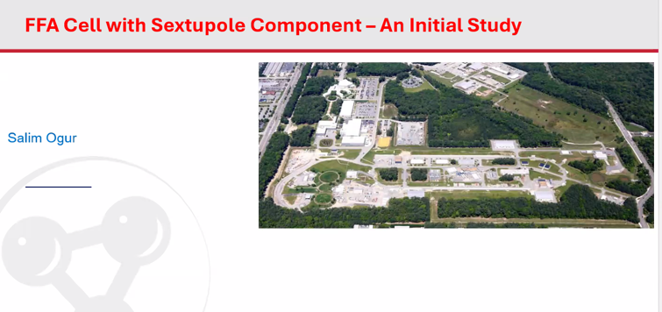
- Learning by self – need to accept and get help
- This is feedback-seeking presentation
- 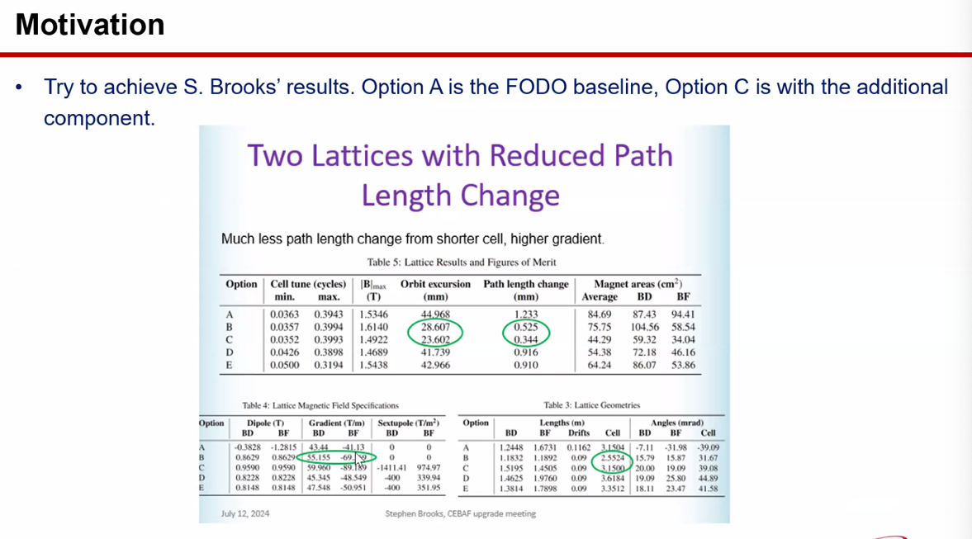
  - Can use Option C using Option A as a guide?
- 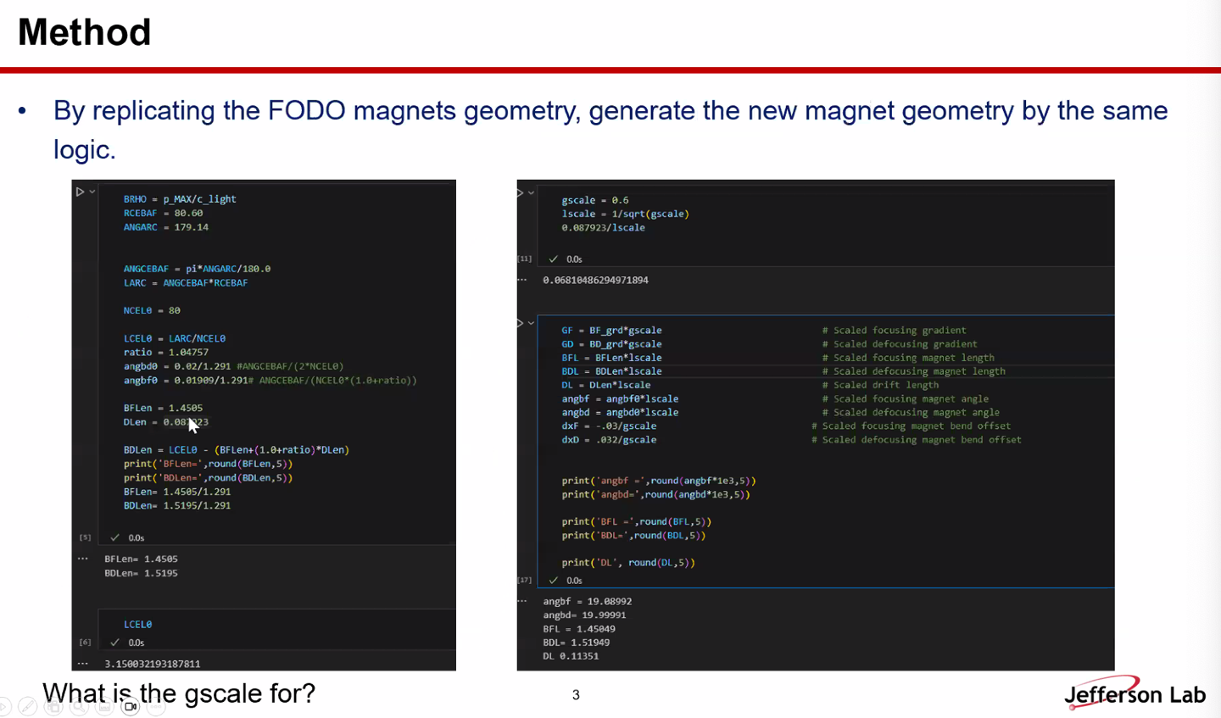
  - Python script to get the lengths needed
  - First attempt to create geometry
- Stephen - Gscale b/c families of different magnets with different lengths
  - Change and get different length cells with different lengths but same tune
  - Just set it to 1
  - Salim – adjusted manually with BFLen/BDLen
- dxF/dxD – thought use it as optimization – maybe too early to do such a thing
- 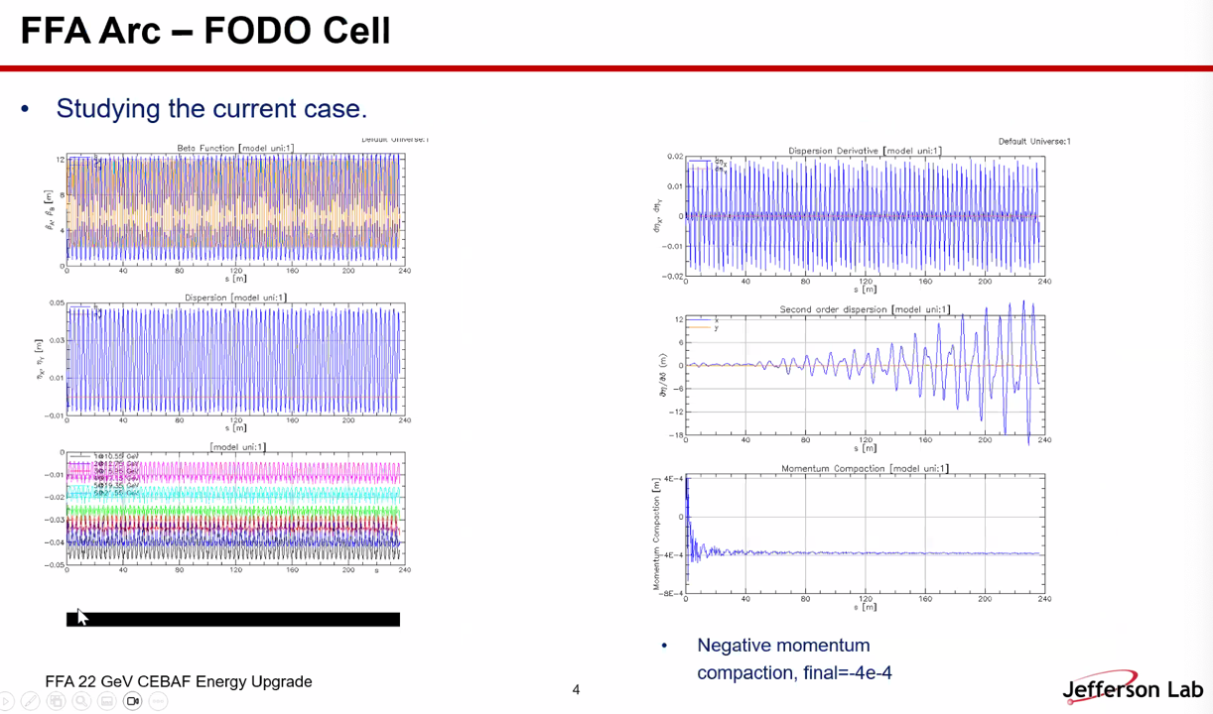
  - Plotting routine needs more points
  - Kirsten – can add that, but it takes longer to plot
  - Took D’ and D – get mom. Comp.
- 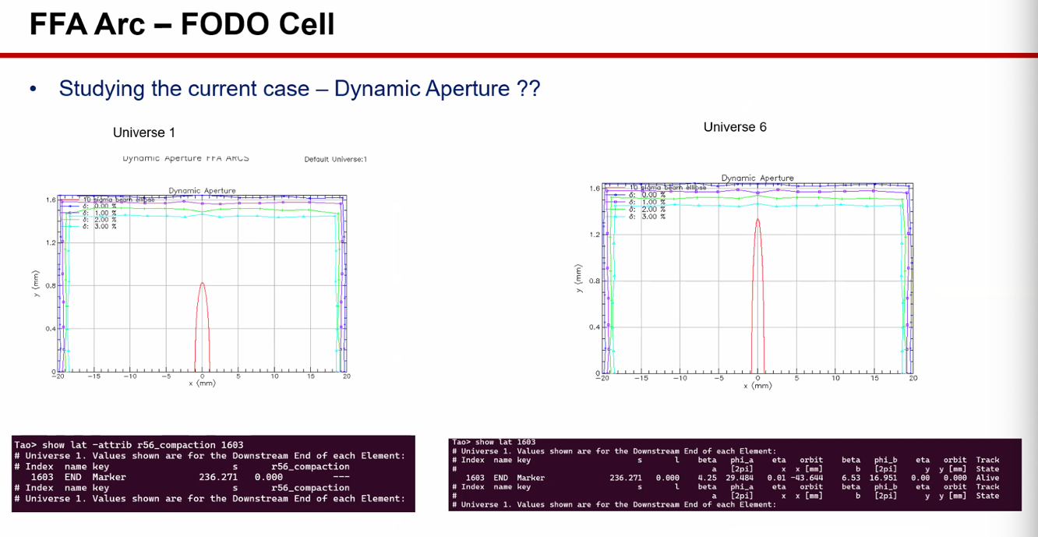
  - Tried DA scan
  - Can’t interpret yet
  - Scott – going to have to start on closed orbit and start scanning by yourself
    - Unless DA has some way to specify your initial closed orbit position, going to have to do it yourself.
  - Salim – starts at 4 cm orbit, but shows that it doesn’t start there.
- Alex B – that’s sort of a generic feature that Bmad gives you, but it’s not really what you want
  - Scott – this is a separate program (Bmad’s DA program)
    - Haven’t used this – not designed for what we are doing with closed orbit that varies with energy. Probably assumes that closed orbit is at 0 for all energies
    - Not sure, might center around closed orbit. Not sure
    - Pure FODO? Yes
    - Hard to interpret – would try for sextupole lattice where you should have finite DA and see
- 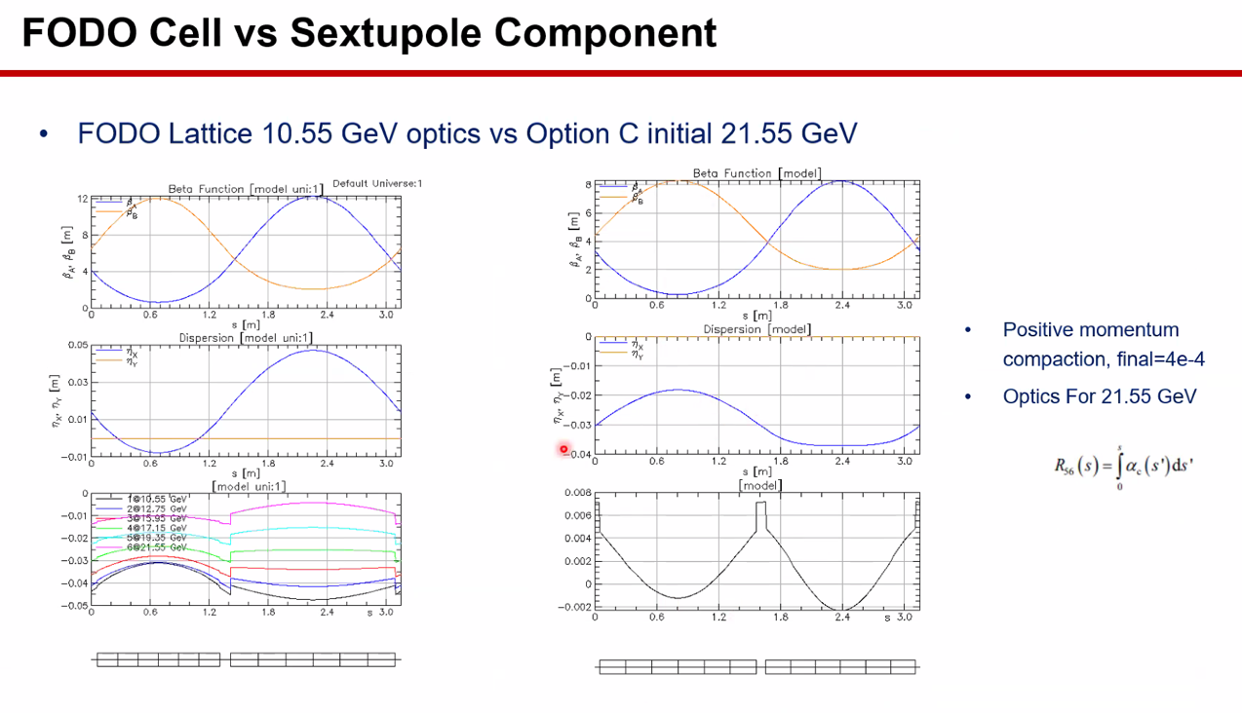
  - Geometric loss in closed orbit
  - When add sextupole, looks like right
  - Ryan – is the bottom right orbit? – yes
- Stephen – 21.55 GeV not in any of the energy ranges. They go up to 21
- Dejan – why is dispersion positive? Using positrons?
  - No, using electrons
  - It’s from the table
- This might be back-to-front or something
- Could be that A was the wrong one in the table
- 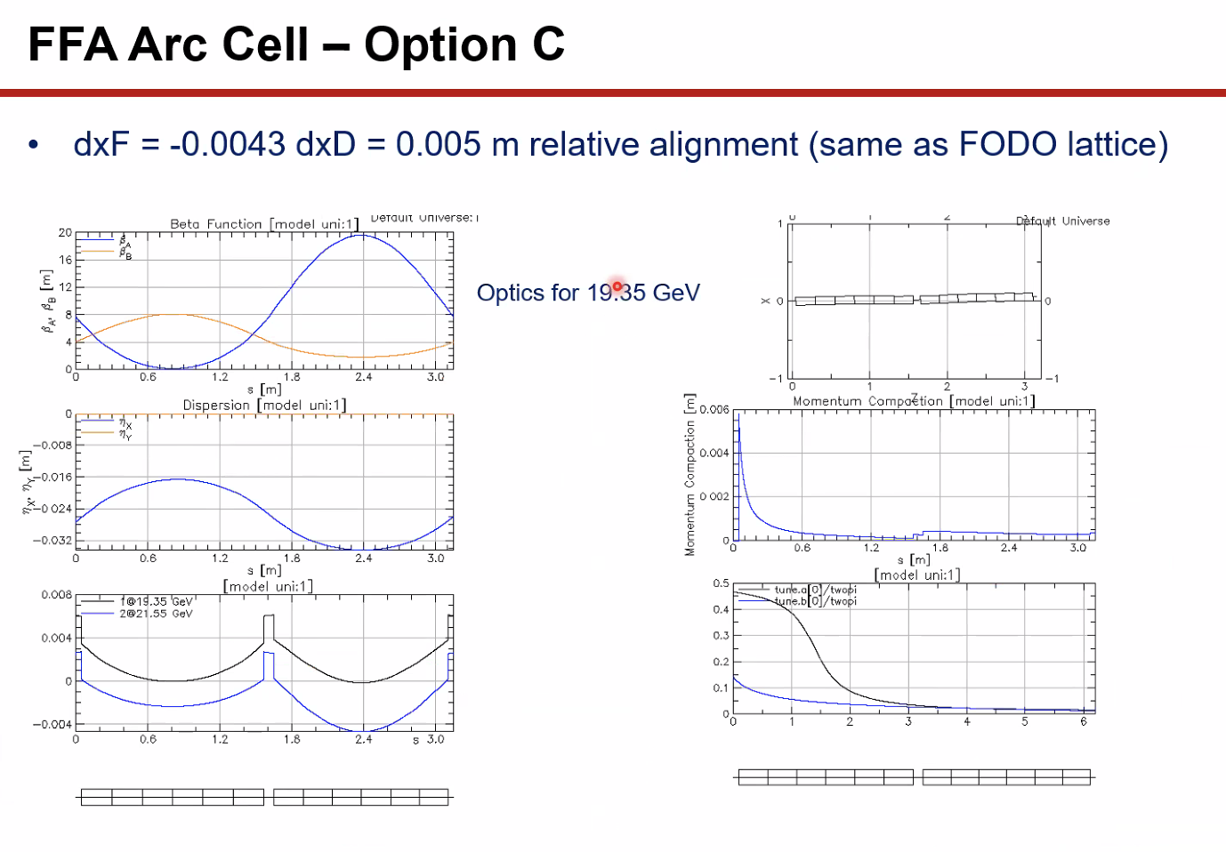
  - Energy changed WRT central E
  - Take lattice, close orbit with periodic solution in Bmad
  - Take closed orbit, get initial parameters then open the lattice
  - Fine for 19.35 GeV
  - Dispersion is doing what it’s supposed to
  - Mom.Comp is very small (10^-4 level)
  - Same as FODO
- Stephen – look at floor plan – they’re bending the wrong way in sextupole
  - Ryan – yes, looks like they’re bending the wrong way – should be bending “down”
  - dxD values off
- Stephen – you can set those values to 0 at first? But how are you lining these magnets up? You have to decide where to put the corners
  - Dejan – suggest putting the magnets where they need to be with the proper offsets first
    - Make them all sector magnets first to see what you’ll get to get close to the results, then make them with patches in the next step
- Stephen – IPAC24 paper tells the angles of the magnets. They have two half angles at the ends and the right offsets
- Ryan – looks like you’re doing it mostly right, just change the bend
- 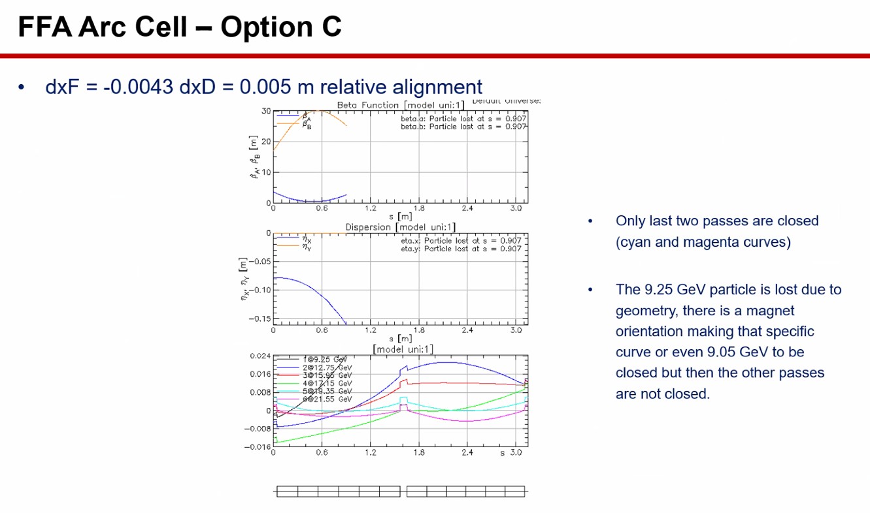
  - For different energies, couldn’t find closed orbits for all the passes. Plotted here
  - Particles lost
  - There’s an aperture that is being hit
- 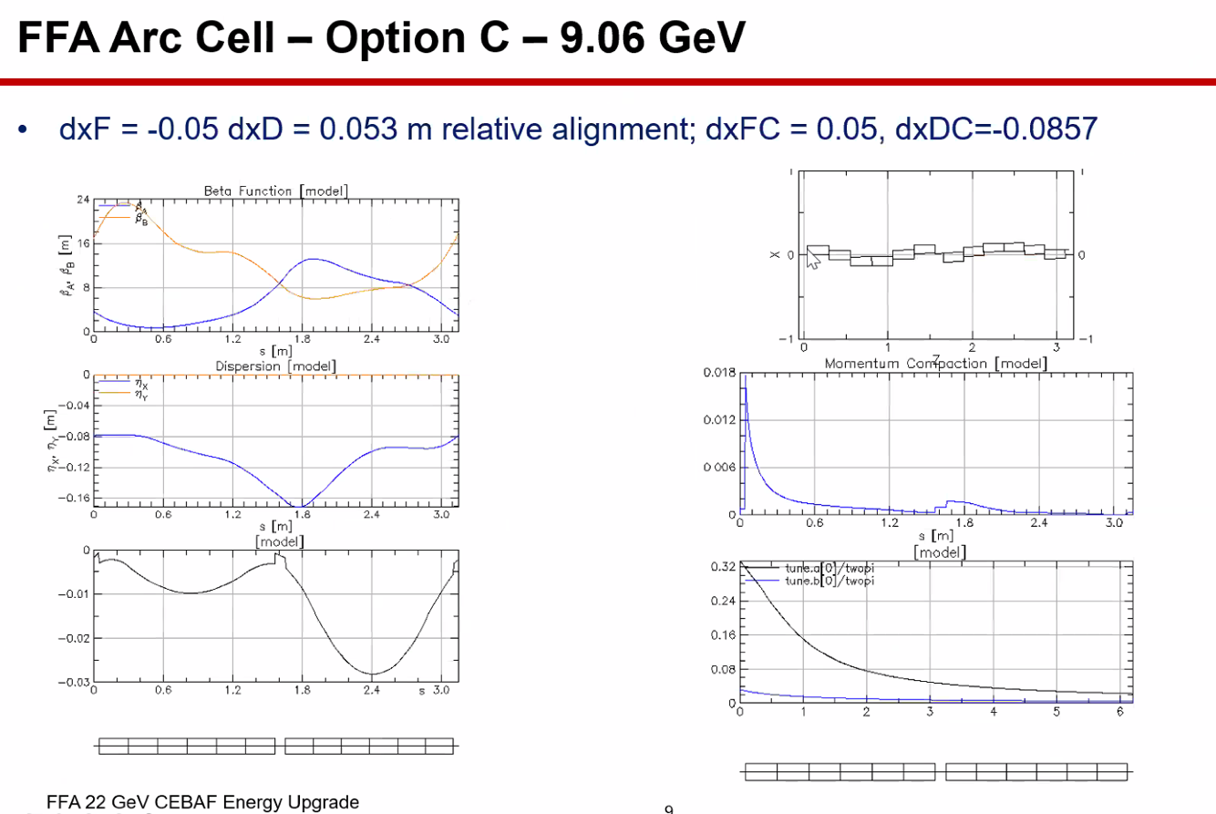
  - Tried to get 9 GeV through with closed orbit
  - Stephen – 9.06 GeV won’t go through this. It’s out of the energy range for Option C
  - Look in IPAC24 paper
- 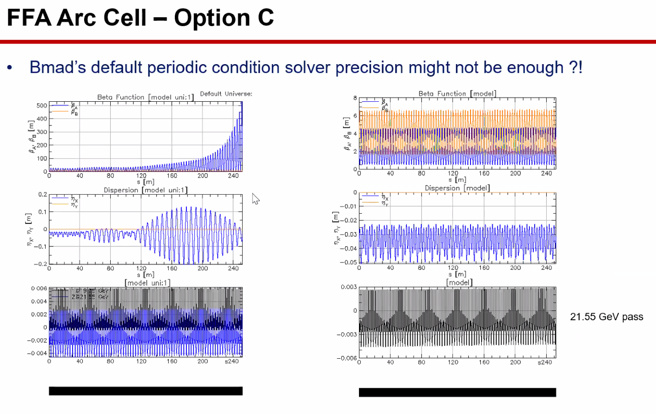
  - So made the arc with above
  - Beta beating, not closed
- 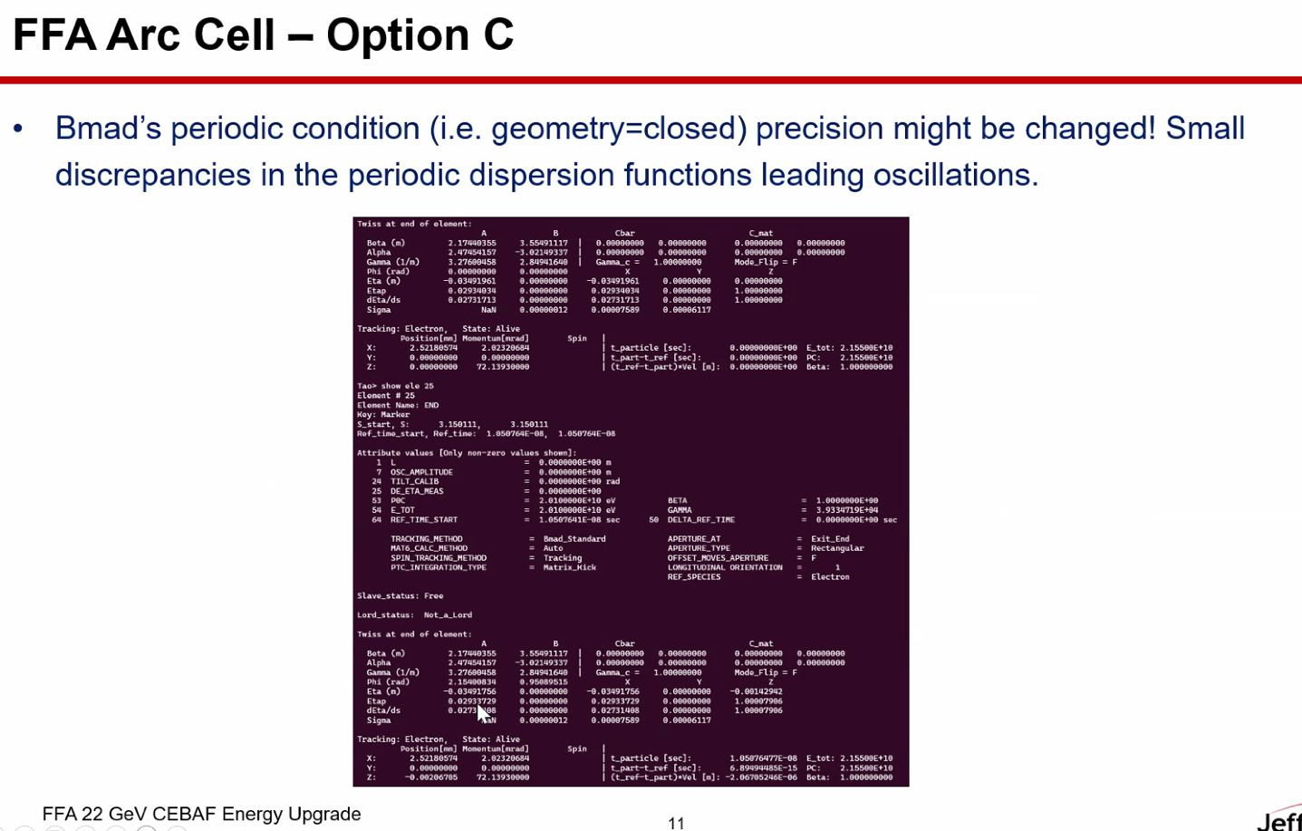
  - Dispersion changing
  - Need to change the precision of the closed orbit
- Scott – this is confusing me:
  - The closed orbit itself will only come back with only some precision
  - After if finds the closed orbit, does a calculation for a periodic cell
  - Basically calculates the transfer map, and the dispersion function and beta functions are all just computed from that map
  - By construction, they are the same (within round-off error)
  - Not at the level you see here
  - Eta should agree perfectly (to machine precision)
- Scott – you expect the oscillation of the cell to be the same (looking at eta)
  - Maybe part of what is going on: are you treating the whole arc as a periodic section?
  - Salim - No, making one cell into closed
    - Beginning elements all at 0
  - Are you familiar with Bmad SLACK? Maybe mention this on there and show the one-cell example
  - For a single cell that is a closed lattice, those dispersion numbers should just agree by construction
- Dejan – I run 4 different codes. If they agree you’re fine
- Stephen – when finding closed orbits, start from the middle of the energy range, not the ends.
- Scott – you can send things my way and I can look too
- Dejan – Yes, Scott can solve any problem with any code
- Salim – tried this in elegant first, and it mostly agrees with Bmad
  - Might come from changing geometry wrong or something
- Dejan – another advantage: anytime you do something in one code, you might make a mistake. Run it in another, sometimes you can find where you made mistakes
- 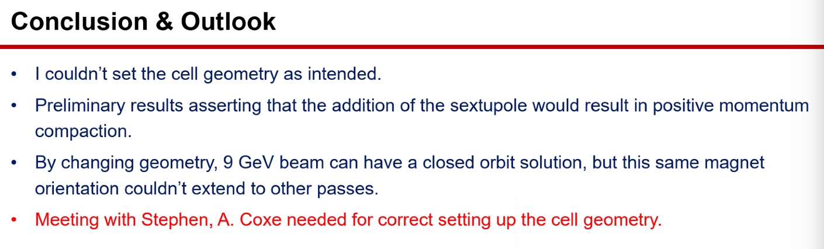
- Alex Coxe – I’ll be around all week next week. Let’s meet – send an email
  - In terms of DA – found it easier, instead, look at acceptance aperture instead of a DA.
  - Very fast in a few minutes at a laptop
  - Alex B – if you have a python script, please share
  - Alex C – will do! Will be in GitHub in a few days. Will give a rundown beforehand
- Stephen – can put more up on sharepoint, but didn’t want to confuse people
  - Can add it if desired, or email

Action Items | Person responsible | Deadline

Time allotted | 10 mins | Agenda topic AOB | Presenter All
- Alex B – following up on SBIR efforts
  - Ended up not working out
  - Spoke with JLab people (Spata for example) – there’s an opportunity. Next week, the new Niobium-Tin cryo
    - DOE/Shin will attend – will approach her then
- Dejan – what did Spata say?
  - He’s a bit busy with other things, put it back in Alex B’s court
- Dejan – feeling that slowly losing support from JLab directorate
  - Things are looking less favorable
  - Alex B – I see these things go up and down, but JLab is still putting lots of effort into convincing users that this is right
  - Next month, workshop for high-lumi physics at 22 GeV in Italy
  - Dejan – yes, but we have to criticize ourselves too. We’re not done
    - Alex B – but we don’t have resources
      - Do we blame DOE/CR?
- Stephen – I don’t have funding to keep working on this either b/c of CR
  - Alex B – but promised 0.5 FTE – assured it would resume
  - Stephen – in the muon collider meeting, seems DOE doesn’t have any money for future projects b/c saturated with current
- Alex B – take a look at white paper, and fill stuff in
  - Corrections can probably come from Alex C’s dissertation
- Dejan – a few weeks ago, pointed out that Splitters might be a huge problem.
  - Alex B – thought it would be similar to spreaders, but we have to work harder
  - Kirsten – updated the slide deck with more clear-cut info (5 passes vs 6 passes etc…)
    - Spreadsheet uploaded as well, strongly recommended starting with the slide deck b/c it might make more sense
- Stephen – need to know how much to reduce values
  - Looked at which lattice options have smaller R56
  - Lattice B already reduces R56 by about 40% - might work if we match the Splitters into it
- Scott – caution here: take with grain of salt.
  - Generally:
    - When R56 was in the -10 to +10 cm range, it was OK, larger hard
    - Each splitter line has an R56 that it likes to make, basically
      - Match splitter with weakest focusing config – that’s what it wants to create
      - From radiation PoV, not really what you want to do, want dispersion low at bends. So letting it do what it wants might make more radiation
      - Maybe look at higher phase advance configs
  - Because you have small dispersion in bends, can’t make large R56 corrections
  - Want numbers small in magnitude, then see how much the splitters have to fight to get that number
  - When you have a particular solution, easier to get R56s that are 3-4 cm in either direction from solution (usually, if not unlucky)
- 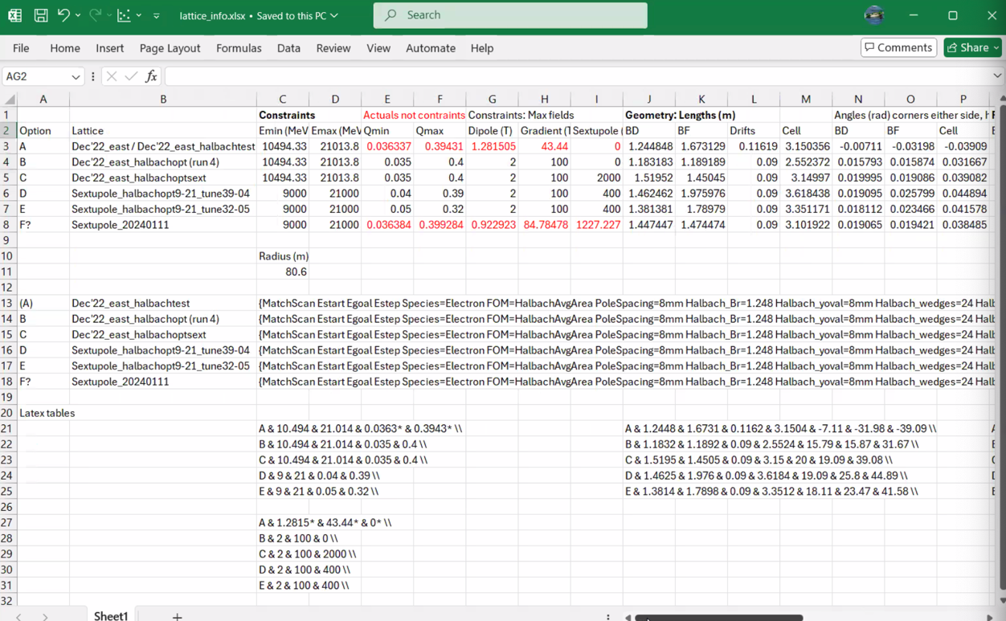
- 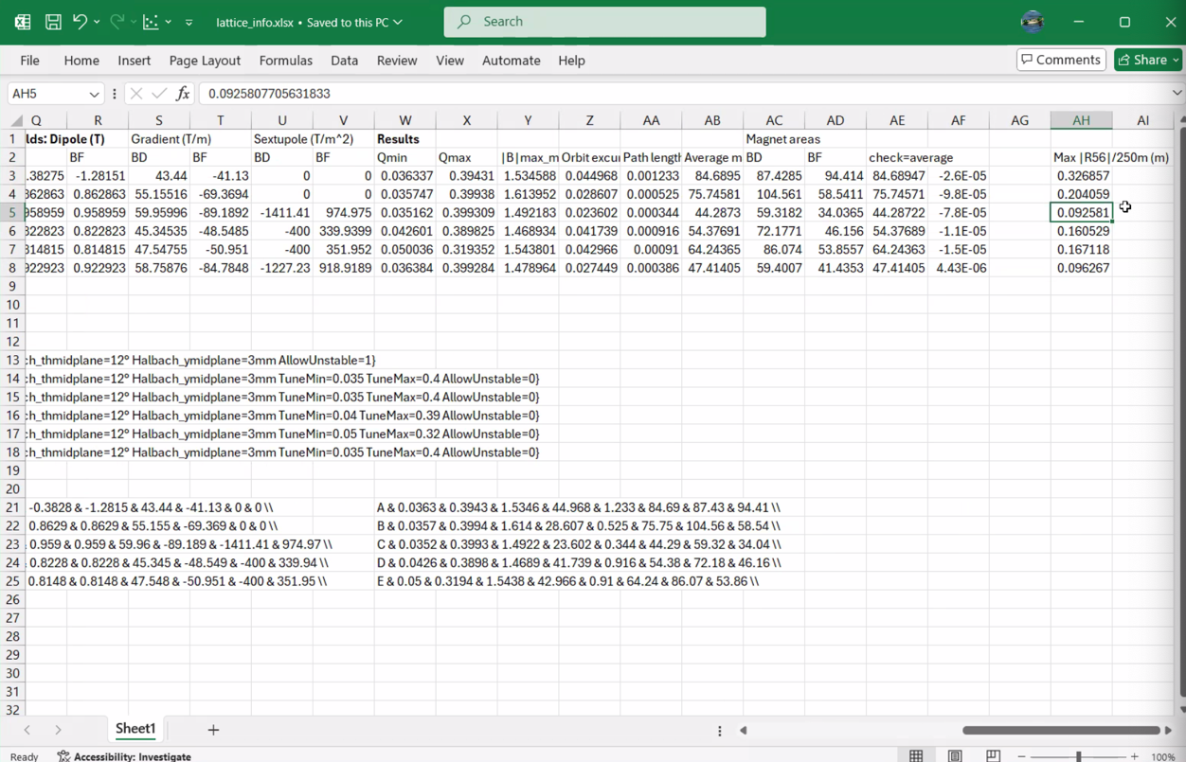
  - Baseline has over 30 cm, B is around 20 cm, but some options are below 9cm
- Dejan – remember 22 GeV beam harder to bend than 150 MeV
- Stephen – Scott is probably right. Maybe increase phase advance in splitters and reduce FFA R56
  - Alex B – sharing this?
    - Basically same as paper, but can upload file
- Scott – can make large R56 with large phase advance (or force to)
  - But when you have a small phase advance, R56 comes to whatever it wants to be
  - High phase advance solutions want particular R56 usually
- Dejan – remember, limited longitudinally
  - If you do the splitters in two steps, reduce dispersion by changing phases
  - Do in 5 steps, reduce 5x
  - But we don’t have enough space to do this
- Scott – reluctant to say how much numbers scale b/w CBETA and the upgrade
  - Yes, upgrade is larger, but at the same time, the energy ratios our splitters are more compact than CBETA splitters
  - Ryan – yes, more constrained in a way
  - Scott – yes.
- JLab all hands next Friday – likely no meeting next week.
Action Items | Person responsible | Deadline

Special notes

Pathway to Repository: https://jeffersonlab-my.sharepoint.com/:f:/g/personal/tristan_jlab_org/EqZ5MeS-nipCgPfZB5p0oS4B9Is67d3nQb9sLJI3Zyev9g

