FFA@CEBAF Working Group|Minutes

## Meeting date | time 01/10/2025 | 11 AM EST | Meeting location <https://jlab-org.zoomgov.com/j/1614898082?pwd=TnUzMS81M2sxbDZIbERJU01tYkJCQT09>

|  |  |  |  |  |  |  |  |  |  |  |  |
| --- | --- | --- | --- | --- | --- | --- | --- | --- | --- | --- | --- |
| |  |  | | --- | --- | | Meeting called by | Alex B | | Type of meeting | Weekly Meeting | | Facilitator | Alex B | | Note taker | Ryan | | Timekeeper | Alex B | | Attendees  Alex B, Ryan, Donish, Edith, Scott, Dejan, Stephen, Randika, Kirsten, Andrei, Salim, Vasiliy, Nick |

# Intro Discussion

* Welcome back from holiday.
* EIC milestone? CD3b – stuff to buy?
* 2034 startup?
* EIC talk – Roser worried about polarization
* Trapping different rigidity ions in the same beamline – Stephen wrote a note
  + Wigglers have charge to mass squared, but normal magnets are just charge to mass
  + Someone working on dipole/sextupole wigglers
  + Math is interesting
  + Works for two rigidities, not more yet

# Agenda topics

## Time allotted | 50 mins | Agenda topic Sym. Splitters| Presenter Donish

* 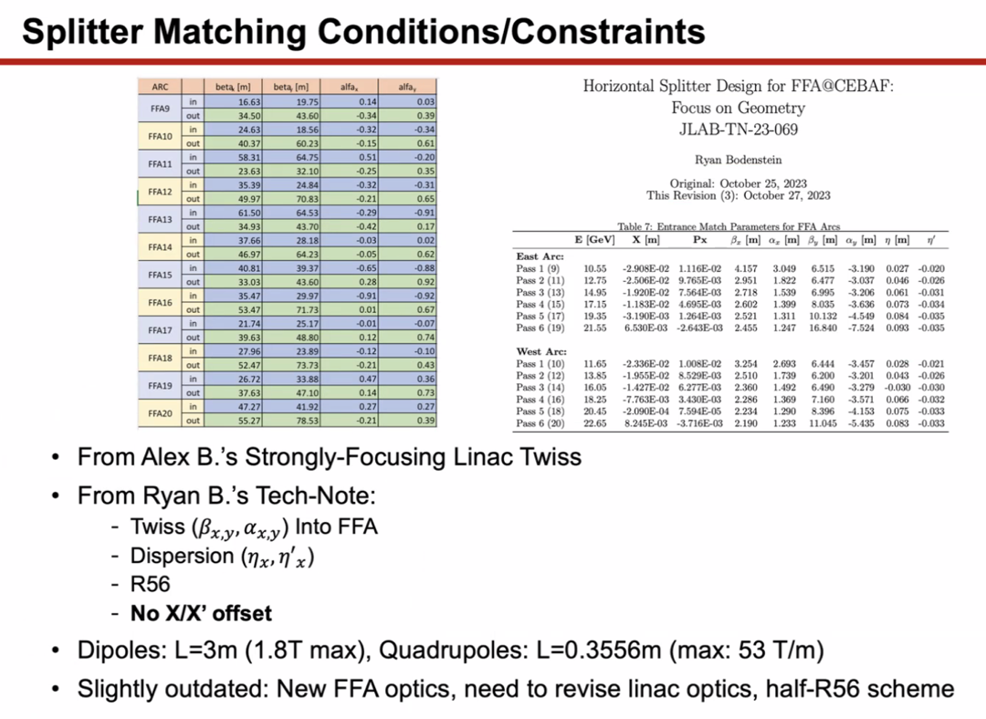
  + Doesn’t match to x/x’ offsets b/c matching is already too hard
  + Using dipoles from Ryan’s tech note
  + Concern about revisiting LINAC optics
    - Need realistic quads
    - Optimization
    - What’s coming out of Transition
  + Some variation of R56 – not considered here
  + Time of Flight still not considered
* A picture containing graphical user interface

  Description automatically generated
  + Had to separate out three lower passes
  + No ToF bending included – must be added
  + Matching through rigorous optimizations – got large beta spikes
  + Max field is below 1 T, so in range – large/wide dipoles can be switched to something smaller
  + Not flexible with any matching or correction
  + Ryan – I don’t think 800 m is so bad – it’s similar to what we have in our Spreaders now
    - Alex B – at that energy I agree
    - Scott and Kirsten think it’s a problem b/c Curly-H
    - Donish – large betas are important, but may not be able to drop them down
  + Scott – Said you matched R56. Don’t for now (do it later). See what comes out when you match the other things without R56. See what you get for R56 – if R56 is drastically different than what you want, you’ll need a different matching setup.
    - Find a new solution with a new phase advance and probably a new focusing/defocusing in the magnets that brings you closer to R56 by itself
  + Ryan – and let’s remember that R56 is not a firm target right now. We don’t know what it is, so to follow on Scott – make R56 a soft constraint and match the rest, aiming to get close to R56.
  + Scott – once you throw dispersion in, things get harder. Get more constrained
    - For a given focusing structure, you’ve gotta get dispersion right. Then you have pinned down everything – not much wiggle room for R56. If R56 isn’t in that zone you won’t get there. If that’s the case, you need a totally different solution
    - Basically restart to get in the zone
    - Sequence: get beta match, get dispersion, see where you are with R56
  + Donish – very little wiggle room
  + Donish – relying too much on optimizer. They are rigorous – would be simple if if I could find a solution in a couple hours. Take nearly a day of work
  + Stephen – what optimizer are you using?
    - Using DE in Bmad and the simplex in elegant
    - Scott – DE is a non-local one – not usually good
    - Ryan – cycle though them. Be hands-on, and make it do what you want more
* Dejan – been keeping quiet – but getting very close to end of isochronous ring. Might be able to have all these things removed from the list. R56, ToF – everything is within a couple of mm.
  + Getting solutions from 12 – 22 GeV, stable solutions in isochronous ring.
    - Glad if can provide it to others for more work
    - Could use help. Vary many parameters
    - Provided some info to Alex/Donish – central part looks.
* Dejan shares:
* Chart, line chart

  Description automatically generated
  + ~9 m cell that would go into FFA arc
  + Making higher-order magnets (up to octupole)
  + Don’t get as good results as can – will send to Stephen
  + No idea about SR
  + Lowest E is 11.65 GeV – want to get down to 9.45 GeV and up to 22 GeV.
  + This solution depends on where pick up central energy – right now it’s moved down
    - Top energy is 18 GeV right now to make it so we can get to 11.65 GeV lowest energy
    - When set at 21 GeV – optimal for SR loss, so had to drop it
* Stephen – what R56 is Donish assuming?
  + Sent around a lot of other FFAs. R56 and ToF can be made smaller
  + Possibility – add higher orders to make isochronous
  + How small ToF will make it easier?
* Ryan – we need to remember that ToF must be adjustable
  + Dejan – I agree. We cannot get rid of splitters no matter what b/c we need to adjust things.
* Alex B – tried to get LDRD on alternative arcs
  + Need to speed up and bring this up quickly.
  + We’re trying to match too many things. If we go with a quasi-isochronous lattice, might help.
* Scott – don’t sweat details too much. No matter what, need a splitter.
  + Either you’ll find that a small difference doesn’t matter – some lines will be off by a whole wavelength anyway
  + R56 – there will be a natural R56 – it’ll be nonzero no matter what. Have to get them down from the 25ish cm numbers down to 5-10 cm numbers
    - So just make the R56 smaller to make it easier for splitters
* Alex – yes – that’s the FMC – park it somewhere
* Scott – the accomplishment would have been brining the R56 down to 10ish cm
* Alex – I think Salim put things into DIMAD.
  + Trying to put Stephen’s other lattice, but Dejan’s is always on my mind
  + Can look deeper – if he can share, can try in elegant/Bmad
* Dejan – will provide in 3 codes: Bmad, PTC, etc…
  + Codes should agree is because there’s such a large angle
  + End fields not right in Bmad
  + This time, no difference
* Back to Donish:
  + Remember, V0 not flexible at all
* Text

  Description automatically generated
  + Addressing from a different way to address tunability – thinking about the control room
  + Divide splitter into several sections: Rlinac and Rffa – do transverse separation and recombination
  + Central section divided into 3 sections: matching ends and a periodic section
  + Very little optics control in first and last bends anyway – optics static
    - Can maybe get a few quads that can control beta peak
    - Roughly static
    - Can’t fit quads
  + On the Rlinac side – optics passes through fine. No big problems
  + On the Rffa side, things harder b/c need to match into a very small beta
  + Want periodic section b/c it’s what provides tunability
  + Ryan – where would you put the chicane for ToF?
    - In the periodic section
* Chart

  Description automatically generated
  + Only pass 1 layout
  + Ryan – if those magnets are the right size, you’ll have to bring those back up to put them in the limit. Do that before you do the other passes around it so they all fit
  + Use transverse offset as a “like” and then start pushing them where they need to go
  + 3m magnets are maybe too big
  + Ryan – that’s why I had Jay make those magnets. B/c they are bigger than necessary, but if they fit, then smaller ones will be easier
* On LINAC side of Splitter, matching to FFA side of Splitter
  + Getting the periodic condition easily
  + Make Alpha and D, D’ = 0
* Still hard to keep beta down and matching right
* Chart

  Description automatically generated
  + Beta stays ok until the end where you have to match into the FFA optics
  + Matching betas on the FFA side to the LINAC side – adds a constraint
  + Scott – you were just using some fixed endpoint on the FFA?
    - Might be helpful to pick a point in the FFA cell you want to match to
    - For example, end on a half quad. Gives a small alpha at that point
    - Ryan – I have split the FFA arc cell into 15 points – provided in github
* 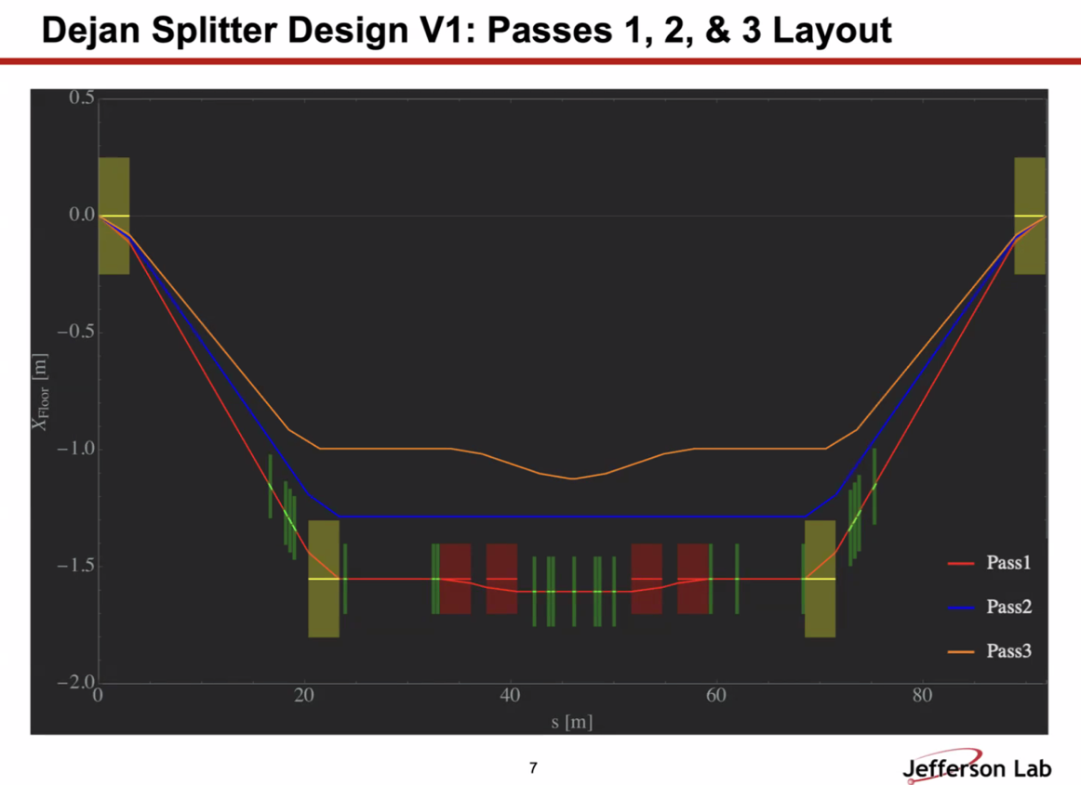
  + Getting reasonable answers from there and fitting in space
* Diagram

  Description automatically generated
  + Brute force solutions this way
  + This one has ToF included
* Graphical user interface, text

  Description automatically generated
* Ryan – about LINACs – could we alternate doublets and triplets? Could give similar optics, save space, and make weaker magnets
  + Alex – we’ll stick with triplets

|  |  |  |
| --- | --- | --- |
| Action Items | Person responsible | Deadline |
|  |  |  |
|  |  |  |

## Time allotted | 10 mins | Agenda topic AOB | Presenter All

* N/A

|  |  |  |
| --- | --- | --- |
| Action Items | Person responsible | Deadline |
|  |  |  |
|  |  |  |

## Special notes

Pathway to Repository: <https://jeffersonlab-my.sharepoint.com/:f:/g/personal/tristan_jlab_org/EqZ5MeS-nipCgPfZB5p0oS4B9Is67d3nQb9sLJI3Zyev9g>

No meeting next week!