FFA@CEBAF Working Group|Minutes

## Meeting date | time 01/24/2025 | 11 AM EST | Meeting location <https://jlab-org.zoomgov.com/j/1614898082?pwd=TnUzMS81M2sxbDZIbERJU01tYkJCQT09>

|  |  |  |  |  |  |  |  |  |  |  |  |
| --- | --- | --- | --- | --- | --- | --- | --- | --- | --- | --- | --- |
| |  |  | | --- | --- | | Meeting called by | Alex B | | Type of meeting | Weekly Meeting | | Facilitator | Alex B | | Note taker | Ryan | | Timekeeper | Alex B | | Attendees  Alex B, Ryan, Salim, Edith, Volker, Kirsten, Nick, Randy, Andrei, Stephen, Tim, Vasiliy, Donish |

# Intro Discussion

* Snow days, travel days

# Agenda topics

## Time allotted | 50 mins | Agenda topic FMC Optics| Presenter Salim

* Graphical user interface, text, application

  AI-generated content may be incorrect.
  + Didn’t get cells from Dejan – continued with Stephen’s cells
  + Didn’t get the geometry right, did something different
    - Something between option c and something else
* 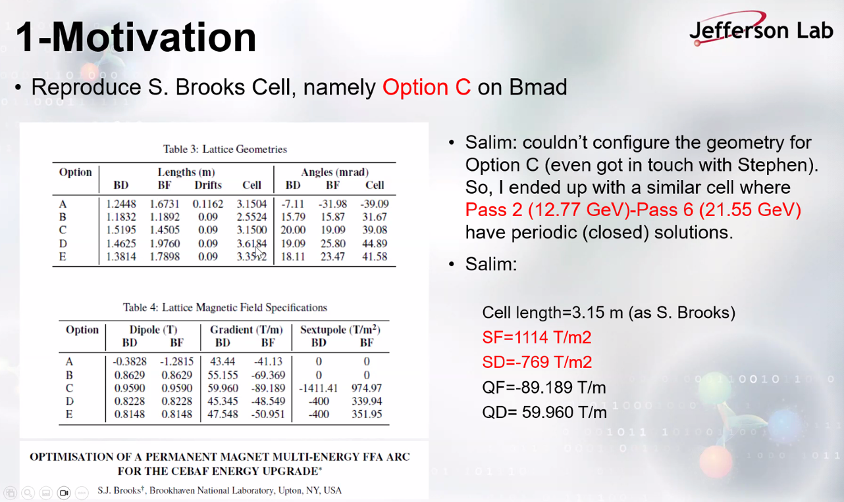
  + Defocusing is negative/positive
  + If do this, go to higher energies and get closed orbit
  + Changed polarities, can find cell that fits the passes we have?
  + Worked late – found passes 2-6 only
* Chart

  AI-generated content may be incorrect.
  + Ryan – looking at floor plan, seems odd - use DB field
  + Stephen – A is going clockwise rather than anti-clockwise
    - The reason this one is backwards is because it was set backwards
    - Not sure why floor plan is bending the wrong way
    - Salim – played with geometry to get kicks from the other parts
  + Salim – see optimization variable that helps by offsets
    - Stephen – you shouldn’t do that – looks like you have cm offsets and that’s silly
      * Maybe don’t segment for now, and just get longer magnets
      * Have Bmad tell you the highest magnetic field of each part you’re going through
* Chart

  AI-generated content may be incorrect.
* Graphical user interface, text, application

  AI-generated content may be incorrect.
* Doesn’t have Dejan’s work, so not sure where to go
* Are we starting from permanent magnets, then making a cell?
* Stephen – propose different strengths of quad/sext/etc…
  + First thing is check the max field
  + If 2 T or more, not practical
  + Halbach area script can get you started, then optimize
  + Figure out simple cell first, figure out max field
* Alex B – about momentum compaction – we’d optimize based on other systems
  + Need to compensate for other parts
  + For now, can make it close to zero, but it’ll be different for different passes
  + Park it somewhere and see what we get
* Ryan – can you add sextupoles to Alex C’s lattice?
  + That’s where started, but don’t have all the info
  + Ryan – I can ping AC to get his taotaofornow repo
* Kirsten – let’s have a Bmad chat – some of this seems like Bmad problems
* Alex – yes, please check with the experts on Bmad
* Stephen – did you have the curvature of those sections as an optimization parameter
  + Only the start, then the rest follow
  + Diagram

    AI-generated content may be incorrect.
    - This is 1 m to -1 m scale
  + Stephen - These slices should only be offset by mm – but these are cm apart
    - Looks like you shifted the sextupole to get more quads, but it’ll be wrong

|  |  |  |
| --- | --- | --- |
| Action Items | Person responsible | Deadline |
|  |  |  |
|  |  |  |

## Time allotted | 10 mins | Agenda topic AOB | Presenter All

* Ryan – spoke a few weeks ago about saving space on the girders with doublet-triplet lattices.
  + In the control room, brought up the idea to Michael Tiefenback, who remembered that he had a similar idea back in 2007, but with singlets instead of triplets
* Graphical user interface, text, application

  AI-generated content may be incorrect.
* Alex – so what’s the rationale – there will still be triplets taking up space
  + Ryan – yes, but on every other girder, so things like correctors can be placed on the girders with singlets. Overall, it would save space
* Chart, histogram

  AI-generated content may be incorrect.
  + Here, you see triplets controlling the lower energy, and since the singlets are at nodes, they pass through almost unscathed
* Chart, line chart

  AI-generated content may be incorrect.
  + Here, the singlets control the higher energies like a FODO.
  + You get a smaller beta at the end
  + The magnets (at first glance – no real time to look deeply) are all much weaker and reasonable in strength
  + Tief said he didn’t look into chromaticity or the like yet
  + Only sent a few example files for now
* If we expand this to more energies, and set it up in the current lattice, this may help our problem
* Tricky part is getting the first pass energy through. Once you have that, the others fall into place
* Alex – boils down to a question of strength – looking into the phase advance
  + This would be a super-cell
  + Forget why they didn’t pursue this?
    - Ryan spoke to Yves, who said it was because they just didn’t need that strong of focusing for 12 GeV
* Ryan can ask Tief for more files and/or write-ups
* Alex – the figure of merit would be those higher passes, keeping the magnets not too strong, and keeping the betas down at the end
  + In principle, could play a game with the modulation of the nodes
  + Can explore and see
* Stephen – if anyone has Bmad working and spare time, it would be interesting to do optimization where you use the LM optimizer on all the quad strengths
  + FoM would be minimizing beta at end, or that plus something limiting magnet strengths
  + If had funding like last year, would probaby have a go at it. Would have many hours to run optimizer on ~40 quad strengths for example
* Alex – doesn’t have to be linearly scaled
  + Individual power supplies – would add cost
  + Things with phase advance – rule of thumb to start with relatively higher phase advance when go above 10 GeV that you still have some (diminishing) phase advance to play with
    - If you don’t, you’ll be bound by asymptotic behavior with betas roughly the length of the linac
    - Shoot for Betas on the order of 100 m
      * Even with the current strong focusing, hard to build splitters with that matching, lower is the right direction
  + The principle is there
  + Could actually use the existing lattice. Just turn every other outer quad off in the current triplet design
    - Ryan – might be smarter to do that since Tief’s work was on older linacs
  + If you want to explore it, Ryan, go for it
    - Ryan – if I have some time, I may. I’ll bug Tief as well, but not sure I have time
* Delays with CEBAF startup – impacting magnet LDRD
  + When we get beam, we can have the “fun part” of the study
* Beam to physics now scheduled for March 7 – number as delivered
  + Spinning up. Beam on today
  + NL in restricted, tuning injector
* Monday is an access day
  + Add signs, may swap some dosimetry
  + No control rods to get calibration
* 2/3 or all magnet samples installed
  + Hall probe broken, fixed for now, but not calibrated
  + 30 locations, 2 plates on each location, want 3
  + Likely one of the largest studies of this kind
* Alex – silver lining of delay is instrumentation can be handled
* Ryan – have to recalibrate hall probe. Temporary fix for now, need to calibrate on NMR
  + Will keep using that until new probe arrives – it’s like $8K
    - Kirsten and long lead time
* Kirsten – we have enough TLDs to do swap now, and need to give them back at end of June anyway
  + So we can swap them, and leave rods in?
  + Ryan – yes, likely we can take out some areas and leave in rods
  + Swapping only requires time, so might be smart
  + Down side of areas – every 6 months required swap out
    - Ordered enough from Jan-Jun, so we may as well swap them.
* Ryan – current plan is still 25 weeks of running
  + Andrei – confirms – 25 weeks is the planned run time
  + Ryan – so we’ll get the same amount of data, just in a different time frame
  + Alex – one of the most massive measurements at CEBAF
* Alex – some predictions about doses? BDSIM can look at magnets and calculate what the dose would be?
  + We’re working on that. Prioritizing integrated dose simulations first, then go back and make sure what we’re getting for integrated dose aligns and whatnot
  + Making sure we can predict what will happen at higher energies
* Short meeting?
  + Yes
* No meeting next week – Alex teaching USPAS

|  |  |  |
| --- | --- | --- |
| Action Items | Person responsible | Deadline |
|  |  |  |
|  |  |  |

## Special notes

Pathway to Repository: <https://jeffersonlab-my.sharepoint.com/:f:/g/personal/tristan_jlab_org/EqZ5MeS-nipCgPfZB5p0oS4B9Is67d3nQb9sLJI3Zyev9g>

No meeting next week!