FFA@CEBAF Working Group|Minutes

## Meeting date | time 02/07/2025 | 11 AM EST | Meeting location <https://jlab-org.zoomgov.com/j/1614898082?pwd=TnUzMS81M2sxbDZIbERJU01tYkJCQT09>

|  |  |  |  |  |  |  |  |  |  |  |  |
| --- | --- | --- | --- | --- | --- | --- | --- | --- | --- | --- | --- |
| |  |  | | --- | --- | | Meeting called by | Alex B | | Type of meeting | Weekly Meeting | | Facilitator | Alex B | | Note taker | Ryan | | Timekeeper | Alex B | | Attendees  Alex B, Ryan, Donish, Dejan, Salim, Randy, Nick, Edy, Stephen, Kirsten, Vasiliy, Andrei, Volker |

# Intro Discussion

* Dejan on vacation
  + Worked out on isochronous lattice – not yet translated b/c busy with EIC work.
  + Will translate (maybe on vacation) to MAD-X or Bmad.
  + Alex – Salim is waiting
  + Dejan – going from 10 – 25 GeV, need to drop it down

# Agenda topics

## Time allotted | 50 mins | Agenda topic Sym. Splitter| Presenter Donish

* Table

  AI-generated content may be incorrect.
  + Still using the strong focusing, Ryan’s boundary conditions, etc…
* Splitter designs do not include the updates with the FFA optics, LINACs, half R56
* Diagram

  AI-generated content may be incorrect.
  + Divide into 3 main sections.
  + Make it all fit
  + Free variables are quads, bends, drifts
* Diagram

  AI-generated content may be incorrect.
  + Setup 1 – match each section in order (left-to-right)
  + No guarantee that the betas will match into FFA (may exceed space)
    - Sometimes get km-scale beta spikes
  + Going from left to right, may finish periodic, but then matching into FFA might not work
* Diagram

  AI-generated content may be incorrect.
  + With this setup, skip periodic section and get green and yellow to match
  + Here, need the alphas in both planes and etax’ = 0
  + Make the requirement to match into the FFA
  + Approach is a bit ambiguous: have the freedom to have 1 point where alphas and eta’ is zero, but don’t know where/how to define that point
    - Often get too strong of quads, or no space
* Diagram

  AI-generated content may be incorrect.
  + Run backwards to make sure the parameters are nice in the periodic
  + No longer running into FFA
  + All these requirements and constraints are still conserved.
    - Now periodic betax and betay and dispersion in horizontal have to be equal
  + Still tight longitudinially
* **Chart

  AI-generated content may be incorrect.**
  + Still large spikes
  + Dedicating two sections for matching left very little space for periodic section
    - Thought would have a lot more space for R56, etc…, but finding that there’s not a lot of space
  + Just not a lot of space – matching sections took up most of the available real estate
* This whole thing can be done modularly
* Ryan – you have about 25 m in the periodic? And 4 x 3 m dipoles for the chicane?
  + Yes
  + So then 12 m is taken up by dipoles alone, and not a lot of space for quads.
  + Donish – yes – I’d go further and say it’s probably not feasible
    - Thought I’d have enough space to work on the R56 in the periodic section, but it’s looking less likely
* Salim – Do you have quads, or are they just drift space?
  + Donish – start simple. At first no quads – still gave reasonable solutions.
    - Backwards propagate betas, and see how large they blow up. Under 400 m or so, probably OK without quads.
    - Noticed in the drift section – opens up more flexibility if you have quads in the first drift
  + Ryan – is there space for quads in that drift?
    - Only toward the second dipole, upstream toward the first dipole, you don’t have space b/c of adjacent lines
  + Salim – I asked b/c if you go to the optics, I see the beta up to 16-17 m or so, it behaves like a drift. I don’t see the impact of the quads.
    - Kirsten – could be problem of scale
  + Salim – do you put this is the max beta, disp limits?
    - Yes – there’s a way to put limits in elegant and Bmad.
      * Problem is that you can put those in, but the system is so complex, it either won’t find a solution, or it’ll find a bad solution
      * Following Scott – put the things you want to match first. Then R56, then optimize for dispersion and max beta.
  + Ryan – you have to weigh the constraints as well. You can weight something, but if it’s wrong, you’ll sacrifice something else.
    - Donish – exactly
* Donish – as Ryan pointed out, the periodic section is just too small. It doesn’t seem possible to get that to work.
* Chart, histogram

  AI-generated content may be incorrect.
  + Tried looking at the FFA side
  + Ryan gave spreadsheet cutting the cell into 15 match points. Adds flexibility
* Wanted to avoid small betas, alphas and eta’ = 0, also try to minimize curly-H
* They’re not EXACTLY 0 everywhere, but close.
* Stephen – where was the first point?
  + At the beginning
  + Actually chose a point similar to at CBETA…basically a half-magnet
  + Dejan – not changing the FFA, just finding another point.
* Ryan – do be careful about rounding off too tightly. It can be a problem later. Fine to start there, but you’ll have to bring it back later.
  + Basically, you have to be careful how you’re rounding. Run it through a few cells to see what happens
  + Donish – that’s really good to know. Very good point. I didn’t realize
* This point can cause problems b/c large beta_x and small beta_y
* Ryan – another bit of unsolicited advice, is look for places in the cell that are close to the match you are able to get elsewhere. Try to hit that one
  + Donish – tried that. Sometimes it screws up the upstream optics
  + Ryan – yes, it can. Some spots are OK, but some are awful
* Donish – turn off R56 for a lot of this. It’s too hard to hit
  + If you ignore the R56 and make the smallest matching section possible, but it wasn’t really working out
  + Wanted to see how small to make matching sections
* 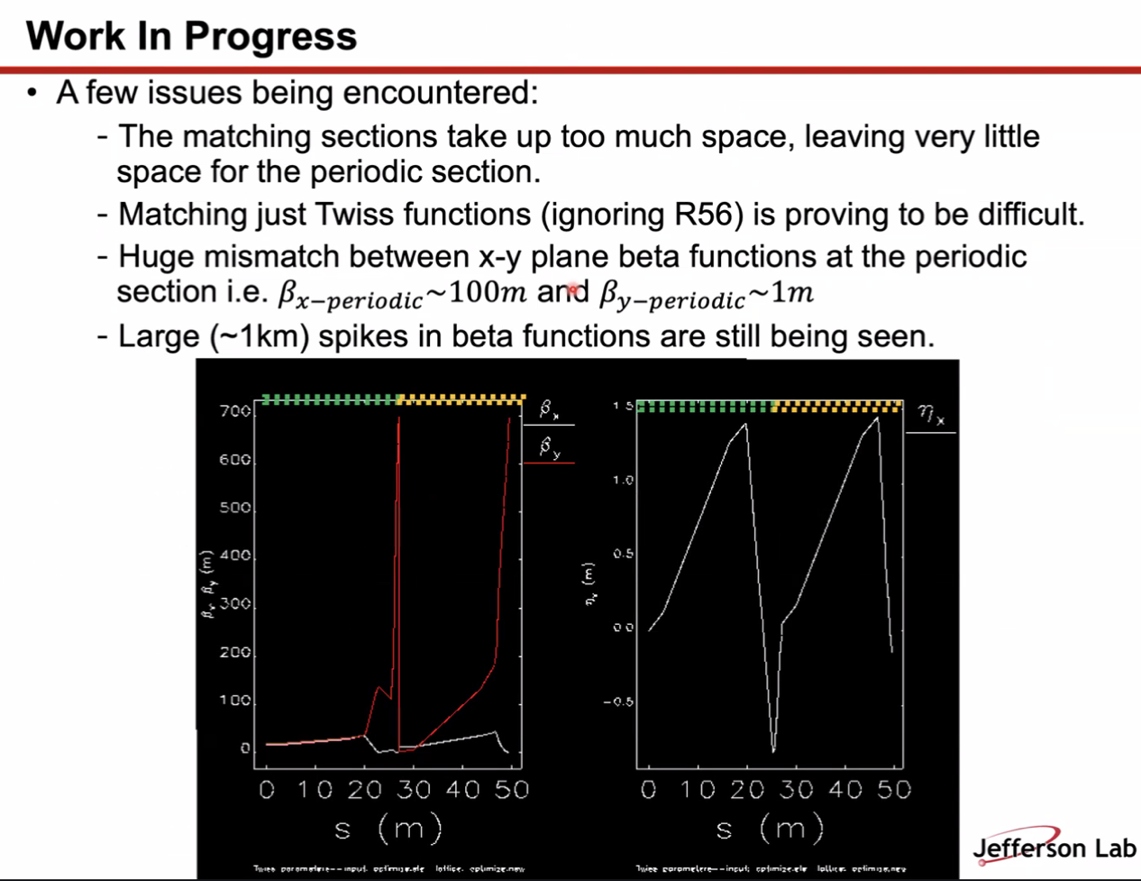
  + Matching too big, no space for periodic
  + Ignoring R56, and it’s STILL too hard to match
  + As soon as X-Y plane beta match, some solutions give massive mismatches between periodic BetaX and BetaY
  + Not favorable solutions
  + These are JUST the matching sections. No periodic section shown. Yellow side is the FFA side backwards propagating
    - Dropoff not physical
    - Forward propagate through green, stick in FFA betas and propagate through orange
  + At the interface between green and orange, you should mirror-image the orange to see more what’s really happening
  + Beta grows a bit large at times. This controlled it a bit.
  + Here we’d have about 40 meters for the periodic section
* Dejan – your quads are probably not in the right place, and probably not enough to control the vector functions.
  + Look at the normal conditions. 700 m is something you’d not expect
  + Ryan – I think the spike is OK. We get it in the spreaders.
  + Alex – right, we have that in CEBAF now, and I think we can tolerate it. Perhaps if we aim for under 1 km we can be OK.
* Donish – will let spaces between quads vary as well
  + Optimizer keeps extending the matching sections.
* Dejan – maybe look at multifunction magnets
  + Donish – yes, that’s something Scott brought up before.
  + Ryan – it will introduce sextupole and higher order terms as well, but one thing at a time
* Alex – I like the modularity.
  + Can shift matching tasks.
  + Fact that started looking into FFA arc is a good idea
  + Going in reverse from the FFA going backwards – that might give us some clues on how the linac optics need to be changed.
* Donish – Liked the modular approach – problem is solved if can get the matching from the FFA to the periodic section. Would be easier that way.
  + Alex – yes, different people could take different pieces would be useful

|  |  |  |
| --- | --- | --- |
| Action Items | Person responsible | Deadline |
|  |  |  |
|  |  |  |

## Time allotted | 10 mins | Agenda topic AOB | Presenter All

|  |  |  |
| --- | --- | --- |
| Action Items | Person responsible | Deadline |
|  |  |  |
|  |  |  |

## Special notes

Pathway to Repository: <https://jeffersonlab-my.sharepoint.com/:f:/g/personal/tristan_jlab_org/EqZ5MeS-nipCgPfZB5p0oS4B9Is67d3nQb9sLJI3Zyev9g>