FFA@CEBAF Working Group|Minutes

Meeting date | time 02/14/2025 | 11 AM EST | Meeting location https://jlab-org.zoomgov.com/j/1614898082?pwd=TnUzMS81M2sxbDZIbERJU01tYkJCQT09
Meeting called by Alex B  Type of meeting Weekly Meeting  Facilitator Alex B  Note taker Ryan  Timekeeper Alex B | Attendees  Alex B, Ryan, Edy, Kirsten, Sali, Reza, Scott, Donish, Stephen, Andrei

Intro Discussion
- Salim working on some stuff with Rui Li

Agenda topics

Time allotted | 25 mins | Agenda topic LDRD| Presenter Ryan/Kirsten/Edy
- Ryan first:
  - 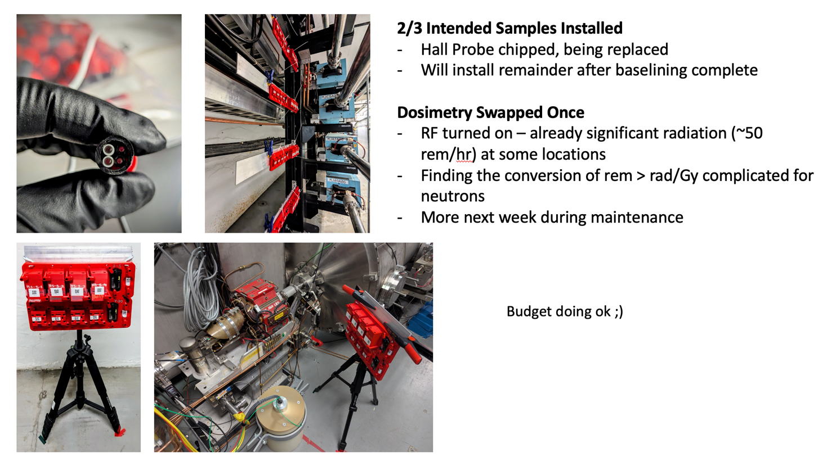
    - White circles in top left are low-dose optichromic rods, black are high-dose
    - In arcs, the samples are mounted on arms behind the beamlines
    - In LINACs, they’re on tripods, and when possible near NDX detectors
      - NDX has two detectors, one is sensitive to both gamma and neutron, and the other only gamma. Subtracting the values gives the neutron dose.
  - 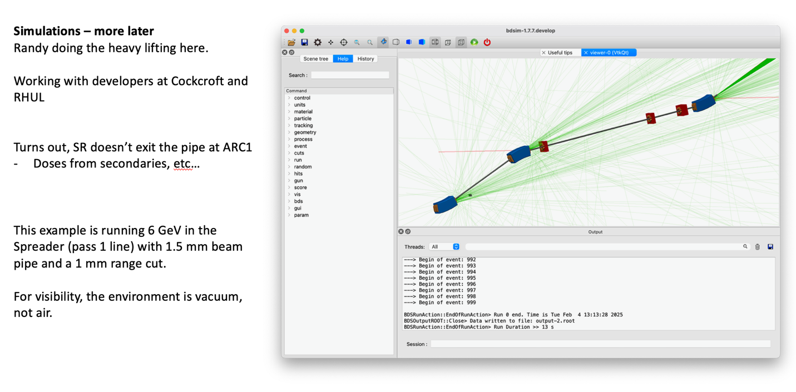
    - Significant dose, lots of secondaries
- Kirsten:
- 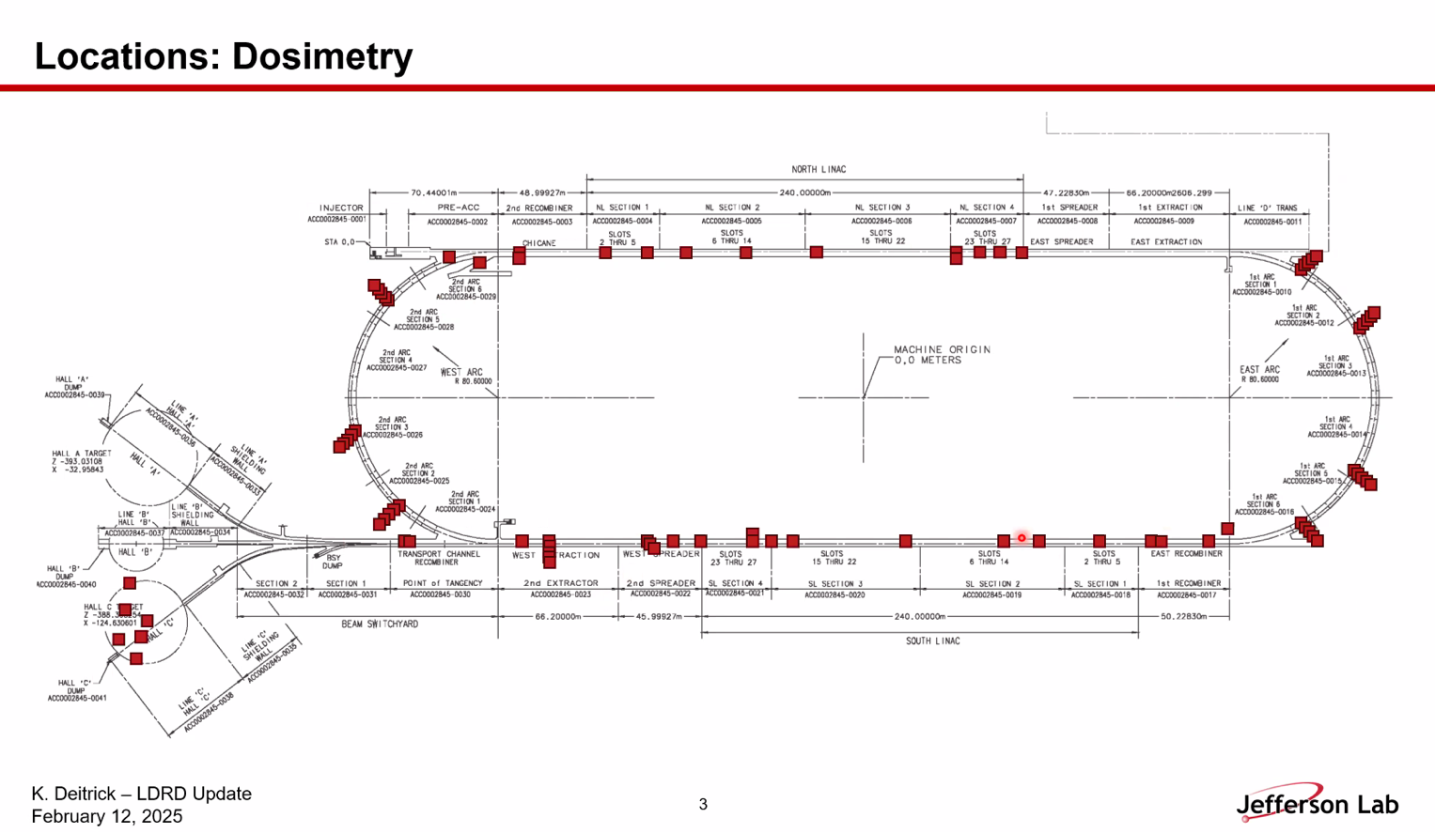
  - This is where we placed all dosimetry at first to get ideas of the “map”
  - Put everything in for 2 weeks, and then another 2 weeks we pulled everything
    - All dosed at 2 or 4 weeks
- 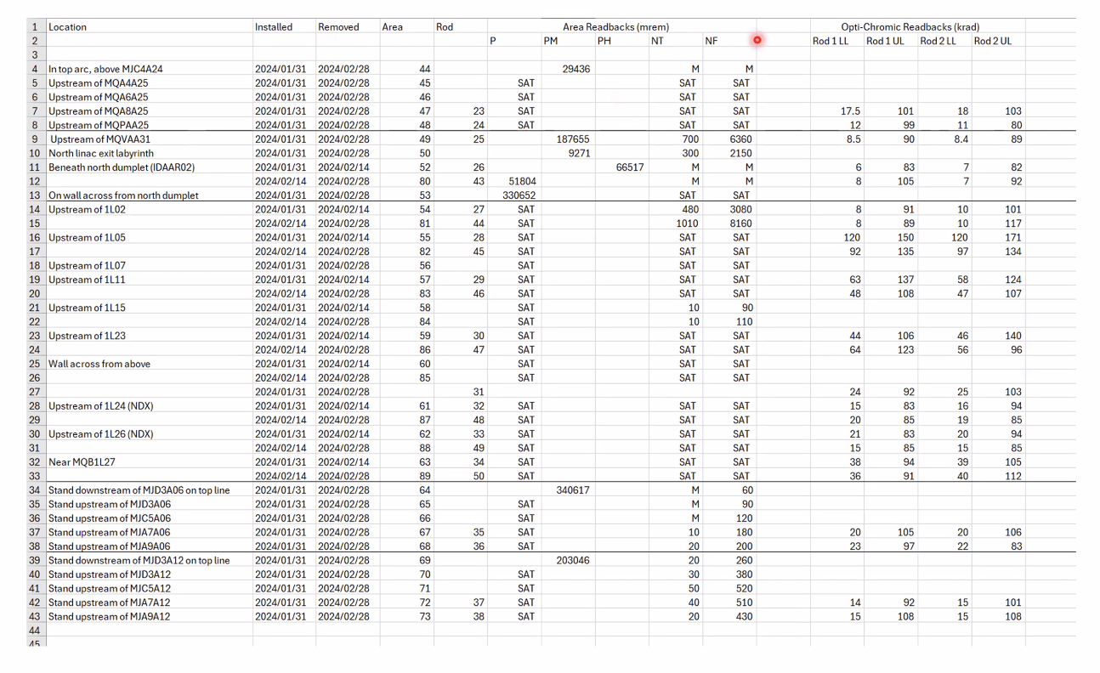
  - In the LINACs, things are almost all saturated in the area dosimeters
  - Rods read in the LINACs still
- 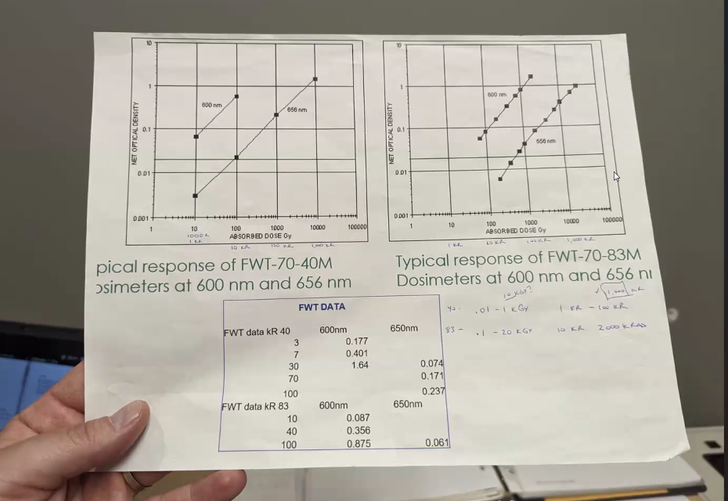
  - We had a small gap in our dosimetry coverage
  - Example, 8 krad and 188 rad on different dosimeters –
  - Needed to add lower-dose optichromic rods to close that gap
- Stephen – what’s the conversion from REM to RAD?
  - In gammas – it’s 1 to 1 (1 rem is 1 rad)
  - In neutrons, it’s dependent on the neutron spectrum
- Range in rod readbacks, some range in neutrons, but it’s hard to tell b/c they’re saturating
  - A lot of neutrons can read better in the arcs
  - Rods highest in linacs
- 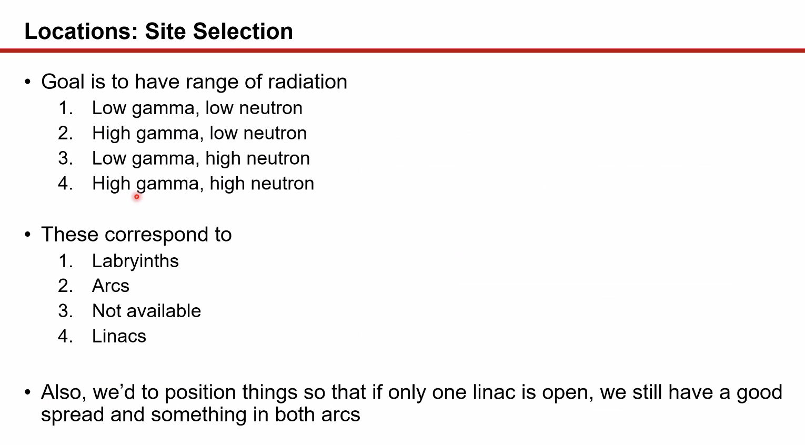
  - Didn’t seem to have low gamma high neutron
- 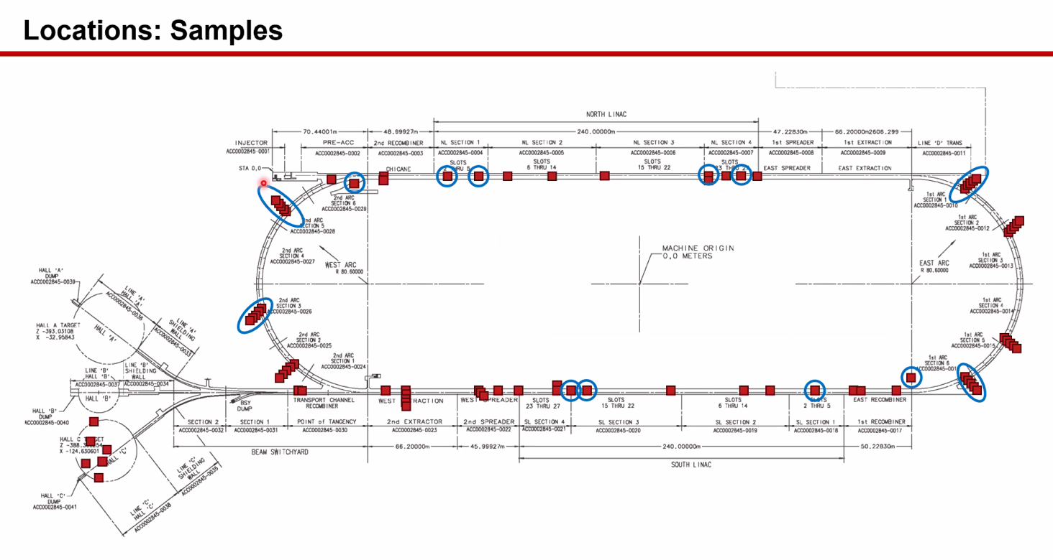
  - Already swapped areas once
  - Most likely the areas will keep getting saturated during the run
  - Since we pulled them once already, and are going to again next week, we might be able to at least benchmark against the NDX detectors and get an idea of what we will get
- 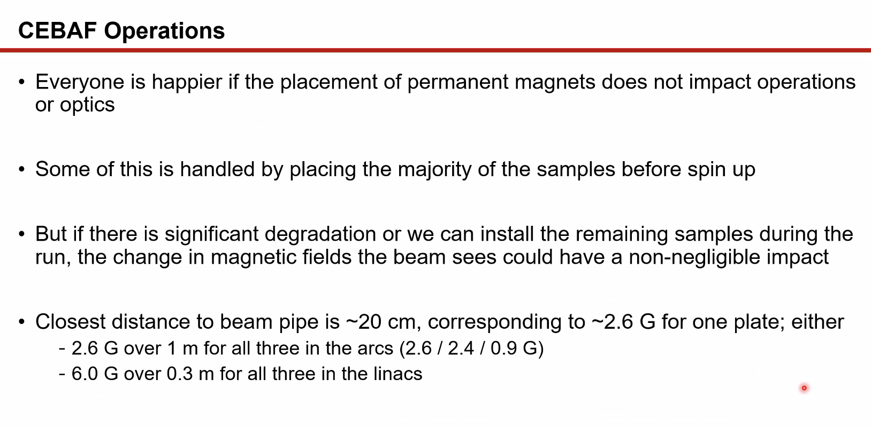
  - Samples already placed before the beam spin-up
  - Possible problems: if the magnets degrade so badly that the fields change over the term of weeks, it may impact the operations
  - Once we add in the rest of the magnets after baselining the rest, that may have a tiny impact on the beam
  - Joe Meyers did a field mapping measurement of our assemblies
    - 5 Gauss limit is ~10 cm
- 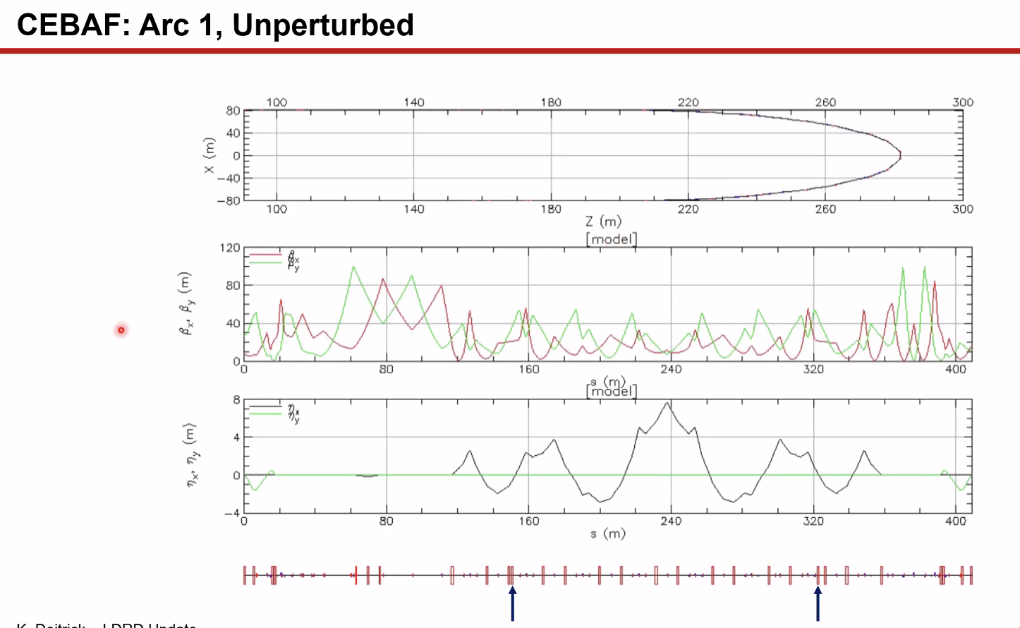
  - Arrows indicate sample placements
- 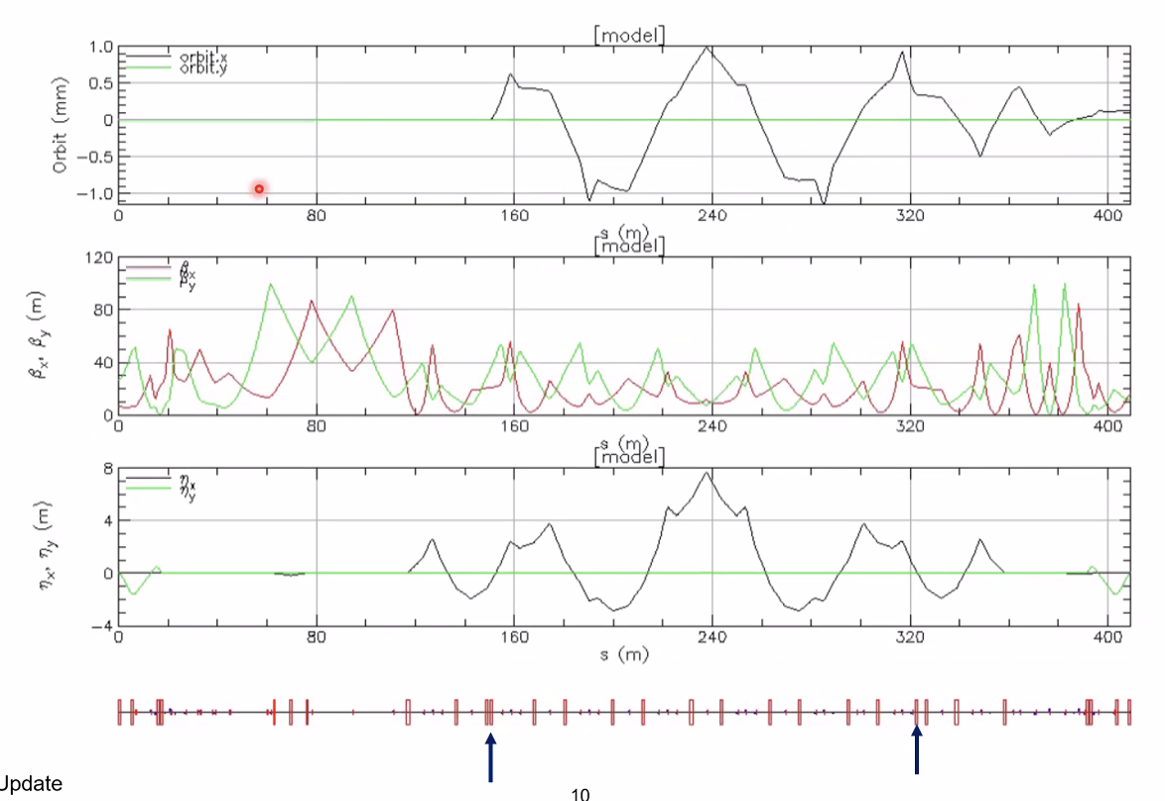
  - Dipole kicks added here
- 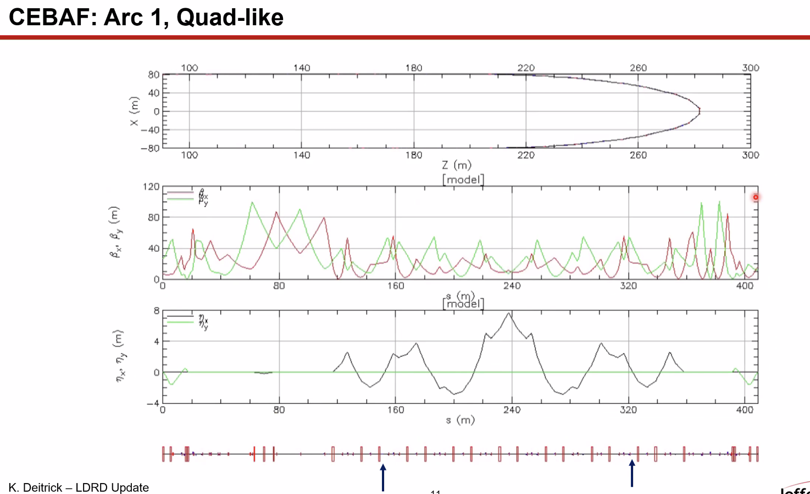
  - Quad terms added here
- Stephen – how often do you have correctors?
  - Ryan – I believe every girder has correctors
  - Stephen – that won’t be a problem at all
- 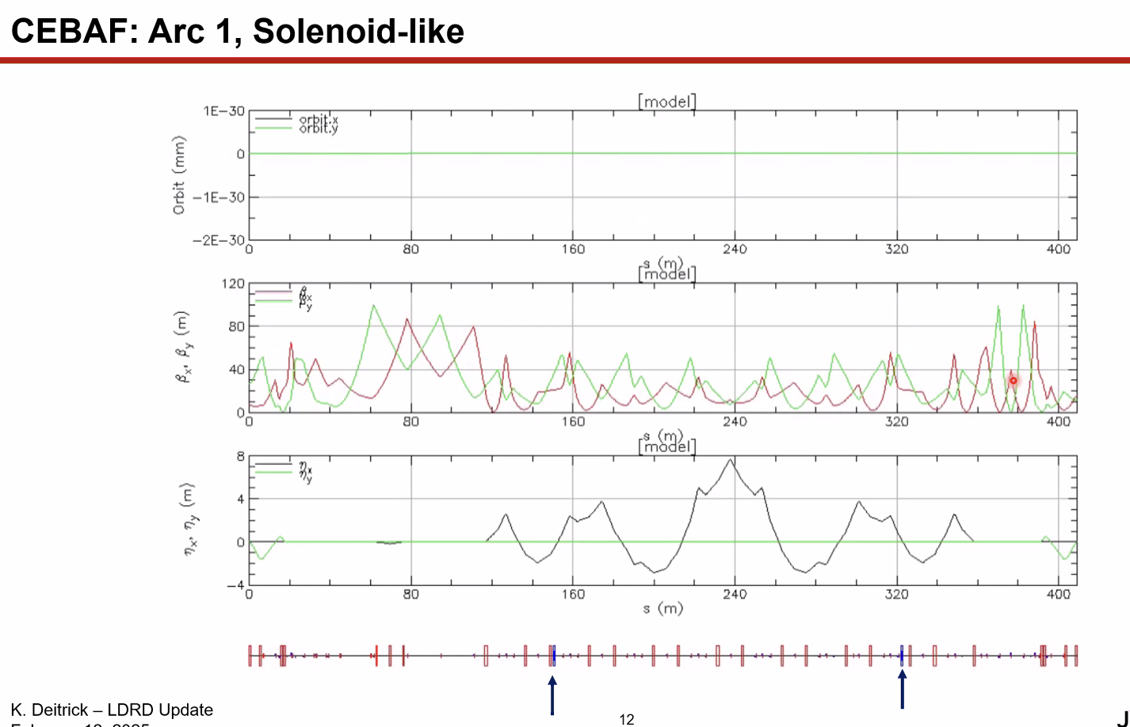
  - Solenoid-like kicks
- Will be less noticeable at higher energies
- LINAC simulations in progress
  - There is one set near the early LINAC1 to look at, but likely OK
  - Samples more like 40-50 cm away from beamline
- Stephen – 100 krad level on the optichromic rods – basically the CBETA limit was set at that
  - So they are likely the right order of magnitude for what we’re doing
- Areas max at 1 krad (gamma)
- Rods go up to 1000 krad (gamma)
- In the 5 krad area, we need to read low-dose rods
- Learning curve when we get stuff back to make sure we’re ok
- Stephen – on RHIC beam dump, saturated the optichromic film. Pulled the net current from the beam logs to extrapolate
  - Kirsten – and we’ll need to be doing that as well.
- During the 4 weeks these were installed, Hall D was not running.
  - Still, in that line, the photons saturated
    - It’s seeing a lot of dose from adjacent lines
- Stephen – if you put the rods in shielding, it could help as well
  - Plot integrated current with reading, or something to get a linear curve in there
  - Also, if you have optichromics at different distances, and then do an axis plot
    - Ryan – we do have enough to maybe check
- Kirsten – during the readings, we would have one set on the NDX and one on the wall across from it.
  - They still saturated
- Alex – can you run for longer/get more money?
  - Ryan – I hope so. I’m planning to ask for some dosimetry money
- Reza – did you decide which direction of the magnets to put these samples?
  - Yes – North is pointing downstream. They are aligned with the beam propogation
- Reza – please show the map
  - On the arc detectors, when we are not running beam, didn’t get radiation on those?
    - We assumed no beam, no RF, probably no radiation
- No magnets pulled off yet either.
- Edy’s Tour:
  - 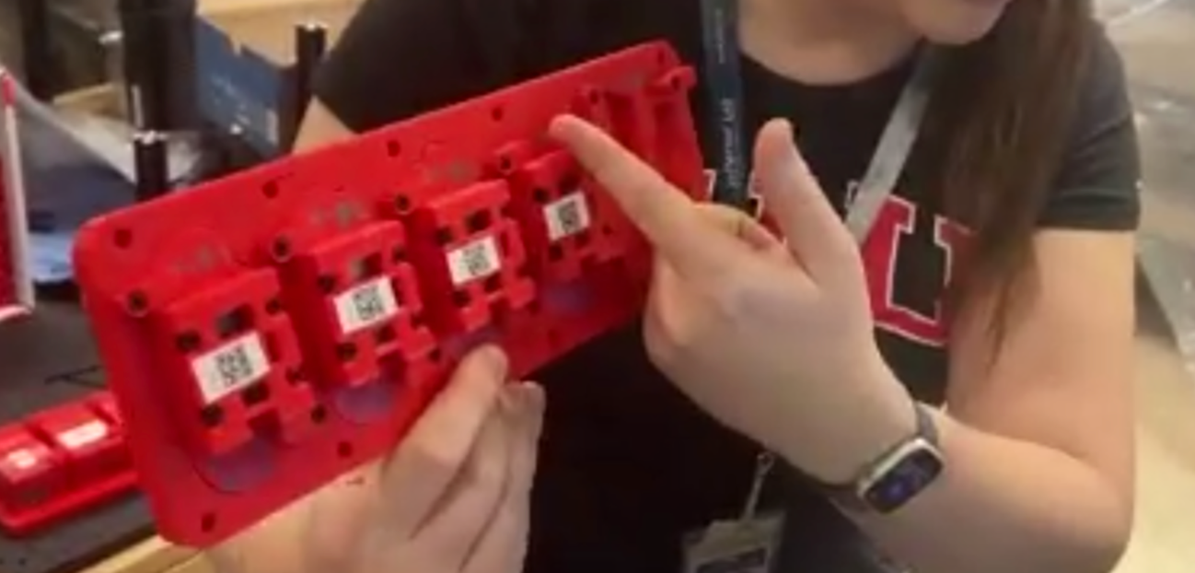
    - Single samples – 4 materials, randomized order, all fields pointing in the same direction as beam propagation
  - 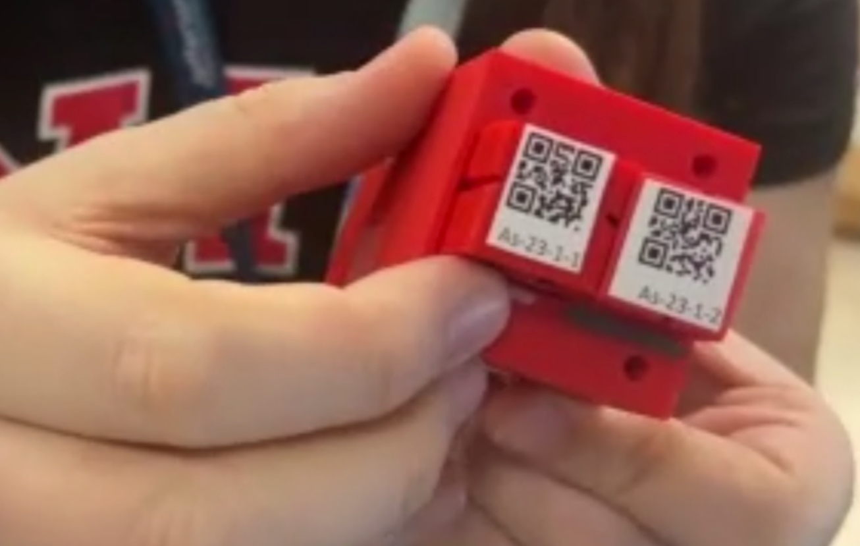
    - Inside of a pair assembly
  - 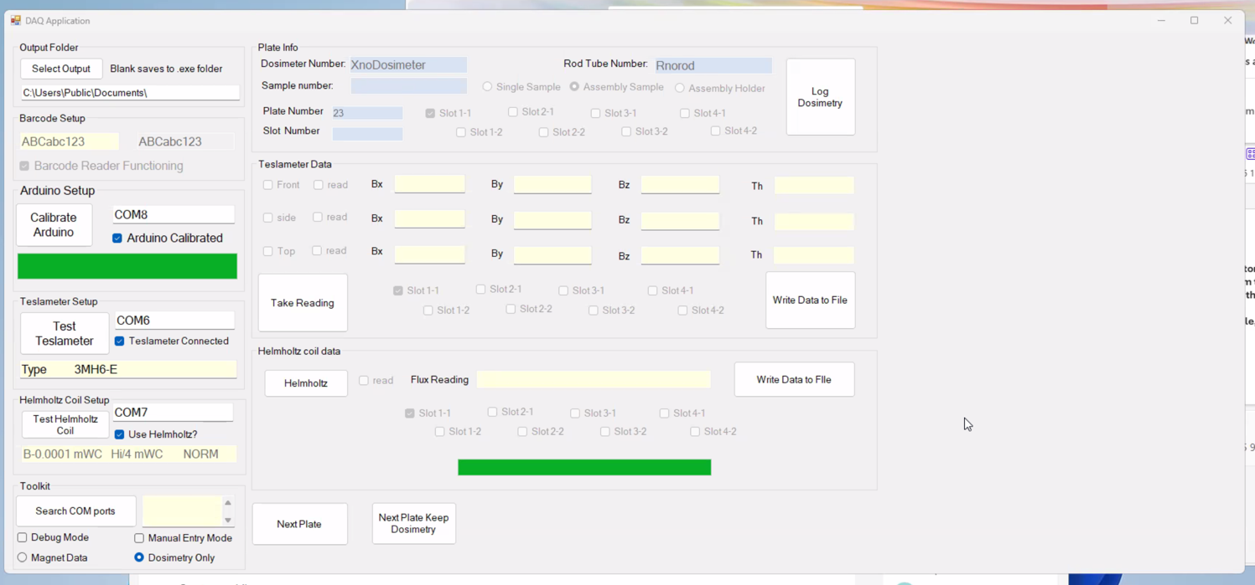
    - Screenshot of DAQ
  - 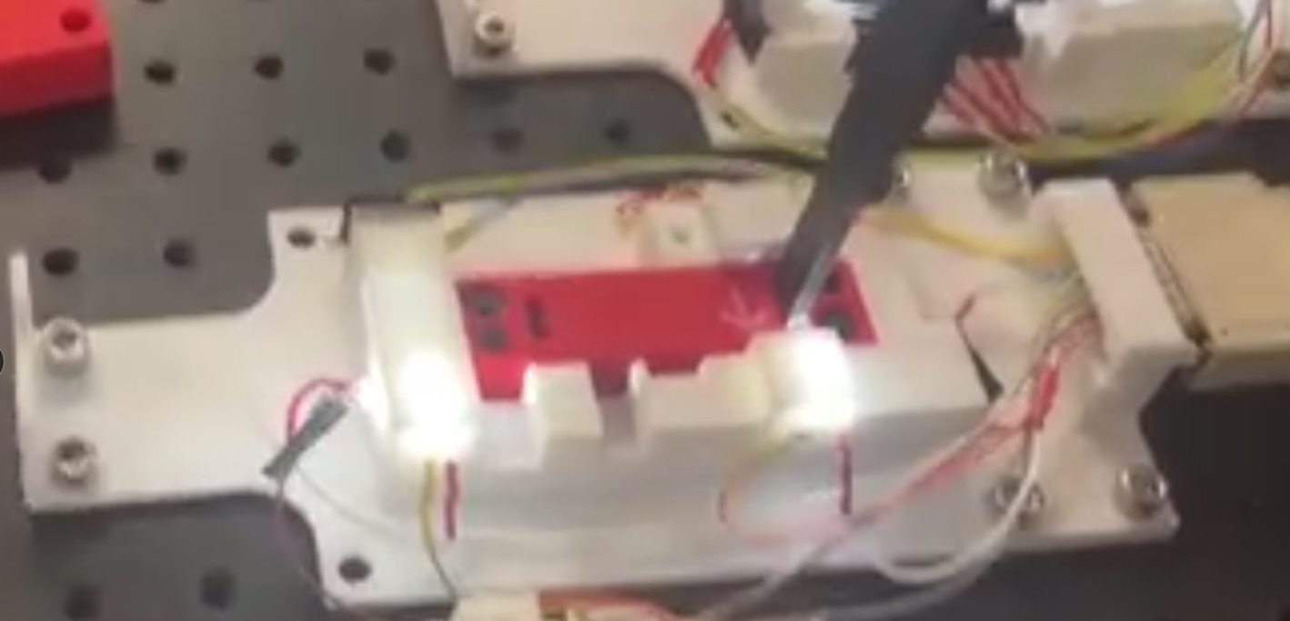
    - Measuring a single pair in the rig. Lights used to indicate which measurement position, 3 total on each sample.
  - 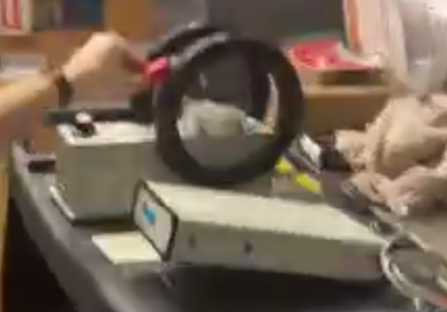
    - Helmholtz coil with rotator and fluxmeter to get integrated measurements
  - 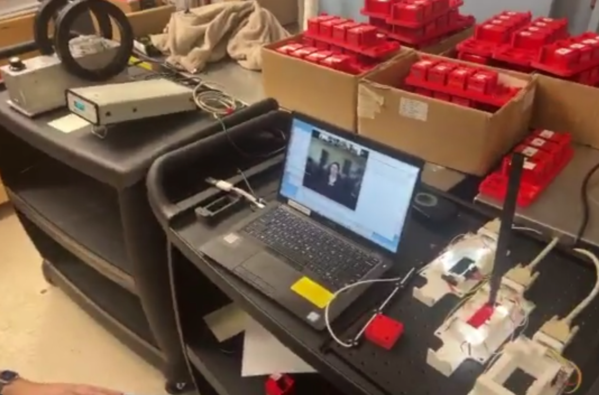
    - Most of the setup. Two carts, to be taken into tunnel for readings
    - Remaining pairs in background to be baselined
- Stephen – if you plot integrated CEBAF current and dose readings and get straight lines, means that they haven’t changed the machine/distribution
  - Always same? Or are the operators/motion changing things?
  - Is it always the same per current/charge?
    - Have to do this in BDSIM as well
Action Items | Person responsible | Deadline

Time allotted | 25 mins | Agenda topic Full Cell Test| Presenter Alex/All
- Defer to brainstorming next week
- 
  - Think about these things to discuss next time
- 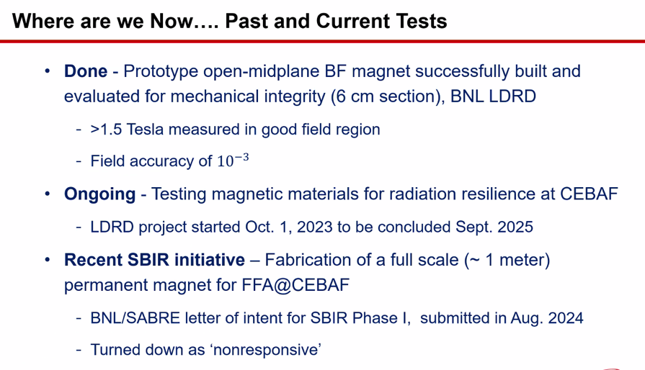
- 
Action Items | Person responsible | Deadline

Time allotted | 10 mins | Agenda topic AOB | Presenter All

Action Items | Person responsible | Deadline

Special notes

Pathway to Repository: https://jeffersonlab-my.sharepoint.com/:f:/g/personal/tristan_jlab_org/EqZ5MeS-nipCgPfZB5p0oS4B9Is67d3nQb9sLJI3Zyev9g

