FFA@CEBAF Working Group|Minutes

## Meeting date | time 03/14/2025 | 11 AM EST | Meeting location <https://jlab-org.zoomgov.com/j/1614898082?pwd=TnUzMS81M2sxbDZIbERJU01tYkJCQT09>

|  |  |  |  |  |  |  |  |  |  |  |  |
| --- | --- | --- | --- | --- | --- | --- | --- | --- | --- | --- | --- |
| |  |  | | --- | --- | | Meeting called by | Alex B | | Type of meeting | Weekly Meeting | | Facilitator | Alex B | | Note taker | Ryan | | Timekeeper | Alex B | | Attendees  Alex B, Ryan, Volker, Edy, Scott, Dejan, Stephen, Kirsten, Salim, Donish, Todd, Roger, Randika, |

# Intro Discussion

* CEBAF operational woes – broken LCW pipes, etc…
* Salim will aim for an LDRD on Kirsten, Ryan, Jay, and Kitty’s idea from a few years ago at the retreat.
  + There are tech notes, slides with costing, etc…

# Agenda topics

## Time allotted | 50 mins | Agenda topic Field Map Measurements| Presenter Volker

* A picture containing text, plant, bird, screenshot

  AI-generated content may be incorrect.
* **Graphical user interface, text

  AI-generated content may be incorrect.**
* 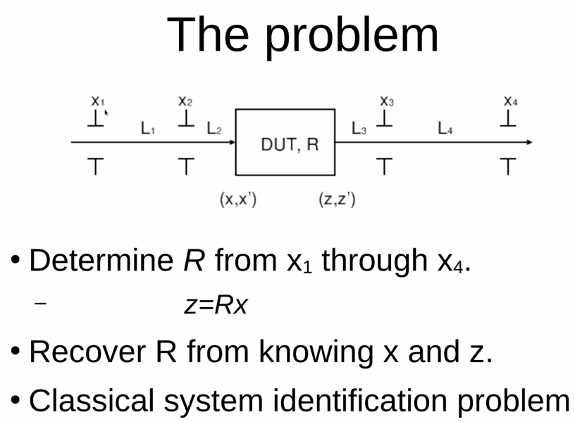
* Table

  AI-generated content may be incorrect.
* Diagram

  AI-generated content may be incorrect.
* Text

  AI-generated content may be incorrect.
* 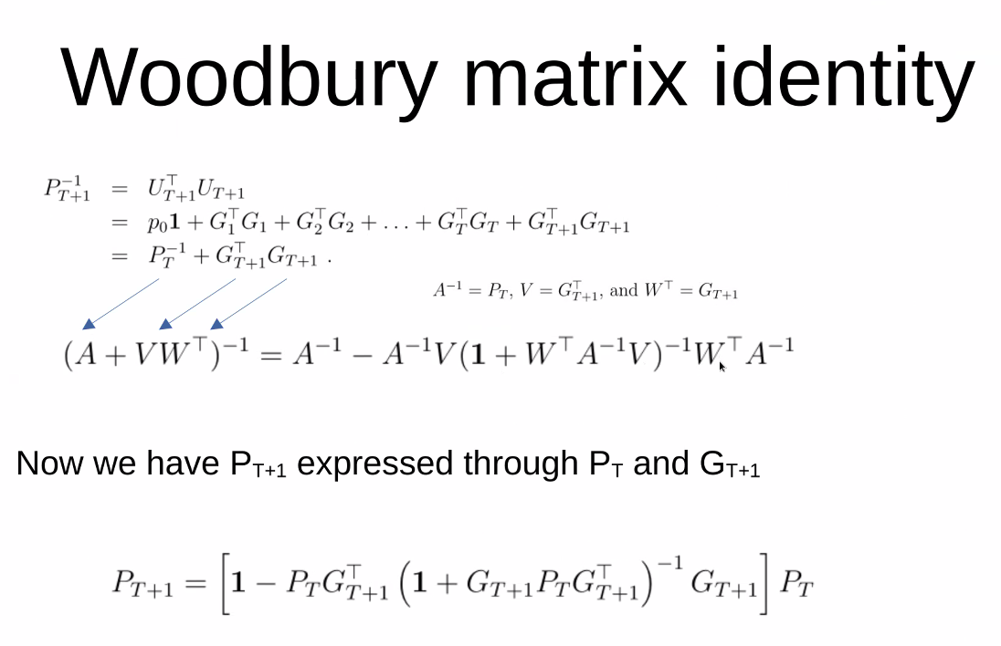
* **Text, letter

  AI-generated content may be incorrect.**
* **Table

  AI-generated content may be incorrect.**
* **Text

  AI-generated content may be incorrect.**
  + Essentially, wiggling the beam
  + Record positions, add noise
  + Algorithm gets the good stuff from each
  + G is a transfer matrix – calculate auxiliary parameter
  + Eye is a unit matrix in MATLAB
  + Qhat – update the best transfer matrix element guess after the new iteration arrives
  + Copy new P to old P
  + P is 4 x 4 matrix
  + Do identification error (last equation) – Rt is best guess
* **Chart, line chart

  AI-generated content may be incorrect.**
  + Factor 100 in variation vs RMS noise on BPMs
  + Drops as 1/T
  + ID error is red – on order of unity
  + True transfer matrix is R (not a quad, just a random matrix with determinant = unity)
  + Simulation takes no time at all
  + After 10K iterations (orbits)
* Graphical user interface, text, application

  AI-generated content may be incorrect.
  + Can do this analysis anywhere we have input and output
* Text

  AI-generated content may be incorrect.
* Stephen – can you generalize if you have nonlinear transport?
  + Around slide 5 – when you do this in a clever way, you might be able to accommodate nonlinear mapping?
  + Volker – T matrices?
  + Yes
  + If you express it the right way around, comes out as a linear system still.
    - G would contain all the monomials
  + Volker – hadn’t thought about nonlinear yet – interesting
* Stephen – have considered nonlinear magnets, but also would be nice to quantify “accidental nonlinearities”
* Scott – you’re basically treating this as a least squares system, can generalize to higher-order
  + Feel like this is doing it the hard way. In principle, when you have a least squares system, just solve it numerically with Qr
  + This will give the solution, the RMS errors, and the error propagation is straightforward
  + Have to be a little careful with errors, but you’ll get rid of inverses, etc…
  + This is sort of a one-shot with all the data
    - Volker – yes, if you accumulate all data, then solve with eq on slide 6
    - If you have continuous data, fold it into best fit system
  + Basically, you just work with a rectangular matrix. Factorize.
  + Volker – which rect. Matrix? Scott – U is rectangular
    - No, U is a column vector (each G is 2 x 4)
    - Large number of rows, small number of columns, QR algorithm solves it without the UtU
    - Result lets you compute everything you need
* Dejan – We have a system, and have to do exactly what you’re looking at.
  + This is exactly what Scott is saying. Approach the problem from going through repetitive measurements, or get all the measurements at once and do LS.
* Scott – this has some tricks where you could “get it as you go”
  + One reason QR is used is b/c forming the companion matrix is “numerically fussy”
  + Volker – start with a unit matrix guess, then change as you get more data
  + Scott – what I’m saying is that you’re still forming the companion matrix, even if it’s through iterations. Our problem isn’t really numerically fussy, so probably not a problem. But however you make the companion matrices, it can make problems if there is fussy numerical problems.
* Stephen – I like SVD on rectangular matrices for stuff like this.
  + SVD is QR on steroids – doesn’t make much sense here – too much. If you start dropping off some of the coefficients, you’d have issues.
  + Stephen – so delete all the small coefs, and the biggest ones give you the LSF
    - Scott – can’t do that here, need all the coefs
* Dejan – we do have a nonlinear system with different energies into the input
  + We have very nonlinear magnets for each energy’s mag field
  + This way, we can find out the errors in the multipoles coming out
  + Volker – the nonlinearities in the phase space coords? – So higher-order depending on other monomials
* Volker – will make github with MATLAB so we can play
* Alex will add things into presentation folder
* Salim – was going to ask about the error – but that’s answered
  + Now thinking, what about adding misalignments, etc… Will this determine R correctly?
  + Volker – you wiggle the orbit around some initial reference, and then make a tangent map around orbit you had when you started
    - Basically a linearized map around where it’s varying.
  + Salim – calculating an R matrix with dipoles and quads – but in return, I’ll get one exact value for each element. If the beam is off-axis, and the BPM which is measuring is also off-axis, at what percentage is this reliable?
  + Volker – you address an ambiguous point – in the end a dipole is a dipole, but one job is to change reference trajectory, but also the motion around the reference trajectory.
    - Global offsets related to job of the dipole as a defining element of reference energy
  + Salim – the “black box” we’re looking at, it’s one box, and we may have many other terms inside
  + Volker – this addresses the transfer matrix only
* Ryan – this is similar to how we do some things in CEBAF – we start with absolute orbits, but then once you’re set up, you re-zero everything and have relative orbits
* Alex – I recall Alex Coxe having issues displaying things from patches. I think it was something about how Bmad was handling the transition from the strong-to-weak focusing?
  + Ryan – no, it’s more about redefining the local coordinate system. So you’ll have a place that has a reading that is then reading zero, b/c the coordinate system shifted.
* If you put in the “forgetting factor” with 20-30 minutes and get good variation, you can pull out the time scales. Can track as you go along. Adapts to slow parameters
* Ryan – can use that for a slow feedback system
  + Volker – this uses the idea that the orbit feedback system – reconstructs the response matrix. Use LOCO-type analysis
  + Accumulate FB data and parasitically extract cavity parameters
* Recursive least squares is “Volker’s Hammer”
* Alex – also Volker has an accelerator physics text using MATLAB
  + Open access (oapen.org) and publisher’s website
* Dejan has Bmad again – can do translations.
* Dejan – what about support from JLab?
  + Todd – have to look at how the CR vote goes.

|  |  |  |
| --- | --- | --- |
| Action Items | Person responsible | Deadline |
|  |  |  |
|  |  |  |

## Time allotted | 10 mins | Agenda topic AOB | Presenter All

* N/A

|  |  |  |
| --- | --- | --- |
| Action Items | Person responsible | Deadline |
|  |  |  |
|  |  |  |

## Special notes

Pathway to Repository: <https://jeffersonlab-my.sharepoint.com/:f:/g/personal/tristan_jlab_org/EqZ5MeS-nipCgPfZB5p0oS4B9Is67d3nQb9sLJI3Zyev9g>

No meeting next week!