FFA@CEBAF Working Group|Minutes

## Meeting date | time 03/28/2025 | 11 AM EST | Meeting location <https://jlab-org.zoomgov.com/j/1614898082?pwd=TnUzMS81M2sxbDZIbERJU01tYkJCQT09>

|  |  |  |  |  |  |  |  |  |  |  |  |
| --- | --- | --- | --- | --- | --- | --- | --- | --- | --- | --- | --- |
| |  |  | | --- | --- | | Meeting called by | Alex B | | Type of meeting | Weekly Meeting | | Facilitator | Alex B | | Note taker | Ryan | | Timekeeper | Alex B | | Attendees  Alex B, Ryan, Salim, Donish, Kirsten, Dejan, Edy, Stephen, Donish, Randy, Kirsten, Volker, Roger, |

# Intro Discussion

* Still trying to reinstate funding to BNL, but unsure of how.
* IPAC delays
* Budget
* All-hands at noon for JLab with Director

# Agenda topics

## Time allotted | 25 mins | Agenda topic BSY Dump Tests| Presenter Salim/Alex

* Want to do demo experiment for beam transport of FFA
* 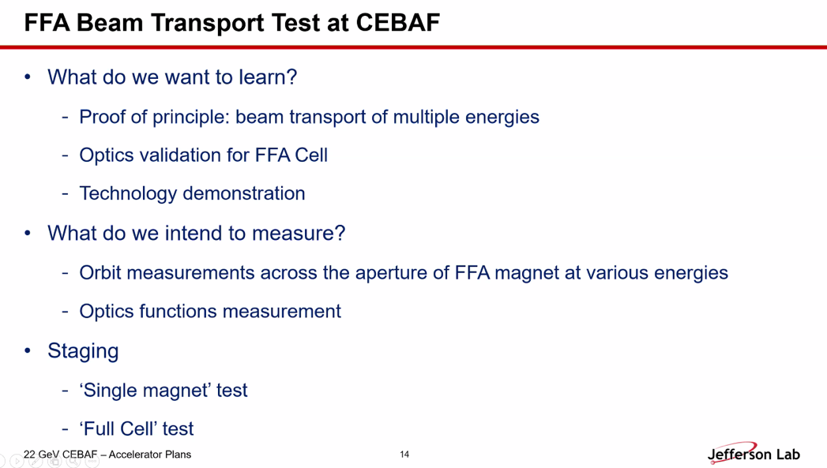
  + If we could measure optics qualities, that would be good
  + Tech demo with 1 m + long permanent magnets
  + Measure orbits across the aperture
* Salim was thinking about polarization measurement
* Graphical user interface

  AI-generated content may be incorrect.
  + Stephen: These are actually the short magnets for Dejan’s medical FFA, not the CEBAF one.
* Last year, tried to do an SBIR, but it didn’t get funding
  + Encouraged to keep trying
* **Diagram

  AI-generated content may be incorrect.**
  + Could try to utilize this for testing FFA beam dynamics
  + Squeeze in FFA magnet
* Diagram

  AI-generated content may be incorrect.
  + Multiple energies usable, bend with extra magnets if needed
* Next level:
* Chart, line chart

  AI-generated content may be incorrect.
  + “relatively empty” slot to install things
  + Stephen – won’t get a full scale at these energies, but you can keep the aperture the same and shorten the magnets
  + Ryan – and you could make the specific cell to match what we need, and maybe get rid of the extra dipoles
  + Dejan – we’re doing something similar. Multiple magnets to make it enter the area with a normal magnet – make all alphas equal zero, etc…
    - So as Ryan says, you won’t need those bending magnets, they’ll behave
    - As Stephen says, adjust the magnets for the appropriate energy range
  + Alex – but the bends can just be correctors
  + Dejan – need to be able to change the entrance angles, so need BPMs on both sides
  + A picture containing chart

    AI-generated content may be incorrect.
  + Ryan – so if you’re changing the magnets anyway, incorporate the bend of the original EM magnet into the FFA cell we make
* Back to full-cell experiment
  + Chart, waterfall chart

    AI-generated content may be incorrect.
  + Put quads and flying wires so we can get betas measured around it
* Chart, line chart

  AI-generated content may be incorrect.
* Table

  AI-generated content may be incorrect.
* Routine harp scan from CEBAF
* Asked Salim to take the cartoons and develop things.
* Dejan – you’d like to make the entrance to the assembly so that the beam enters at a normal to the magnets
* Stephen – had to rotate the magnets up to 40 degrees – can do it without normal angle, but need to rotate a lot.
* Dejan – Stephen has done ATF experiment with ~12 magnets (huge angle) – exactly what you’re proposing to do here
  + Done in +/- 50% in dp/p using ATF beam. Used correctors f
  + MeV scales
  + Changed energy would change plate position, two screens upstream and downstream each
* Dejan – with this kind of test, things should look much much better. As soon as you have real magnets in hand, things change
* Alex – want funding to have a crisp idea of what to do
* Ryan – We priced this two years ago, and these hardware tests were priced out of the LDRD realm. We said after the degradation studies, we’d aim for an FOA for this work
  + Alex – yes, the LDRD would maybe be a scoping study to lead into the FOA.
* Diagram

  AI-generated content may be incorrect.
* A picture containing graphical user interface

  AI-generated content may be incorrect.
* Chart

  AI-generated content may be incorrect.
* Chart

  AI-generated content may be incorrect.
  + Replace the final magnet with the FFA magnets
* **A picture containing chart

  AI-generated content may be incorrect.**
  + Intentionally large beta into dump and no closed dispersion
* Graphical user interface, text

  AI-generated content may be incorrect.
  + 3 m dipole can be removed, get about 3.7 m of space
* Ryan – be careful, a lot of those magnets are the Hall C optics line. You may have space to have unpowered elements for when we are running and C isn’t.
  + The triplet is part of the Hall C line. Maybe add unpowered elements around it, and turn it on when we are testing.
* Graphical user interface

  AI-generated content may be incorrect.
  + Example of possible matching into the FFA magnet
  + Can get close to betas, dispersion not constrained.
  + Magnets already strong enough to get these values
  + If constrain dispersion, can manipulate, but b/c the dipoles are rotated, so not pure X/Y
    - Should we consider mounting the ffa cell on an angle too?
  + Likely need a set of matching after the first two dipoles
* Alex – wouldn’t look at pristine dispersion matching.
  + Ryan – likely need some dispersion b/c you’re going into a dump
  + Alex – likely too much to ask to match everything into the periodic condition.
* Text

  AI-generated content may be incorrect.
  + Ryan – you can re-define the coordinates to that you tip things at the angle.
  + Diagram, engineering drawing

    AI-generated content may be incorrect.
* The existing triplet can be used for Twiss measurement.
* If you have some extra quads, it’s better
* Graphical user interface, text, application

  AI-generated content may be incorrect.
  + Alex – the idea with the degrader is great! We have the positrons experiment – will have much larger emittance. If we can show that a larger emittance can transport, could be great!
* Ryan – you could also add in dump/component feasibility studies into the LDRD
* Alex – “what beam to do we have, and what flexibility for the experiment”
  + Skew quad may help re-partition horizontal and vertical
  + Start with “what beam do we get, and how to customize”
* Volker – if you have skew quads, you’ll have a coupled beam matrix, then you’ll be interpreting in a skewed way
  + Might want to add a U and a V wire
  + Ryan – our harps are mostly 3 wire harps
  + Salim – need to allocate funding for beam diagnostics
    - It’s coupled, need to measure the coupling
  + Volker – need more wire scanners b/c there are 4 DoF in coupling
    - Need at least 1 or 2 wire scanners to measure diagnonal
* Volker – any diagnostics you can afford. BPMs, harps, etc…
  + Ryan – can also add screen if you go to viewer limited

|  |  |  |
| --- | --- | --- |
| Action Items | Person responsible | Deadline |
|  |  |  |
|  |  |  |

## Time allotted | 25 mins | Agenda topic Sym. Splitter | Presenter Donish

|  |  |  |
| --- | --- | --- |
| Action Items | Person responsible | Deadline |
|  |  |  |
|  |  |  |

## Time allotted | 10 mins | Agenda topic AOB | Presenter All

* N/A

|  |  |  |
| --- | --- | --- |
| Action Items | Person responsible | Deadline |
|  |  |  |
|  |  |  |

## Special notes

Pathway to Repository: <https://jeffersonlab-my.sharepoint.com/:f:/g/personal/tristan_jlab_org/EqZ5MeS-nipCgPfZB5p0oS4B9Is67d3nQb9sLJI3Zyev9g>