FFA@CEBAF Working Group|Minutes

Meeting date | time 04/11/2025 | 11 AM EST | Meeting location https://jlab-org.zoomgov.com/j/1614898082?pwd=TnUzMS81M2sxbDZIbERJU01tYkJCQT09
Meeting called by Alex B  Type of meeting Weekly Meeting  Facilitator Alex B  Note taker Ryan  Timekeeper Alex B | Attendees  Alex B, Donish, Ryan, Randy, Reza, Dejan, Kirsten, Edith, Stephen, Salim, Donish, Andrei, Nick, Scott,

Intro Discussion

Agenda topics

Time allotted | 50 mins | Agenda topic White Paper | Presenter Alex
- Need pre-conceptual design white paper
- ToC is done, some chapters written, some not.
- Think about those assigned sections, and add those in.
- Alex will write about multipass linac optics
- Linac Optics:
- 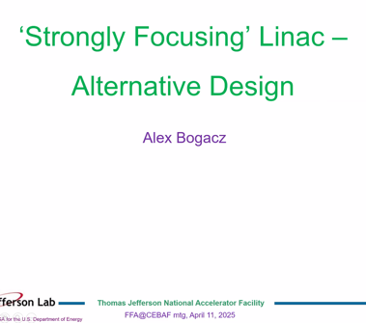
- 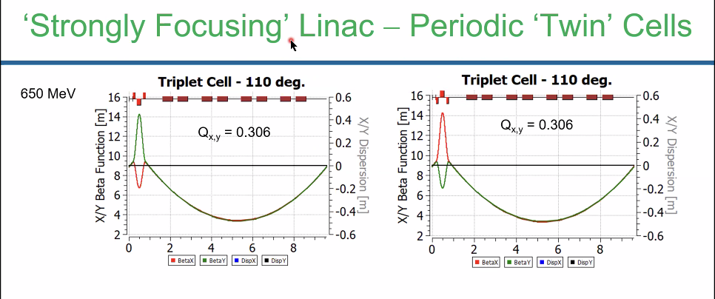
  - 140 degree phase advance excessive, but balancing between strength of quads and betas at the higher passes
  - Looked into triplet lattice with smaller phase advance
  - First cell starts at 650 MeV
  - G = 2 kG/cm for both types of magnets in the triplets
  - 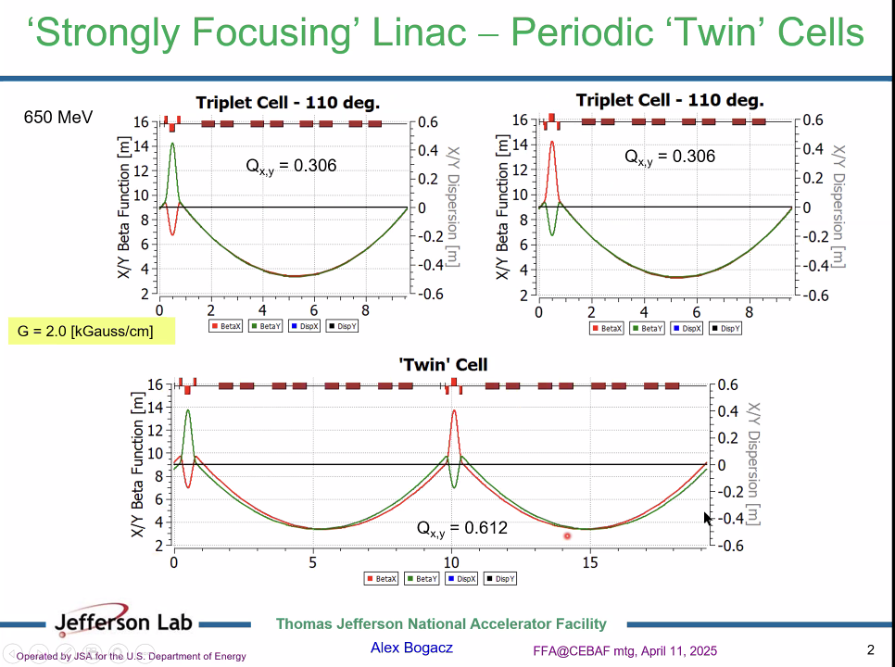
  - Periodicity for twin cell shown
- 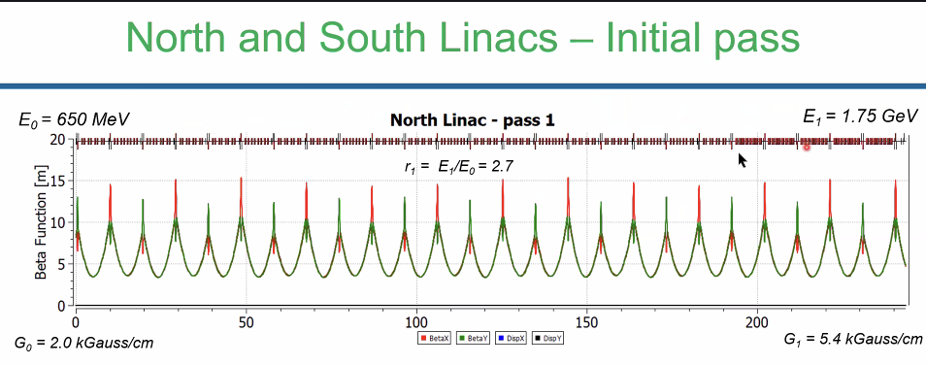
  - Crank up strengths of triplets
- 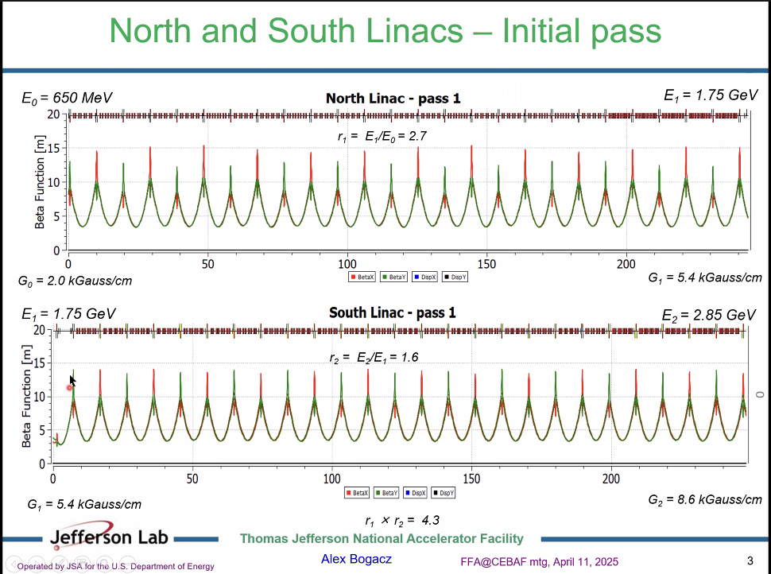
- 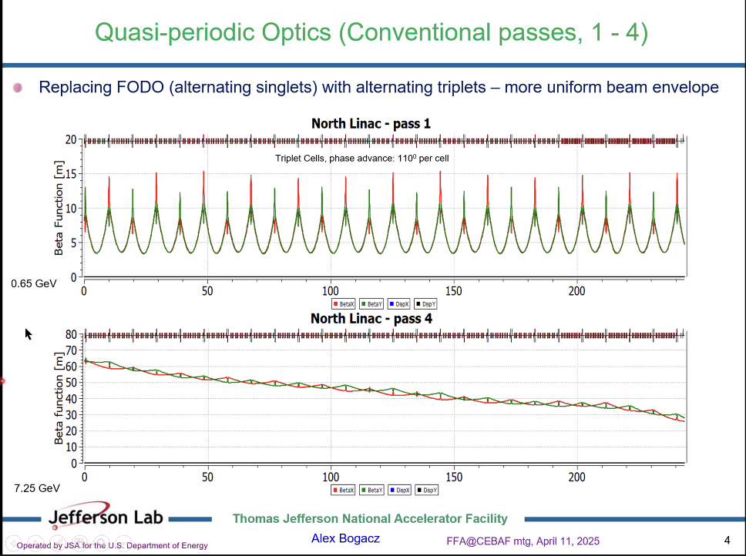
  - Increasing energy, the triplet “morphs” into singlets. Reversing polarity gives something similar to a FODO
- 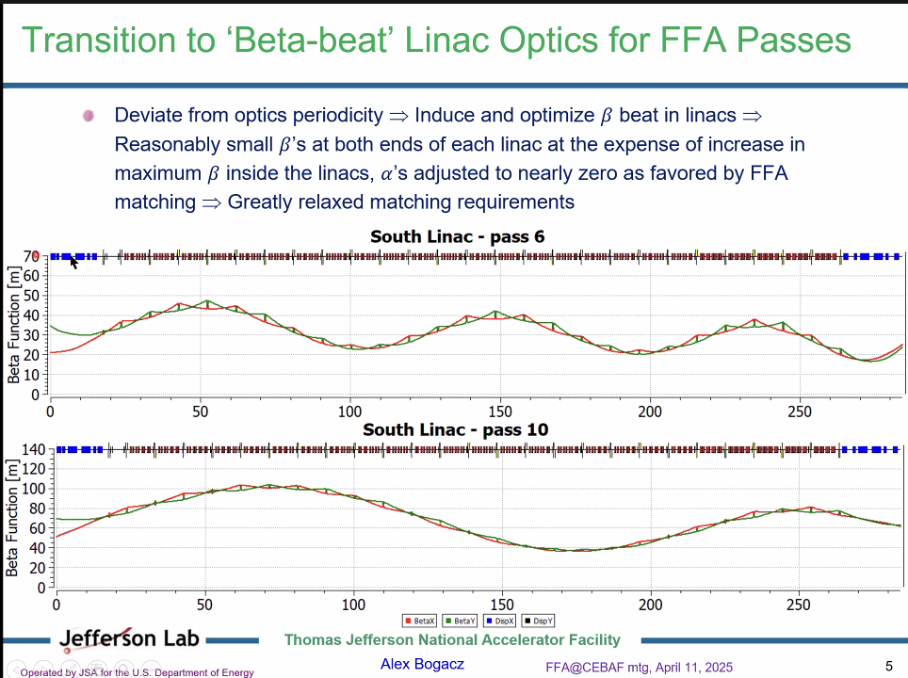
- Dejan – how high to they go?
  - Passes go around 80ish m
  - For higher passes, no quads
  - Final values of the functions is driven by the beta beating, not so much by initial phase advance needed
- Ryan – still have a problem with the quads are far too strong
- 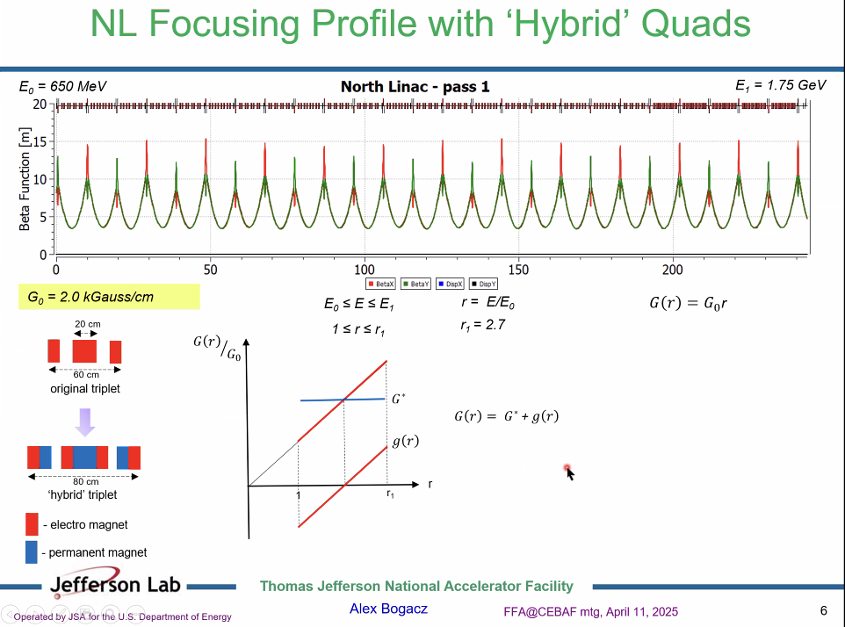
  - Ryan – this was a problem we discussed last time, where there is no space, and the permanent magnets are weak enough to just be Ems
- 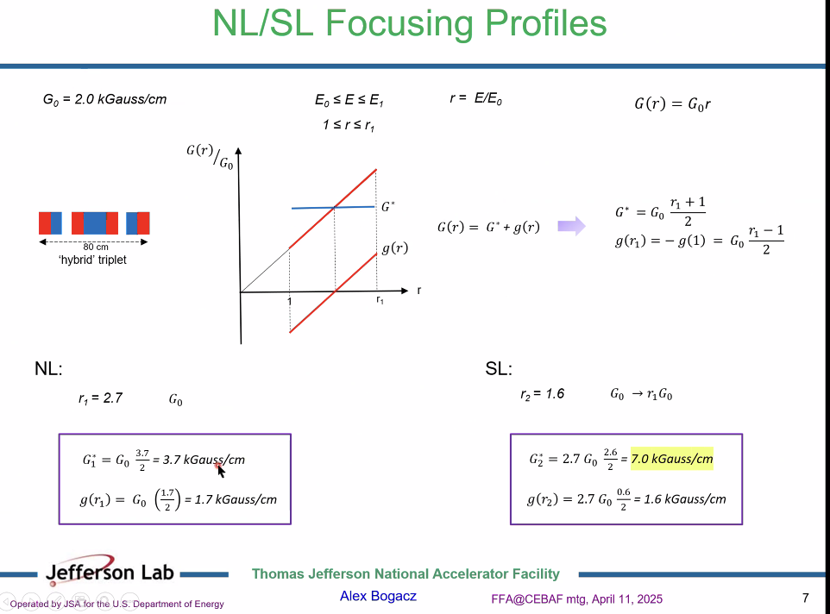
- Instead of bi-polar, got to unipolar:
- 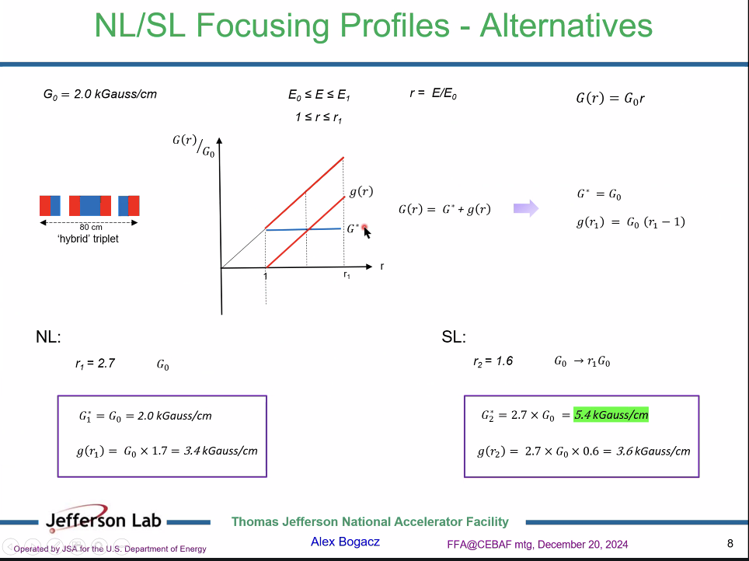
  - Reachable by permanent magnets
- 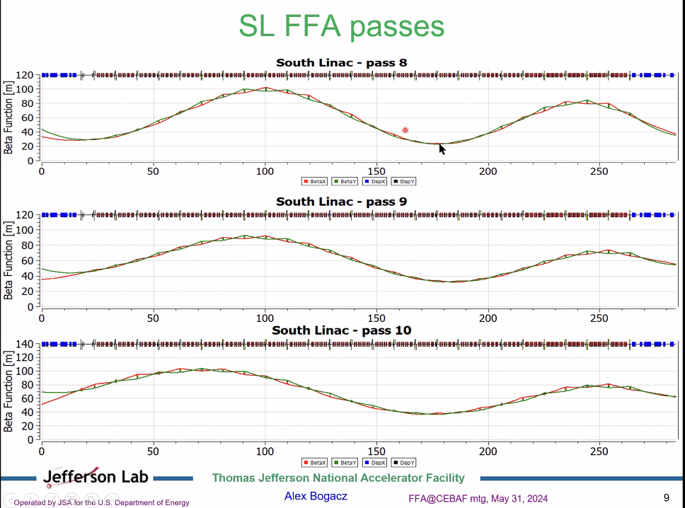
  - What do we get with slightly weaker-focusing linacs?
- 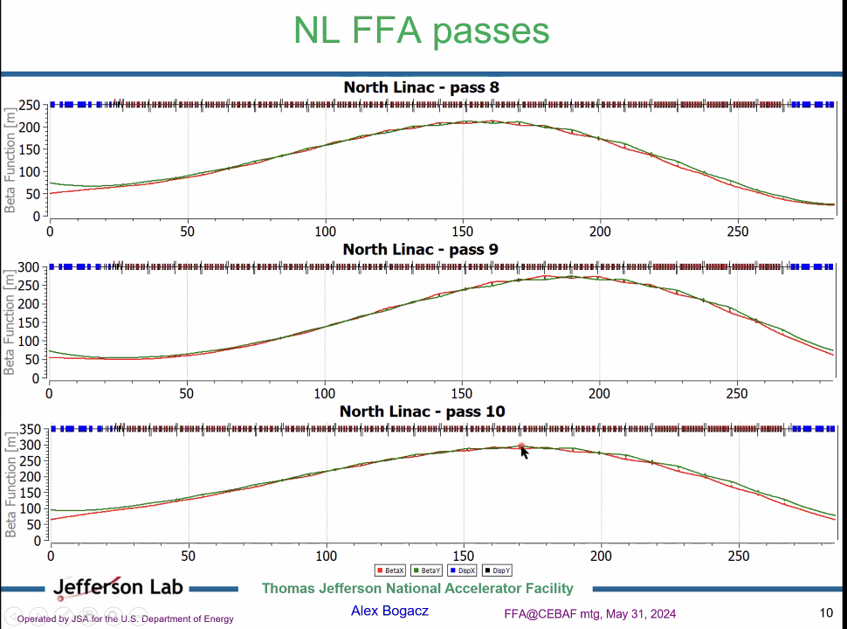
- 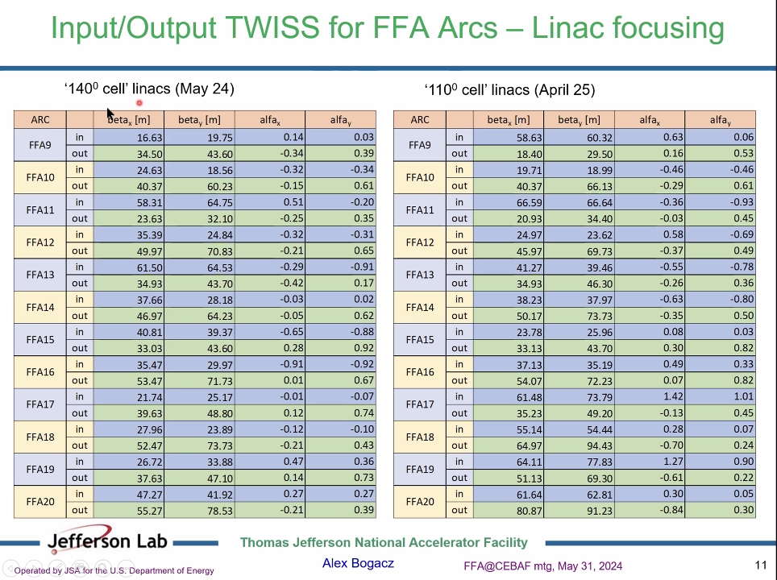
  - Not very different – numbers are a bit higher, but not bad
  - Lowered quads to get this done
- Dejan – the latest achievements of the light source quads combined with permanent magnets goes up to 100 T/m, depending on aperture
  - The PM allows for superposition
  - Ryan – might be hard with our apertures
- Kirsten – hybrid – length is 80 cm?
  - Alex – yes, but solves the problem of offsetting the strengths
  - 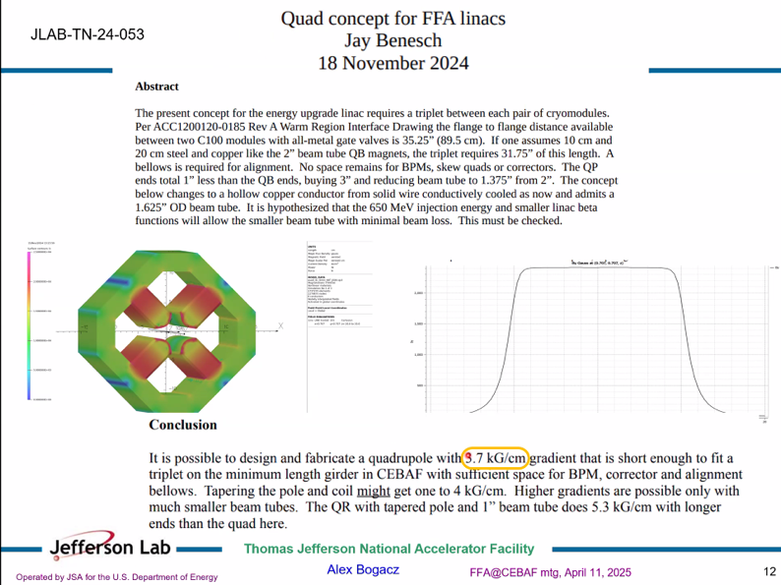
    - Pole tip is still very high
  - Alex – Nick gave a follow up with APS magnets
    - Yes – but far smaller aperture
  - Ryan – what about Tief’s shielded lattice?
    - Single/triplet supercell
    - Alex – don’t see benefit
    - Ryan – it gives us space
    - Alex – will still have the same problem – you’ll have a triplet. If you put triplets, you’re removing uniformity
    - Ryan – but gain control of higher passes
    - Alex – You’ll need stronger quads for the triplets
      - Ryan – perhaps, but you’ll get more space
    - It gives every other girder to put things
- Kirsten – aperture is 47.5 mm
- In the chat:
  - Kirsten is correct. APS
  - Q1 and Q2 quads have an aperture of 11 mm (dia. 22 mm) roughly a factor of two smaller than required for JLab linac vacuum chambers.
- APS quads can’t do that gradient
- Alex – not doing engineering design – need target values for betas
- Stephen – did you try unbalanced triplets?
  - Presently, we have alternating singlets
  - Started singlet, then triplets, then “twin cell” triplets to get betas under control
- Tief replaced every other girder with a triplet
  - Alex – my feeling about the singlet-triplet lattice might be worse – to get comparable betas, probably overload the strength of the triplets
    - Ryan – but they were placed at nodes of each other. Lower passes controlled by one set, higher another, but the triplet would be at a node for the other passes. Complicated
    - Alex – welcome to look. Triplets more robust, figure of merit would be betas
    - Ryan – no disagreement that triplets are more robust. They just take up too much space
      - One BPM might fit in the triplets without the permanent magnets.
      - Right now, we only correct every other girder in a plane anyway
- Dejan – also take into account the beam sizes are larger in lower energies – strong focusing at beginning – can only help wrt to emittance growth
  - Alex – passes 1-4 for current CEBAF, we have a tight envelope for pass 1
  - Spoke with Yves – thinking about adopting for 12 GeV
- Ryan – another point, brought up by Stephen last time, the radiation is too high for the PMs, especially near the C100s. High radiation zones. PMs won’t persist long
- Salim – Light sources reach 100 T/m with EM magnets – imagining lightsource – have radiation
  - Ryan – right, but it’s different. Those are rings, so they won’t have cavity field emission, etc… It’ll be SR
- Stephen – 100 T/m with a too small aperture for needs
  - Hard to beat Jay’s electromagnets in the conditions where you can put these
- Dejan – let’s go back to the optics
  - Ryan – we’re in the middle of discussing a legitimate concern
  - Alex – we’re just looking at concepts, not engineering
    - It’s not just engineering
  - Stephen - We can’t make it a concept if you can’t build the concepts you need
- Dejan – who decided on this aperture of 47.5 mm for a beam with a max mm beam size?
  - Ryan – sit in the control room, we lose beam all the time, it’s tight
  - Kirsten – Having larger diameter apertures where you are near the cryomodules is not uncommon for any machine. Had it in CBETA. There’s only so much vacuum transition you can deal with
    - Even if you neck it down, it take space
    - Even if perfect beam, this is a different concern
    - Dejan – please explain more
      - Look at the cryomodule cross section – have the beam pipe in the cavity – usually larger than the vacuum
      - Dejan – what vacuum? – Kirsten, the beam pipe
      - Dejan – the turbopumps are connected to the beam pipes
      - Kirsten – The pipe aperture next to cavities is often very large – larger than you’d like it to be in other locations.
  - Scott – right now, do you neck down?
    - Kirsten – not sure – can’t imagine we are necking up from the cavities
- Scott – guessing 60-70 mm iris size. May have a slightly larger beampipe outside, not sure
  - Kirsten – the beam pipe is 45.5 mm diameter between cryomodules
    - So necking down, but not a lot
    - It is what it is
- Dejan – I don’t get your argument about vacuum? so what are you saying about vacuum?
  - Kirsten – meant vacuum pipe diameter
    - There’s a spot with vacuum and a spot with cooling
  - Dejan – you have no arguments, you’re speaking nonsense
    - Vacuum is the same in the cavity pipe as it is near the quads. I don’t understand
    - Kirsten – I said vacuum, but I should have said vacuum pipe diameter
      - Regardless of what the decision was at the time, it is what it is
  - Dejan – it is really a very large aperture
    - Not necessary is what I’m saying. Should be 35 mm
- Scott – Let’s be a little careful. What happens when you neck down, you cut off the propagating modes from the cavities. You introduce wakes and HOMs. Might not like that.
  - Dejan – usually they damp the modes
  - Scott – depends how they do it – don’t know to what extent they are catching the propagating modes.
    - Typically only have it on one side
  - Dejan – would be very good if Alex or someone could bring to the next meeting to describe the cryomodules, HOMs, etc… why 45.5 mm? etc…
- Alex – will ask Roger Ruber
  - Lots changing over the next two years – there is a program of refurbishment. Some old beam pipes/flanges will be replaced – good question – we may even have more room in places
    - Ryan – they’ve actually taken up more space with pumps, etc…
- Dejan – my feeling is that the moment you go from 45 to 35 mm, things get easier
- Alex – Nick brought an interesting idea – if you build the LINAC with all C100s, can shrink the LINACs and reduce length by 2
- Dejan – before review, maybe next week, hear experts?
  - Next Friday goes into Easter
- Reza – suspect decision for aperture was to make the radius of curvature large b/c don’t want to have small radius in SRF cavity
  - Length of cavity fixed
  - Make the ratio different between larger/smaller, you have to change the curvature
- Alex – Big picture. 12 GeV upgrade was 10+ years, so looking forward, may have different hardware and modifications – can maybe tailor.
  - Think outside the box, not be overly constrained
- Ryan – Just to be a raincloud, curious – when we started, it was supposed to be a minimally invasive upgrade, but it’s been snowballing. It used to be a cheap, manageable upgrade, to a big upgrade. Are there other more cost-effective means?
- Alex – there will be a LINAC refurbishment with more high gradient C100s – there’s an independent effort we need to keep track of
  - Opportunity, things will change
- Alex – strongly focusing if we go for 110 degrees, can still do periodic twin cells, gradient goes down by 20% and still get the outcome
  - Get things quantitatively
- Dejan – want to ask those running the machine – how do you correct the orbits through the linacs?
  - Ryan – tune mode. Differentiate passes – you steer the lowest energy toward the highest. Adjust initial conditions, massage it down so the lowest E goes toward highest E.
  - BPMs have about half a mm on the screen
  - Dejan – basically correcting mostly at the lowest pass
  - Ryan – rigidity – in tune mode anyway. Mostly needed for threading through
  - Dejan – CBETA – able to correct orbit around but not in the linac itself. Had a separate entrance
    - Linac is like a parabolic function. I like Alex’s solution. I like this more, it’s more controlled
- Ryan – invite Tief to give an update on the shielded lattice
- Alex – Ryan can go through Tief’s idea
  - Ryan – If I had the time, I would. I absolutely do not have the time to do that
  - Alex – you think it’s better, so you can try
  - Ryan – I never said I think it’s better, I said I think it’s more practical and allows us to keep elements in the beamline
  - Alex – it comes down to what’s the gradient and what’s the payoff in terms of beta functions. If you can get the table here, we can compare.
  - Ryan – and I said I don’t have time to do this. Someone else is welcome to, or we can have Tief come give a description, but I don’t have cycles to do that work.
  - Dejan – I worked very hard to understand the properties of the linac. My lowest Beta was higher than whatever Alex is doing. It’s very preferable to matching the linac to the 3 m beta of the FFA
  - Ryan – I’m not arguing that it’s not nice optically. I’m arguing that it’s nice optically, but that the practical side is not. That is my concern.
  - Dejan – We don’t know that, let’s see what the experts have to say about that.
  - Alex – let’s not jump to conclusions.
  - Ryan – I just know how long dipoles are, how long correctors are, and how long BPMs are, and I know we don’t have space with the extended magnets. That is what I know. I walk the tunnel every other week, see it firsthand, touch it, space is a real concern. It must be a constraint we add to the design, as conceptual as you want to make them, we still need some level of practicality.
  - Alex – we have to be clever about that
- Alex – again, this is the example of the 110. If we can bring it lower we can try. This is the idea/concept that actually works.
- Ryan – what about making the weakly focusing lattice stronger. We had a weakly focusing lattice that did the same thing, but was too weak. What about adjusting that one.j
  - Alex – the betas were too large – it wasn’t the same thing
  - Ryan – but it’s alternating triplets.
  - Alex – it was unacceptable, we started with weakly
  - Ryan – we started with strong, then weak, then went back to strong. Weak was alternating triplets as well, maybe make them stronger.
  - Alex – you are welcome to pursue
  - Ryan – again, my cycles are pretty limited – find someone else to explore
  - Alex – if we looked at this and removed the triplet and put a singlet – that would be a weaker focusing solution
  - Ryan – it might be
  - Alex – you’d have to do something about it. You’d need to increase the quad strength to compliment the singlet. Going in the wrong direction. This is handwaving
  - Ryan – I think you should invite Tief as the expert to present that lattice
  - Alex – you’ve described it. It won’t tell you anything different, and it’s limited
    - Wasn’t worth the hassle
    - Ryan – they didn’t need that level of strong focusing for 12 GeV was the reason.
  - Alex – the phase advance, perhaps we can lower it a little bit, but we have a process and a way of designing
    - But it won’t work
- Dejan – We’ve been working on Muon collider lattices with RLA – going on for 25 years. This experience with linac lattice design should not be neglected
  - What Alex is doing is something that comes out from experience of 20 years. All these comments about focusing – we know what we are talking about.
- Argument breaks out here.
- Apologies made here.
- Meeting end.
Action Items | Person responsible | Deadline

Time allotted | 10 mins | Agenda topic JLAAC | Presenter Donish
- N/A
Action Items | Person responsible | Deadline

Time allotted | 10 mins | Agenda topic AOB | Presenter All
- N/A
Action Items | Person responsible | Deadline

Special notes

Pathway to Repository: https://jeffersonlab-my.sharepoint.com/:f:/g/personal/tristan_jlab_org/EqZ5MeS-nipCgPfZB5p0oS4B9Is67d3nQb9sLJI3Zyev9g

