FFA@CEBAF Working Group|Minutes

## Meeting date | time 05/02/2025 | 11 AM EST | Meeting location <https://jlab-org.zoomgov.com/j/1614898082?pwd=TnUzMS81M2sxbDZIbERJU01tYkJCQT09>

|  |  |  |  |  |  |  |  |  |  |  |  |
| --- | --- | --- | --- | --- | --- | --- | --- | --- | --- | --- | --- |
| |  |  | | --- | --- | | Meeting called by | Alex B | | Type of meeting | Weekly Meeting | | Facilitator | Alex B | | Note taker | Ryan | | Timekeeper | Alex B | | Attendees  Alex B, Ryan, Randika, Vasiliy, Nick, Dejan, Salim, Volker, Reza, Scott, Edith, Stephen, Kirsten, Tim, Donish, Andrei |

# Intro Discussion

* JLAAC talk
  + Table

    AI-generated content may be incorrect.
    - Values from Frascati
  + New recommendation: CSR effects
    - Two topics for PhDs
    - Spoke to Rui, she did initial calculations.
      * Concluded it’s negligible based on Vlasov equation/analysis
      * Threshold was so high that it’s not feasible
      * No microbunching b/c low gain
      * Such small dispersion in our Arcs
      * Tech note in prep
      * Stephen – for FFA arc, or splitters as well?
        + Just FFAs

# Agenda topics

## Time allotted | 25 mins | Agenda topic Transition | Presenter Randika/Vasiliy

* Vasiliy first:
* A picture containing chart

  AI-generated content may be incorrect.
  + Randy/Vasiliy tried in parallel
  + Hard to control orbit and dispersion when exciting betas, especially at the lowest pass
* In the past, looked at long straight sections. But what if consider short straight?
  + Space is limited – maybe look into doing things logically in two steps
    - First orbits/dispersion, then excite betas
* Magnet apertures can be less b/c no dispersion
  + Can get shorter magnets with higher fields
* Chart

  AI-generated content may be incorrect.
  + Another issue with the straight section
  + Exciting resonances in both planes. Fundamental issue for FODO, most natural place to excite betas at maxima
    - But the other plane focuses there.
    - Exciting in the focal plane is much harder. Need stronger resonance quads
      * Go through multiple focal points, chromaticity
    - Resonance quads so strong, the couple to other passes
  + Can look into doublets instead of FODO, or triplets
  + Perhaps can make the focusing/defocusing quads have the phase advance equal in both planes?
    - Single set of quads for both planes?
  + What about exciting betas in one plane – can we then couple them to the other plane?
* Chart

  AI-generated content may be incorrect.
  + Thought it would be easy to excite, but realized that when matching that each parametric resonance is introduced by parametric quads, with strengths varying according to sine wave
  + To first order, the amplitude is related to size, and the phase is the slope of the beta
  + Fix the amplitude of the resonance quads and tune the phase to get alpha = 0 at end.
  + This is sensitive to initial guess of resonance phase
  + Might be smarter to use GA
  + Bottom is what happens when applying procedure to two highest passes
    - Pick initial guesses for resonance phases by hand
    - Able to excite both of the last passes, but they are also clearly talking to each other and the 4th pass
    - Initial conditions are difficult
* Matching section so short, it’s hard to avoid resonant crosstalk
* Needs futher work
* Dejan – on the left side, these are the triplets, right?
  + No, these are FODO
  + Dejan – but they cannot be triplets if they’re from the arc
    - Was using triplets to get into the linacs
  + Vasiliy – can think of triplet as a FODO in some ways
    - Can adiabatically turn FODO into triplet
    - Goal to increase space between triplets
* Ryan – that’s 30 m – can you make it shorter?
  + Can try less cells
* Alex – in principle this works in both planes
  + Vasiliy – we’ve demonstrated the concept in the past, but implementing it here is hard
* Vasiliy – a way to use coupling to make X and Y work together
* Dejan – can you show these in normalized phase space, so we can see the kicks?
  + Phase would be exactly the angle between the positions
  + Vasiliy – that would be helpful
* Kirsten – if it’s the optimization function – possible to run in pyTao
  + Vasiliy – yes, doing that
  + Stephen – lm, lmdif, etc…
  + Vasiliy – can an external optimizer. Stated with DE, then find more precise using LM
  + Ryan – I’ll often start with SVD (fails a lot), then DE for broad, then LM/LMDIF and mix between.
* Stephen – how many cells need to make this go? Might give an idea of how far away from making it possible
* Vasiliy – number of parametric resonance quads – one on each cell. Is that optimum?
  + Stephen – can change drift and magnet lengths instead of strengths
    - Useful if going from FODO to triplets for doublets
* Amplitudes could be tweaked
* Stephen – want something to give different phases on different beams. Thought length changes could be more useful. Can slice lengths of magnets
* Ryan – once installed, wouldn’t be able to adjust magnet lengths, but could put magnets on movers to adjust drifts if needed
* Randy presents:
  + Turns out, the thing thought he had didn’t work. It’s running this moment
  + Can show code, but that’s it
* Alex – can you narrate?
  + Doing exactly what Vasiliy is doing, but focusing on Beta_X
* Vasiliy – Beta_X is harder
* Chart

  AI-generated content may be incorrect.
  + Running now. Currently on Pass 2. Pass 1 was close
  + Not trying to do anything on the right hand side
  + Vasiliy showed two slides – also sees this beating. Tried Beta_Y in hope that a different lattice or coupling could helps
* Randy – can try both together, and use horizontal and vertical
* Vasiliy – tried similar, but too much cross-plane crosstalk. As you add more passes, it gets worse
* Vasiliy – what do you all think? Coupling? Different lattice?
* Ryan – can you couple and then uncouple before the linac?
  + Vasiliy – interesting. If it’s round, coupling in the linac doesn’t matter
  + Alex – we have skew quads in the linacs
  + Ryan – I think if it’s linear coupling, it’ll probably be ok
* Dejan – might matter what is in the splitters
  + Kirsten – do you mean the spreaders or the splitters? Spreaders are the vertical. Transition is before the recombiner
  + Dejan – make somehow adiabatic arrays of the betas, then combine with the separate energy splitter lines
    - Means the area nearby the transition?
    - Raise the betas
* Dejan – our problem is – in the splitter the high difference. The dispersion value is on the order of the height difference. Let’s say 2 m
  + Smaller the better emittance growth
  + Best solution for transfer line is to have something like FFAs where dispersion is small
  + Don’t have enough room for those
* In the new transfer line you’re proposing, apply this rule right there. If dispersion is small, what Kirsten is showing to us, that is the main reason for the emittance problems
* Alex – one of the terms Donish is doing is to keep an eye on curly-H
* Way to reduce dispersion is with multiple steps – but don’t have room.
* Closing discussion about transition – looks like Vasiliy and Randy are doing interesting optimizations. We’ll hear from Randy when the time is right
* Vasiliy – wish we could show good results, but it’s hard. We’ve tried

|  |  |  |
| --- | --- | --- |
| Action Items | Person responsible | Deadline |
|  |  |  |
|  |  |  |

## Time allotted | 25 mins | Agenda topic RF | Presenter Roger

* Alex – had asked Roger to present here, but he’s been wrapped up in JLAAC/reviews

|  |  |  |
| --- | --- | --- |
| Action Items | Person responsible | Deadline |
|  |  |  |
|  |  |  |

## Time allotted | 10 mins | Agenda topic AOB | Presenter All

* Dejan – preview for next time.
* Chart, line chart

  AI-generated content may be incorrect.
  + FODO with double interrupting in the middle
  + Isochronous
  + R56=0
  + Red curve is horizontal beta, green is vertical
  + Made fixed tunes from 9.4 – 22.6 GeV
  + Found out that the path length is behaving very well for the first 10 energies
  + Alex – isochronous for this energy – checking on others?
* Dejan – at the top energy:
  + 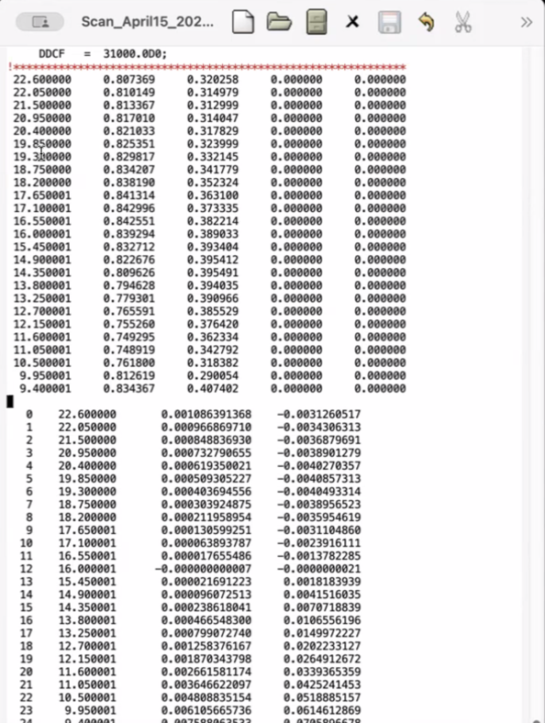
  + Top energy max orbit offset is 1 mm, 0.9 mm, etc…
  + At 16 GeV (central energy) – 0 offset
  + 7 mm offset at 9.4 GeV
  + Table

    AI-generated content may be incorrect.
    - Path length – 18 cm path length difference at lowest
  + Not really isochronous, but improving well
  + With Stephen’s matching program – will provide this. Can improve
  + Using multipoles up to dodecapole – not something that Stephen can build
  + A picture containing text, receipt, screenshot

    AI-generated content may be incorrect.
    - D3 is in the middle of everything
    - Did these values by hand
* Good feeling about proposal b/c results have now are good
* Having problems with Bmad not reproducing non-central energies
  + Scott – at this level, showing same models.
    - You’re doing something in PTC, then something different in Bmad, limited control in re-doing in Bmad.
    - Try reverse. Look at Bmad with end-fields, then implement into PTC
    - Can’t always go PTC > Bmad, but can always go the other way
    - Issue is that you’re using a slightly different model. Using the same number of step sizes, end models, etc… all matter. If you’re finding that the different models are really making a difference (not just small), that’s a red-flag. Maybe it’s not the greatest design on the planet b/c relying too much on end-fields.
    - Dejan – this lattice has enough variables to confirm path length, etc… - I think the concept is good, except you have to get the variables in the best possible way.
    - Scott – avoid creating a design where it’s too sensitive to small magnet details.
    - Kirsten – I would agree that more sensitive lattices aren’t desirable. Thinking this might also be a difference in treatment.

|  |  |  |
| --- | --- | --- |
| Action Items | Person responsible | Deadline |
|  |  |  |
|  |  |  |

## Special notes

Pathway to Repository: <https://jeffersonlab-my.sharepoint.com/:f:/g/personal/tristan_jlab_org/EqZ5MeS-nipCgPfZB5p0oS4B9Is67d3nQb9sLJI3Zyev9g>