FFA@CEBAF Working Group|Minutes

Meeting date | time 05/09/2025 | 11 AM EST | Meeting location https://jlab-org.zoomgov.com/j/1614898082?pwd=TnUzMS81M2sxbDZIbERJU01tYkJCQT09
Meeting called by Alex B  Type of meeting Weekly Meeting  Facilitator Alex B  Note taker Ryan  Timekeeper Alex B | Attendees  Alex B, Ryan, Volker, Roger, Dejan, Stephen, Reza, Donish, Andrei, Salim, Kirsten, Tim, Vasiliy

Intro Discussion
- Might be upgrading dumps for 22 GeV
- BBU study might be needed.

Agenda topics

Time allotted | 25 mins | Agenda topic (S)RF History | Presenter Roger
- 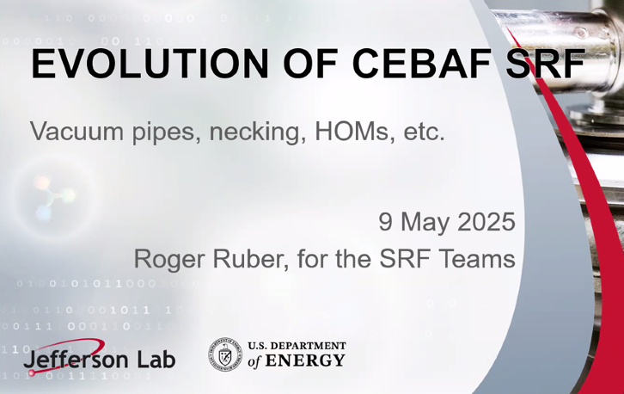
- Haven’t run through colleagues yet
- 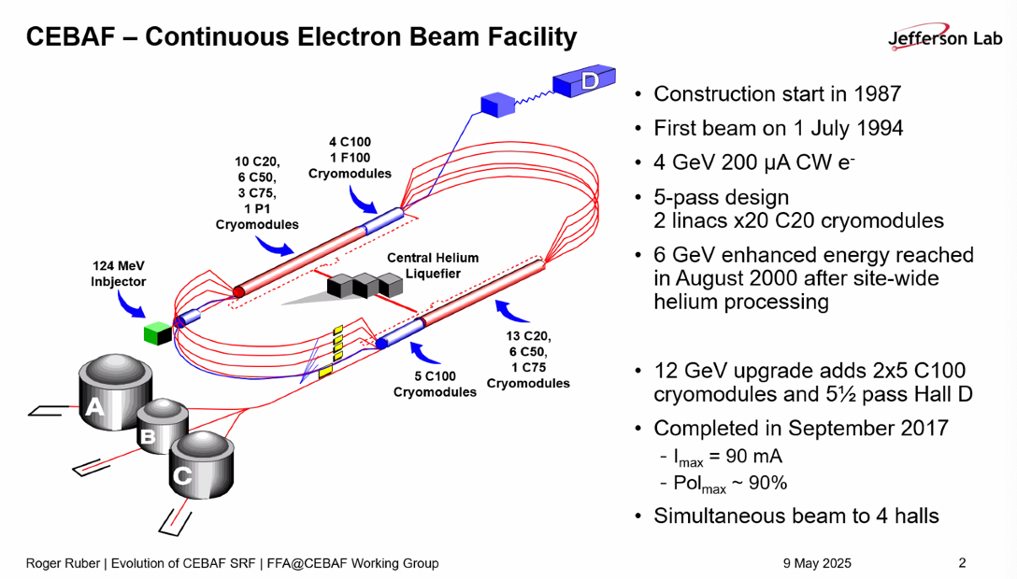
  - Red was originally for 4 GeV, blue was added for upgrade
  - Not all cryomodules are identical – see how they’re split in the image below
  - 6 different types in the machine total
- 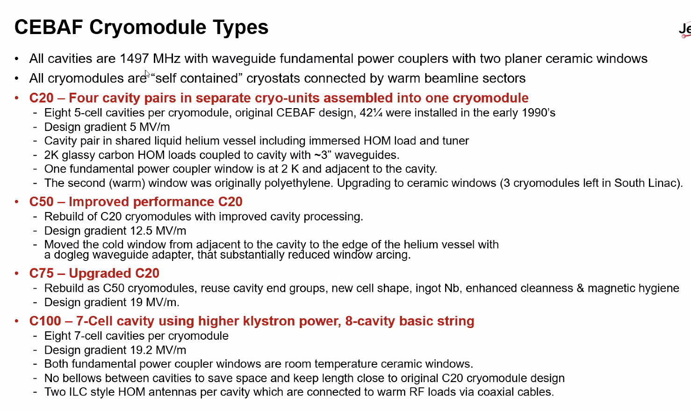
- 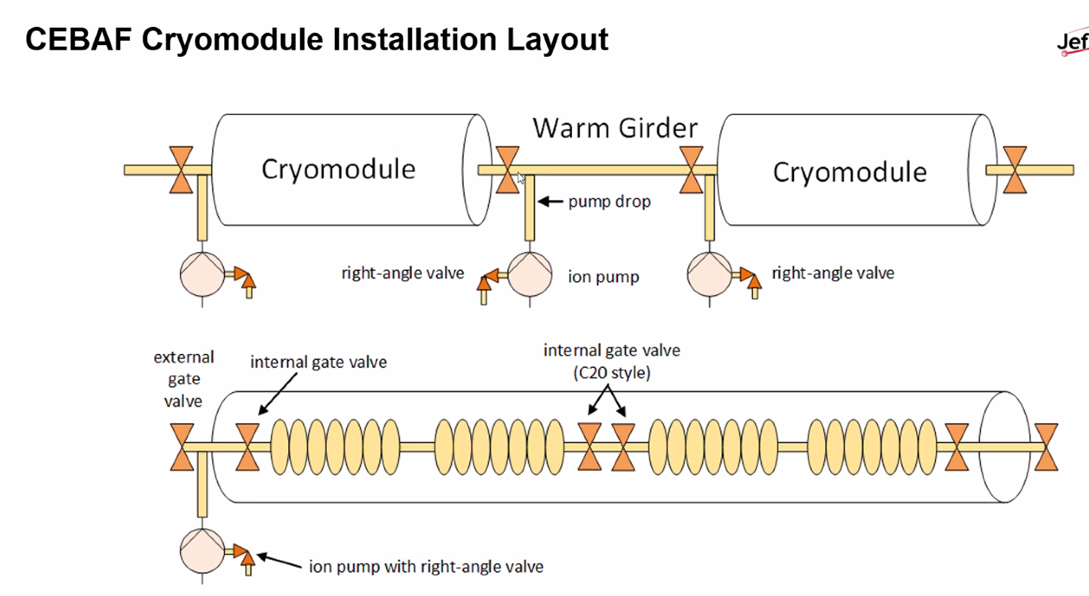
  - Two vacuum pumps
  - Internally, series of gate valves
  - Externally, additional pump
  - C100s don’t have gate valves between pairs, but keep them at the end of the string of cavities
  - Dejan – internal valve cold?
    - Yes, not immersed in helium, but it’s cold
    - In C20s, they are elastomer
  - Dejan – warm to cold?
    - Only at the ends of the cryomodule.
    - Cold in middle
  - C20 are elastomer
  - In C100, all metal valve on end
    - Changing elastomer to all metal on ends
    - Reza – due to radiation?
      - Yes. Elastomer seal close to valve, and they get destroyed due to radiation
- 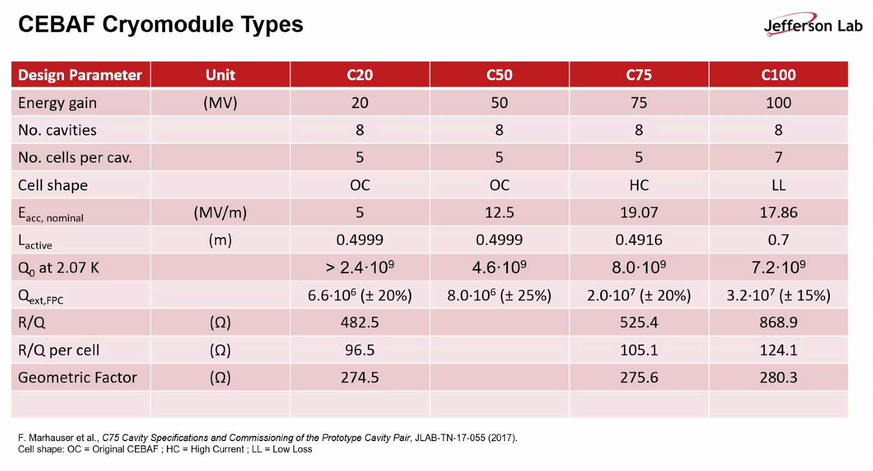
  - Q0 differences due to enhanced processing for C50s over C20s
- 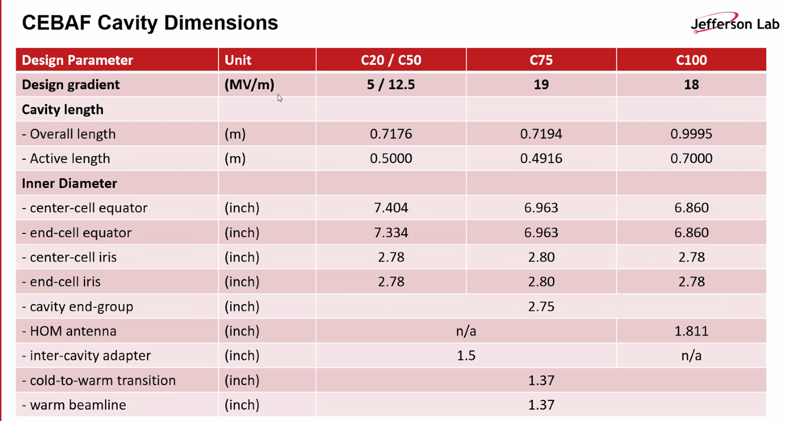
  - Should say cryomodule
  - Active lengths change for types of cryomodules
  - Cavity end groups have a diameter of ¾ of inch
  - Warm beamline has diameter of 1.37 inches
    - Likely what lead to some confusion
    - Cavity and warm beamline have different diameters
  - Internally in the cryomodule, between the two cavities in the C20s, there is an adapter
    - Called inter-cavity adapter – 1.5 inch diameter
    - Means we have impedance steps instide the cryomodules
- 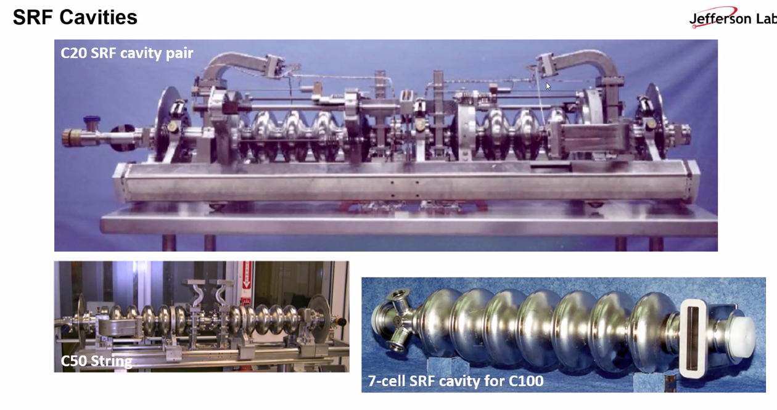
  - Waveguides are for HOM damping
  - C50 window at top
  - C100 has 7 cells – HOMs are now antenna instead of waveguides
    - Input still waveguide
- Reza – curvature of inner aperture in the cavities – why some are smaller aperture vs larger? Due to fact that the higher voltage would spark at smaller curvature? Could you tell us what determines the inner size of the cavities?
  - Roger:
  - 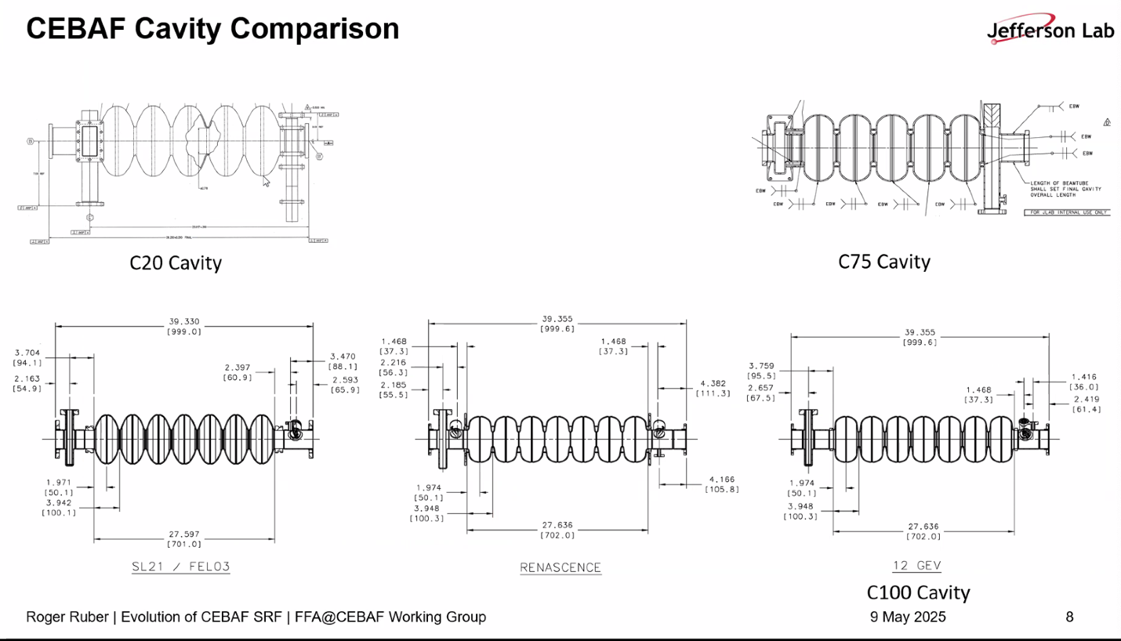
    - Equator linked to fundamental frequency
    - Length of cell linked to beta of particles (1 for electrons)
    - Iris diameter is linked to the coupling between the cells (How easily RF energy transported between cells)
      - Also linked to HOMs
      - Diameter of intended beam
      - Maybe a beam dynamics person should correct this
    - Originally, this design was made for protons at Cornell – not optimized for e-beam at CEBAF
- Reza – I mean the inner curvature
  - Linked to electric fields/Gradient you can achieve
    - Linked to EM design and voltage that is achievable
    - Linked to losses – it’s superconducting. Higher frequency, higher the losses
- Ryan – is this why some places switched to 1300 MHz instead of 1500?
  - Yes – depends on RF source.
  - Often decided by what’s available for military radar applications
    - Why we can’t change now – whole machine is based on fundamental frequency
- Looking above, the Cell Shapes change
  - LL is low loss, HC is high current
  - FEL on bottom left
  - To save cost, the support rings were removed from Ren* to C100
    - Now we have microphonics problems
  - C20s have less of that problem b/c cavity shape
  - C75 similar shape, but include the support rings
- 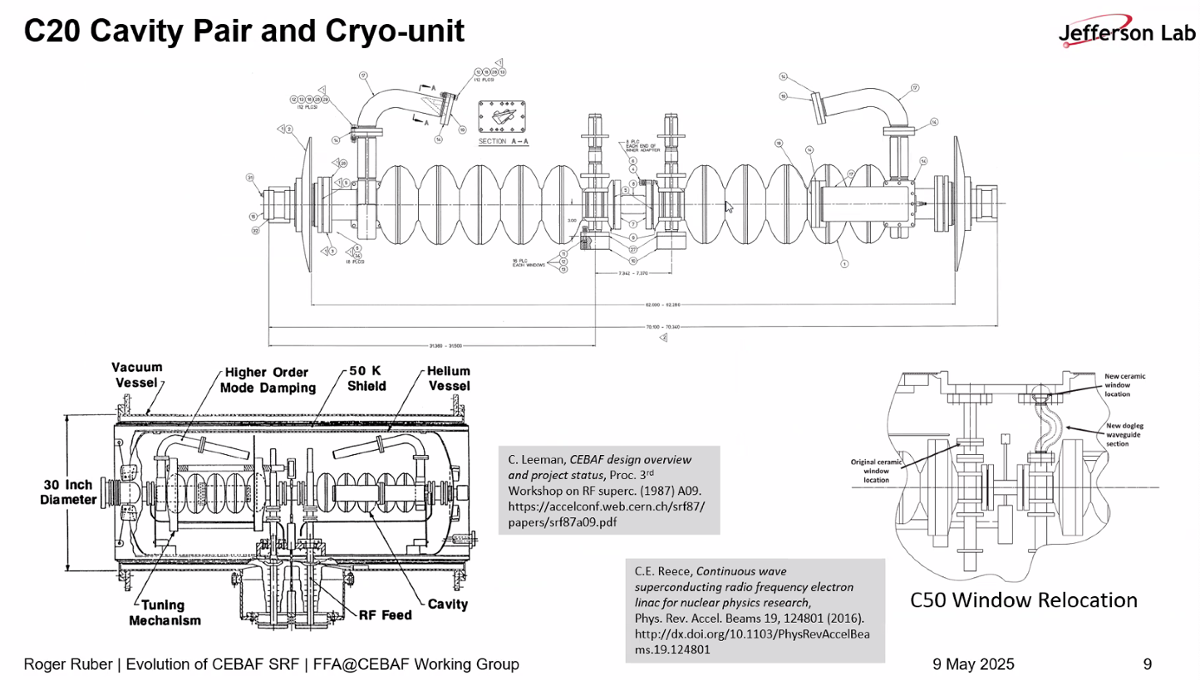
  - Diameter of beam tube smaller in middle
  - Bottom left is inside cryounit - ~200 L of He
  - Tuner inside of vessel
  - Bottom right – change to C50 from C20
    - Replaced with dogleg and window – no direct line of site to beamline, reduced electric loading of window and arcing
  - Dejan – what’s the diameter for the pipe in the middle?
    - 1.5 inch
    - The warm beampipe is mostly 1.3 inches
- 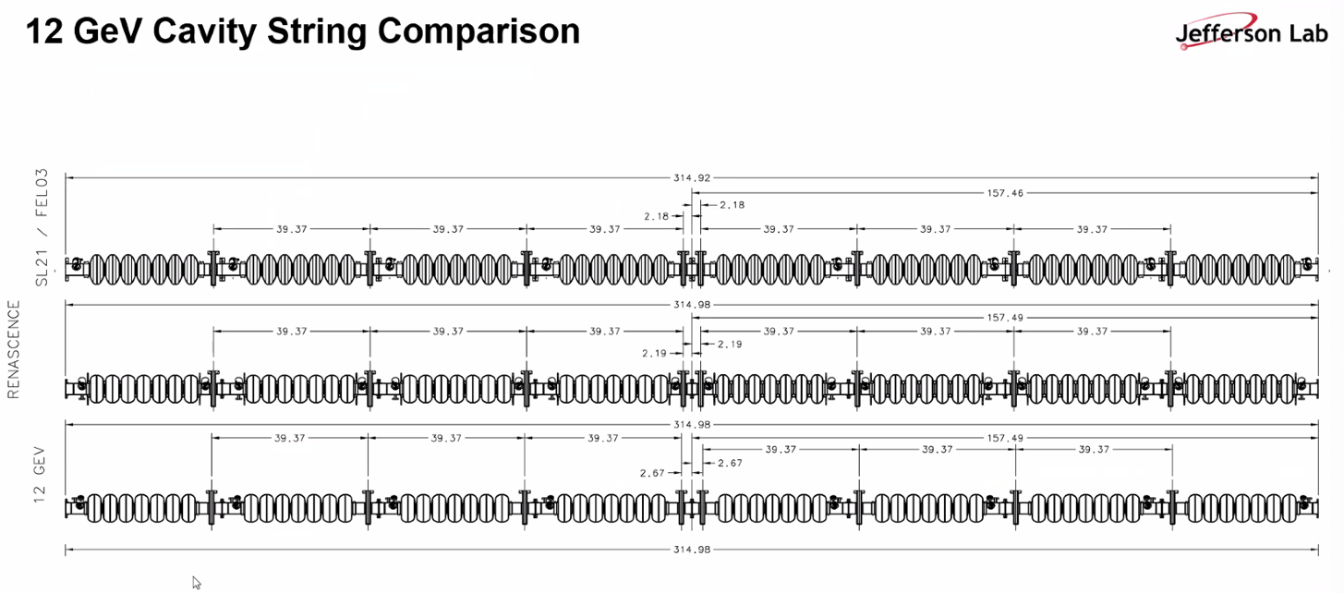
  - Both C20 and C100s have 8
    - Different numbers of cells
    - Inner adapter removed from C100
    - No bellows around cavities in C100s
      - Don’t have support rings
      - Microphonics problems – all the other cavities ring as well
      - The whole chain acts as a bellows
- 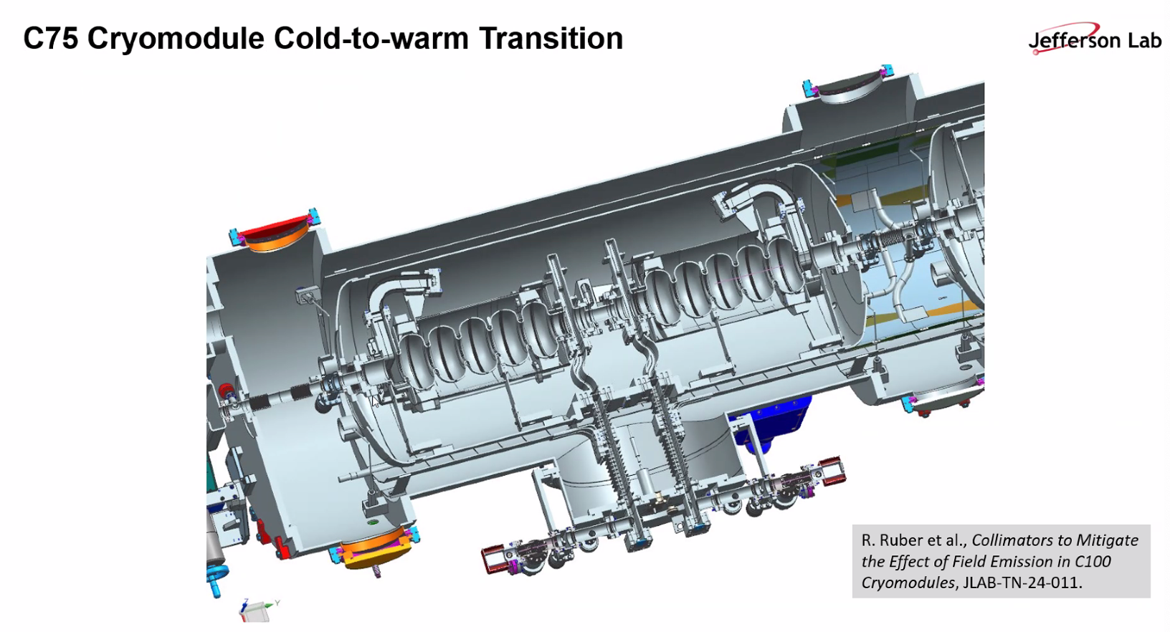
  - Cold to warm – 1.37 inch to cavity diameter
  - Bellows and valves between cavity pairs
  - Input couplers at the bottom
  - Reza – this has same gradient of C100
    - C75 has 8 cavities with 5 cells, C100 has 8 cavities with 7 cells
- 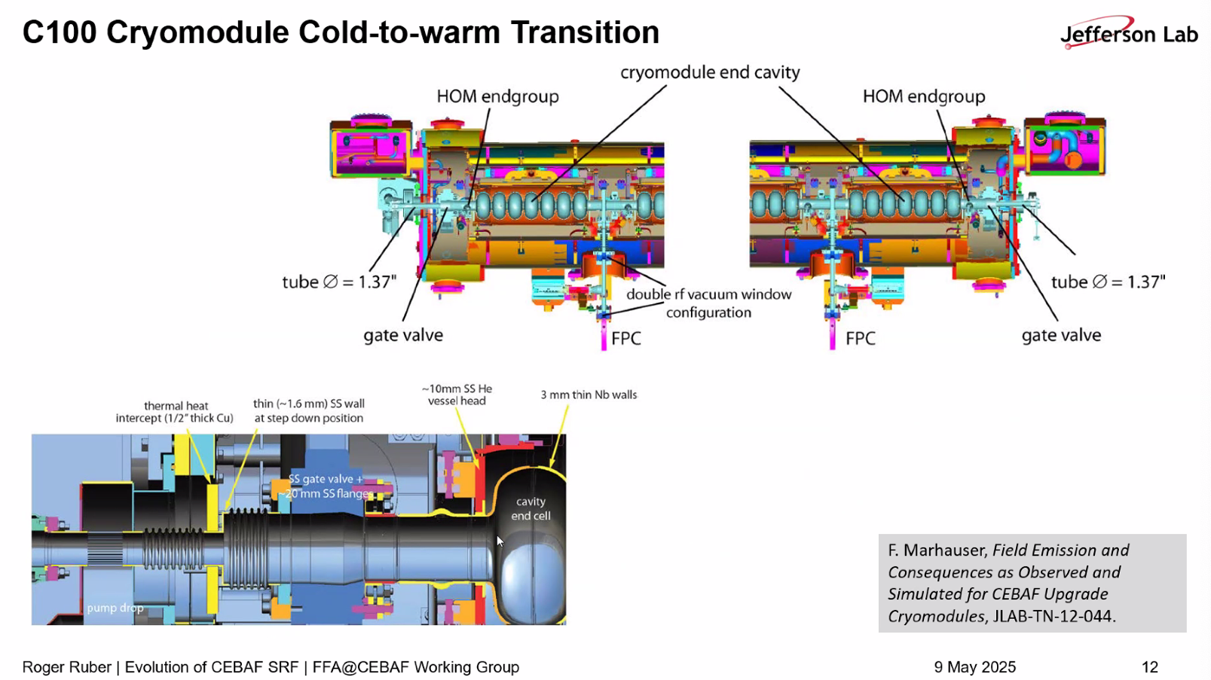
  - Beam pipe steps down to 1.37 inch diameter at end
    - Gives impedance
    - Warm gate valve outside, internal cold inside the cryomodule
- Ryan – The beampipes in the dipoles are flat (I think 3”x0.5”), and doglegs are very fat, but in the linacs it’s all about the same
- Dejan – I feel like we can’t put anything smaller than 1.37” beam pipe.
  - Roger – cavity is 2.75 iris
  - The limit is 1.37”
  - Dejan – right. We should not go smaller than 1.37”
    - This is very important. We should be very cautious not to reduce that. That’s the end of the cryostat pipe size
- 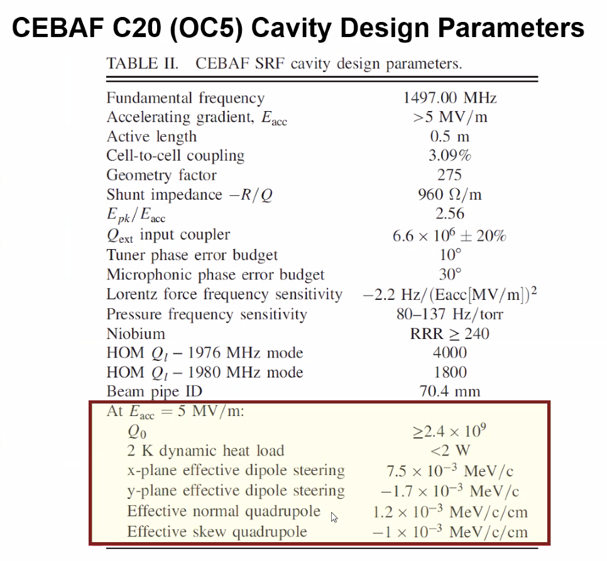
  - Must note that there are optical parameters as well
- 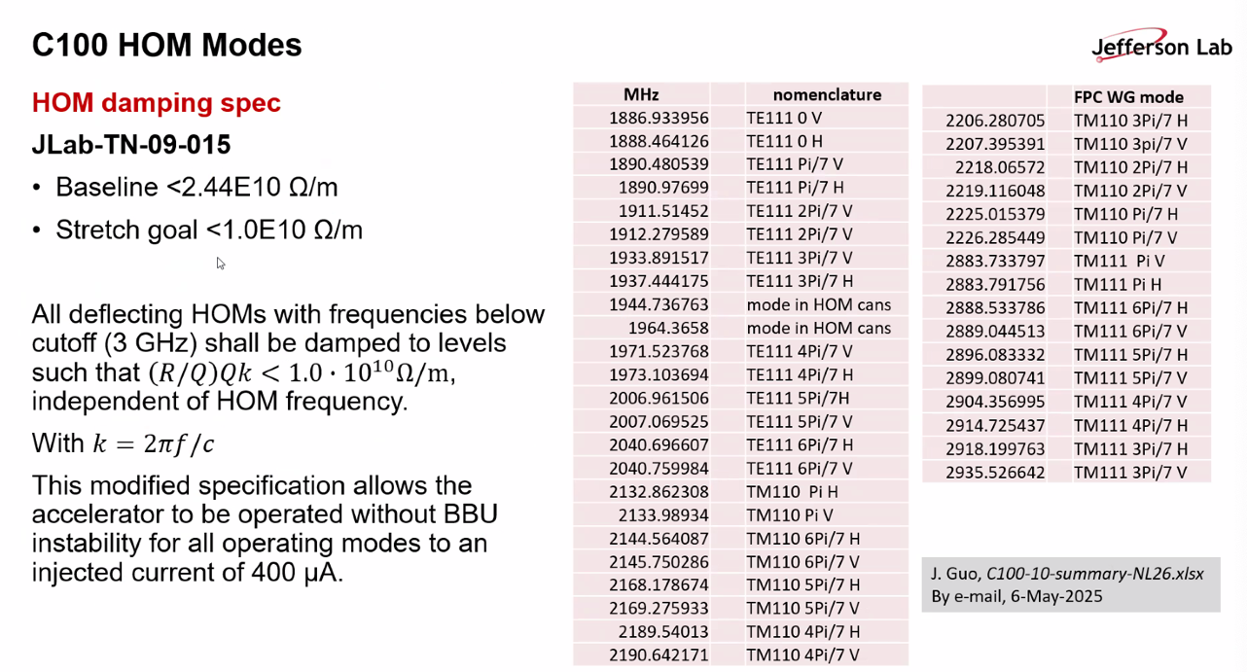
  - More details in the tech note, or get hold of J. Guo
- Alex – going back to parameters – there’s also a skew quad component coming from couplers
  - Roger – this is listed here.
- Dejan – do you put that in the code when you calculate things?
  - Alex – every girder has a dedicated skew quad to compensate
    - They were measured in an older PhD
    - They’re compensated, so we sort of ignore them
- Roger – there’s something similar on C100s – but can’t recall exactly
- Reza – design was improved so there’s much less skew quad
  - Roger – no HOM waveguides, it uses antennae
  - Reza – some of skew and kicks cancel as well
  - Roger – right, they’re essentially mirrored to perhaps cancel
- Dejan – you probably have some dampers for HOMs
  - Roger – yes, HOM dampers. C100s has antennas to damp HOMs
- Alex – can we put this in the presentations folder
- Andrei – trying to figure out, what is the difference between C100 and LCLS cryomodules for SLAC?
  - Length, 200 MeV, etc…
  - Which factor(s) contributed most to improvements
  - Roger – it’s 8, 9-cell cavities
  - And longer?
  - Ryan – 1300 MHz
- Dejan – for microphonics – without supports in the middle, how do you deal with it? What are the hardest frequencies?
  - Roger – related to 60 Hz of electric equipment, plus the multiples
    - Any equipment in the surrounding impacts things
    - Tried to mitigate with damping environmental frequencies
- Ryan – remember the sandbags on top of the C100s? That was for this. Also Kevin Jordan’s BNNT dampers are being applied
  - Roger – yes, there are other efforts as well
- Dejan – the outside influences are clear. Piezoelectric dampers can be used
  - Roger – yes, on tuners
    - Tom Powers knows all these calculations, etc…
Action Items | Person responsible | Deadline

Time allotted | 25 mins | Agenda topic FMC Lattice | Presenter Dejan/Stephen
- 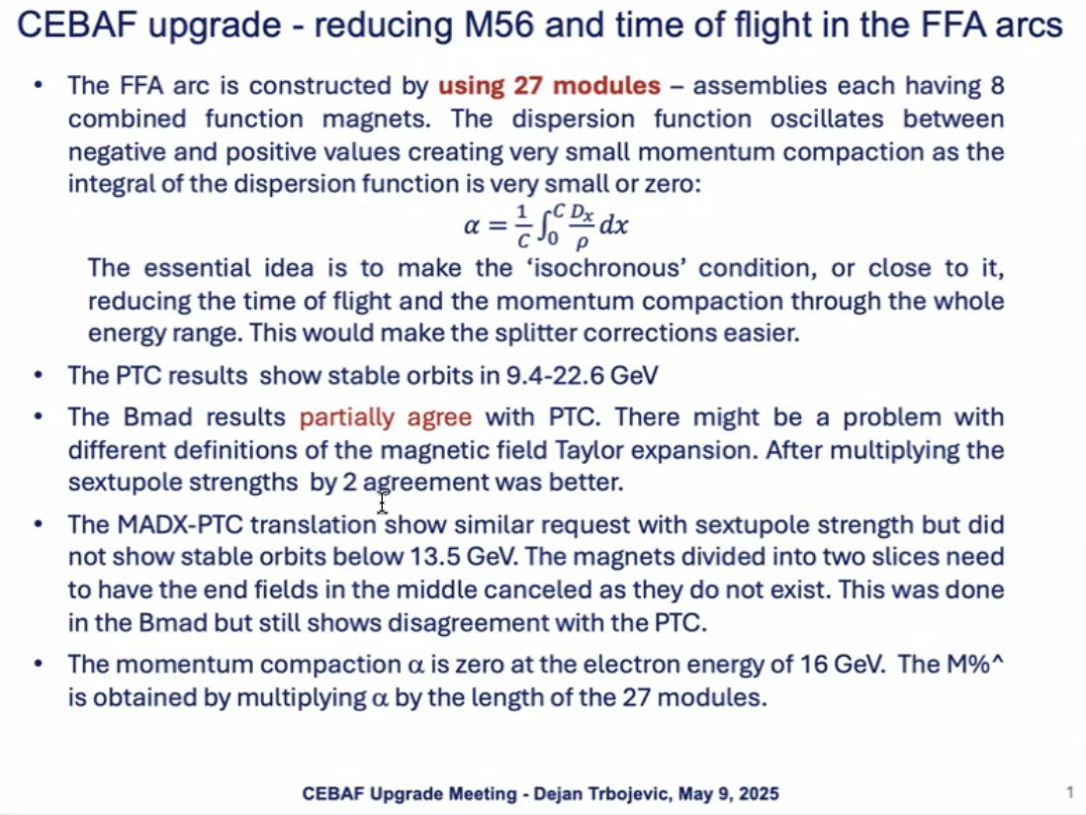
  - Didn’t get results wanted yet
  - If you can reduce the R56 and ToF it reduces stress on splitters
  - PTC shows stable orbits from 9.4 – 22.6 GeV
  - Bmad partially agree – might have problems with Taylor expansions
    - Scott helped with this. Thought it was end fields, but didn’t help
    - Multiplied sextupoles by 2, that helped significantly, not perfect
    - Had to do that in MadX as well
- 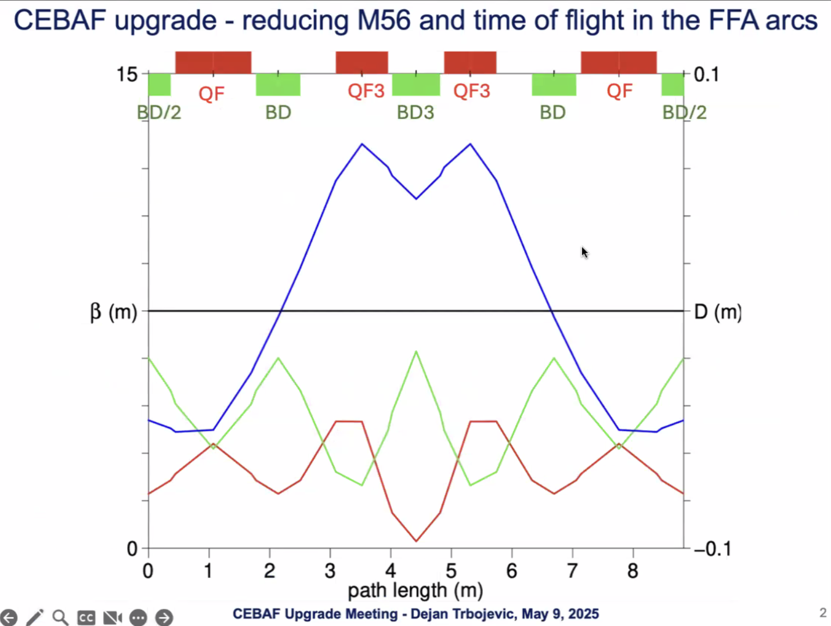
  - FODO cell on the left
  - Switch dispersion by using a stronger quad to flip the phase of dispersion (different length magnets WRT FODO)
    - Length of central magnets is a variable, drift lengths is variable, each magnet has higher-order multipoles
    - MadX doesn’t allow more than octopoles
- 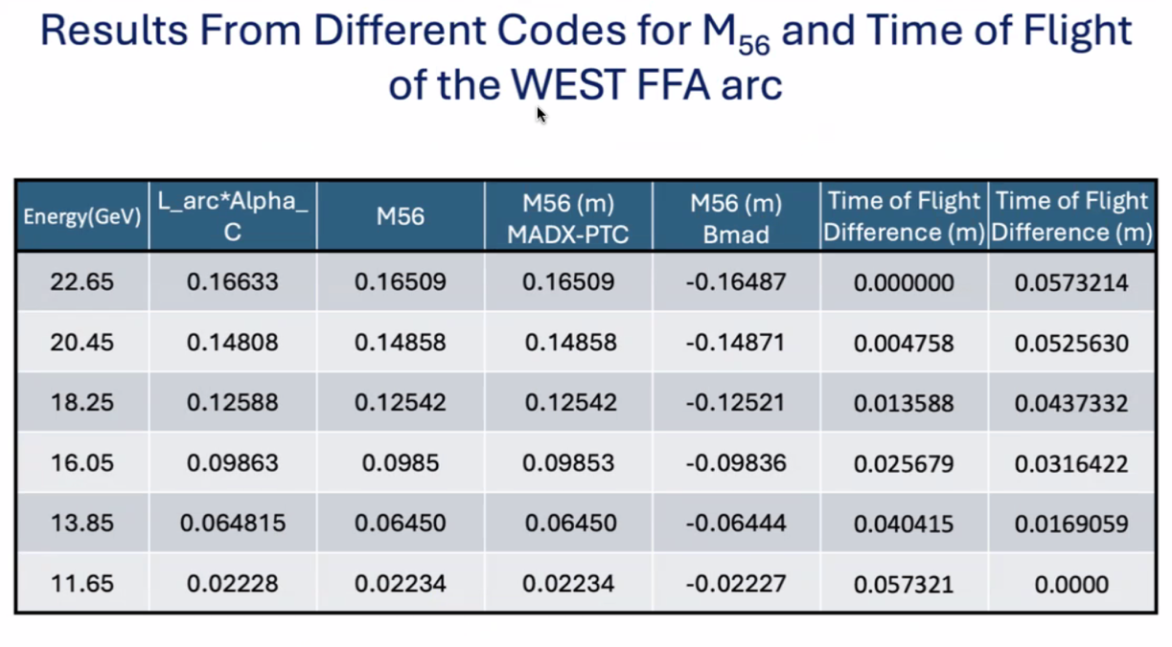
  - Problems b/c R56 was pretty large in highest E, ToF was pretty large too
- 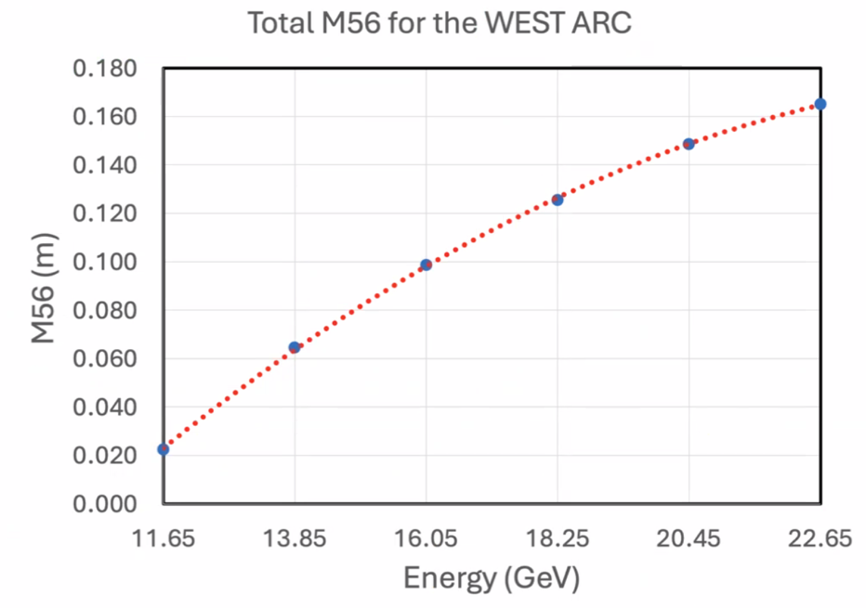
- 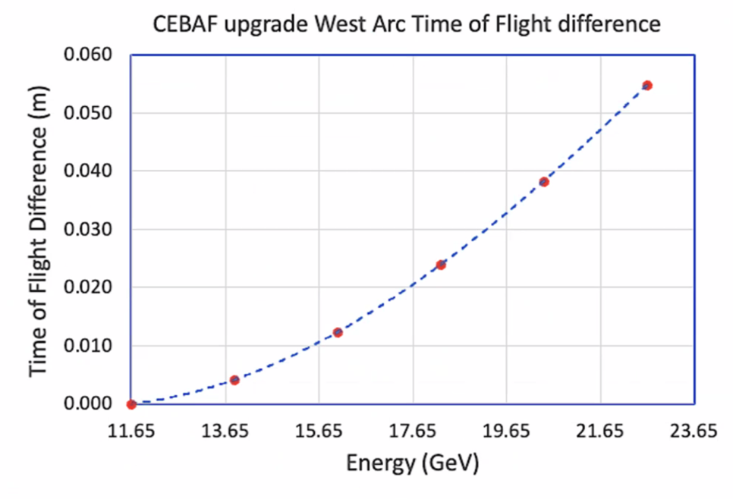
  - From 2023
- 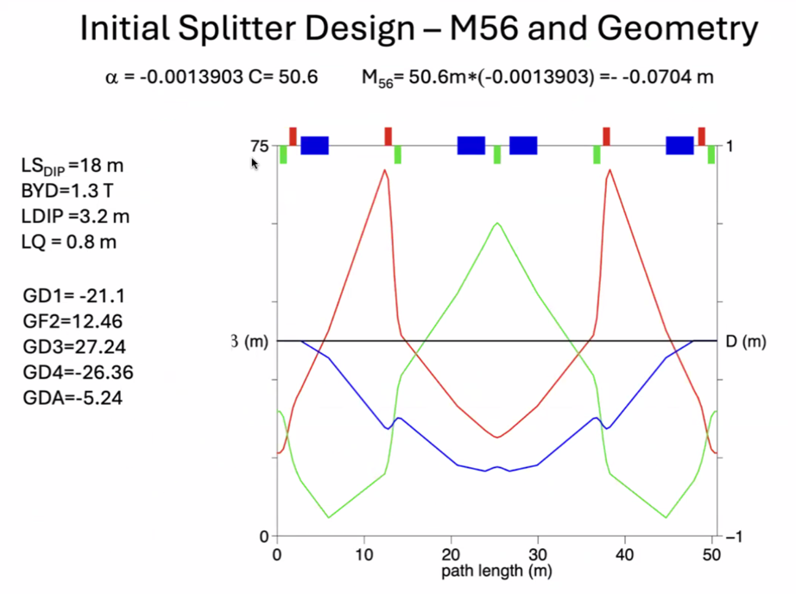
  - Old (2023) Splitter idea
- 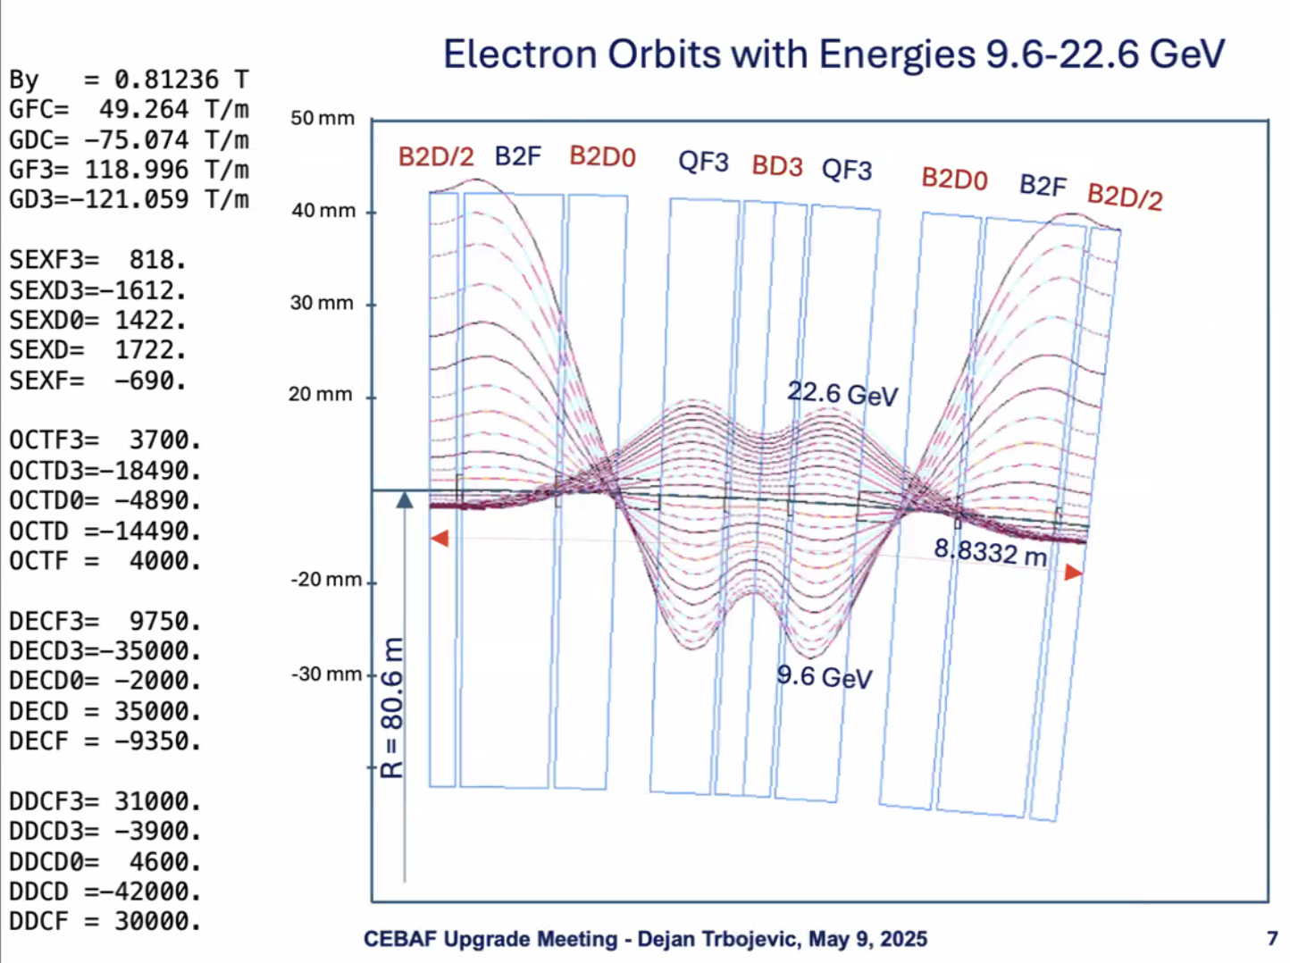
  - These are the electron paths in the cell
  - Starts with negative value, oscillates around, makes the mom. Comp. small
  - As you go to lowest to highest E, orbits oscillate more.
  - Did by hand to see where to get stable orbits
  - Didn’t get all the energies to be exactly the same.
  - Basic cell is about 8.8 m long
  - Each magnet – dispersion is positive at the highest beta (at QF3). Require chromatic correction one sign of sextupole
    - At the other plane, have positive and highest B_y – need to figure out the sextupole signs
  - Sextupoles at FODO not crucial
    - Dispersion is negative
    - Sextupoles will need to maybe flip signs from in the central section
- Problem with the other codes – didn’t get the 9.6 GeV. Only get up to 11.5 GeV instead.
  - Need something with multipoles
- 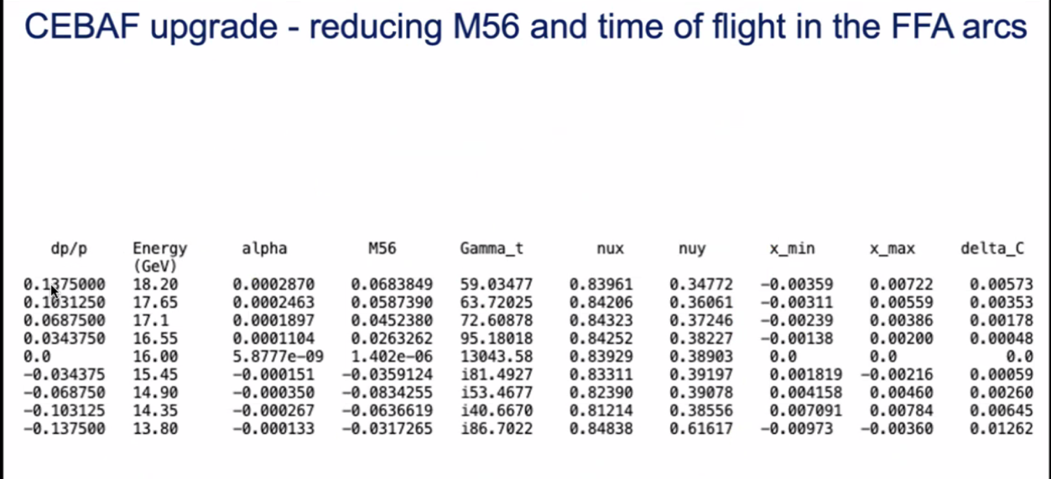
  - MadX results
  - Cut off – go to 22.6 GeV
  - Value of MomComp in second column (?)
  - Gamma_t is infinite in original design
  - M56 is alpha * arc_length
  - Largest M56 is 7 cm
- Sent the files out to see if they work
- Value of M56 is changing – need to change that so they aren’t
- Tunes are ~same range, except the 13.8 GeV
- Orbit offsets all agree with every code
  - 3 mm, 9 mm, etc…
  - Max goes to a few cm
  - ToF (delta_C) is small
- 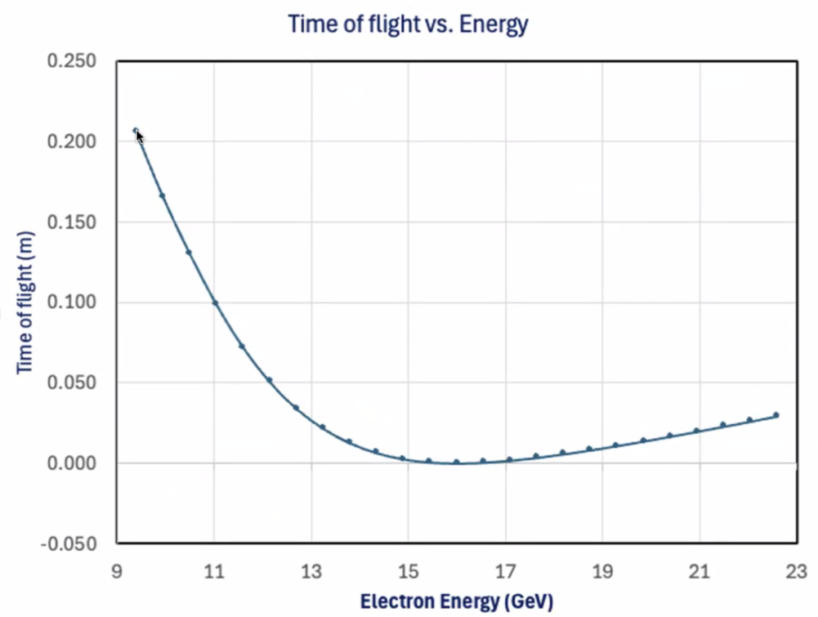
  - Higher E, it’s hard to correct ToF in splitters – the magnets would have to be very high-field.
  - For the 3 cm ToF should be doable
- 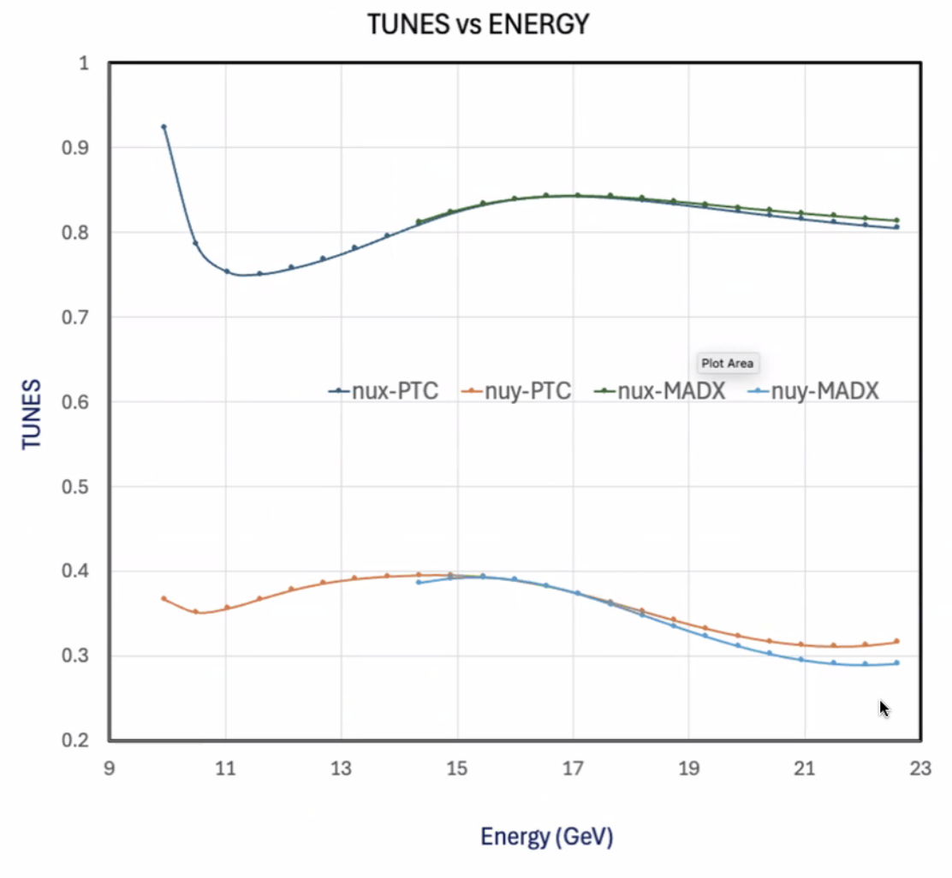
  - Horizontal tunes at top, vertical at bottom
  - Don’t know how to do end fields in MadX
- 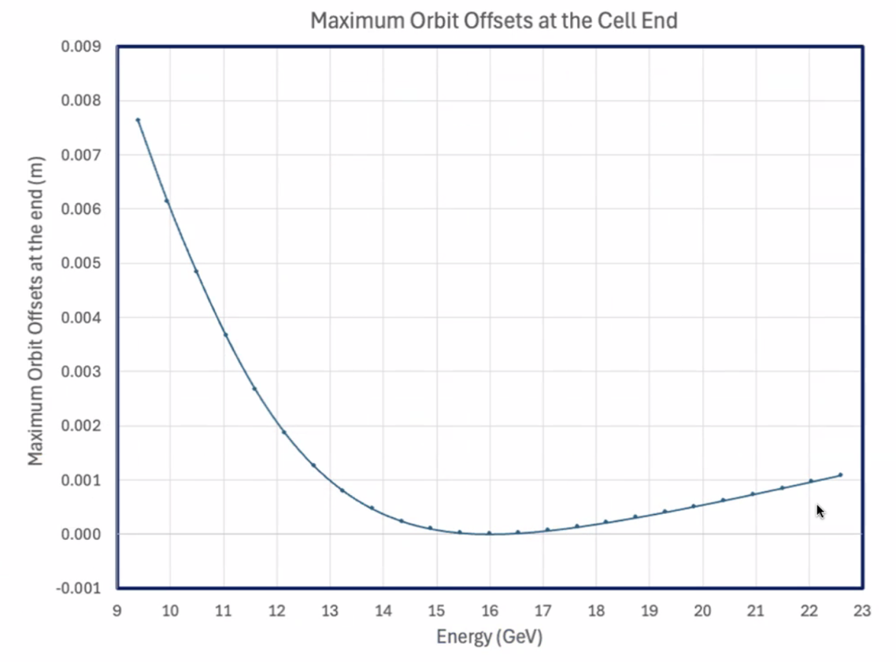
- 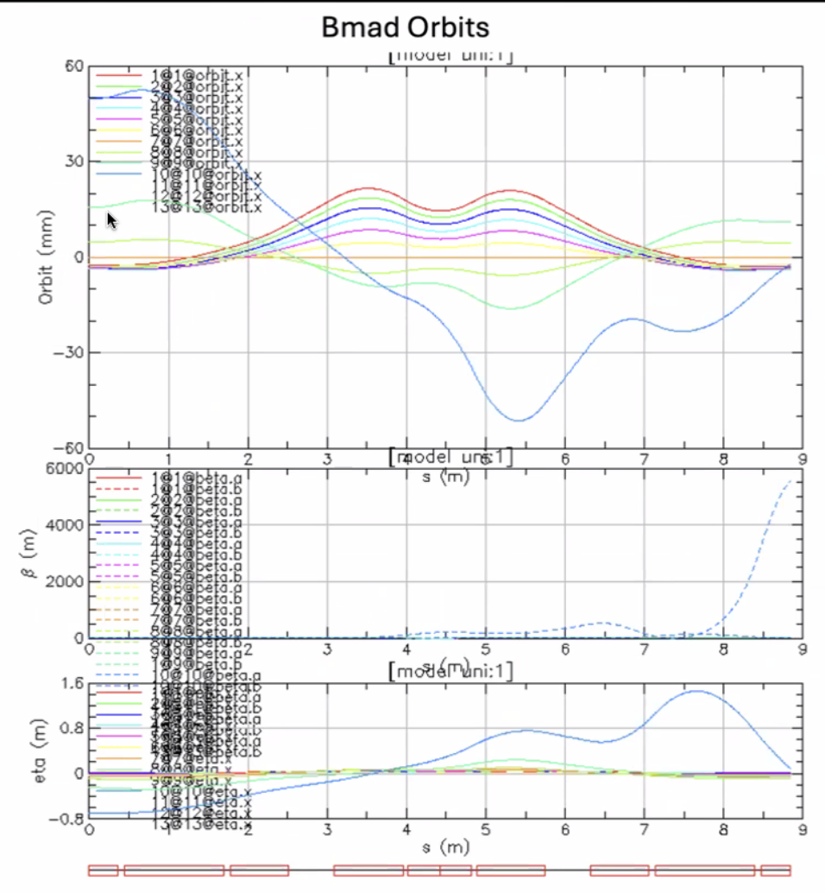
  - Doesn’t find closed orbit for lowest energies
- In the chat, Salim: FINT (Default: 0) The fringe field integral at entrance and exit of the bend. This has been activated for all elements listed above, not just for (S|R)BEND, as in MAD-X.
  - Dejan – should be able to do that correctly then
  - BD2 should be 0 on one side – that needs to be corrected in MadX
  - Command in chat
- 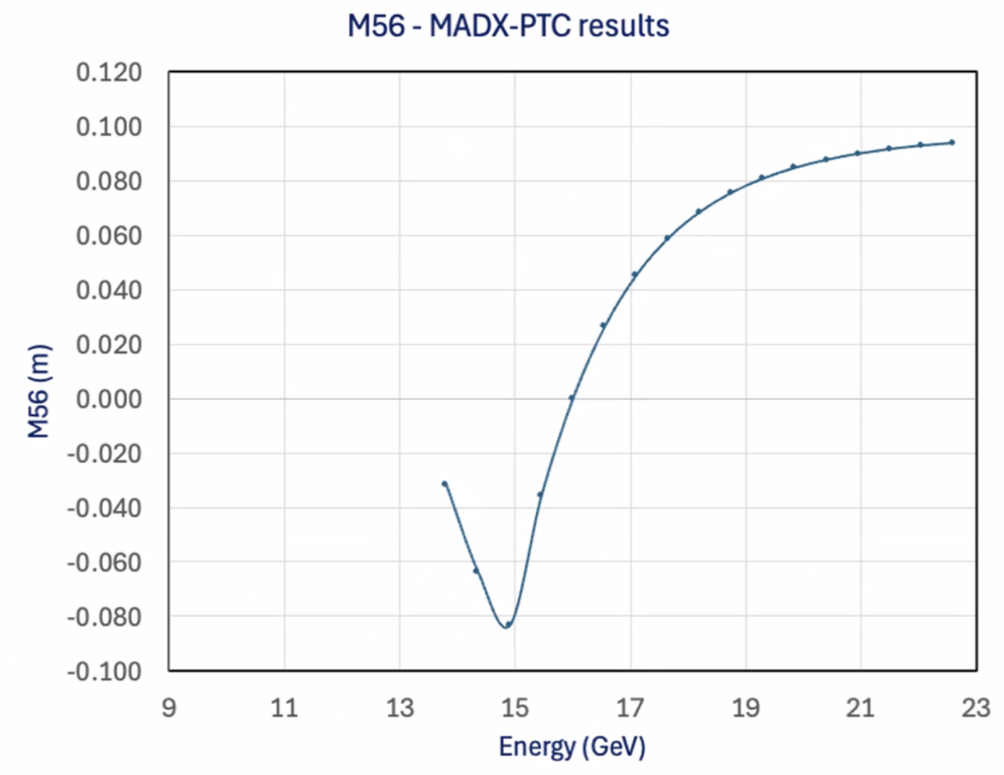
- Ryan can put files into shared area (GitHub)
- This is M56 calculated from MadX – at 22 GeV, about 9 cm – less than 14!
  - Maybe we don’t need to have this complicated cell, we can use the existing lattice we have and just use sextupoles to reduce M56
  - If we give up with FMC proposal
- Stephen – with sextupoles, bring it down well
  - Cell lengths also help
  - Octupoles can help too
  - Don’t want to correct too much. You need tune changes. Differences in Tunes allow corrections
  - If all the tunes the same, can’t make adjustments
- Alex – maybe sextupoles themselves will be enough
- Dejan – Stephen can easily build these magnets
  - Think it’s important to have variable tunes
  - Alex – no worries about resonances
Action Items | Person responsible | Deadline

Time allotted | 10 mins | Agenda topic AOB | Presenter All

Action Items | Person responsible | Deadline

Special notes

Pathway to Repository: https://jeffersonlab-my.sharepoint.com/:f:/g/personal/tristan_jlab_org/EqZ5MeS-nipCgPfZB5p0oS4B9Is67d3nQb9sLJI3Zyev9g

