FFA@CEBAF Working Group|Minutes

## Meeting date | time 05/16/2025 | 11 AM EST | Meeting location <https://jlab-org.zoomgov.com/j/1614898082?pwd=TnUzMS81M2sxbDZIbERJU01tYkJCQT09>

|  |  |  |  |  |  |  |  |  |  |  |  |
| --- | --- | --- | --- | --- | --- | --- | --- | --- | --- | --- | --- |
| |  |  | | --- | --- | | Meeting called by | Alex B | | Type of meeting | Weekly Meeting | | Facilitator | Alex B | | Note taker | Salim | | Timekeeper | Alex B | | Attendees  Alex B, Nick, Rui, Sadiq, Stephen, Kirsten, Donish, Salim, Andrei, Vasiliy, Randy, Dejan, Volker |

# Intro Discussion

* Might be upgrading dumps for 22 GeV
* BBU study might be needed.

# Agenda topics

## Time allotted | 25 mins | Agenda topic New Ideas | Presenter Nick

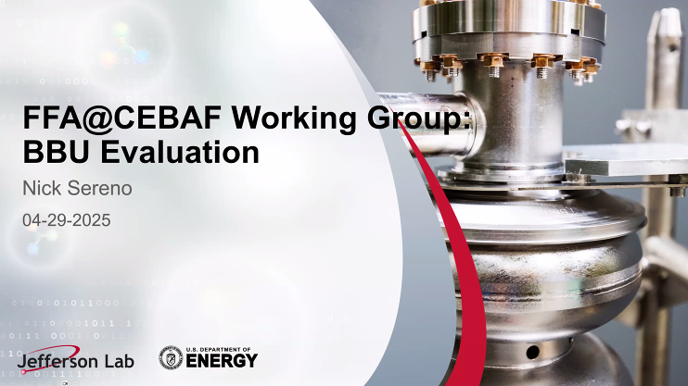

* + FFA ARCs shown in yellow, thanked Ryan for sending the overview.
  + Splitters and transitions making it more challenging for the beam optics.

* Kirsten comments that this more of a functional layout.

* Nick commented that he has seen higher current machines. Alex responded that those high current beams are unpolarized.

* Alex asked onto the last bullet: ‘threshold current dependence on number of passes’, is it seen in simulations or analytical?
* Nick: simulations. Sadiq commented that Rob Apsimon has done some analytical calculations, yet this was omitted in their PRAB paper.
* Kirsten emphasized that the Hall D has additional pass, that needs to be addressed. She asked about 100 uA of current?
* Nick: from the discussions with Yves and Jay at MCC.
* K: due to SR, we may not be able to deliver 100 uA with highest energy, referring to the SR heat load on the beam screen. Alex: 300 W/m is the limit, so that current can be mitigated.

* Alex quoted Andrei such that an intense CEBAF upgrade can be thought of.

|  |  |  |
| --- | --- | --- |
| Action Items | Person responsible | Deadline |
|  |  |  |
|  |  |  |

## Time allotted | 25 mins | Agenda topic CMS | Presenter Rui

Limited to the first arc, due to higher ARC energies, MBI would be negligible if 1st arc is fine.

* Head will accelerate; the tail would decelerate due to CSR.

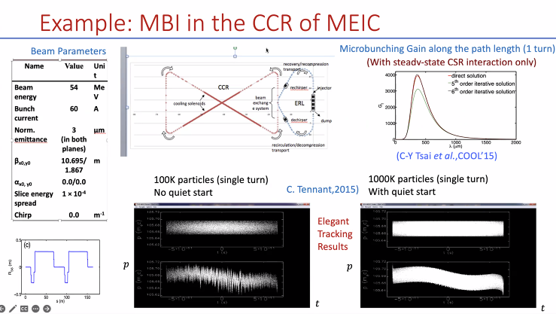

* As an extreme example of Micro Bunching Instability studied for the Circular Cooler Ring at JLAB, referring to C. Tennant’s study.

Two ways to solve this gain:

Second way to solve this:

An example of MBI amplification:

* R56/momentum compaction impacts the MBI gain.

* Comparing the FFA to the other examples:

* Using the iterative approach to calculate the MBI Gain for the FFA ARC:

* LSC, Longitudinal Space Charge can be problematic for the 650 MeV injector! LSC can be accumulated through the CEBAF leading density modulation which will translate to energy modulation, CSR.
* Conclusion: CSR is negligible for our FFA ARCs.
* Alex: is it negligible due to the small variation of R56
  + Rui: mainly it is the bending radius, bigger rho; the less the CSR impact is.
  + Dejan: 650 MeV recirculating linac injector is the problematic for the CSR.
  + Rui: affirmative and also stated that LSC also needs attention.

* Rui: emphasized that CSR calculations are start-to-end and this is just for the FFA Arc.
  + - Alex: Next, spreader and splitter may be included in the CSR Study.

|  |  |  |
| --- | --- | --- |
| Action Items | Person responsible | Deadline |
|  |  |  |
|  |  |  |

## Time allotted | 10 mins | Agenda topic AOB | Presenter All

* Meeting closed.

|  |  |  |
| --- | --- | --- |
| Action Items | Person responsible | Deadline |
|  |  |  |
|  |  |  |

## Special notes

Pathway to Repository: <https://jeffersonlab-my.sharepoint.com/:f:/g/personal/tristan_jlab_org/EqZ5MeS-nipCgPfZB5p0oS4B9Is67d3nQb9sLJI3Zyev9g>