FFA@CEBAF Working Group|Minutes

Meeting date | time 06/13/2025 | 11 AM EST | Meeting location https://jlab-org.zoomgov.com/j/1614898082?pwd=TnUzMS81M2sxbDZIbERJU01tYkJCQT09
Meeting called by Alex B  Type of meeting Weekly Meeting  Facilitator Alex B  Note taker Salim  Timekeeper Alex B | Attendees  Alex B, Donish, Salim, Dejan, Stephen, Sadiq, Kirsten, Volker, Kirsten, Reza, Tim, Vasiliy, Scott

Intro Discussion

Agenda topics

Time allotted | 50 mins | Agenda topic General/Splitter Update| Presenter Donish
- 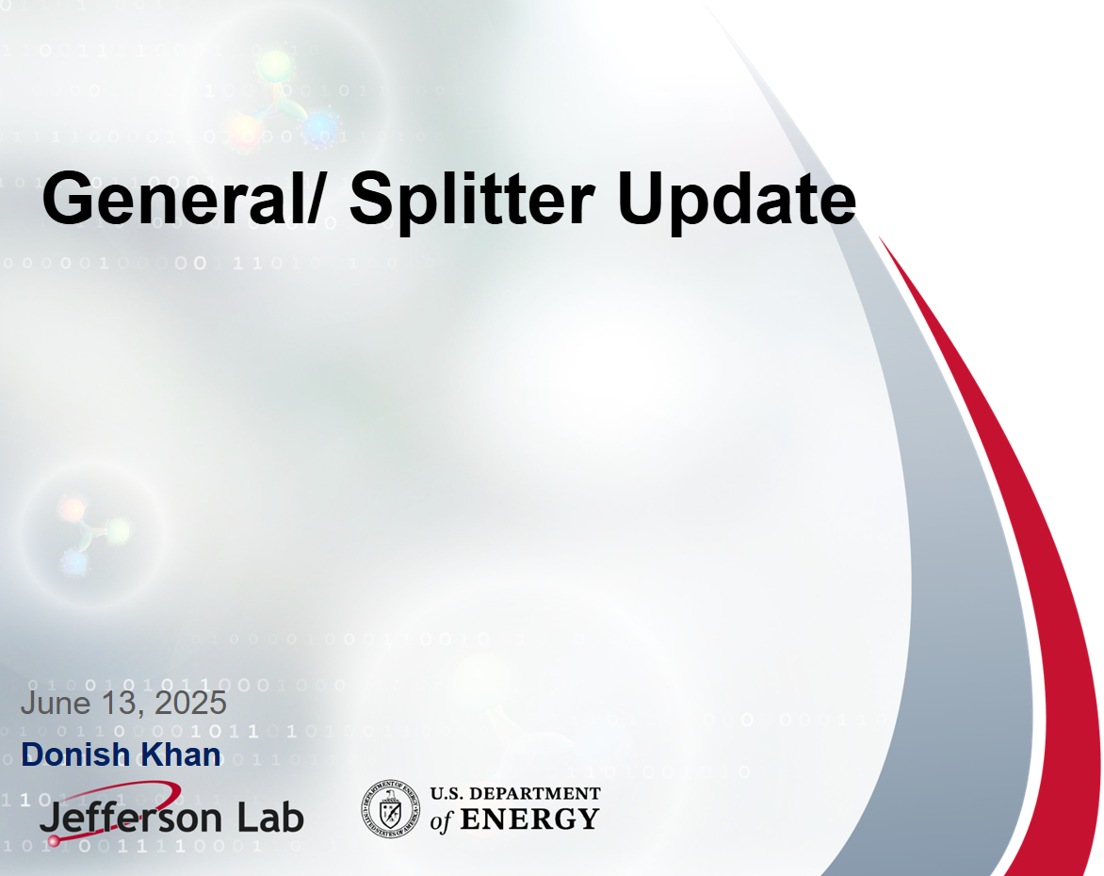
- 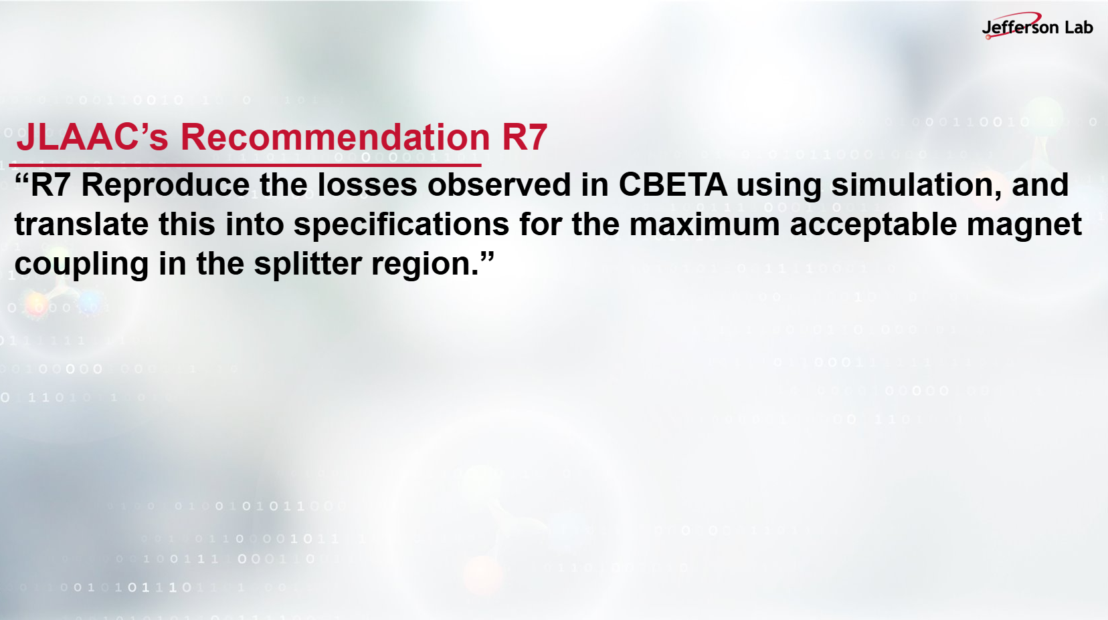
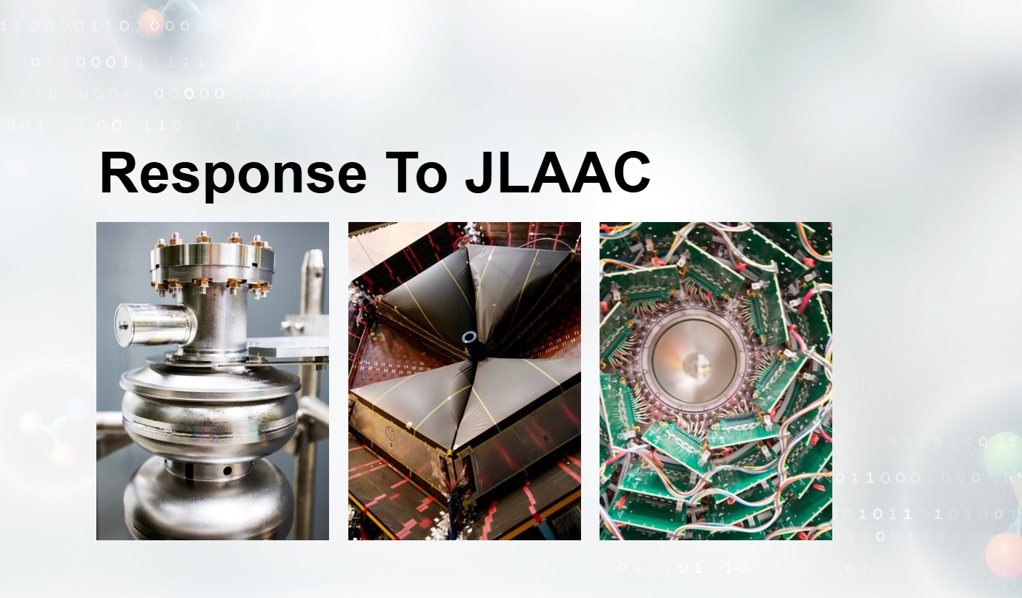
- 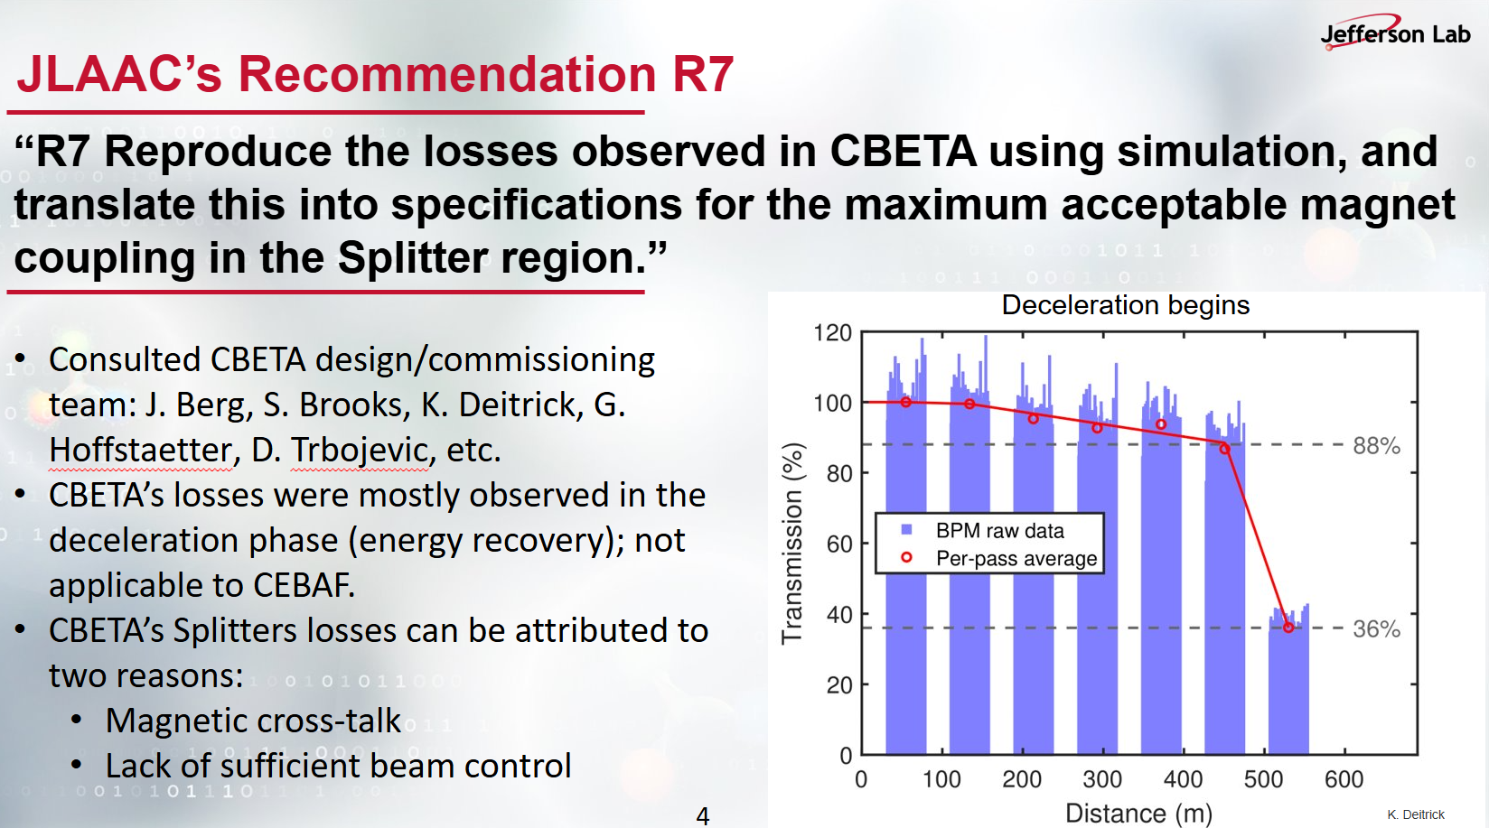
- 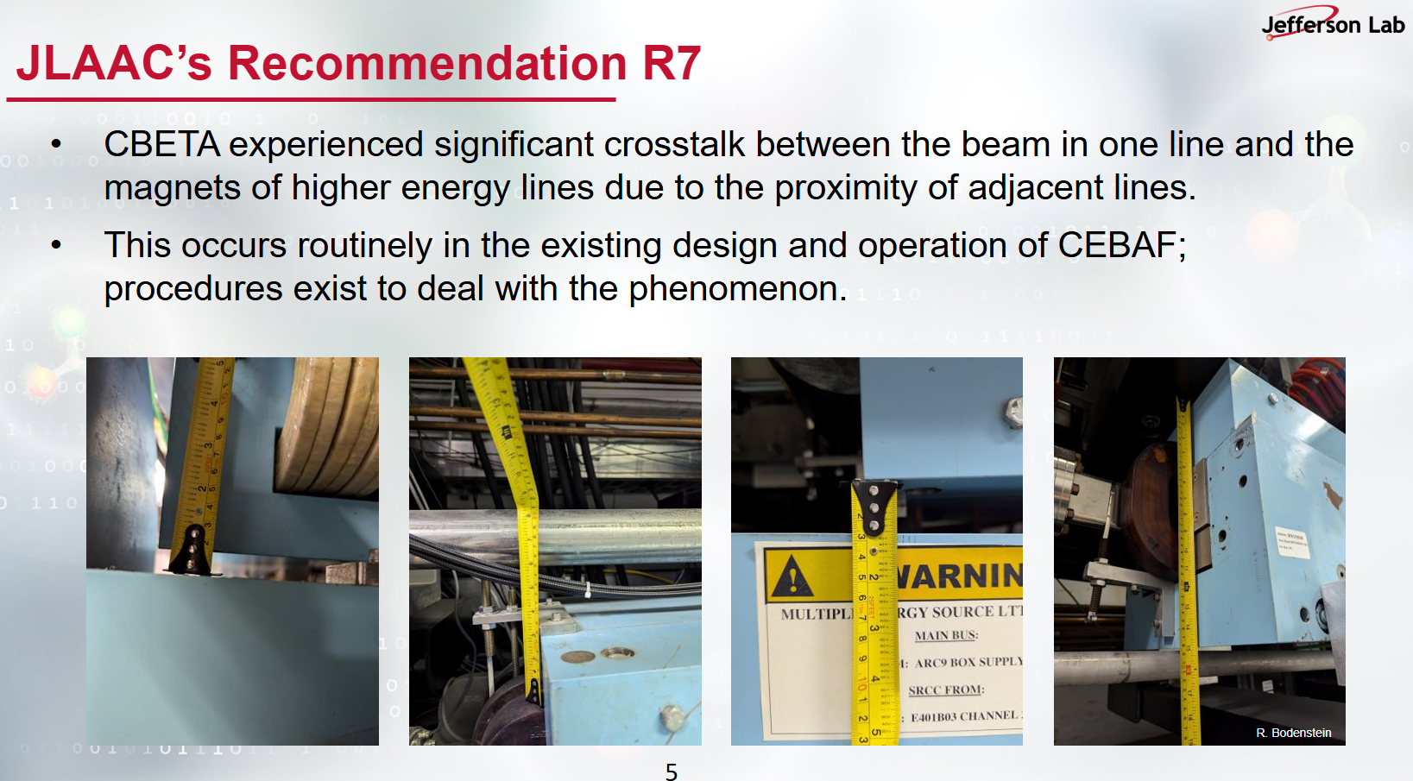
- 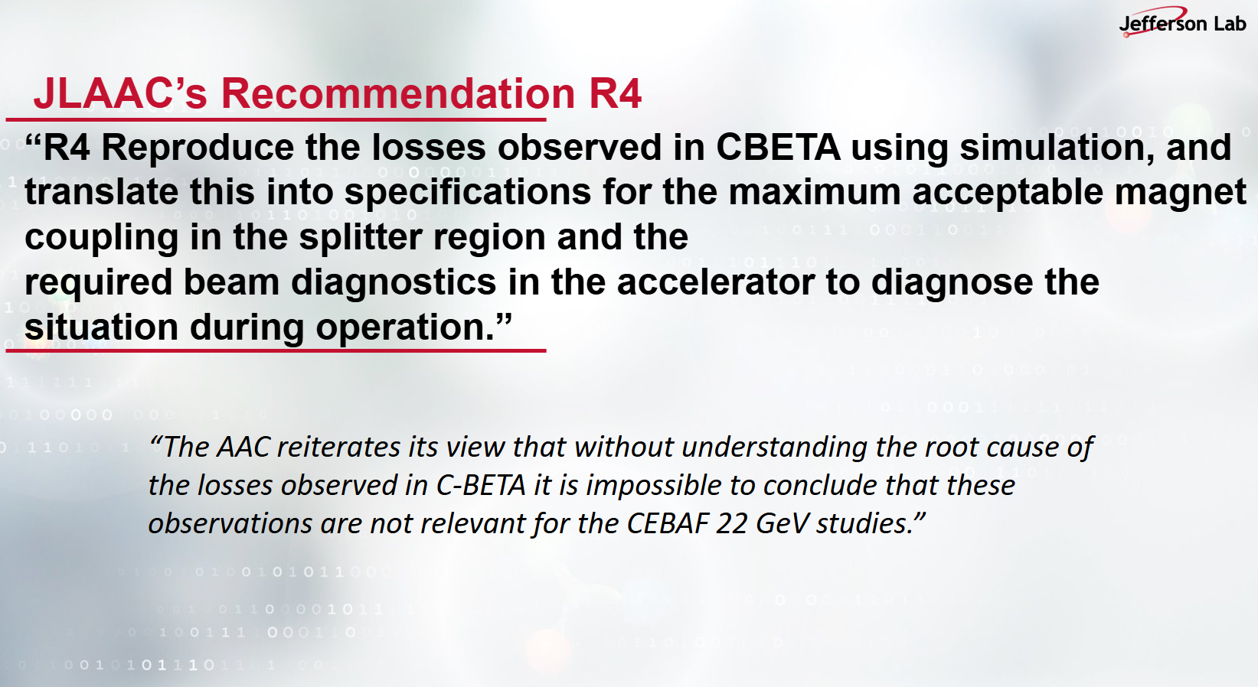

- 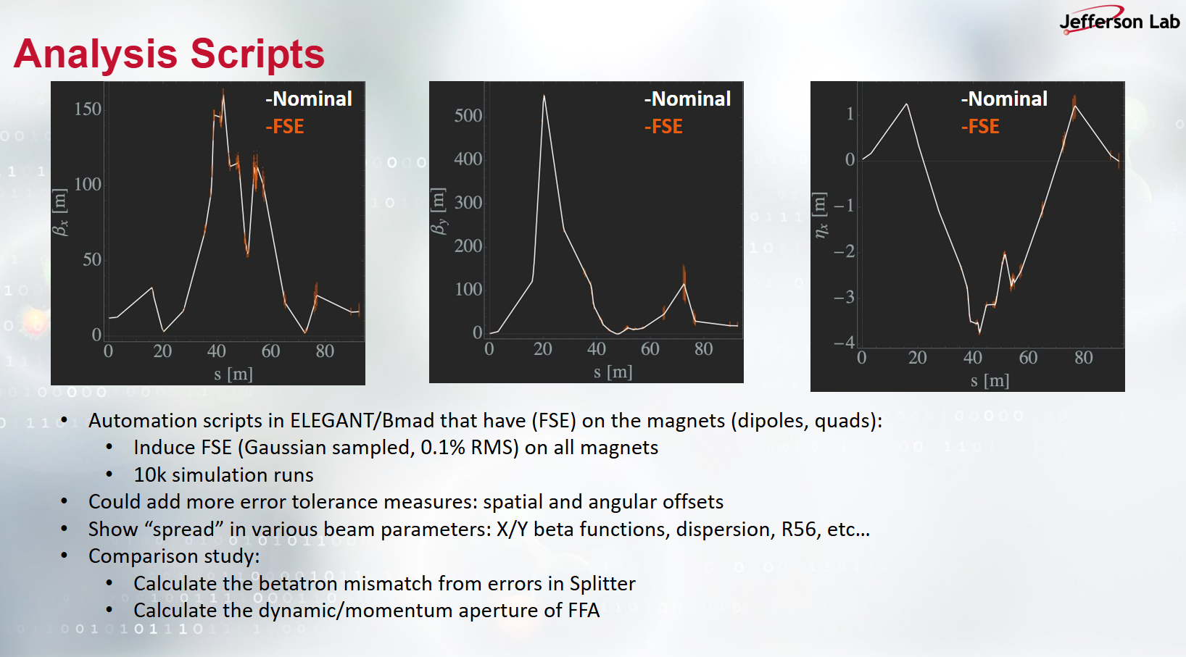
- 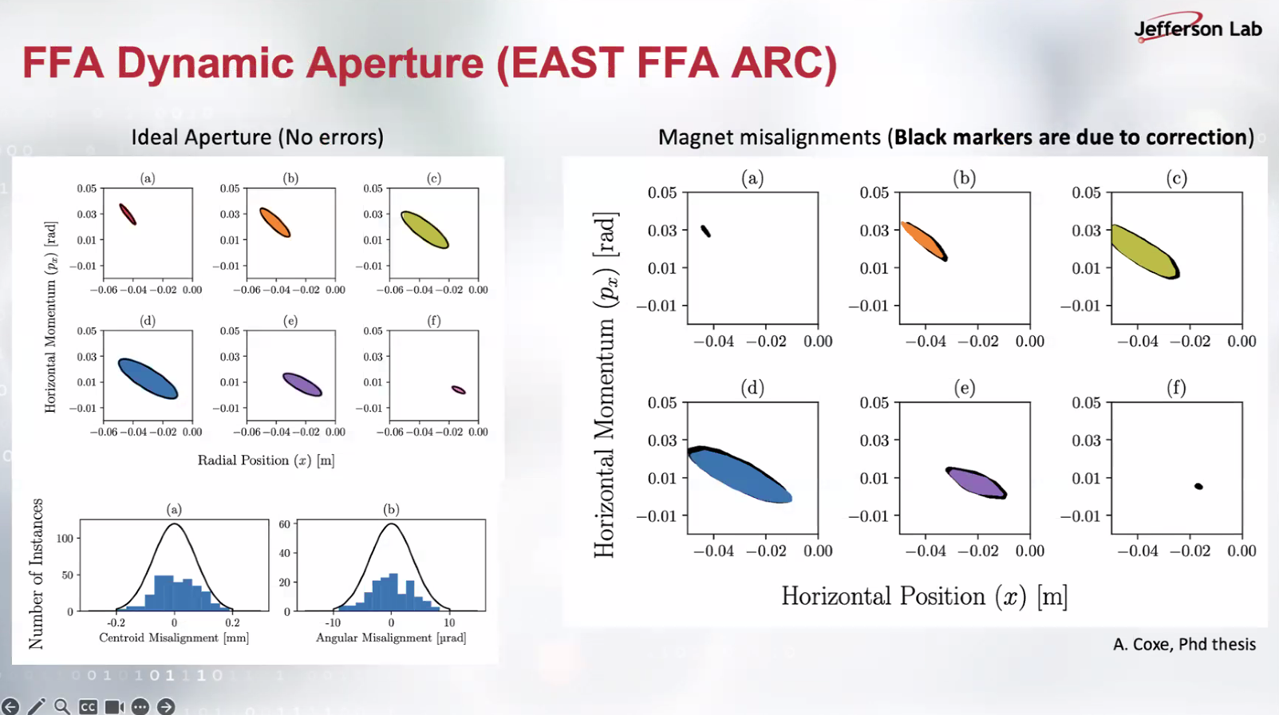

- 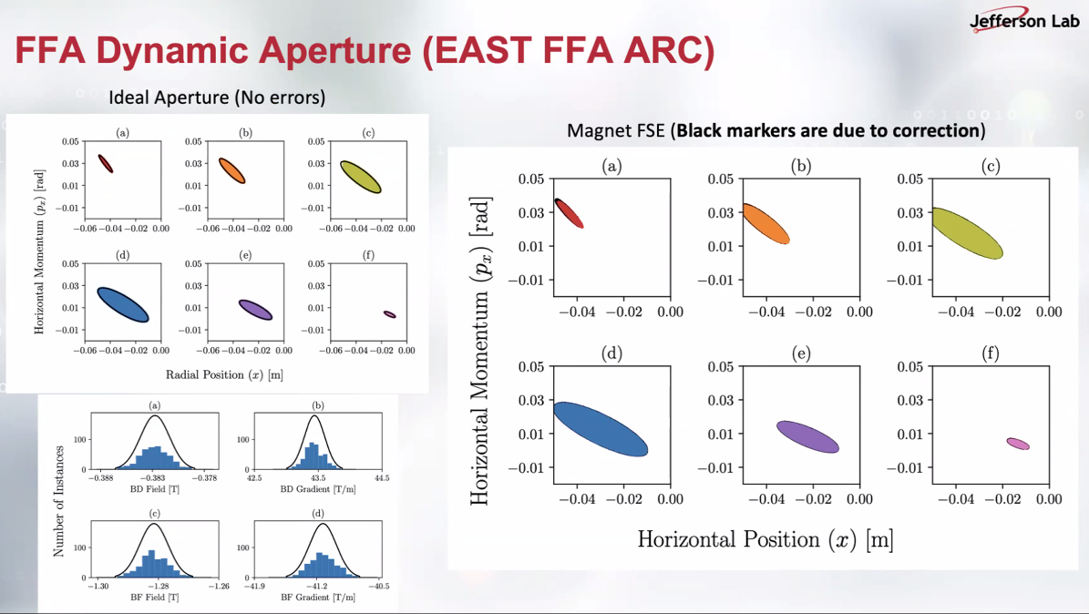
Alex B: why is the improvement in DA limited, is it due to the correction system?
Donish: looks like the correction is not at the level we want.
Alex B: this can be a bottleneck; this needs to be addressed.
- 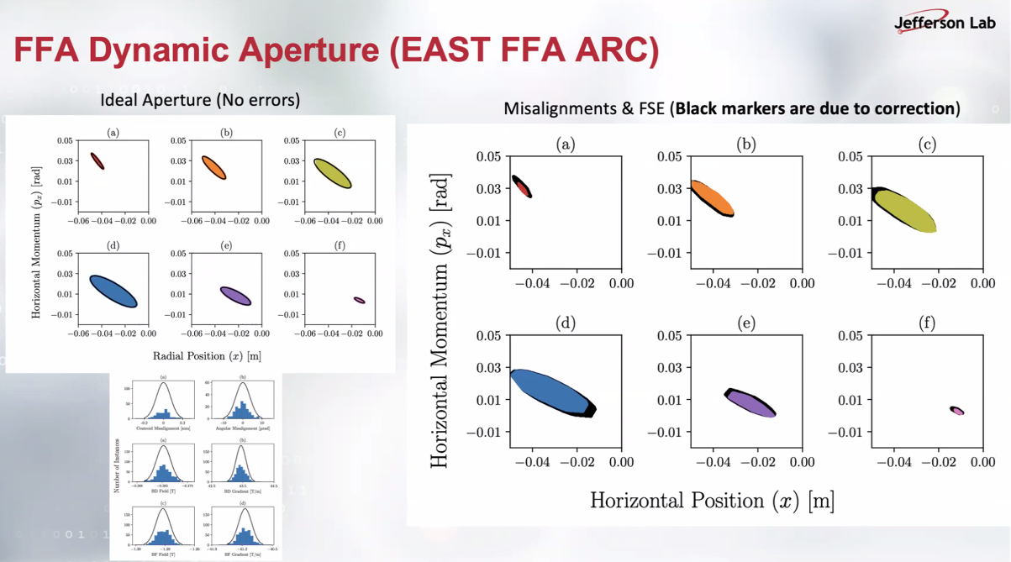

- 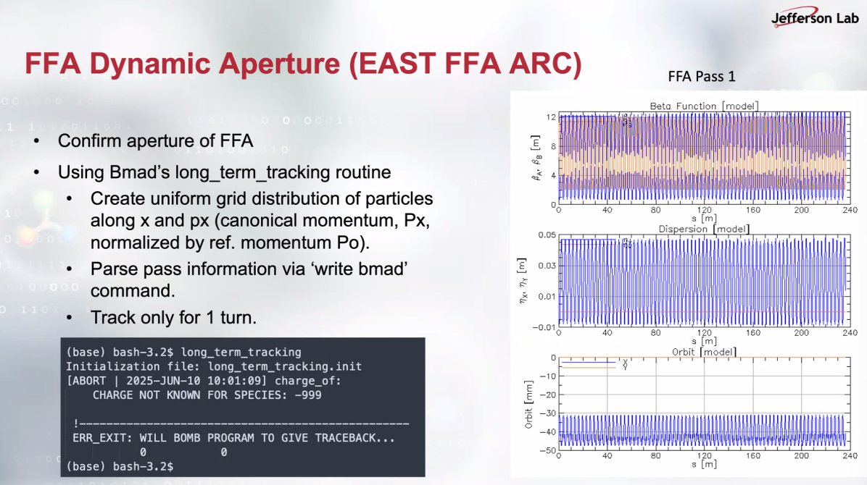
Kirsten: working on the orbit offset of the “baseline” FFA lattice after meeting with Stephen, Scott.
Dejan suggested to give a 5-min talk next time on how to generate the magnet layout.
Donish: having some problems with Bmad. Kirsten will meet Donish on this.
Scott: D is using the long_term_tracking module. It is about the reference orbit and this module is more useful multiturn tracking.
- 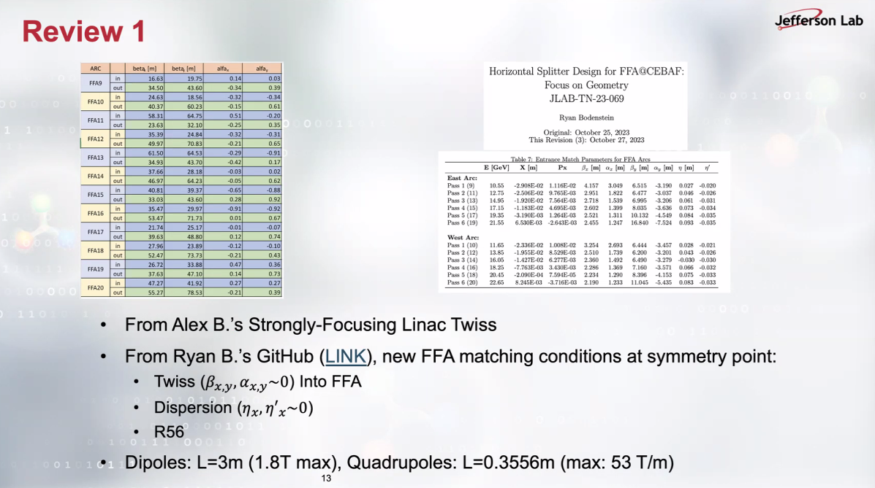
Alex B: these are up-to-date parameters.

- 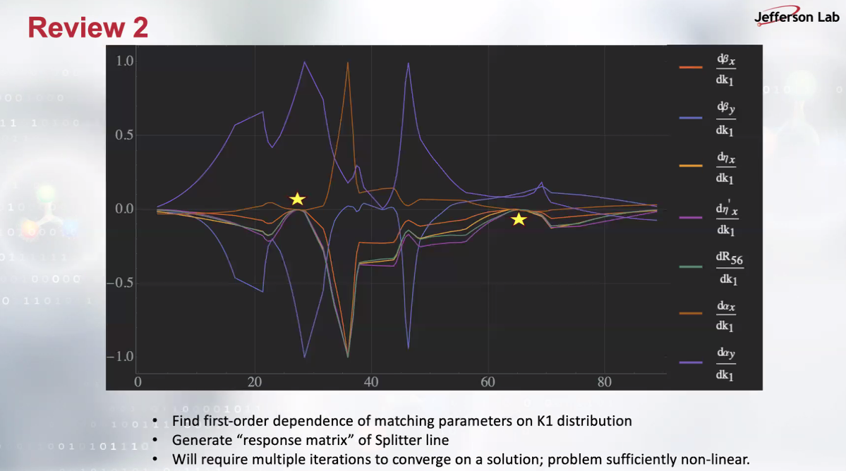
Ideal (theoretical) knobs are shown with stars.
Scott recommends not to consider R56 at this point, and recommends D to use the first star in the plot above and continue exploring this response matrix method.

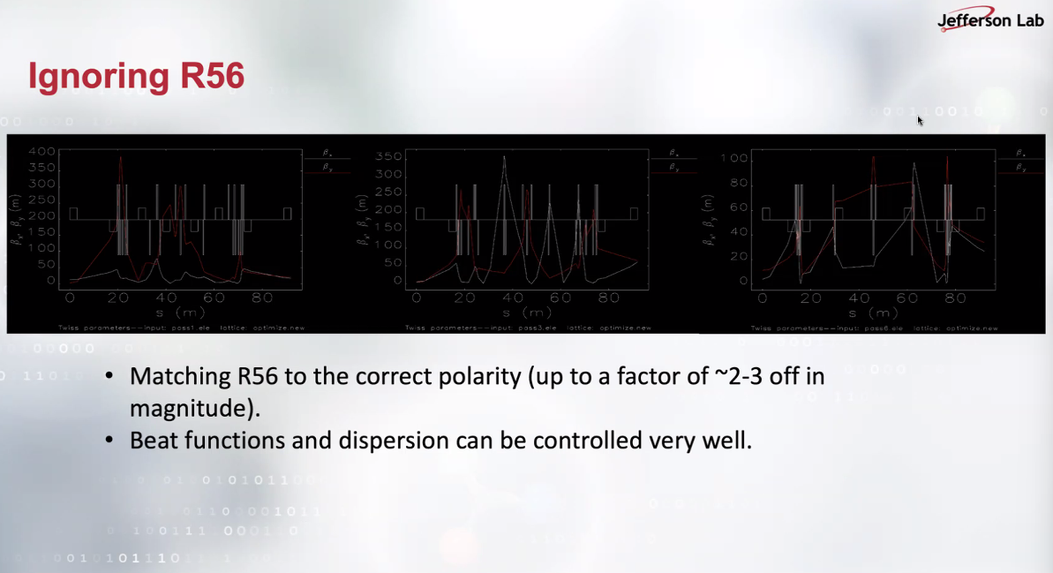
Beat->beta* correction.
Alex B: you can use the R56 you got from here? Donish: I wasn’t aiming that, only R56 polarity. Scott: just try to add R56 to your matching but just changing from this value by a mm or a cm.

- 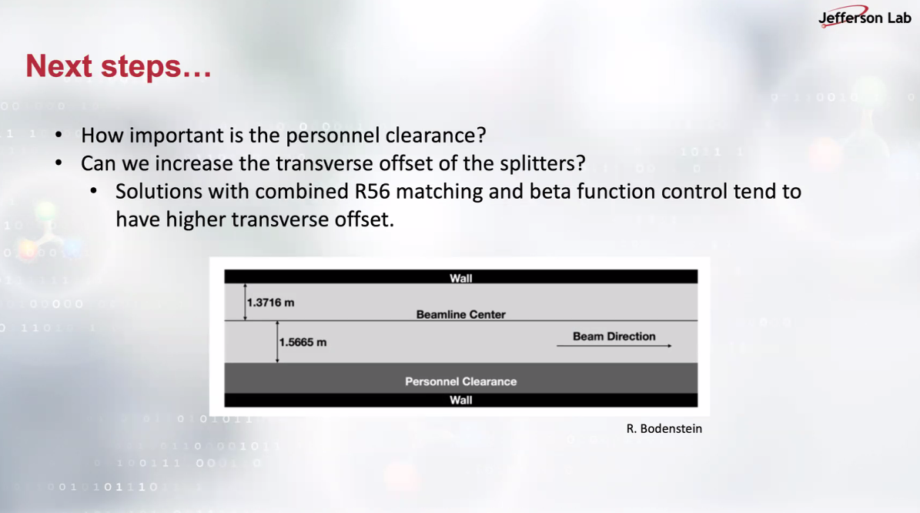
Alex B: this personal clearance is determined by the ESH. Tim: not only the personnel but also the carts to move stuff eg. Cryomodules.
Action Items | Person responsible | Deadline

Special notes

Pathway to Repository: https://jeffersonlab-my.sharepoint.com/:f:/g/personal/tristan_jlab_org/EqZ5MeS-nipCgPfZB5p0oS4B9Is67d3nQb9sLJI3Zyev9g

