FFA@CEBAF Working Group|Minutes

## Meeting date | time 07/11/2025 | 11 AM EST | Meeting location <https://jlab-org.zoomgov.com/j/1614898082?pwd=TnUzMS81M2sxbDZIbERJU01tYkJCQT09>

|  |  |  |  |  |  |  |  |  |  |  |  |
| --- | --- | --- | --- | --- | --- | --- | --- | --- | --- | --- | --- |
| |  |  | | --- | --- | | Meeting called by | Alex B | | Type of meeting | Weekly Meeting | | Facilitator | Alex B | | Note taker | Salim | | Timekeeper | Alex B | | Attendees  Alex B, Sadiq, Edy, Stephen, Donish, Salim, Randy, Dejan, Volker, Joe Grames, Ruber, J Scott |

# Intro Discussion

* Splitter optics, new optimizations - Donish
* 650 MeV injector, design startup - Alex

# Agenda topics

## Time allotted | 25 mins | Agenda topic *Splitter optics, new optimizations* | Presenter *Donish*

* 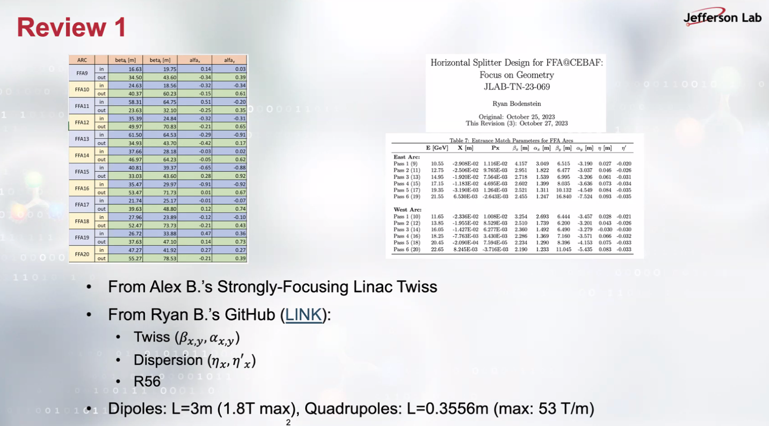
* 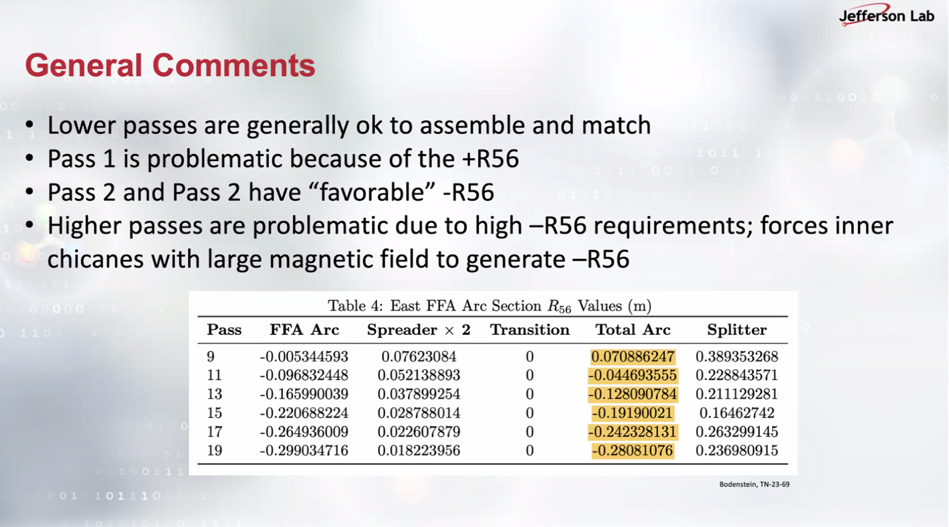   
  You must use positive quadrupole due to positive R56. Higher passes refers to 4 through 6, requiring additional bending.
  + Stephen comments that the magnet design can be altered. Dejan points out that R56 25-30 cm has changed to even below 10 cm, which will be given to Donish.
* 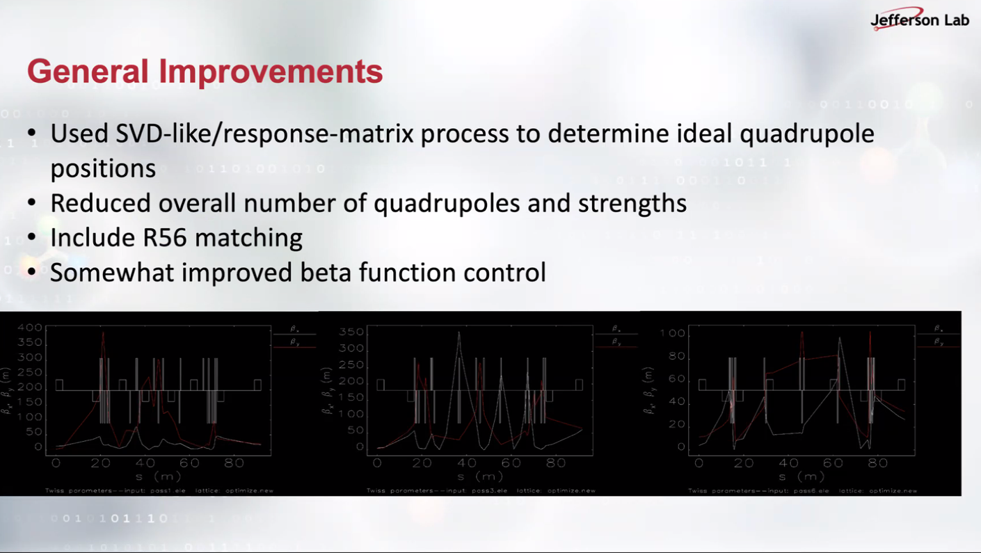  
  Earlier studies were not including R56 in the optimization.
* 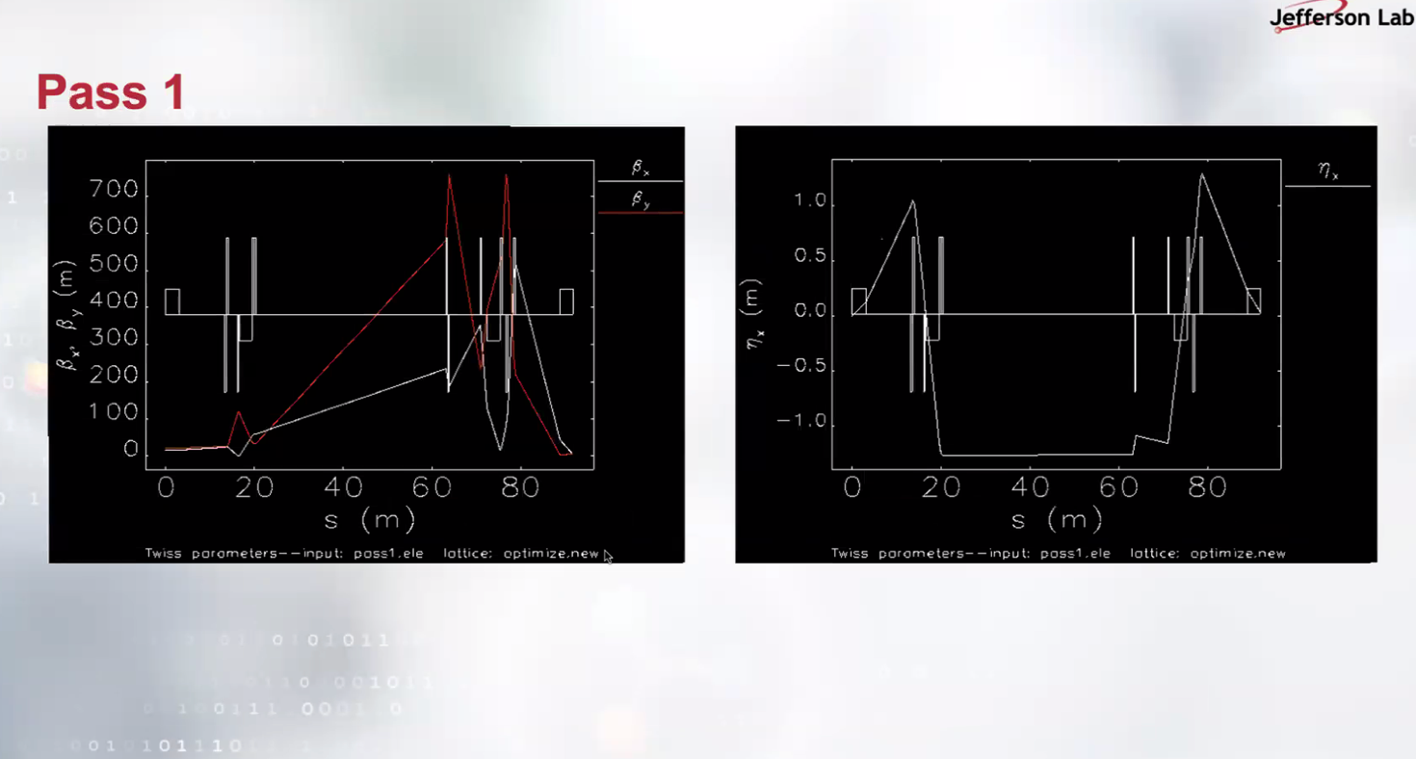

Curly H function is also kept small this time; Donish referring to Kirsten’s curly H emittance dilution study.

* 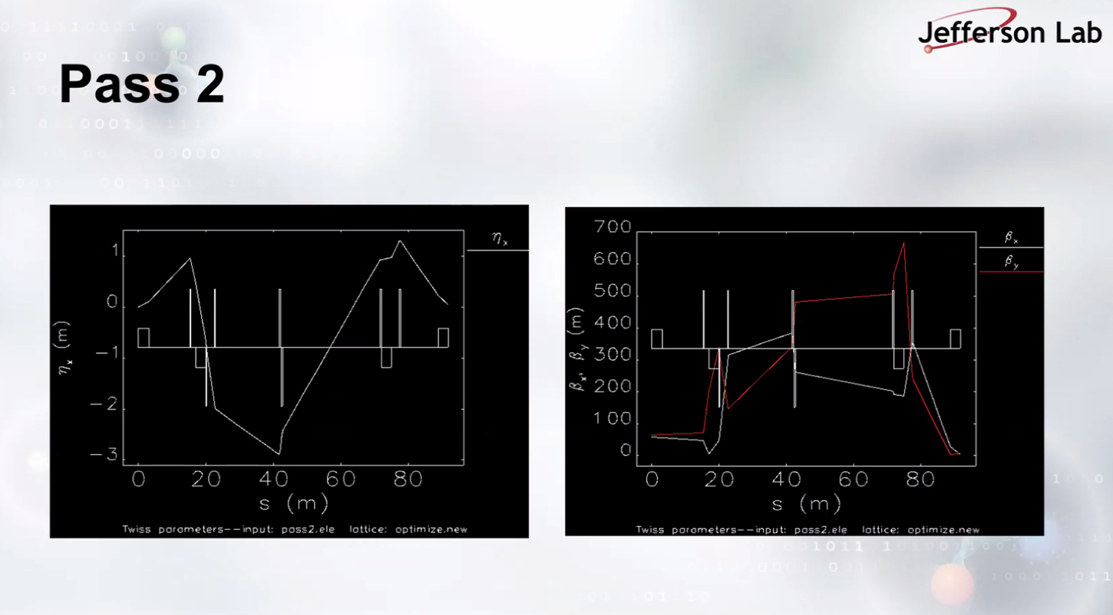
* 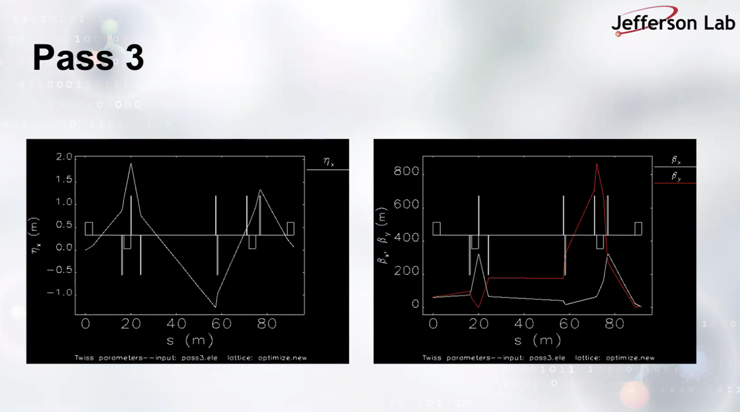
* A screenshot of a computer screen

  AI-generated content may be incorrect.

Pass 4 has extra magnets than pass 1-2-3.

* 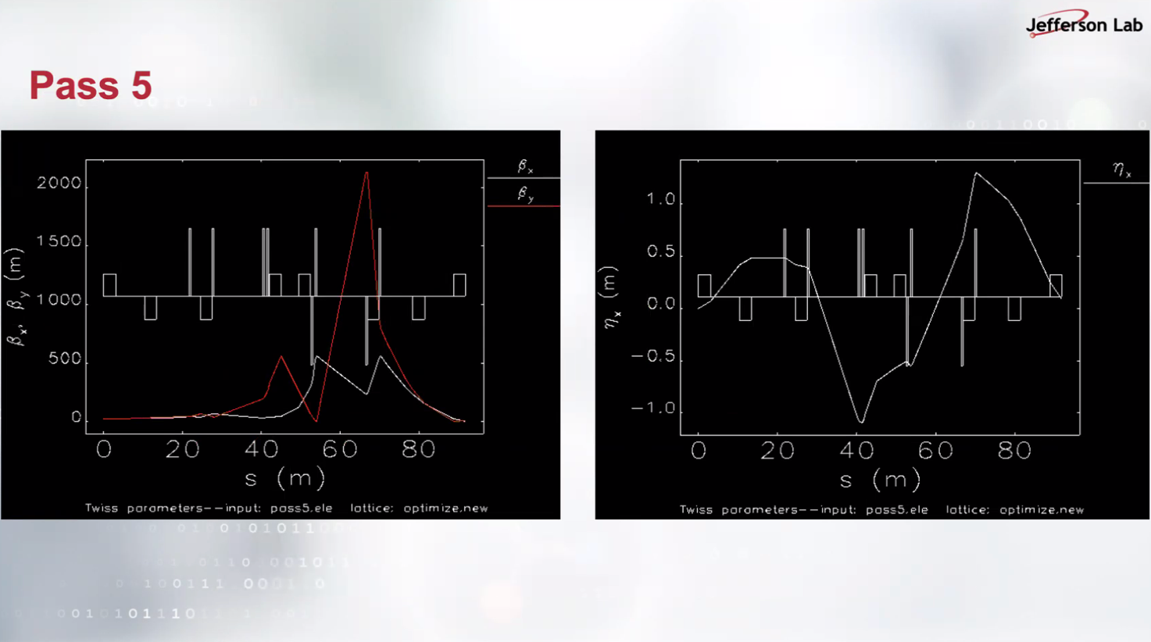

Beta function explodes near its end. Donish says he may change the layout to control beta function better.

* 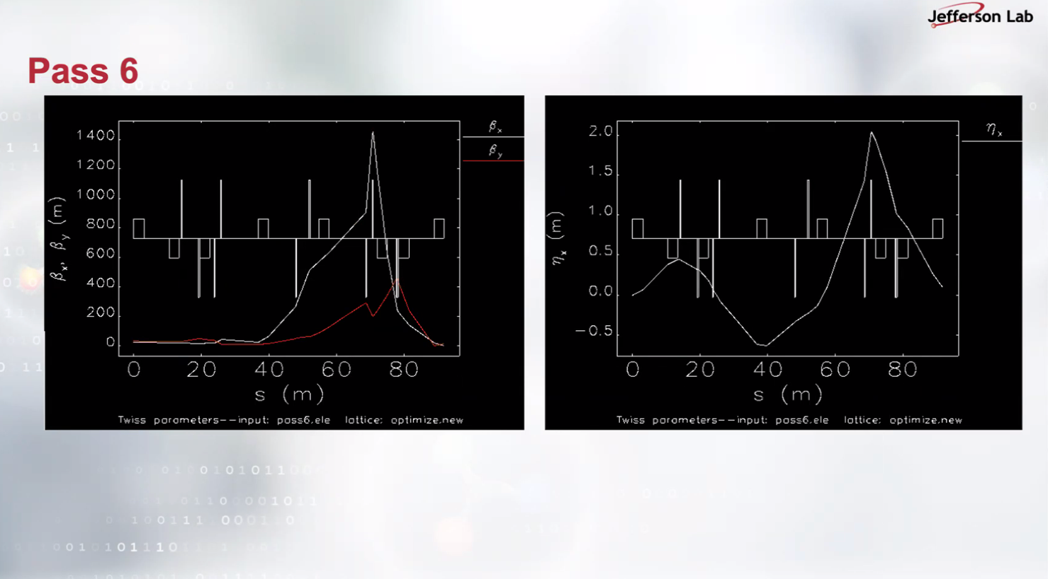
* Scott suggests: you have a problem that can be described as 7x9 matrix, QR on transpose matrix… 2-layer-optimizer: inner layer (the 7 params) for matching; outer layer is minimizer (remaining 2 vectors). Second comment, sextupole can solve ToF problem.
* Stephen Brooks shared his option B design a.k.a. Brooks_optionB_linear [this link during the meeting](https://jeffersonlab-my.sharepoint.com/personal/tristan_jlab_org/_layouts/15/onedrive.aspx?id=%2Fpersonal%2Ftristan%5Fjlab%5Forg%2FDocuments%2FGrad%20Student%202019%2FGraduate%20Student%20Steering%2FCEBAF%20FFA%20Working%20Group%2FOptics%2FFFA%20Arcs&sortField=Modified&isAscending=false&noAuthRedirect=1)
* Stephen commented out that except Dynamic aperture study which hasn’t been done; FFA with sextupole returns better results.
* Dejan says Donish using still 30 cm and shouldn’t be used. Option B or Dejan’s June24 2022 meeting lattices in the FFA@CEBAF shared folder.

|  |  |  |
| --- | --- | --- |
| Action Items | Person responsible | Deadline |
|  |  |  |
| * The baseline lattice on github should be revised. | ? ? | ASAP |

## Time allotted | 25 mins | Agenda topic *650 MeV injector, design* *startup* | Presenter *Alex B*

* 650 MeV injector, design startup
* A diagram of a machine

  AI-generated content may be incorrect.

LERF, the former FEL, is the candidate for 650 MeV (3 of C75 cryomodules.) This image above is FEL which is copy pasted for visualization. Instead 75 MeV oer cryomodule 71 MeV is chosen.

* Joe: multiple energy extraction from this linac for positron generation. Old 120 MeV was aimed for e+ generation. Since that returned large emittance, the primary electron energy needs to be increased. If FFA@CEBAF needs 650 MeV, positron study can use higher than 120 MeV primary e- beam as well.
* A diagram of a conveyor belt

  AI-generated content may be incorrect.

Horizontal or vertical stacking for recirculation arcs. Horizontal might be simpler in terms of dispersion.

|  |  |  |
| --- | --- | --- |
| Action Items | Person responsible | Deadline |
|  |  |  |
|  |  |  |

## Time allotted | 10 mins | Agenda topic AOB | Presenter All

* Meeting closed.

|  |  |  |
| --- | --- | --- |
| Action Items | Person responsible | Deadline |
|  |  |  |
|  |  |  |

## Special notes

Pathway to Repository: <https://jeffersonlab-my.sharepoint.com/:f:/g/personal/tristan_jlab_org/EqZ5MeS-nipCgPfZB5p0oS4B9Is67d3nQb9sLJI3Zyev9g>