FFA@CEBAF Working Group|Minutes

Meeting date | time 08/08/2025 | 11 AM EST | Meeting location https://jlab-org.zoomgov.com/j/1614898082?pwd=TnUzMS81M2sxbDZIbERJU01tYkJCQT09
Meeting called by Alex B  Type of meeting Weekly Meeting  Facilitator Alex B  Note taker  Timekeeper Salim | Attendees  Alex B, Ryan, Stephen, Scott, Edy, Donish, Dejan, Kirsten, Salim, Andrei, Randy, Sadiq, Volker, +1

Intro Discussion
- Design Progress for the 22 GeV CEBAF Energy Upgrade – Edith Nissen
- Update – Donish Khan

Agenda topics

Time allotted | 30 mins | Agenda topic Design Progress for the 22 GeV | Presenter Edi
- 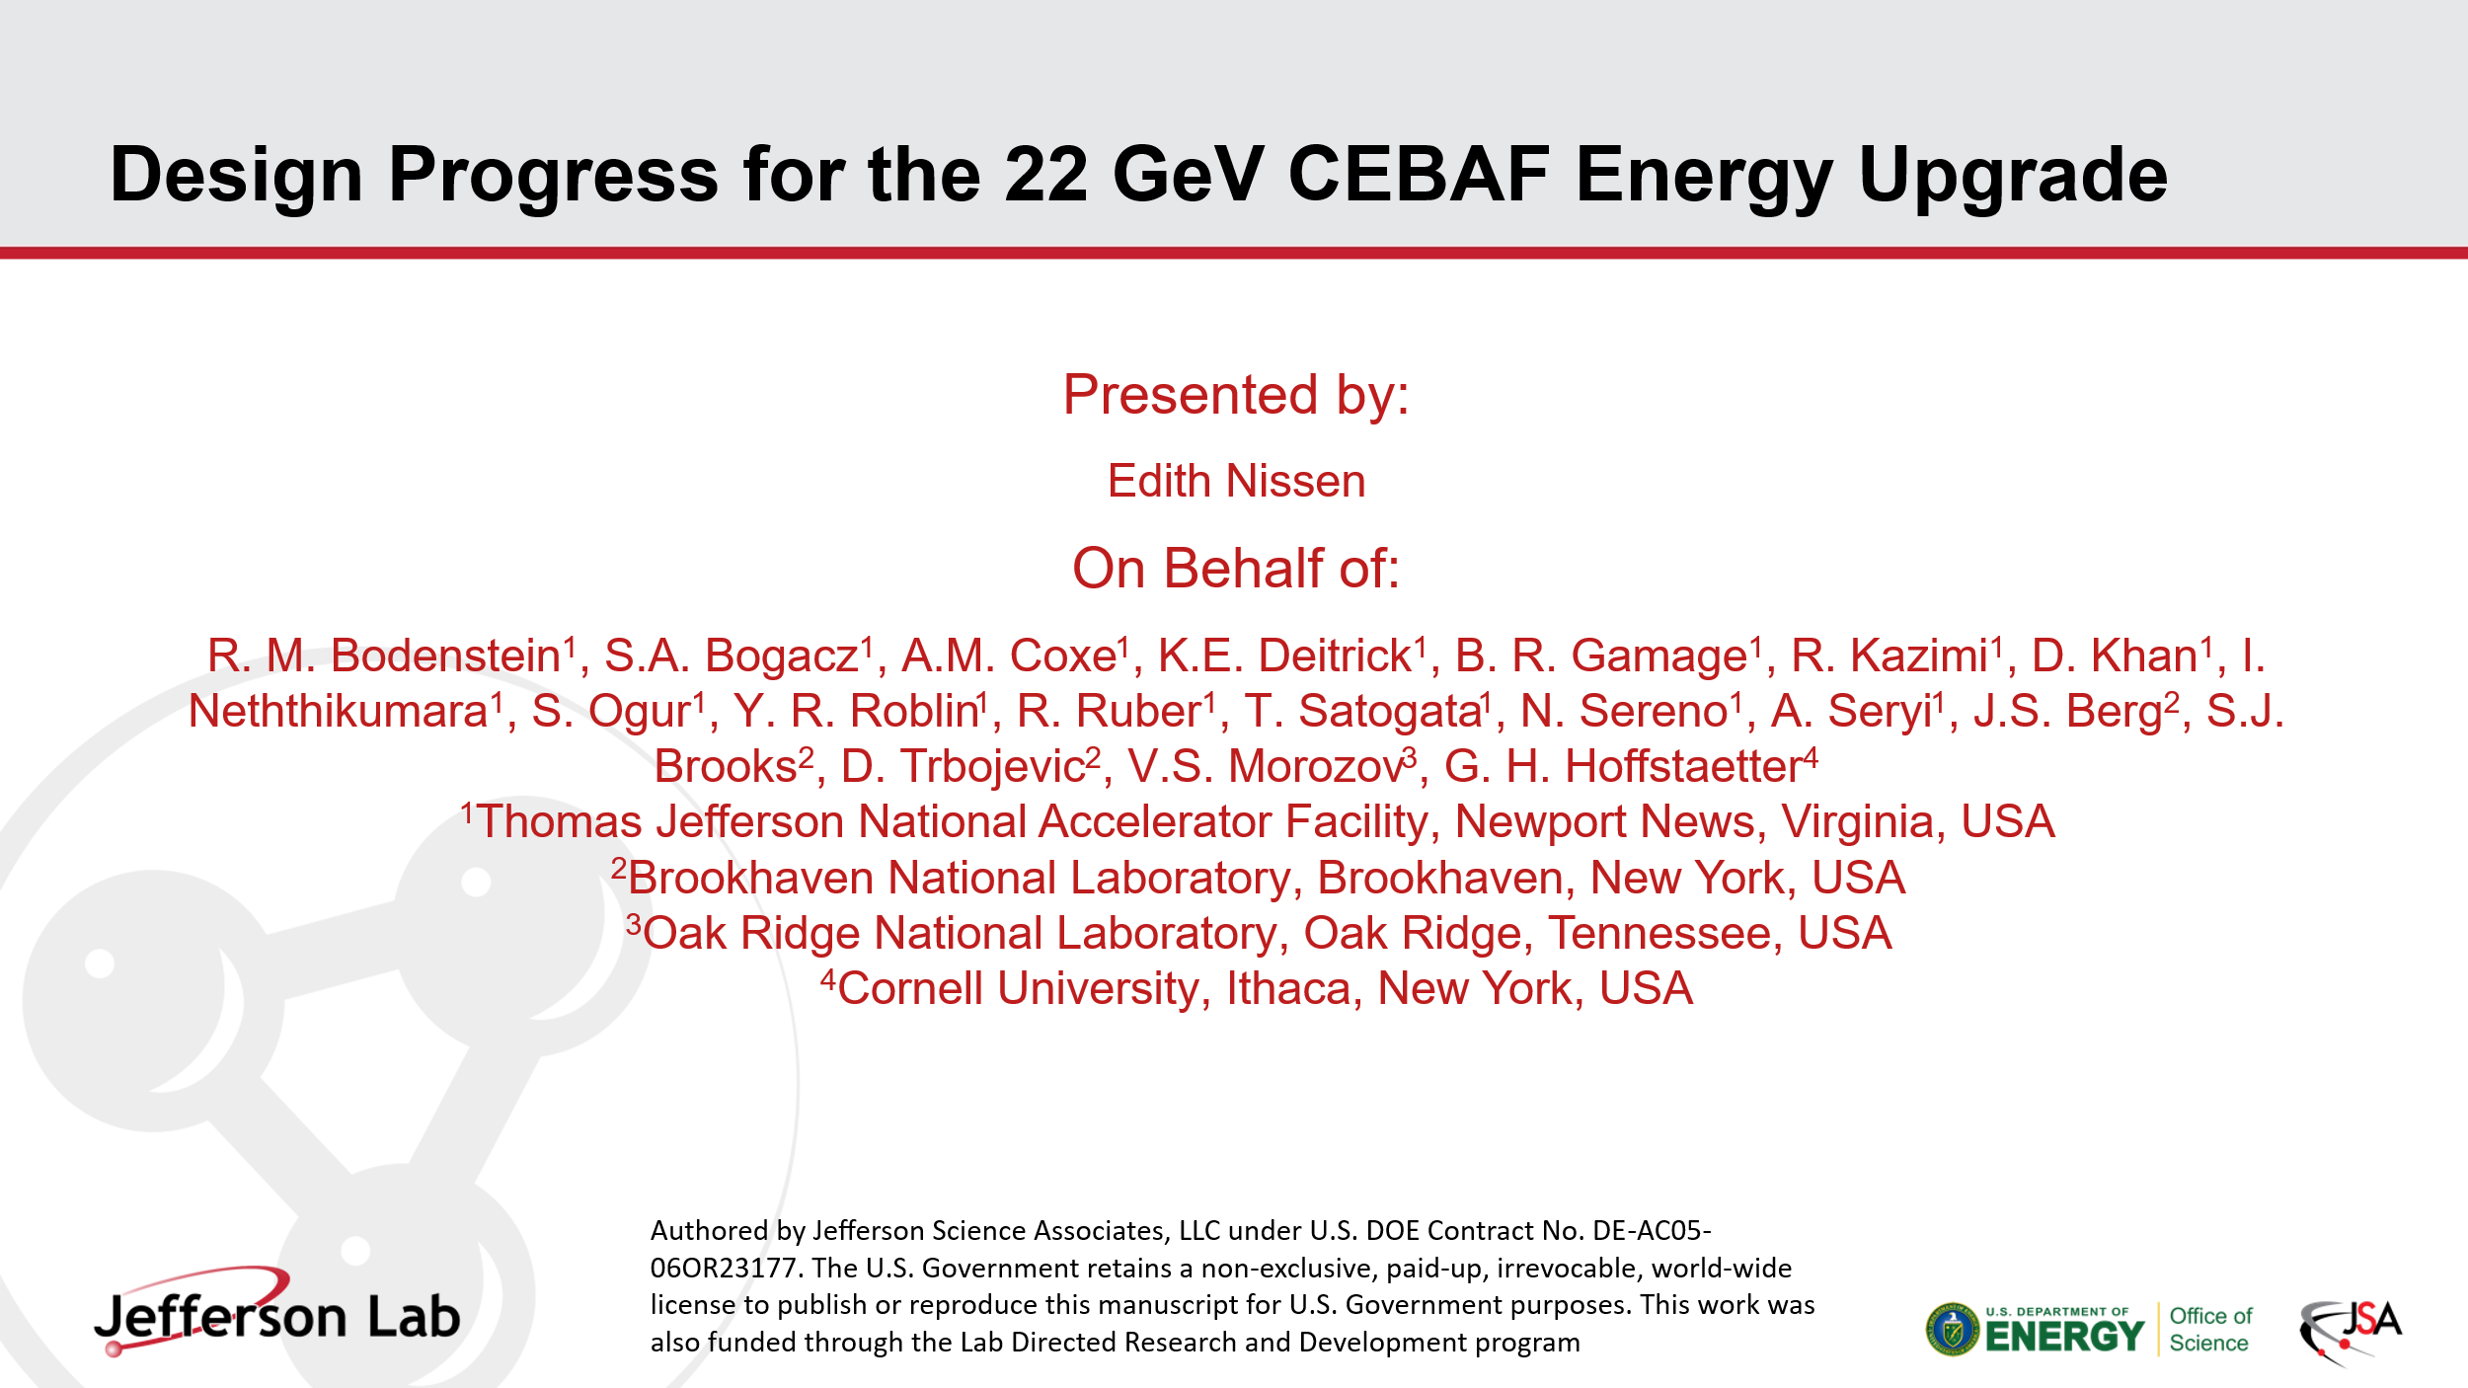
  - Rehearsal Talk for the NAPAC 2025.
- 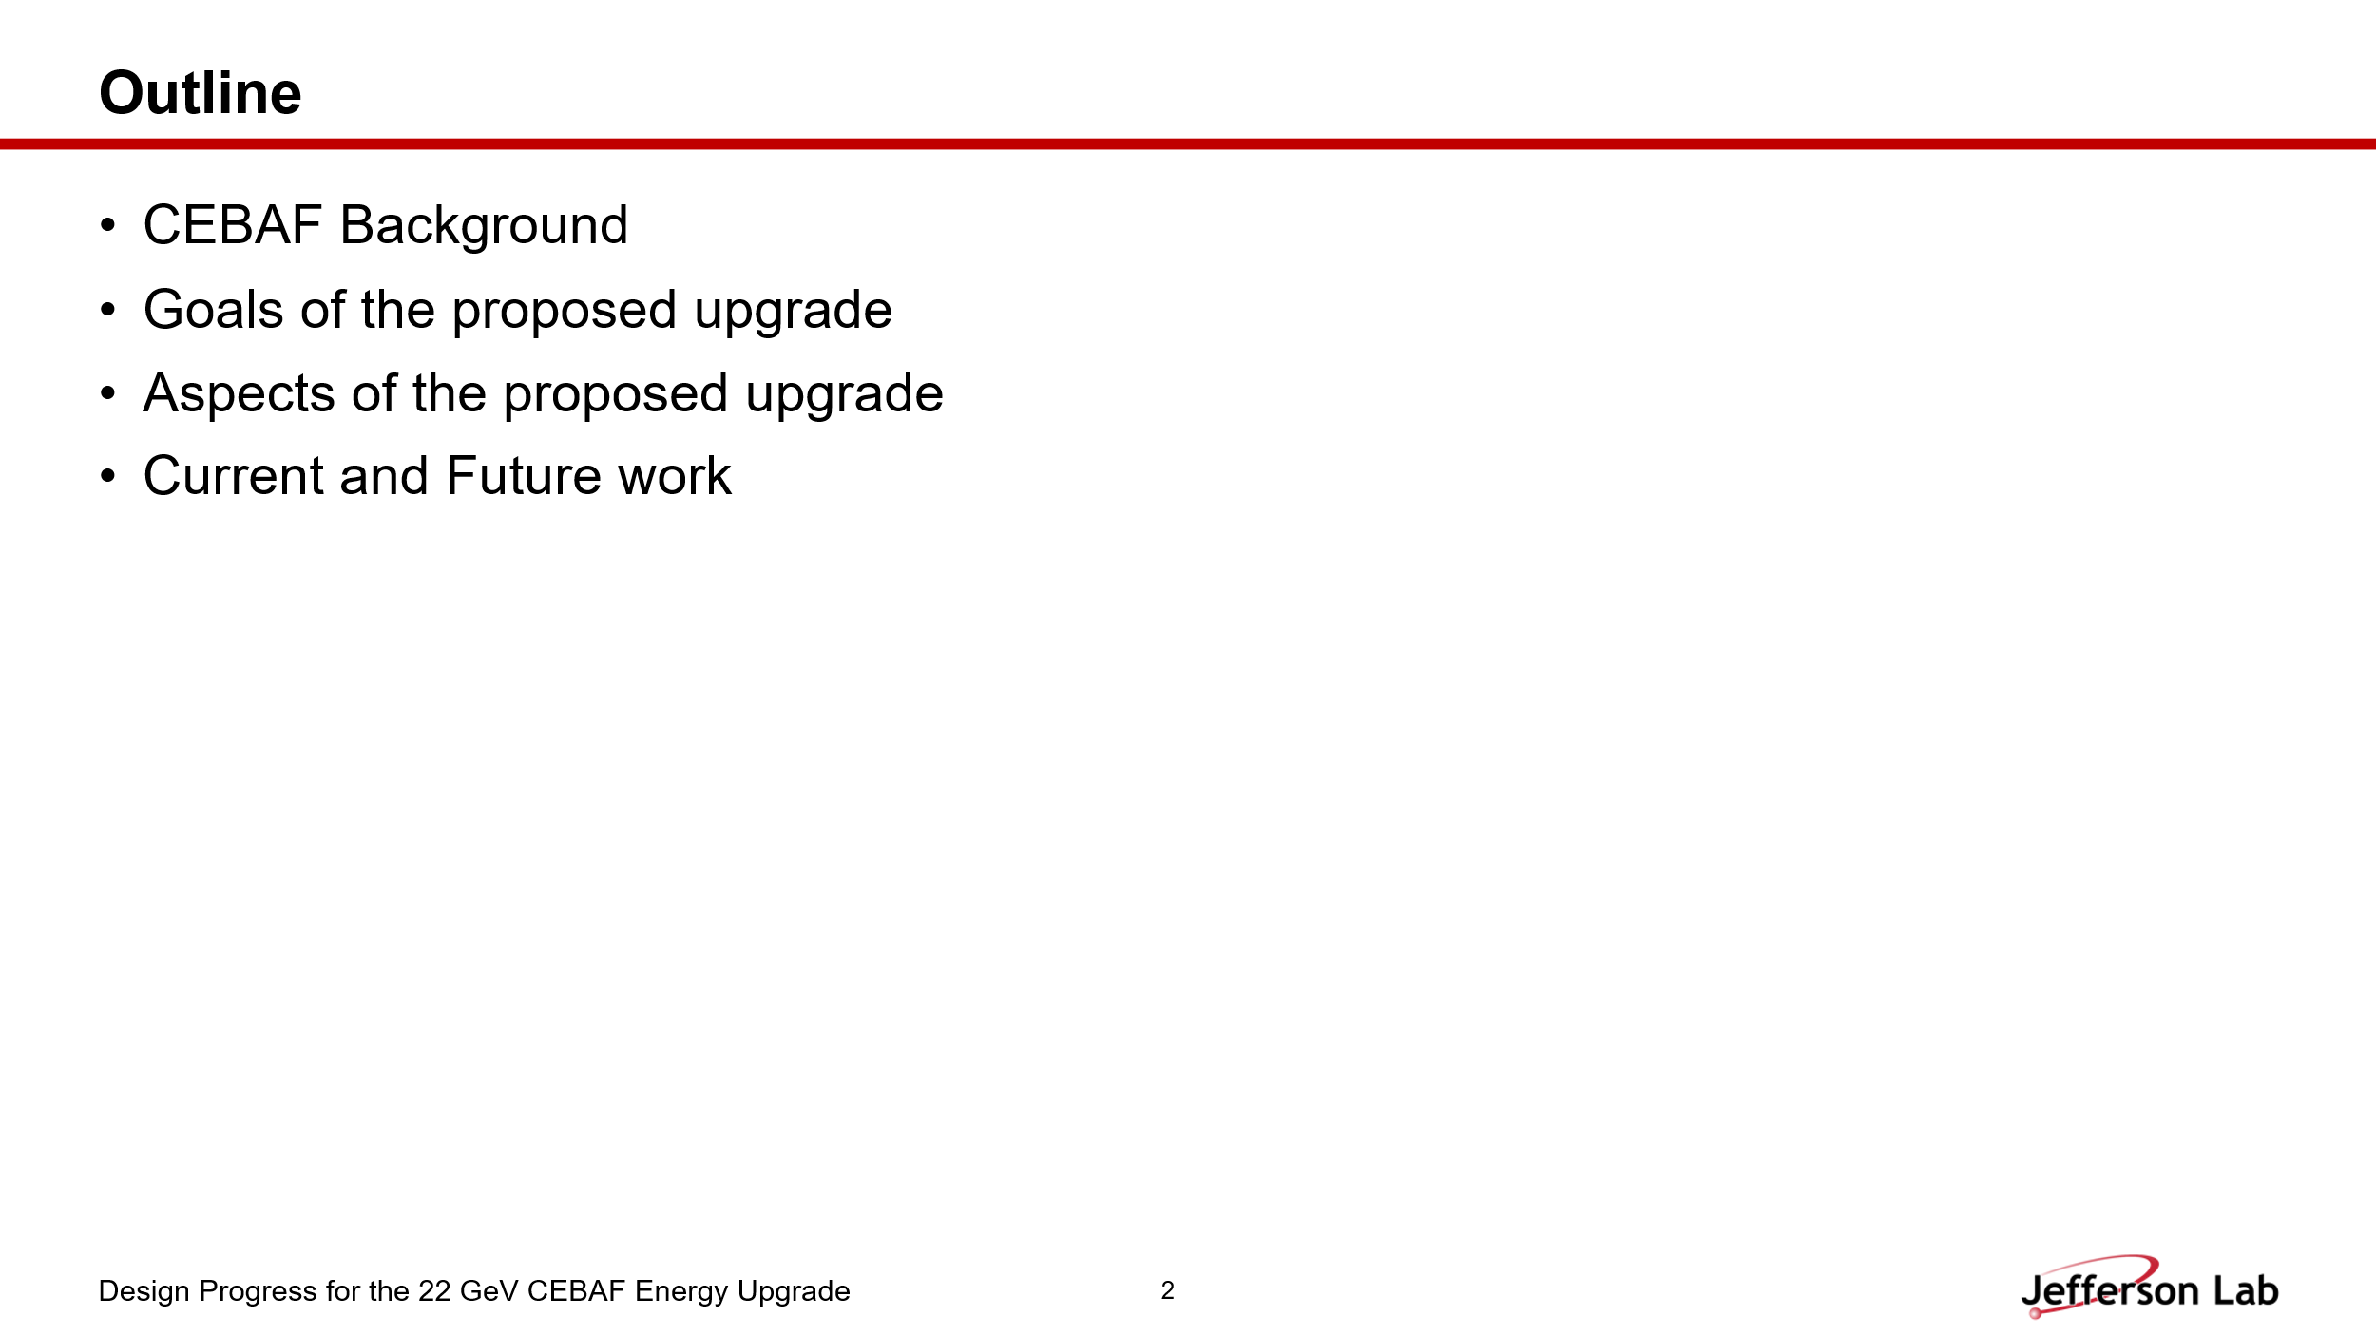

- 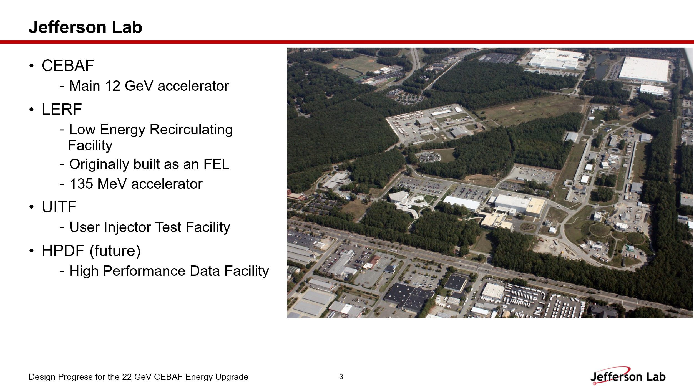

- 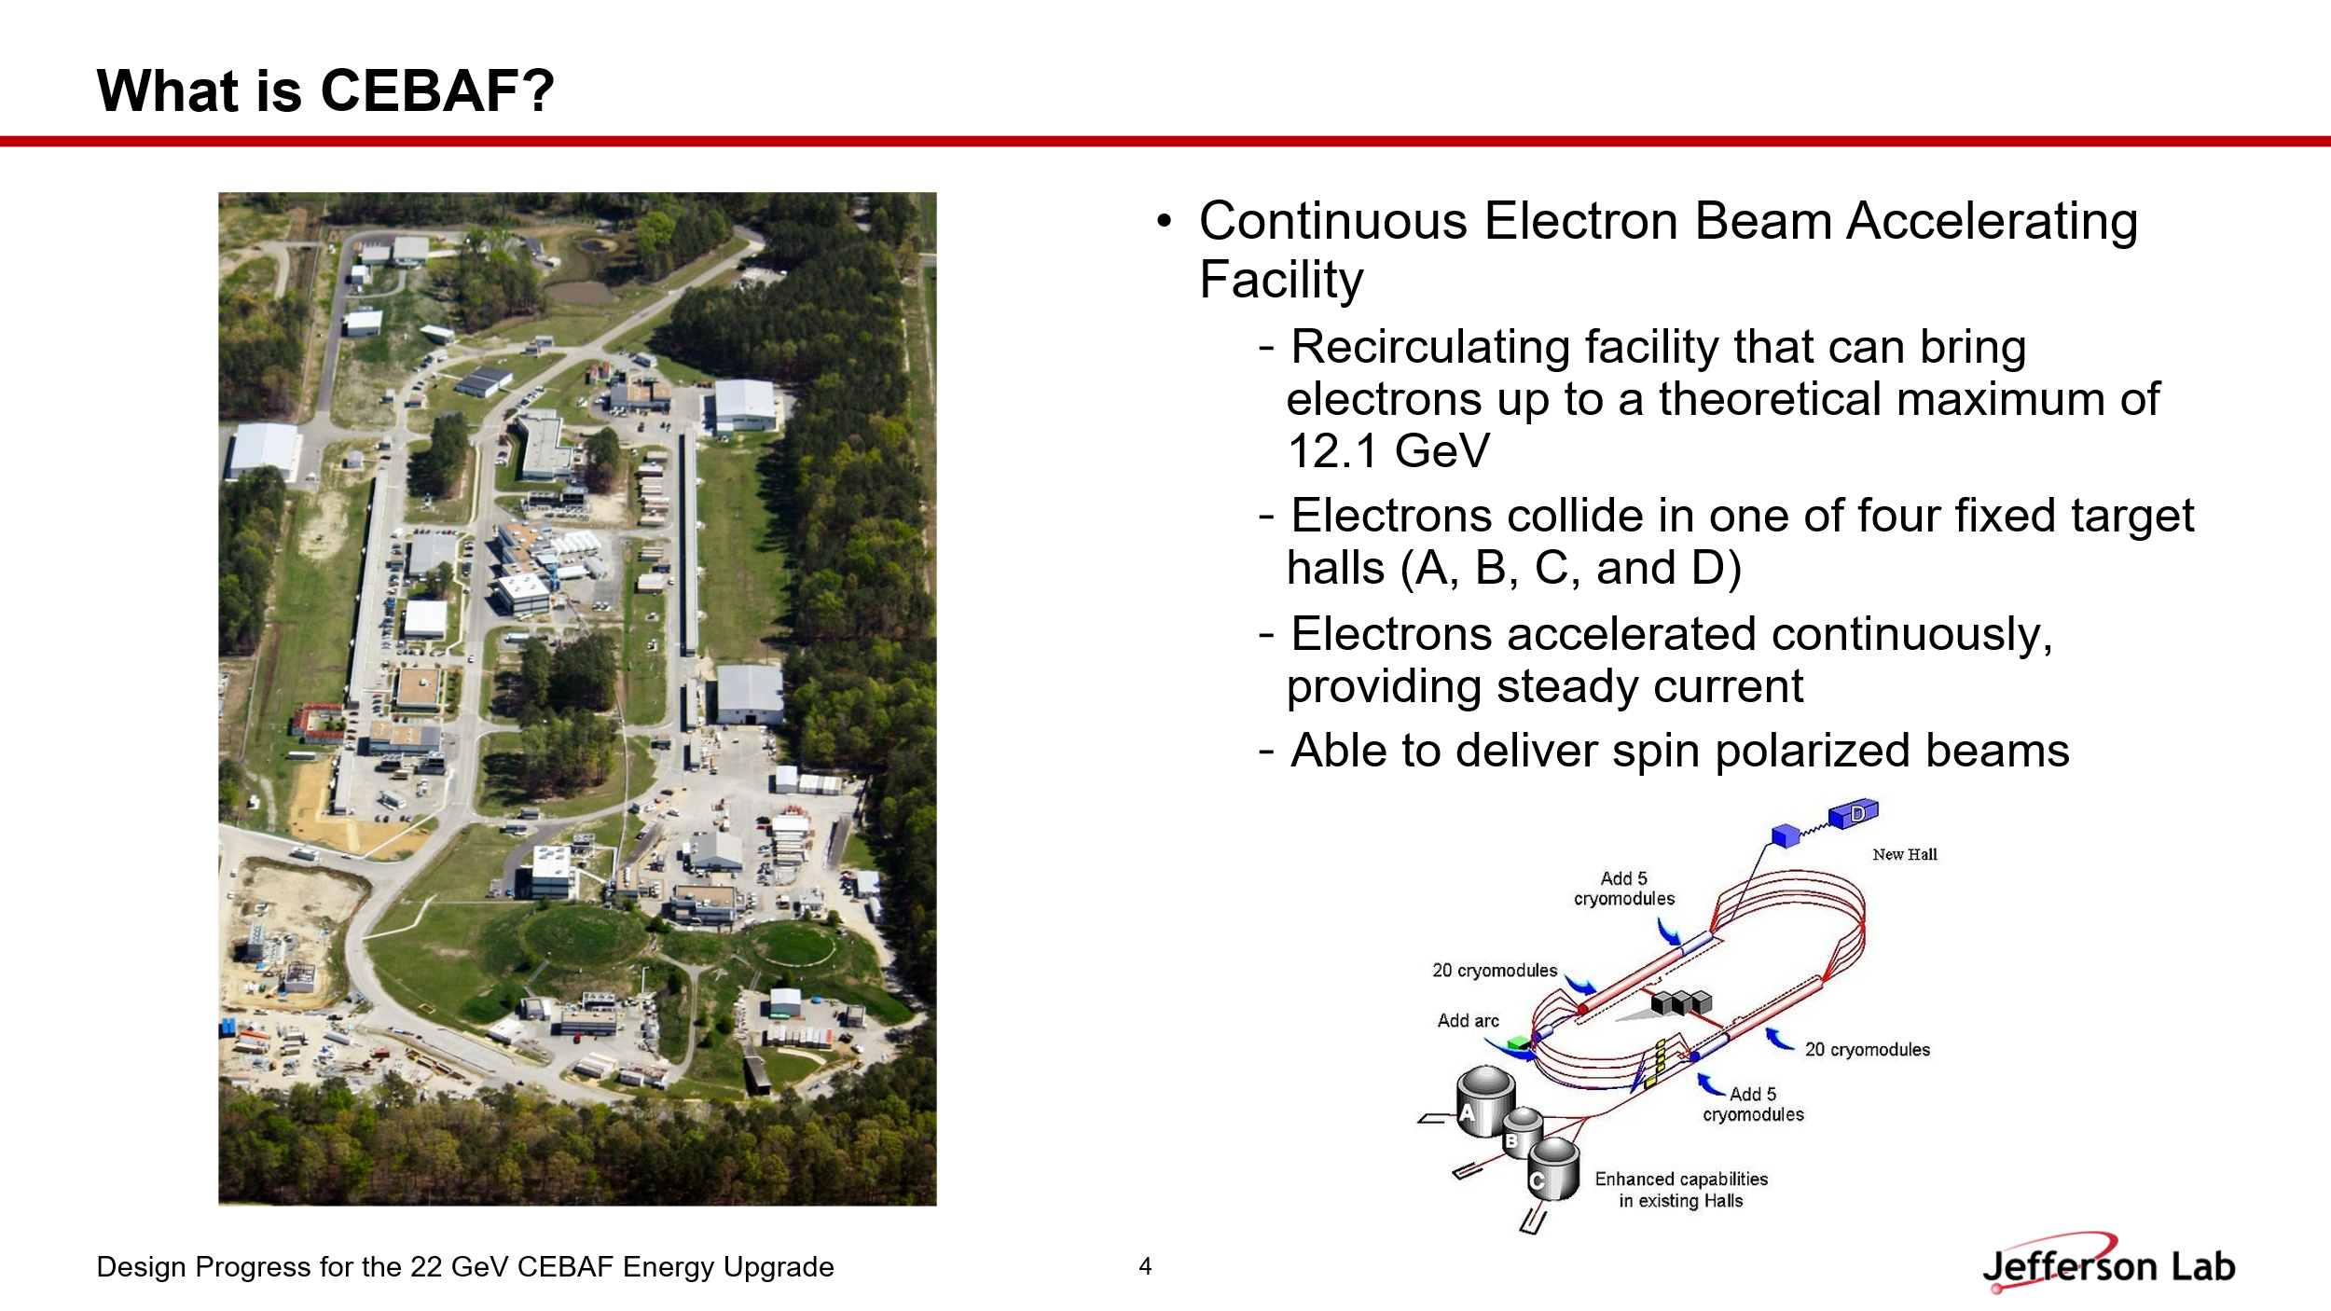

- 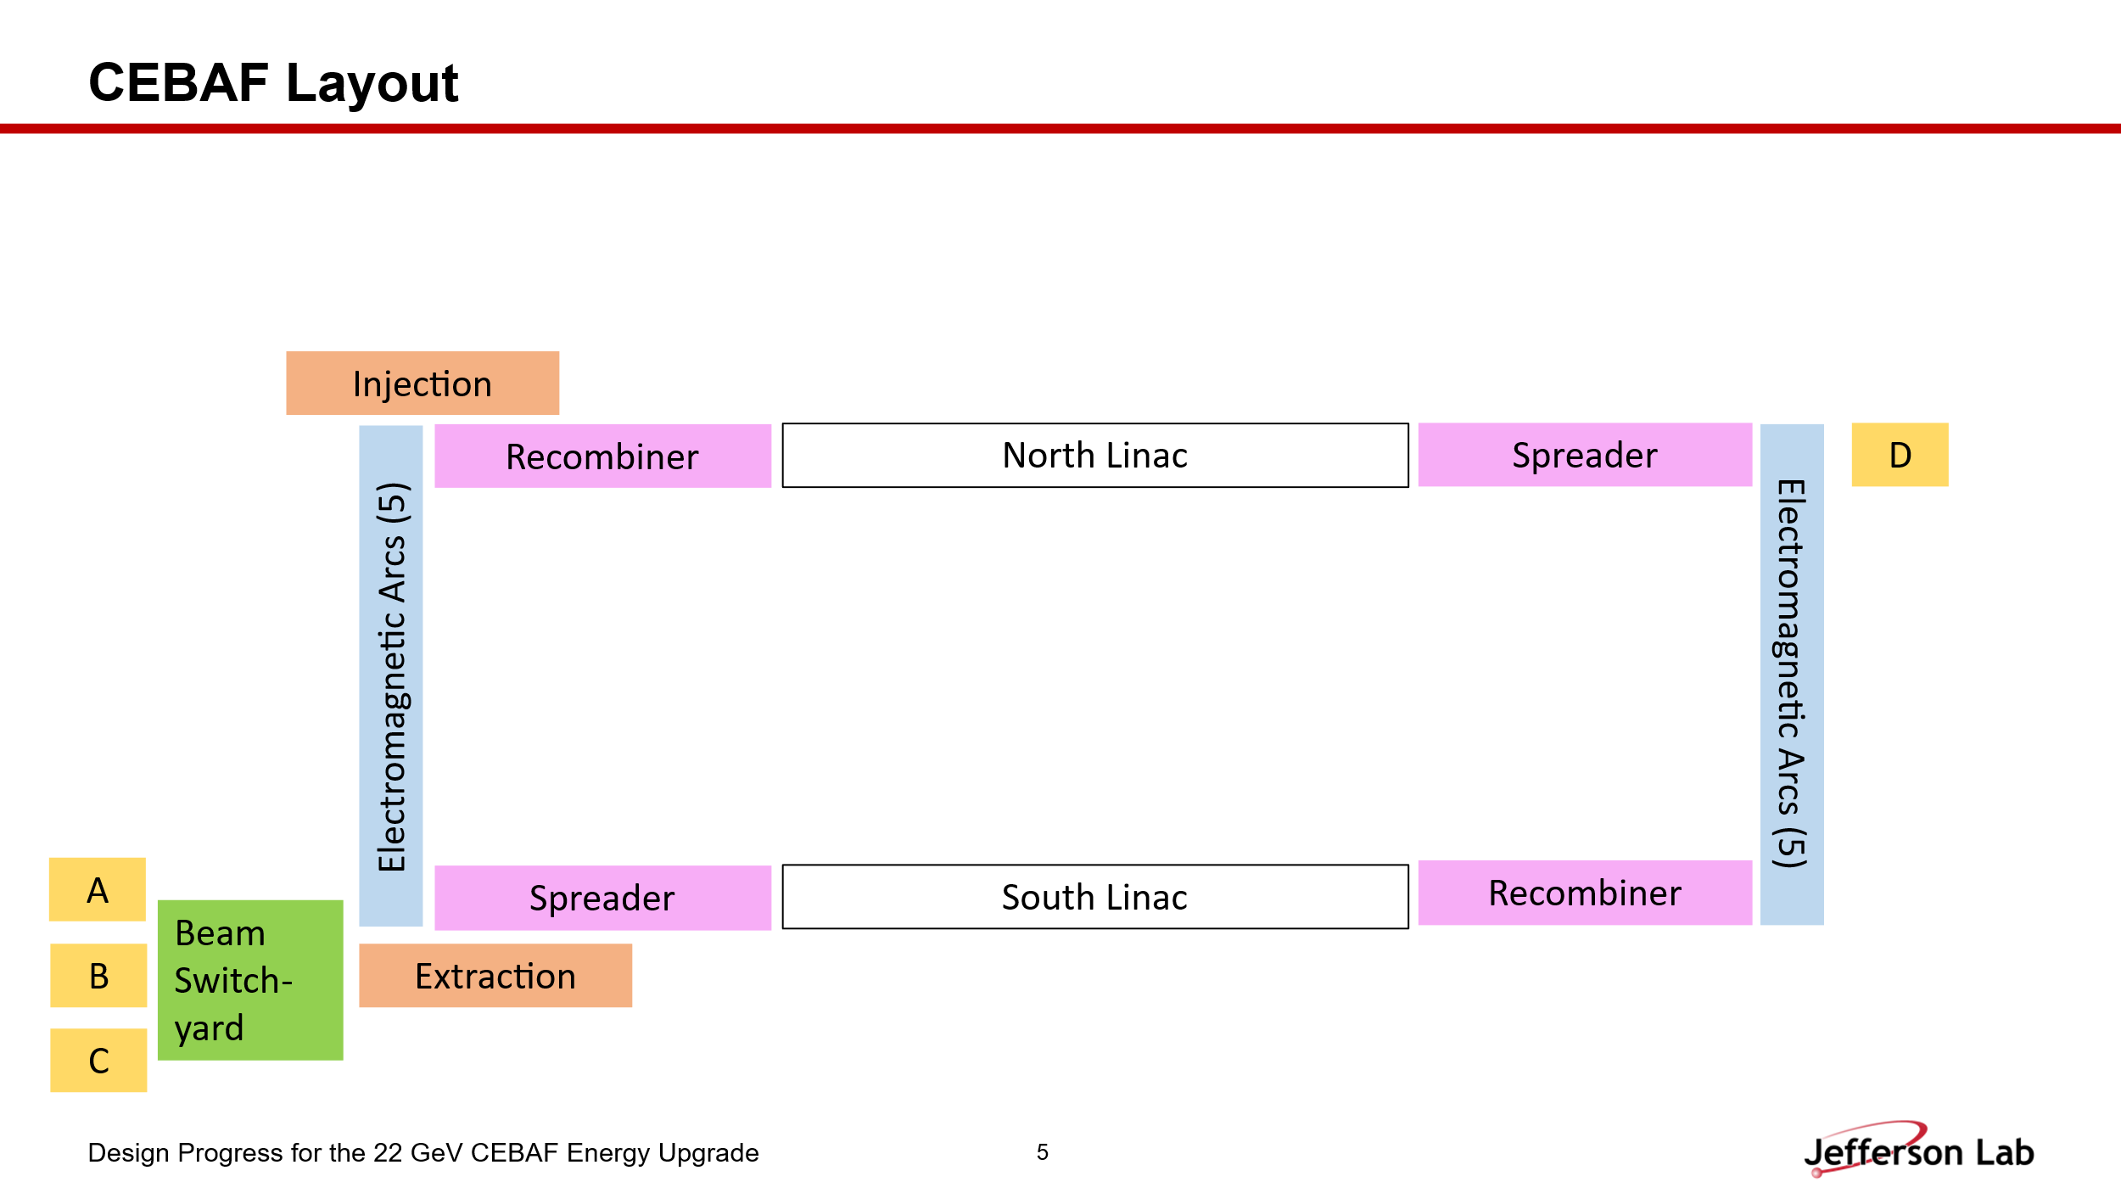
  - Dejan recommended adding a CEBAF racetrack layout in the middle.

- 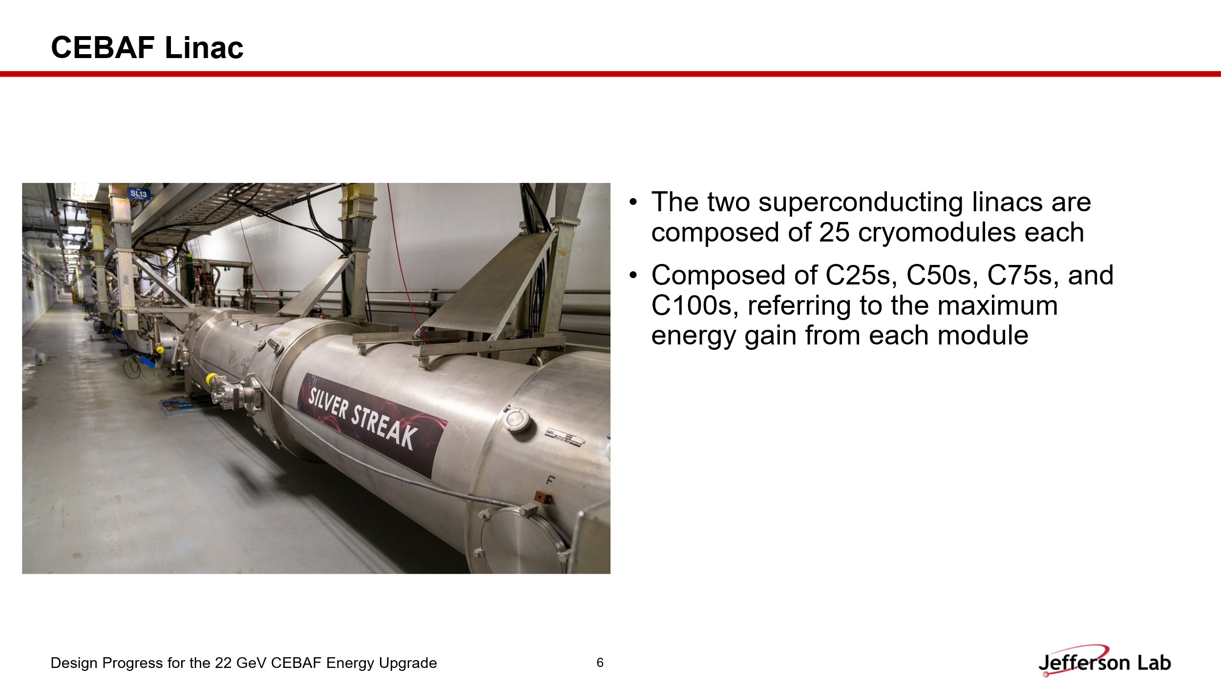
- 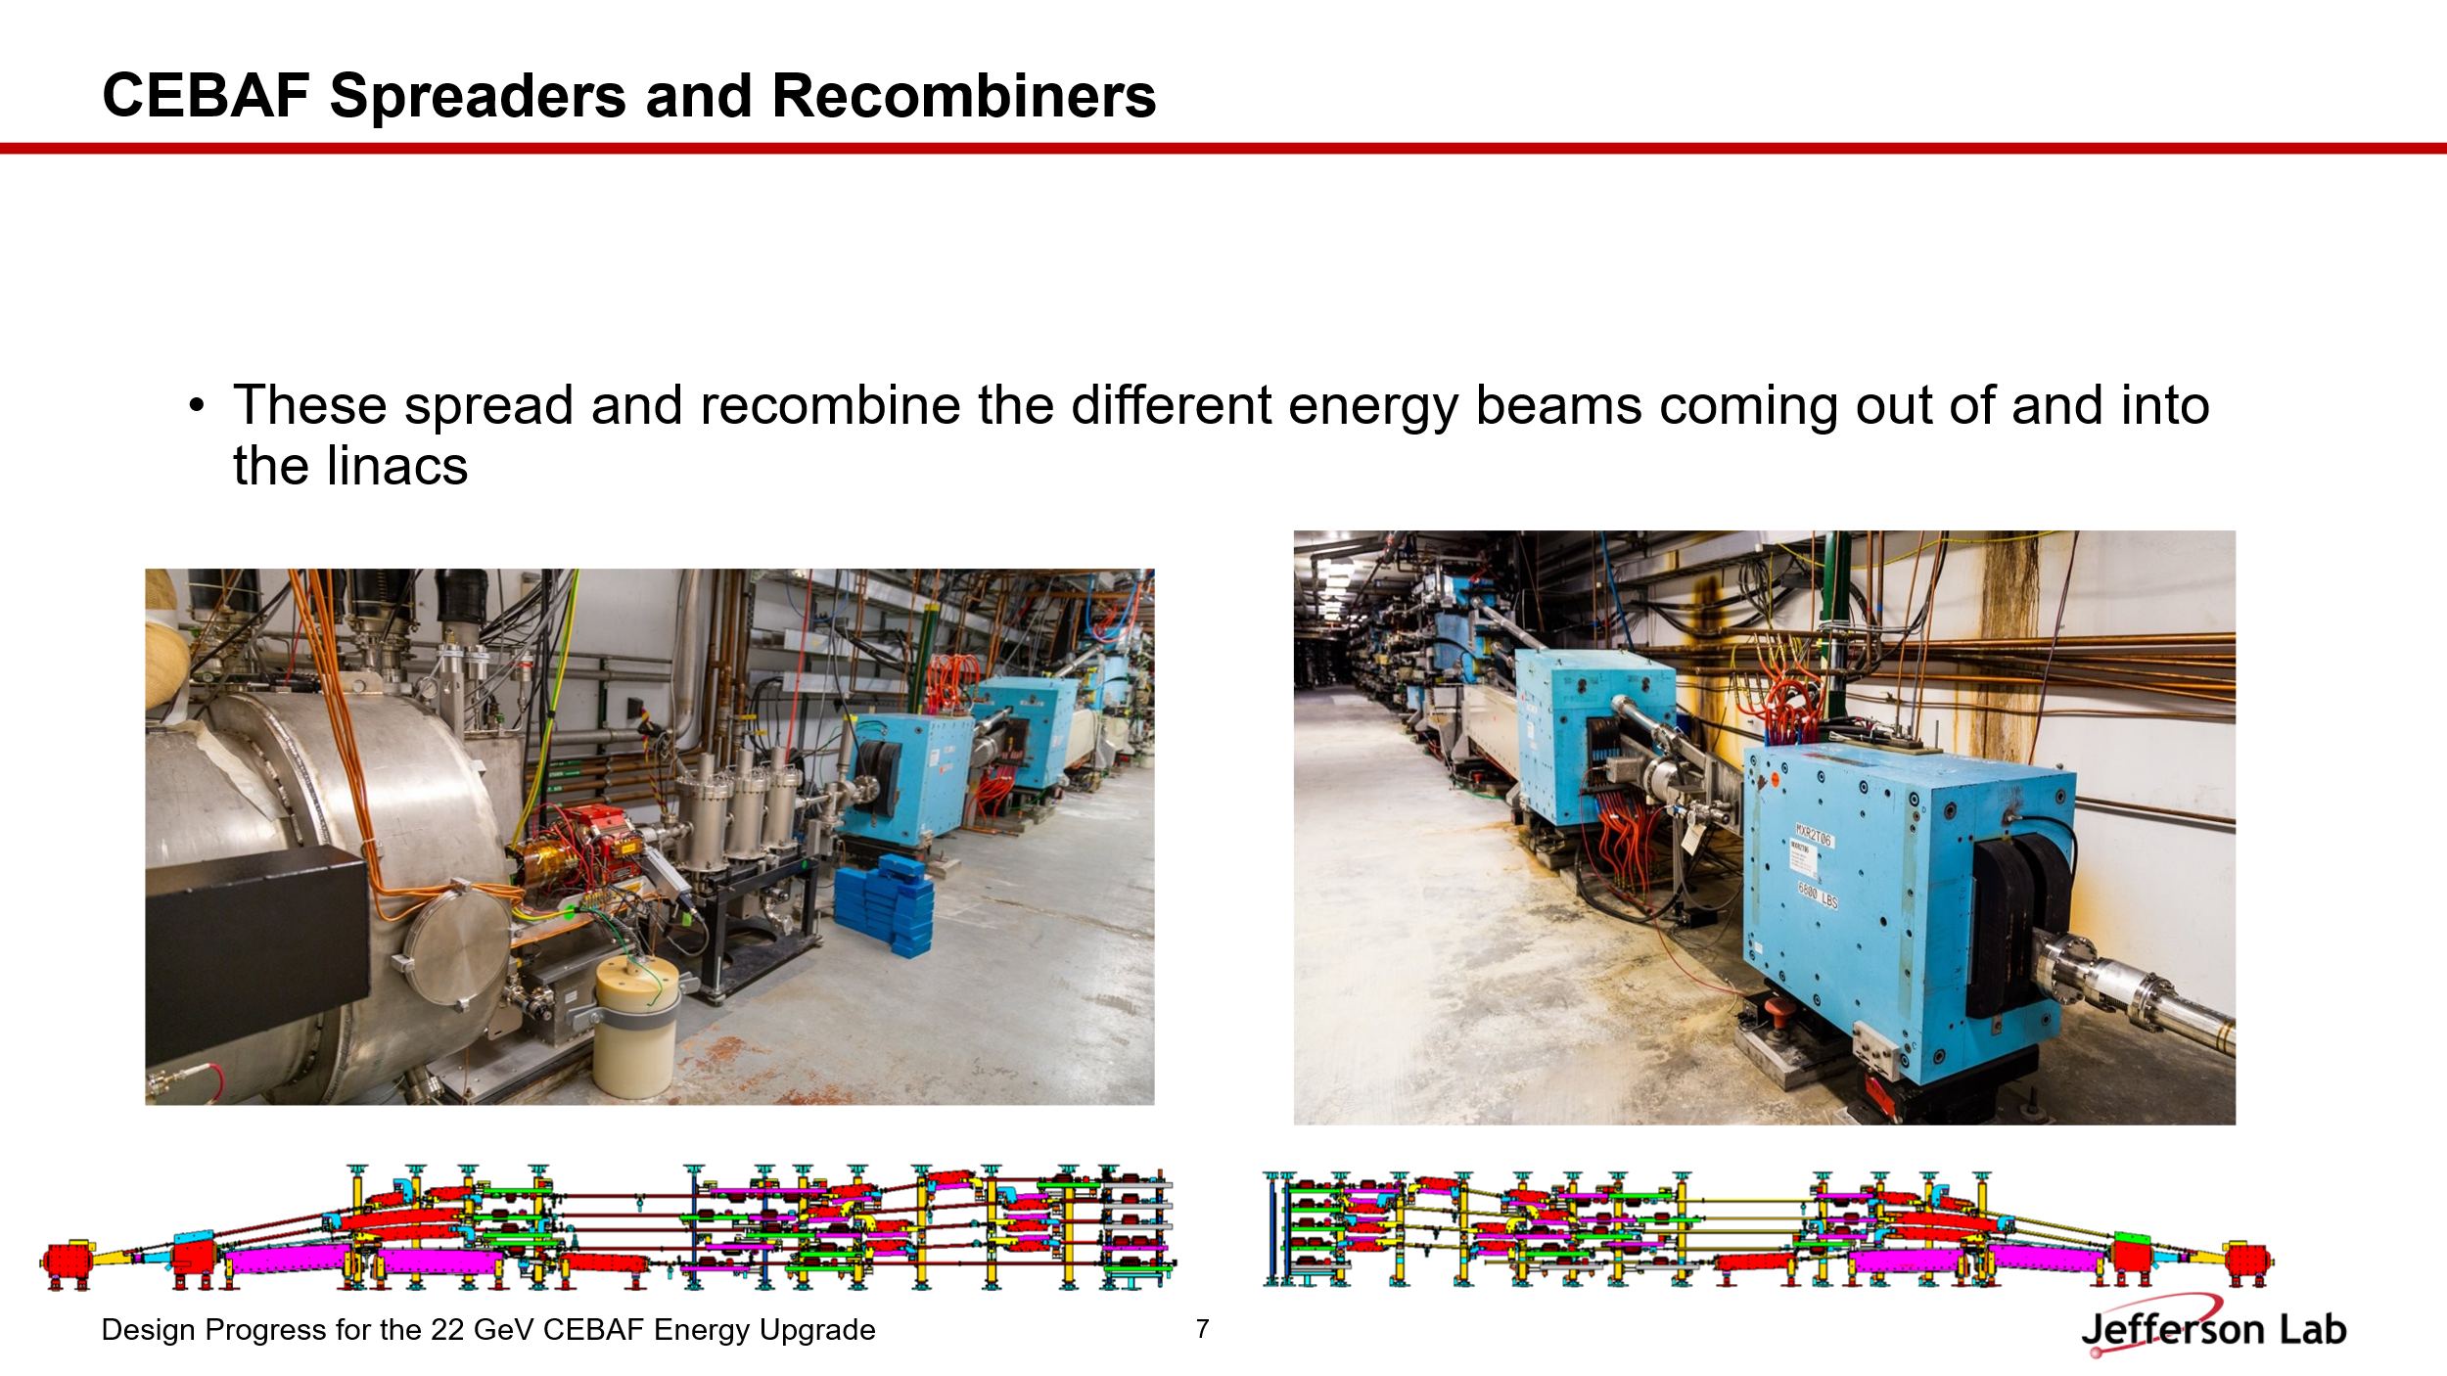
- 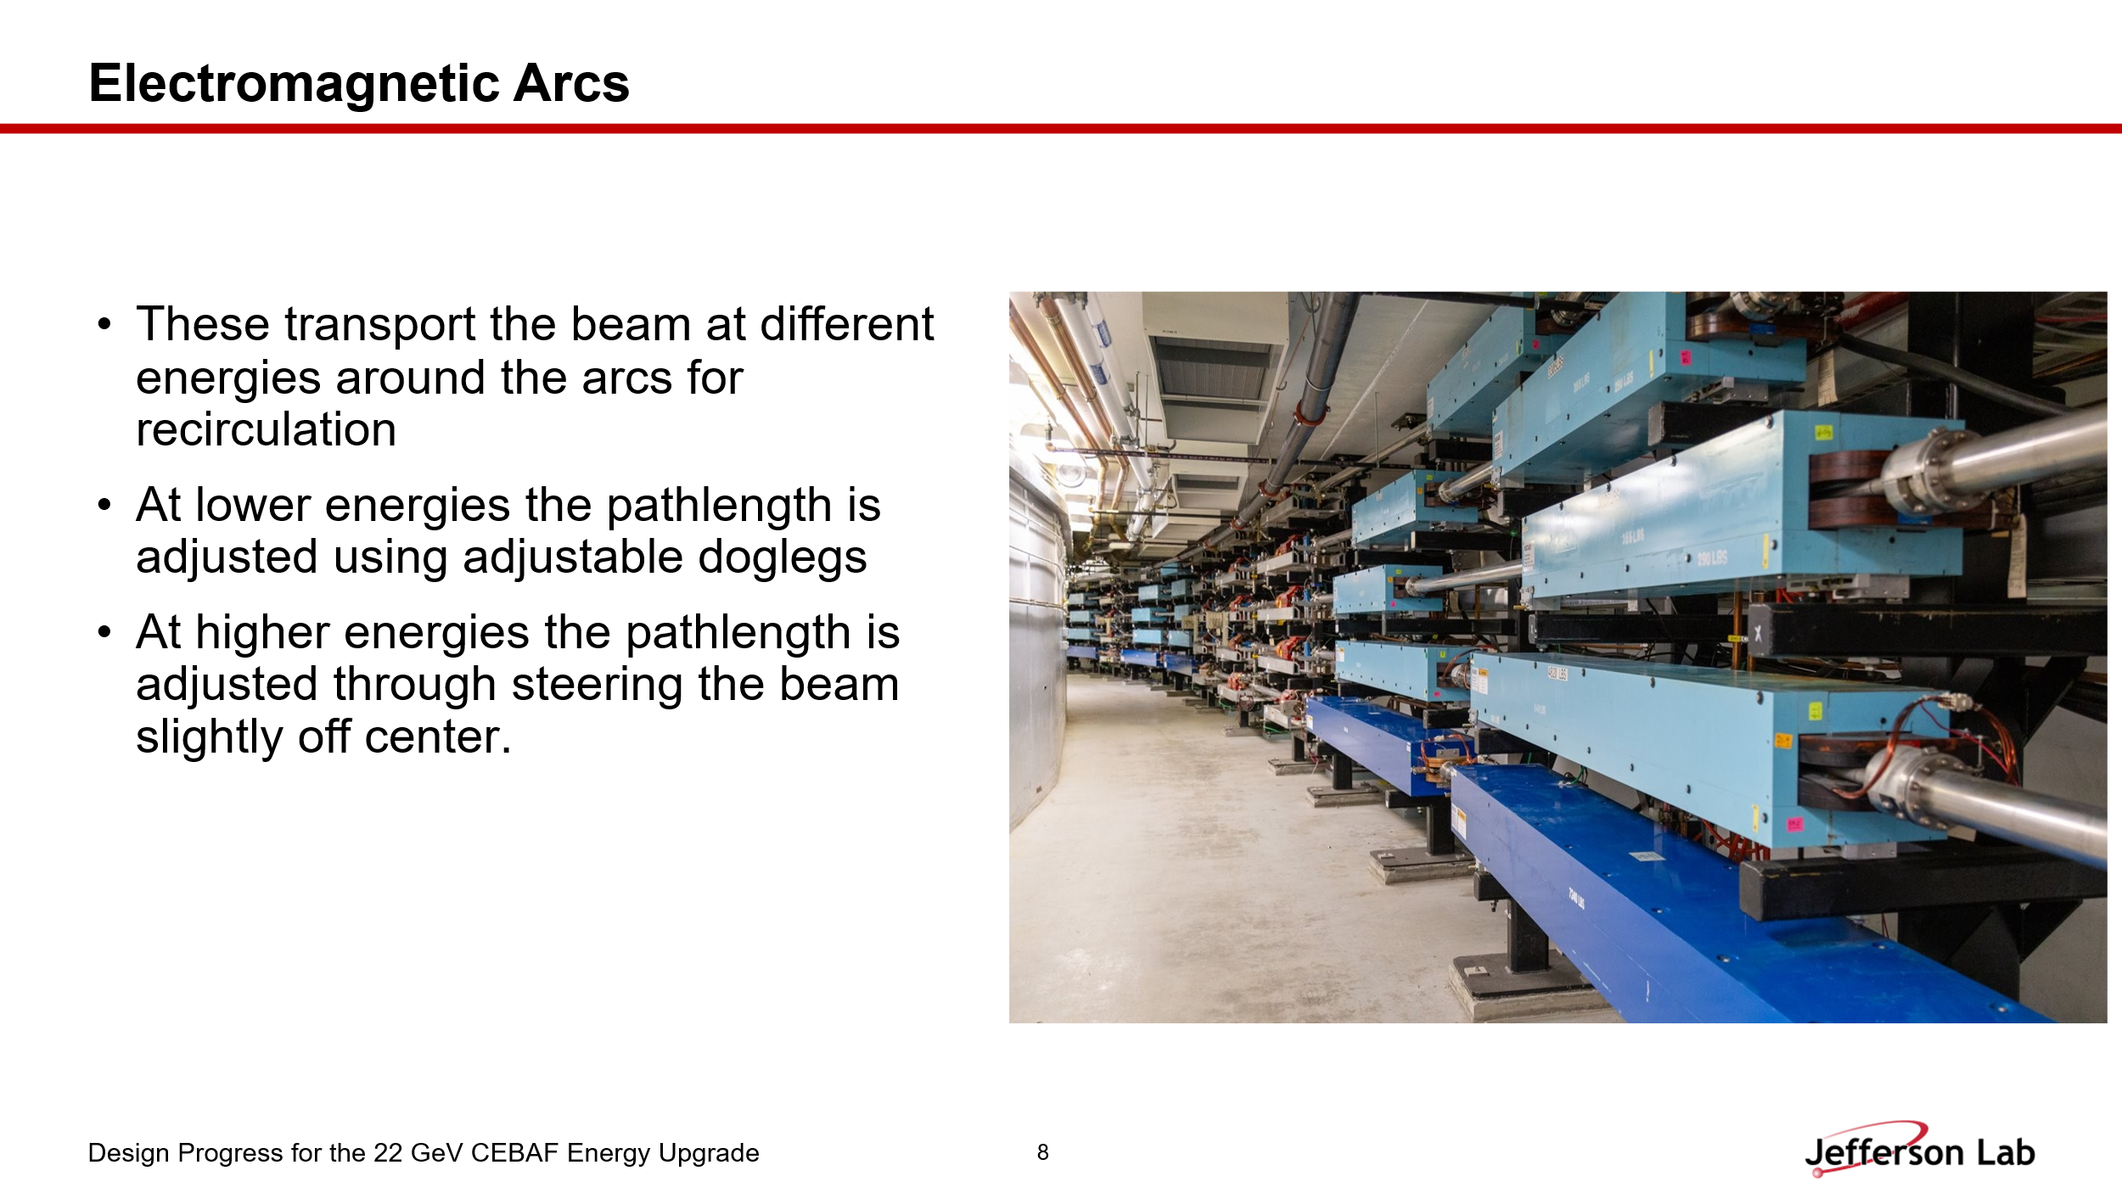

- 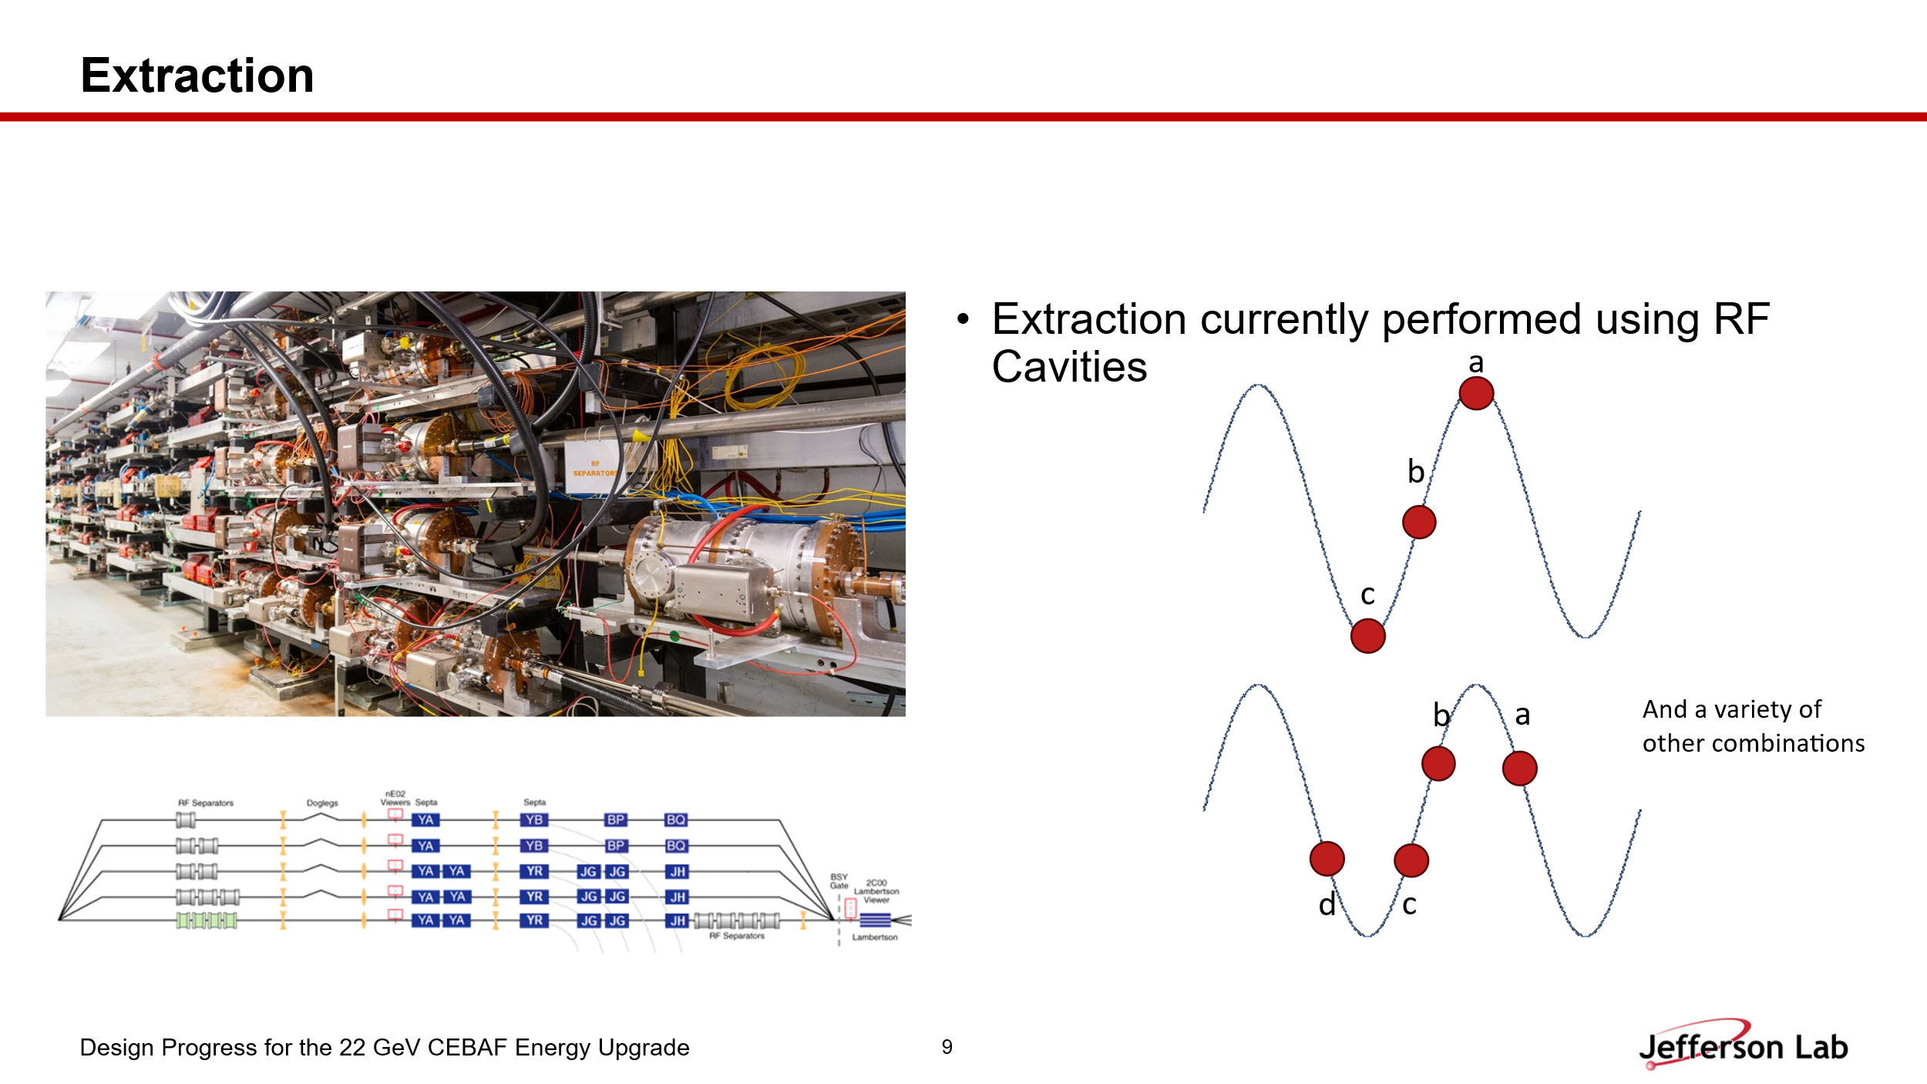

  - Dejan recommended having another slide to highlight the uniqueness of CEBAF extraction, maybe referring to Andrei’s older presentation. Ryan: maybe Reza’s presentation.
- 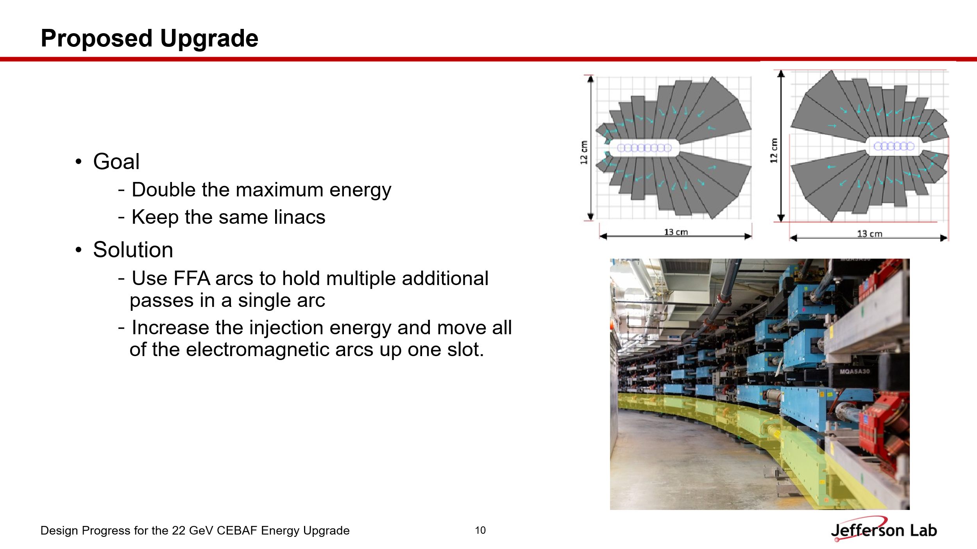
- 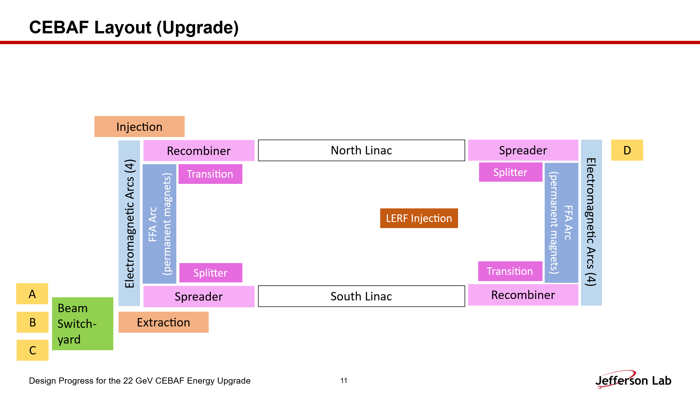
- 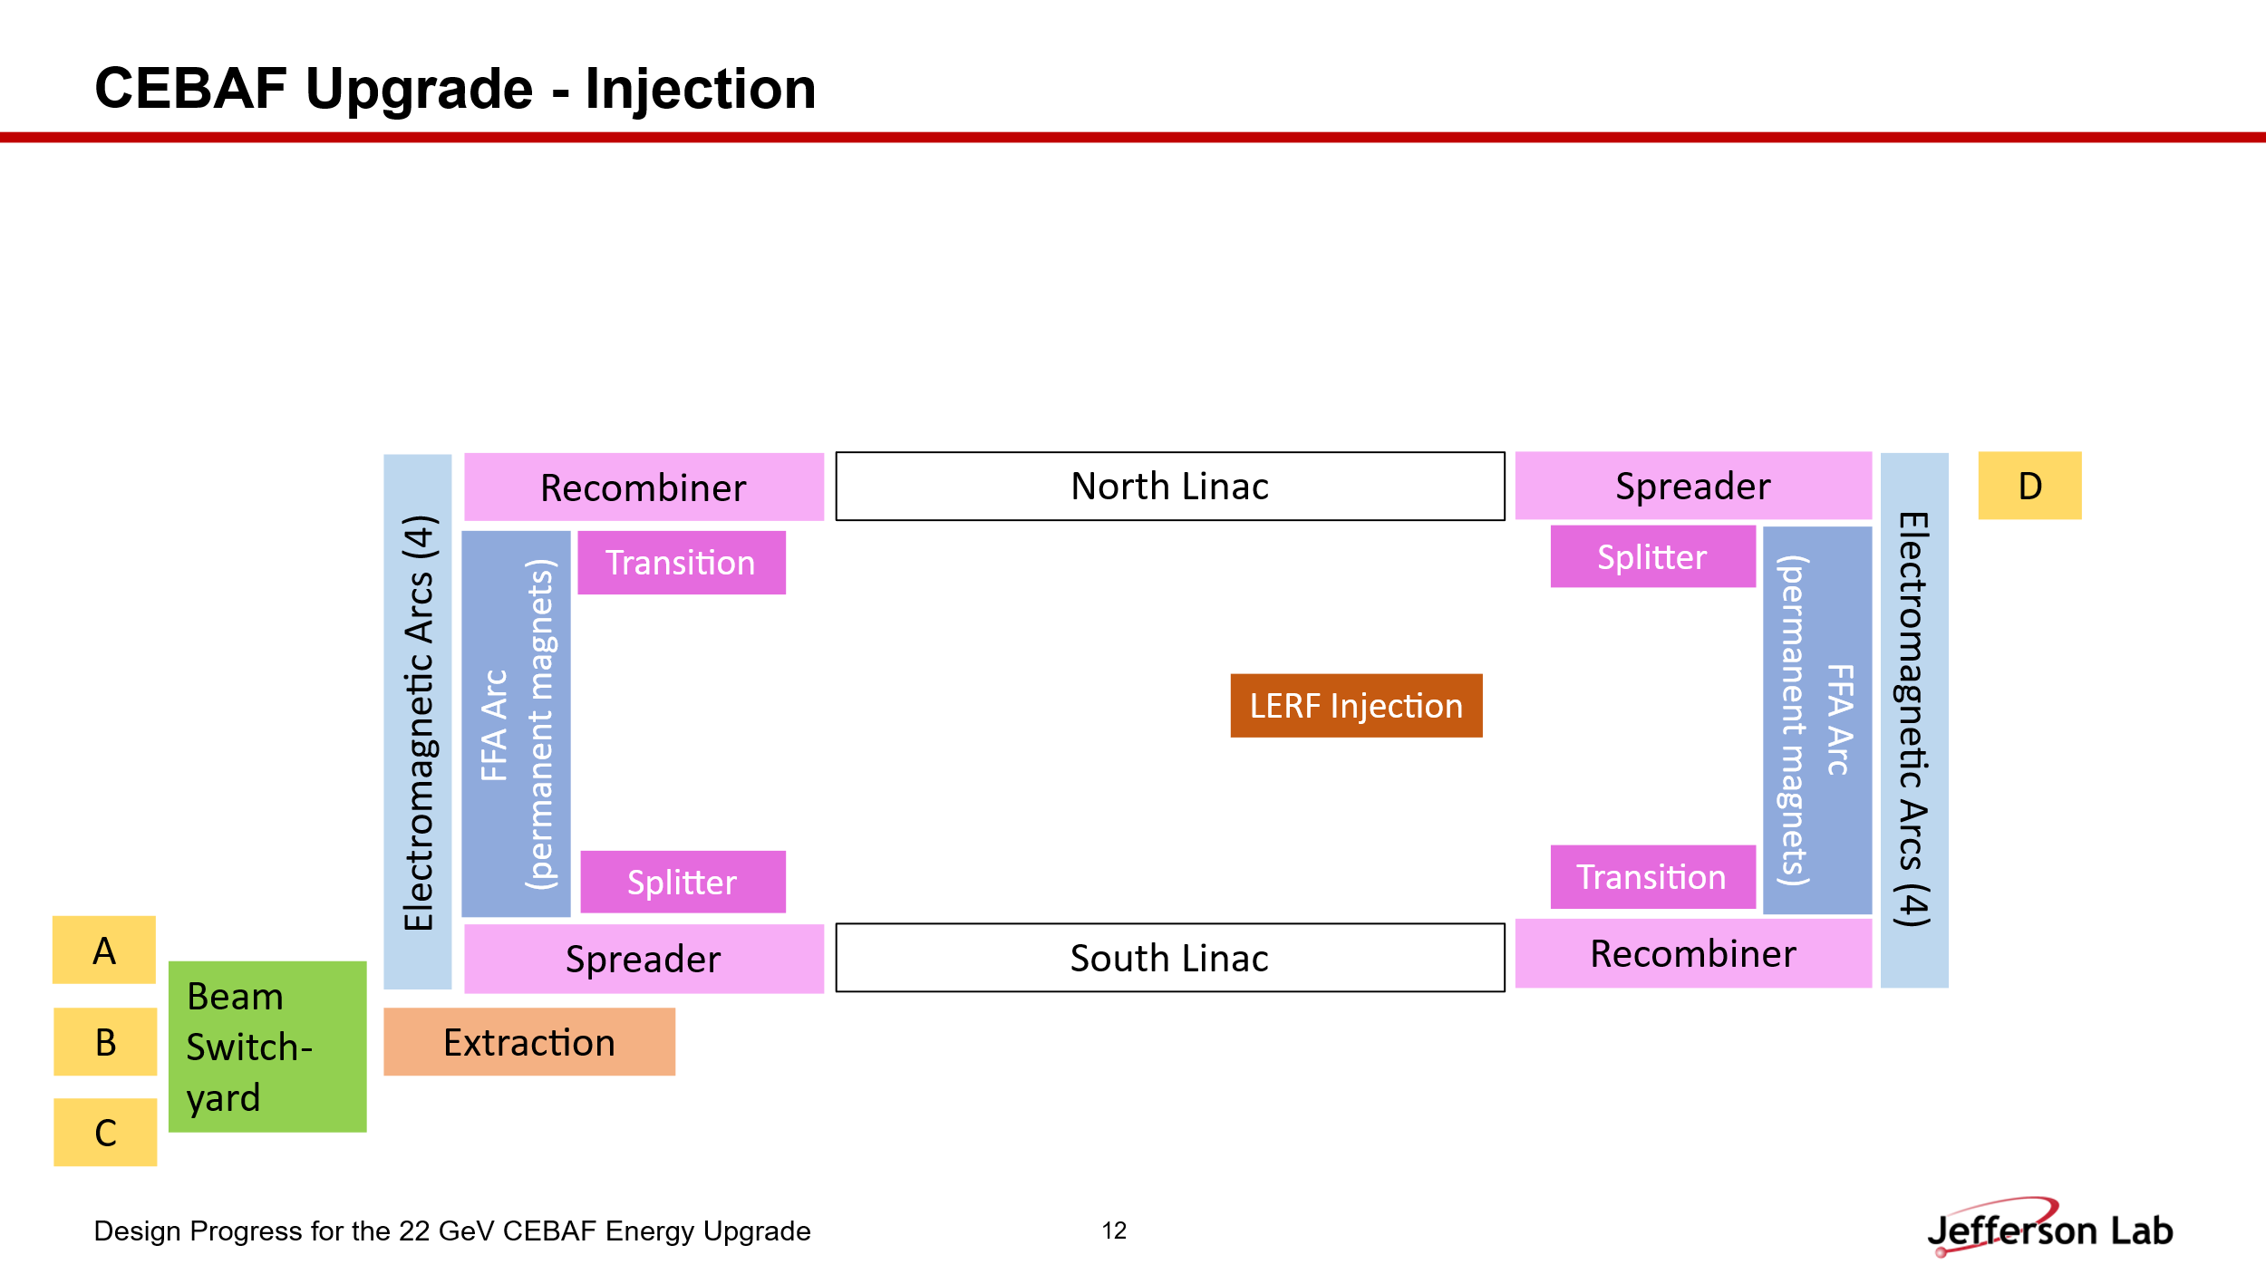
- 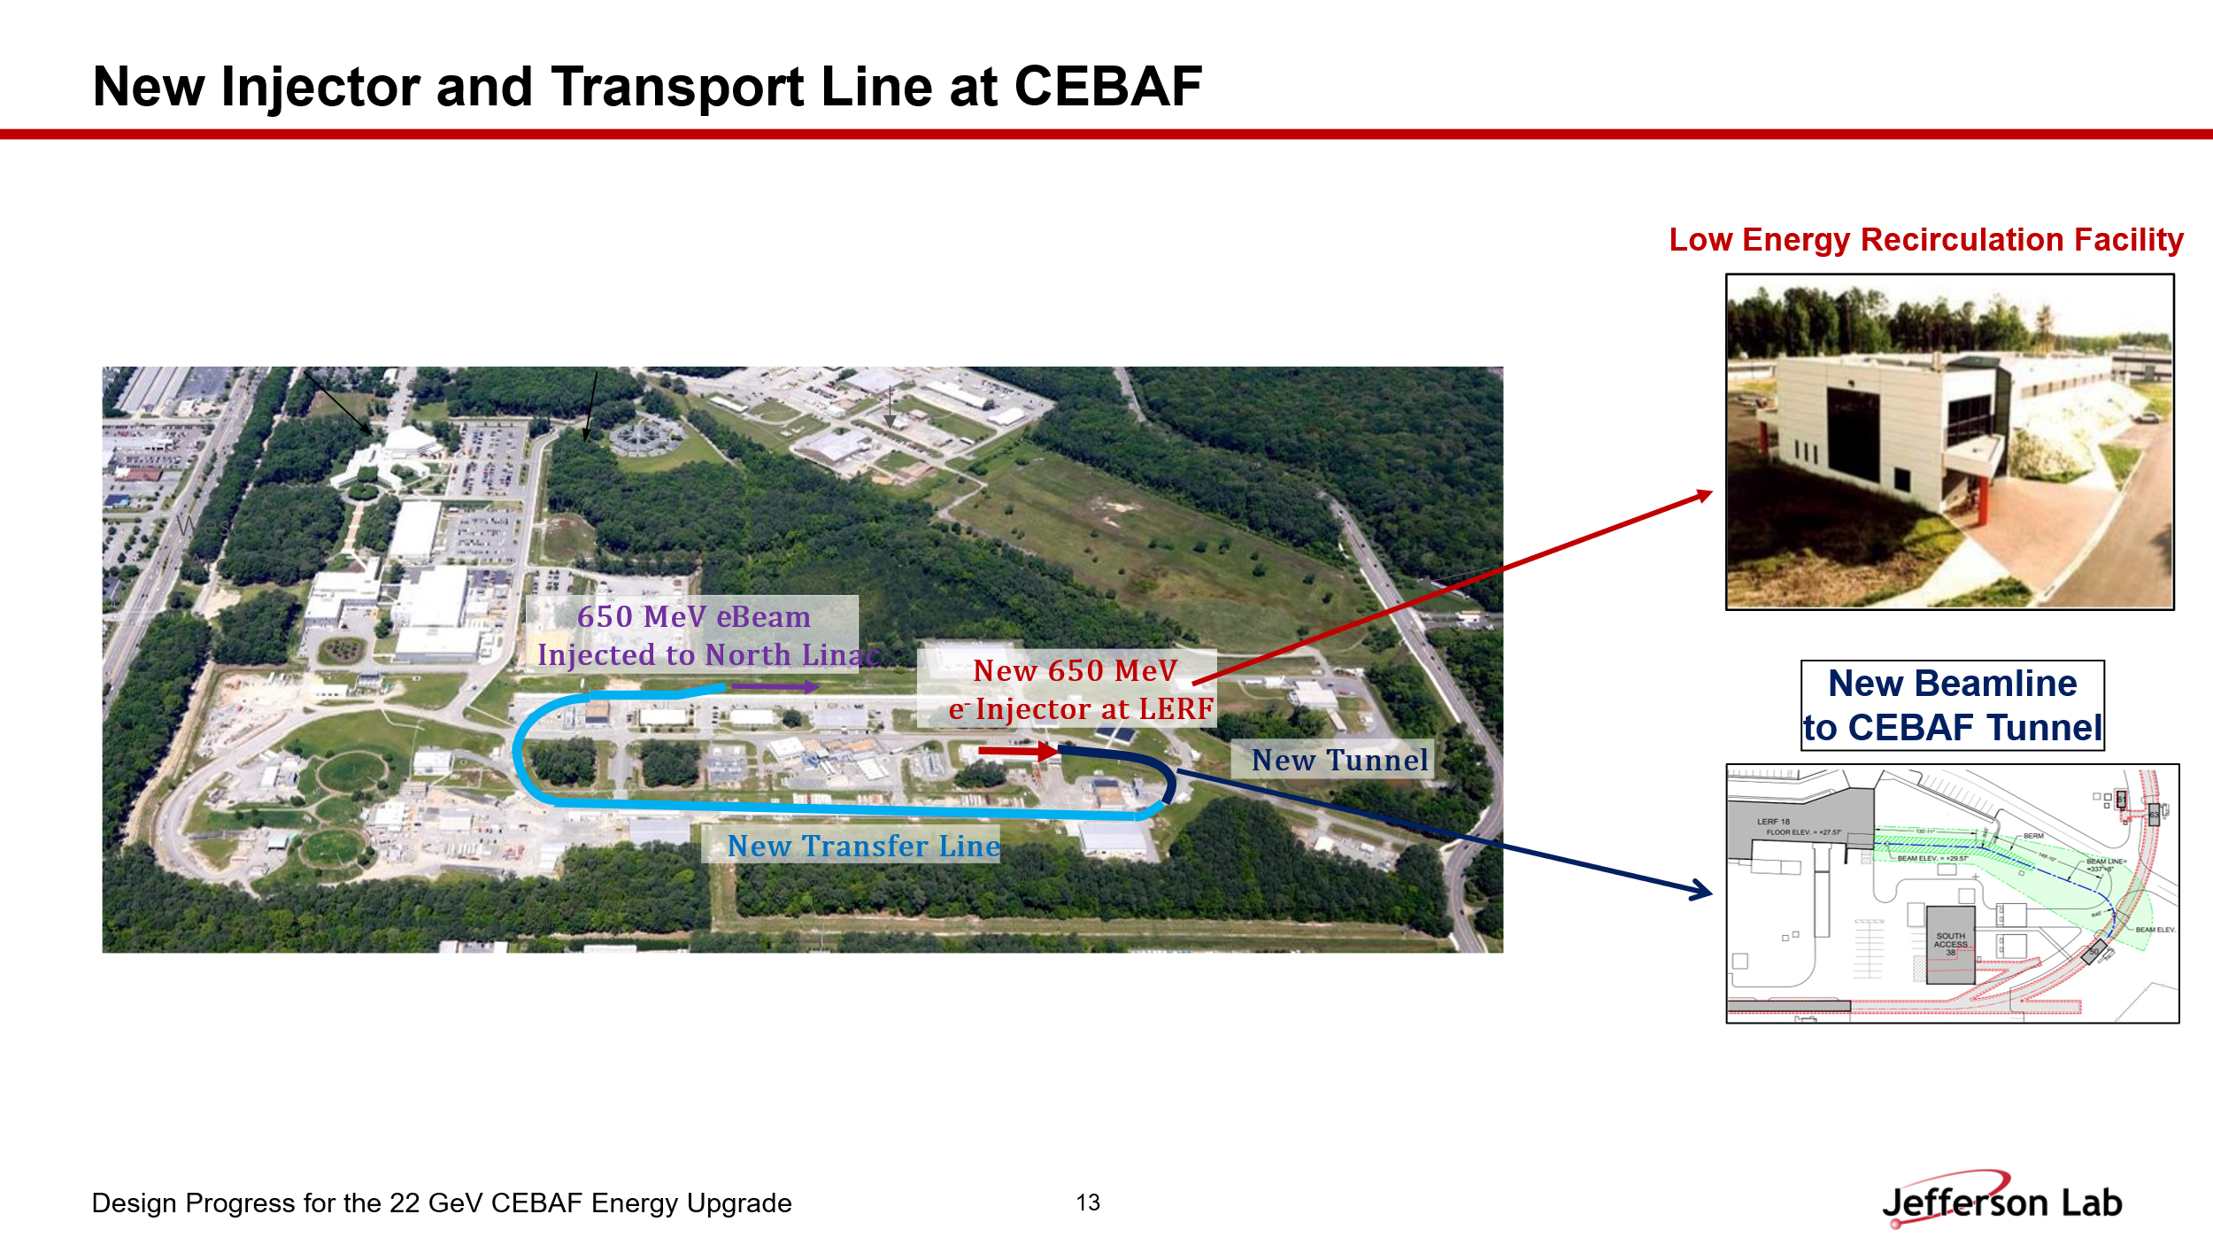
- 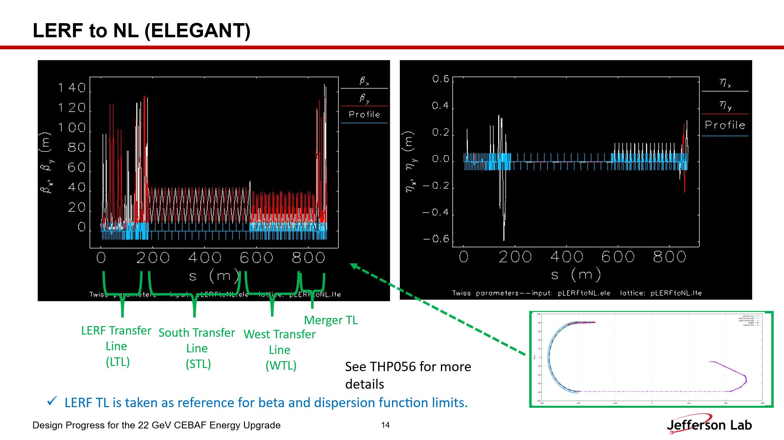
- 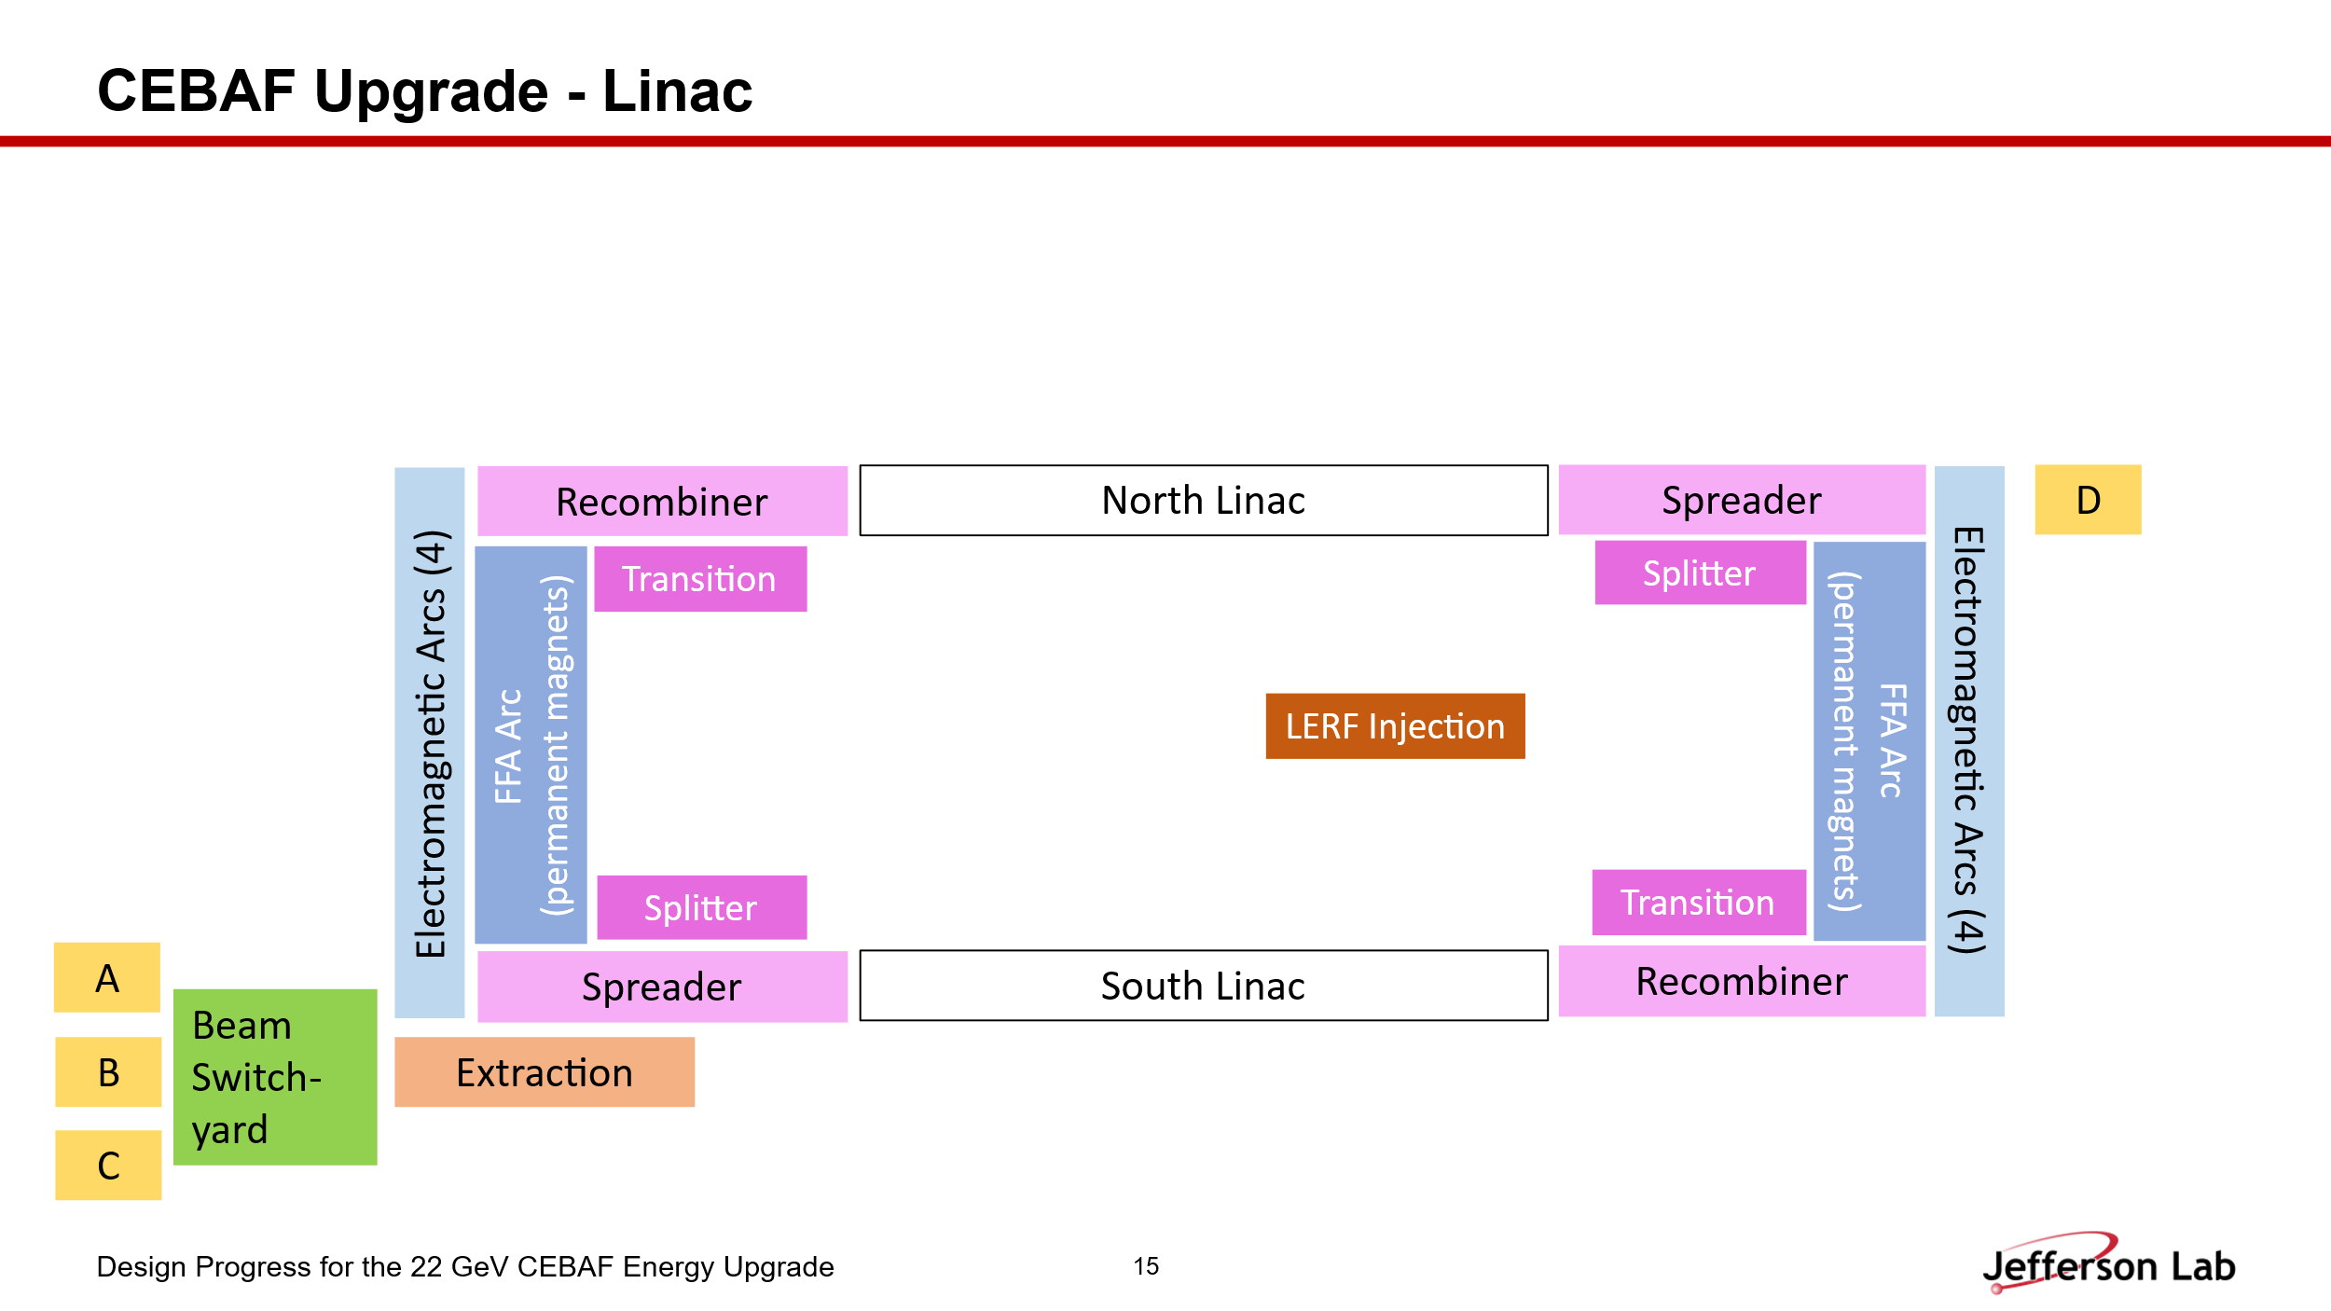
- 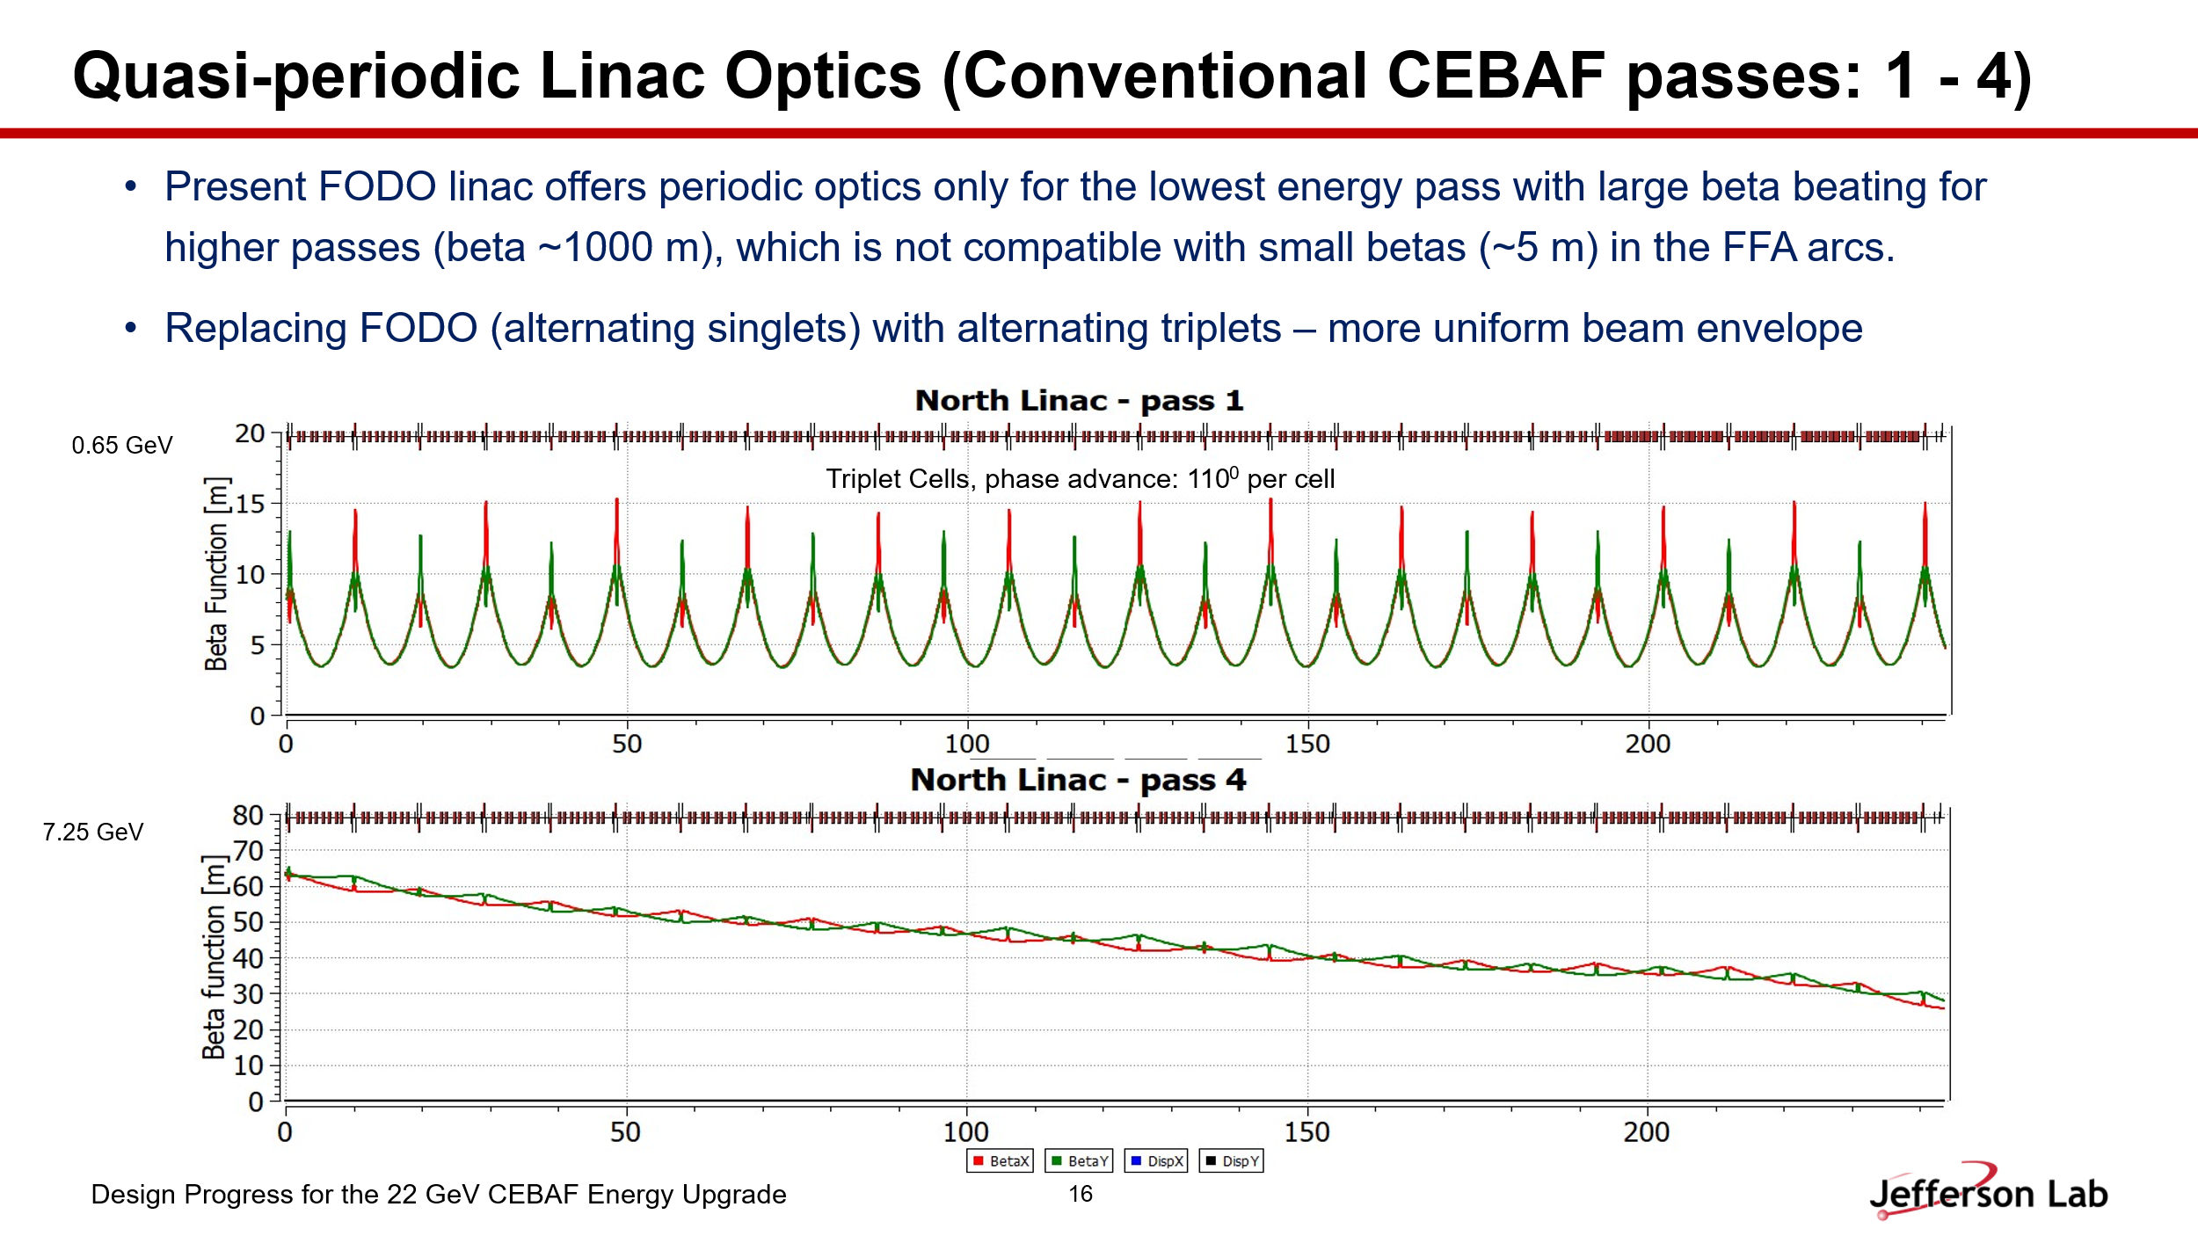
- 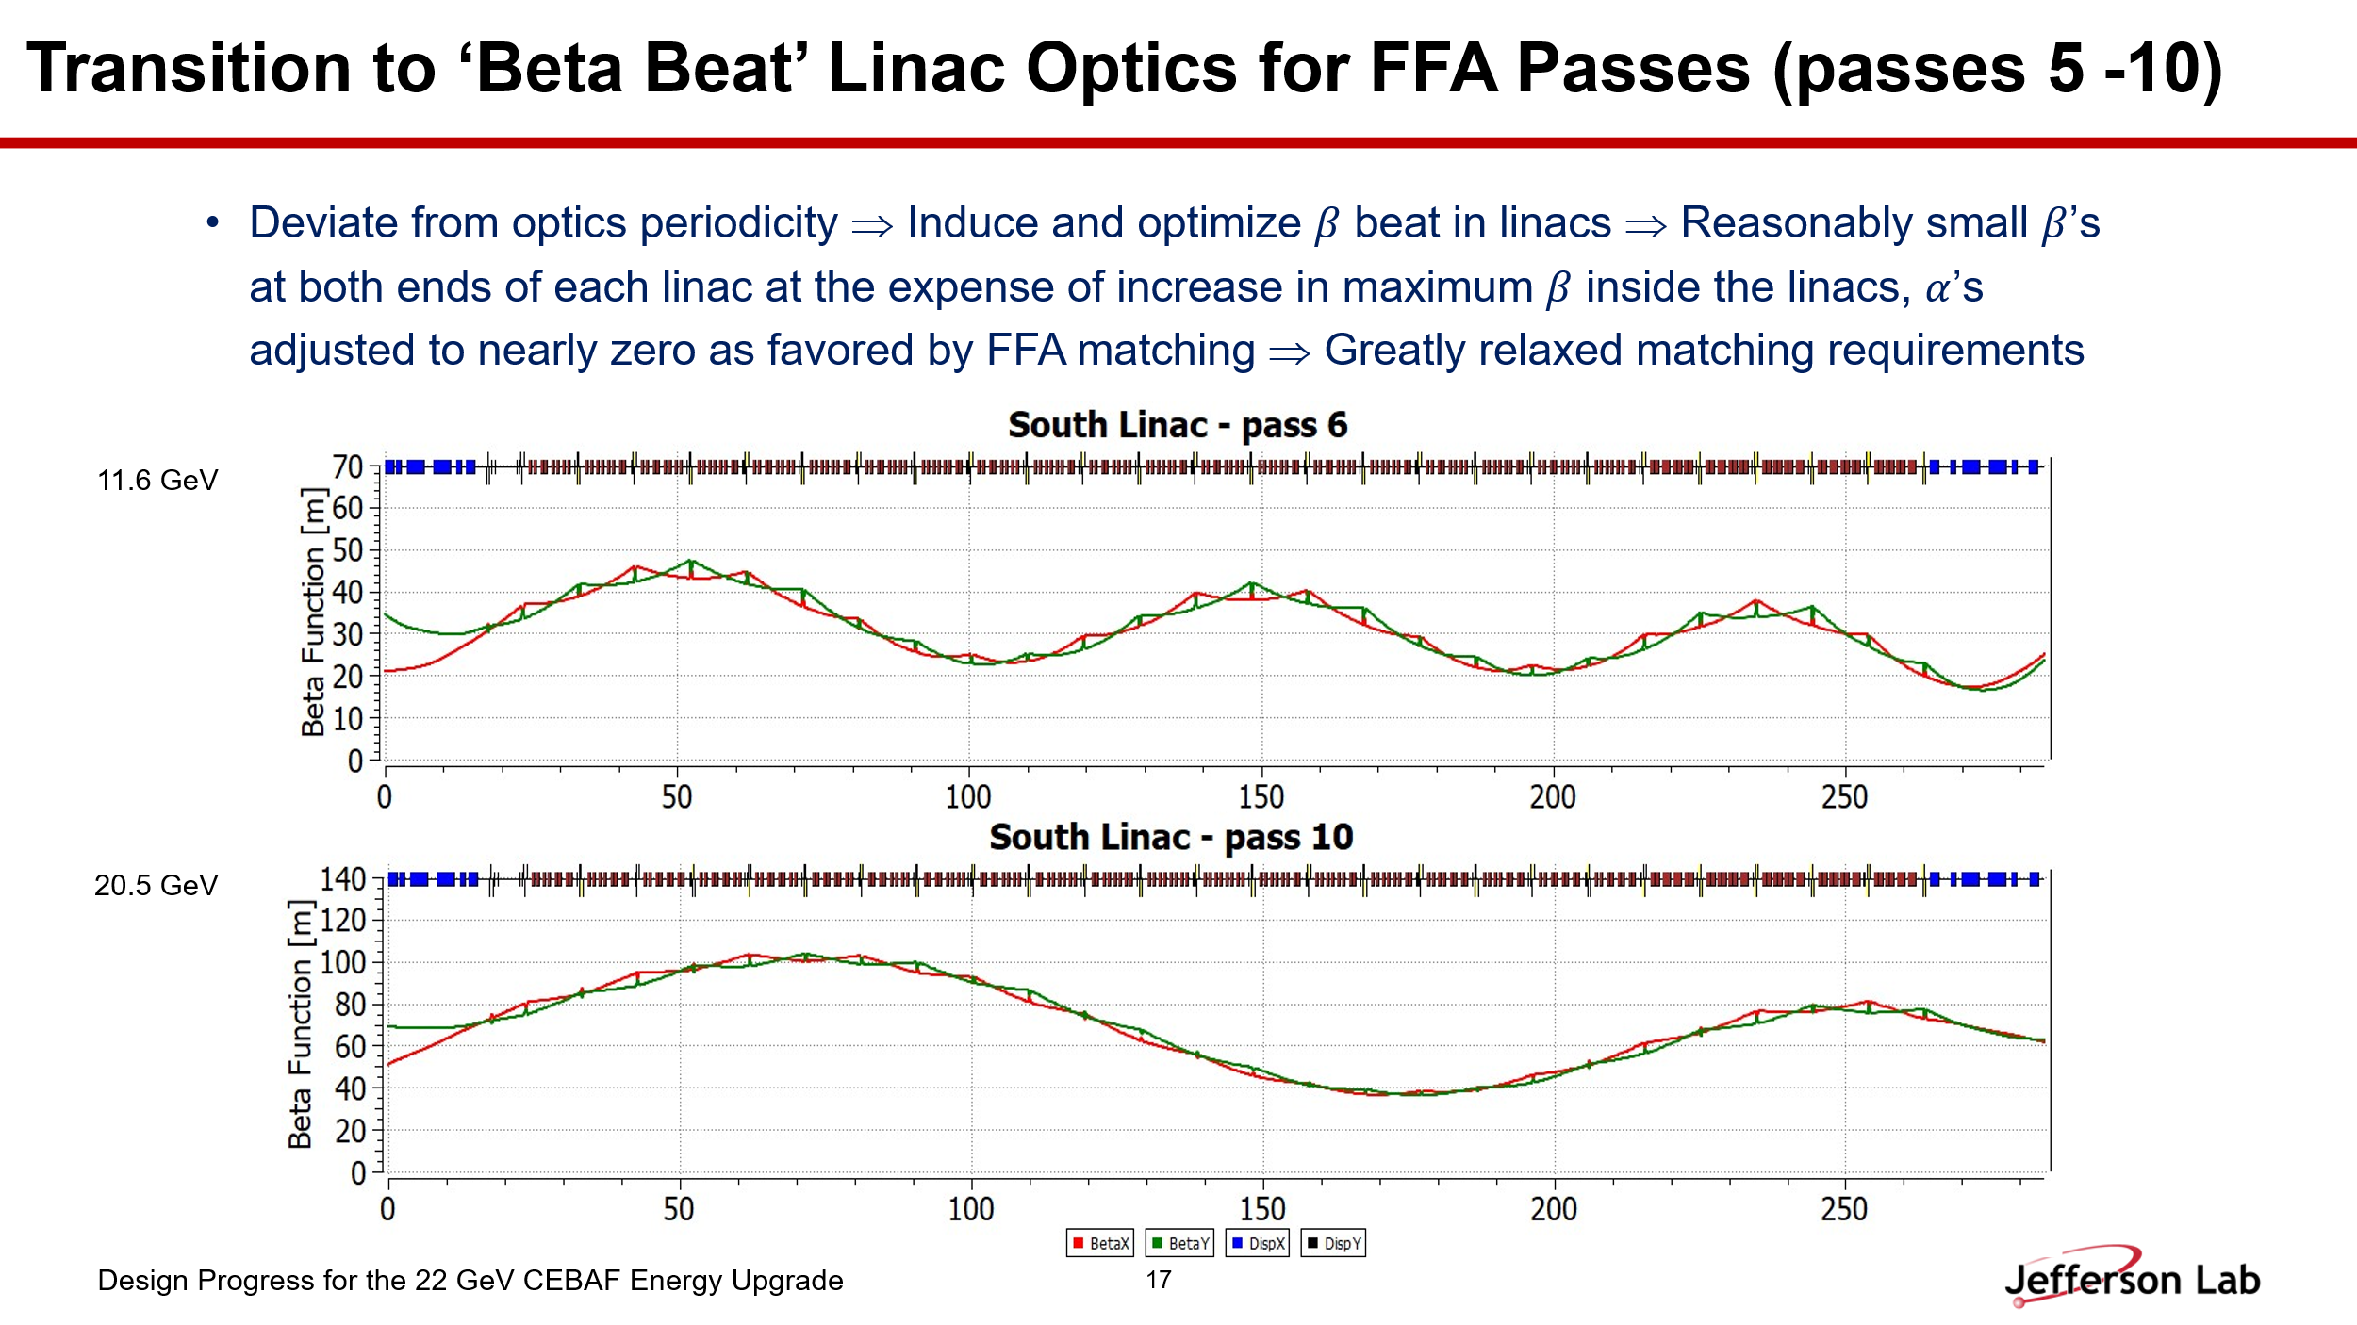
- 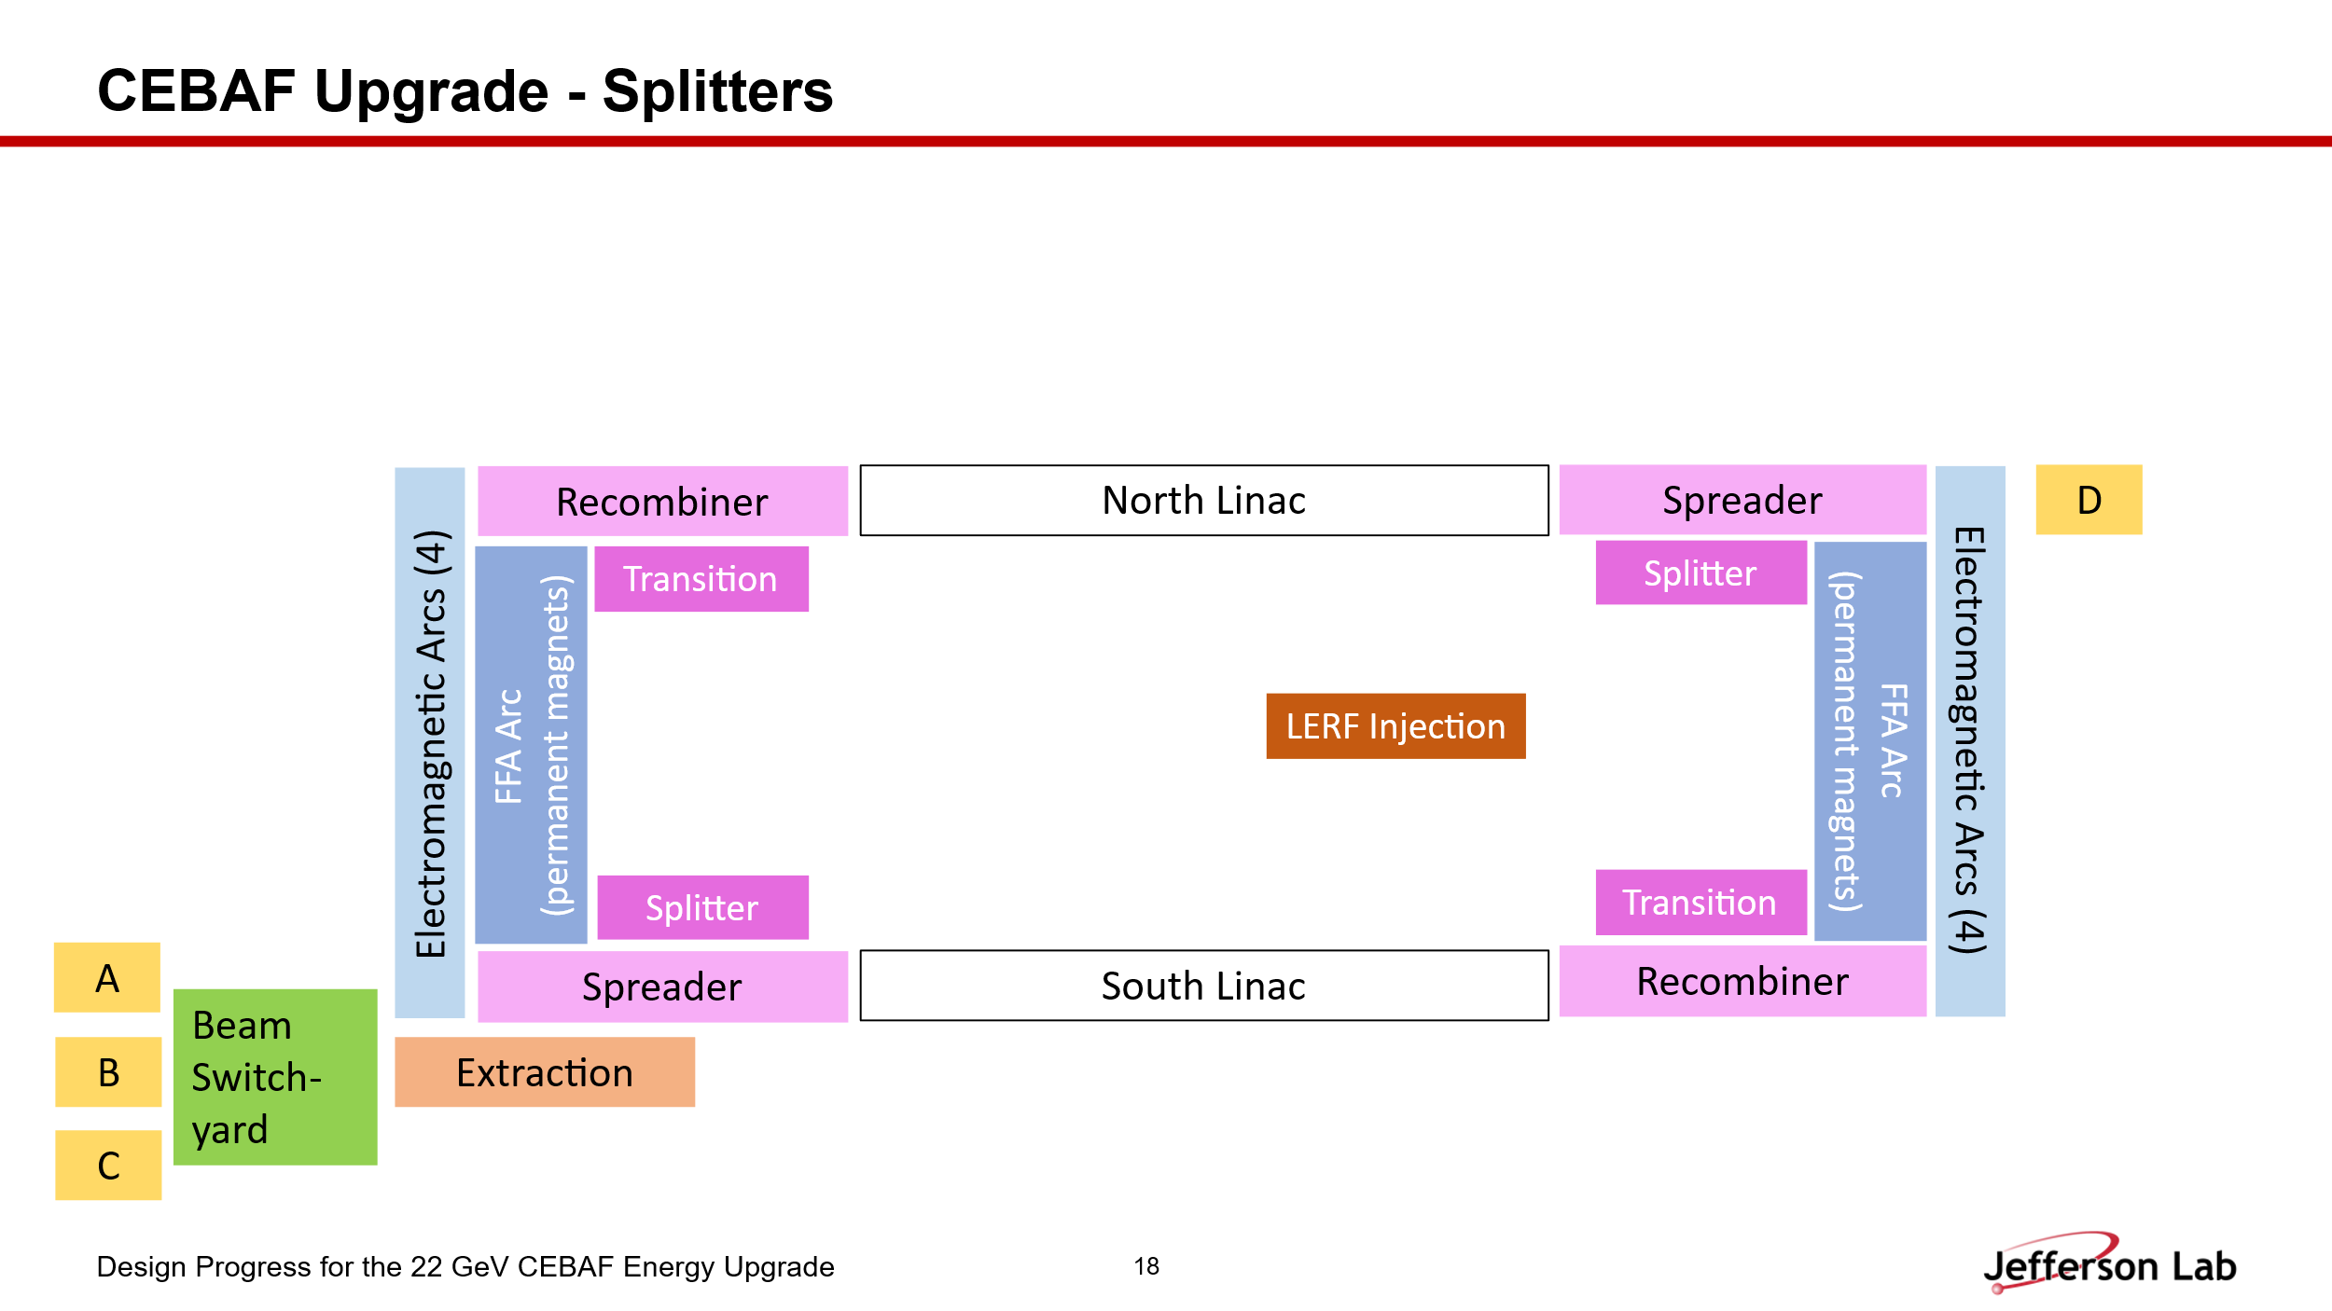
- 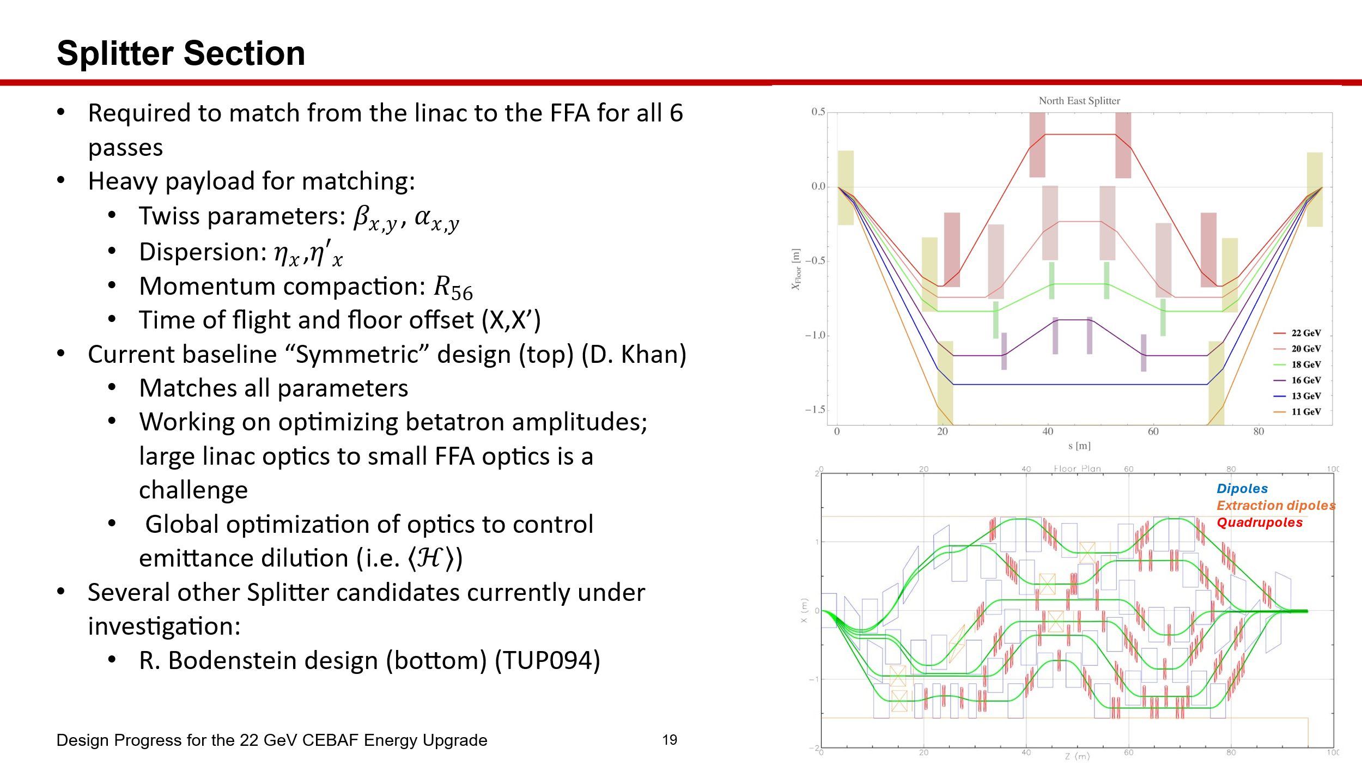
- 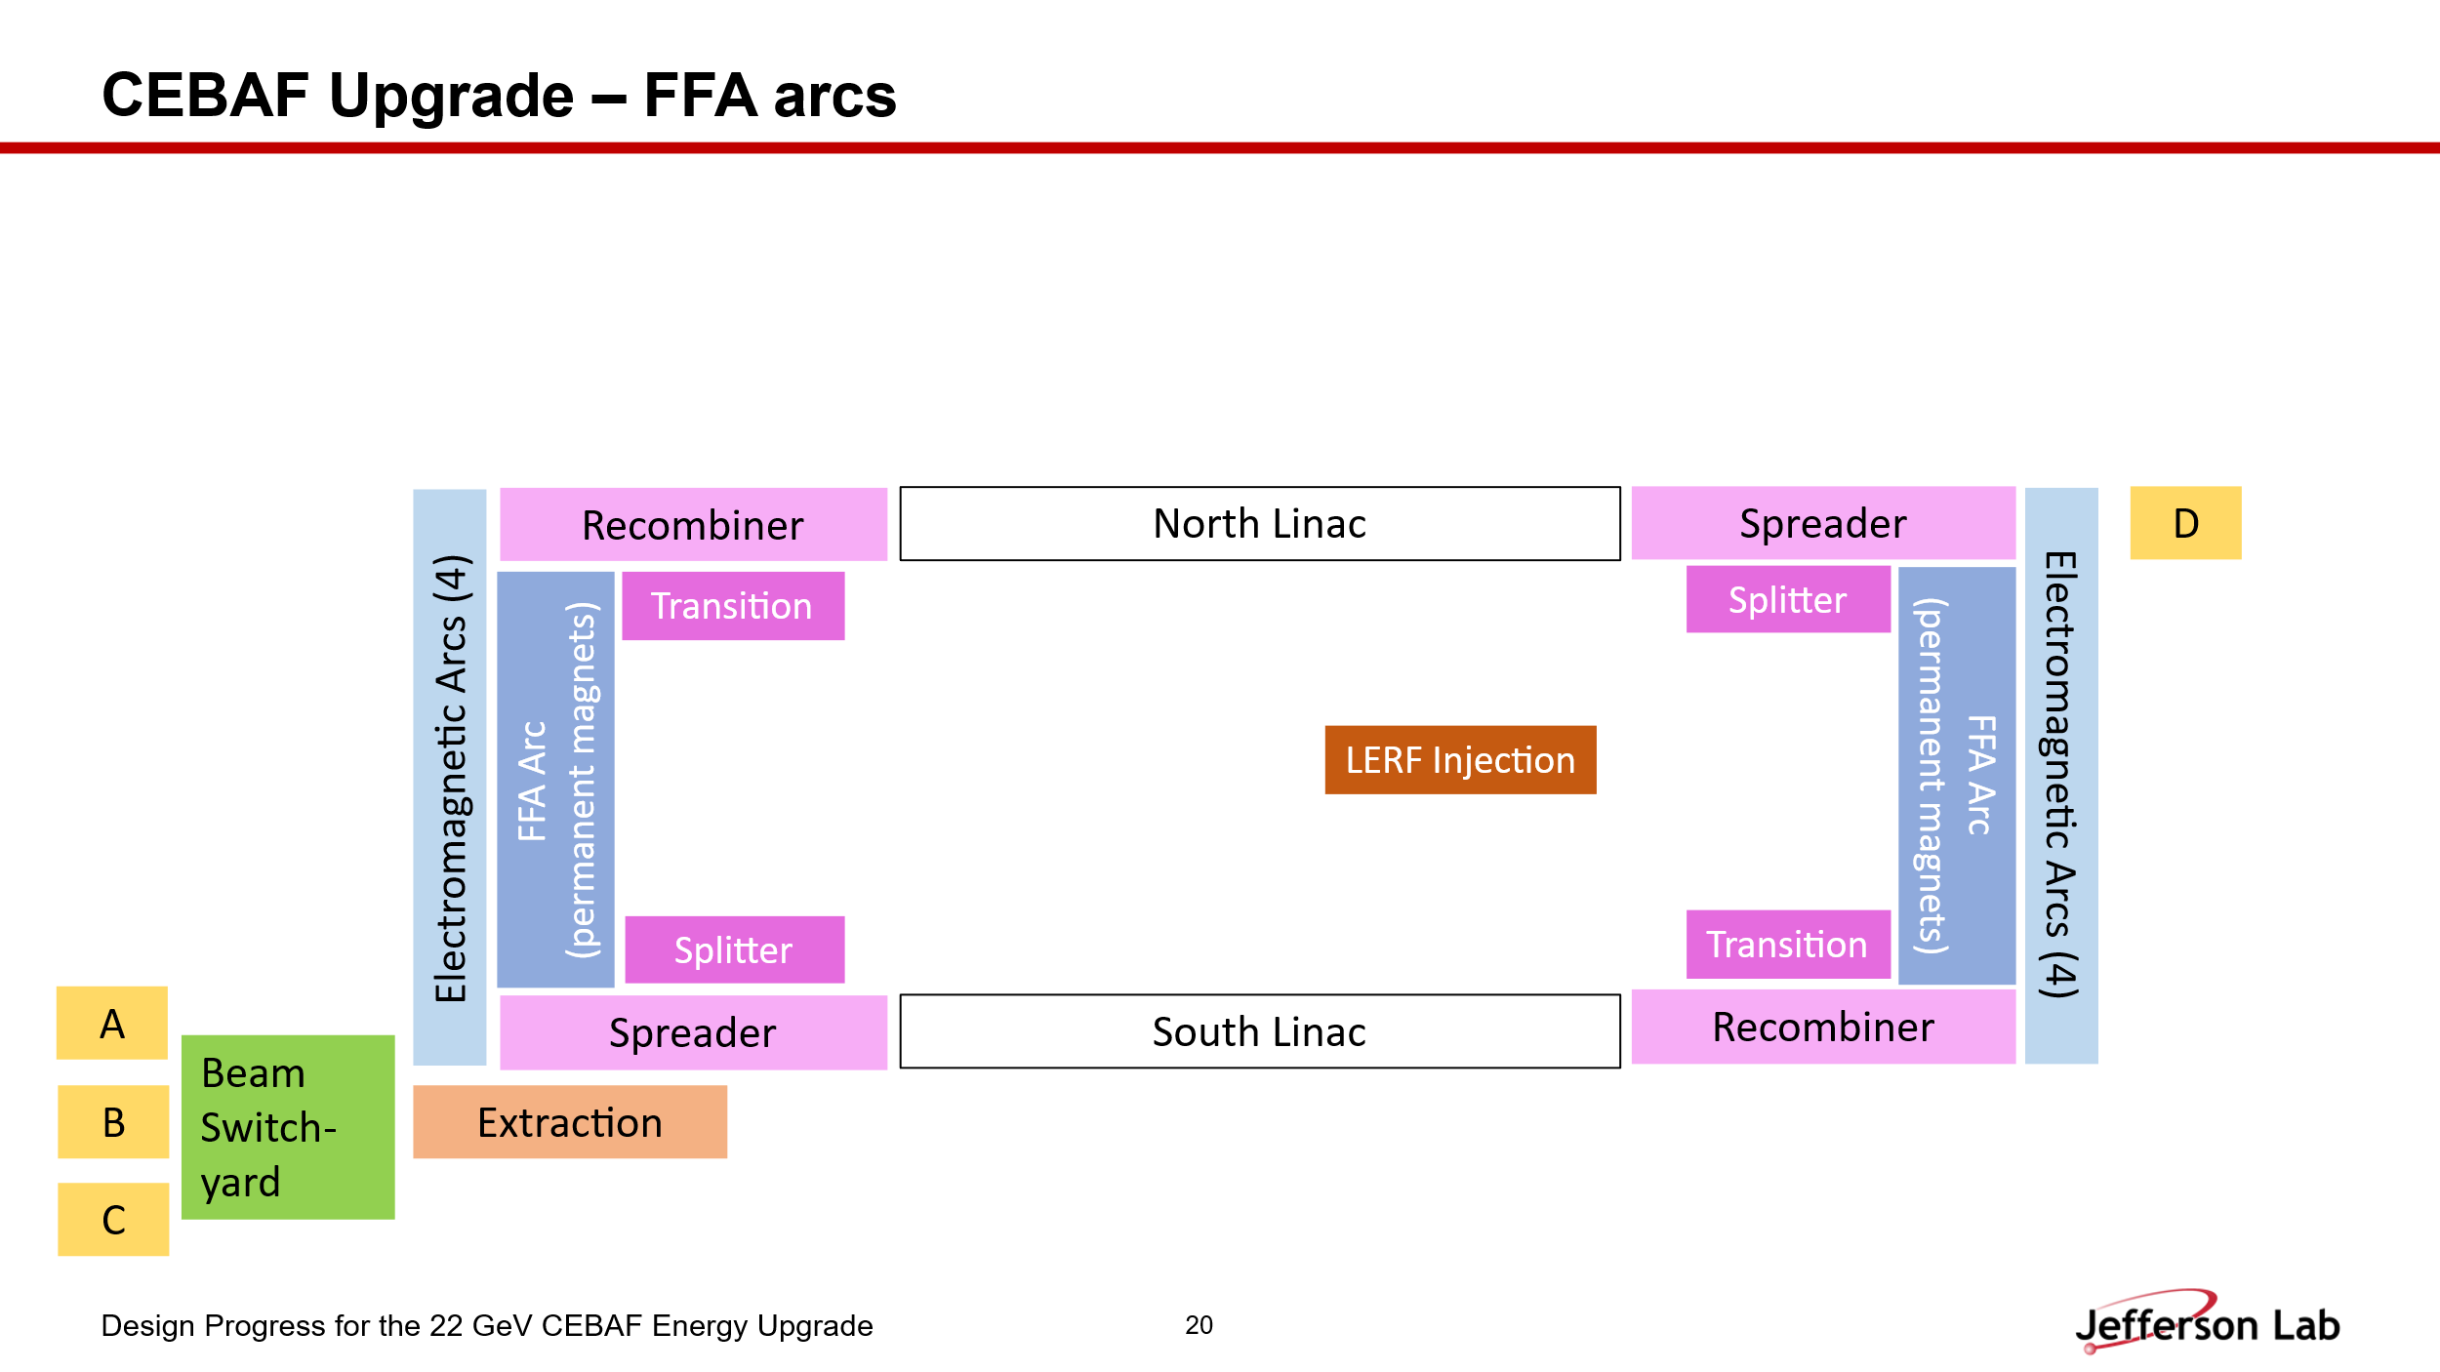
- 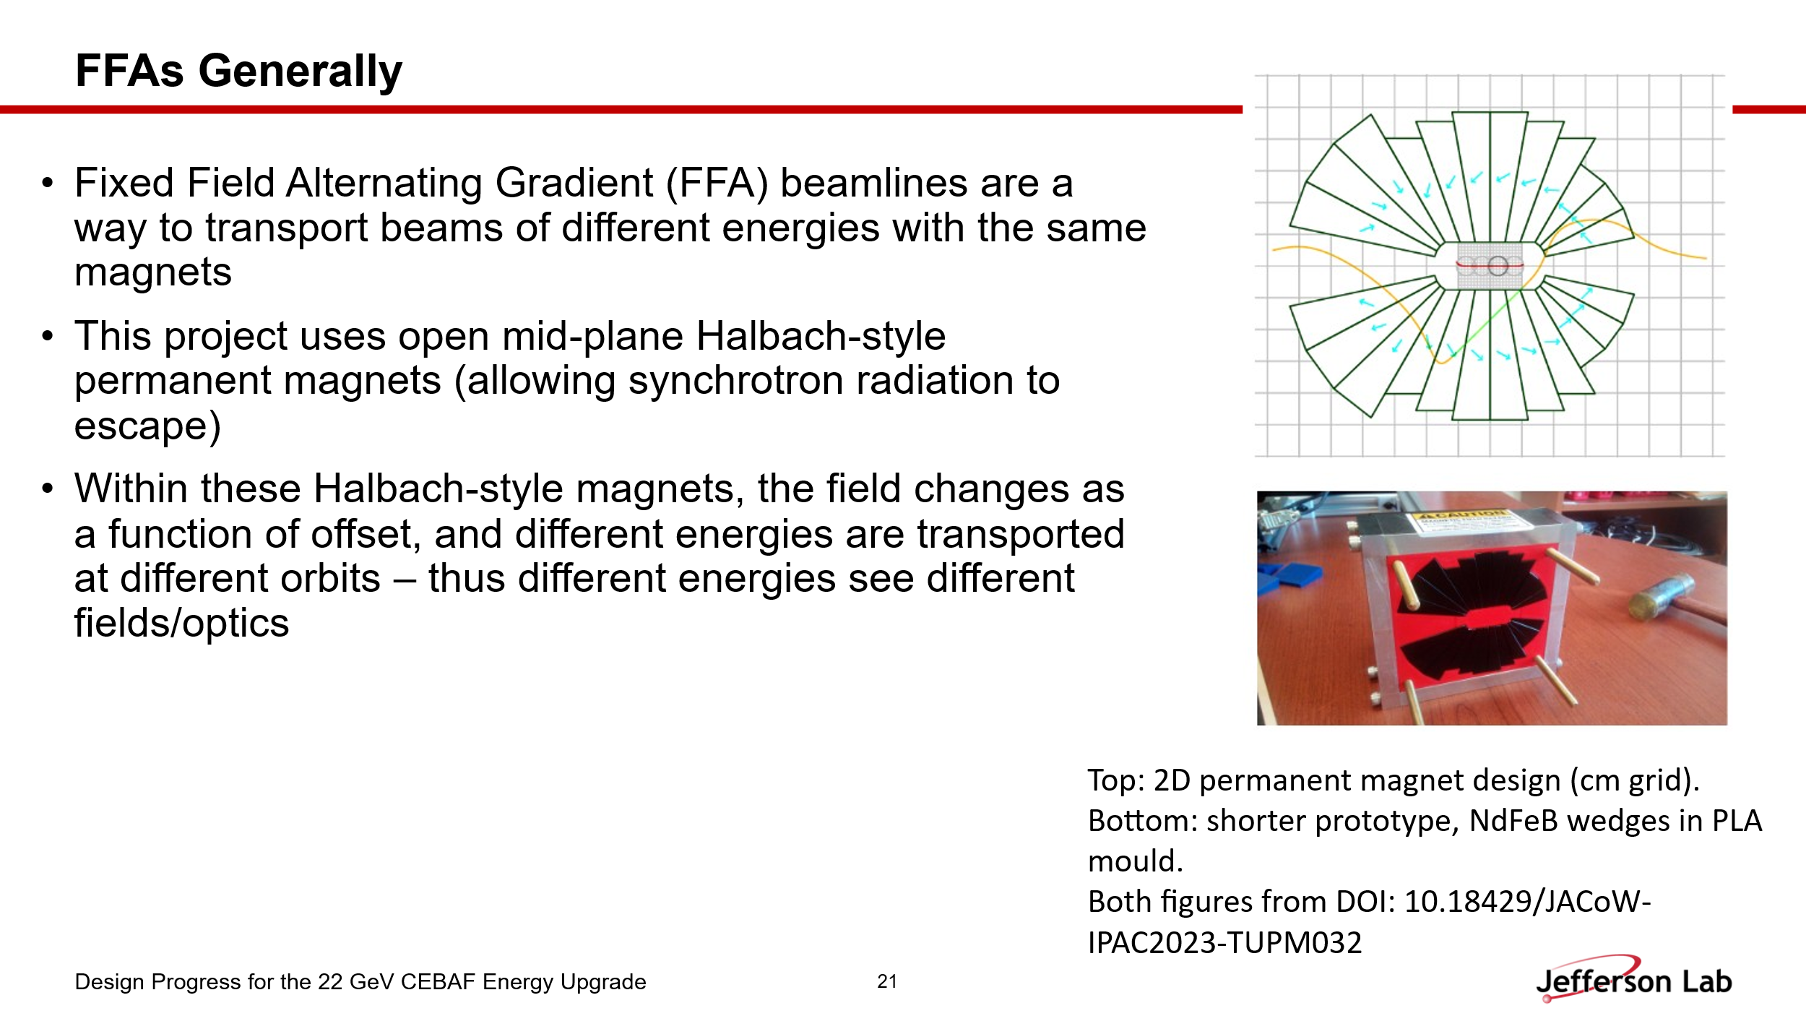
- 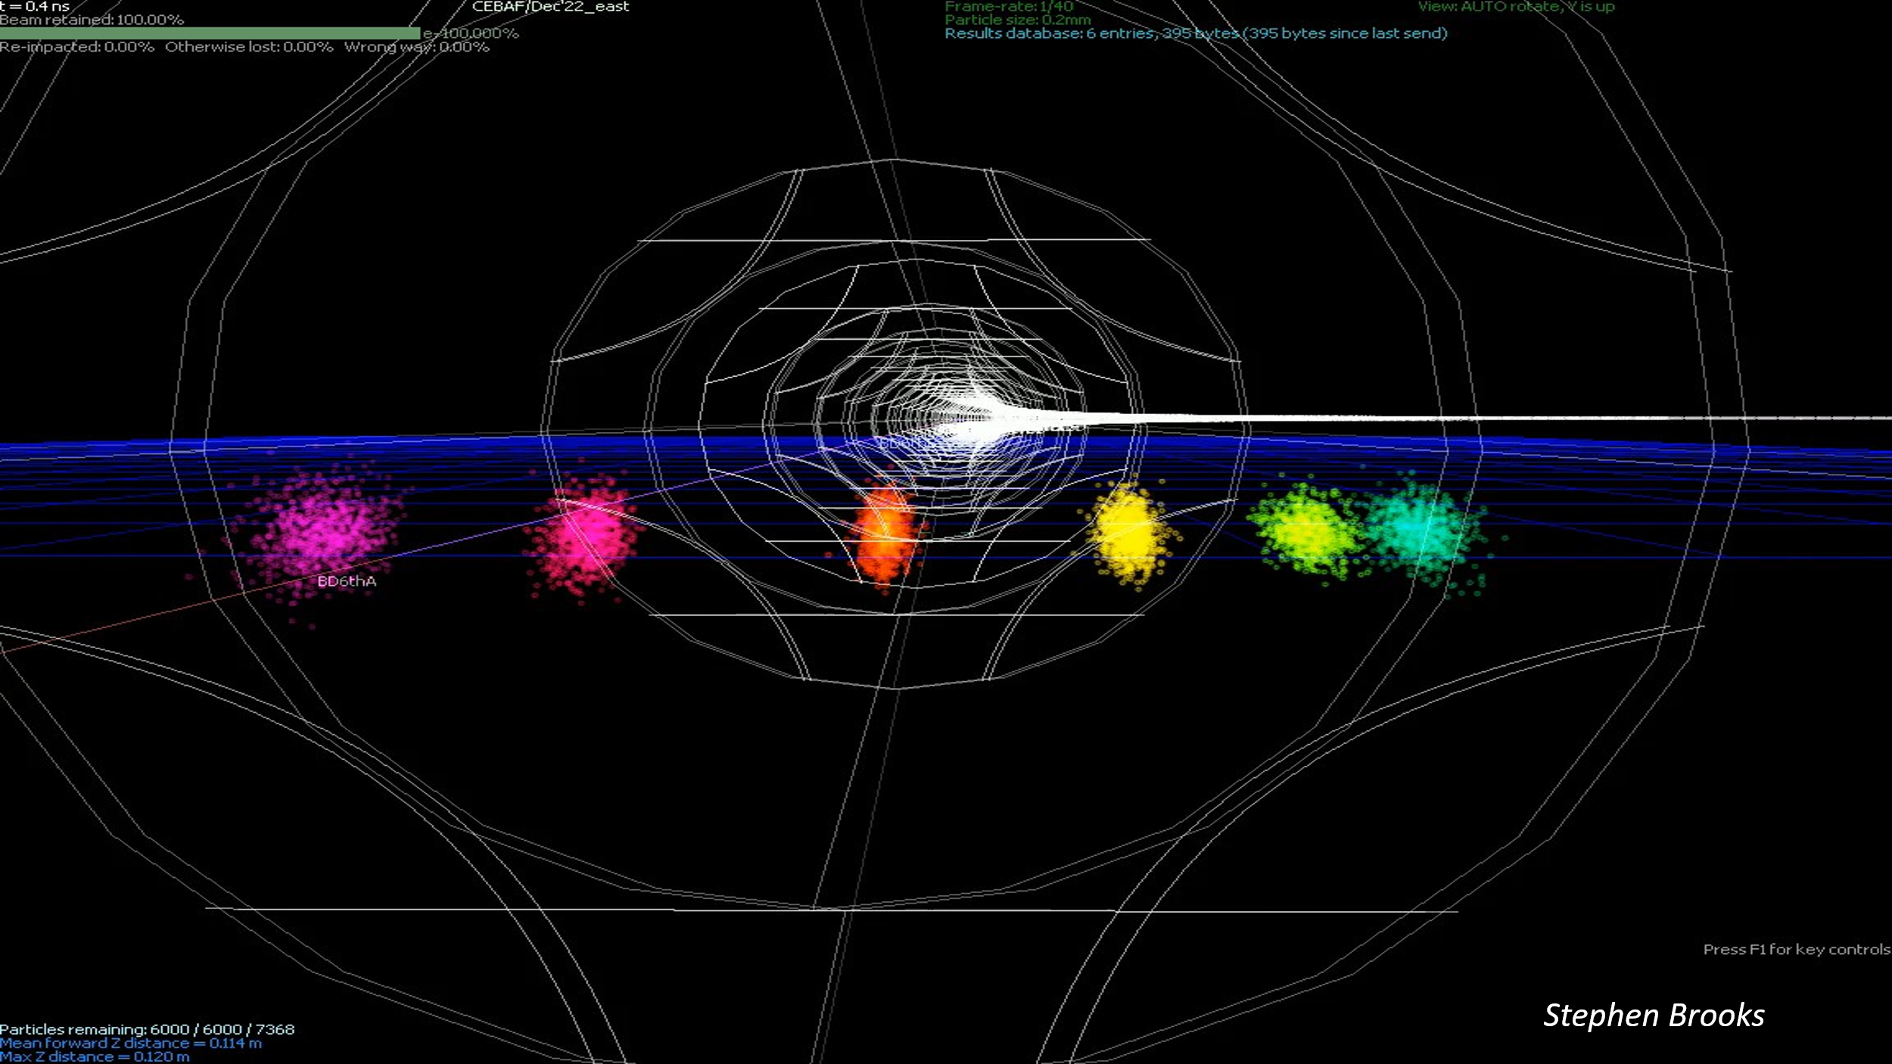
  - This is a video screenshot showing 6 different energy-beams traversing FFA arc.
- 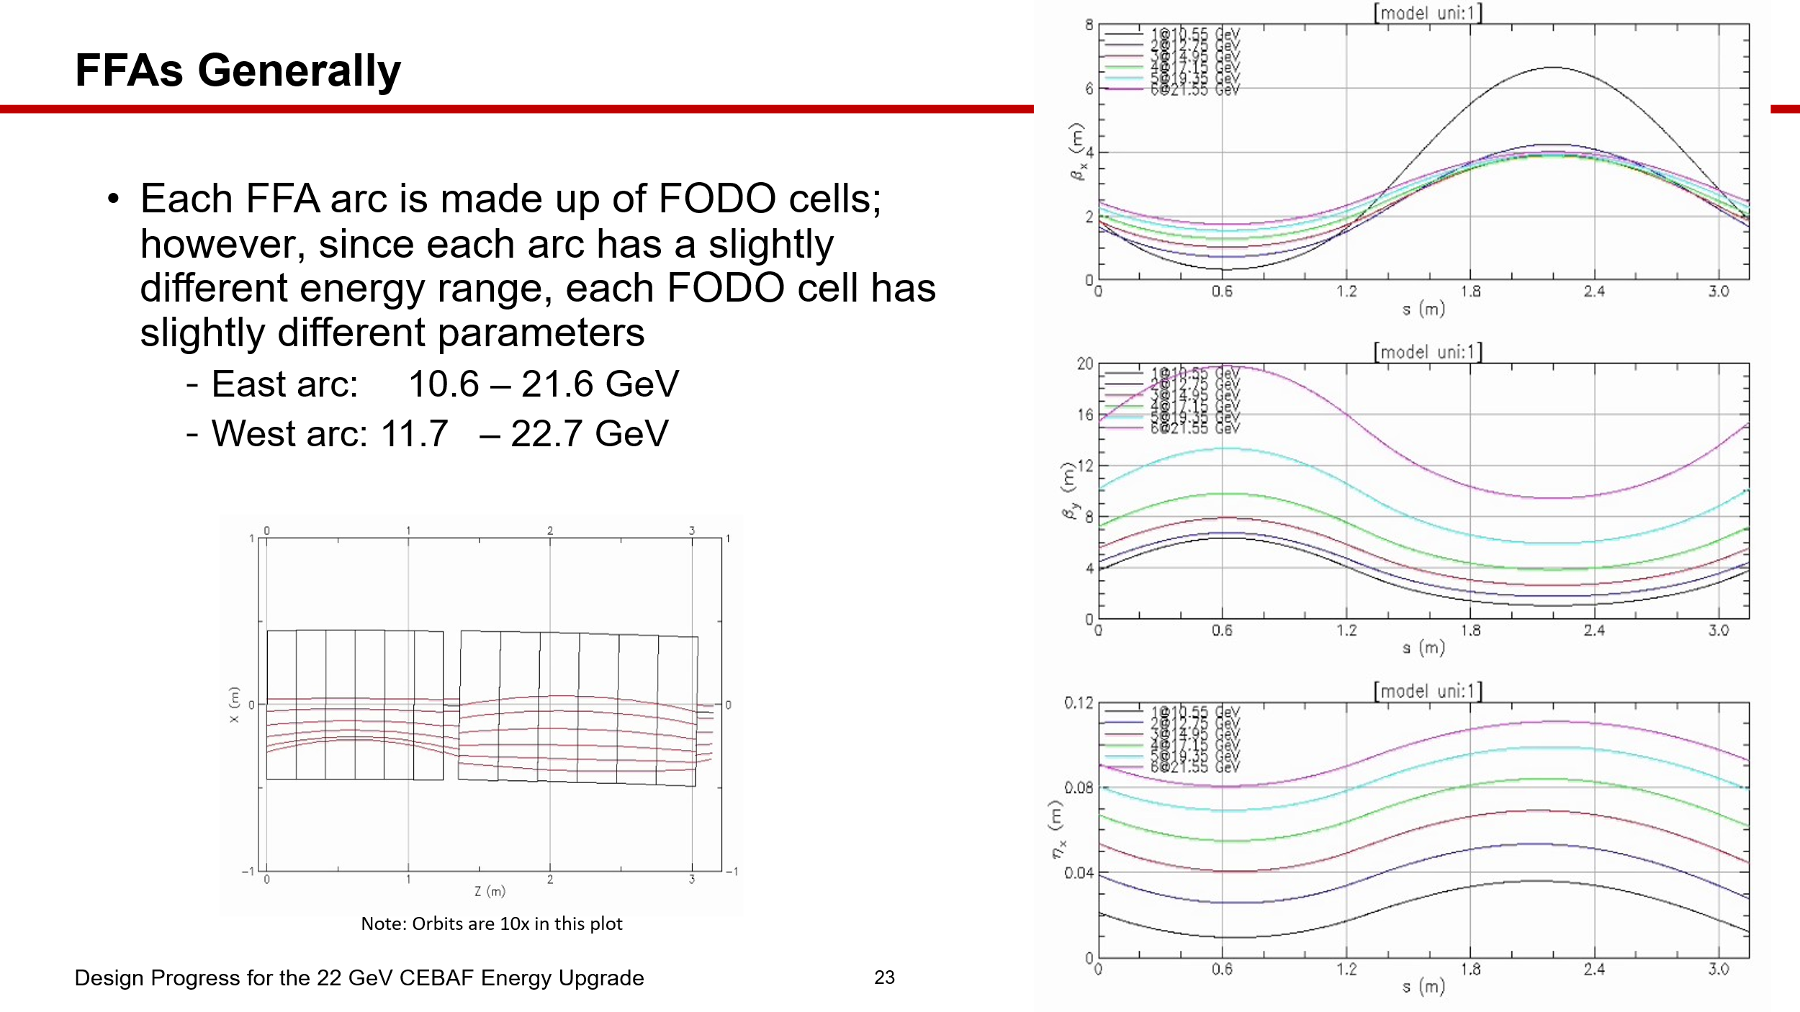
- 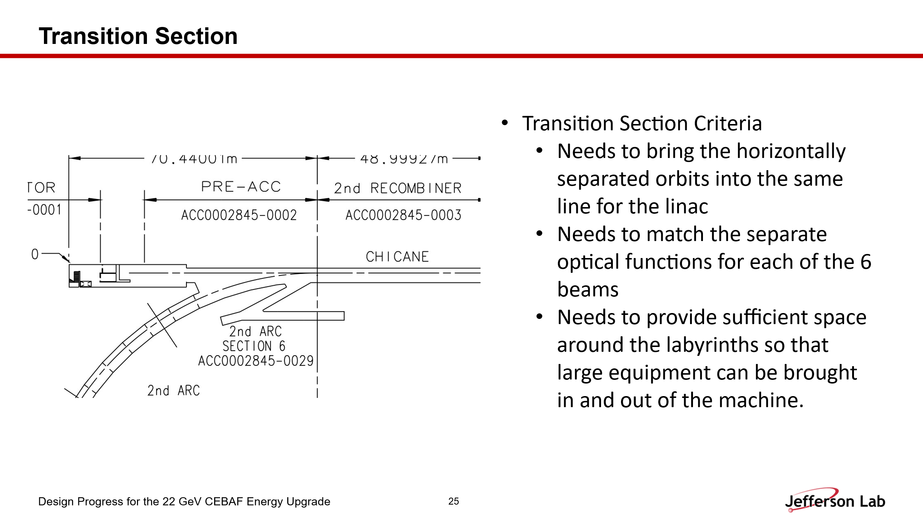
- 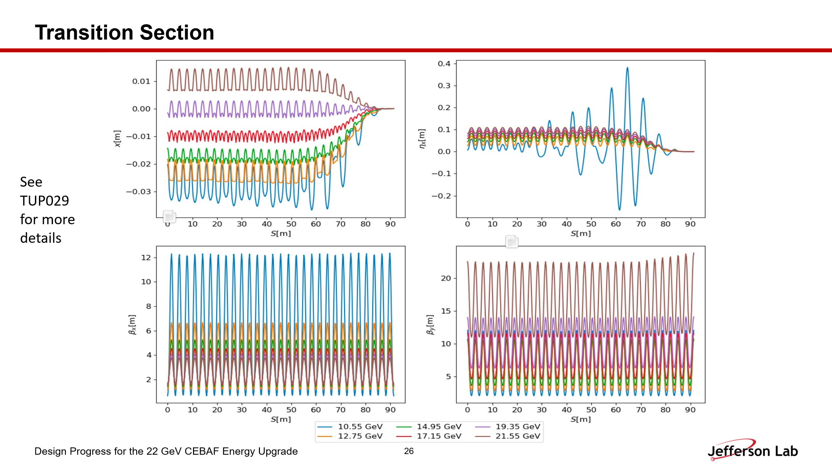
- 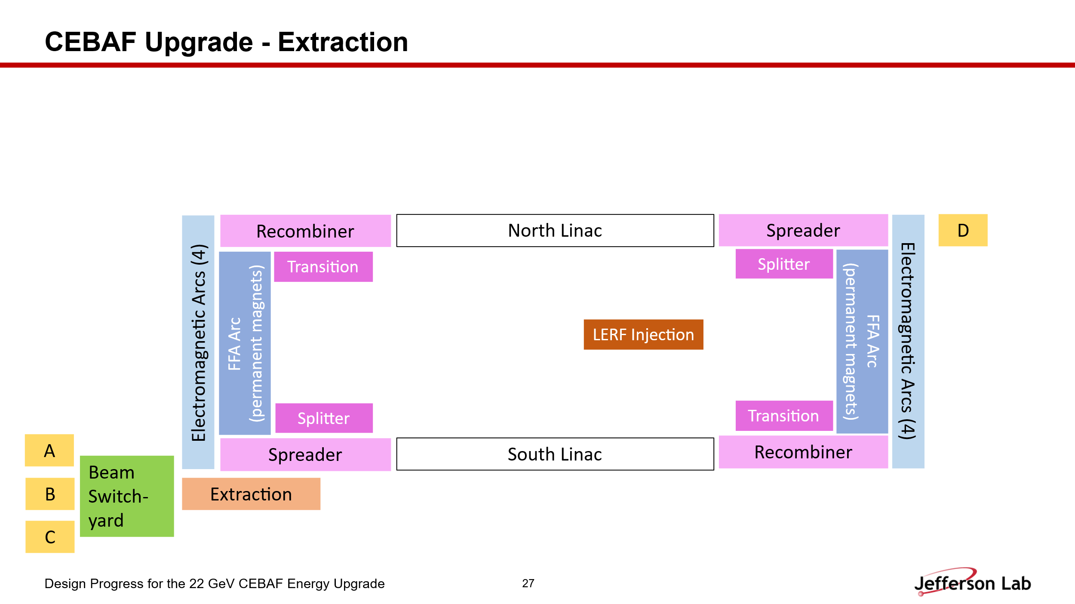
- 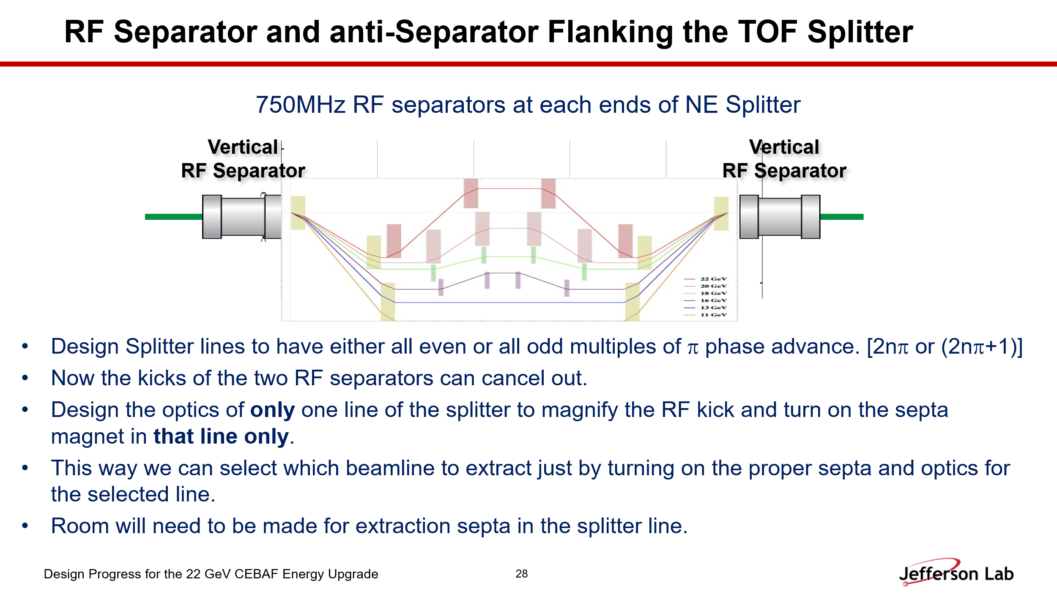
- 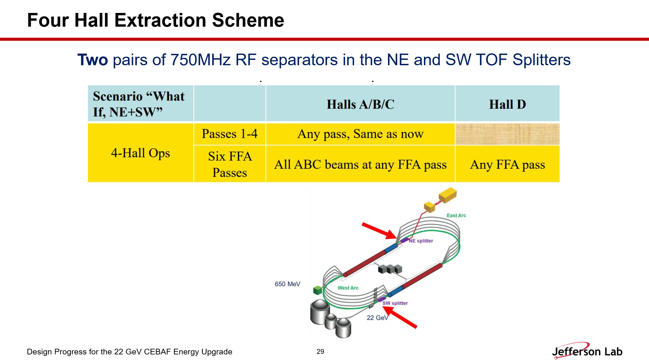
- 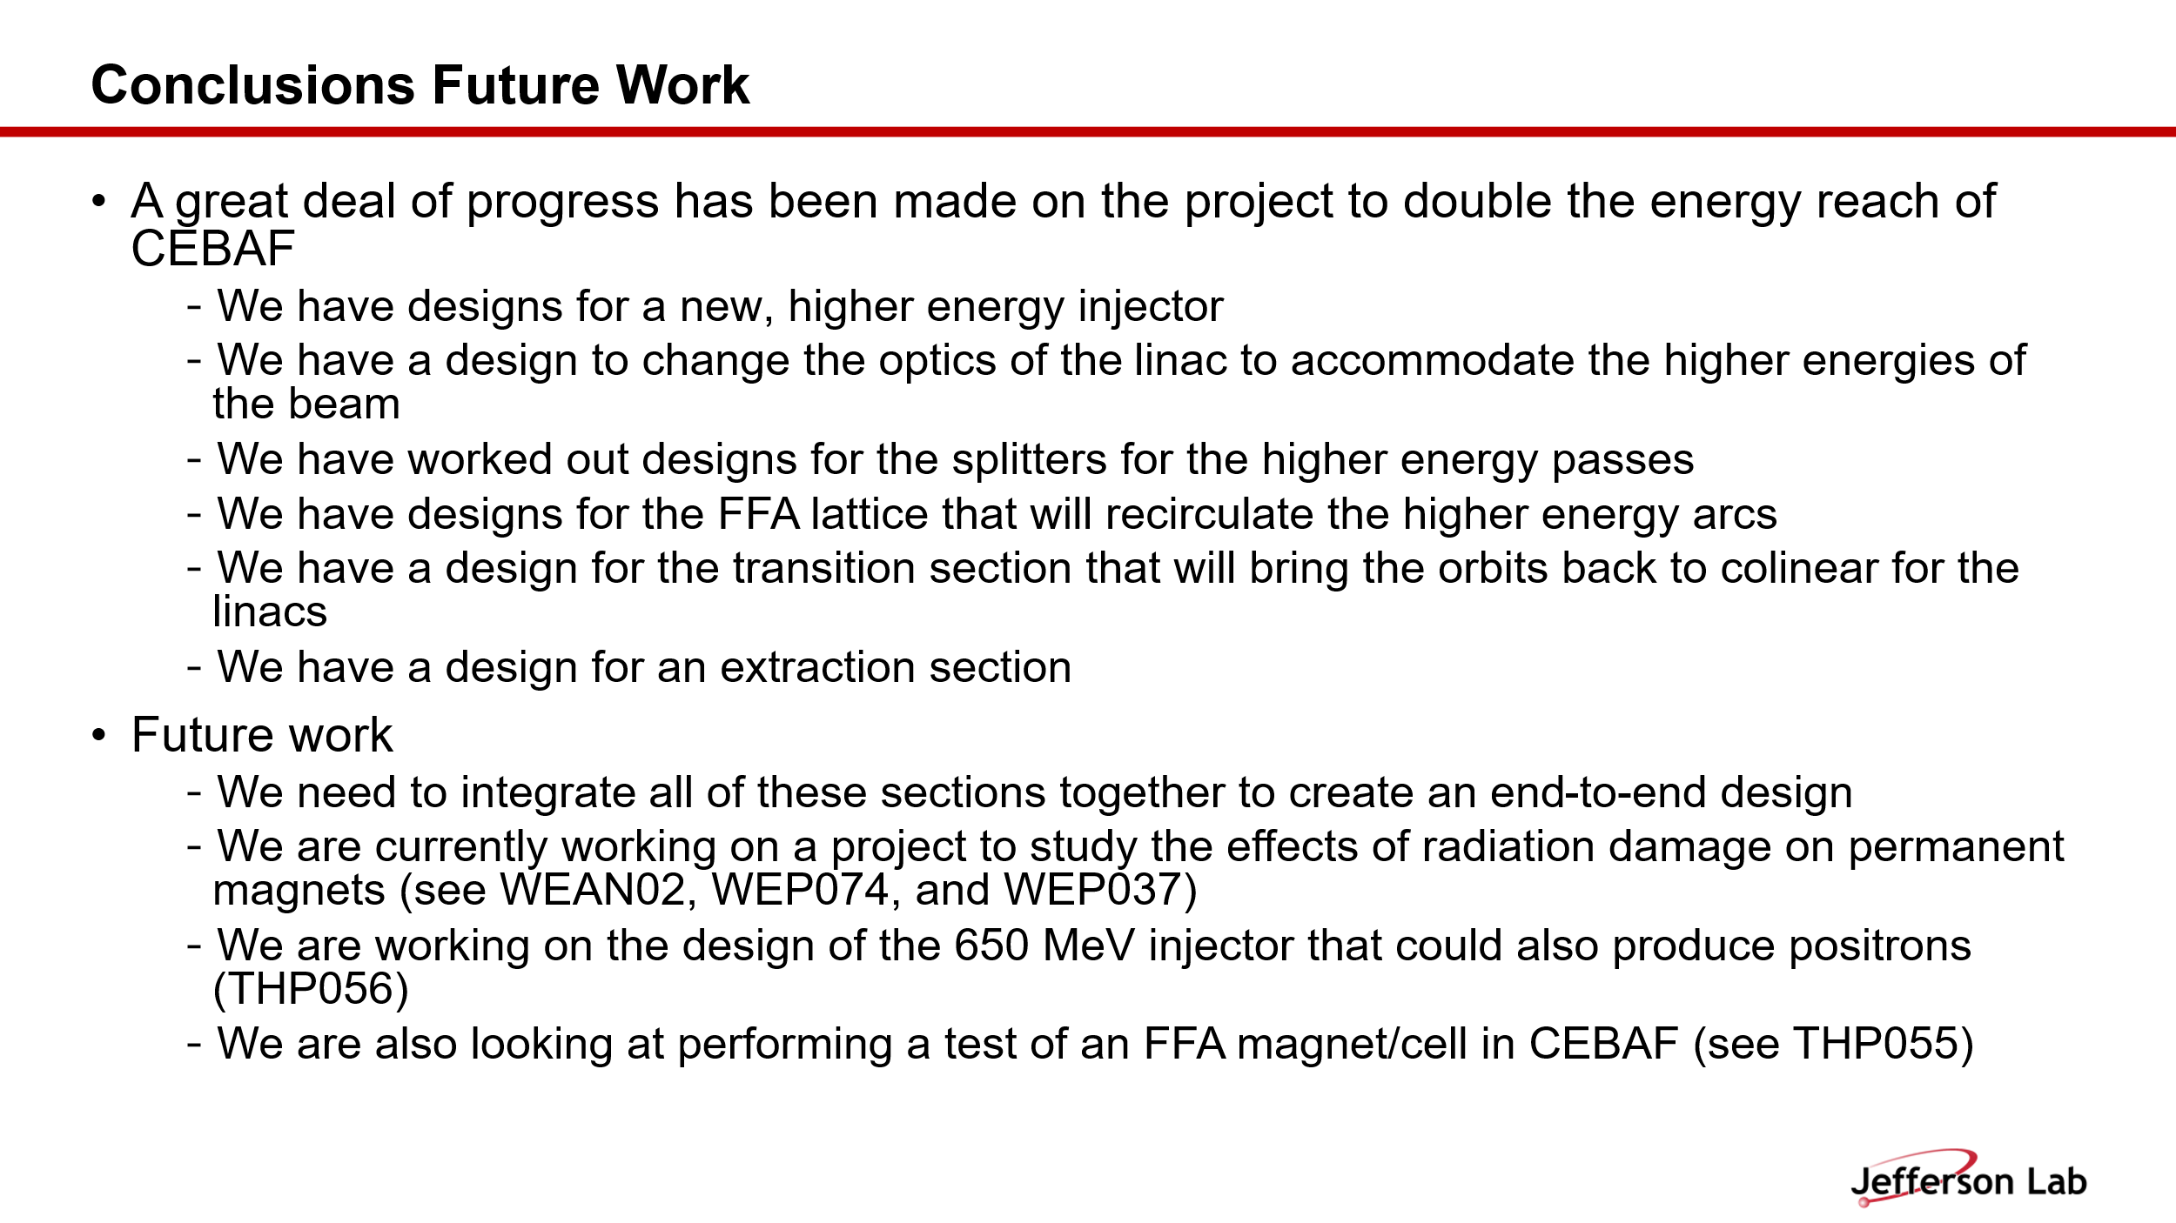
  - Alex B recommended to add all the related posters to this conclusion page in order to highlight JLab’s contributions related to this talk. In this slide, Edy has already updated Alex’s recommendations.
Action Items | Person responsible | Deadline

Time allotted | 25 mins | Agenda topic Update| Presenter Donish
- 
  - Donish gave update on his work related to JLAAC recommendations and also on the FFA Bmad lattice converting from Muon 1 Option B and compares his results and highlights the discrepancy between two different codes.

- 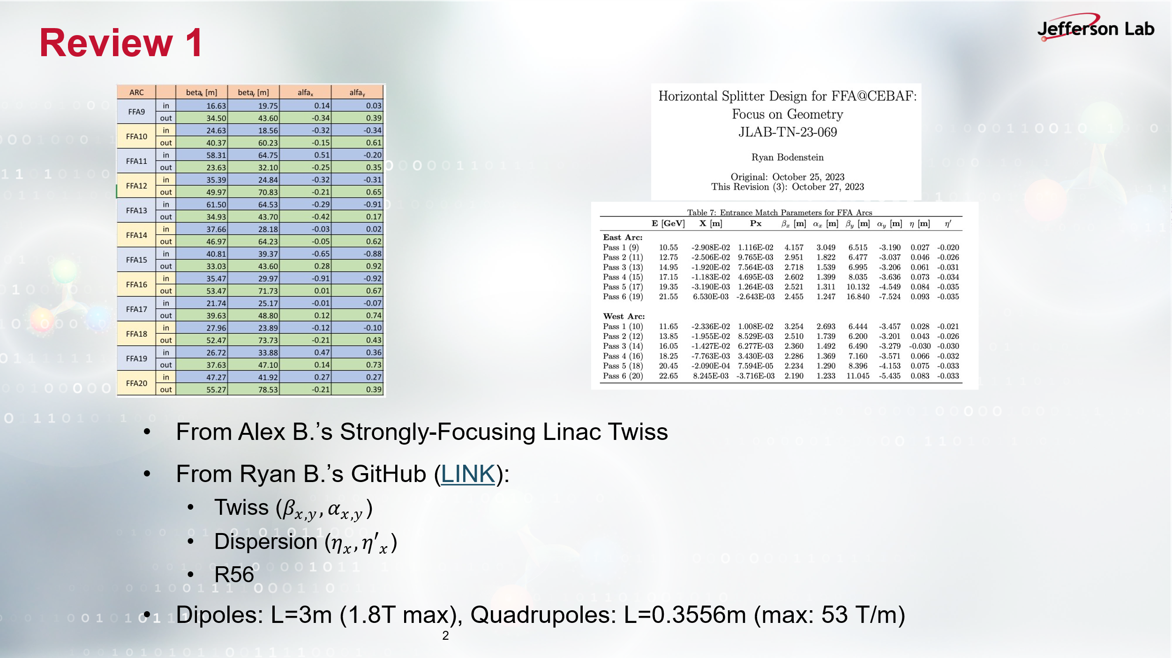
- 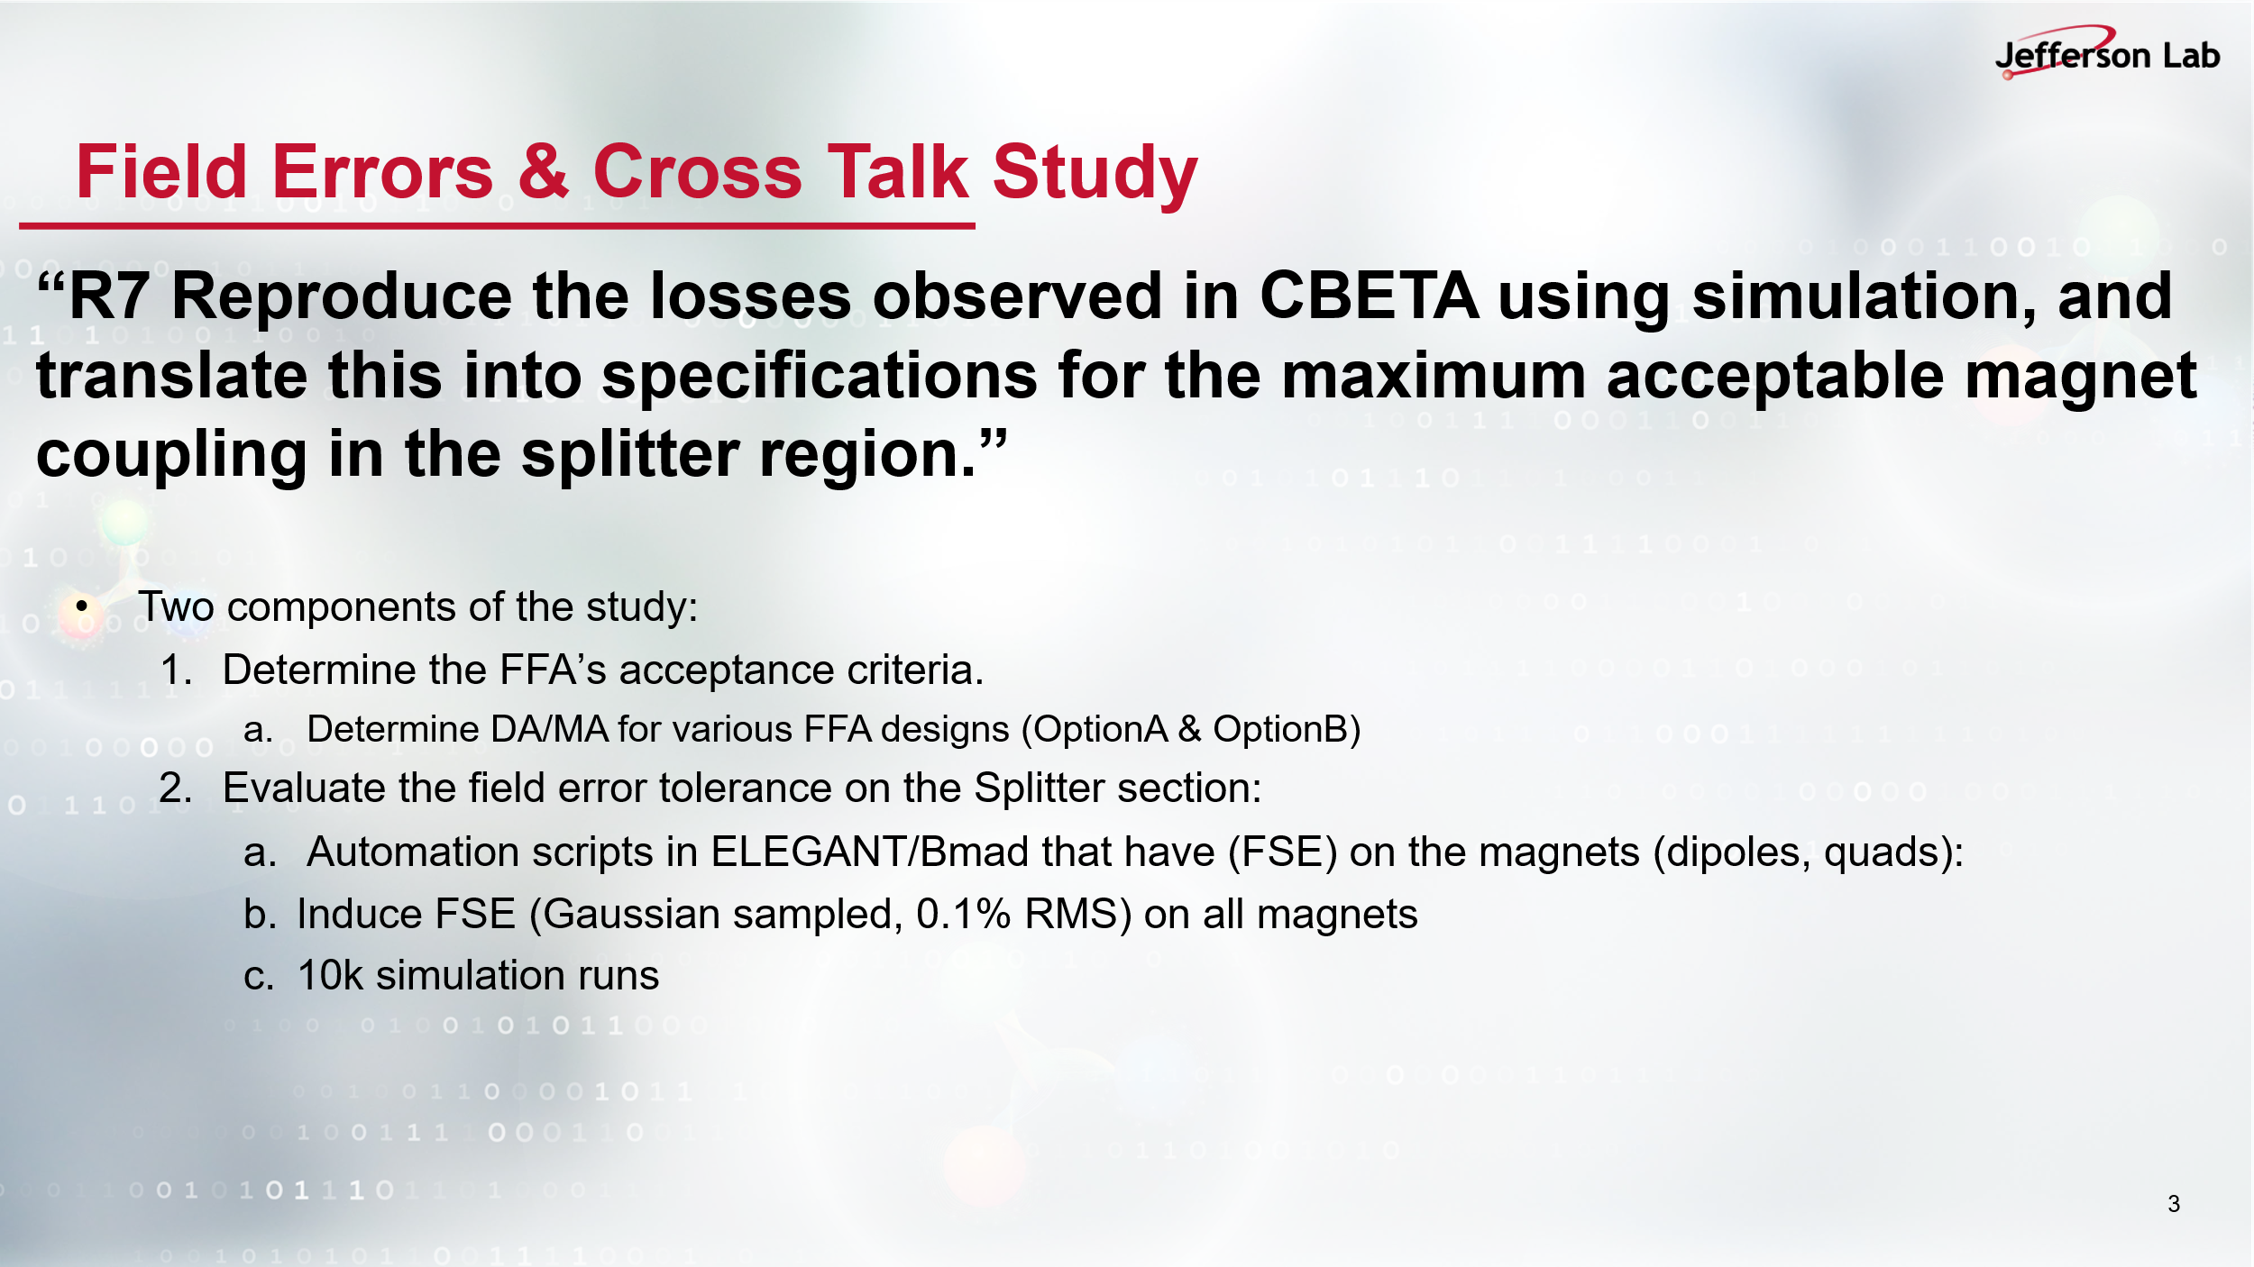
- 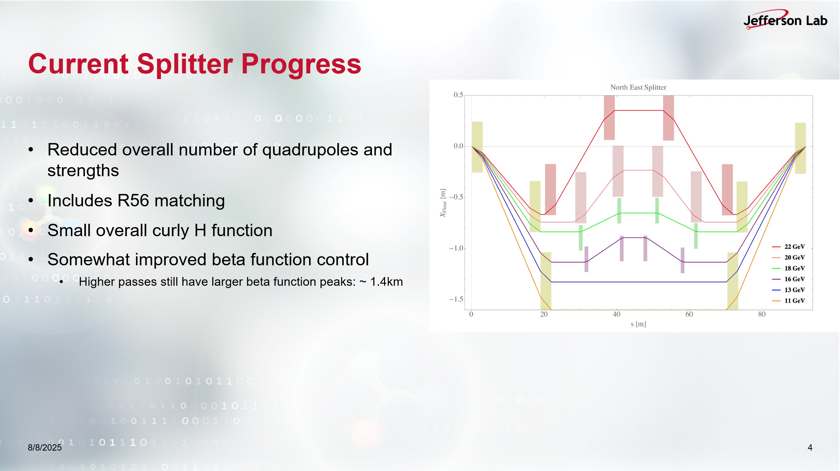
- 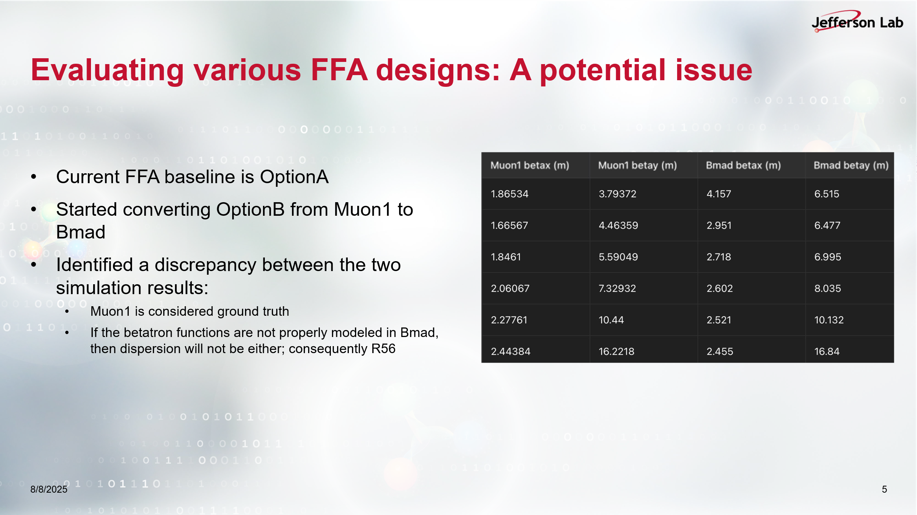
  - Kirsten said that she has already pushed an FFA lattice conversion of Option A, which is ‘a direct conversion’ from Muon 1 to Bmad. Kirsten is working with Scott and Stephen on this topic, as well.

- 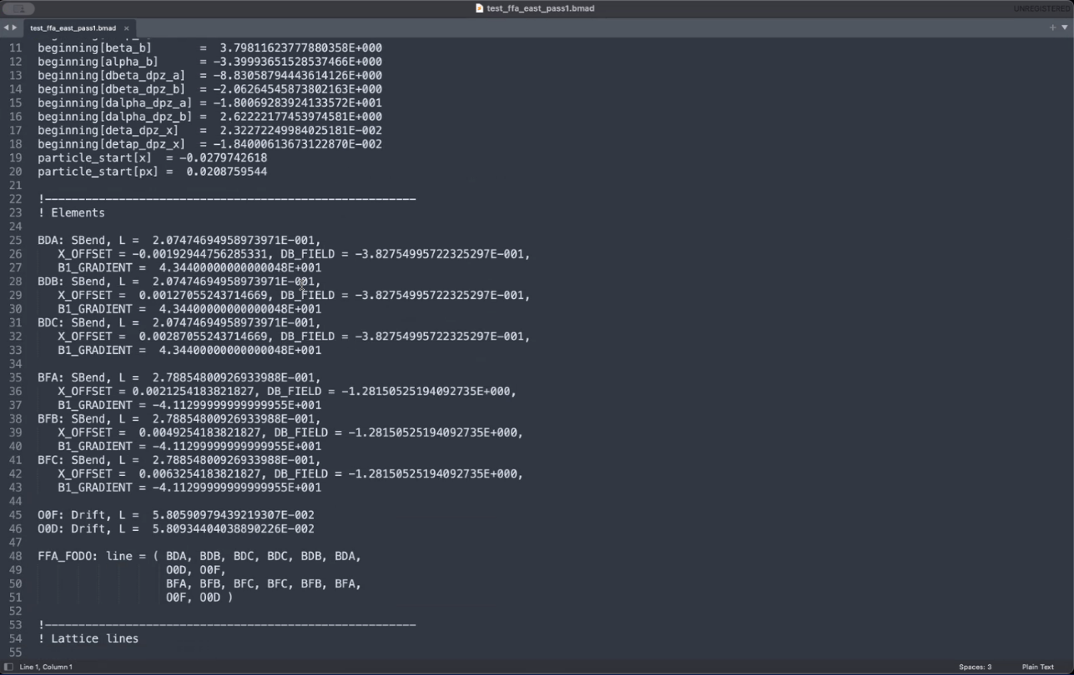
  - Donish has shown this script and said this agrees better than the one with patches.
  - Kirsten: this is defined as SBEND, but it is without the edge angles, so practically this is RBEND. Donish: but this agrees with Stephen’s Muon1 beta functions better.

Action Items | Person responsible | Deadline

Time allotted | 10 mins | Agenda topic AOB | Presenter All
- Kirsten is currently working on the conversion of the lattices from Muon 1 to Bmad. She is bridging between Scott and Stephen, and said we (Kirsten, Donish, Ryan and Salim) will meet on this subject sometime after NAPAC.
- FFA@CEBAF Meeting on 08/22/2025, regular time.

Action Items | Person responsible | Deadline

Special notes

Pathway to Repository: https://jeffersonlab-my.sharepoint.com/:f:/g/personal/tristan_jlab_org/EqZ5MeS-nipCgPfZB5p0oS4B9Is67d3nQb9sLJI3Zyev9g

