FFA@CEBAF Working Group|Minutes

Meeting date | time 08/22/2025 | 11 AM EST | Meeting location https://jlab-org.zoomgov.com/j/1614898082?pwd=TnUzMS81M2sxbDZIbERJU01tYkJCQT09
 | Attendees  Alex B, Salim, Donish, Reza, Vasiliy, Dejan, Nick, Stephen, Ryan, Edy, Volker.
  Meeting called by | Alex B
  Type of meeting | Weekly Meeting
  Facilitator | Alex B
  Note taker
  Timekeeper | Salim

Intro Discussion
- 4-Halls extraction scheme - Reza
- Postponed, we run out of time, Arc-to-Linac Transition update - Randy, Vasiliy
- AOB

Time allotted | 50 mins | Agenda topic 4-Halls extraction scheme | Presenter Reza
- 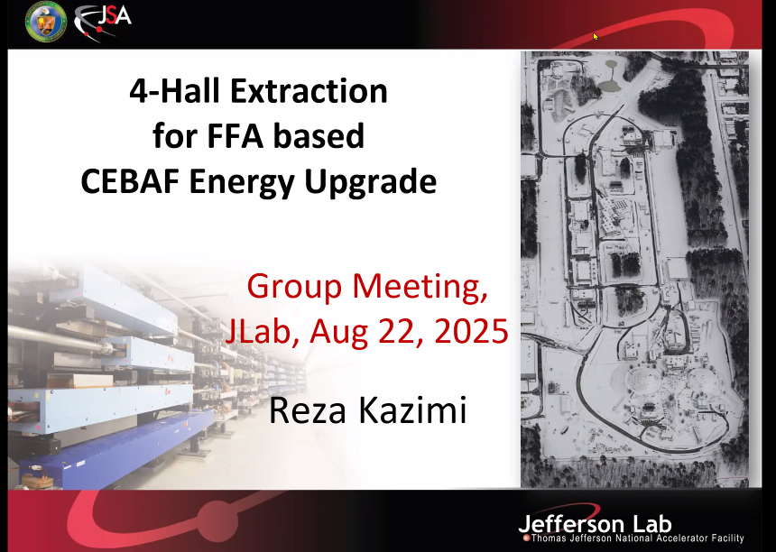
- 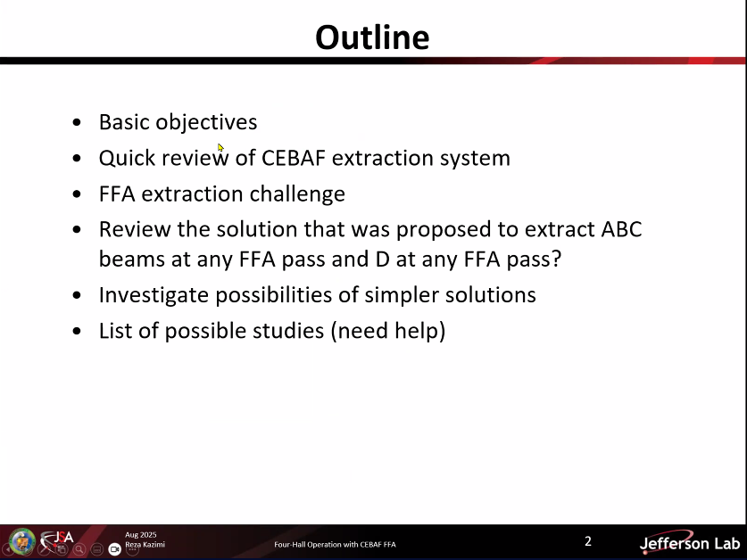
- 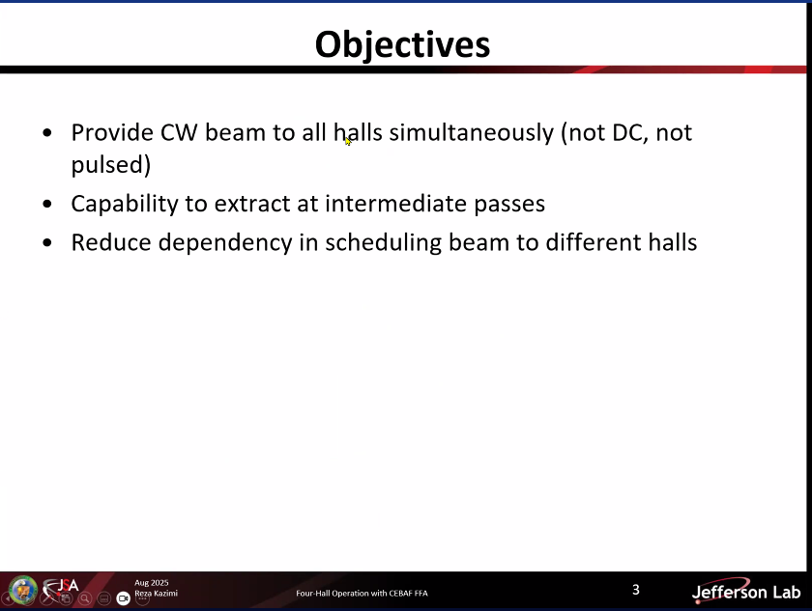
- 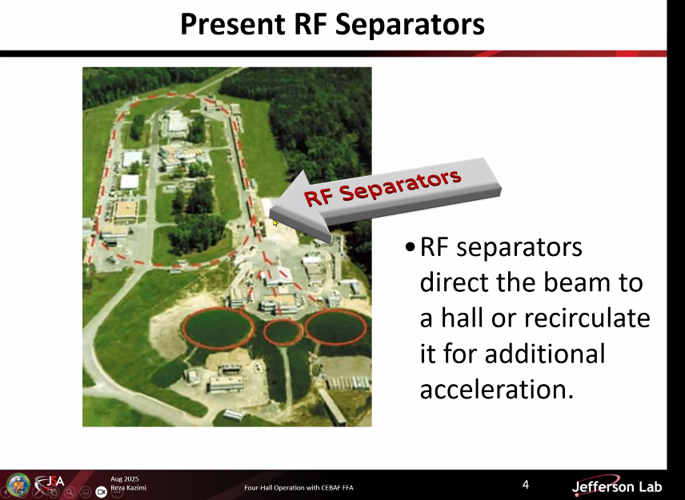
- 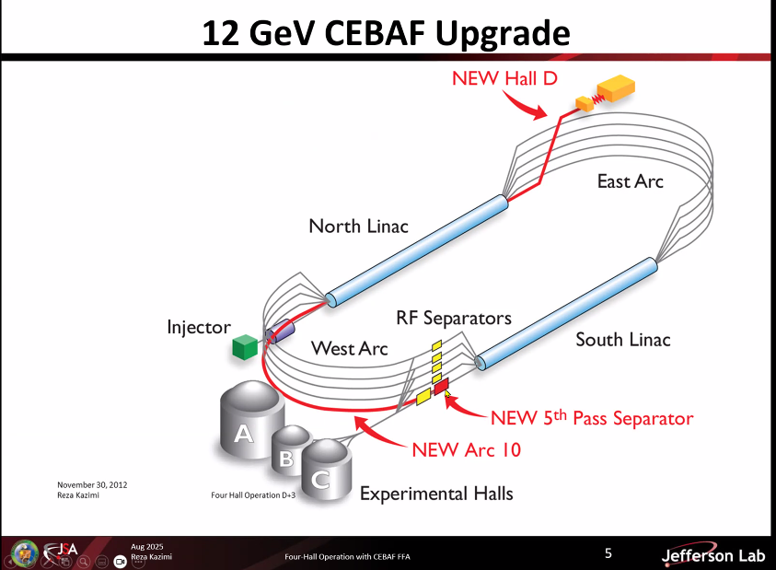
- 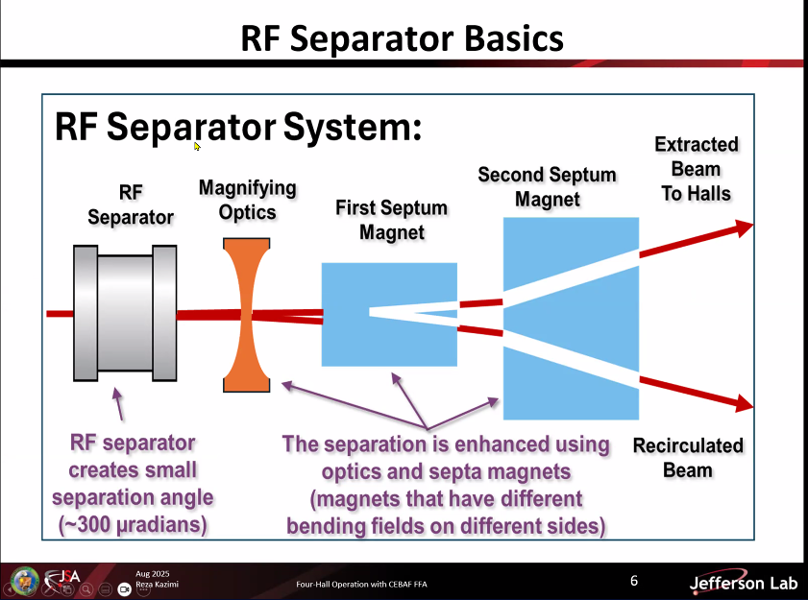
- 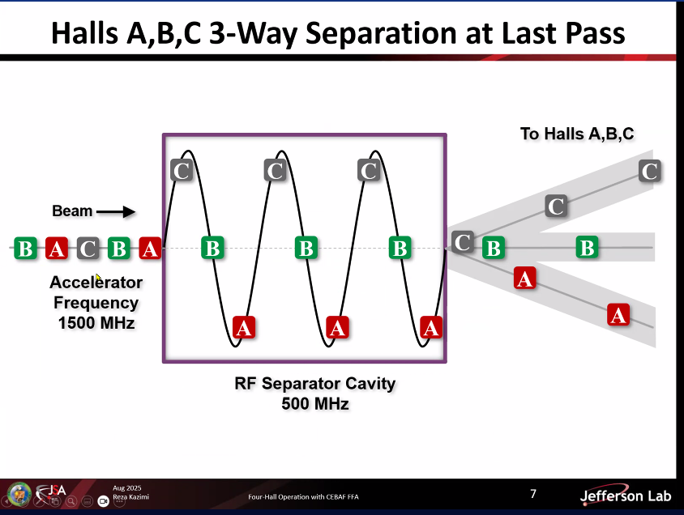
  - Accelerator frequency 1500 MHz.
- 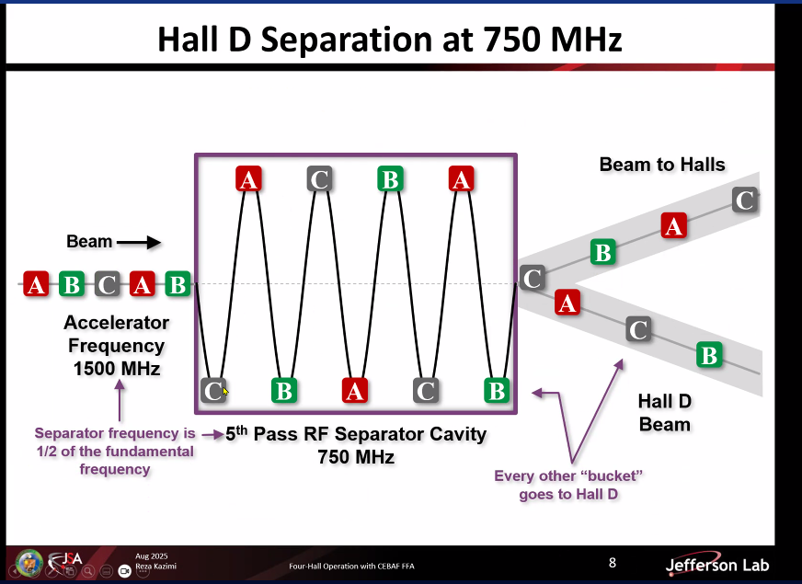
  - Animated video showing different hall beams extracted thanks to RF separator.
  - 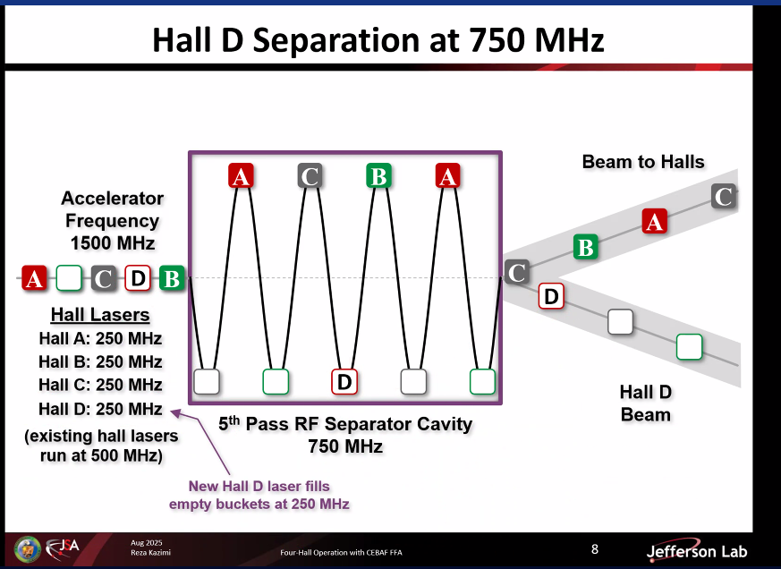
Volker: integrated current becomes less, due to empty buckets. Reza: no, we can put more bunch charge into a budget, current can be adjusted.
- 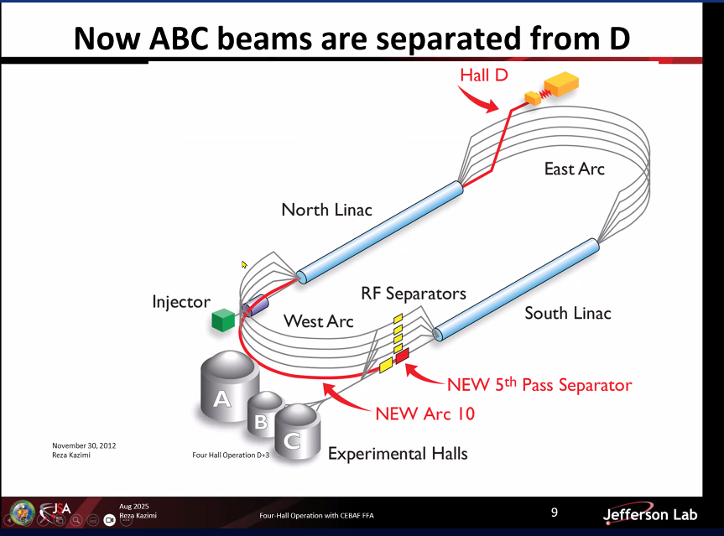
- 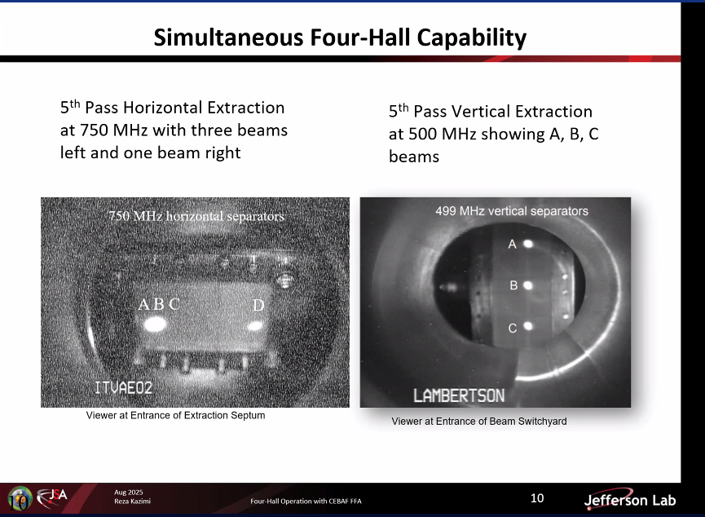
- 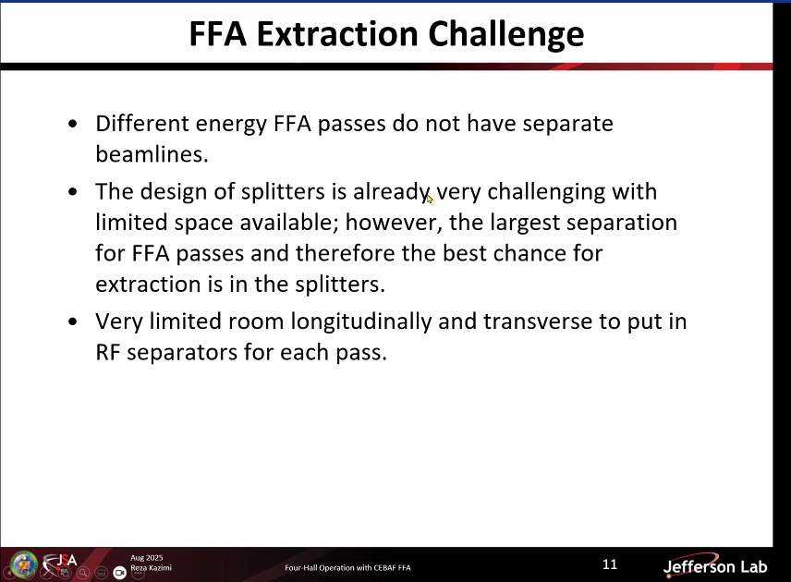
  - FFA challenge is due to multi-pass traversing in the same beam pipe.
- 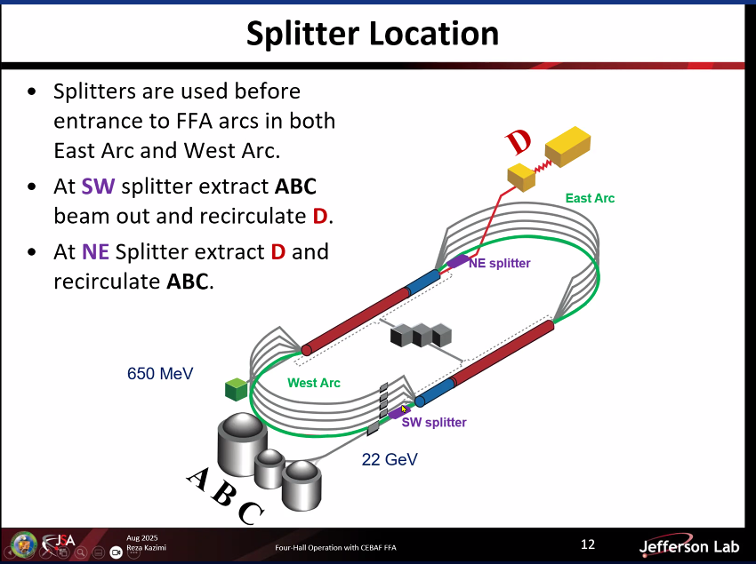
  - Two options to deploy the extraction line.
- 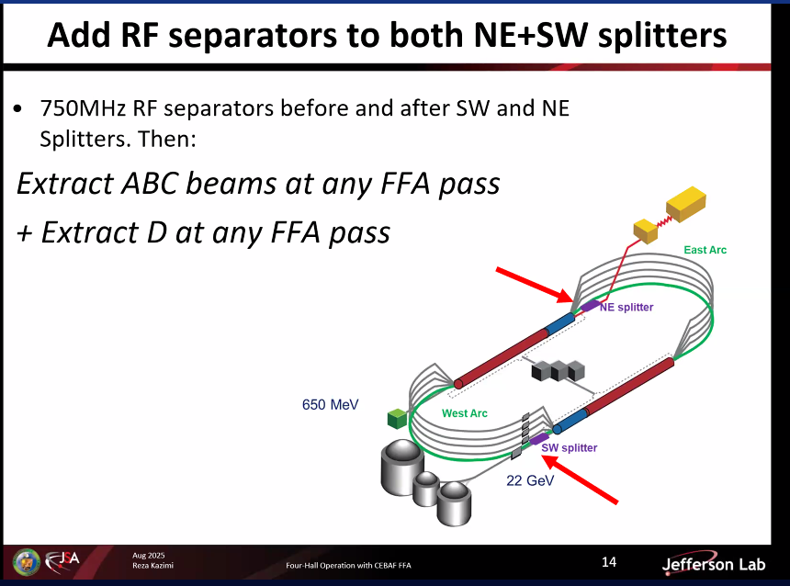
  - Reza: This is pretty much the extraction system, but can it be simpler ?!
- 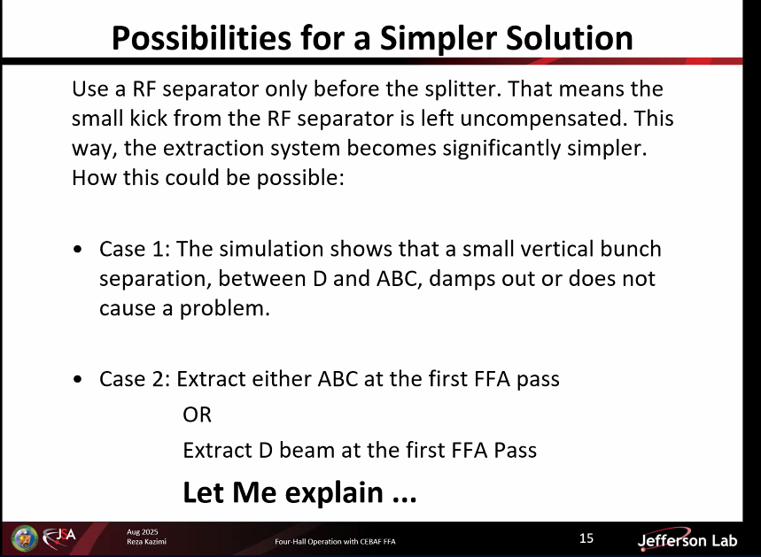
- 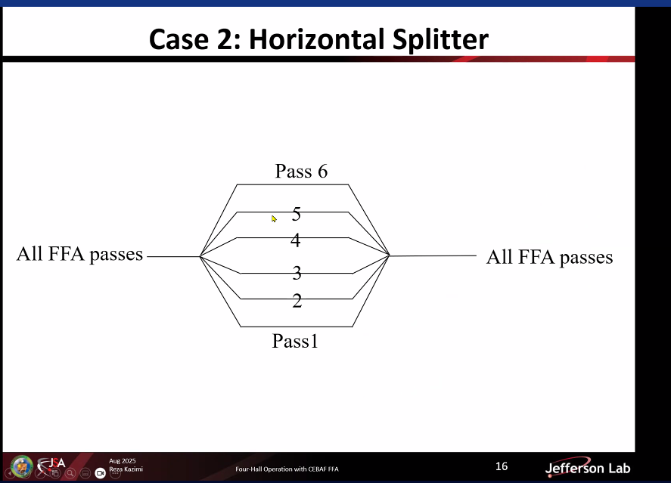
- 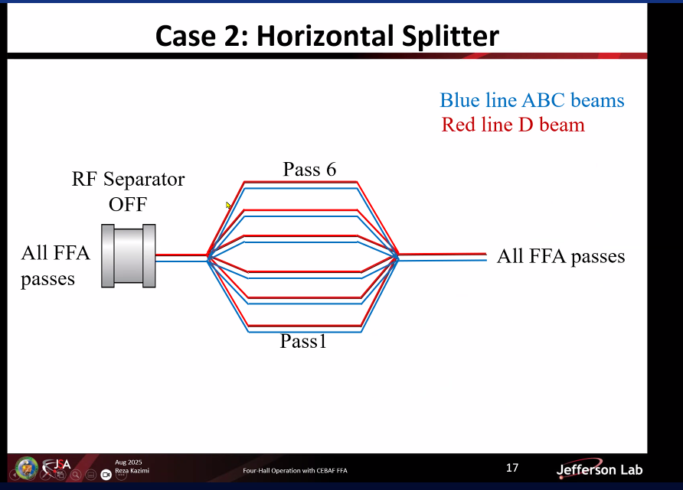
- 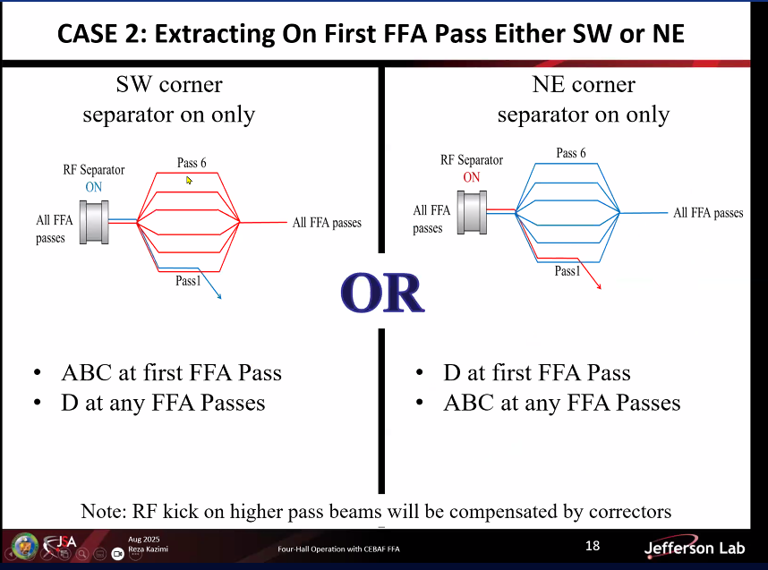
- 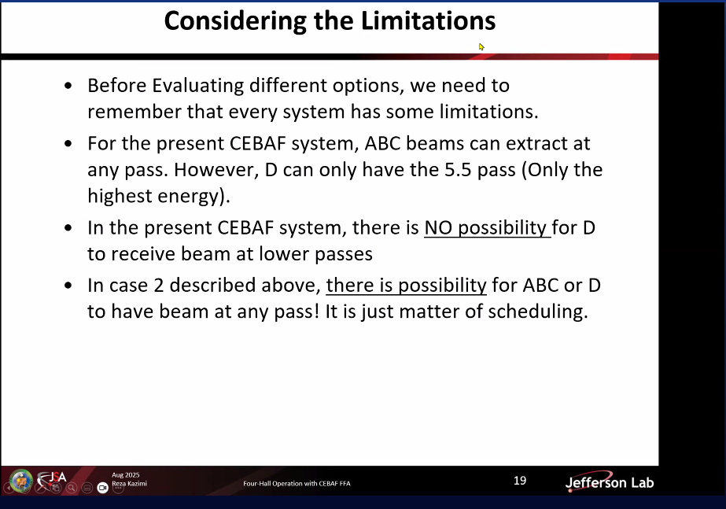
- 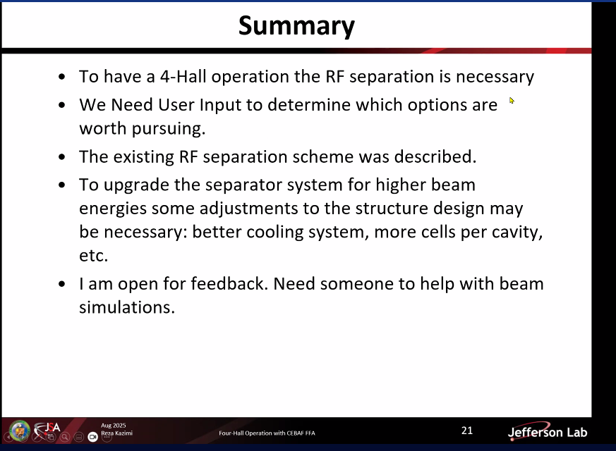
  - Up-to-date Splitter optics needed for further simulations.
  - User feedback required to determine the extraction requirements.
- Alex: we promised ABC same pass extraction and D half pass more. So, maybe further considerations create not required complications.
- Dejan: 6 us required for extractions? Reza: 4.2 us.
- Dejan: can you have a pilot bunch? How are you going to distinguish the bunches? Reza: tune beam can be used. CW beam can be used with a short pulse beam that can be used to distinguish passes. Reza refers to his earlier ‘notched beam’ model.
- Dejan: using a leading bunch, can you deploy the RF separators? Reza: the bunches are on top of each other. Their separation is in small degrees, so we cannot separate them like this, they are at the same phase in the cavity for acceleration.
- Dejan: what is the size of the RF separator cavity? There are 2 rods in which the current resonates. The encapsulating cavity is large but irrelevant. See Ryan’s picture as follows.
- Ryan put the picture of RF separator below to the chat:
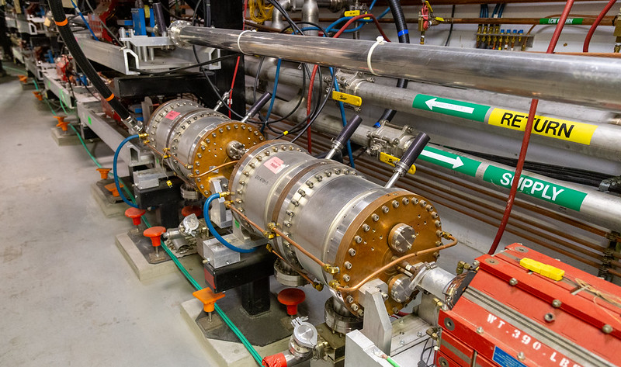
  - Dejan it is large half-meter or so.

- Ryan provided below picture to highlight the extraction of different passes:
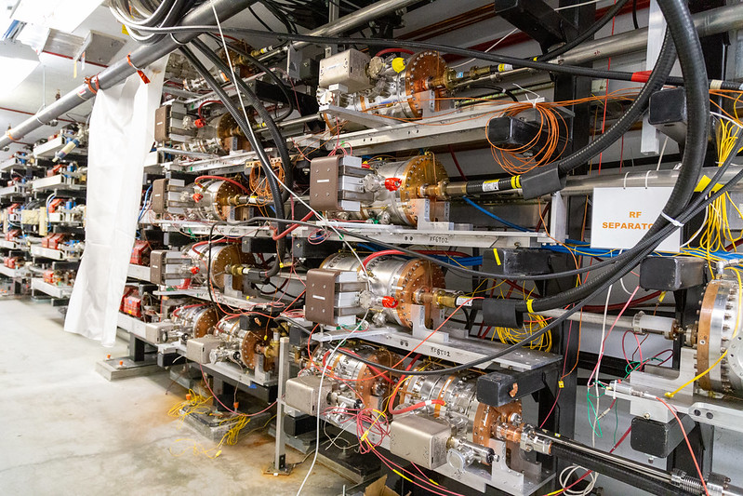
- Edy: Do the 6 passes of the bunches experience the same kick? Reza: yes, they would experience, but only the designated pass kick will be amplified.
- Alex: Reza you showed a certain phase advance of 2n pi or 2n pi +1. Has this been taken into account in the splitter design, a question to Donish? Donish: no.
- Ryan commented that Panofsky quads can be deployed for correction.
- Dejan: how big is the kick? Reza: slide 6, ~300 mu-radians.
- Ryan: how many RF separators are needed? And where to deploy them? Alex: they need to be next to each other due to coupling.

- Ryan: has tech changed since the 12 GeV extraction system was designed by Reza? Reza: no, excluding the option of super-conducting cavities. Alex: if needed SC can be considered. 100 feet is required after the RF separator kicking with ~300 urad.
- Alex: crab cavities and deflecting cavities used in the colliders, can those be deployed? Reza: yes, these what I am referring as SC.
- Ryan: Can C100 be used? Reza doubted that since there are world-wide R&D’s resulting in the usage of crab cavities.
- Reza: the 2-rod design with its tuning and production are robust and effective.
- Alex: have you performed the notched beam in the current CEBAF? Reza: to be tested. Ryan: is it in the next MD? Reza: yes.
- Ryan: when we increase the beam energy, I assume, we need to decrease the beam current. Reza: Yes. There are certain bunch charge and energy adjustments for the current CEBAF as well. So, FFA would be fine.

Time allotted | 10 mins | Agenda topic AOB | Presenter All

Special notes

Pathway to Repository: https://jeffersonlab-my.sharepoint.com/:f:/g/personal/tristan_jlab_org/EqZ5MeS-nipCgPfZB5p0oS4B9Is67d3nQb9sLJI3Zyev9g

