FFA@CEBAF Working Group|Minutes

Meeting date | time 09/19/2025 | 11 AM EDT | Meeting location https://jlab-org.zoomgov.com/j/1614898082?pwd=TnUzMS81M2sxbDZIbERJU01tYkJCQT09
 | Attendees  Salim O., Ryan B., Edith N., Patrick N., Sadiq S., Donish K., Kirsten D., Stephen B., Volker Z., Vasiliy M., Andrei S., J Scott B.,
  Meeting called by | Salim O.
  Type of meeting | Weekly Meeting
  Facilitator | Salim O.
  Note taker | Edith N.
  Timekeeper | Salim O.

Intro Discussion
- Magnet Degradation: Initial Results

Agenda topics

Time allotted | 45 mins | Agenda topic Permanent Magnet Degradation | Presenter Ryan
Ryan states intention to run through NAPAC slides and rough data

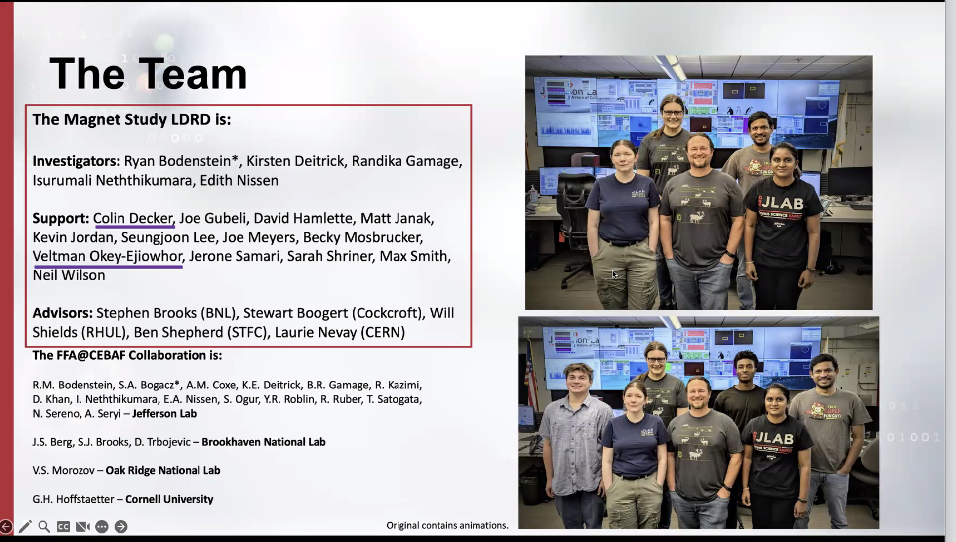
Ryan skims through CEBAF background since the audience understands it already
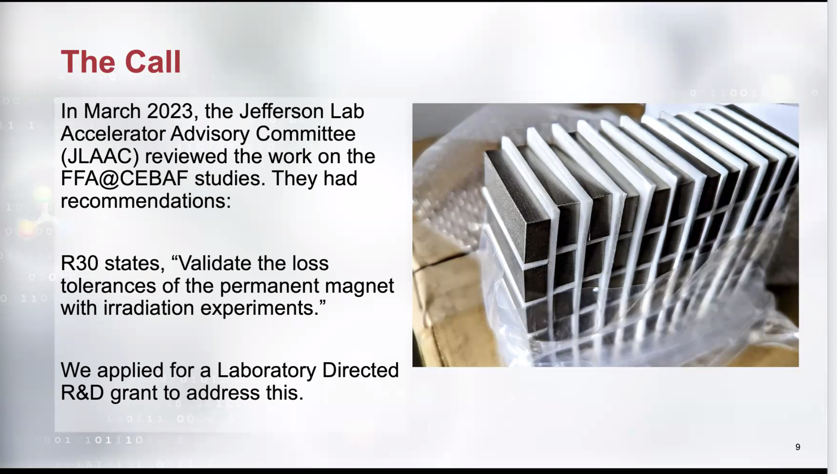
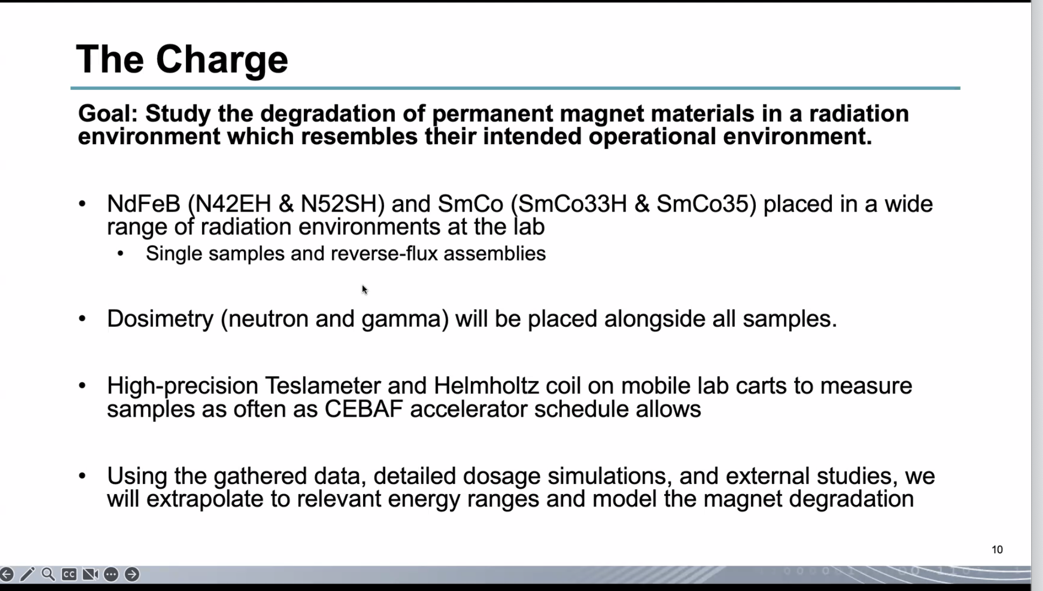

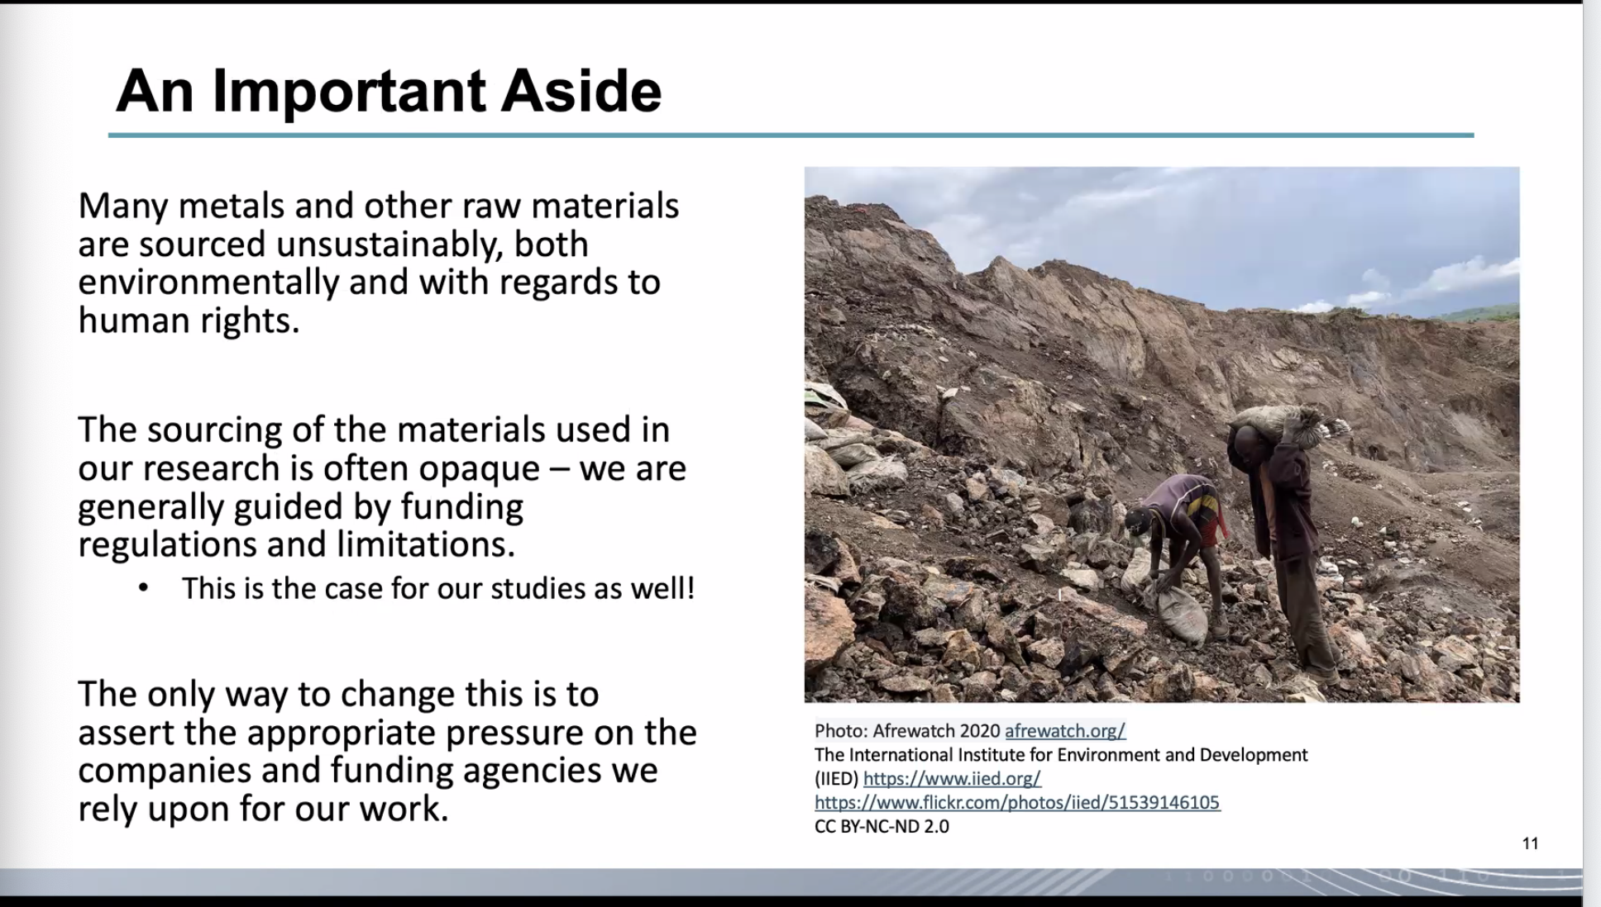
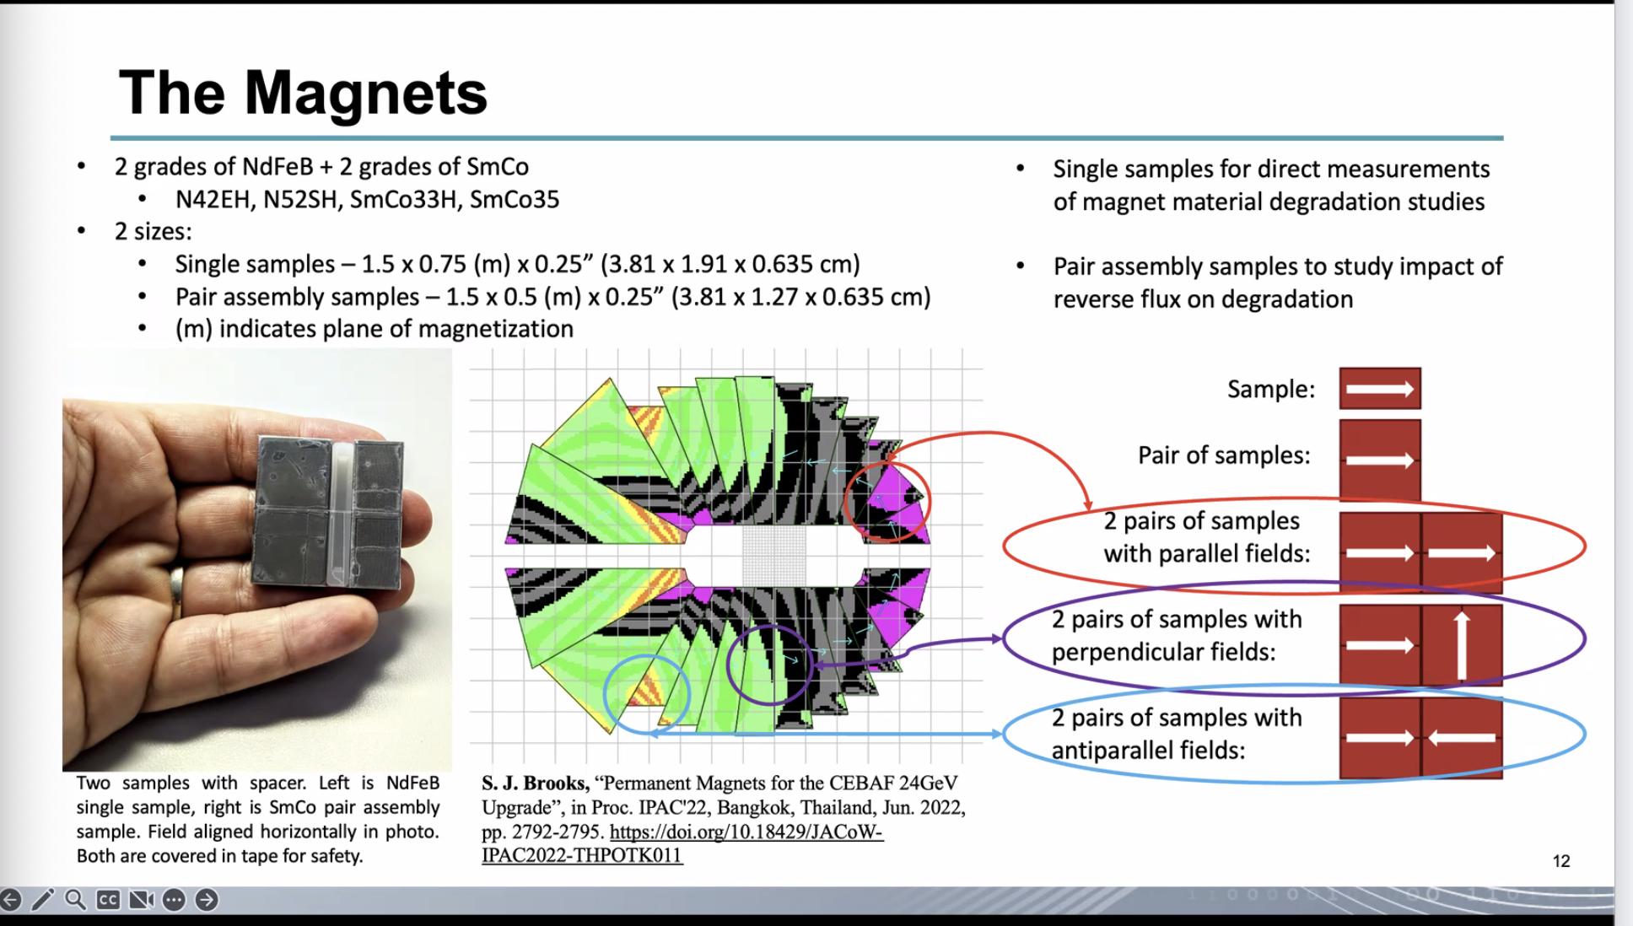
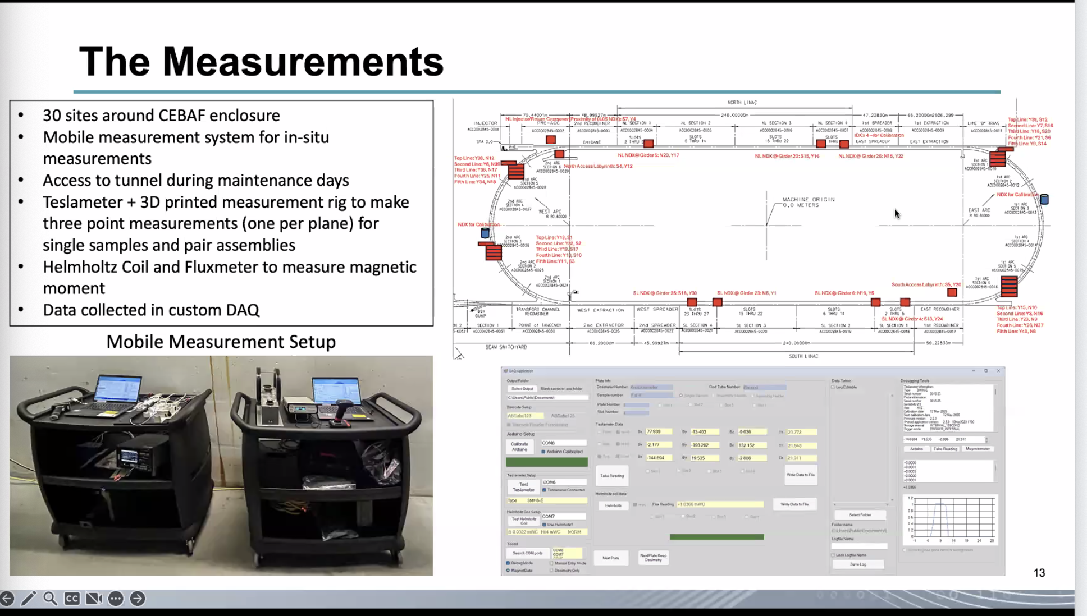
Ryan also explained the different PSS zones in the CEBAF tunnel
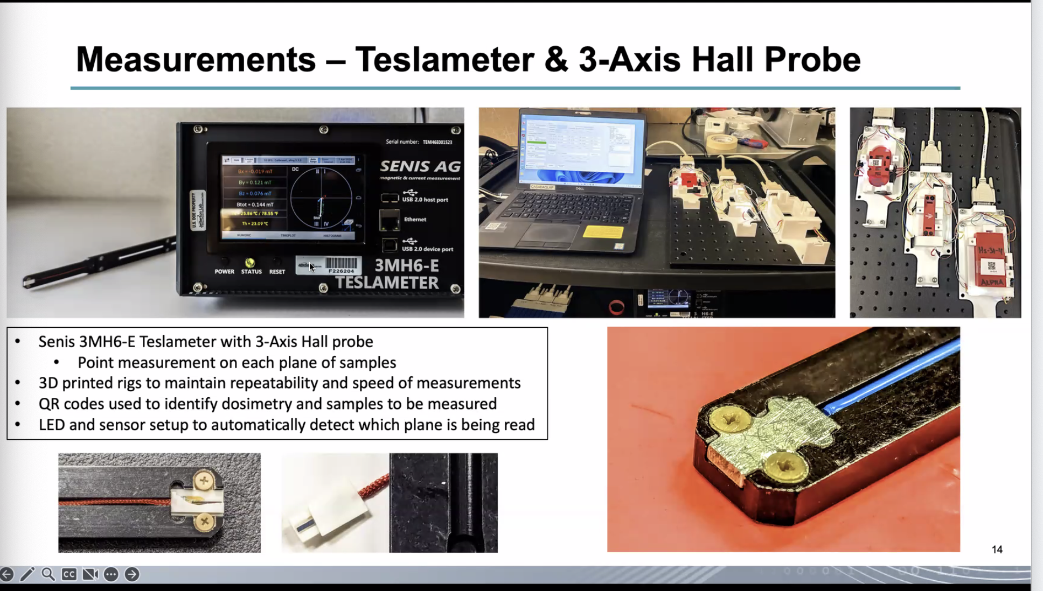
Ryan detailed how the initial and second probes were damaged.
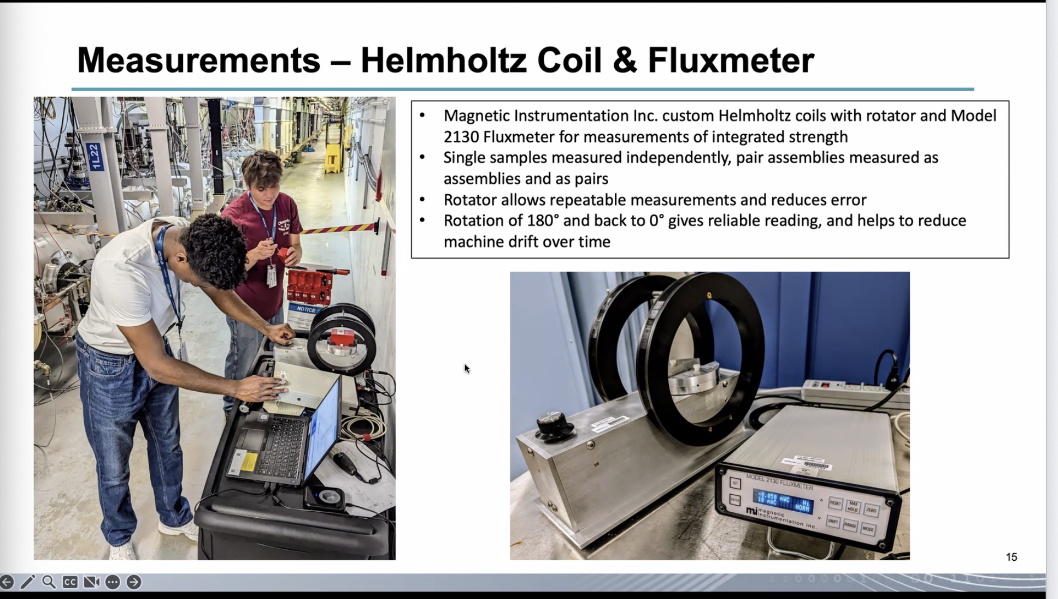
Ryan explains how the Helmholtz coil is operated, as well as problems with the value occasionally drifting.
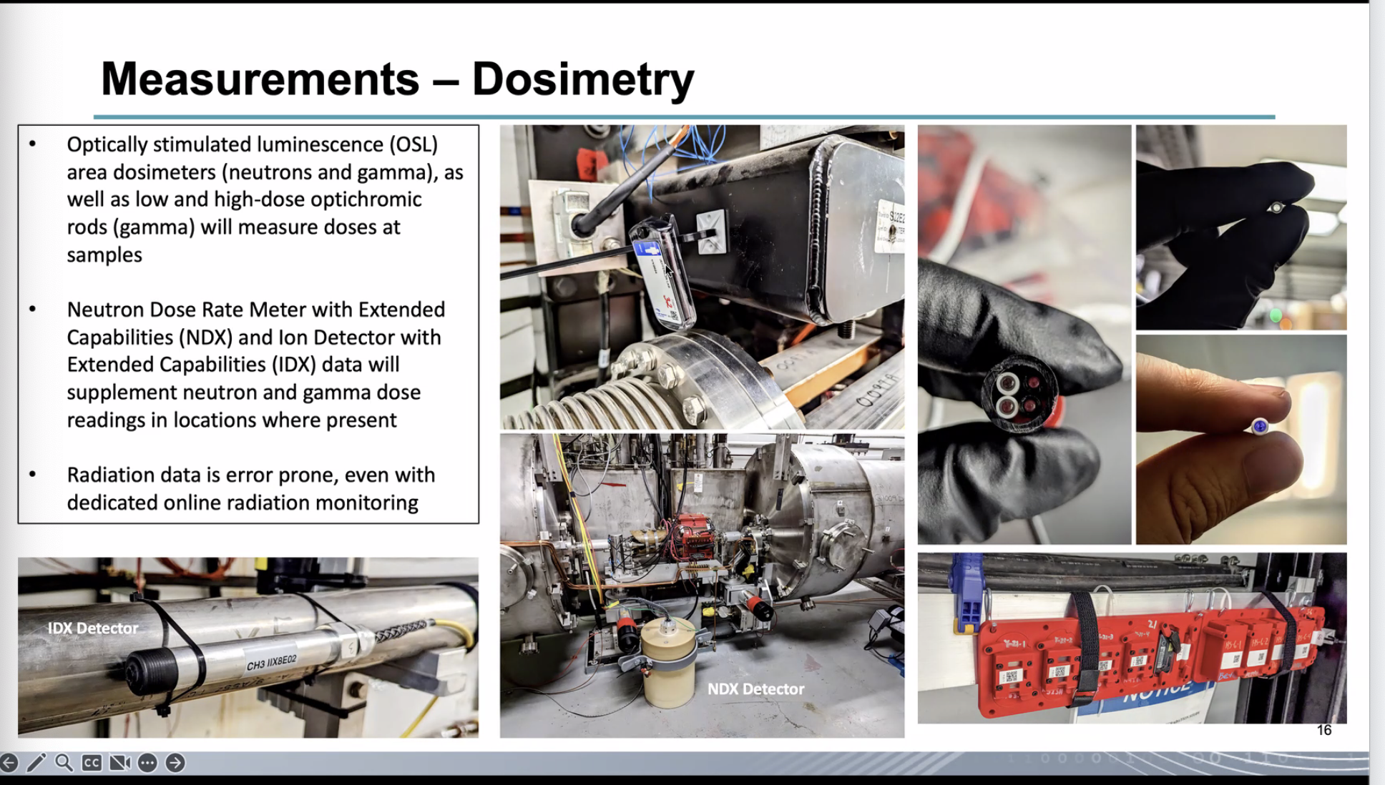
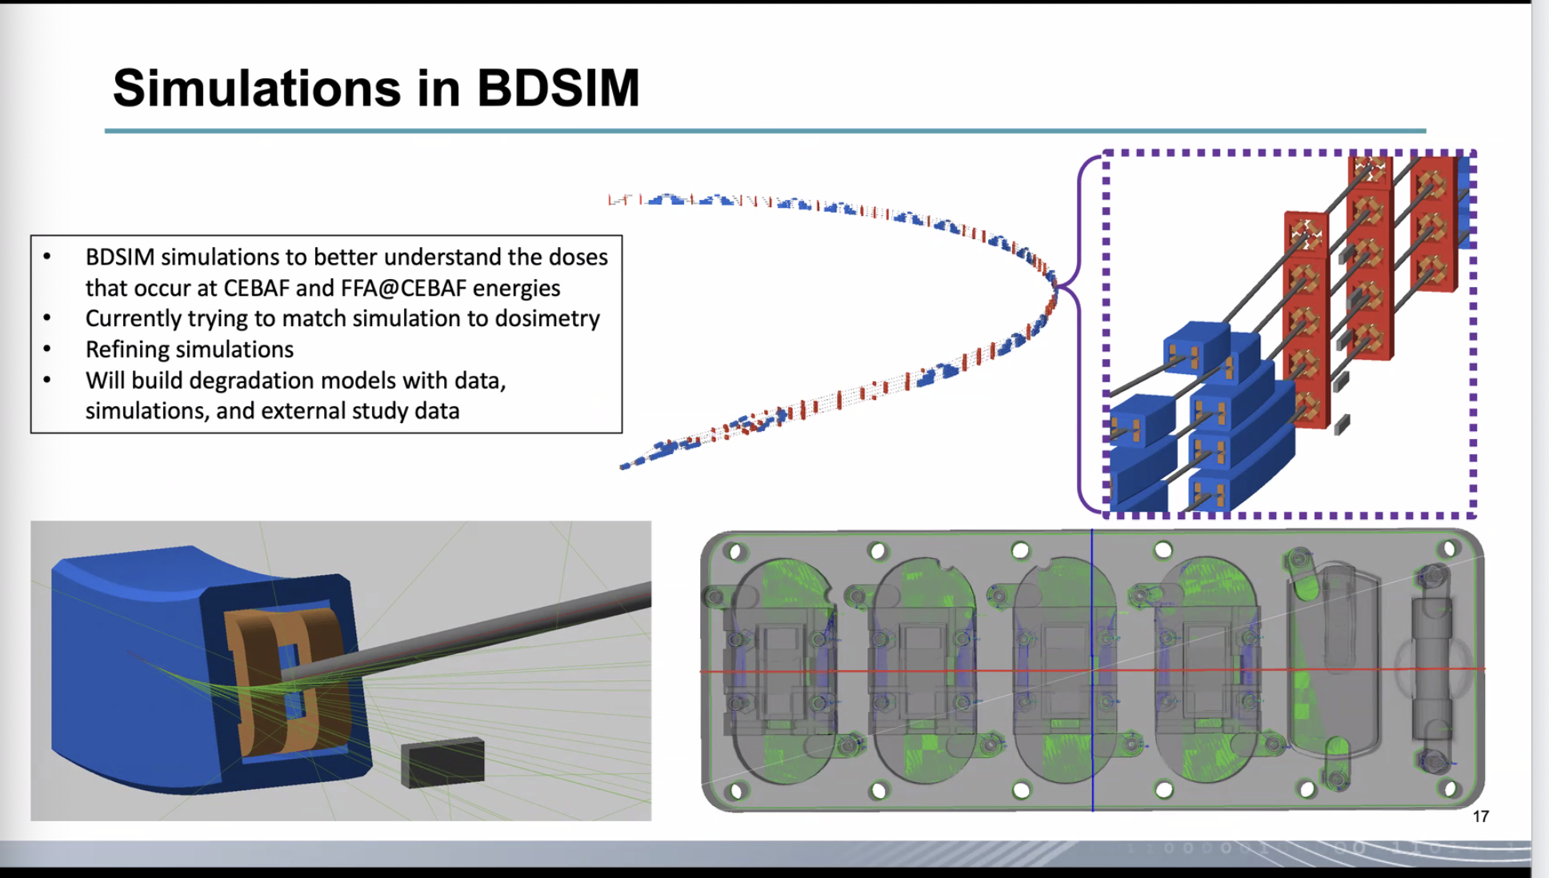
Ryan mentions problems with using CAD files for BDSim simulations due to overlapping vertices.
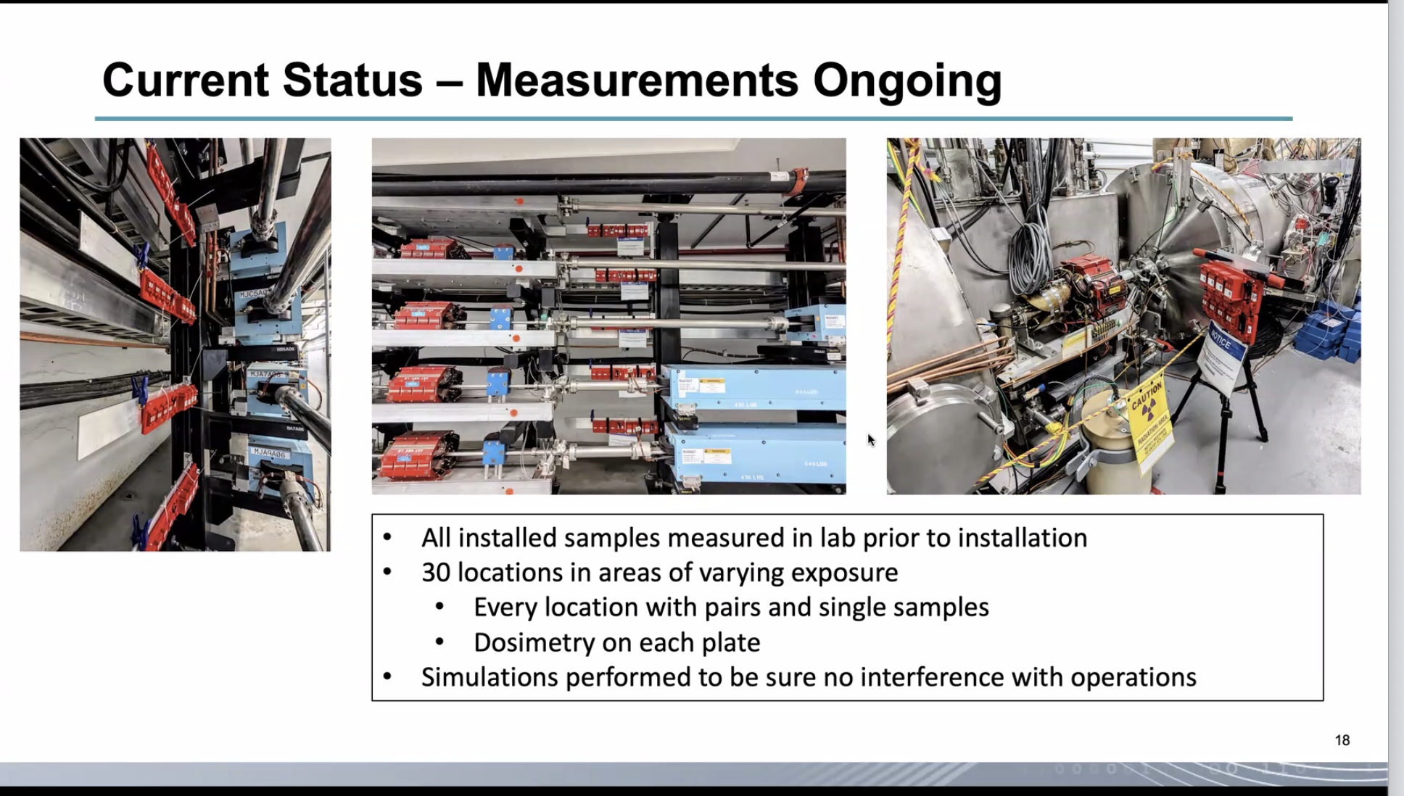
Salim asked for clarification of the motion of the beams as shown in the figures, Ryan explained how the image is oriented.
Ryan then discussed the decisions based around the placement of the samples at various points in the machine. Kirsten added that the experiment was looking for a variety of doses.
Ryan continued mentioning the different expected doses based on placement.
Volker asked about whether we see more dose at higher energies vs lower energies. Ryan mentioned that this was an ongoing concern that the team is looking at.
Kirsten mentioned overall that higher energies have higher doses, and mentioned that there is enormous amount of spray and secondary radiation. The analysis is still ongoing.
Volker suggests weighing with the current in the various lines, Kirsten mentions that that is part of the process. She also mentions that there is a lot of data processing going on.
Salim mentions possible synchrotron radiation from quads, Volker doesn’t believe that is a major issue. Kirsten believes it comes from spray from upstream dipoles as well as scraping. Ryan mentions potential showers from synchrotron radiation hitting the quads.
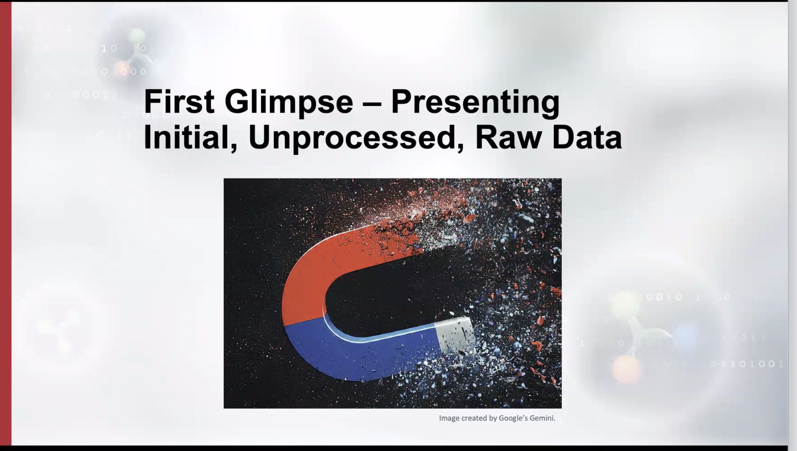
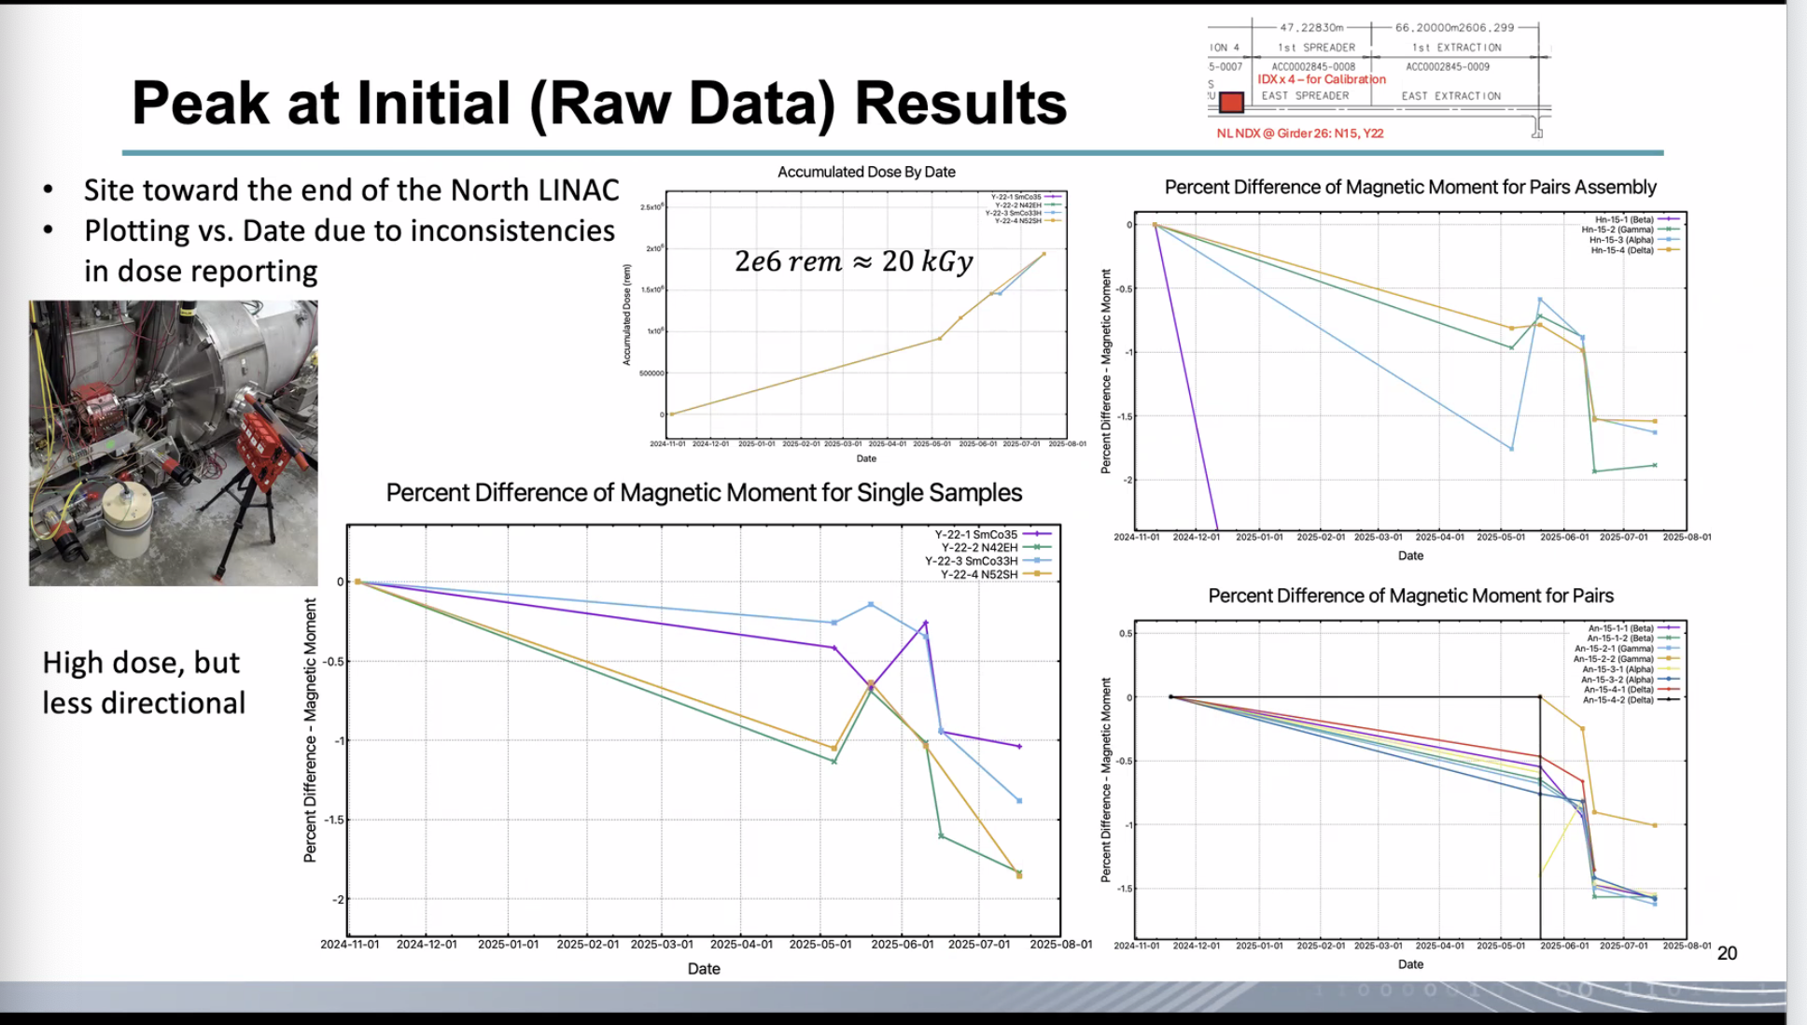
Ryan mentions that this is raw data and rough estimates.
Stephen asks for the types of assemblies, Ryan shows on an earlier slide, Edy says which arrangement is labeled Beta.
There was a discussion about the readings from beta (antiparallel) assemblies.
Stephen Brooks mentions temperature as a confounding factor, Ryan mentioned that there would be more about that later.
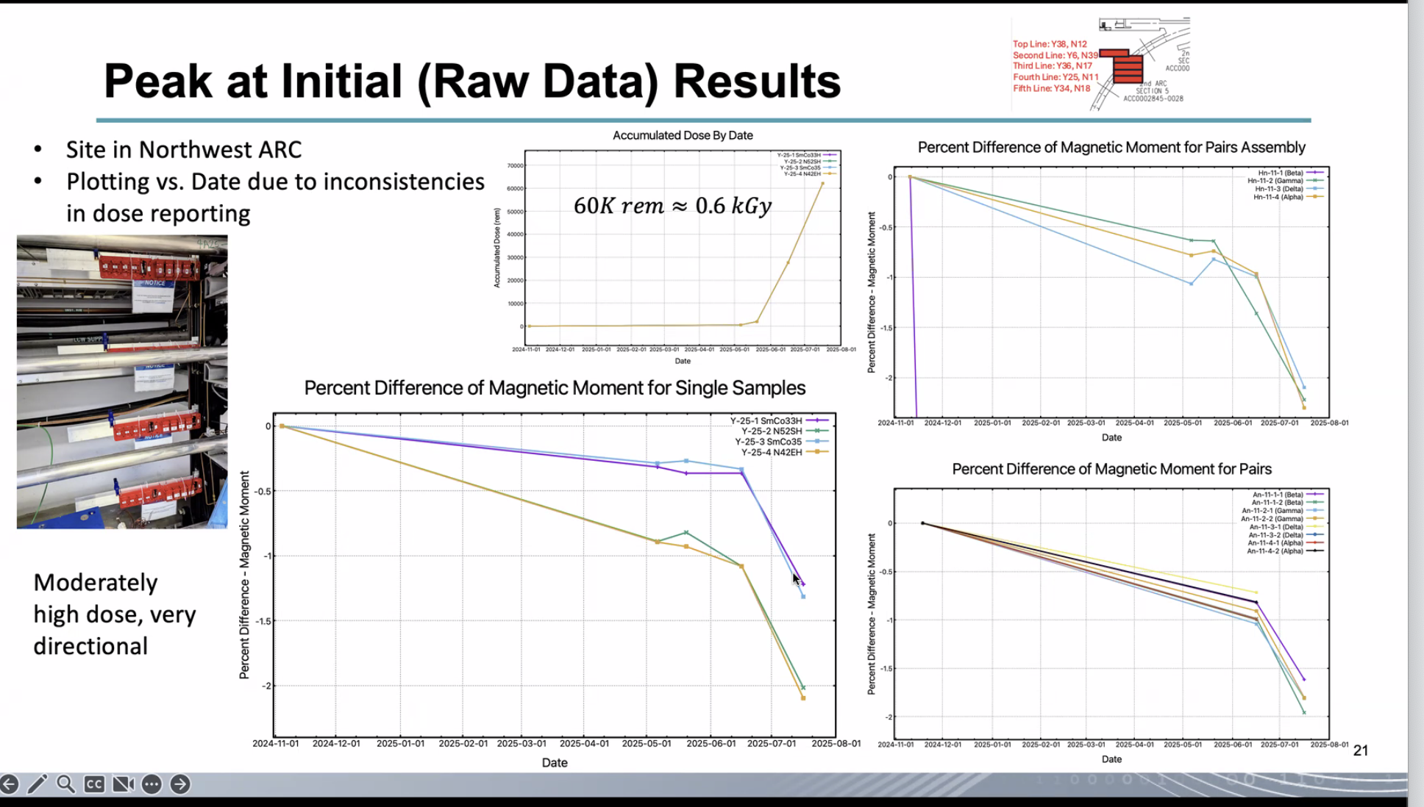
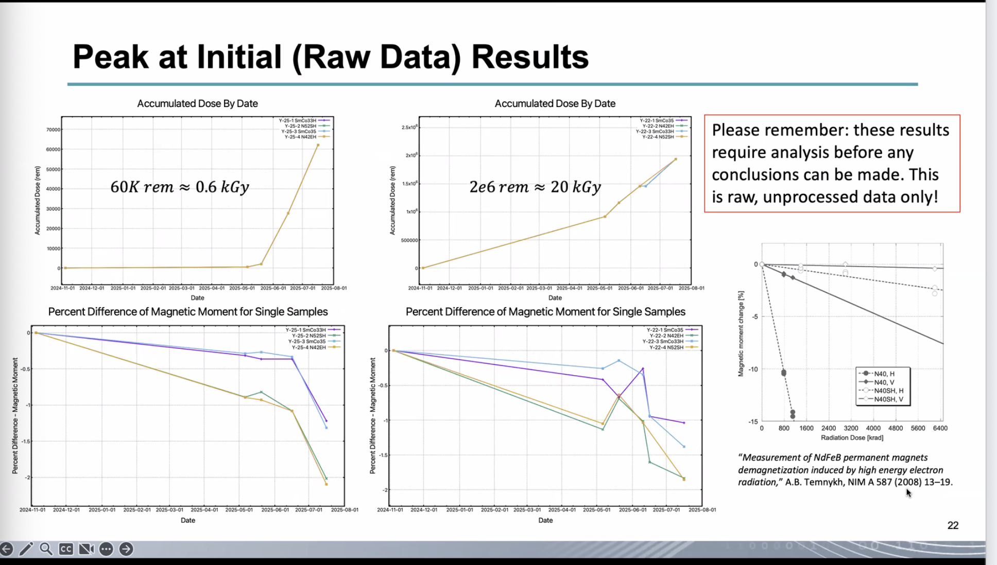
Ryan mentioned that we could skip over the end since the issue of temperature on the readings is still and issue.
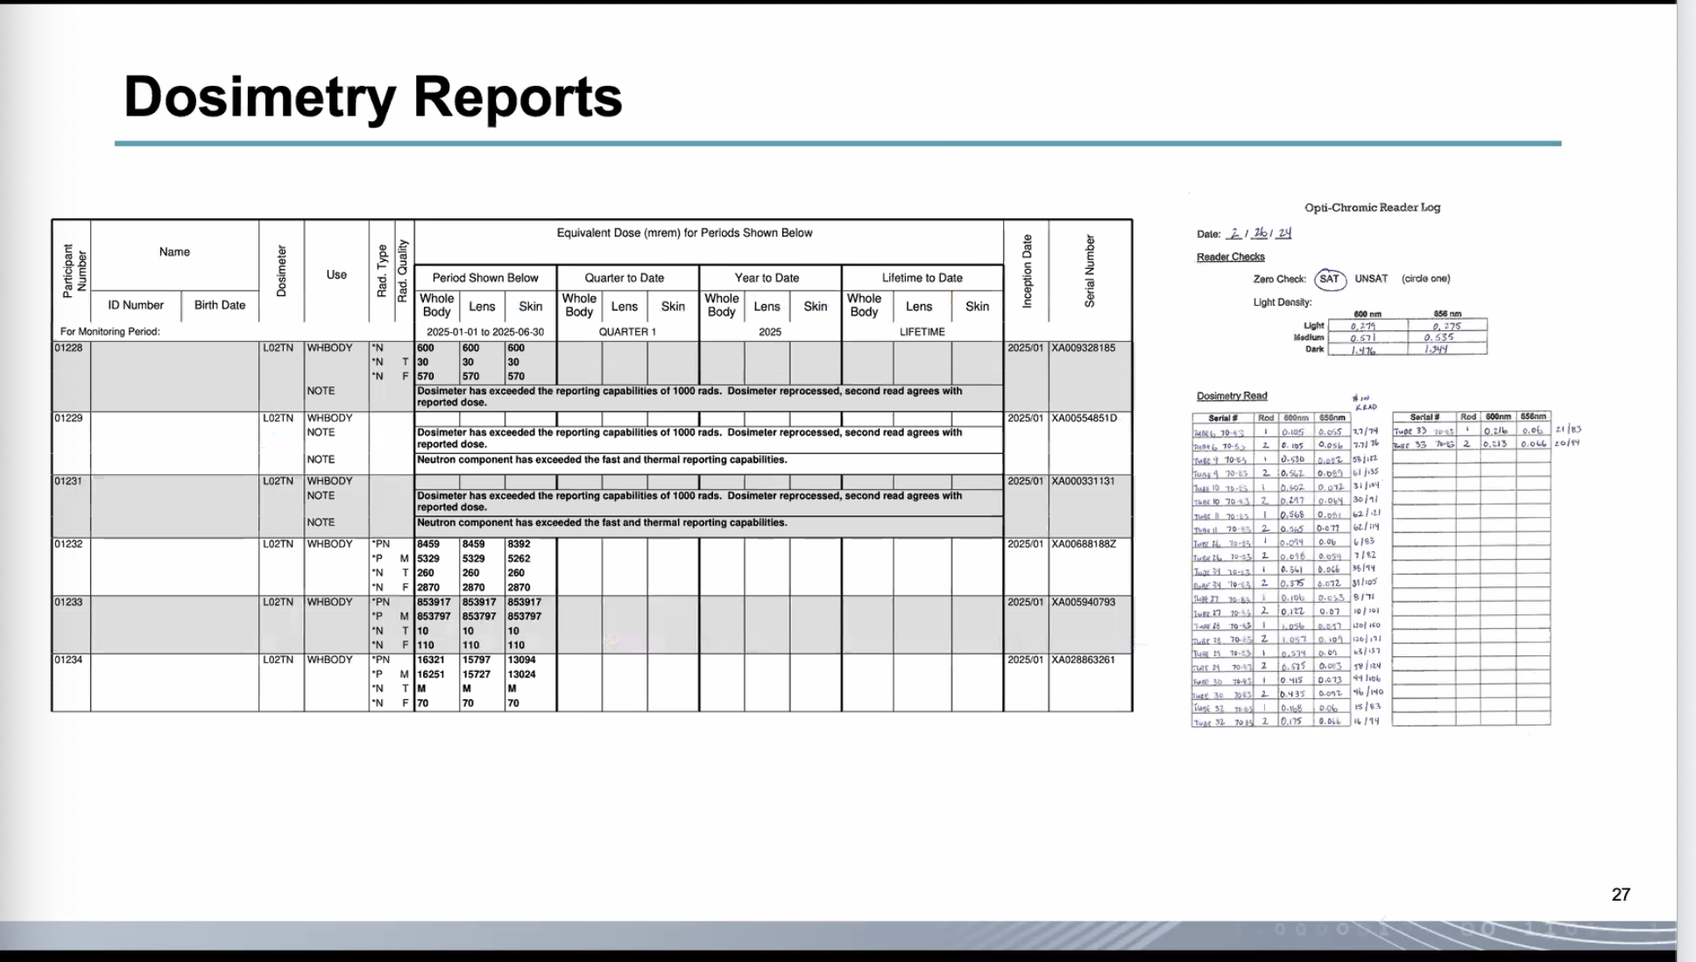
We are switching to different data sources that were taken after NAPAC
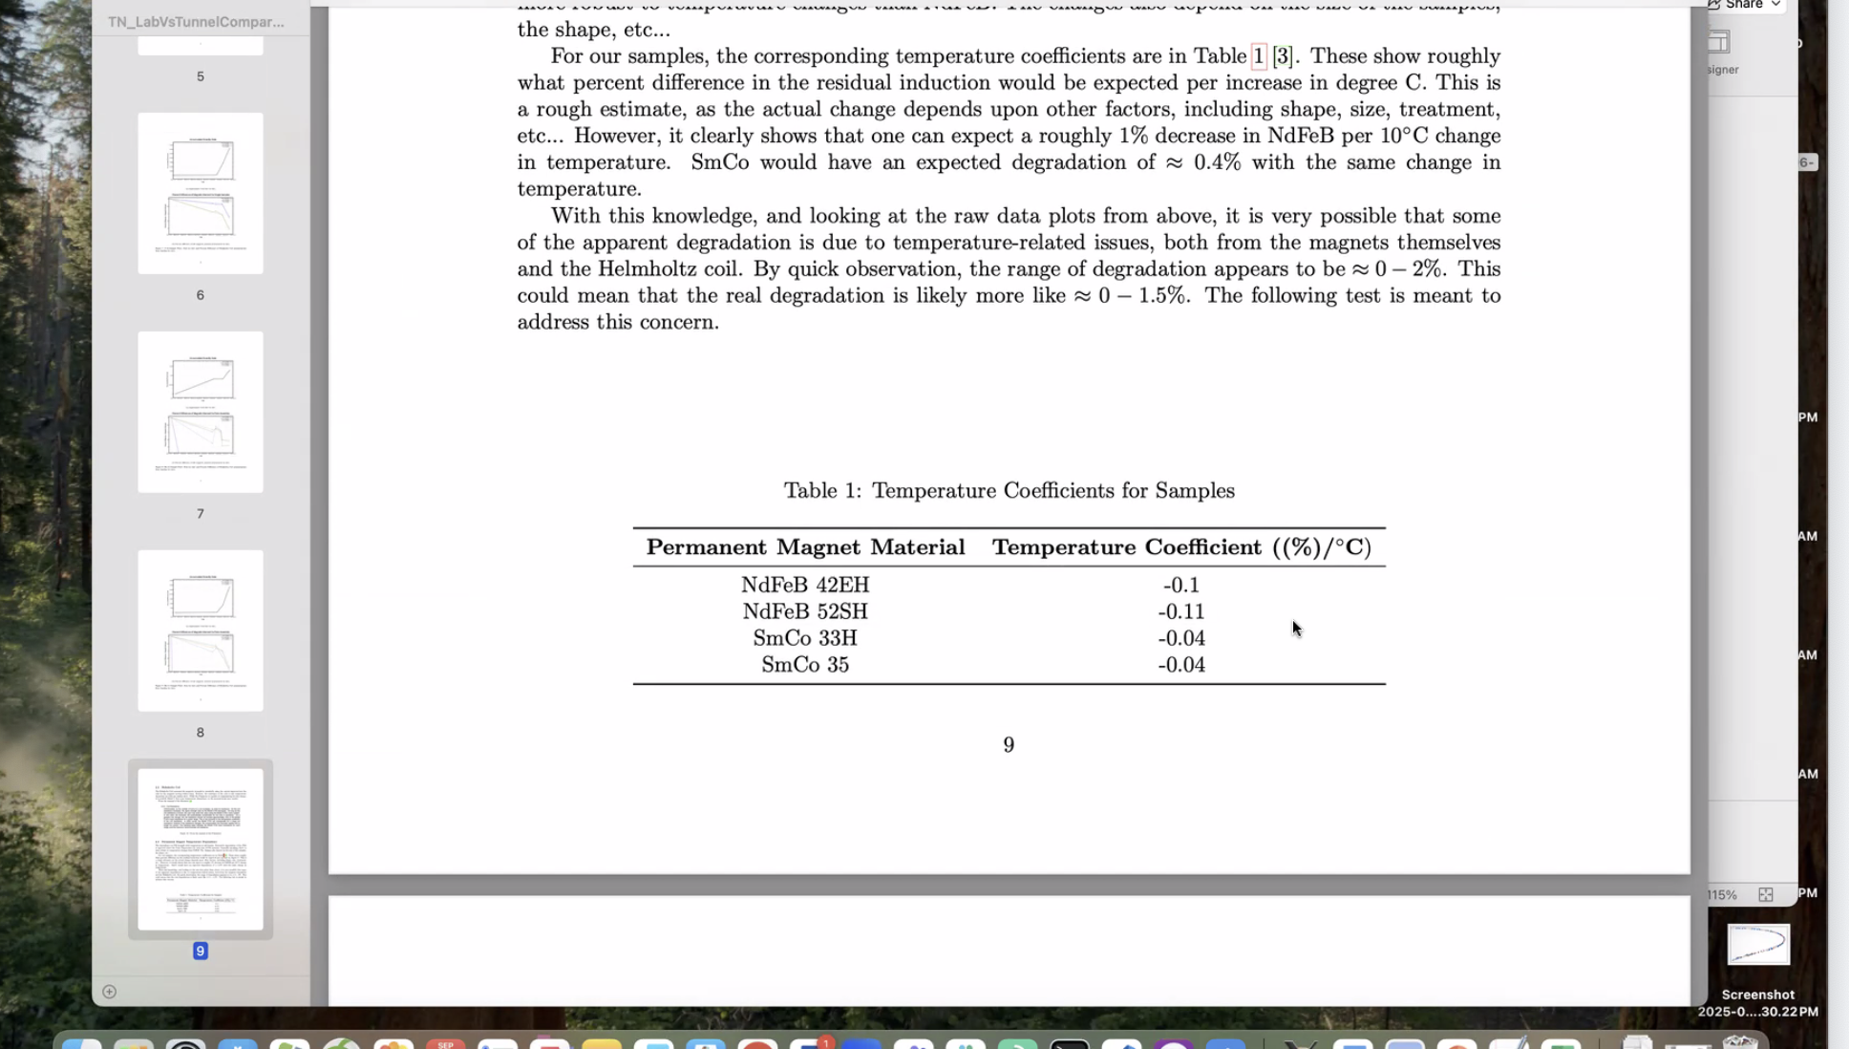
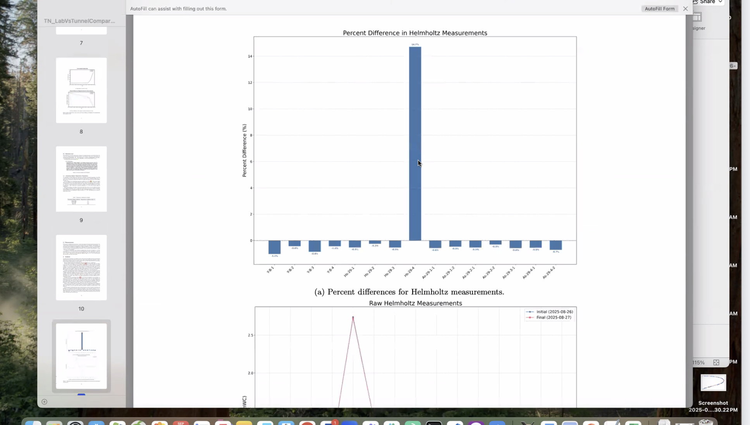
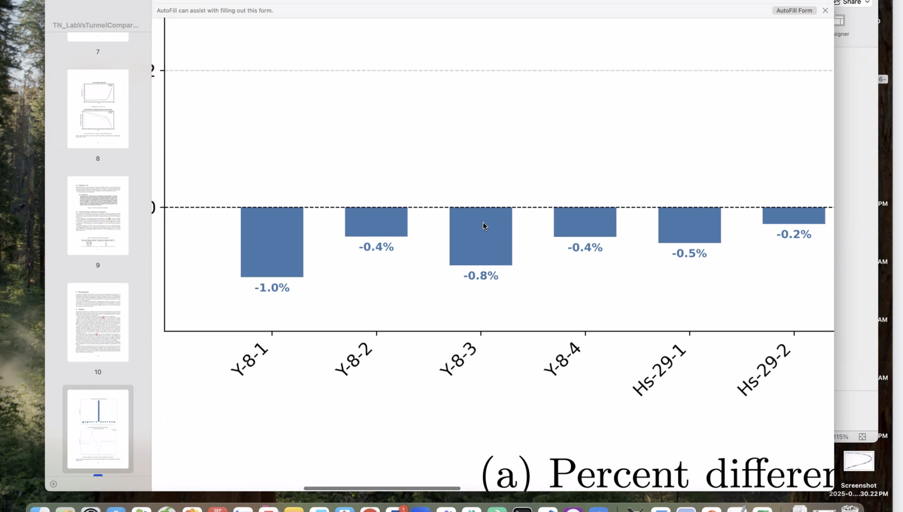
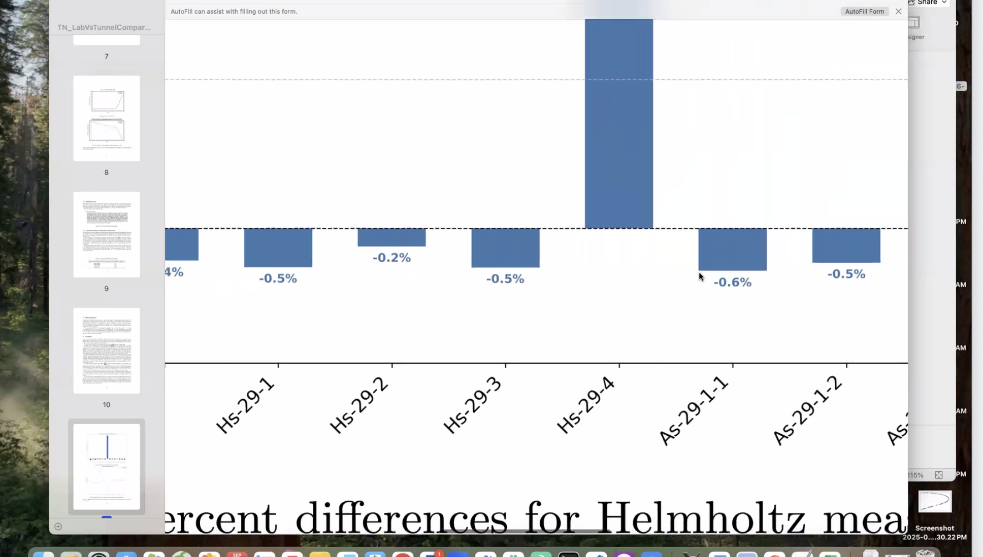
Different temperature errors based on smco vs neodymium
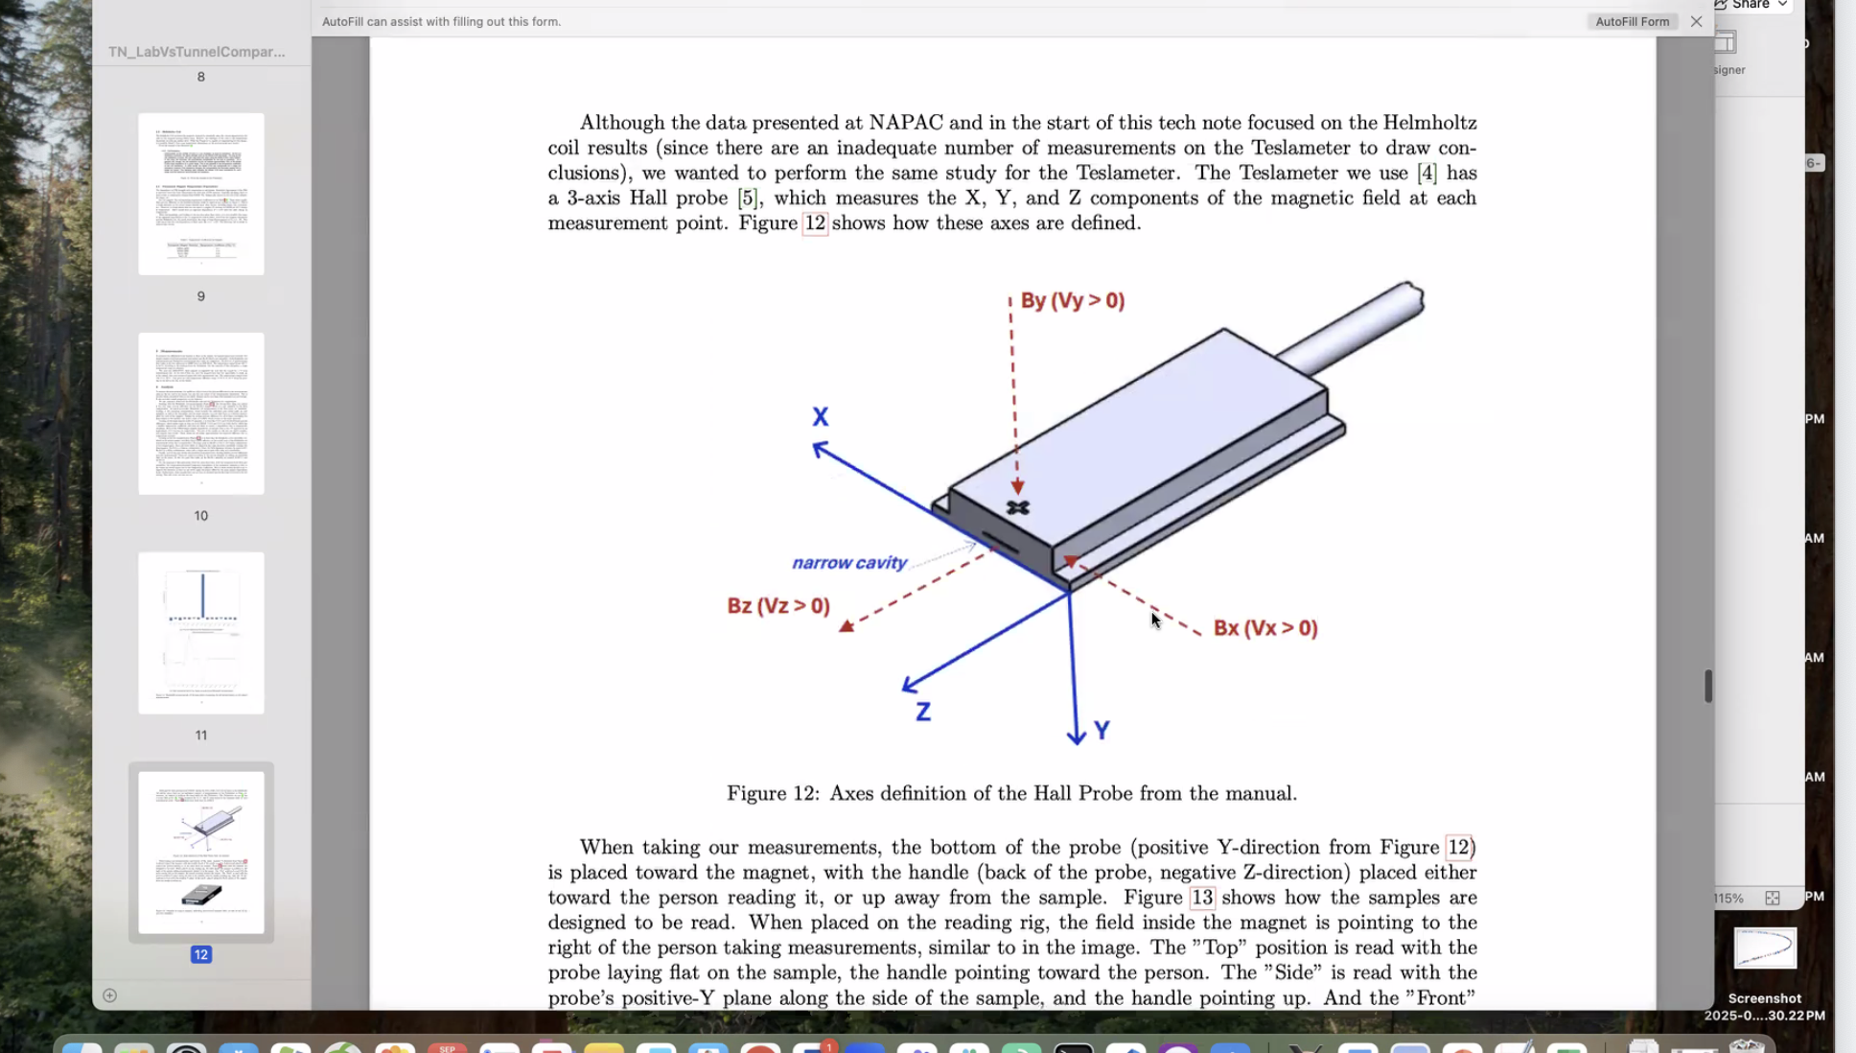
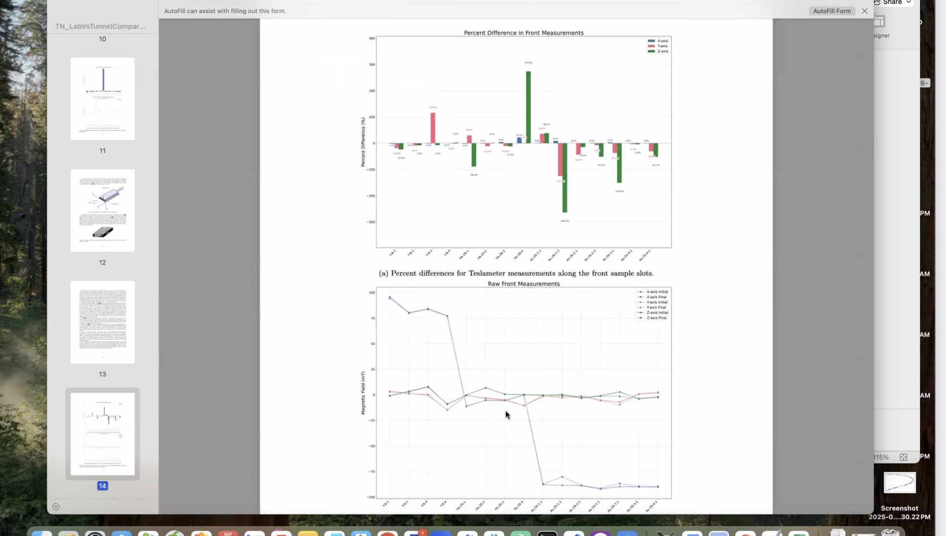
Ryan mentions that this teslameter difference is more sensitive to position
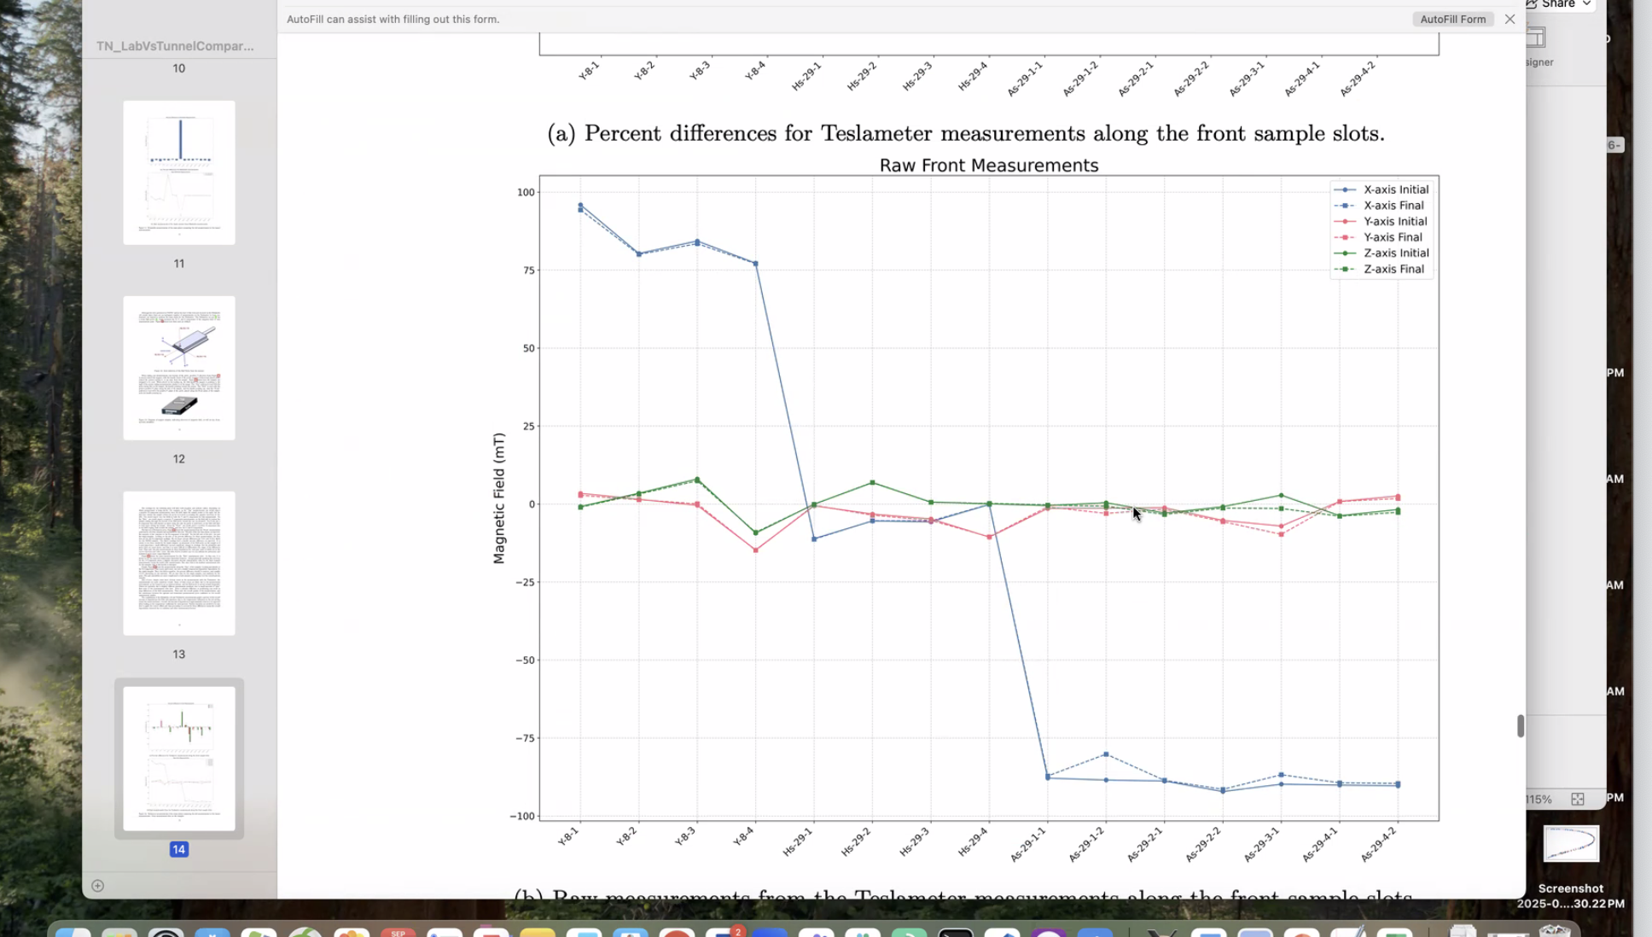
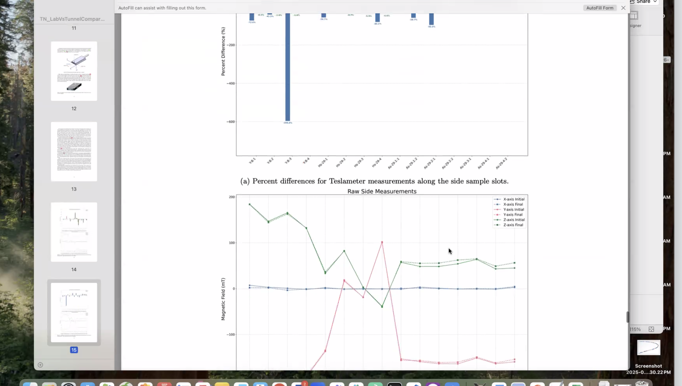
Stephen recommends using the temp data to help analyze the data
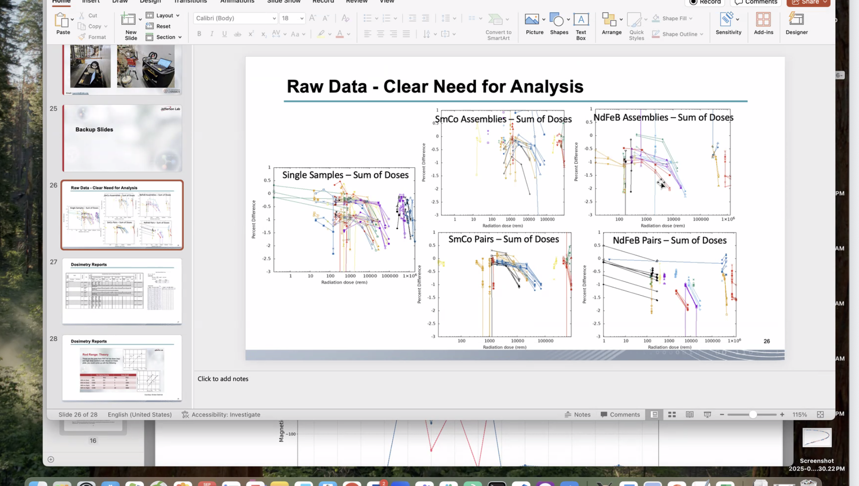
A discussion ensued about dosage gap in the raw data, furthermore there is a data issue since we only have full data for optichromic rods.
Salim brought up that permanent magnets in the upgrade will need to be actively cooled to prevent temperature-based drift and dropoff.
Ryan brought up a concern that the data we have is from a low current run and if we are already seeing degradation this could be an issue.
Patrick mentioned that some wedges in a Hallbach array could degrade at different rates. Stephen explains the color scale in the Hallbach plot on slide 12. Lowest demagnetization is purple and black, highest is green and yellow.

Salim mentions that Kirstens talk which hasn’t been presented yet is available on the sharepoint for FFA at CEBAF. She mentions that there needs to me an energy correction for each run to get BMad to run correctly. BMad normalizes everything to reference energy. It can be corrected for, if there are any concerns, please email Kirsten.

Special notes

Pathway to Repository: https://jeffersonlab-my.sharepoint.com/:f:/g/personal/tristan_jlab_org/EqZ5MeS-nipCgPfZB5p0oS4B9Is67d3nQb9sLJI3Zyev9g

