FFA@CEBAF Working Group|Minutes

Meeting date | time 10/03/2025 | 11 AM EST | Meeting location https://jlab-org.zoomgov.com/j/1614898082?pwd=TnUzMS81M2sxbDZIbERJU01tYkJCQT09
 | Attendees  Alex B, Salim, Donish, Sadiq, Dejan, Stephen, Edy, Roger, Volker, Andrei, Patrick Ngotta, Vasiliy, Scott.
  Meeting called by | Alex B
  Type of meeting | Weekly Meeting
  Facilitator | Alex B
  Note taker | Salim
  Timekeeper | Alex B

Intro Discussion
- Splitter design update, magnet tolerance specs - Donish
- Attempts to get Isochronous FFA arcs for the CEBAF upgrade’ - Dejan
- AOB - All

Time allotted | 25 mins | Agenda topic Splitter design update, magnet tolerance specs | Presenter Donish

Due to an issue in Donish’s pc, Dejan gave the first talk then Donish.
- 
- 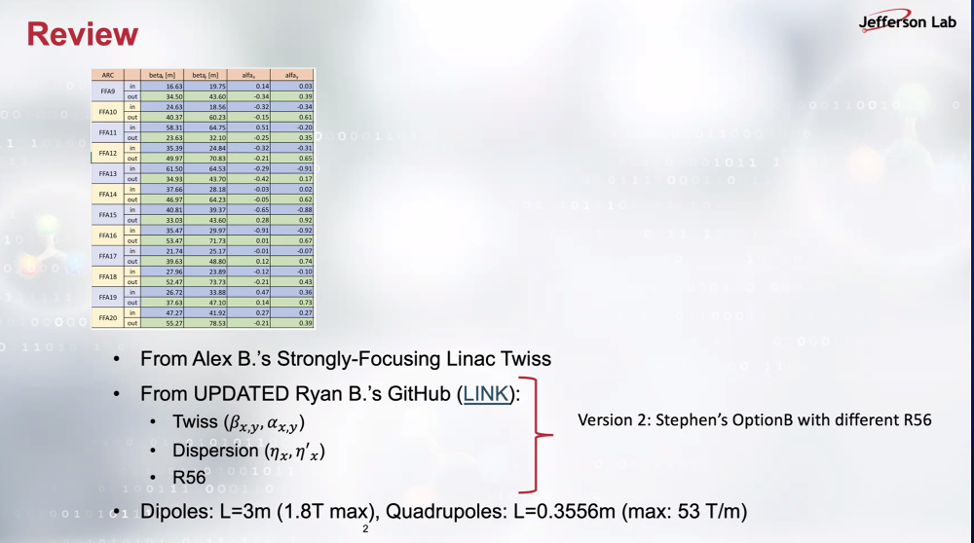
  - Smaller R56 in version 2 compared to v1.
- 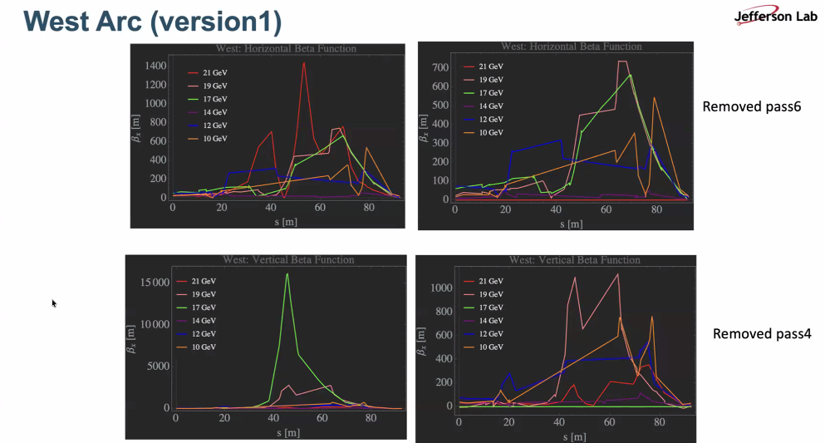
  - Current progress for the West ARC. Certain passes are removed from the right plots. Work in progress, not final. Pass 6 needs to have half of beta functions or so, work ongoing for that pass. Bottom ones have a typo; correction is beta_y for the vertical axes, the plot titles are correct.
  - Dejan: What is the M56 that needs to be corrected in this design? Donish: can’t remember exactly the value from heart but about 17 mm or so.
  - Dejan showed his screen:
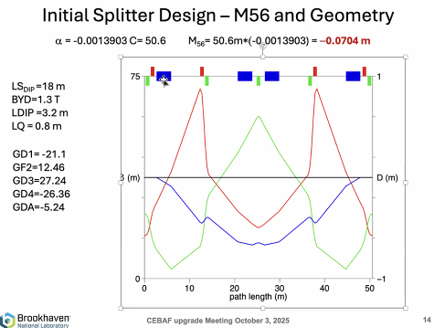
Beta functions in Dejan’s design are below 100 m. He asks to Donish why Donish’s beta functions goes to 1000 m or so. Donish says it is due to the doublet Dejan deployed on his design, and Donish says this doesn’t fit to his splitter design.
- Dejan refers to Ryan design where Ryan had opposite direction placements to reduce the magnet impact on each other.
- Dejan: maybe zig-zag solution should be considered to reduce the beta functions. We may not get stuck to the one solution for the splitter.
Donish shows his older design:
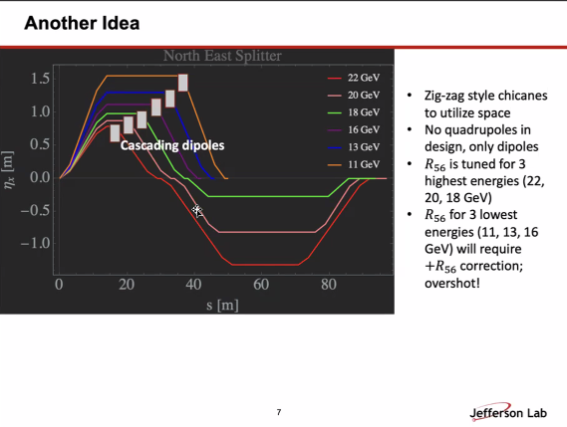
Then Donish shows:
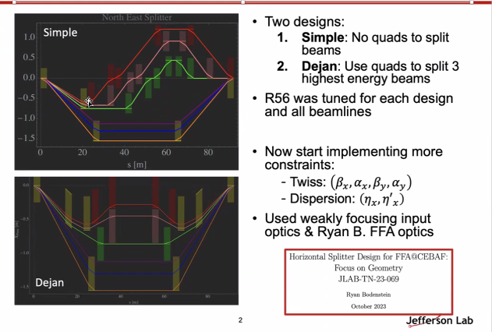
- Dejan: that design can reduce the dispersion and beta. Donish: but still there was the same issue of matching all the parameters: M56, beta, dispersion. Again, there is no space to put the quads between the first two dipoles.
- Salim: why not add edge focusing, or additional windings? Donish: Scott also suggested this earlier, but not enough. Salim: why not just adding such a quad-sextupole field in the optimization, then we should think of how to build it. Scott: it will complicate the things introducing the quad gradient will change the geometry, that space constraint was the source from the problem from the beginning.

- Dejan shows this:
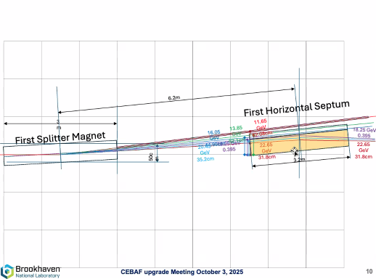
Dejan says the main problem is how small the septum we can put.

- Back to Donish’s slides but time run out, to be continued in the next meeting.
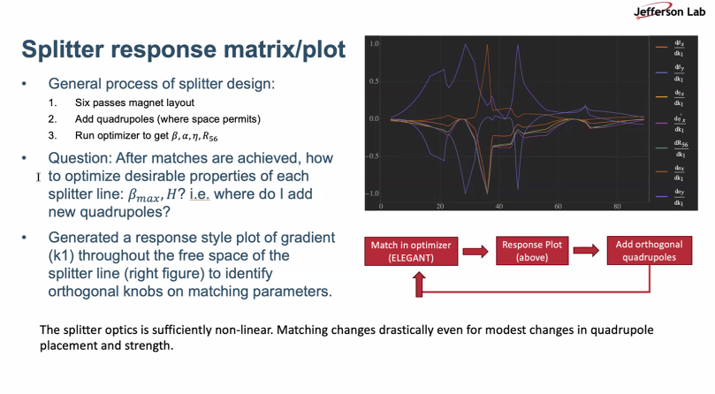
Alex: weakly focusing style from Donish’s one-year ago work might be worth revisiting.
Action Items | Person responsible | Deadline

Time allotted | 25 mins | Agenda topic Attempts to get Isochronous FFA arcs for the CEBAF upgrade’ | Presenter Dejan
- 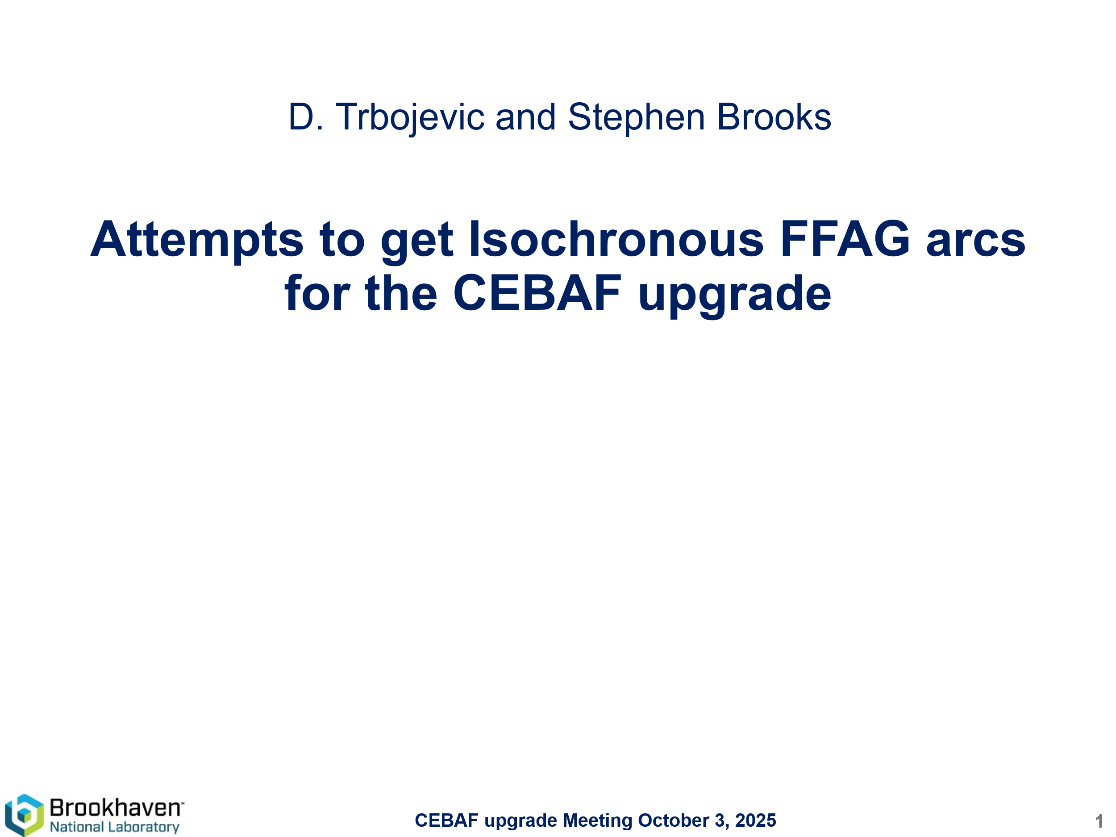
- 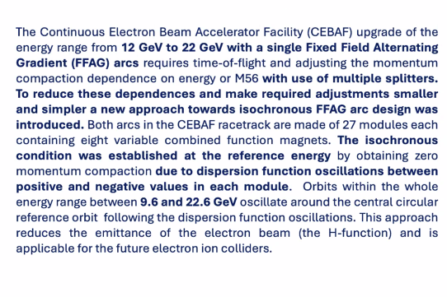
- 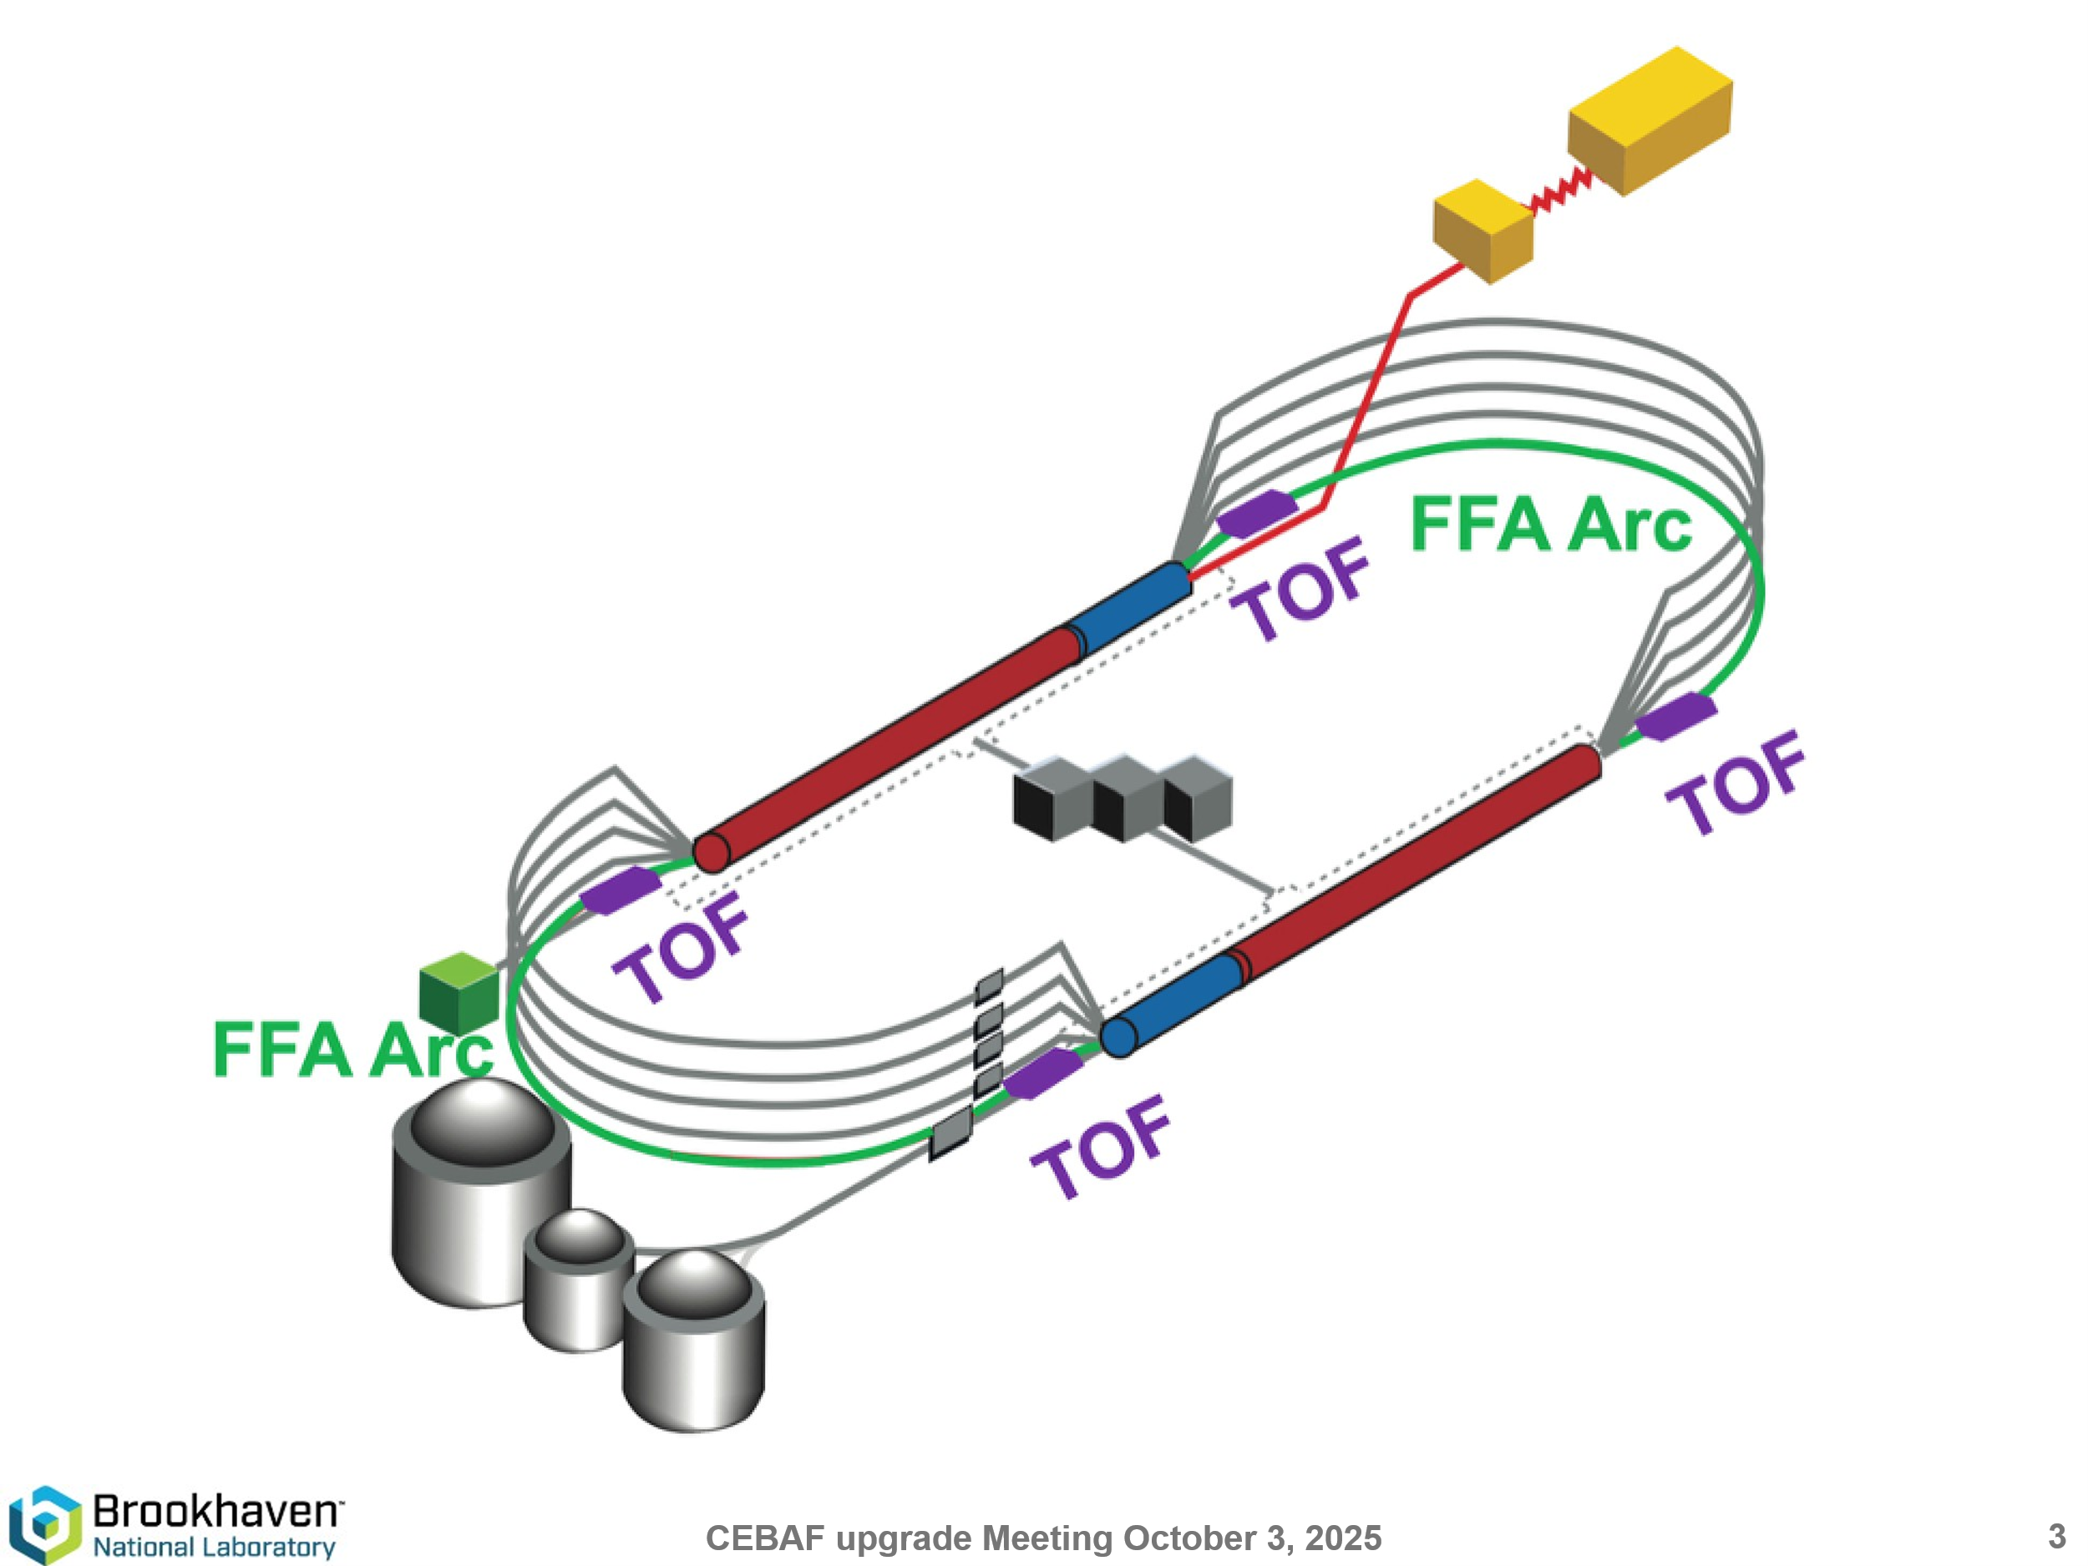
- 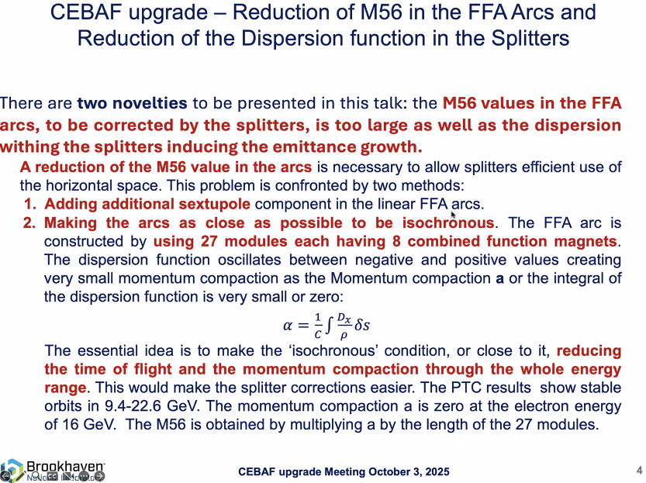
  - M56 needs to be zero or very small, so the momentum compaction factor. This is why lattices using sextupoles are being studied.
- 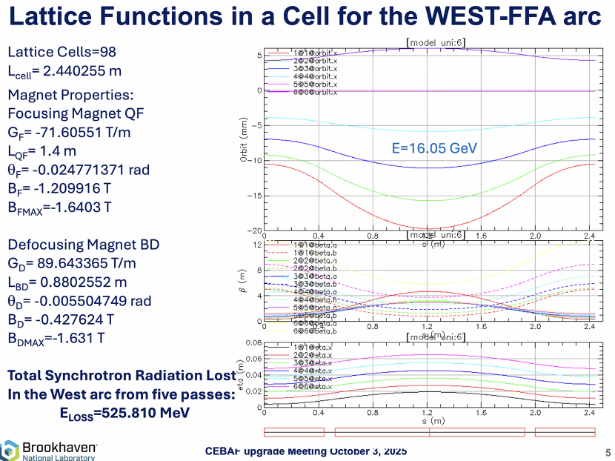
Using S. Brooks’ lattice.
- 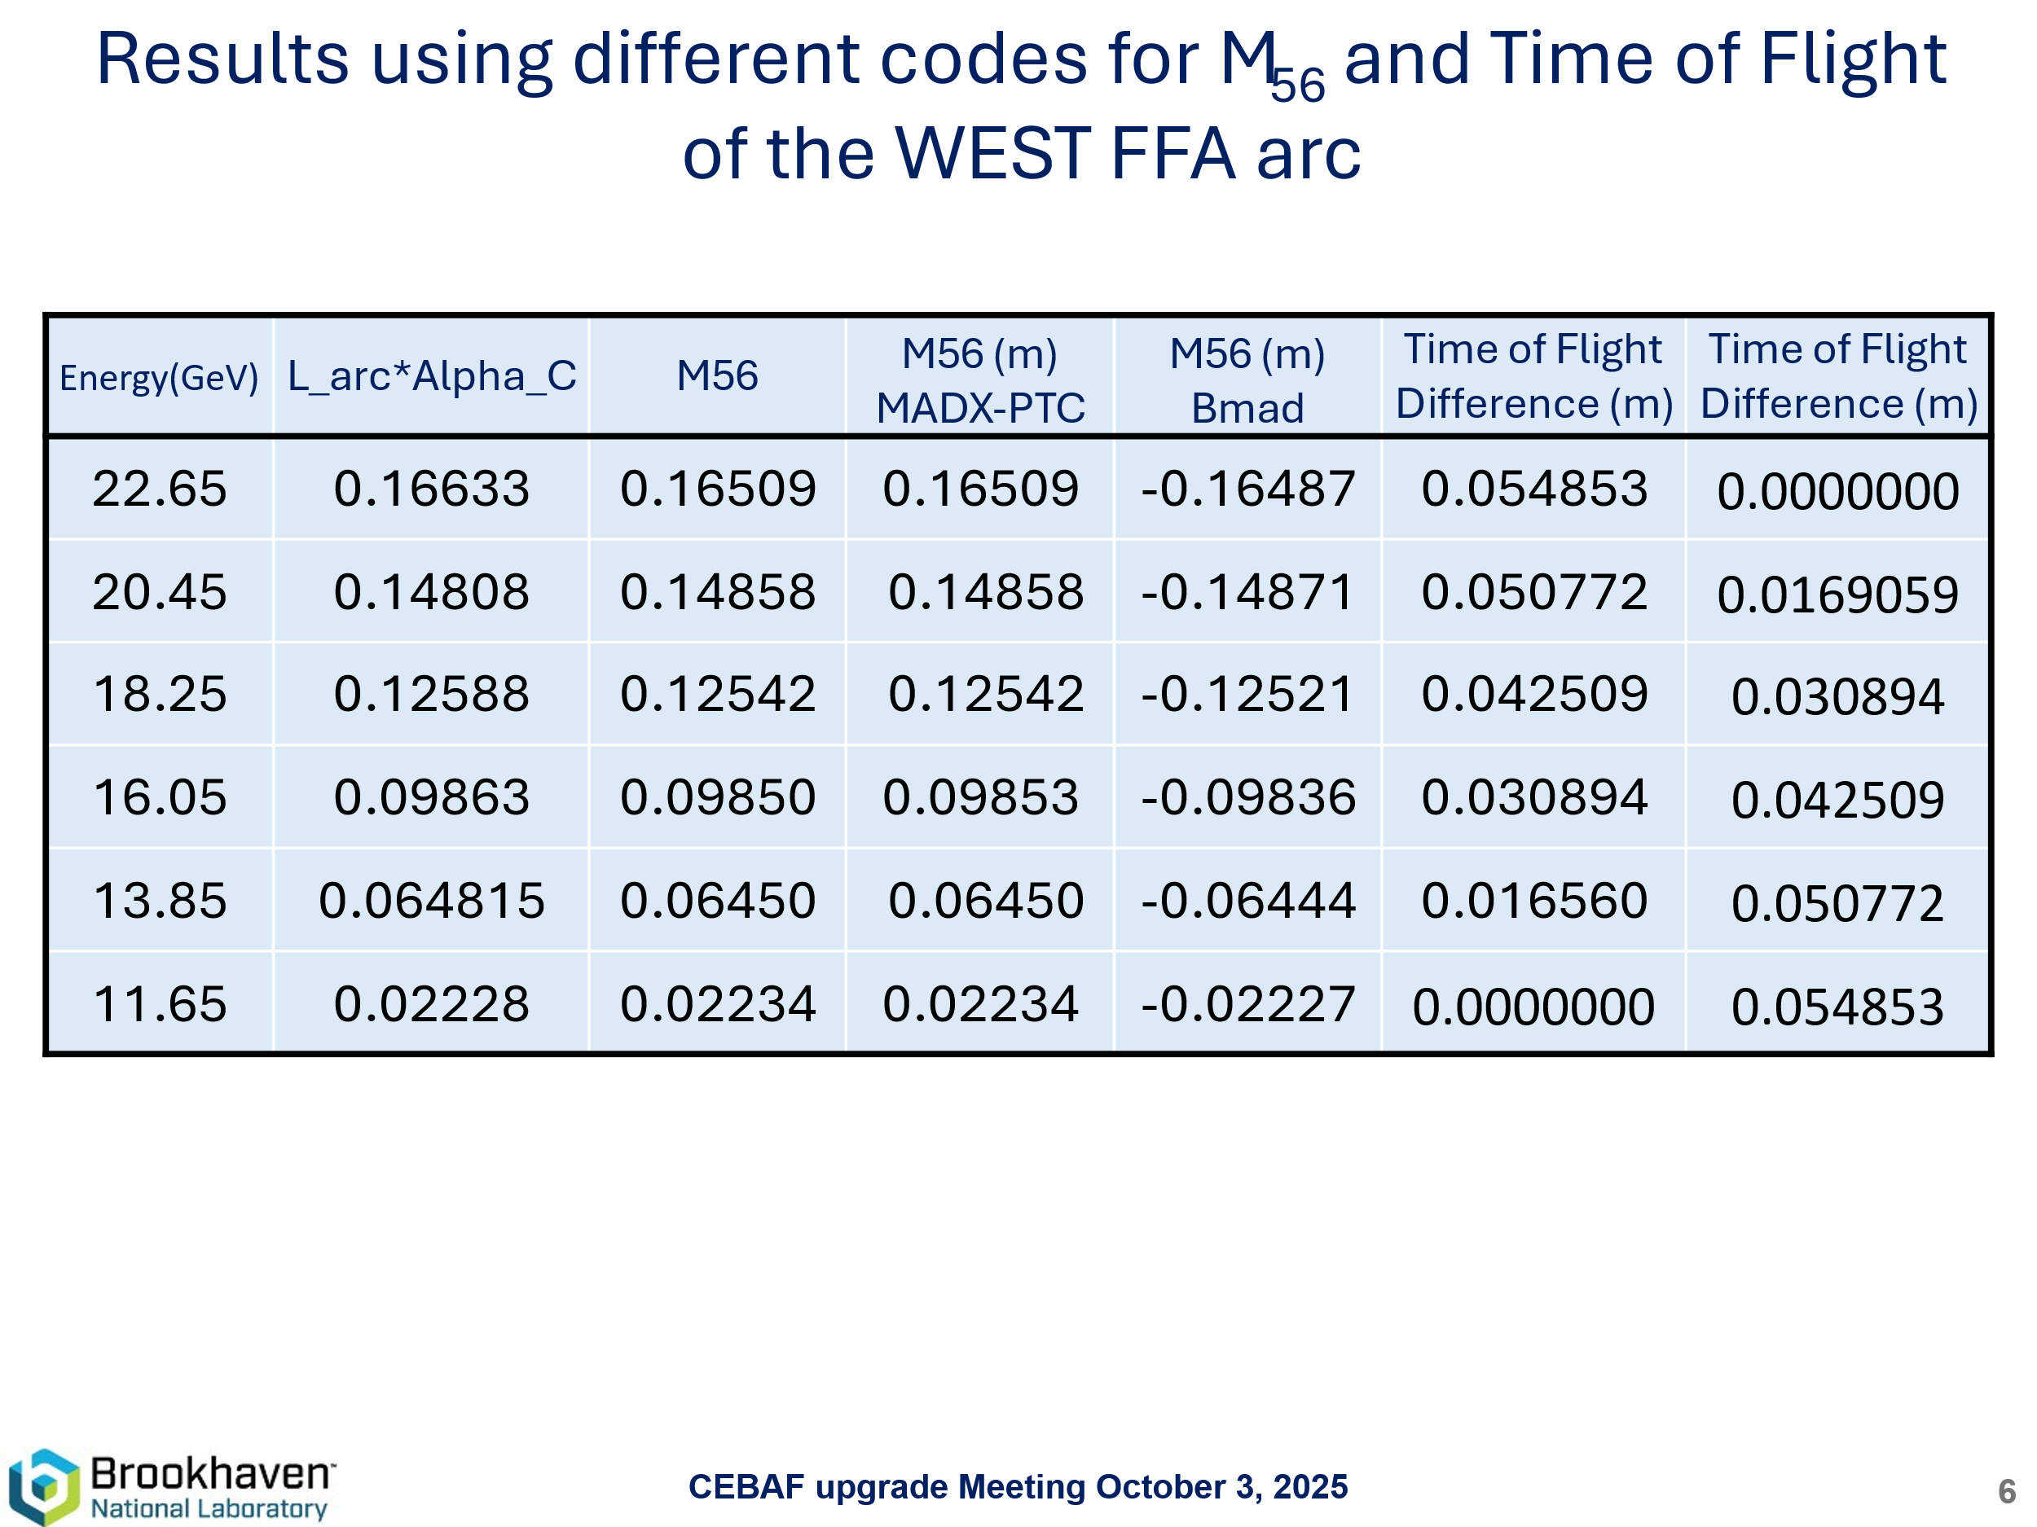
That ToF needs to be reduced for the splitter design.
- 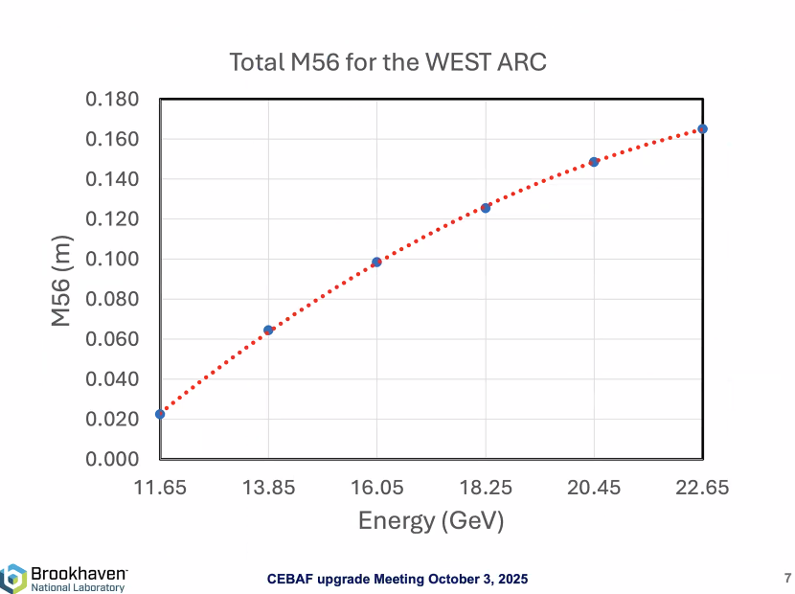
Current status of the lattice.
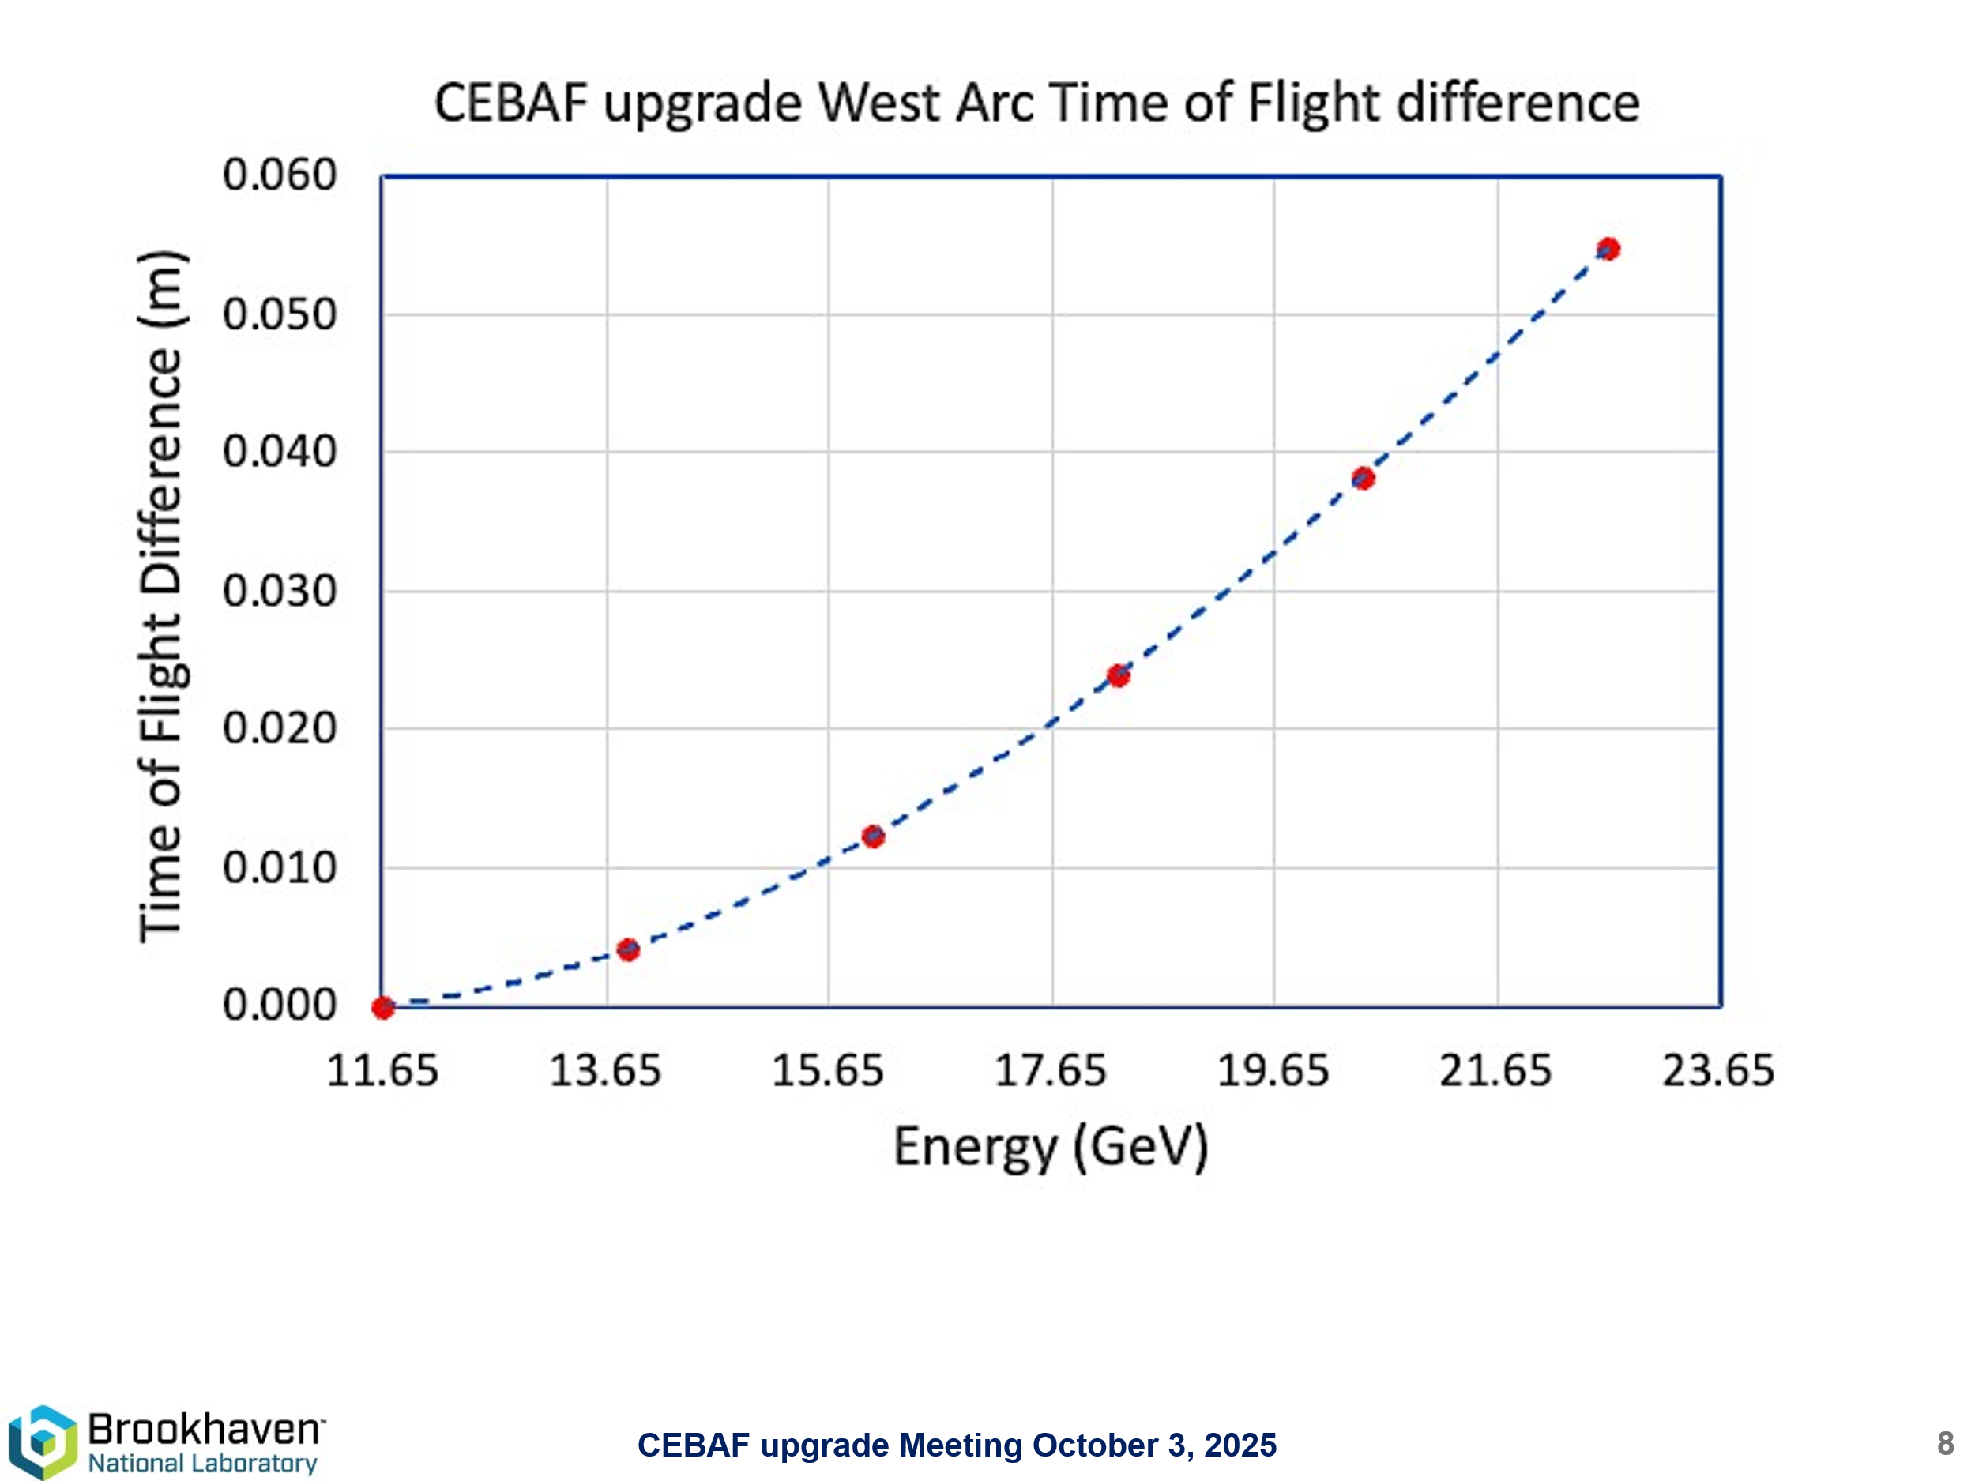
- 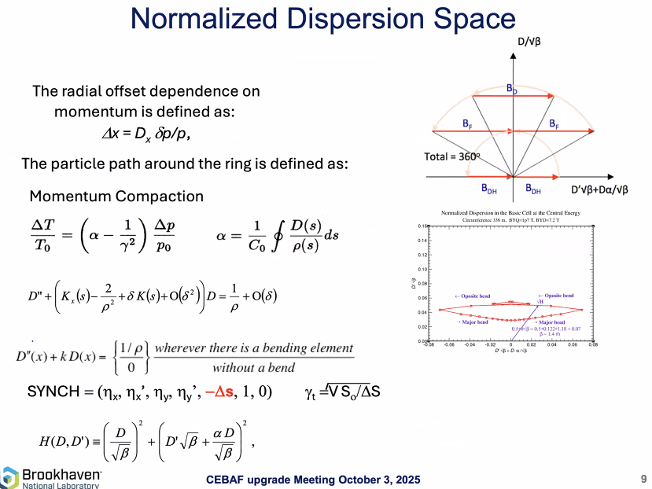
- 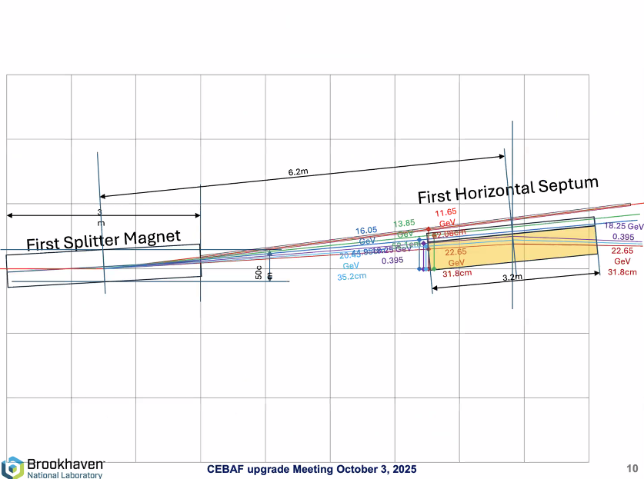
- 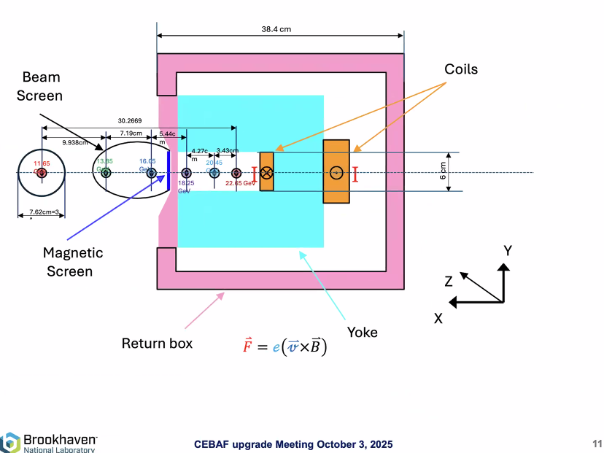
- 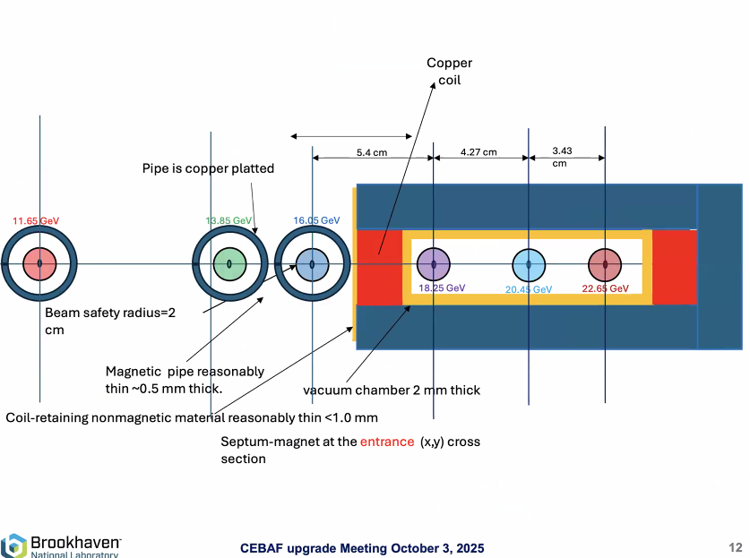
- 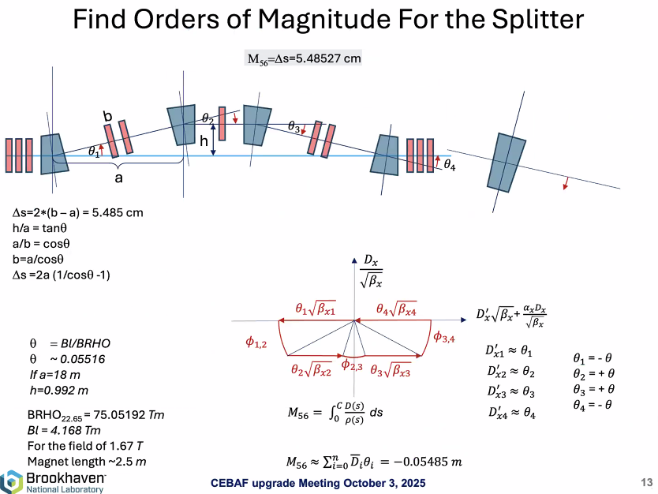
  - h in the plot above is around 1 meter, limited by tunnel. Leading a correction requirement of -0.058 m.
- 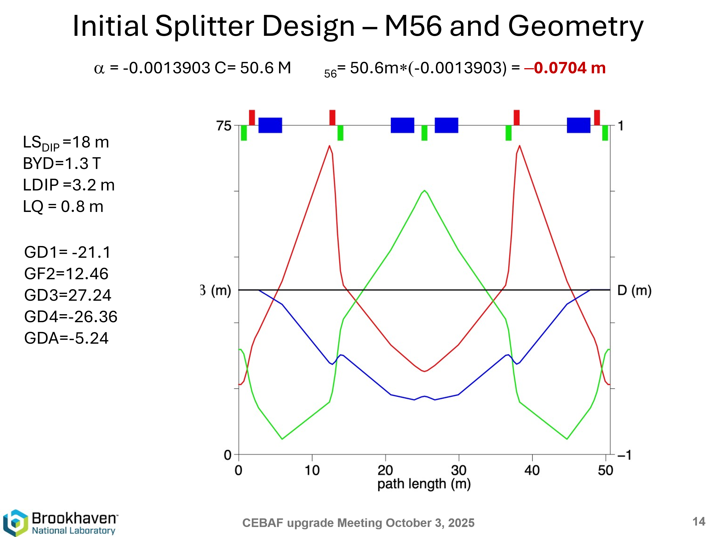
- 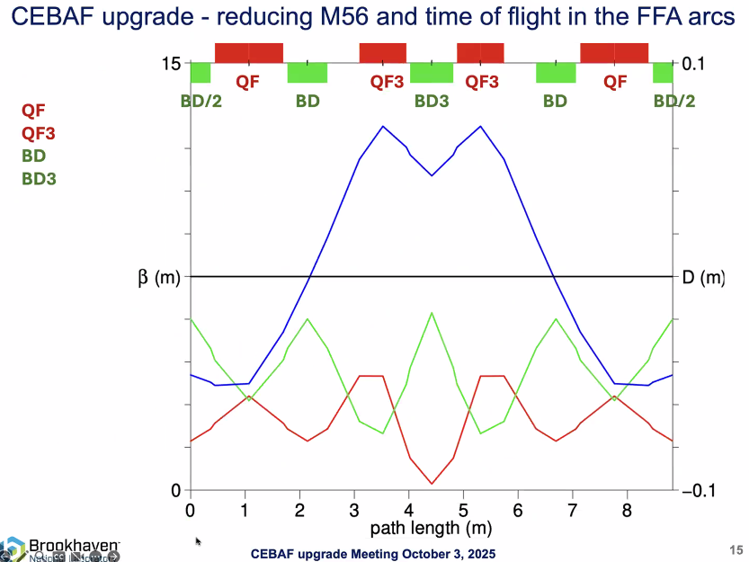
- 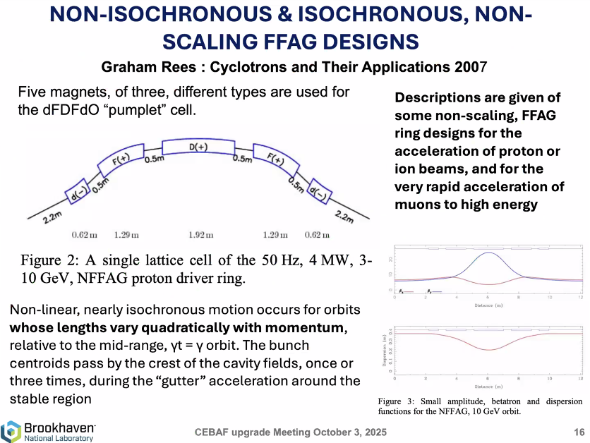
- 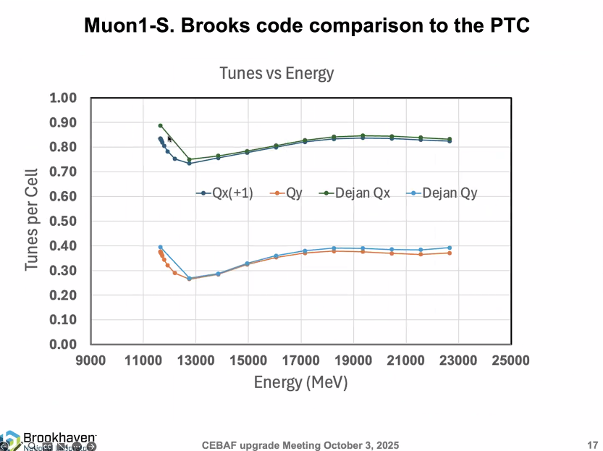
- 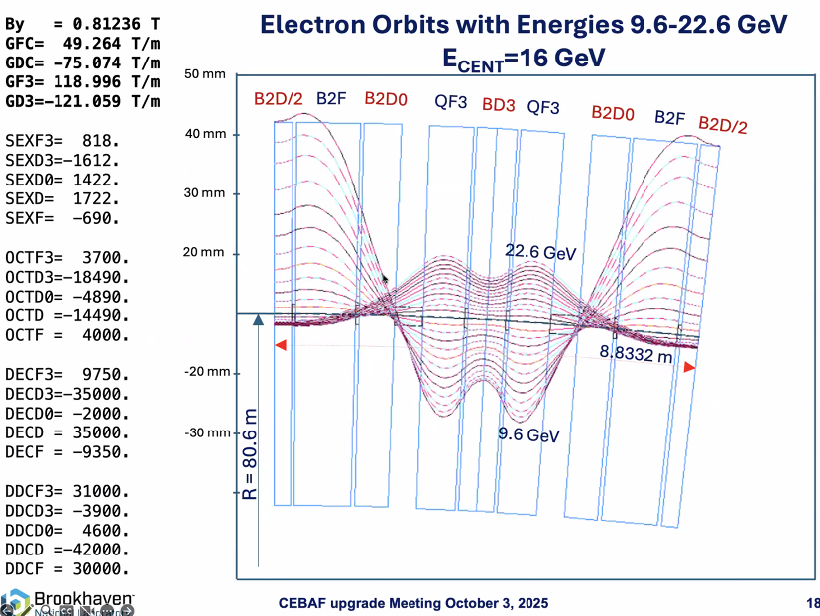
- 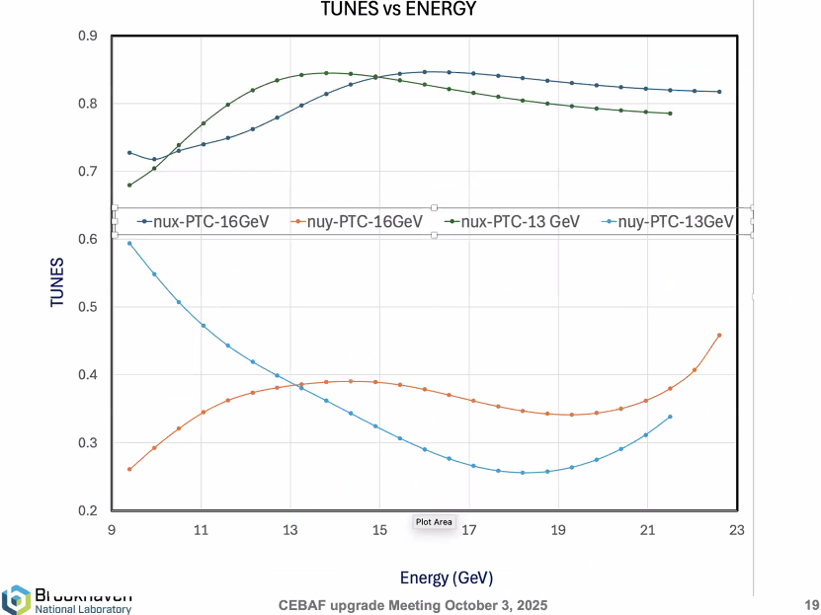
- 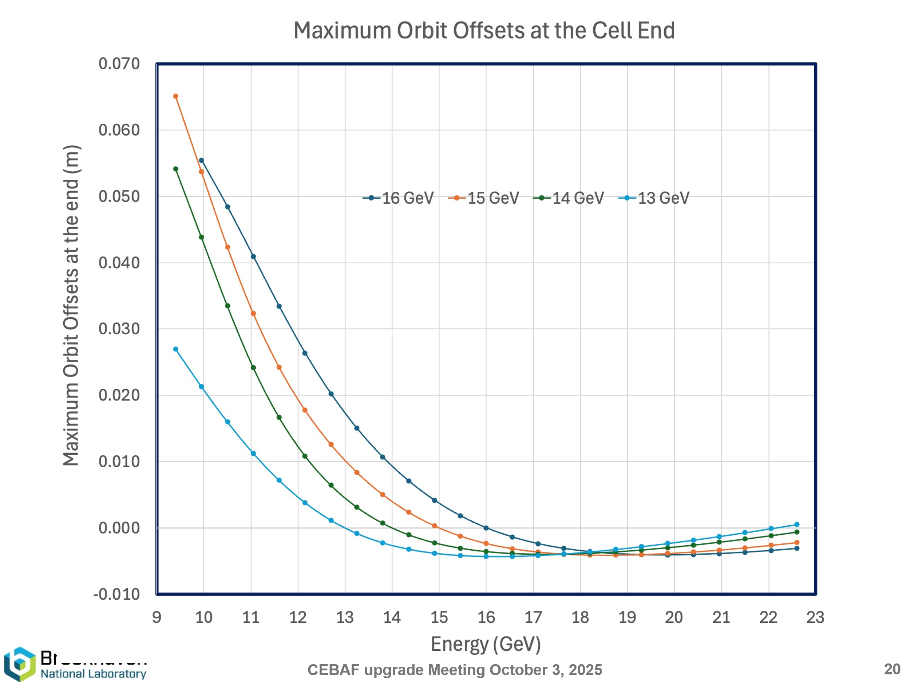
Central energy in circular orbit. To reduce synchrotron radiation loss.
- 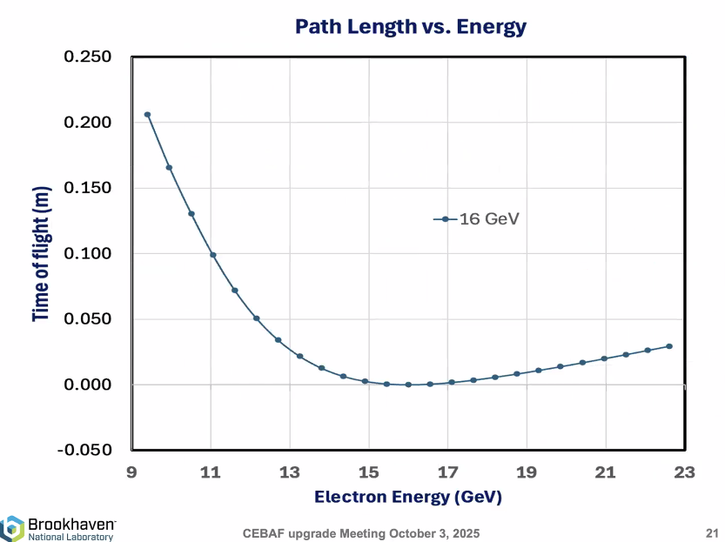
- 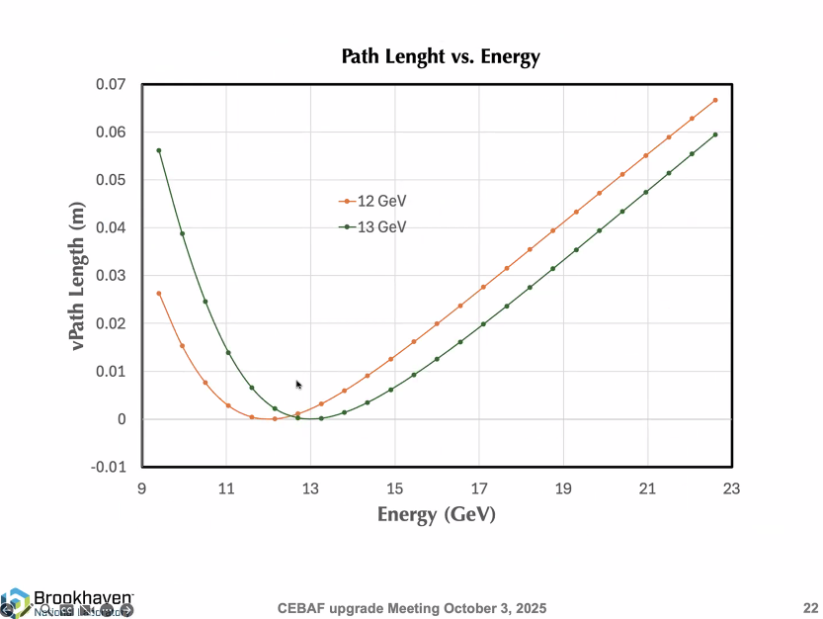
- 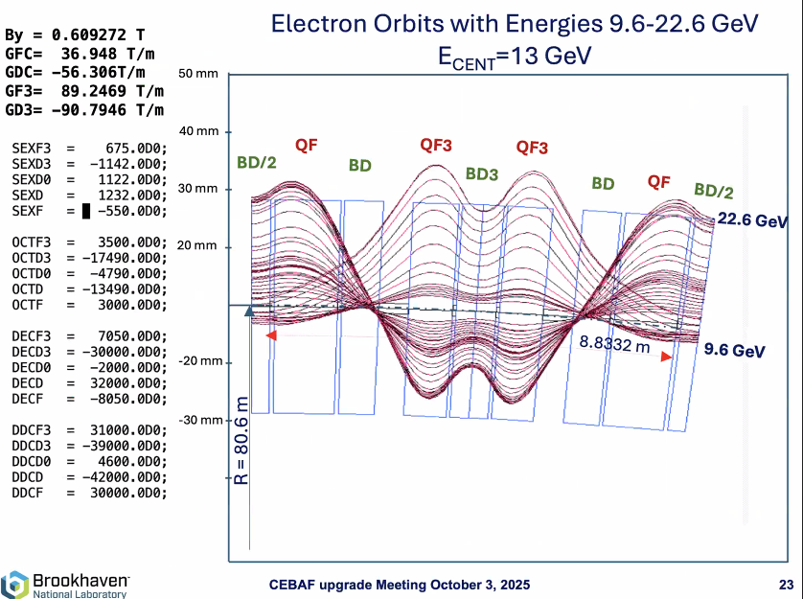
All orbits are closed, but not isochronous.
- 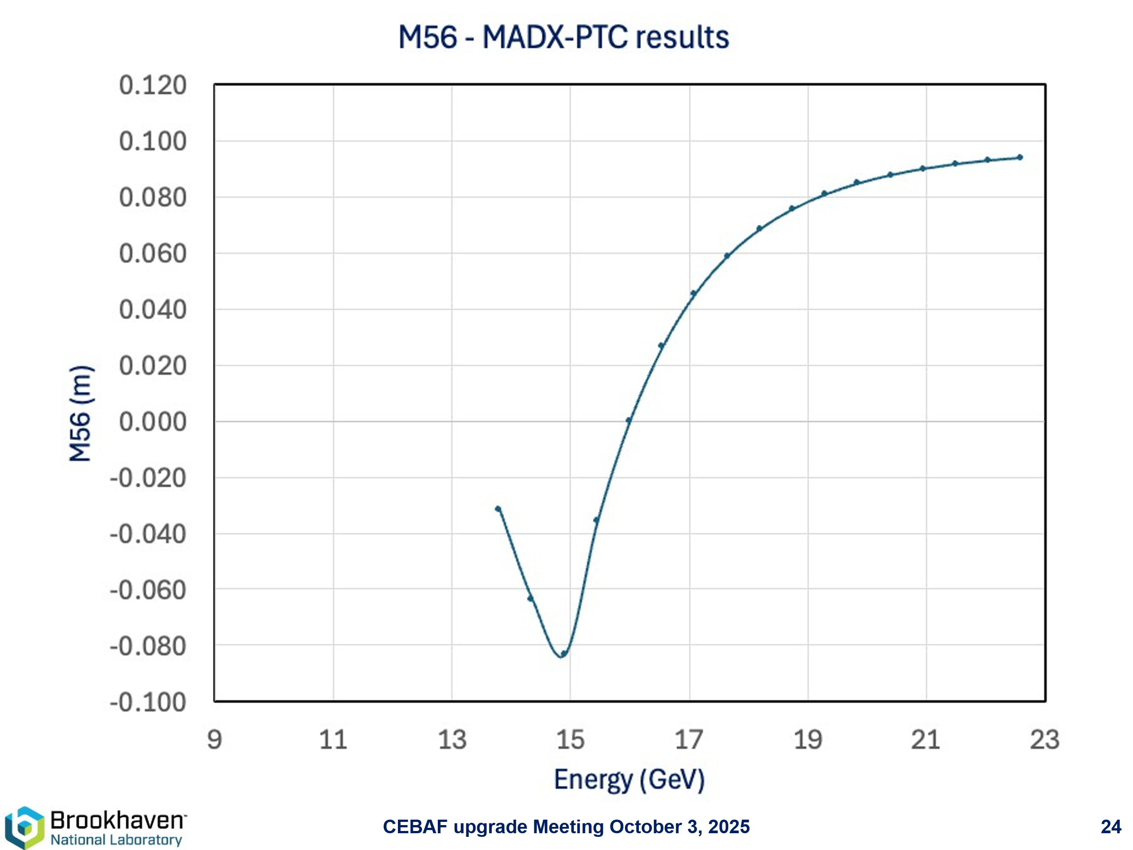
Shows that the M56 is not reduced as Dejan wanted.
- 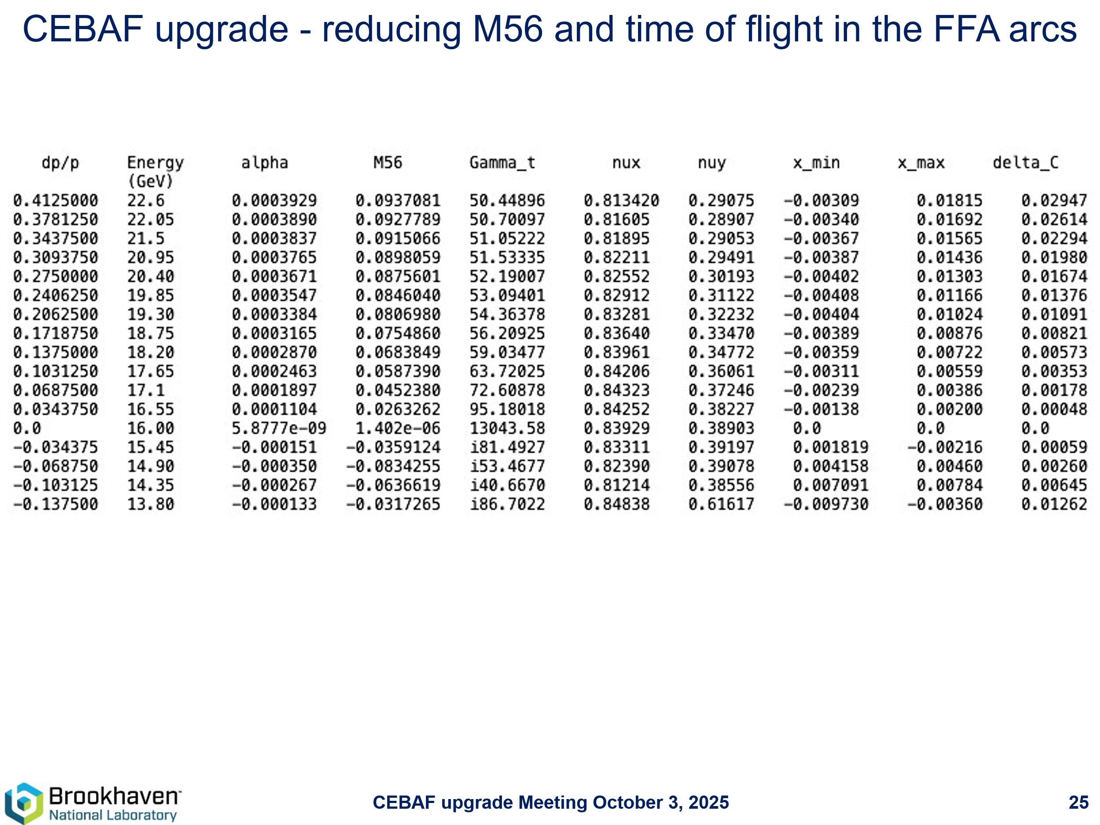
- 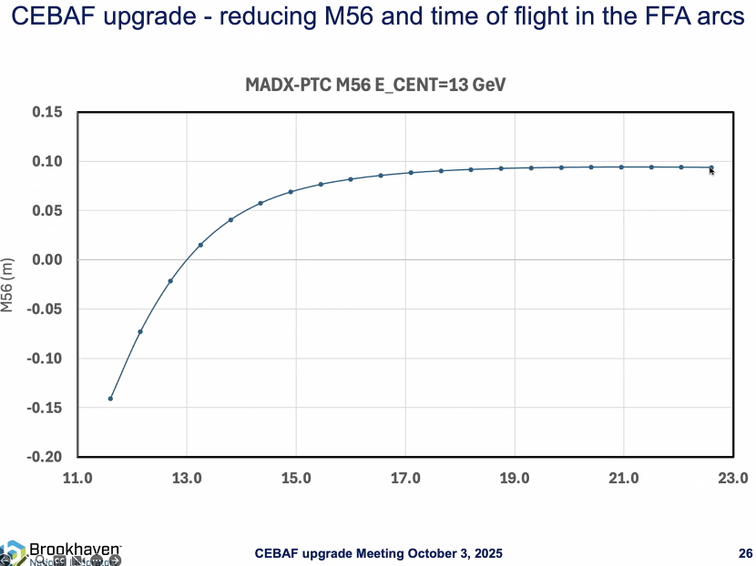
Reduced but still large for our splitter.
- 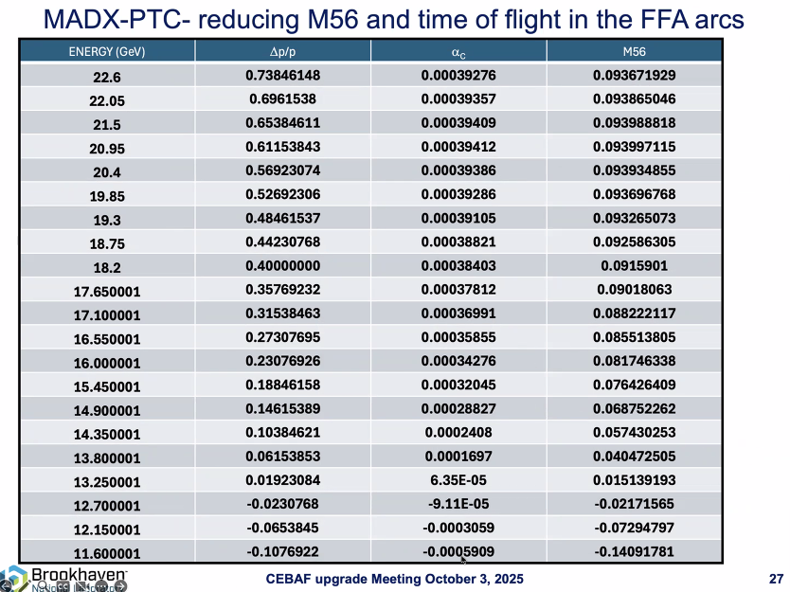
Zero should be where the central energy is.
- 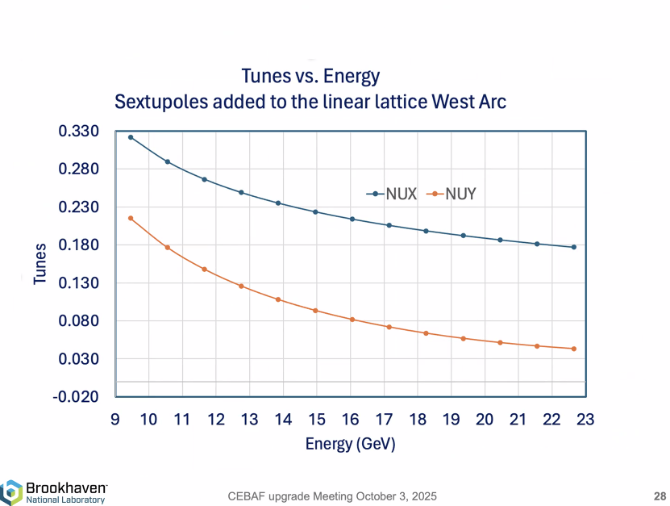
Adding a bit of sextupole component. Smooth change of tunes.
- 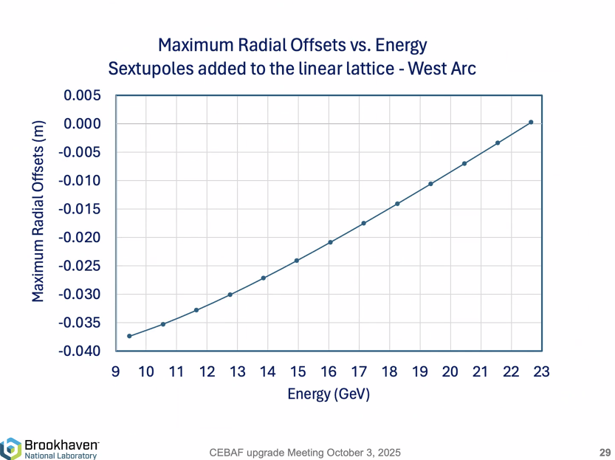
- 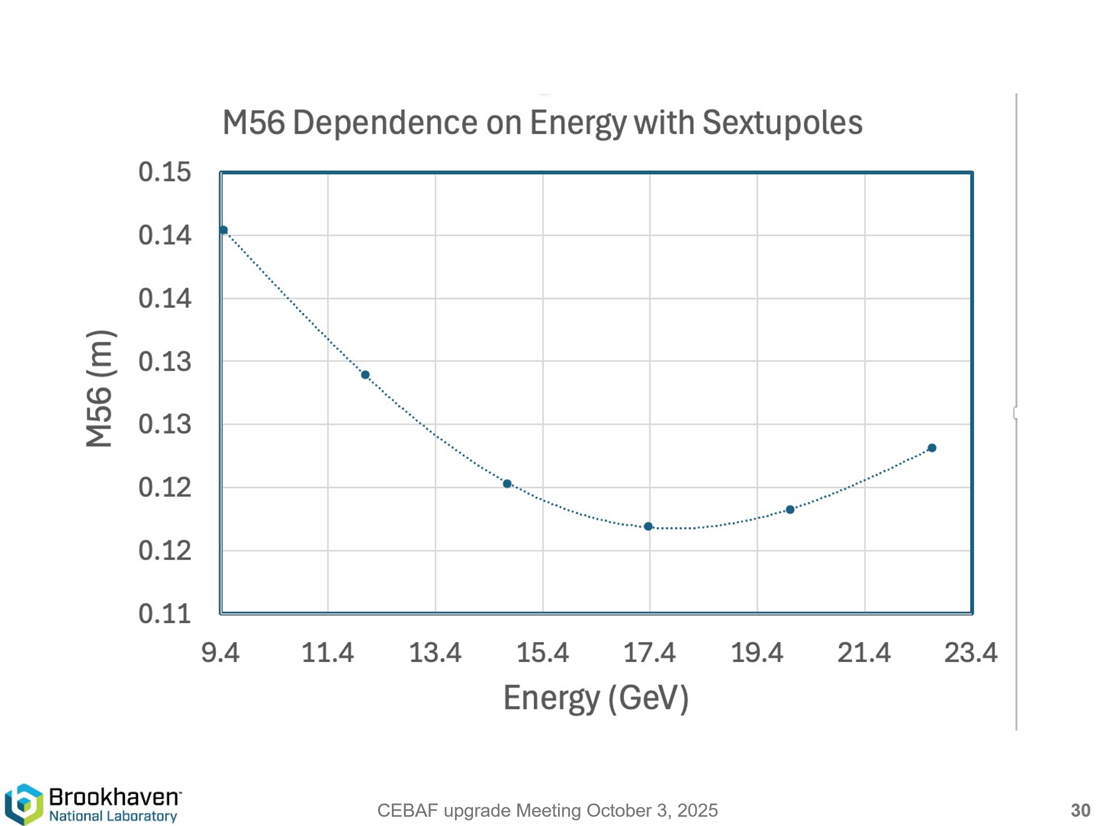
- 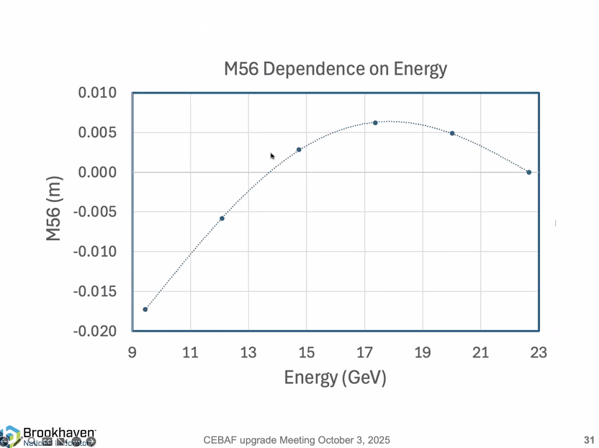
  - Salim asked if the synchrotron radiation included in tune shift plots? Dejan: it is a problem for the highest energy in which the oscillations of the beam due to synchrotron radiation needs to be suppressed.
Action Items | Person responsible | Deadline

Time allotted | 10 mins | Agenda topic AOB | Presenter All

Action Items | Person responsible | Deadline

Special notes

Pathway to Repository: https://jeffersonlab-my.sharepoint.com/:f:/g/personal/tristan_jlab_org/EqZ5MeS-nipCgPfZB5p0oS4B9Is67d3nQb9sLJI3Zyev9g

