FFA@CEBAF Working Group|Minutes

Meeting date | time 10/24/2025 | 11 AM EST | Meeting location https://jlab-org.zoomgov.com/j/1614898082?pwd=TnUzMS81M2sxbDZIbERJU01tYkJCQT09
 | Attendees  Alex B, Salim, Donish, Sadiq, Dejan, Stephen, Edy, Roger, Volker, Andrei, Patrick Ngotta, Vasiliy, Scott.
  Meeting called by | Alex B
  Type of meeting | Weekly Meeting
  Facilitator | Alex B
  Note taker | Salim
  Timekeeper | Alex B

Intro Discussion
- Splitter magnet tolerance specs - Donish
- Launching multi-particle spin tracking in FFA Arcs – Salim, deferred
- AOB – All
The minutes are generated after the meeting, since Alex asked.

Time allotted | 50 mins | Agenda topic Splitter magnet tolerance specs | Presenter Donish

- 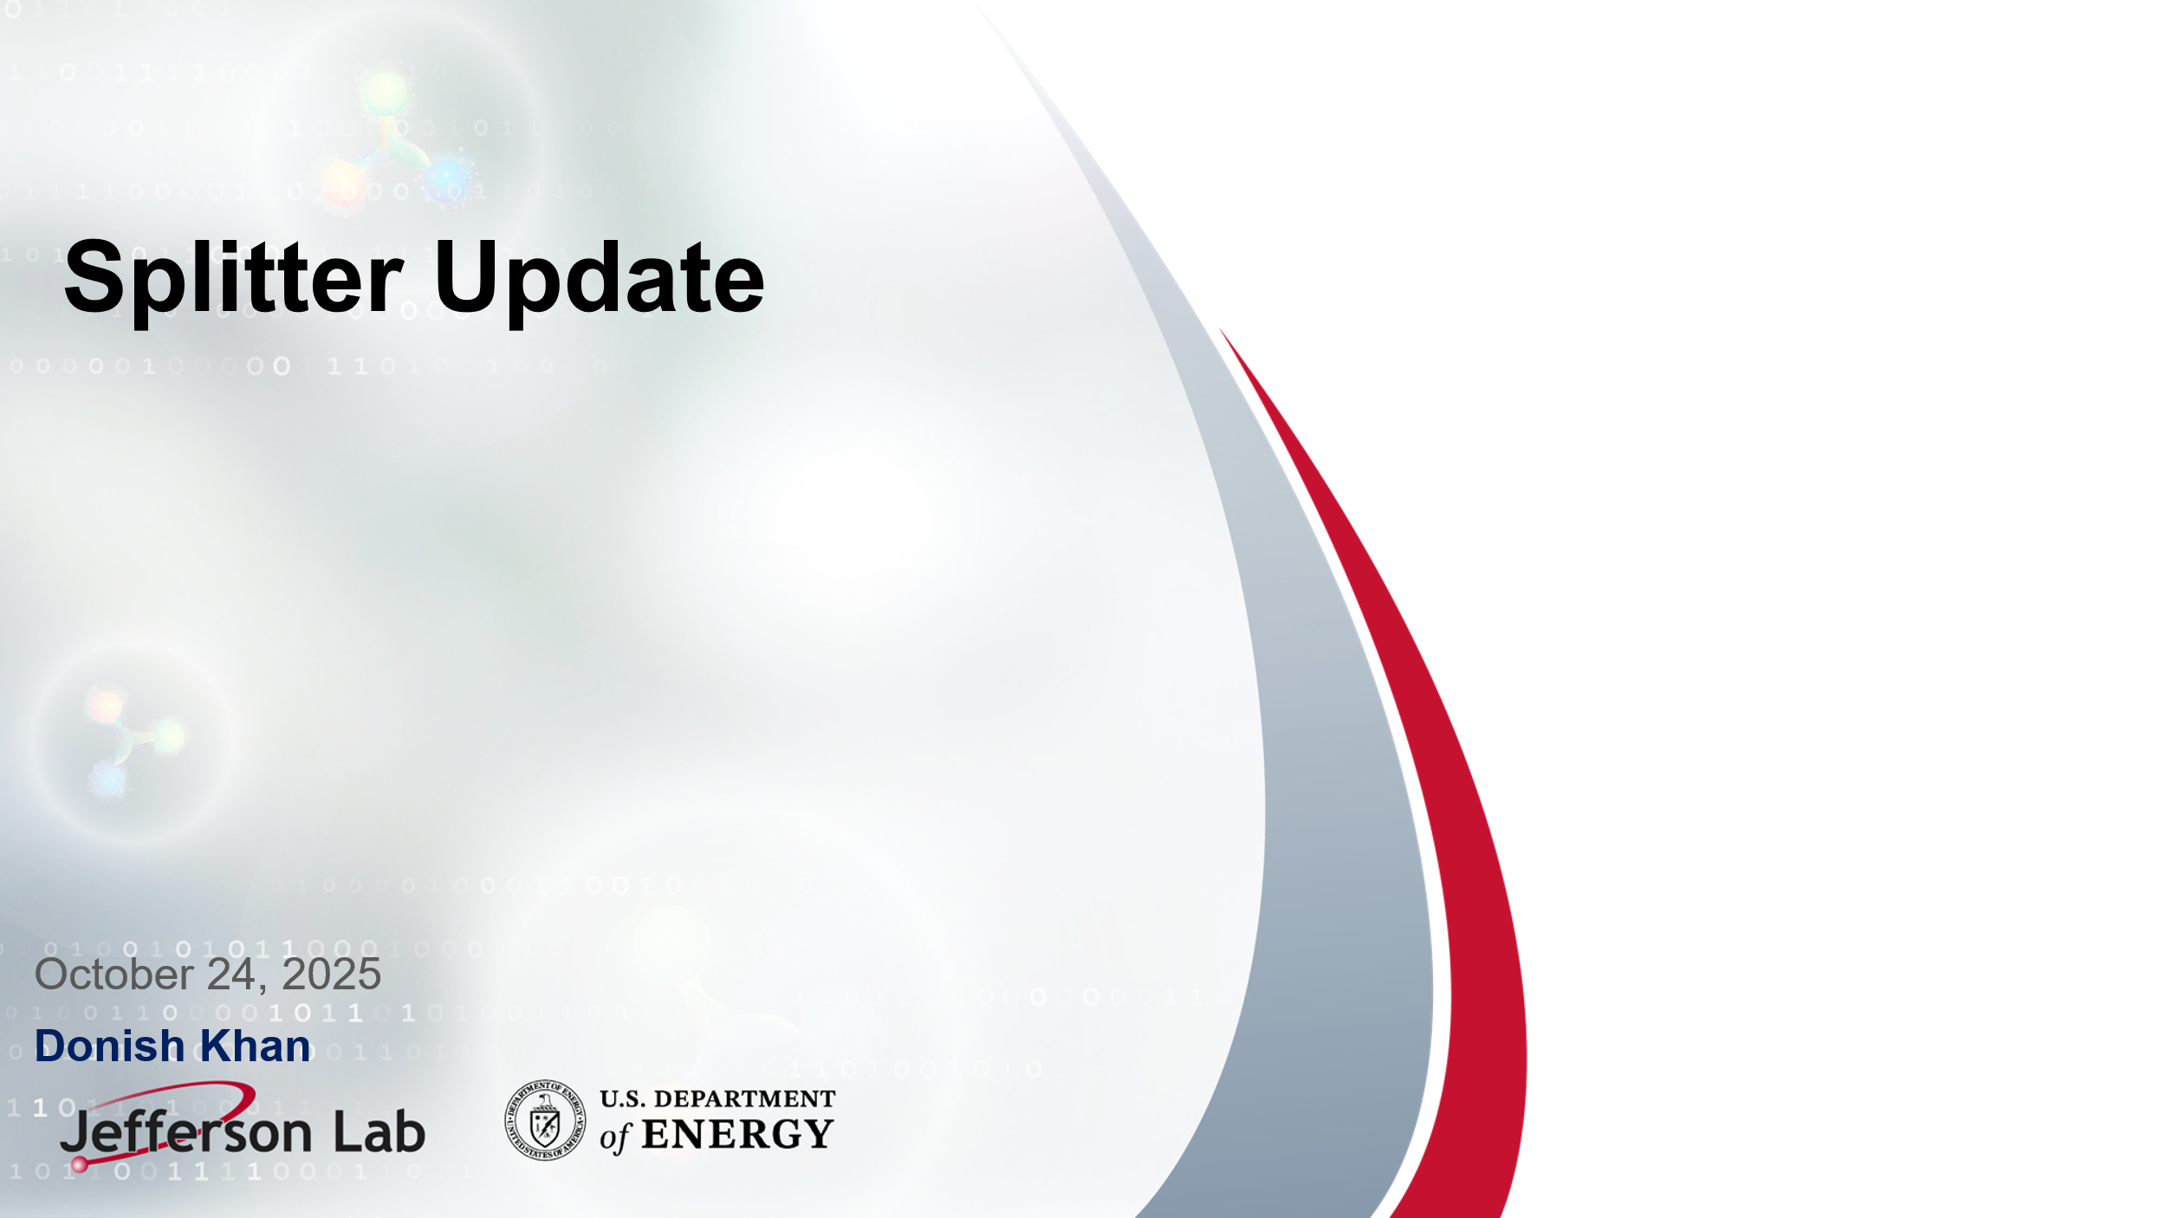
- 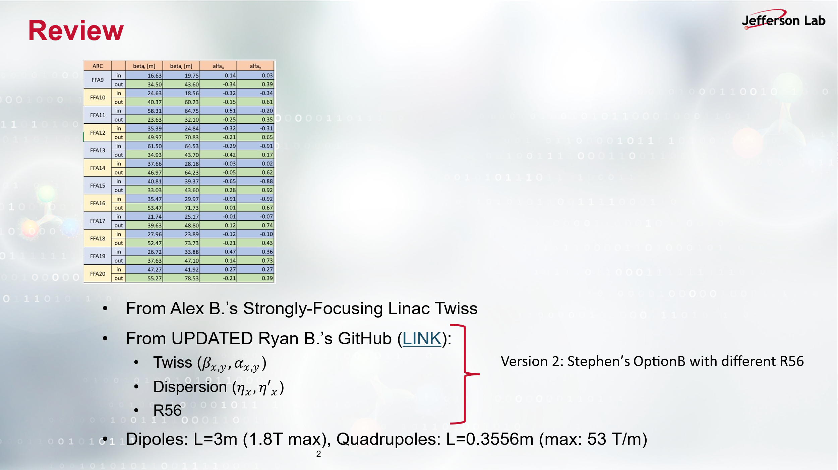

- 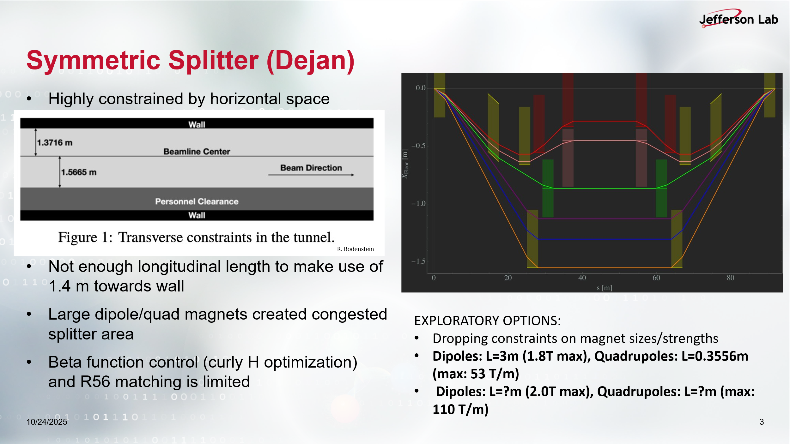
  - There was a question about the beam pipe, the answer is 2 inch diameter beam pipe to be assumed. This question was asked in order to assess the maximum quadrupole gradient which Donish assumes, namely 110 T/m. This gradient is said to be high for such beam pipe, maybe 40 T/m can be assumed.
- 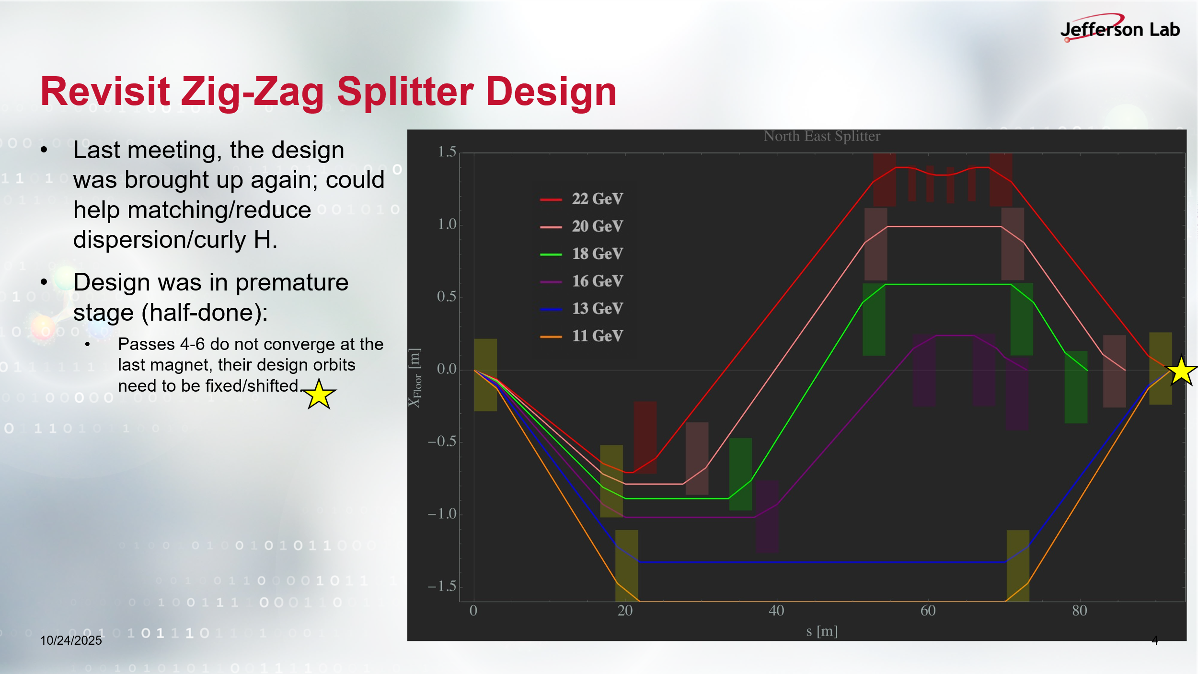
- 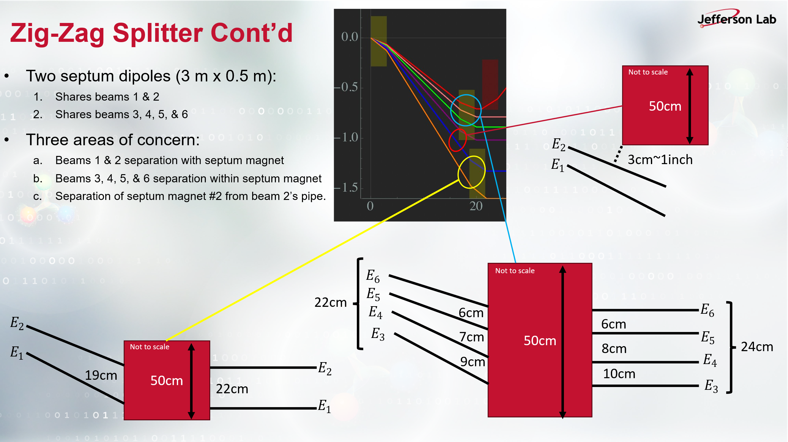
- 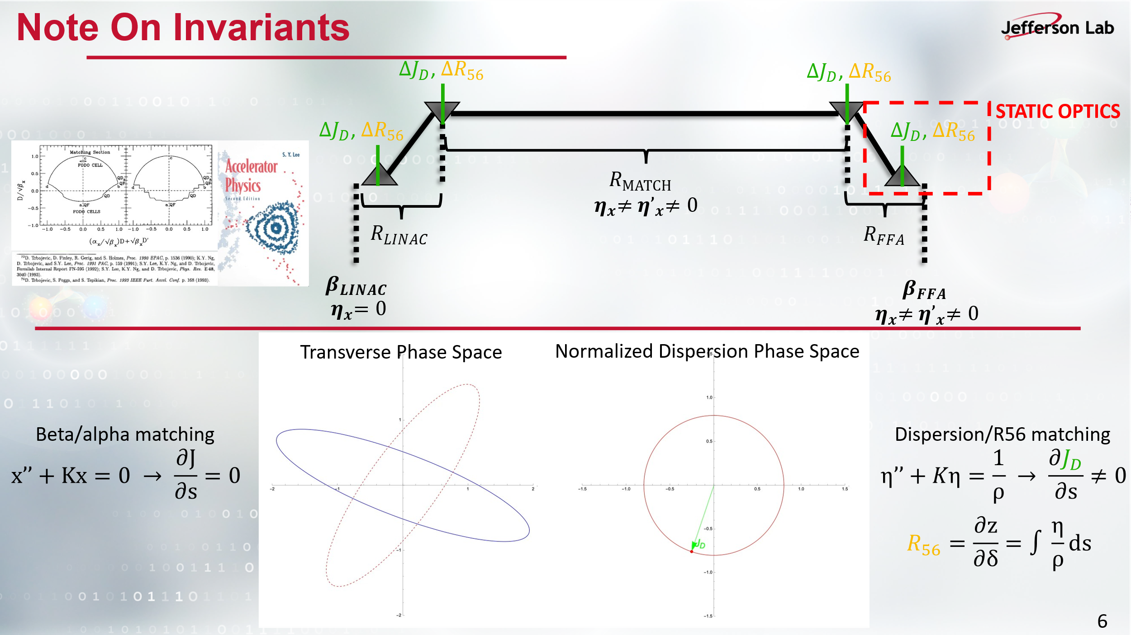
- 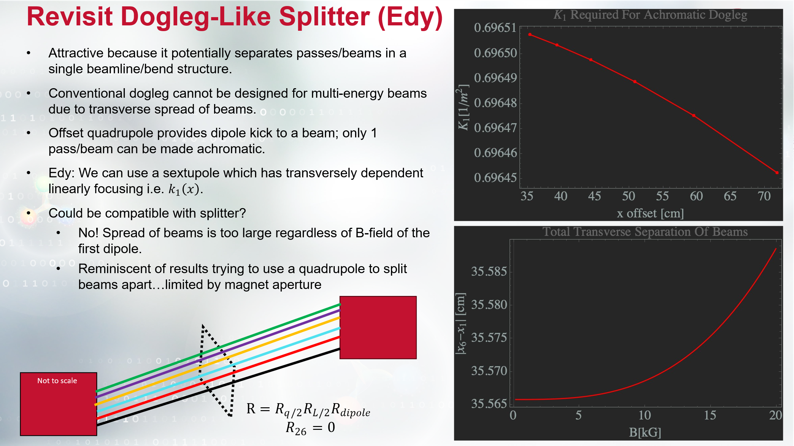
- 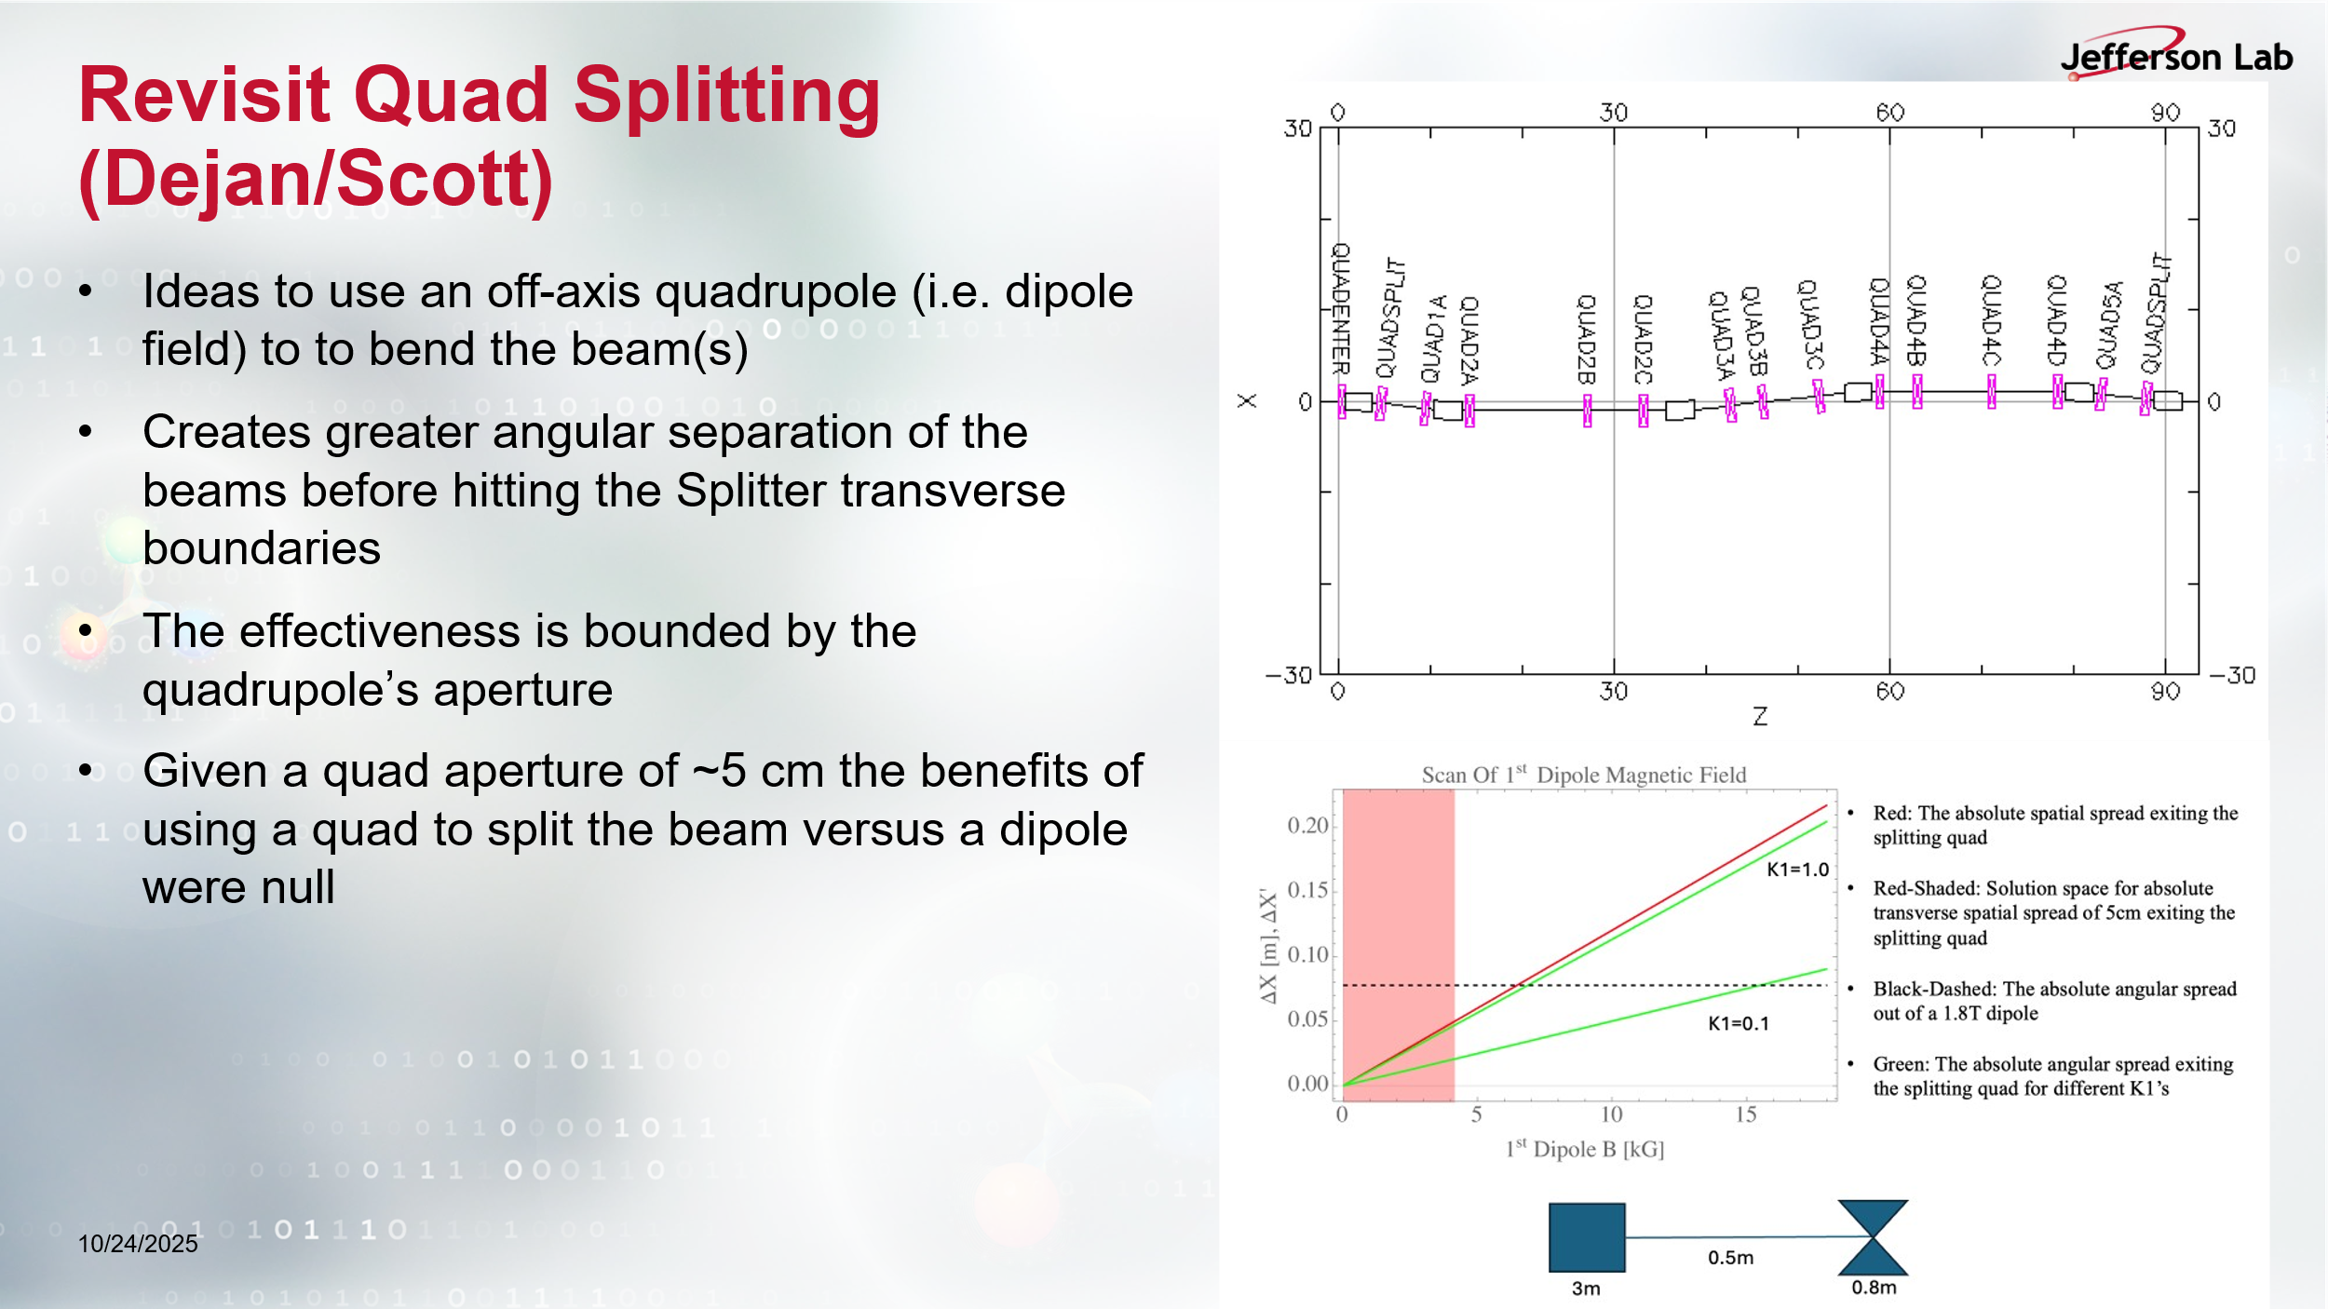
- 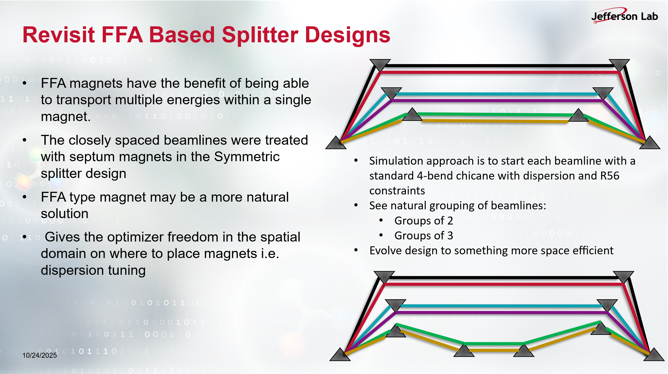
- After Donish gave his presentation, Dejan showed his earlier paper referring to Donish’s Slide#6, which is associated to the old designs of splitters, which also inspired the CEBAF current splitter:
  - 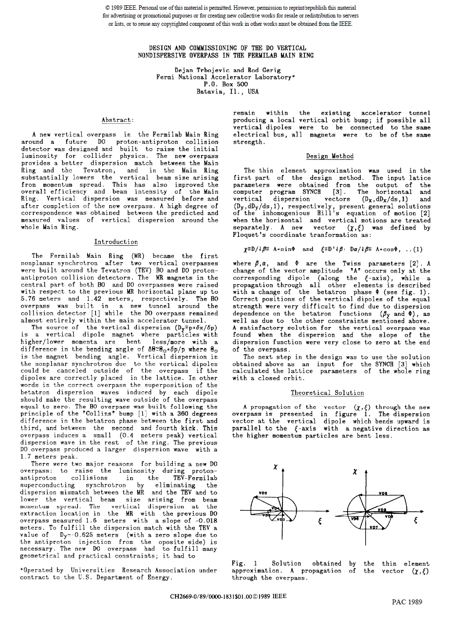
  - 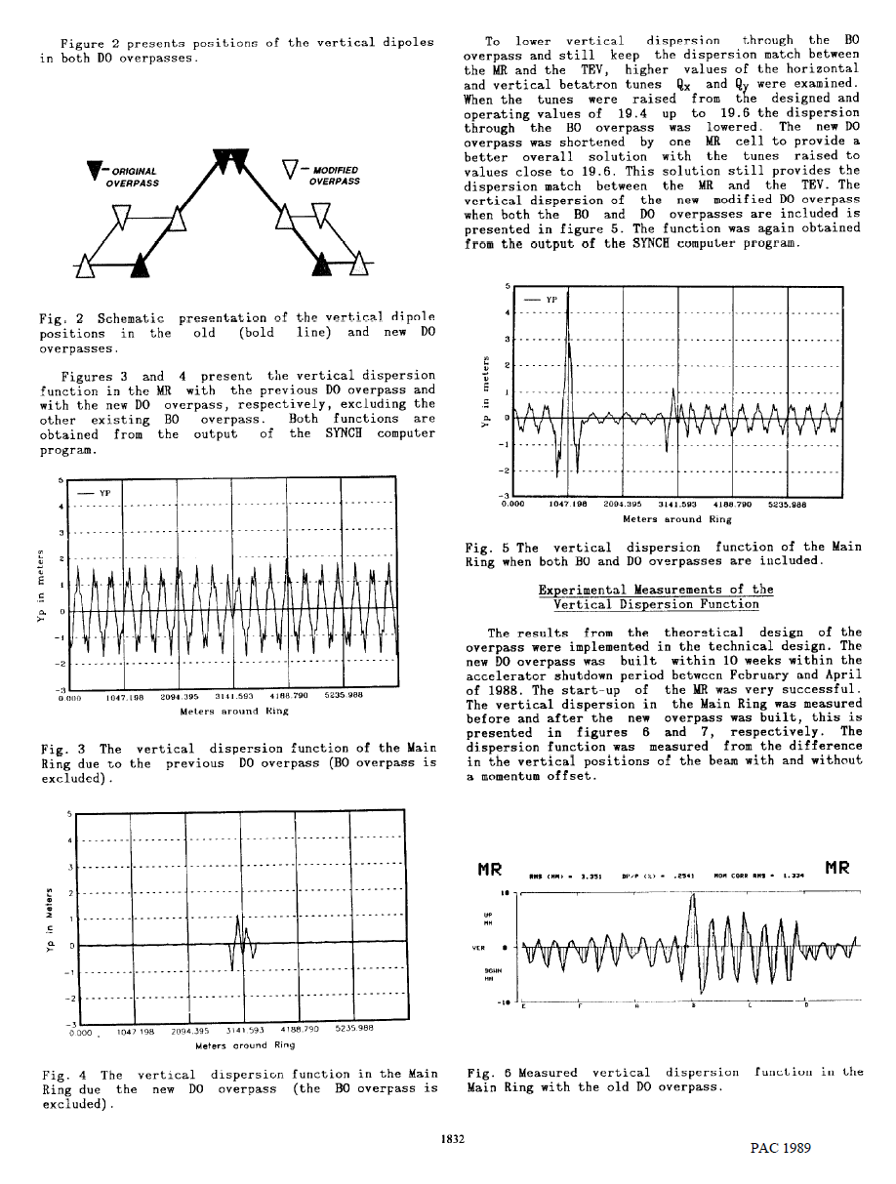
  - 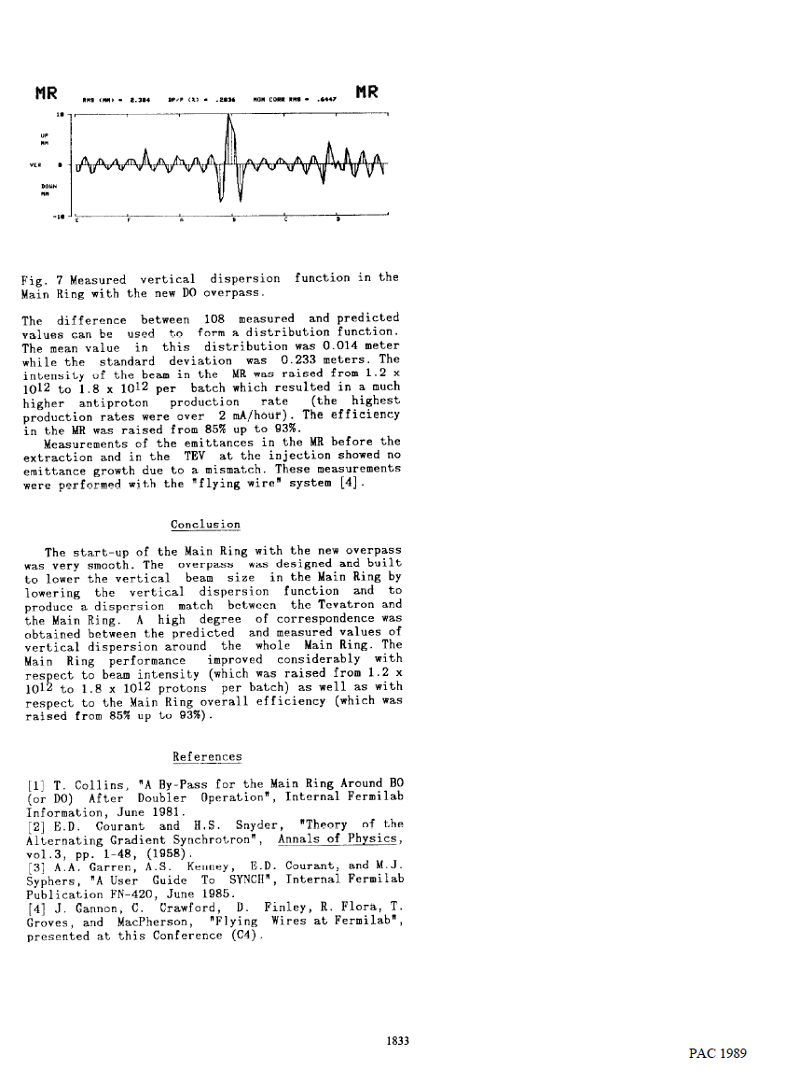

- The splitter design has got rigorous. For this reason, Alex B had suggested looking back to the other options and Donish addressed this in his presentation today. Also, Andrei proposed a new splitter design option deploying FFA magnets to be shared by more than a pass (i.e. different beam energy) which relaxes the space issues since the beam pipes are shared together.
  - 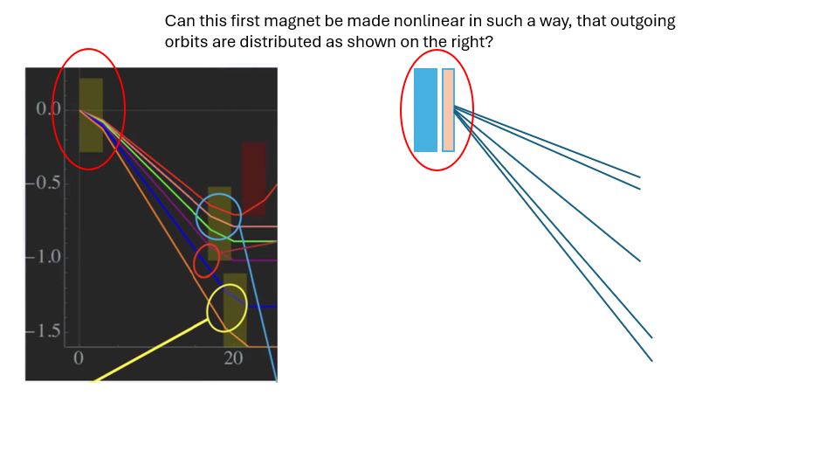
  - 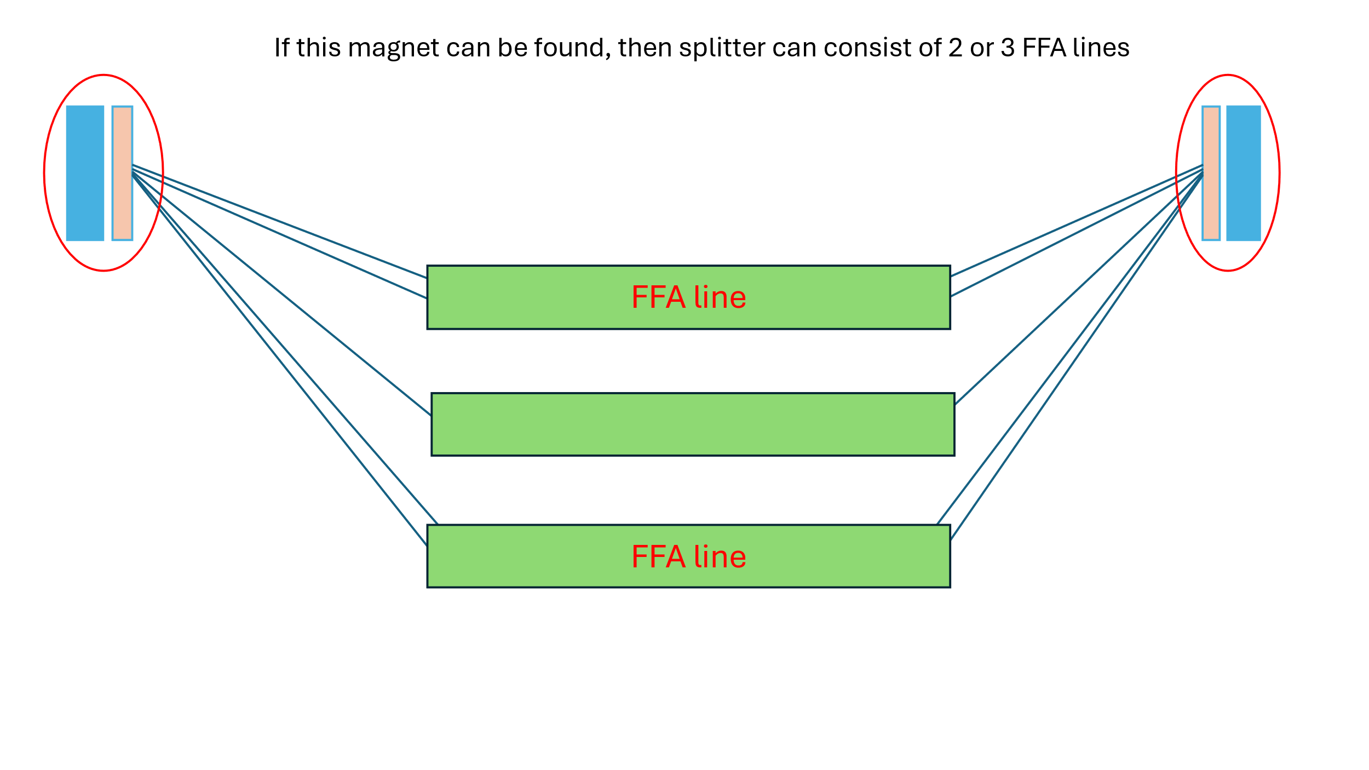

Action Items | Person responsible | Deadline

Time allotted | 10 mins | Agenda topic AOB | Presenter All

Action Items | Person responsible | Deadline

Special notes

Pathway to Repository: https://jeffersonlab-my.sharepoint.com/:f:/g/personal/tristan_jlab_org/EqZ5MeS-nipCgPfZB5p0oS4B9Is67d3nQb9sLJI3Zyev9g

