FFA@CEBAF Working Group|Minutes

Meeting date | time 10/31/2025 | 11 AM EDT | Meeting location https://jlab-org.zoomgov.com/j/1614898082?pwd=TnUzMS81M2sxbDZIbERJU01tYkJCQT09
 | Attendees  Alex B., Salim O., Dejan T., Andrei S., J. Scott B., Kirsten D., Patrick N., Roger R., Sadiq S., Vasiliy, M., Volker Z., Edith N., Donish K.
  Meeting called by | Alex B.
  Type of meeting | Weekly Meeting
  Facilitator | Alex B.
  Note taker | Edith N.
  Timekeeper | Alex B.

Intro Discussion
- Depolarization Effects of Synchrotron Radiation

Agenda topics

Time allotted | 45 mins | Agenda topic Depolarization Effects of Synchrotron Radiation | Presenter Salim
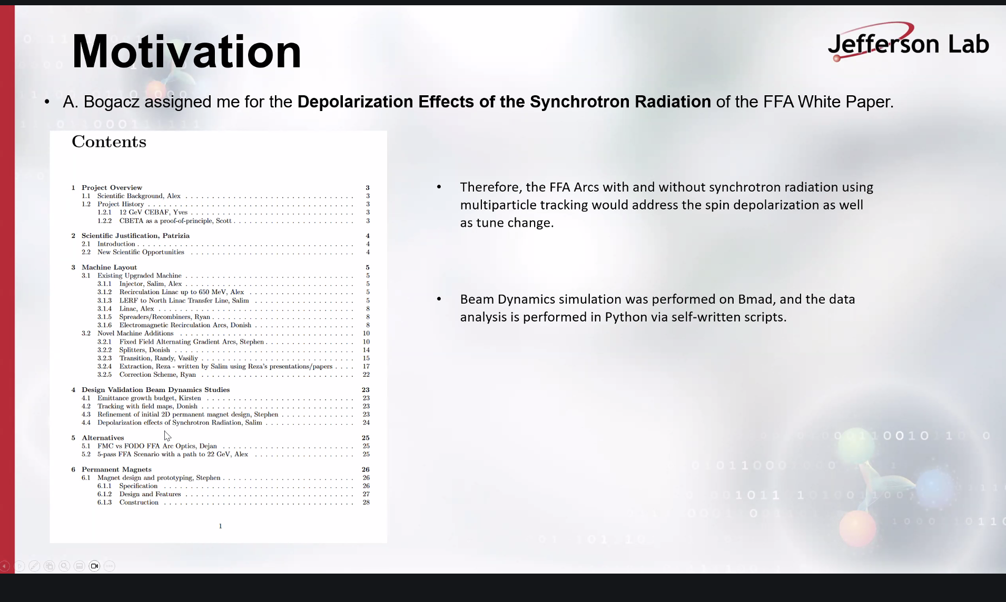

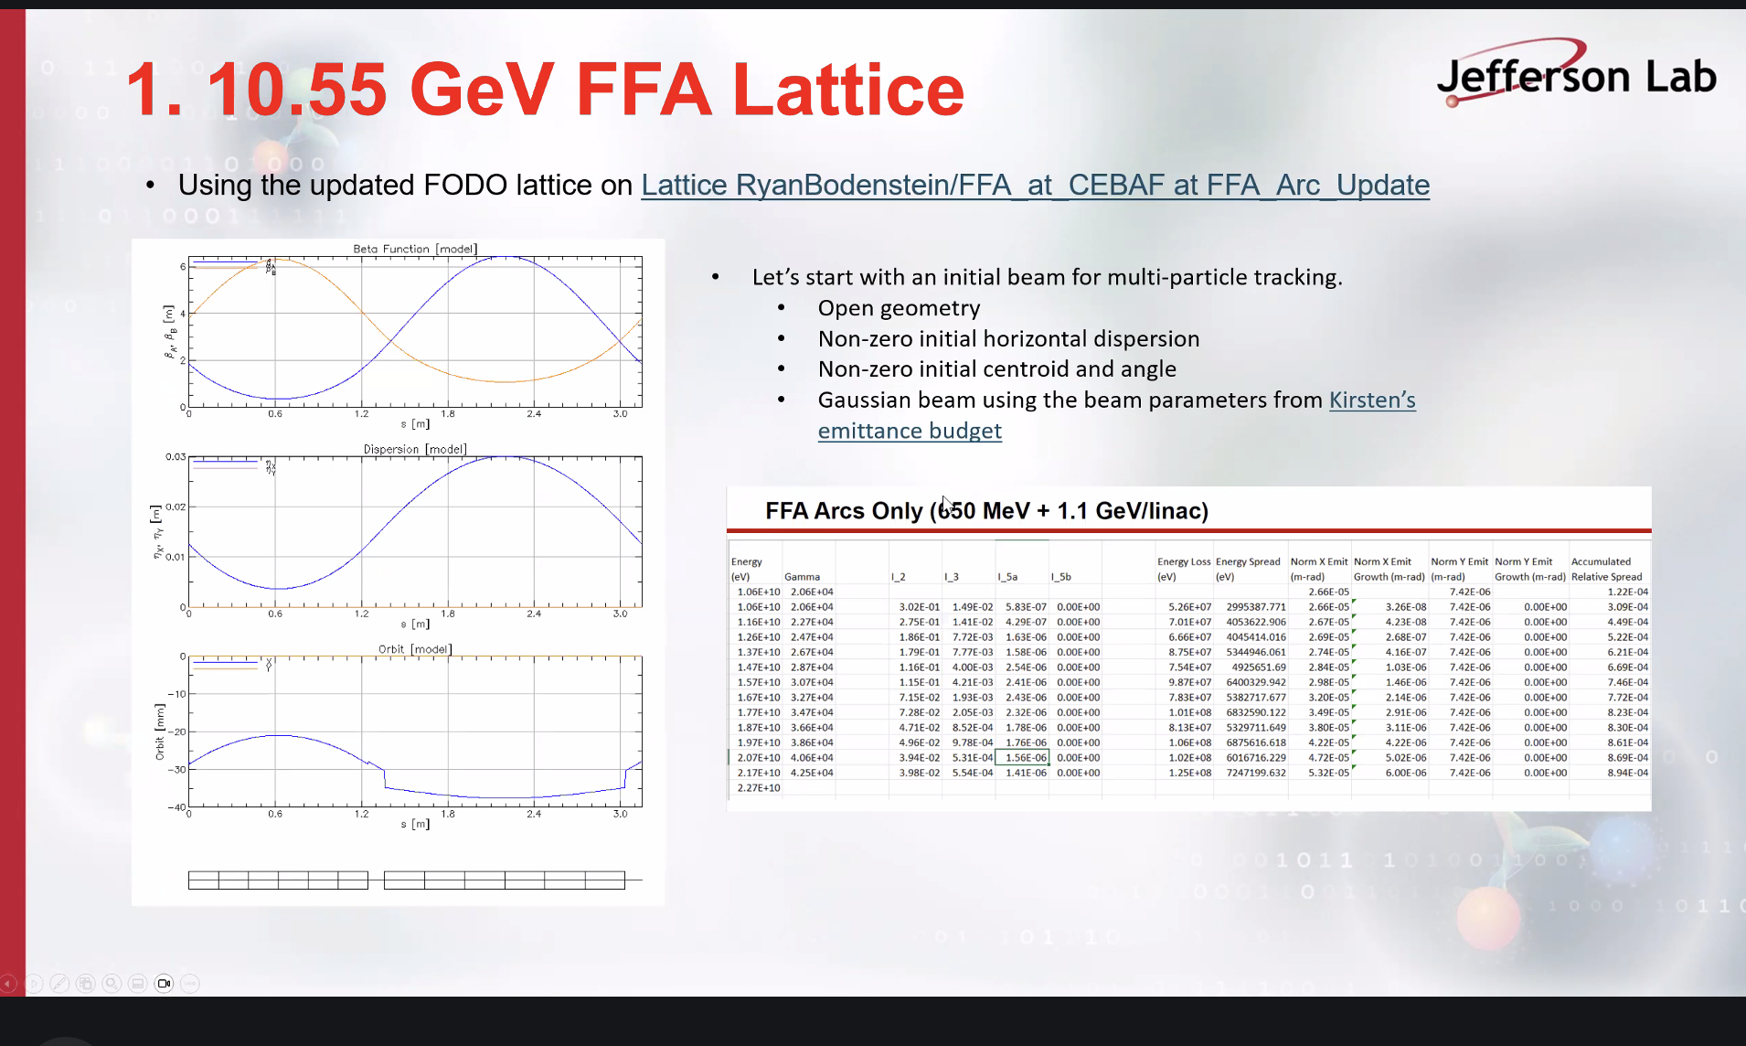
Using Ryan’s lattice and Kirsten’s emittance table.
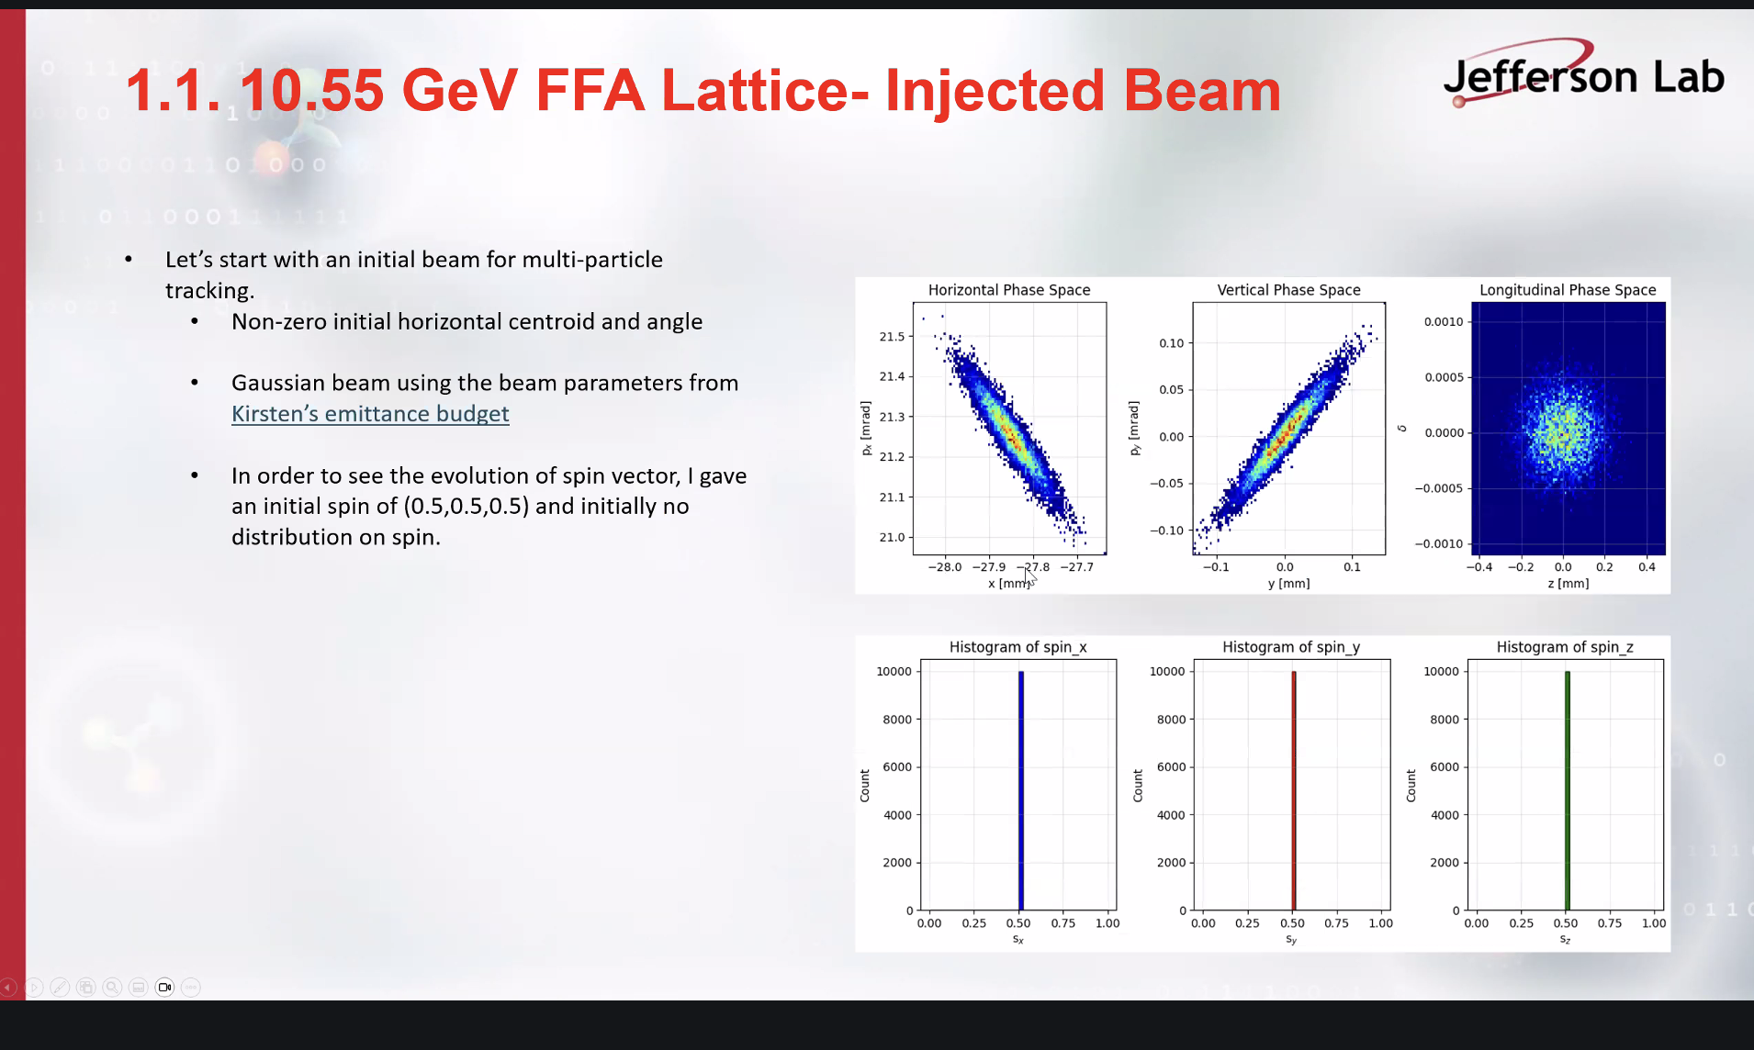
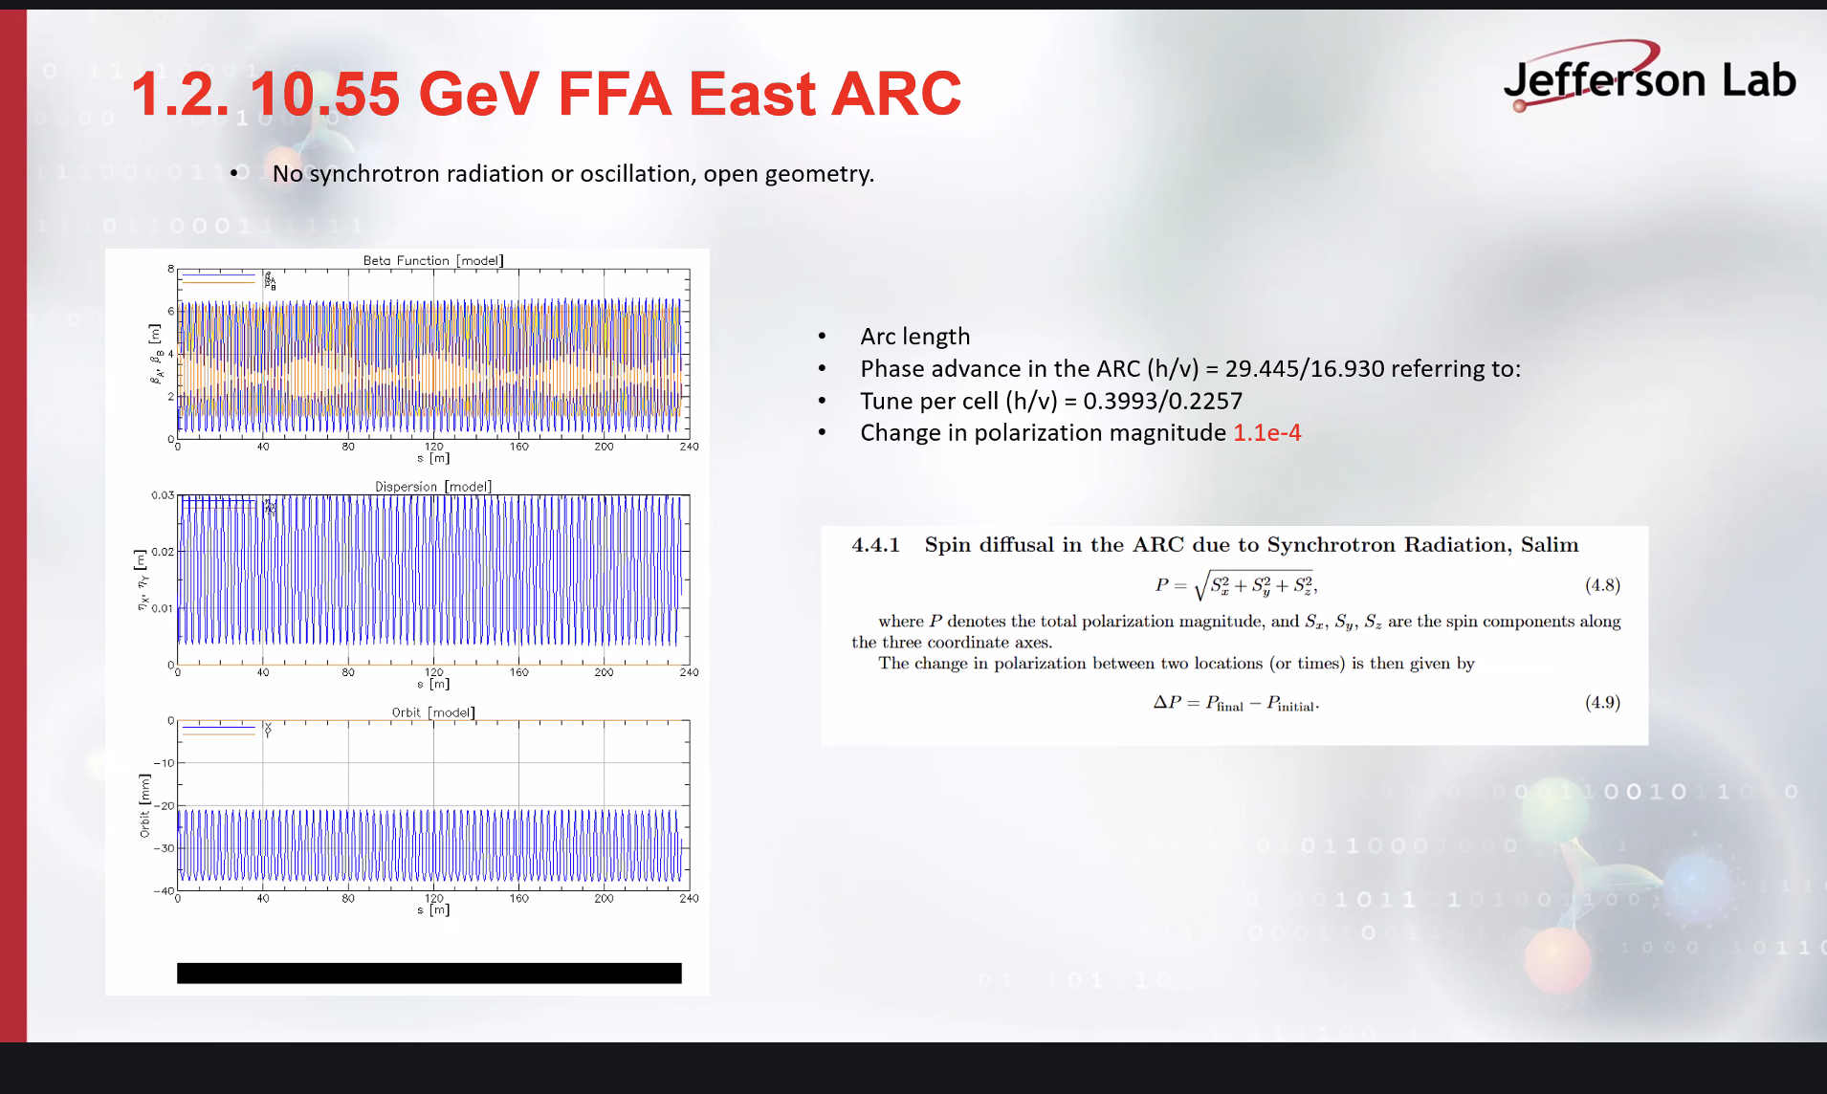
Don’t have end to end tracking but do have arcs
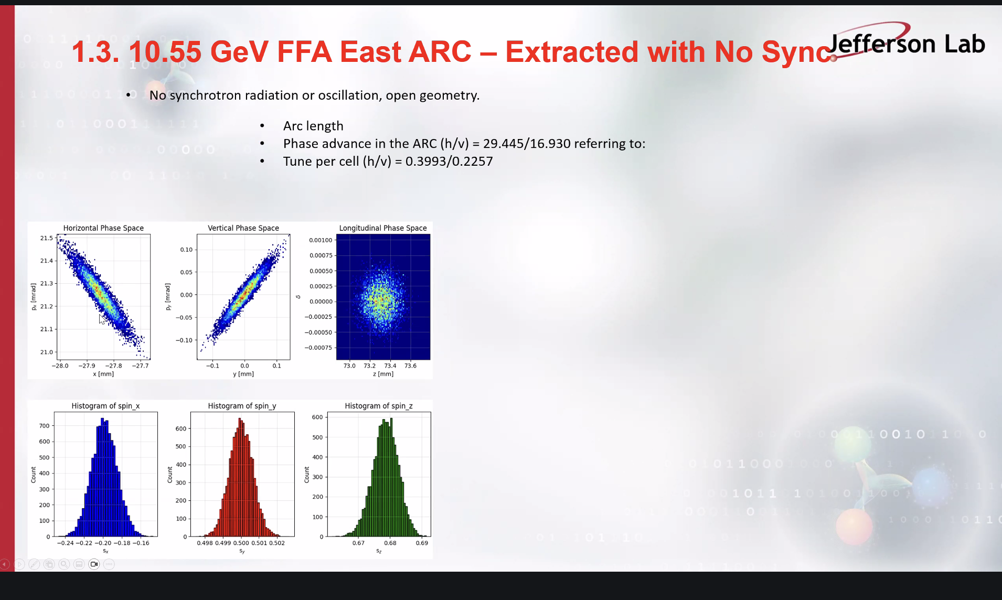
Closed orbit is where it needs to be. Small enlargement.

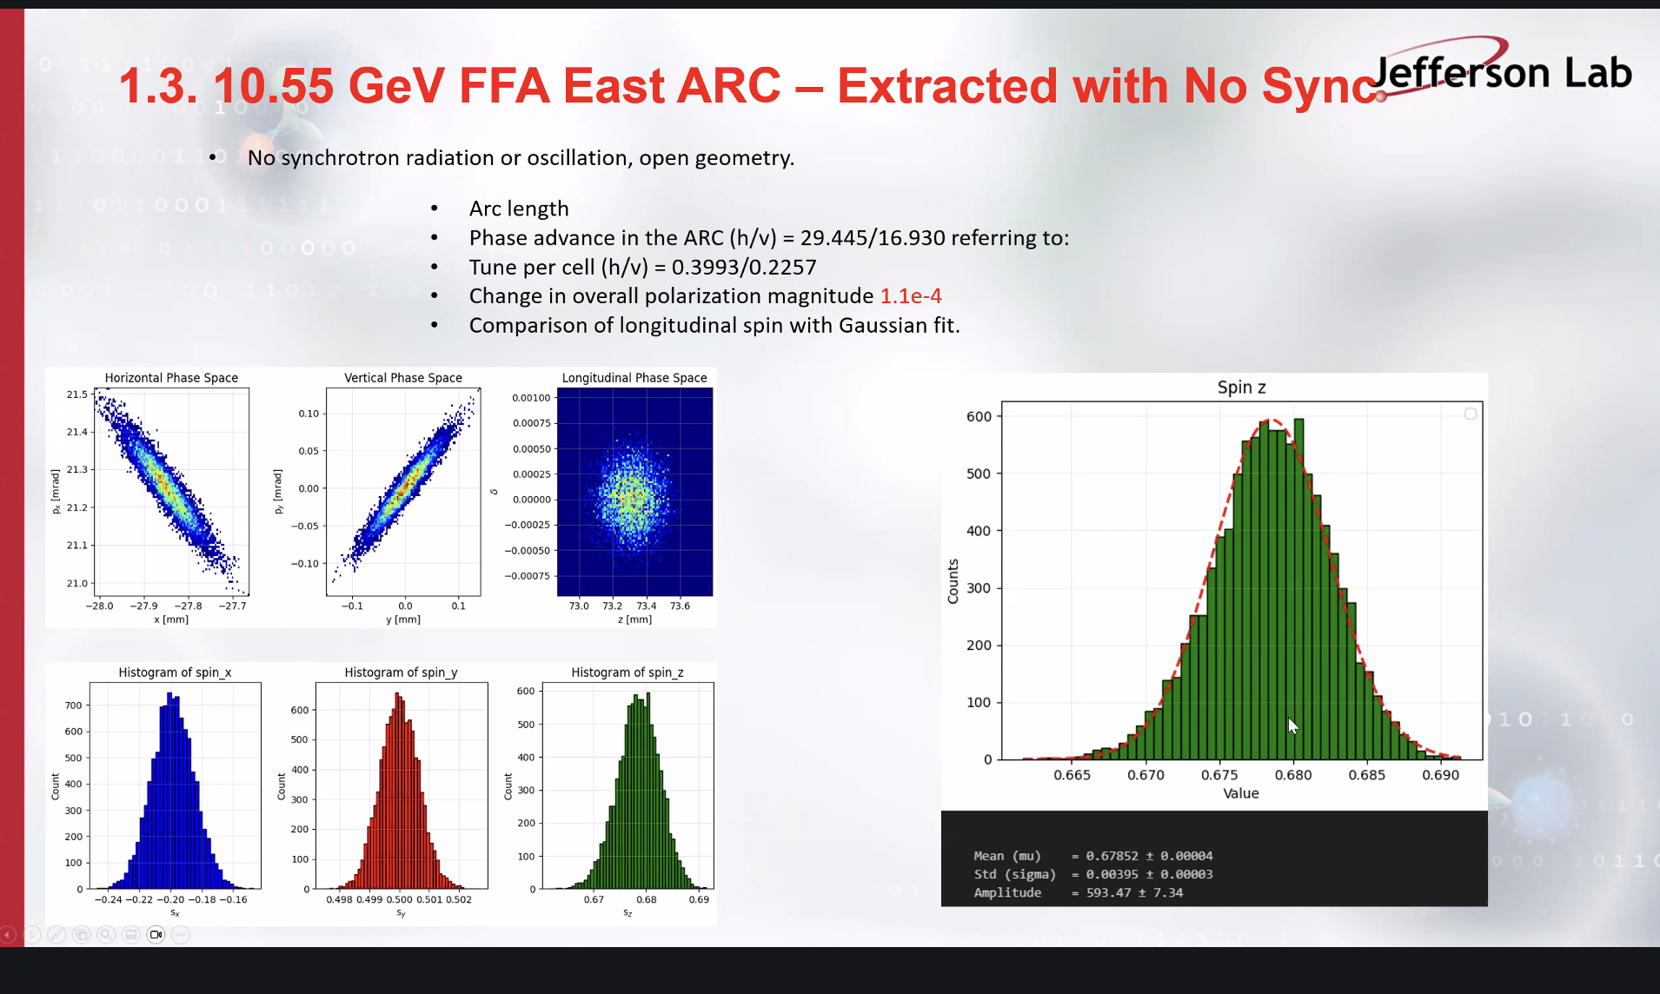
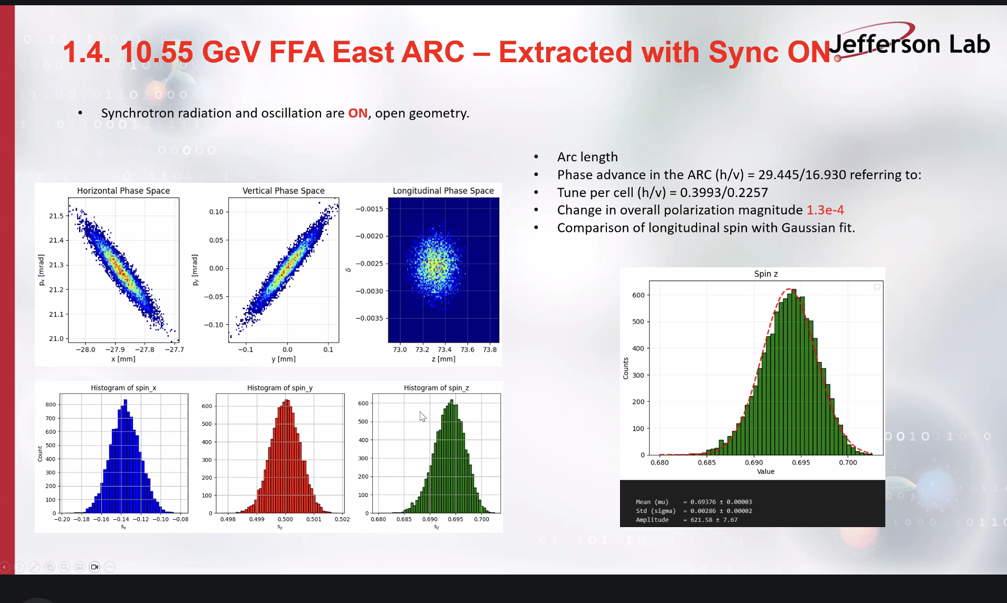
There is a shift in the gaussian when synchrotron radiation is turned on.
Scott is bothered, when going through arc spin should be polarized vertically, since spins should be precessing around vertical axis, slides indicate that horizontal spin is preserved.
Salim corrected that we do see precession.
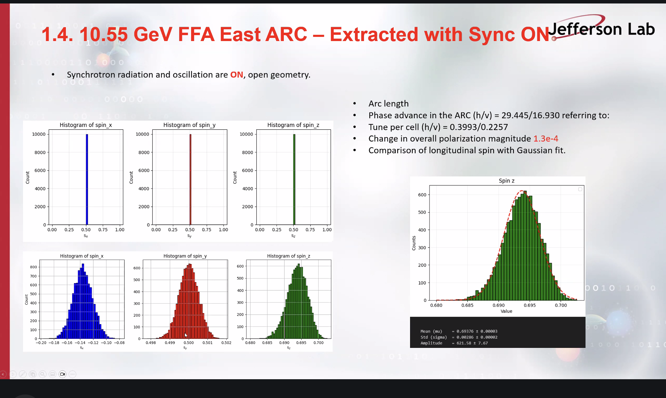
Scott confirms that spin like this would not be pushed through the arc. Salim agrees but is using the study to look at each plane. These plots are a sanity check.
Scott points out that polarization loss is the goal of the studies. Salim mentions that spin needs to be longitudinally polarized, Scott suggests a spin rotator.
Alex mentions a Wien filter, Edy explains that a desired spin is back propagated through the machine to determine the Wien settings and that there are “magic energies” where all of the halls can get high polarization.
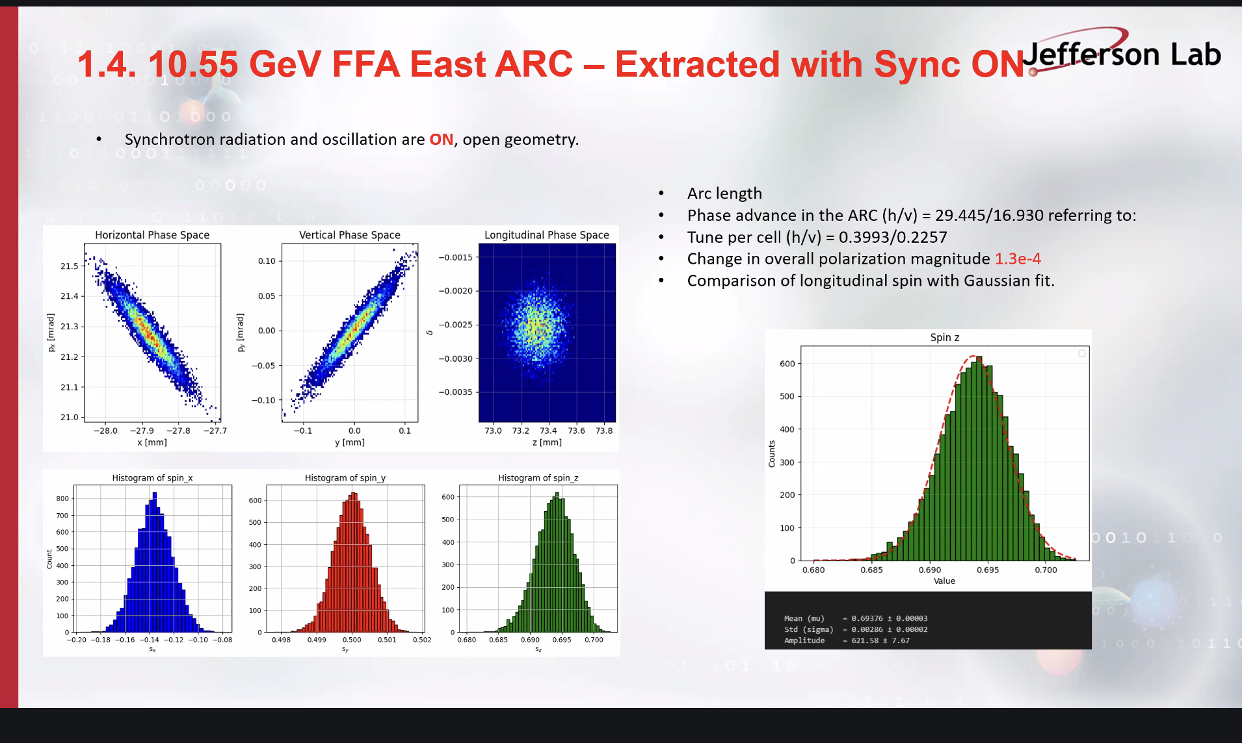
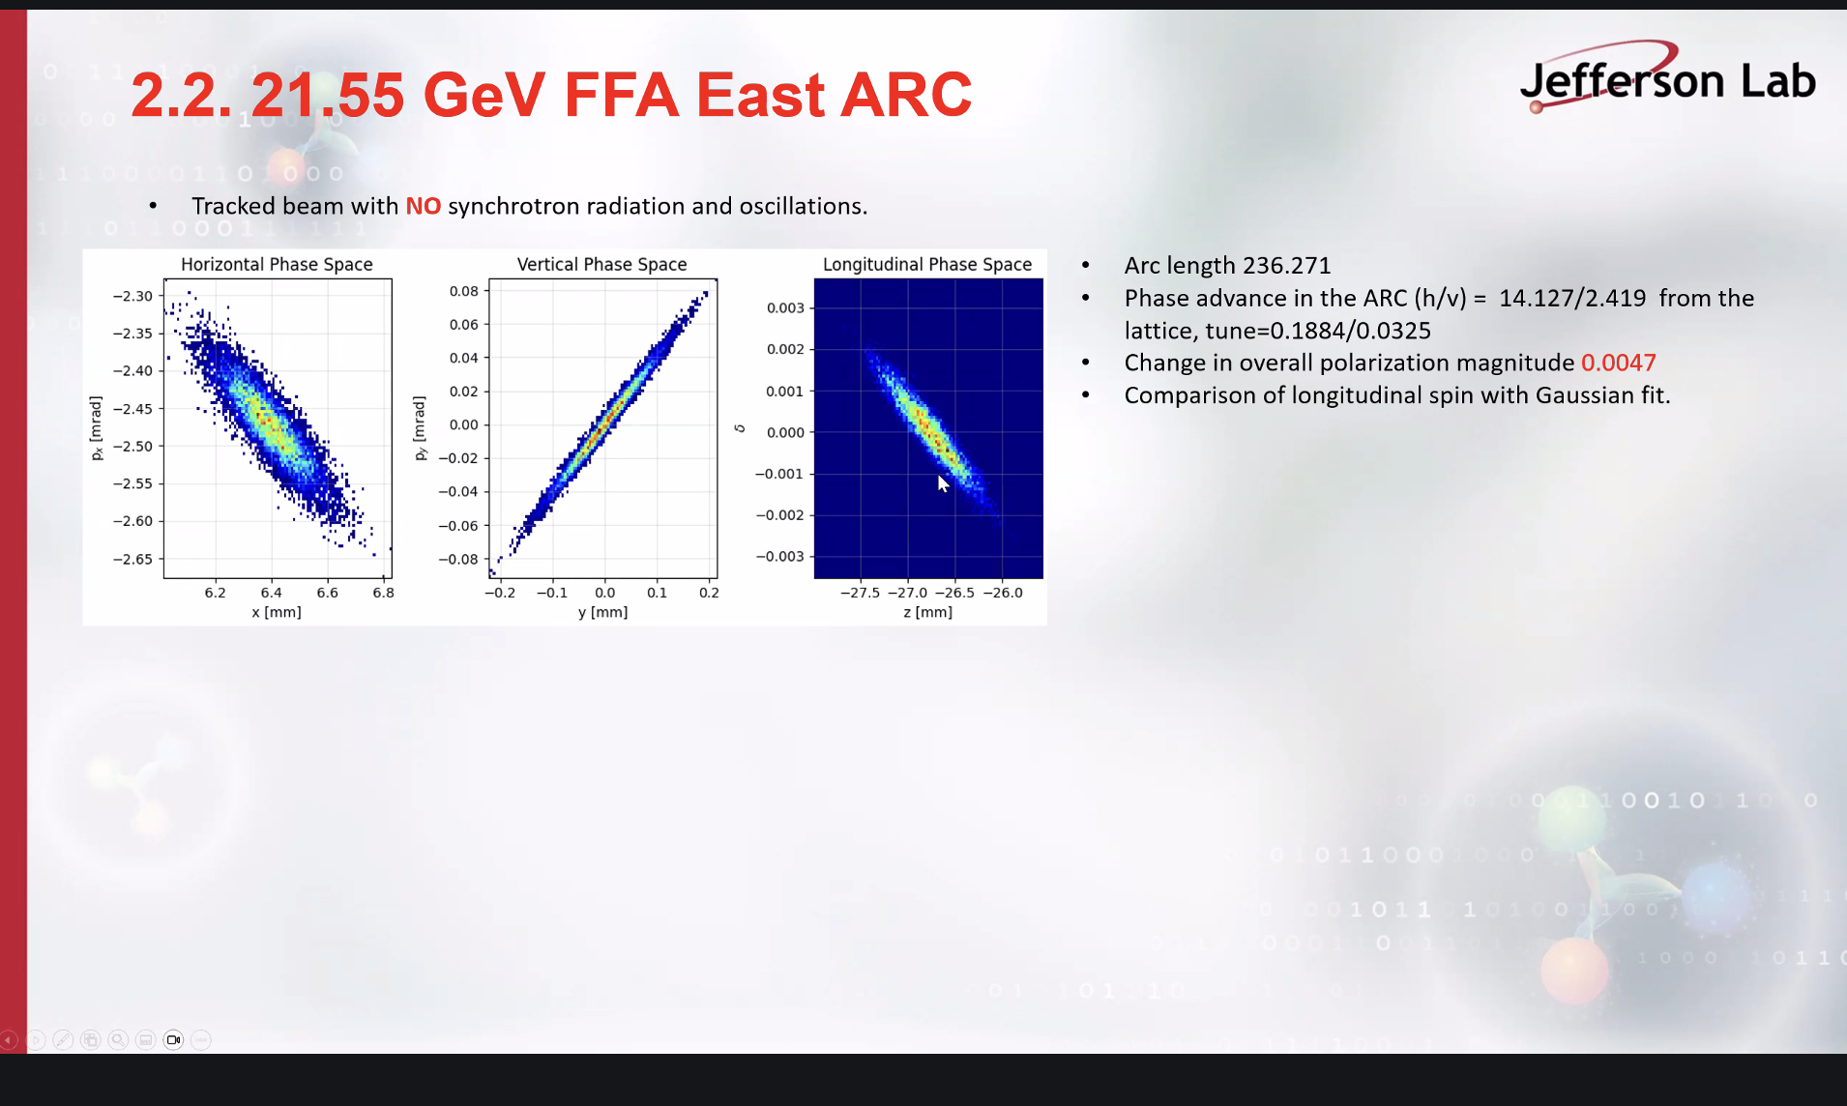
Using 10,000 macroparticles since 100,000 crashes BMad
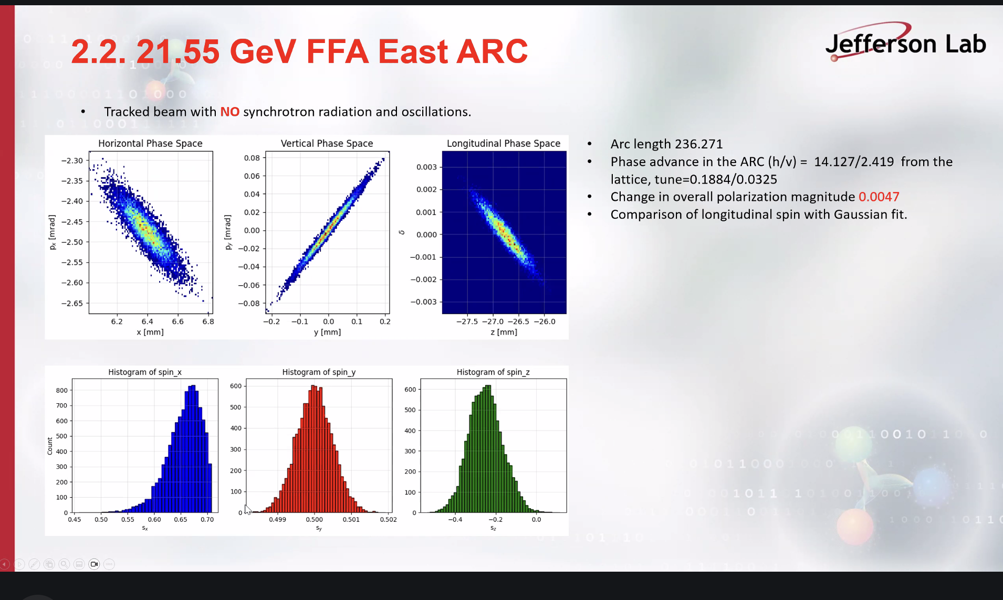
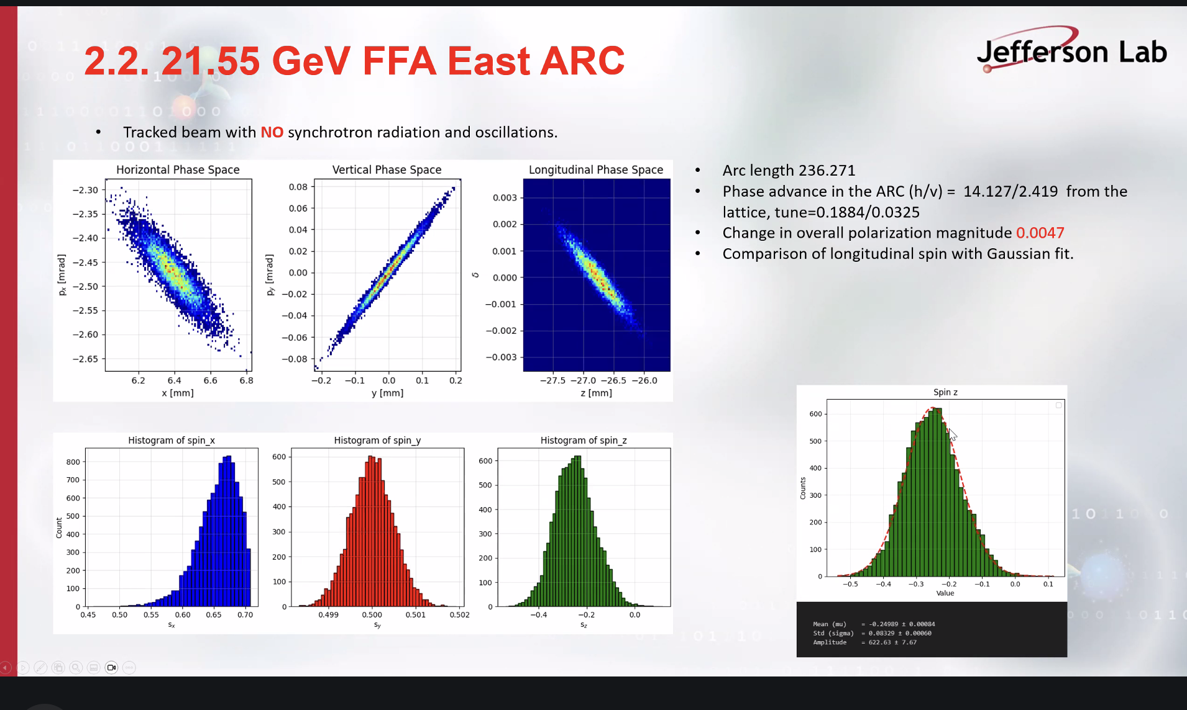
Small shift is seen under the gaussian
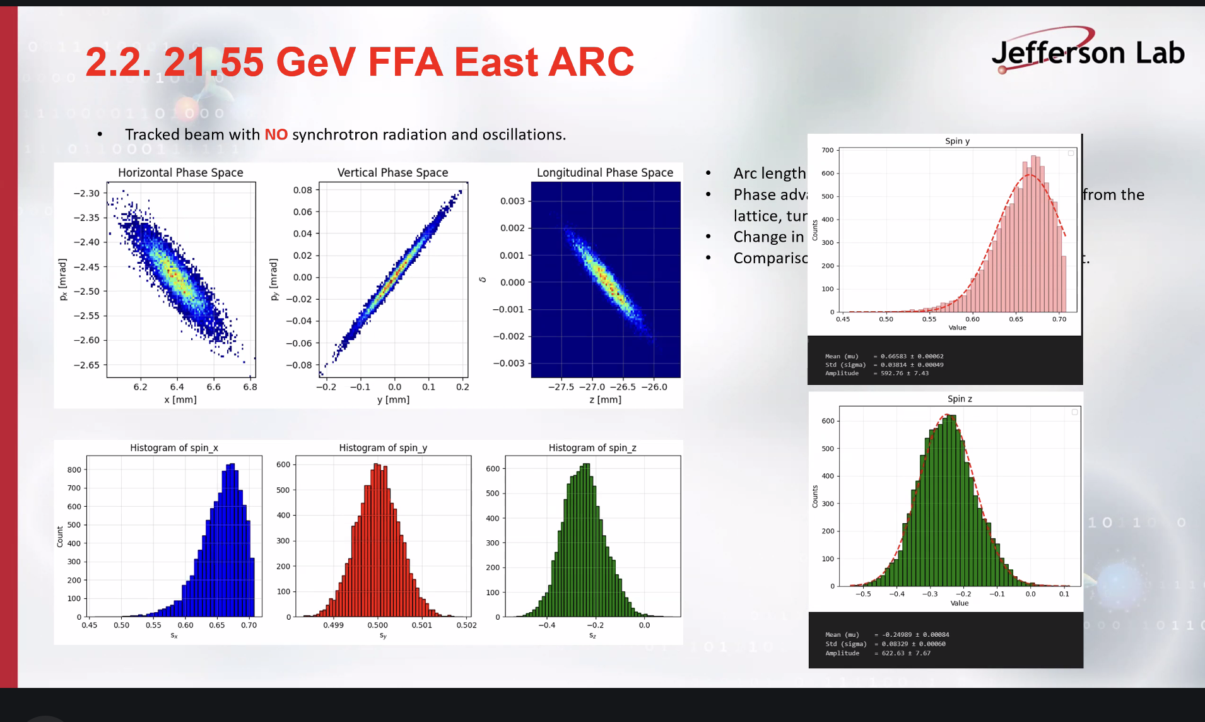
Part of horizontal is lost, doesn’t happen for positrons, without synchrotron radiation
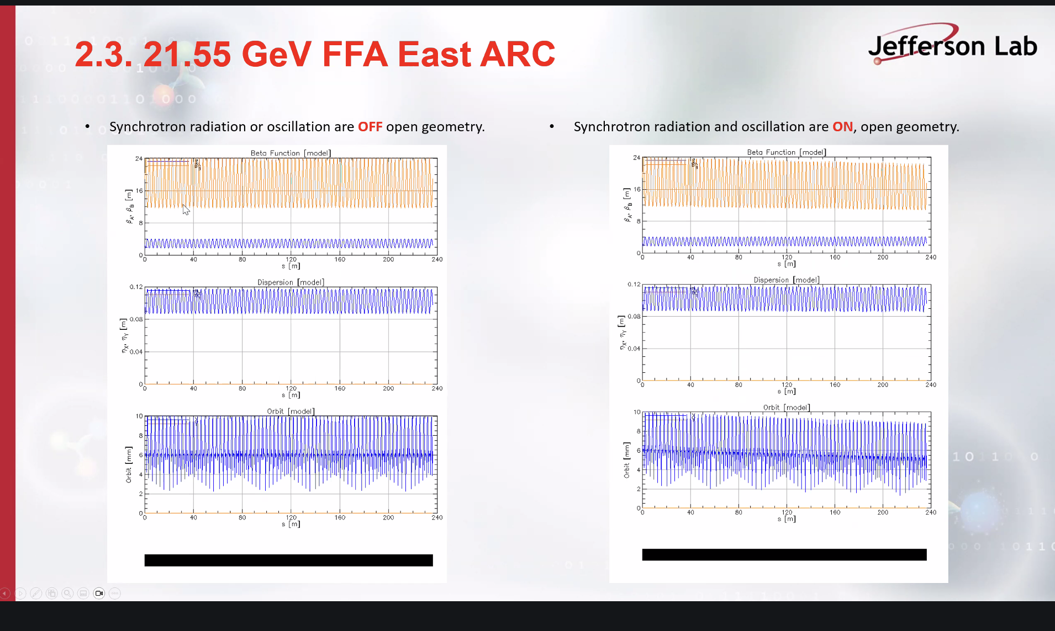
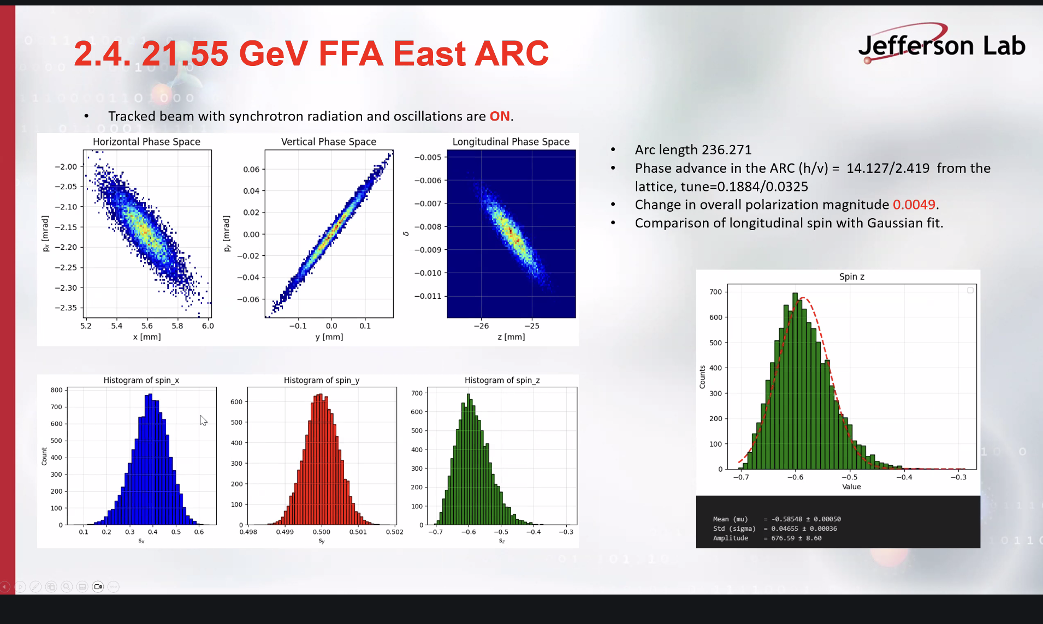

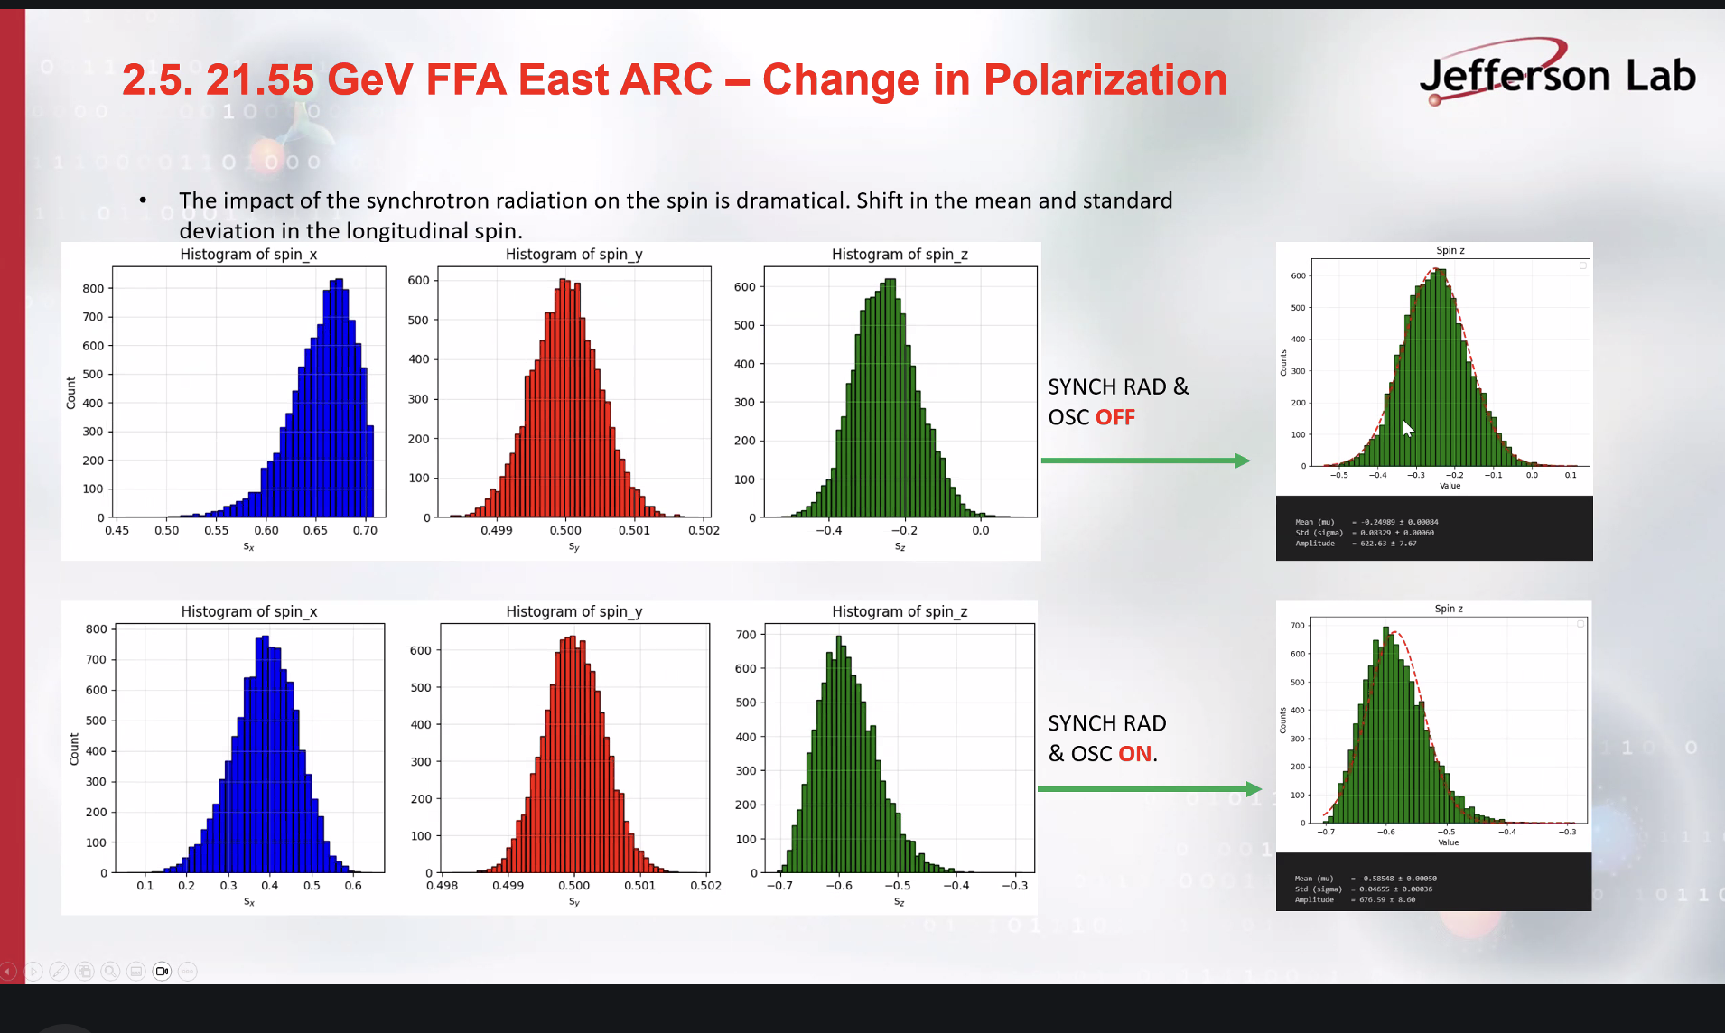

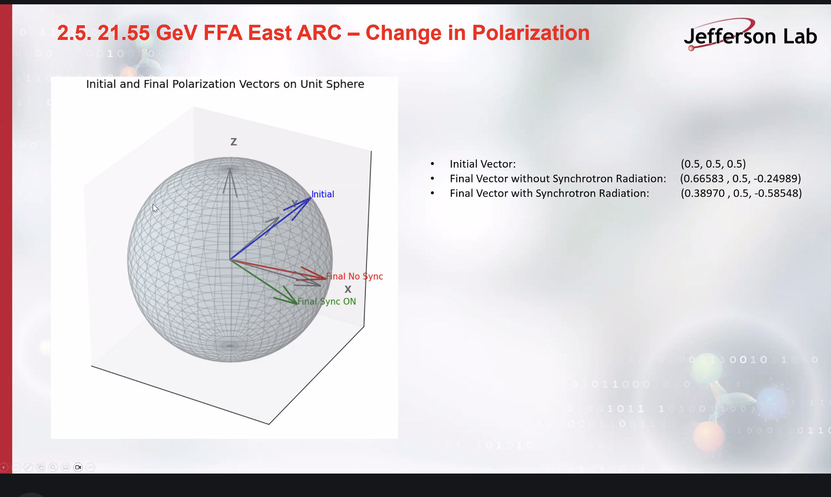

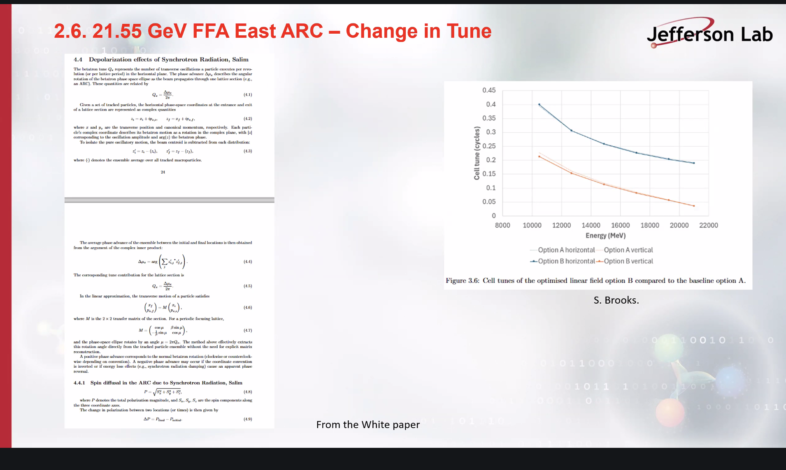

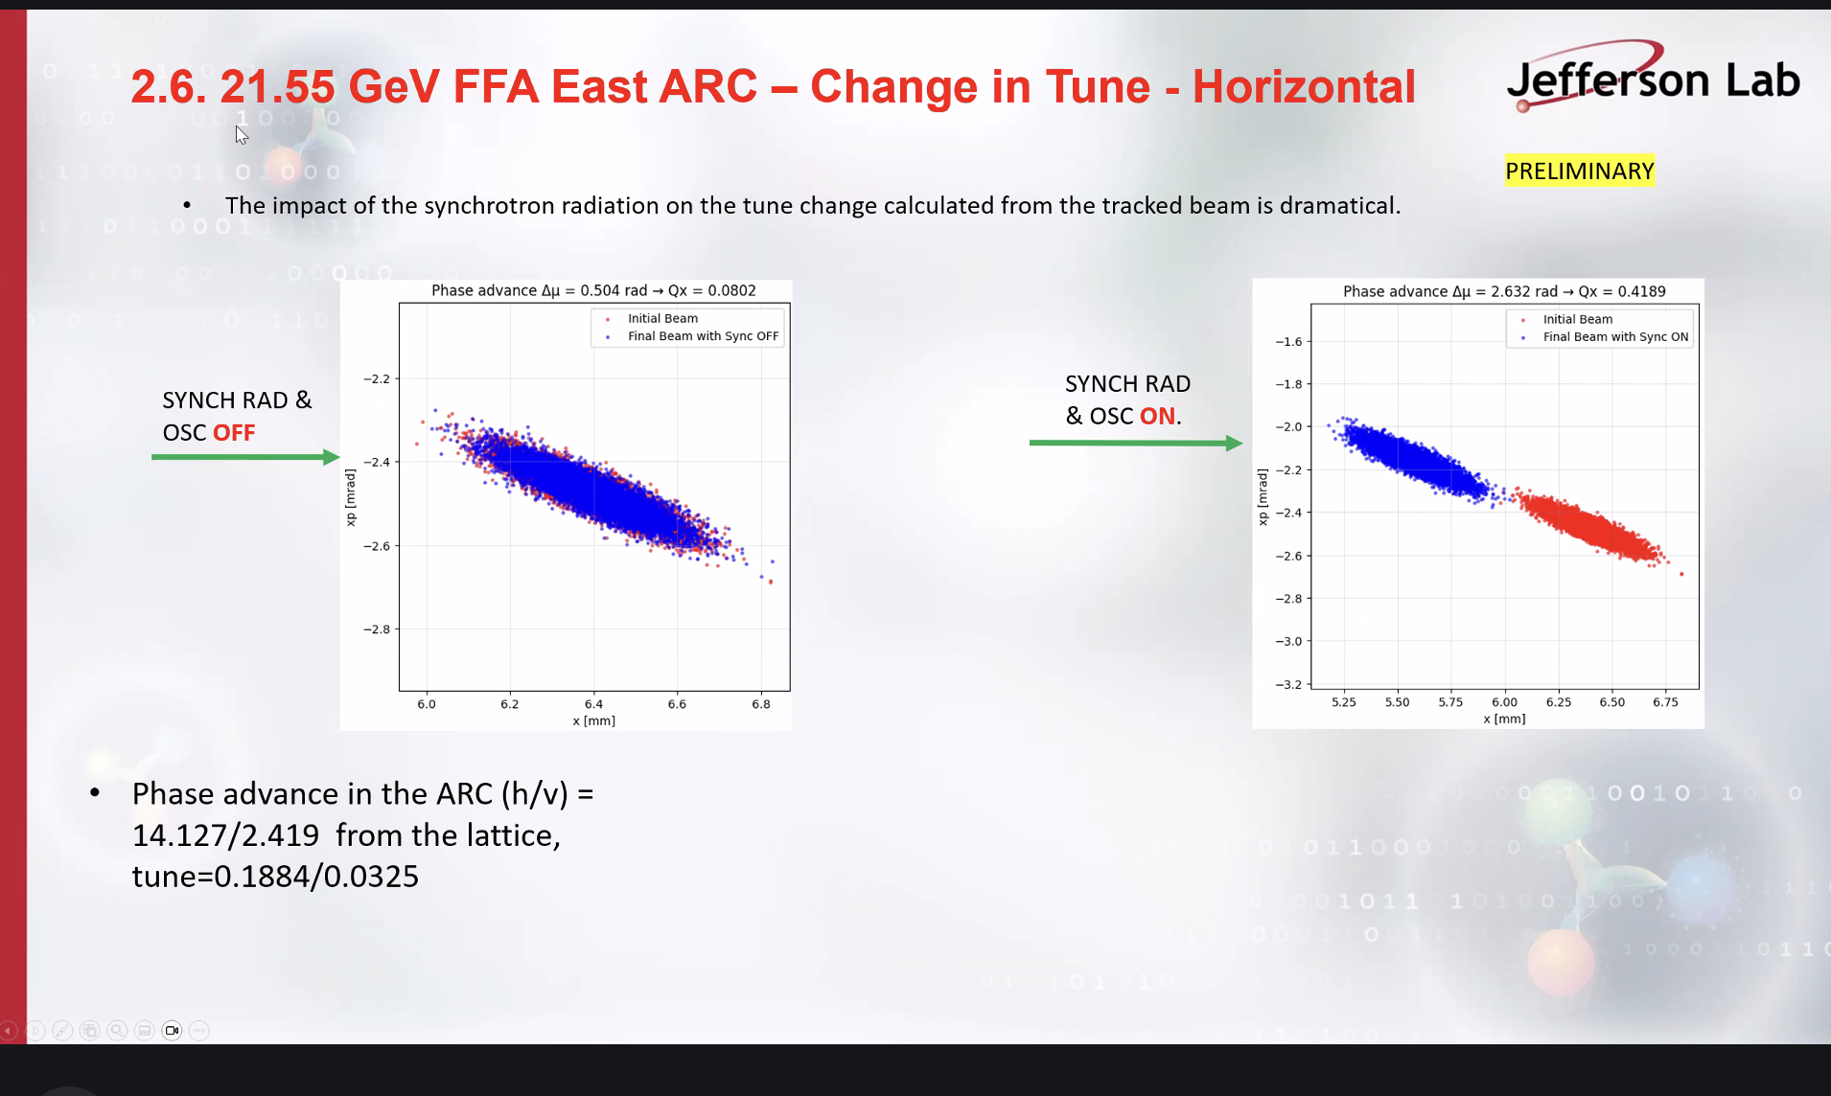
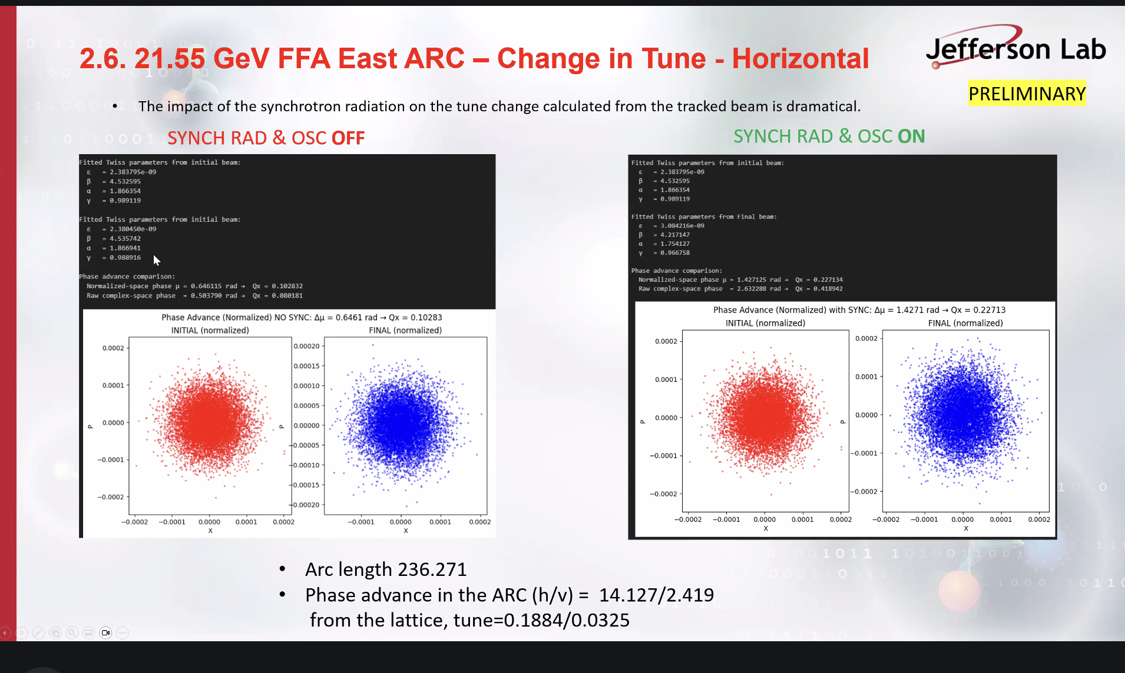

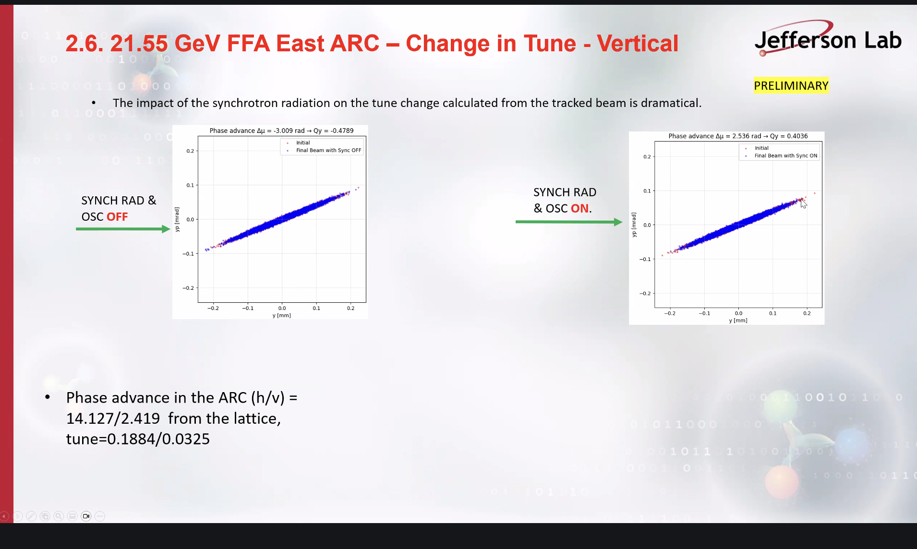

Scott is interested in how he gets his phase axis, Salim references the white paper. Scott asks if it’s the average of the macroparticles, Salim affirms that. Scott suggests histogramming the spin values, since he suspects that there is 2pi wraparound from the particles. If the individual particles aren’t on top of each other in a histogram of the phase advances. Histogram individual values before summing up.
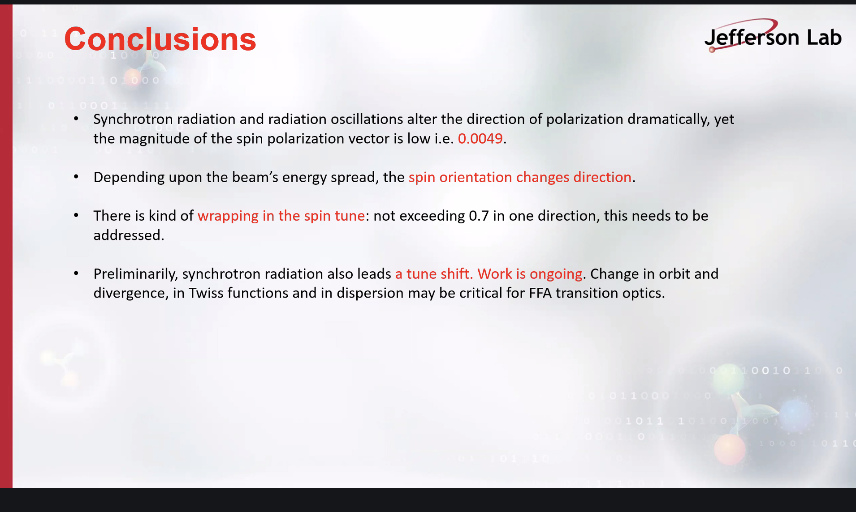
8.5% energy drift, it is a lot. Ggamma at 10 GeV around 22-23.
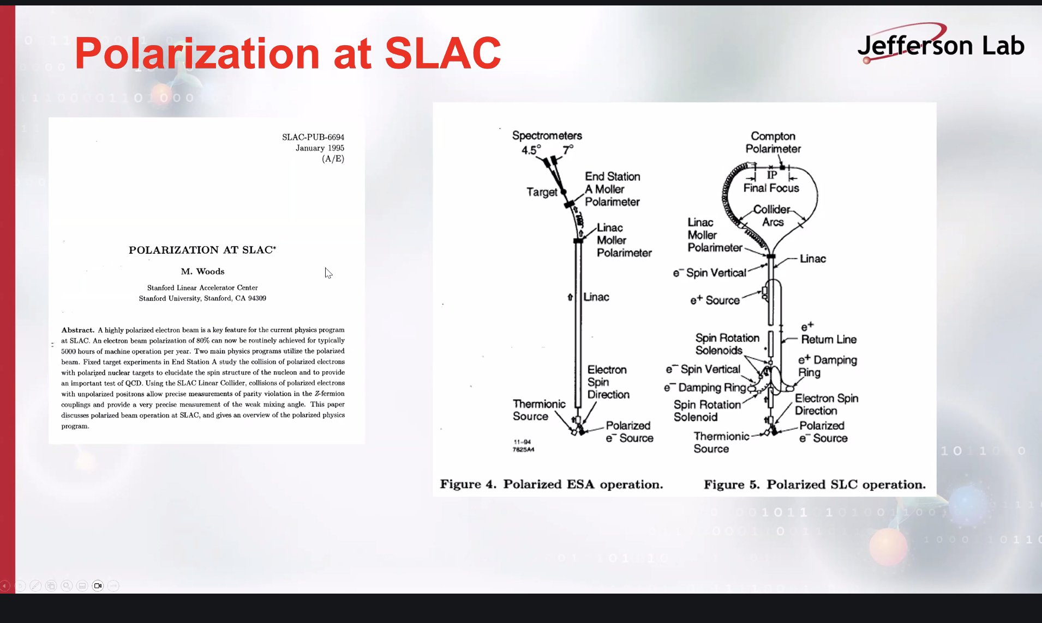
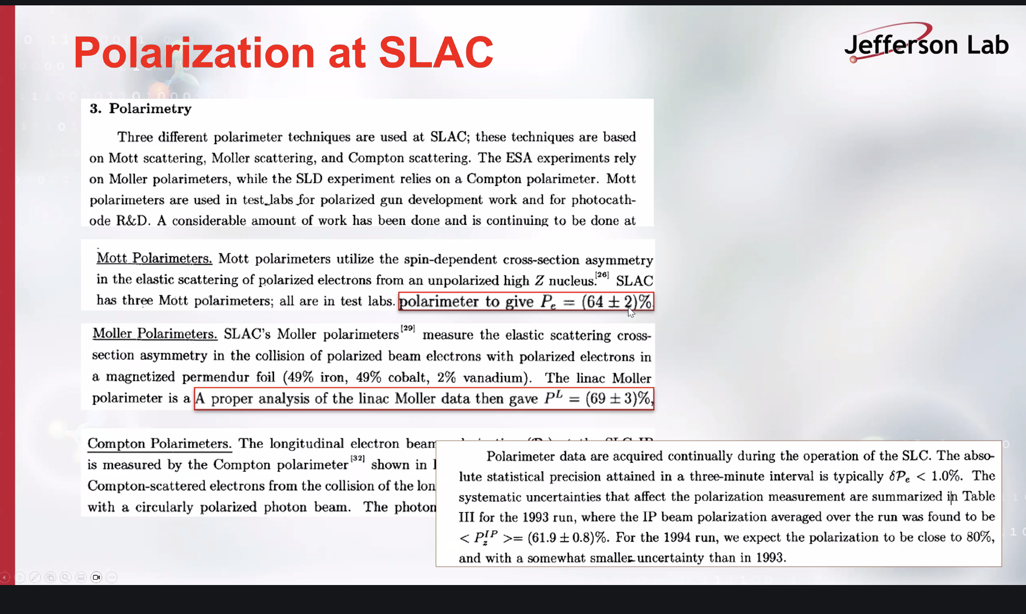
Dejan mentions multiple ways of studying spin in BMad, and would like to know which way Salim used. Salim said BMad spin tracking. Scott explains that BMad can calculate spin orbit coupling, aka the effect of spin on the phase space. There is only one way to track particles, the different methods are for spin orbit coupling.
Volker asked if Salim had used any other tools, e.g. Alex Chao’s Slim. Mais and Ripkin wrote papers on spin at DESY. Also papers by Desmond Barber. Talking about how beam size affects precession and dilution. Keeping track is a tricky business. Sokolov Ternov also a potential source. Back of envelope calculations to check magnitude for different effects, is it relevant to take it into account? What is the physics in BMad?
A conversation ensued about individual codes and the underlying physics as well as the people who developed the codes.
Volker suggests Montague’s paper from the eighties.
Dejan mentions studies done for eRHIC and Francois Meot’s book about these studies.
A discussion ensues about the gradients involved in FFAs. Scott doesn’t believe that Sokolov Ternov will be bad. Should double check since we use stronger magnetic fields.
Scott suggests plots with energy slices. Highly skewed distributions may be coming from different rates of spin precession within the beam.
Alex agrees with Volker about the number of different codes and that we should “look under the hood” to see what the underlying physics is. A discussion ensued about this.

Special notes

