FFA@CEBAF Working Group|Minutes

Meeting date | time 11/21/2025 | 11 AM EST | Meeting location https://jlab-org.zoomgov.com/j/1614898082?pwd=TnUzMS81M2sxbDZIbERJU01tYkJCQT09
 | Attendees  Alex B, Donish, Salim, Dejan, Stephen, Leon, Kirsten, Volker, Kirsten, Sadiq, Vasiliy, Scott, Andrei
  Meeting called by | Alex B
  Type of meeting | Weekly Meeting
  Facilitator | Alex B
  Note taker | Salim

INTRODUCTION
- Leon Van RISSEN-HAUPT is being introduced to the group.
- Alex said CBETA magnets can be taken. Stephen said he has a full magnet, and he recommends caution with such magnets.

PResentations
- Revisiting hybrid-FFA Splitter design - Donish Khan

Agenda topics

Time allotted | 30 mins | Agenda topic Revisiting hybrid-FFA Splitter design| Presenter Donish
- 
- 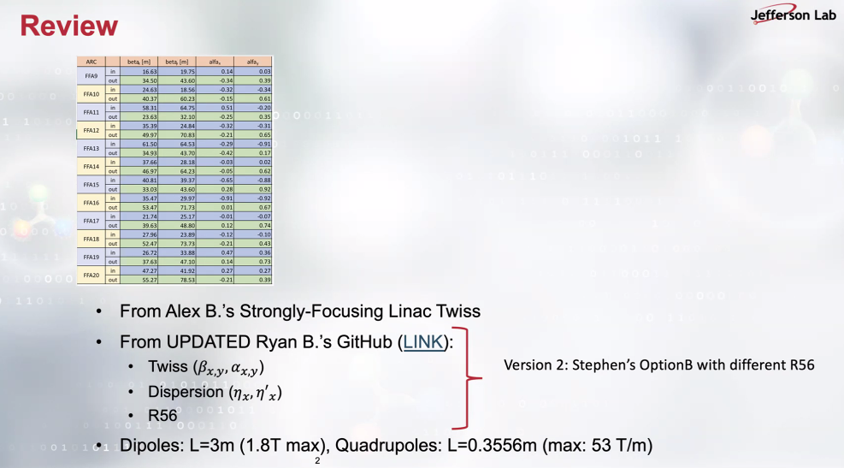
- 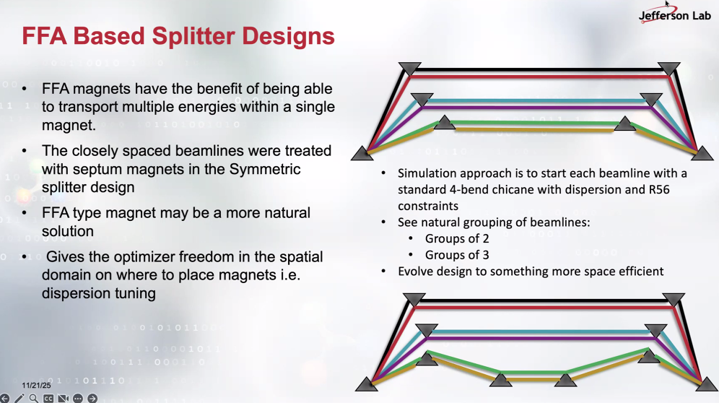
- 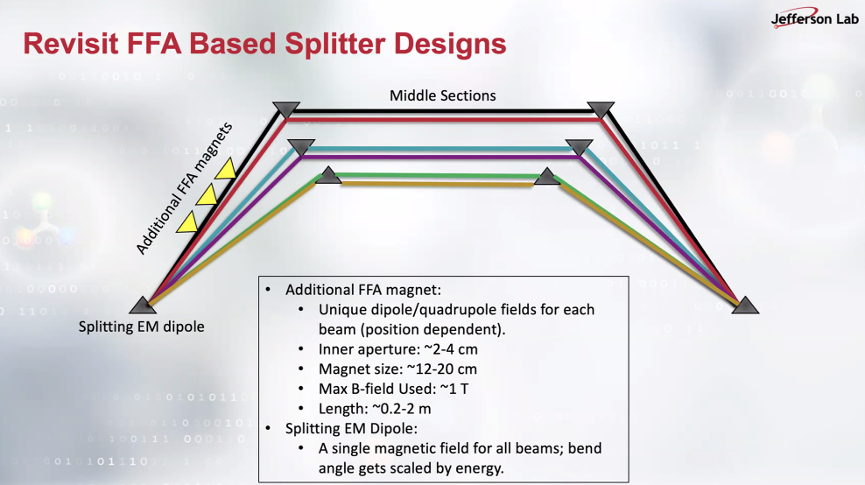
Donish starts with simple chicane and adds FFA magnets where he divides the chicane into 3 sections.
- 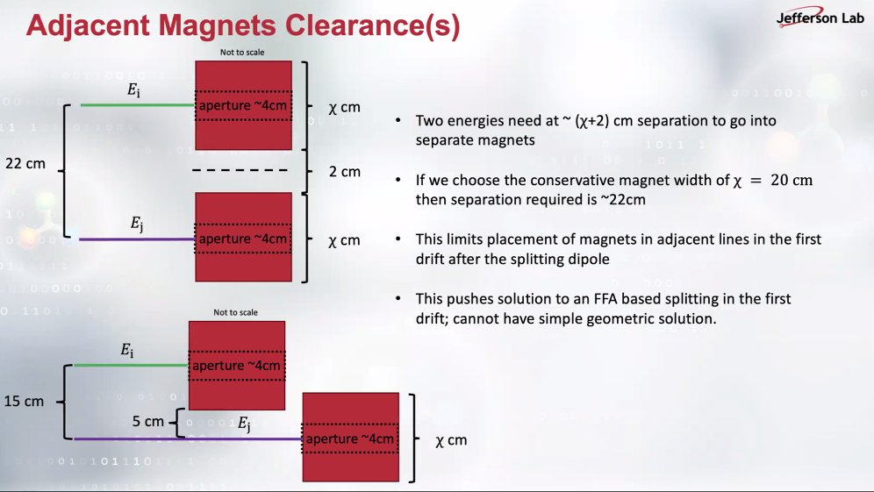
  - Stephen wrote to the chat: “You can get an idea of the size of permanent magnets using this https://stephenbrooks.org/ap/halbacharea/ “
- 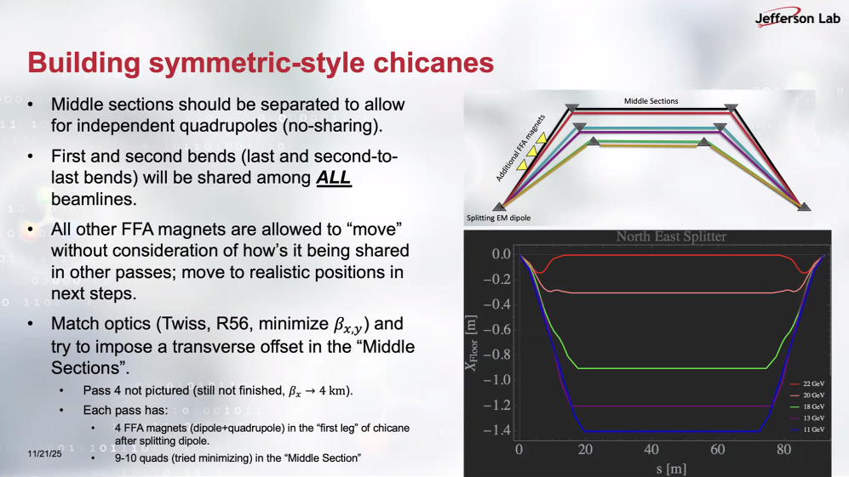
- 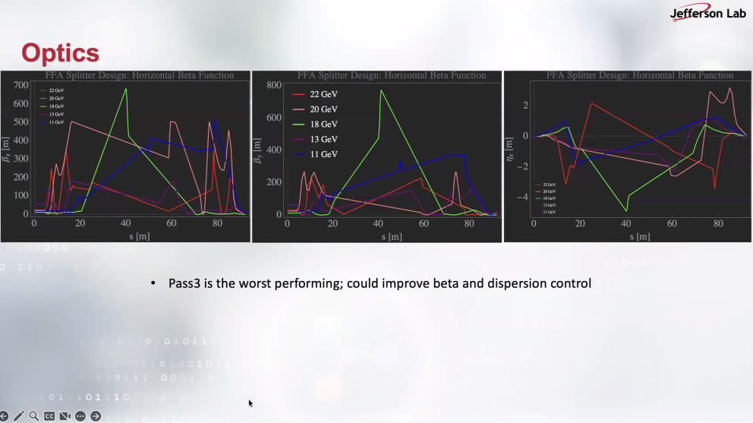
Donish: Middle figure has typo in the title: it should be vertical beta function and rightmost plot should have the title horizontal dispersion.
- Alex B: which optimizer are you using? Donish: Elegant’s simplex method.
- Dejan: you can use the normalized dispersion and check if 360 deg rotation is achieved.
- Stephen: you haven’t assumed the beams are in the same pipe yet? Donish affirmative.
- Dejan: the gradient limit for the magnets? Donish: 53 T/m for the quads, 1 T limit for the dipole.
- Dejan recommends choosing one energy, the most challenging one, and focusing on its optimization by varying the combined function magnet gradient changes.
- Scott: use also the FFA magnets to help you in achieving the smaller beta functions. Donish: not yet done.
- Andrei: the optimizer is optimizing the beta functions and orbit/trajectory? Donish: both. Andrei: are you clustering the distinct energies? Pushing certain energies to certain trajectories? Donish only the lowest energy blue line is pushed.
- Stefan: as done in the muon collider, maybe the triplet can be used better control of dispersion and beta functions.
- Leon: constraint the optimization for example 5-pi phase advances that would automatically close the dispersion and relax the beta function. Donish: it was recommended in the past and can be implemented now.
- Salim: the FFA magnets in the optimizer are allowed to switch the quad gradients to be defocusing and focusing without any quads being imposed to be (de)focusing? Donish affirmative: the optimizer decides and discovers the sign. Salim says partially the triplet structure is automatically explored, then but not fully.

Time allotted | 30 mins | Agenda topic Title Update| Presenter Person2

Action Items | Person responsible | Deadline

Special notes

Pathway to Repository: https://jeffersonlab-my.sharepoint.com/:f:/g/personal/tristan_jlab_org/EqZ5MeS-nipCgPfZB5p0oS4B9Is67d3nQb9sLJI3Zyev9g

