**CLAS COLLABORATION**

**Meeting Agenda**

**October 12 - 15, 2011**

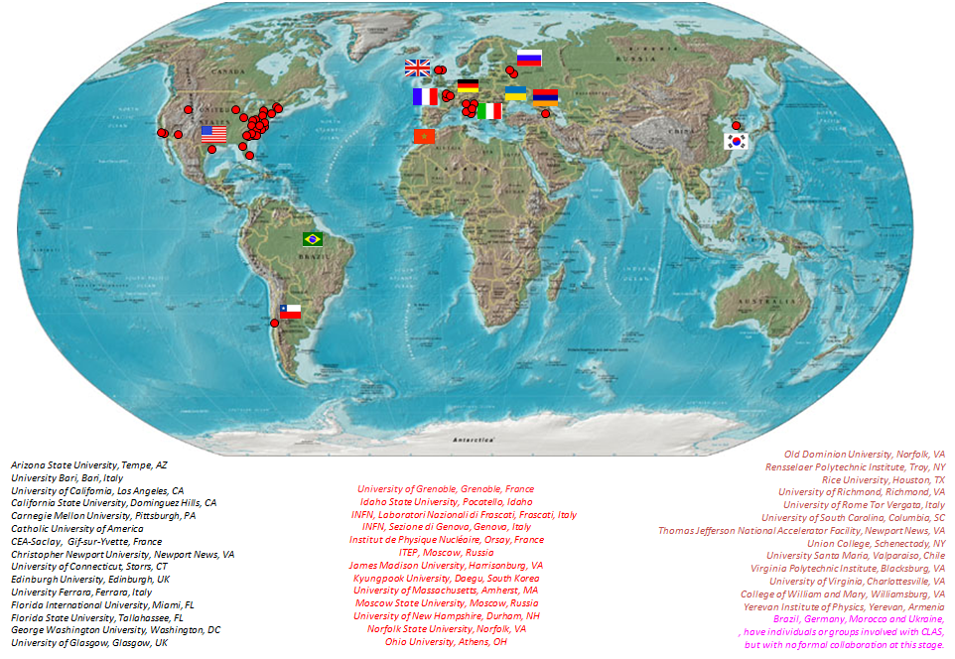

**Wednesday, October 12, 2011  
CLAS12 Technical Workshop**

|  |  |  |  |  |
| --- | --- | --- | --- | --- |
|  | **F113** | **F326/327** | **L207** | **L102/104** |
| **8:30 - 9:30** |  | **RICH** | **Forward**  **tagger** | **Central Detector** |
| **9:30 - 10:00** |  | **RICH** | **Forward**  **tagger** | **Central Detector** |
| **10:00 - 10:30** | **Coffee** | **Coffee** | **Coffee** | **Coffee** |
| **10:30 - 12:00** |  | **RICH** | **Forward Tagger** | **Central Detector** |
| **12:00 - 13:30** | **Lunch** | **Lunch** | **Lunch** | **Lunch** |
| **13:30 - 15:00** |  |  | **PCAL** | **Cerenkov** |
| **Plenary session** | | | | |
|  | **Auditorium** |  |  |  |
| **15:30 - 15:55** | **P. Rossi “RICH summary”** |  |  |  |
| **15:55 - 16:20** | **J. Ball “Central Detector Summary”** |  |  |  |
| **16:20 – 16:45** | **M. Battaglieri “Forward Tagger Summary”** |  |  |  |
| **16:45**  **-**  **17:15** | **S. Boyarinov “DAQ/trigger Over view”** |  |  |  |
|  |  |  |  |  |

**Thursday, October 13, 2011**

|  |  |
| --- | --- |
| **Plenary** | **Auditorium** |
| **8:30 - 8:50** | **K. Hicks – “Collaboration status” - 15+5 min** |
| **8:50 - 9:40** | **V. Burkert – “Hall B and CLAS12 status” - 45+5 min** |
| **9:40 - 10:10** | **K. Griffioen -- “BoNuS Detector physics results” - 25+5 min** |
| **10:10 - 10:45** | **Coffee** |
| **10:45 - 11:05** | **H. Montgomery – “General Remarks” 15+5 min** |
| **11:05 - 11:35** | **A. Sandorfi “The g14 run plans” 25+5 min** |
| **11:35 - 11:55** | **M. Lowry “The HD-ice In-beam Cryostat” 15+5 min** |
| **12:00 - 13:30** | **Lunch - CLAS12 Steering Committee (L102/104) - Membership Committee (A110) - Student and PostDoc meeting (F326/7)** |
| **13:30 - 14:30** | **L. Elouadrhiri “CLAS12 base equipment reports”** |
| **14:30 - 14:55** | **P. Stoler “Report from the CLAS12 Steering Committee”** |
| **14:55 - 15:20** | **R. De Vita “CLAS12 CalCom Organization: Progress Report”** |
| **15:20 - 15:50** | **Coffee** |
| **15:50 - 16:15** | **(D. Weygand) “CLAS12 Software Workshop Report”** |
| **16:15 - 16:40** | **(J. Gilfoyle) “CLAS12 Software Vision”** |
| **16:40-**  **17:30** | **Panel discussion: shifting focus and effort to CLAS12**  **(moderator: K. Hicks, panel: DeVita, Djalali, Elouadrhiri, Stoler)** |

**Friday, October 14 2011**

|  |  |  |  |
| --- | --- | --- | --- |
| **Working**  **Group**s | **Auditorium** | **L102/104** | **A110** |
| **8:30 - 10:30** | **Deep Processes Physics Working Group** | **Hadron Spectroscopy Physics Working Group** | **Nuclear Physics Working Group** |
| **10:30 - 11:00** | **Coffee** | **Coffee** | **Coffee** |
| **11:00 - 12:00** | **Deep Processes Physics Working Group** | **Hadron Spectroscopy Physics Working Group** | **Nuclear Physics Working Group** |
| **12:00 - 13:30** | **Lunch - Coordinating Committee (B101)** | **Lunch - OTWG meeting (L102/104)** | **Lunch -CSC (A110)** |
| **13:30 - 15:30** | **Deep Processes Physics Working Group** | **Hadron Spectroscopy Physics Working Group** | **Nuclear Physics Working Group** |
| **15:30 - 16:00** | **Coffee** | **Coffee** | **Coffee** |
| **16:00 - 17:30** | **Deep Processes Physics Working Group** | **Hadron Spectroscopy Physics Working Group** | **Nuclear Physics Working Group** |

**Saturday, October 15 2011**

|  |  |
| --- | --- |
| **Plenary** | **Auditorium** |
| **8:30 – 9:00** | **Y. Ilieva -- “Two-Body Photodisintegration of 3He”** |
| **9:00 - 9:30** | **L. Weinstein – “Connecting SRC and the EMC effect”** |
| **9:30 - 10:00** | **K. Griffioen – “Deep Processes PWG report”** |
| **10:00 - 10:20** | **Coffee** |
| **10:20 – 10:50** | **D. Ireland – “Hadron Spectroscopy PWG report”** |
| **10:50 - 11:15** | **H. Egiyan – “Nuclear PWG report”** |
| **11:15 - 11:30** | **P. Rossi “Service Work Committee Report”** |
| **11:30 - 11:45** | **K. Giovanetti “Membership Committee Report”** |
| **11:45 - 12:00** | **M. Battaglieri “Speakers Committee Report”** |
| **12:00 – 12:15** | **K. Hicks – “Coordinating Committee Report”** |