PROPANE TORCHES

Small propane torches have multiple applications; the most common are soldering, brazing and heating. Don’t be fooled by their size, they are small, but they do create an area of intense area of heat. They need to be used with caution to avoid injury and fire.

The primary risk is canister leakage and content ignition. In the event of ignition, there is the risk of explosion. If propane reaches its explosive range and is subjected to an open flame, the result could be disastrous.

Read and abide by manufacturers’ instructions and safety data sheets

Store propane canisters in cool, dry, well-ventilated areas

USE THE CORRECT TIP FOR THE JOB

Different tips are made for different applications and create different sizes and shapes of flame. Some tips attach directly to a canister, while others connect to a hose. Some allow for a tiny, focused point of flame, while others diffuse the flame. Choose the one that is appropriate for the job at hand.

During use, hold hand torch cylinders near to the upright position to prevent flare-ups or flashes. If appliance sputters or flares up, turn the unit off. Vent the area to remove unburned gas. Slowly turn the torch back on. After hearing a slight hiss, re-light the torch.

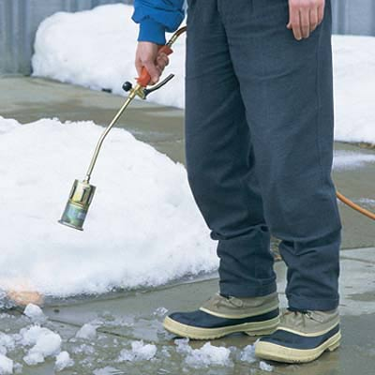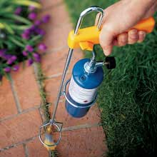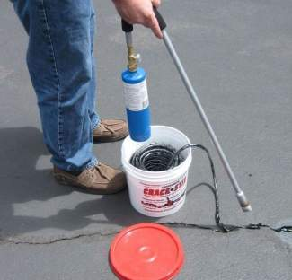
Notice that these tools maintain the propane cylinder in the upright position. Always keep the propane cylinder nearly upright while the torch valve is open and the torch is in use.
WHAT CAN GO WRONG?

Woodtv.com  “An unidentified man in Holland Township, Michigan, recently killed a squirrel for dinner. While attempting to singe the hair off with a propane torch he caused a fire which got out of hand quite rapidly. Eight apartments were destroyed and another twenty four rendered uninhabitable by smoke and water damage.” | 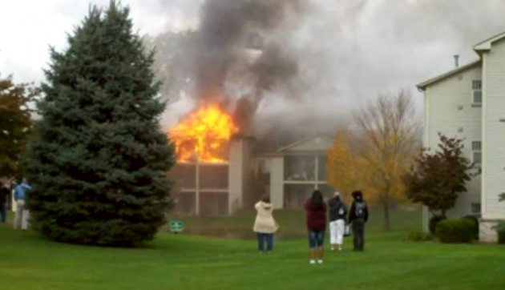
Lessons Learned:  At the University of Arizona a researcher used a match to light a torch. To put it out he dipped the match into an open bucket of clear liquid sitting next to the sink. The bucket contained ethanol and potassium hydroxide solution, which caught fire. The fire extinguisher, used on the fire, sprayed burning liquid onto a broken glass box behind the bucket and it also caught on fire. Eventually, the fire was extinguished and 911 was called. | 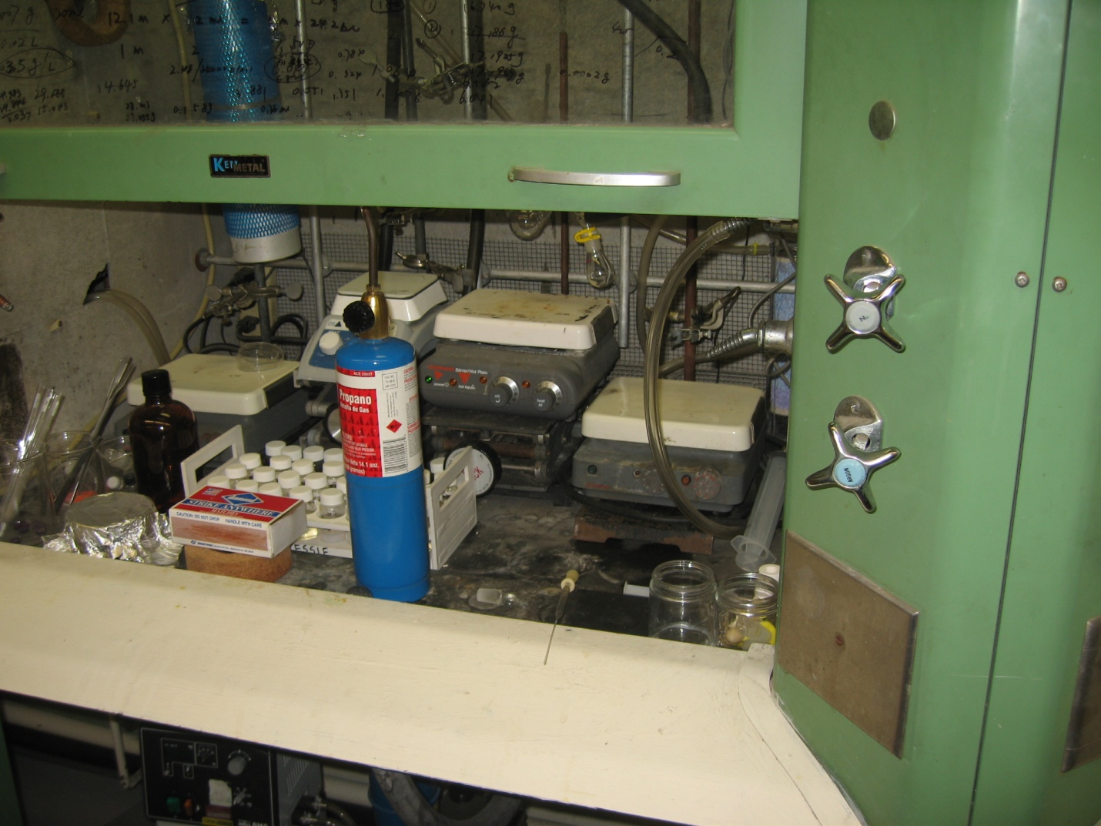

USING PROPANE TORCHES AT JEFFERSON LAB

- Supervisors and Fire Watch personnel must be current on Fire Safety Training (SAF 108)
- Obtain a Hot Work Permit
- Implement all the inspections and controls outlined in the Hot Work Permit Policy

If something unexpected happens take action in accordance with your training and/or dial 911

