**Event Title:** Inadequate Fall Protection Results in Suspended Work in Central Helium Liquifier (CHL)

**Date/Time of Event:** 07/25/2017 ~1100

**Event Number**: ENG-17-0725

**Date/Time of Fact Finding:** 07/25/2017 3:30 pm

**Investigation Team Lead:** Henry Robertson  **Fact Finding Facilitator:** Tina Johnson

**DSO:** Henry Robertson/Will Oren

**Date Fact Finding Minutes Issued:** 07/26/2017

**­­­­­­­­­­­­­­­­­­­­­­­Brief Event Description:**  
  
On July 25, 2017, work on the CHL cold box started around 9:00 am. At approximately 11:00 am, a TJSO employee was conducting a walkthrough in the CHL as a subcontractor employee was torqueing bolts at an elevated height on the cold box. While conducting this work, the worker was approximately 6 feet out on an I-beam, and tied off to a wire that was installed as a temporary guardrail (see photo). Upon seeing this, the TJSO employee asked them to stop work and safely get down from the elevated workspace. There were two Jefferson Lab employees that were generally overseeing this work and they complied with the request. TJSO then informed the supervisor of this event.

The restart work was planned with JLab employees, Fall Protection Subject Matter Expert (SME), Division Safety Officer (DSO) and the immediate supervisor. The contractors were not permitted to complete the torqueing of the remaining bolts that required active fall protection outside a manlift as they did not have the proper fall protection for the newly identified tie off points. After the new work plan (CList) was developed, TJSO was briefed via phone and gave verbal concurrence to the new plan. The DSO requested that the SME remain at the job site and observe the work until completion.

The work finished around 4:15 without further incident.

There was a CList entry 3486 that covered this work. The entry identified working from heights as a hazard, and stated that ladders would be used to access works areas. The need for fall protection was not identified.

The fact finding was held on 7/25/2017 at 3:30 pm in TEDF room 2561A. An investigation team meeting is scheduled for 7/26/2017.

**Relevant Facts Obtained During the Critique (System Descriptions, etc.)**

This event did not affect any systems as the work to the cold box was completed without further incident.

Lockwood is a material handling and lifting subcontractor that the Lab typically deals with on material moves that are large in nature.

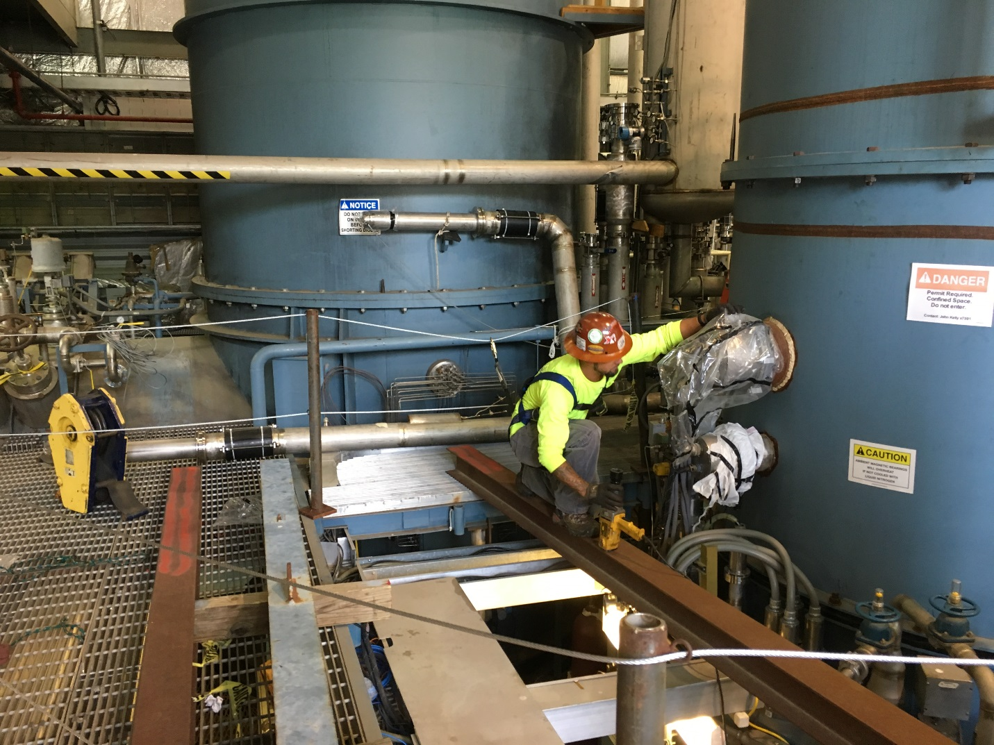

**Immediate Lesson Learned:**

If the planned work goes beyond that as described in the approved lift plan, then additional planning, hazard analysis, and perhaps work control documentation is required.

When working from heights, involving the SME in the planning process is critical to developing a thorough work plan.

Report Due Date:

August 25, 2017