# Zeroing MKS Network MFCs

From a Windows computer on one of the Hall B subnets with LabVIEW 2019 installed run the following VI: O:\hallb_eng_open\LabVIEW\MKS\Example.vi

It will look like the following when opened:

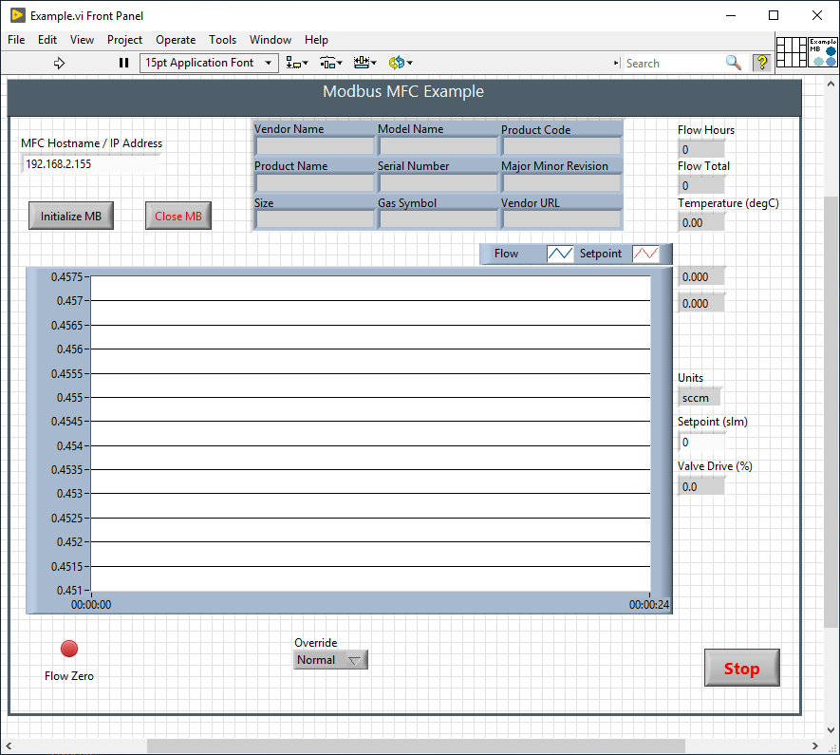

There is also O:\hallb_eng_open\LabVIEW\MKS\Multiple MFC Zero.vi which allows zeroing multiple MFCs at the same time, the procedure is the same (except no graph on step 3 and no step 8).

Prior to running the VI close the valve(s) up/downstream of the MFC being zeroed

At least one valve before/after the MFC must be closed to positively stop the flow.

1. Run the VI (click the “Play” button or Ctrl+R)
2. Enter the hostname or IP in the text field
3. Click the “Initialize MB” button
   1. At this point the MFC information fields should be populated and the flow graph is updating
4. On the “Valve Override” dropdown select “Open”
   1. The flow will probably spike up while the pressure/flow equalizes
   2. Allow enough time for the flow to stabilize
5. On the “Valve Override” dropdown select “Close”
   1. The flow might change, as long as this value is small proceed to step 6, otherwise go back to step 4
6. Click the “Flow Zero” button
   1. Wait for the flow to stabilize
   2. Generally a slightly negative number is preferable to a positive one as to not affect the flow total counter
   3. This step can be repeated multiple times if necessary, or go back to step 4
7. Set “Valve Override” back to “Normal”
8. Click the “Close MB” button
   1. If another MFC is to be zeroed click the button again and go to step 2
9. Click the “Stop” button

# List of MFC Hostnames (as of 2019-11-21)

* DC – located in the Gas Shed
  + hb-mfc-dc-ar-1
  + hb-mfc-dc-co2-1
  + hb-mfc-dc-ar-2
  + hb-mfc-dc-co2-2
* LTCC – located on the Forward Carriage
  + hb-mfc-ltcc-s1 [currently not connected]
  + hb-mfc-ltcc-s2
  + hb-mfc-ltcc-s3
  + hb-mfc-ltcc-s4 [used for return to buffer tanks, located in GS]
  + hb-mfc-ltcc-s5
  + hb-mfc-ltcc-s6
* HTCC – located on the HTCC cart
  + hb-mfc-htcc
* SVT – located on the SVT cart
  + hb-mfc-svt
* MVT – located on the Gas Pad
  + hb-mfc-mvt-ar-1
  + hb-mfc-mvt-c4h10-1
  + hb-mfc-mvt-cf4-1
  + hb-mfc-mvt-ar-2
  + hb-mfc-mvt-c4h10-2