**Radio Isotope target**

The target assembly for the radio isotope production is quite strait forward; the electron beam will be defocused and rastered onto a Tungsten plate which acts a vacuum break between a 10 cm cylinder of liquid Gallium. The cylinder is essentially submerged in a bath of Low Conductivity Water (LCW) that is stabilized to 35C (Gallium melting point is ~29C) (figure 1)

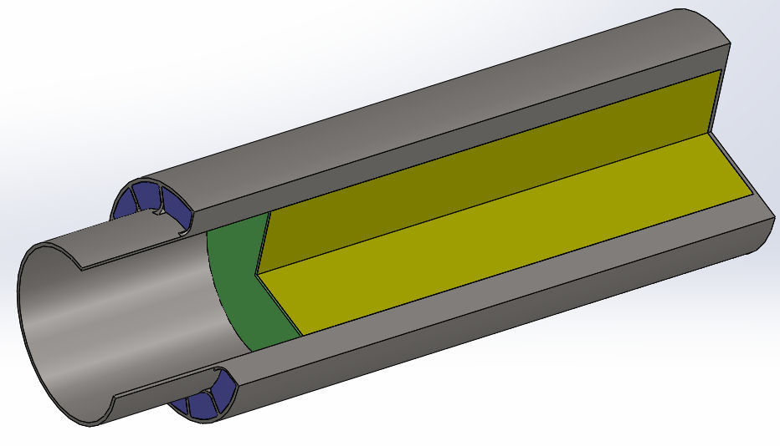

Figure , Gallium Loaded Target (Green is W, Yellow is Ga, Blue is H2O)

The accelerator beam tube is 75mm diameter. A closed cylinder will be constructed with supply & return lines for cooling water. There will be 12 stainless steel ‘fins’ (0.065” thick) welded to the outside of the inner tube, these act as guides for the water and do not need to be attached to the outer cylinder. There are six water supply lines and six return lines, each of these straddle two channels. The Gallium is fed into the lower fitting on the bottom of the rear plate and the top fitting allows the target chamber to vent while filling (figure 2). There will be a small volume of inert gas to allow for the thermal expansion. The fill and drain valves will be fitted with remotely controlled electric/pneumatic ball valves. The total volume is XXX, while the thermal expansion will be XXX cc. Please note that the enclosure is all welded stainless steel and there are no exposed copper gaskets.

The LERF has an isolated water cooling system located the accelerator vault that has sufficient cooling capacity; it is rated for the full recirculated power of 100kWatt. This “Dump Water Skid” has it’s own recirculation pump, monitoring system, resin bed, and a parallel plate heat exchanger to the normal LCW system.

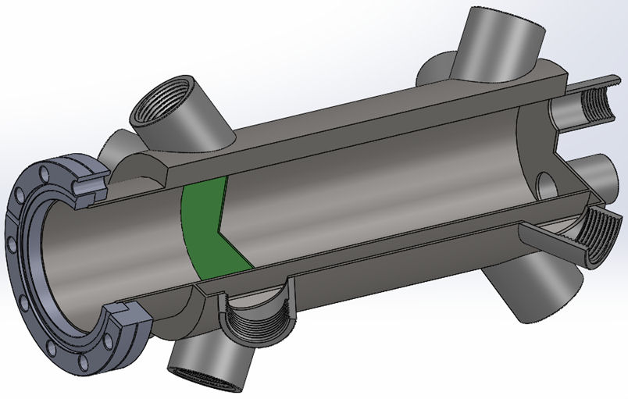

Figure , Cut-a-way view of Ga target chamber

Thermal modeling was done using Comsol Ver. X.X. The inputs to the model were to give a worst case; assume 50 kilowatt dissipated power, no rastered electron beam with a top-hat spot 16mm, and no convection currents in the Gallium. The water flow was set to a total flow of 2.3 liters/minute. The maximum temperature was found to be 62C.

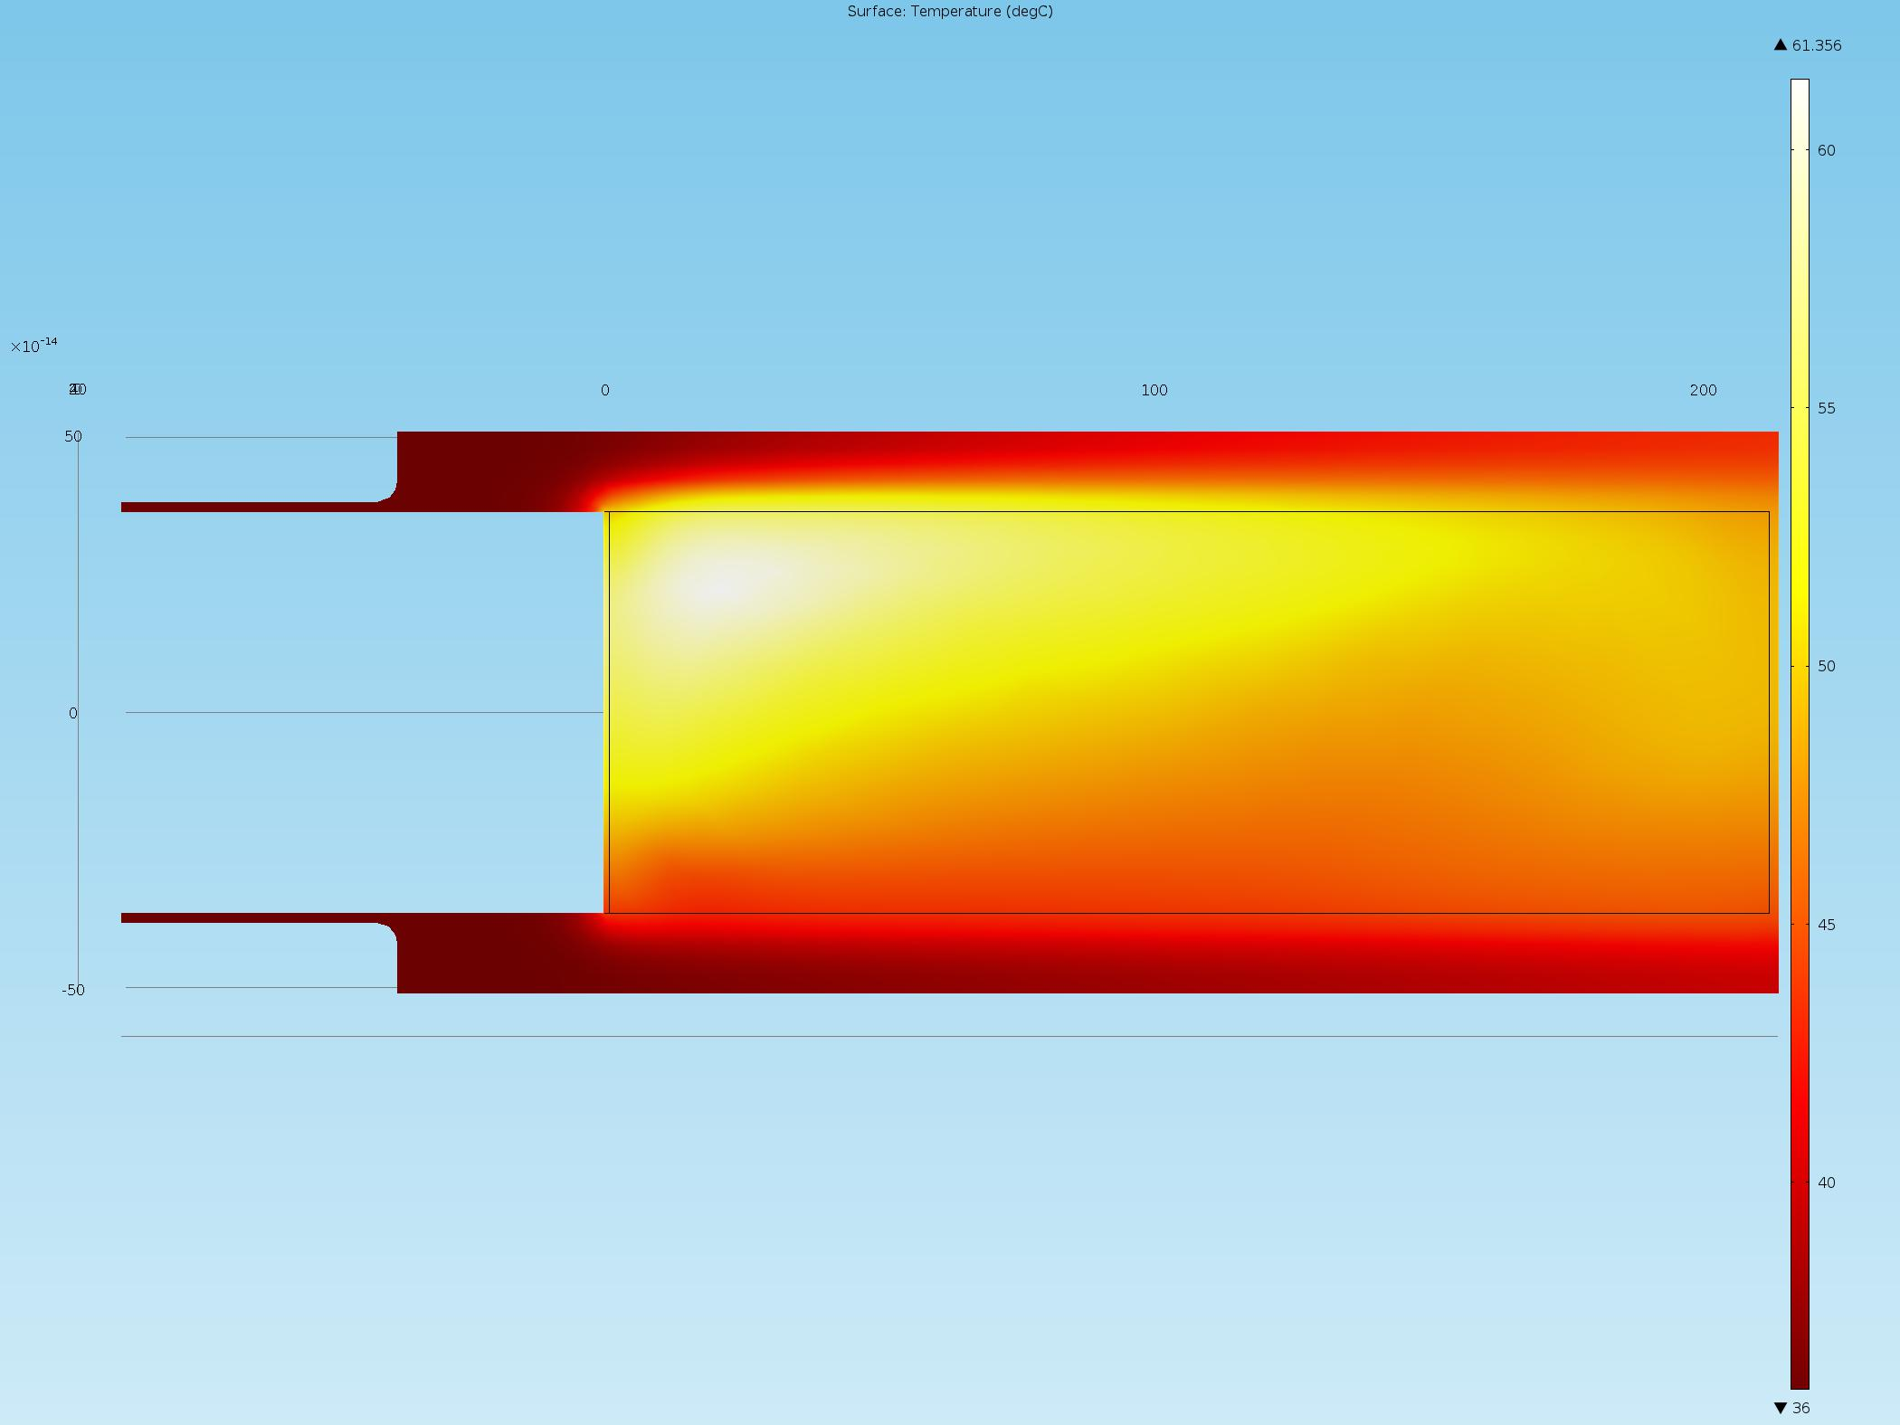

Figure , Thermal modeling showing steady-state temperature rise of XXX

Once the exposure is complete, the load of Gallium will be gravity fed to a container located inside of a shielded “pig”. There will be remote monitoring via video camera. As the Gallium is drained out, the chamber will be back-filled with inert gas. Once the draining is complete the “pig” with the load of Gallium will be remotely lowered and a cover placed on top. A small rail system, that terminates on a removable dolly, is envisioned to enable ease of retrieval of the shielded pig & Gallium to minimize the exposure and easy of exiting the vault.