**Outline**

Isotope Production at the Jefferson Lab LERF Facility Lead Responsibility

1. Executive summary Neil

A concise presentation of the key conclusions.

1. Introduction and background
   1. LERF Facility Description Neil

Most of this exists from previous proposals

* 1. Operating Costs Benson (Neil)

This will summarize operating costs under full cost recovery for LERF

* 1. Isotope Market Wells
     1. 67Cu

Updated market estimates projecting need. This is expected to come from existing reports and updated from recent meetings.

1. Isotope Physics and Conversion Rates Degtiarenko
   1. 67Cu

This section will summarizes results from analysis covering production rates of desired isotopes as a function of incident beam power, optimum energy, production of “contaminant” undesired isotopes and any other practical considerations in the optimization of the physics. Most of this will be a text presentation of what we have seen in ppt form already.

1. Separation, Purification Zweit
   1. 67Cu

This covers the separation process required for each isotope, the cost of that process, and (if required) the cost and process for reconstituting and returning the target for the next run. It should also address the issue of purity in the process for contaminant isotopes.

1. Target Design Jordan
   1. 67Cu

This will present the preferred design of each target, and estimated cost to construct such a target, and the procedures for installing the target material, irradiating it, removing the target, and shipping it to VCU for separation.

1. Production Economics Neil
   1. 67Cu

This will summarize the economics and feasibility of the production of each isotope based on the cost of beam operation, removal and shipping of the target material, purification, and preparation for the next production. It should also cover practical considerations such as expected frequency of runs, compatibility with other programs, etc.

1. Summary and Conclusion Neil

This will wrap up the conclusions of the study summarizing the key points made in each chapter and finishing with an assessment of the viability of such a program.

Appendix A. Description of facilities and capabilities

A.1 Jefferson Lab Low-energy Electron Recirculating Facility Neil

B.1 Virginia Commonwealth University Zweit

C.1 South Dakota School of Mining and Technology Wells

**1.0 Executive Summary**

This document discusses the effort needed produce isotope at the existing Low-energy Electron Recirculating Facility (LERF) at JLab without major investment in construction. After study we have chosen 67Cu as an isotope of interest which may productively be produced from relativistic electron beams. We have determined that there is a unique opportunity to take advantage of the high average power capability of the facility by using a target/beam dump containing liquid gallium after a tungsten radiator. An advantage of this approach is the high power capability of the target material and since it does not evaporate at any reasonably achievable temperature, the target can be directly exposed to the electron beamline during irradiation. We have a conceptual design of the target and have identified the steps necessary to qualify and optimize this design. We intend to use water as a secondary cooling medium which will indirectly cool the gallium. At the end of an irradiation run the liquid gallium can be transferred into a container for transport to a chemical separation facility. Production rates of the desired isotope are high at 11 mCi available a day after irradiation per four hour exposure at 50 kW. We have estimated the total cost of production, and separation as $4700/mCi based on 10 runs per year. Fabrication costs of the reusable target chamber are modest at $$$$. The three collaborating institutions that prepared this report bring complementary skills to this effort: JLab provides expertise in accelerator technology including thermal and radiation shielding, SDSMT provides expertise in photo-nuclear reactions and radio-isotope production, MCI-VCU provides expertise in purification, isolation and determination of specific activity. We propose to perform a follow-on demonstration of this capability which would include beamline configuration, target engineering and fabrication, a production run of ~13 mCi of 67Cu, and separation of the material into a form which could be utilized by the medical and research community. The demonstration effort could be accomplished in less than a year and would be expected to answer any open questions regarding feasibility of this approach. Appendices A, B, and C discuss the capabilities of the collaborators in this effort.

**2.0 Introduction**

**2.1 Background**. High power (~100 kW) electron accelerators are well suited for the production of some important isotopes for medical and industrial applications. There are two methods to produce isotopes at electron accelerators: the first method is to directly irradiate the isotope target with the electron beam and the second is to generate bremsstrahlung photons which in turn irradiate the target. Direct irradiation with electrons deposits a great deal of energy in the target and photon conversion takes place in the isotope target. A large fraction of the electron energy goes into energy loss mechanisms that do not contribute to the production of photons. The second method, using a radiator generates photons in a material that is physically isolated from the isotope target and makes heat management less severe. Additionally, the isotope target could be much thinner (smaller by volume).

High energy bremsstrahlung photons are produced when the electrons from the accelerator encounter a target. For sufficiently high Z targets, a large fraction of the electron energy is converted into bremsstrahlung photons. While the photo-nuclear peak cross-sections are generally lower than proton induced reactions, the large widths of photo-nuclear resonant cross sections, in conjunction with the large flux of photons that can be produced by high power (100 kW) electron accelerators, enables high yields by photo-production. That is, yields are proportional to the integral of flux and cross section. In addition, the high penetrating power of photons enables much thicker targets than proton targets, which further boosts photo-nuclear yields, and alleviates some of the heating and corrosion issues encountered in high power density proton beams. In the sections below we discuss the capability of the LERF facility, and review the research and medical needs for isotopes of interest. Chapter 3 continues with estimates of 67Cu isotope production rates in our beam. We then discuss the methodology for separation of the isotope from the target material in chapter 4. Chapter 5 presents a conceptual design of the target. In Chapter 6 we review the economics for production of 67Cu by our proposed method.

**2.2 LERF Capability** For the production of radio-nuclides at appreciably high activity yields, the average current of the photon-producing electron beam should be as high as achievable. The photon flux density should be as high as practical through an appropriate setting of the electron beam current. The Low-energy Electron Recirculating Facility (LERF) at JLab is a 170 MeV superconducting radio-frequency electron accelerator, tuneable in both energy and current, which can be easily optimized in beam current and energy for photo-production of radioisotopes. While it is capable of very high beam powers in energy recovery mode we will be sending the electron beam to a fixed target which limits the total beam power to under 100 kW. Figure 1 is a schematic representation of the facility for producing isotopes is shown in figure and Figure 2 shows the facility at JLab.

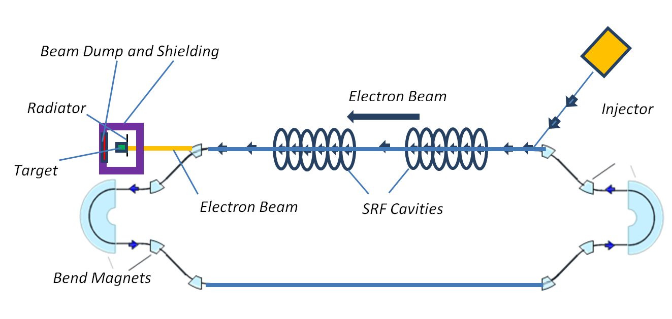

**Figure 2.1: Schematic layout of the isotope production at LERF**

The LERF injector can provide 6 mA of current. The 5 kW klystrons and the present 100 kW beam dump set the limit on energy and current though LERF is capable of producing nearly 200 kW of beam power. Figure 3 shows the maximum electron beam current capability for different energy settings. The klystrons and the beam dump could be upgraded for higher power operations in the future though we believe the existing capability provides a practical level of isotope production per run.

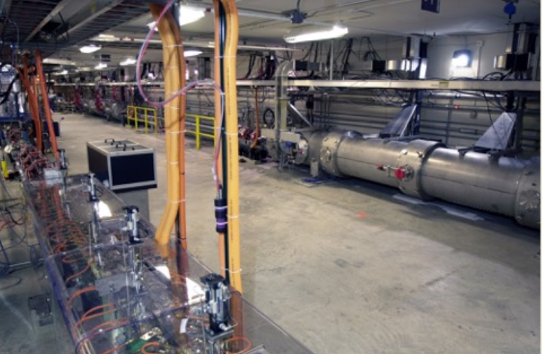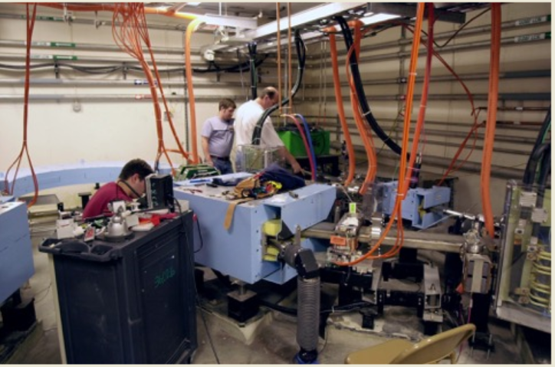

a) b)

**Figure 2.2: a) LERF accelerating section b) Location of the Bremsstrahlung and Isotope Targets**

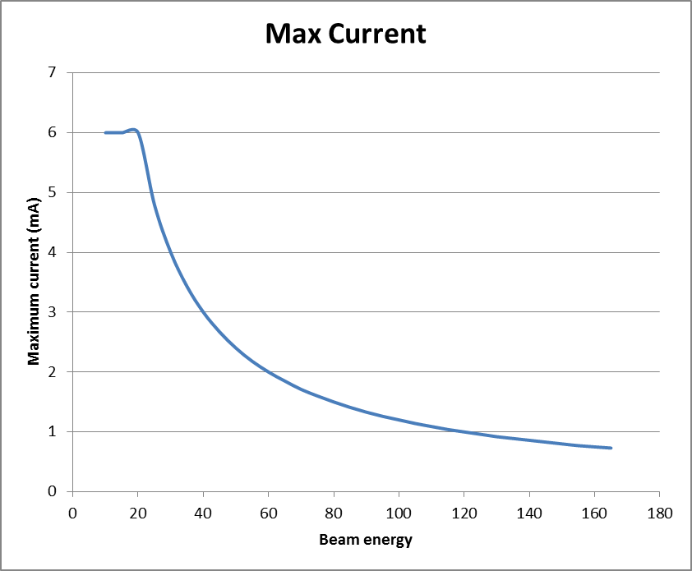

**Figure 2.3: LERF Electron beam fixed target current limit for given beam energies**

We examined those radio-nuclides that are favourable for photo-production and have been identified by either NSAC, DOE, or NIH as of interest [DOE 1999, NAS 2007, Rivard 2005, Pantaleo 2008, Harris 2008]. Nuclides that are of particular interest are those that are produced through other than photo-neutron reactions, e.g. (γ, p). The production of carrier-free species is more straightforward with (γ, p) reactions because the daughter is chemically different.

Copper 67 is attractive isotope for both therapy and imaging because it combines both beta and gamma emissions. It can be used to synthesize various compounds including small molecules and macromolecules. We propose producing 67Cu in gallium via the 71Ga(γ, p)67Cu reaction. The generic beamline at LERF will consist of the usual magnets and beam diagnostics elements. For isotope production the beamline will house a target system which does not exist. Reasonable yields of isotopes (~10s of μCi/g.hr or ~mCi/g.hr) require kWs of beam power. Our analysis has indicated specific isotopes which could be optimally produced in a facility such as LERF. We discuss those below as well as the target design and cost of implementing a demonstration of this production capability.

The bulk of the capital cost of the LERF facility was provided from contracts with ONR and grants from the Commonwealth of Virginia. The system is presently in operational condition in energy recovery mode having been brought to this state of readiness in preparation for a spring 2016 PAC-approved experimental search for dark matter called DarkLight. The operating cost of the LERF is well documented through its previous use in CRADAs and WFO activities as $3076 per hour direct cost for FY16. We estimate that it will take 4 hours to set the machine up for proper irradiation for each run at 40 MeV and 1.25 mA average current. After that point the production rates of the desired isotope will be as projected in the chapter that follows: 13 mCi per hour of beam a day after shut down.

In addition to machine setup time there will be labor involved to put the target in position and to remove it, assay it, and pack and document it for shipping for separation. Shipping costs have been determined to be $3000 per shipment via common carrier with approved radioactive material handling permits.

**2.3 Isotope Market**. The demand and shortfall in supply of radioisotopes for nuclear medicine, for national security applications, and for many other applications in research and industry is enormously important because of its critical impact on each of these endeavours. It is extremely important to note that a shortage of radioisotopes is the fundamental limiting factor in many biomedical research programs that endeavour to exploit advances in molecular biology for targeted treatment with radioisotopes, as noted by both the National Academy of Sciences and the national Nuclear Science Advisory Committee [NAS 2007, NSAC 2015]. Applications of isotopes in research and medicine is a multi-billion dollar industry that serves nearly 20 million Americans each year in nuclear medical procedures, and serves an essential function in the nation’s nuclear security and nuclear research. Despite this, for many isotopes the nation’s supply of research radioisotopes is overly reliant on too few facilities and too few processes to provide adequate quantity and reliability of the supply [ANS 2004, DOE 1999, NAS 2007, Rivard 2005, Pantaleo 2008, Harris 2008]. Moreover, the training of students and development of ‘human capital’ in nuclear sciences relevant to isotope production and nuclear medicine is lagging well behind the nation’s need [NAS 2007].

These numerous reports extensively document the national need for research radioisotopes, especially for beta/gamma emitters that enable synchronous imaging and therapy, such as 67Cu, and alpha-emitters that enable research cellular-level, targeted molecular treatment of a variety of diseases, such as 225Ac. Despite these needs, no robust sources for these research radioisotopes and many others exist today in the United States. Nuclear medicine and bio-medical research are perhaps the most critically-sensitive users of radioisotopes because of the large number of patients involved and the short half-lives of most medical isotopes. Nuclear medicine in the U.S. continues to be an important part of non-invasive disease diagnosis and treatment. Despite the enormous positive impact that nuclear medicine has had on improving patient care, major gains are not only possible, but thought to be highly probable if adequate radioisotope supplies were available. In response to a congressional request, the National Academy of Sciences (NAS) issued a major report and recommendations on “Advancing Nuclear Medicine through Innovation” [NAS 2007] where they point out that the age of “personalized medicine” is emerging where new advances in molecular biology and pharmaceutical sciences can be wed to nuclear techniques and radio-nuclides to specifically target unique individual medical profiles. The creation of new isotopes for medical research would enable further advances in these biomedical sciences.

We propose to partially address the pressing national need of research radioisotopes, especially 67Cu and 225Ac, by investigating photo-production using photo-nuclear reactions induced with bremsstrahlung photons from high-power electron linacs. We propose to investigate the production of useful quantities of radioisotopes using photonuclear reactions, such as (, α), (, n), and related reactions, as well as to investigate (, fission) and electro-excitation (virtual photo-reactions) for their isotope production potential.

Historically, (, x) reactions have not been exploited for isotope production because of the difficulty of achieving useful specific activity (SA), although the technique is well-known to be capable of production of large quantities of total activity, and to be practical for many other applications [see Segebade 1988 and references therein]. However, all photo-nuclear reactions with charge-particle, exit-channel products enable, in principle, post-irradiation separations and subsequent high specific-activity products. In addition, there are important implementation advantages to adding electron accelerators to the U.S. portfolio of isotope production facilities. Electron beam accelerators are substantially simpler to operate, much cheaper, and carry far less of a regulatory, safety and environmental burden than do nuclear reactors. Such a source would further ensure better access to isotopes throughout the U.S. and a more reliable domestic supply of short-lived isotopes.

**References**

[ANS 2004] *U.S. Radio-isotope Supply: a Position Statement*, America Nuclear Society, 2004.

[DOE 1999] *Forecast of the Future Demand for Medical Isotopes*, DOE, 1999.

[Harris 2008] T.J.R. Harris, J.D. Kalen, J. Hall, *Report of the Meeting Held to Discuss Existing and Future Radionuclide Requirements for the National Cancer Institute*, April 30, 2008, SAIC report to the National Cancer Institute, 2008.

[NAS 2007] *Advancing Nuclear Medicine Through Innovation*, National Academy of Sciences, 2007.

[Pantaleo 2008] J. Pantaleo, The *Nation’s Needs for Isotopes: Present and Future*, Presentation to the Joint NCI-DOE Workshop on Isotope Needs, August 3-7, 2008.

[Rivard 2005] M.J. Rivard et al., *The U.S. National Isotope Program: Current Status and Strategy for Future Success*, J. Applied Radiation and Isotopes, **63**, 157-178, 2005.

[NSAC 2015] NSAC, *Meeting Isotope Needs and Capturing Opportunities for the Future,* The 2015 Long Range Plan for the DOE-NP Isotope Program, NSAC Isotopes Subcommittee, July 20, 2015.

[Segebade 1988] C. Segebade, H.- P. Weise and G. J. Lutz, *Photon Activation Analysis*, Walter de Gruyter, B

1. **Isotope Physics and Conversion Rates**

We propose producing 67Cu in gallium via the 71Ga(γ, α)67Cu reaction. Gallium has the melting point of 29.8 °C and the boiling point of 2204 °C. This makes it possible for a gallium target to absorb significant electron beam power without destroying, or evaporating the target.

The proposed irradiation setup consists of an electron beam incident on a 1mm-thick tungsten radiator followed by a thick (10 X0 ~ 21cm) liquid 71Ga target. In the case of 71Ga unavailability, natural gallium target can be used.

The cross section of the 71Ga(γ, α)67Cu reaction is significant above 15.1 MeV, which is the sum of the binding energy of alpha particle in 71Ga Qα=5.3 MeV and its Coulomb Barrier Bα=7.8MeV [1]. Figure 3.1 presents the evaluated cross section of this reaction [2].

**Figure 3.1. Cross section of 71Ga(γ, α)67Cu [2].**

We used FLUKA [3] to calculate 67Cu yields in gallium. Results are generally in good agreement with TENDL-2014 data. However, there are discrepancies between both FLUKA and TENDL-2014 and the cross sections reported by Antonov *et al.* [1] and Segebade *et al.*[4].

Jefferson Lab’s Low Energy Recirculator Facility (LERF) can deliver 50 kW electron beam power in a stable manner. Calculated yields of 67Cu for 40 MeV and 100 MeV electron beams at this power in thick 71Ga and 20 MeV, 40 MeV, and 100 MeV in natural gallium (69Ga – 60.1%, 71Ga – 39.9%) targets are presented in Table 3.1.

Total induced radioactivity in the targets is also considered. Table 3.2 lists half-lives and activities of all notable radionuclides 1 day after a 1 hour-long irradiation by 50 kW beam.

|  |  |  |  |
| --- | --- | --- | --- |
| **Target** | **67Cu Production (mCi/h/50kW)**  **Ee- = 20 MeV** | **67Cu Production (mCi/h/50kW)**  **Ee- = 40 MeV** | **67Cu Production (mCi/h/50kW)**  **Ee- = 100 MeV** |
| **71Ga** | **10** | **43** | **53** |
| **Natural Ga** | **4** | **17** | **22** |

**Table 3.1. Yields of 67Cu per 50 kW beam in thick 71Ga and natural gallium targets calculated using FLUKA.**

|  |  |  |  |  |  |  |
| --- | --- | --- | --- | --- | --- | --- |
|  | | **71Ga** | | **Natural gallium** | | |
| **Nuclide** | T1/2 (h) | **A (mCi)** 1 day after 1 hour irradiation Ee-=40MeV | **A (mCi)** 1 day after 1 hour irradiation Ee-=100MeV | **A (mCi)** 1 day after 1 hour irradiation Ee-=20 MeV | **A (mCi)** 1 day after 1 hour irradiation Ee-=40 MeV | **A (mCi)**  1 day after 1 hour irradiation Ee-=100MeV | |
| **72Ga** | 14.1 | 61 | 81 | 16 | 55 | 72 | |
| **67Cu** | **61.8** | **33** | **41** | **2.7** | **13** | **17** | |
| **69Zn** | 0.9 | 17 | 41 | 0.1 | 7 | 17 | |
| **69mZn** | 13.8 | 16 | 38 | 0.1 | 7 | 16 | |
| **67Ga** | 78.2 | < 0.05 | 31 | 2.3 | 407 | 559 | |
| **64Cu** | 12.7 | < 0.05 | 21 | < 0.05 | 106 | 165 | |
| **66Ga** | 9.5 | < 0.05 | 5 | < 0.001 | 1 | 23 | |
| **Total** |  | **127** | **258** | **21** | **596** | **869** | |

**Table 3.2. Activities of notable radionuclides 1 day after a 1 hour-long irradiation of thick 71Ga and natural gallium targets by 20 MeV, 40 MeV, and 100 MeV, 50 kW beams calculated using FLUKA.**

**References**

1. A.D. Antonov *et al.* Sov. J. Nucl. Phys. **53** (1) 1991
2. A.J. Koning *et al.* ”TENDL-2014: TALYS-based evaluated nuclear data library”, <ftp://ftp.nrg.eu/pub/www/talys/tendl2014/tendl2014.html>
3. A. Ferrari, et al., "FLUKA: a multi-particle transport code" CERN-2005-10, INFN/TC_05/11, SLAC-R-773 2005
4. C. Segebade, H.-P. Weise, G.J. Luts, “Photon Activation Analysis”; De Gruyter 1988

**4. Isotope Separation and Purification**

**4.0 Separation, Purification**

The photo-production process generally converts a very small amount of target material to the radio-isotope, as little as nano-grams of radio-isotope per gram of target. The chemical separation methods must therefore account for separating nine orders of magnitude difference in mass and corresponding dilution, while protecting without loss or contamination, the very small amount of radio-isotopic product. The challenges are significant to achieve contaminations low enough to provide radio-isotope high specific activities in the Curies/milligram range.

Following target irradiations at the JLab Electron Linear Accelerator (LINAC), radioactive targets will be delivered to the radiochemistry laboratory at VCU for processing. Target processing will be carried out inside lead shielded hot cell fitted with remote manipulators. By remote manipulation, the irradiated target material will be removed from the target holder and will be measured in a dose calibrator inside the hot cell to determine total radioactivity in the target. This total activity will contain not only the desired radioisotope, but also other co-produced radioisotopes. The target material will be first dissolved in the appropriate solvent and a small fraction (uCi) of the solution will be taken and processed for initial Gamma spectroscopy analysis. This will determine the identity of the isotopes induced in the target by their respective gamma ray emissions. Following radiochemical separation, gamma spectroscopy analysis will be repeated on the purified radioisotope product as well as the other separated isotopes to determine the efficiency of the purification method and quantify the radioactivity of all produced radio isotopes.

**4.1 Radiochemical separation of 67Cu**

The photonuclear production of 67Cu from 68Zn (γ,p) 67Cu reaction, using >99% enriched 68Zn metal, has been demonstrated by a number of groups (xxxx). Although useful quantities have been produced through this route, the specific activity of 67Cu is compromised by the production of stable Copper isotopes resulting from imperfect enrichment of 68Zn target as well as metal impurities.

Therefore, in this project we propose a new route for the photonuclear production of 67Cu from either natural Gallium or enriched 71Gallium by the 71Ga(γ, α) reaction. Initially, we will be pursuing the production from a natural Gallium target due to the prohibitive cost of enriched Gallium.

Photon irradiation of natural Gallium (Ga) target (60% 69Ga / 40% 71Ga) leads to the production of 67Cu by the 71Ga(γ, α) reaction as well as production of stable 65Cu by the 69Ga(γ, α). Using an enriched 71Ga target, the production of stable copper isotopes (63Cu and 65Cu), will be greatly minimized leading to significant increase in the specific activity of produced 67Cu.

The irradiation also leads to the production of Zinc (Zn) isotopes through (γ, xp) reactions. As a result the radiochemical separation of 67Cu must ensure not only separation from the Ga target, but also from other Zn impurities, and other trace metals (eg: Fe, Co etc,.) that could be induced in the container housing the liquid Ga target.

The radionuclide separation approach is a modified version of previously published methods (Kim et al, 2010 and Liu, 2015), used to separate 64Cu/67Cu from radioactive waste generated during the proton-induced production of 67Ga from Zinc target. We will employ a combination of solvent extraction and ion exchange chromatography to separate 67Cu from the liquid Ga target material and from other trace metals co-produced during the irradiation. The initial step will involve removal of the bulk Ga using isopropyl ether (IPE) solvent extraction in which Ga will be retained in the organic phase and 67Cu/Cu will remain in the aqueous phase. A second IPE extraction of the aqueous phase further removes residual Ga. The aqueous phase containing 67Cu/Cu will be evaporated to near dryness and redissolved in dilute HCl. The 67Cu/Cu activity will be extracted into dithizone phase, this organic agent has high selective affinity for Cu and not Ga, Fe or Zn. The 67Cu/Cu will be back extracted into an aqueous phase prior to ion exchange purification using CG-71 amberchrome column impregnated with dithizone. This chromatography step purifies the final product from traces of Ga, Fe and Zn. The scheme of its workflow is outlined below in Figure 4.1.

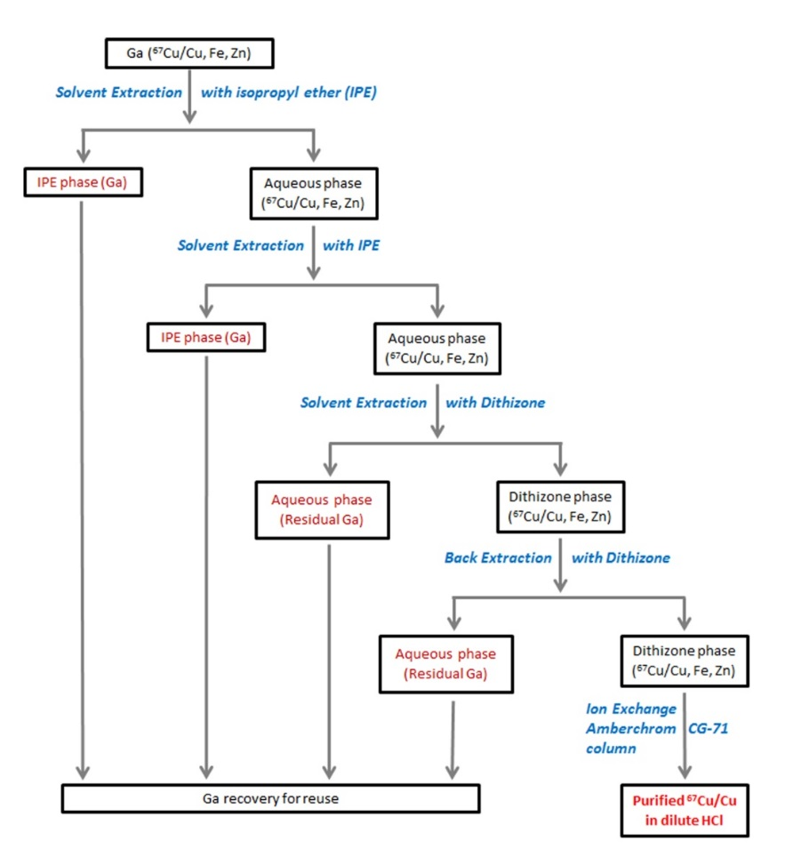

**Figure 4.1:** Schematic workflow showing the steps and processes involved in the separation of 67Cu/Cu from irradiated Gallium target.

**4.2 Radiochemical separation of 225Ac**

225Ac will be indirectly produced by 226Ra (γ,n) 225Ra, followed by beta decay of 225Ra to 225Ac. The separation of 225Ac from Ra is based on rare earth resin (RE resin) and nitric acid media (Apostolidis et al., 2005). The RE resin is made on silica gel support with enhanced radiation resistant compared to organic resin supports. Following irradiation, the Ra/Ac solution is loaded in 4 M nitric acid onto a UTEVA column. The radium is washed from the column while 225Ac is retained at this acid molarity. By reducing the eluent to 0.05 M HNO3, 225Ac is eluted from the column as the nitrate.

Recoil radionuclides need to be separated from the 225Ac product to avoid unnecessary damage to the healthy tissues. Nanocarrier encapsulation will be utilized to remove recoil nuclides, including those of Ra, Po and Pb.

**4.3 Radiochemical Analysis:**

*Gamma-ray and Alpha-ray spectroscopy*: High purity Germanium based Gamma spectroscopy (Ortec, USA) will be used to analyze the samples for radionuclide purity and to accurately measure absolute yields (<5 µCi) using detector efficiency calibrated for a range of gamma rays from 20 keV to 2 MeV. The measured activity will be extrapolated to the total volume of the purified isotopes and verified by dose calibrator measurements (mCi level). Similarly, CMI has access to an Alpha-ray spectroscopy system located within the campus, which will be used to characterize the 225Ac separation.

*Inductively Coupled Plasma Mass Spectrometry (ICP-MS)*: ICP-MS will be used to quantitatively measure stable isotopes of both the desired elemental isotope as well as other stable isotopes. These measurements will yield data on the amount of the trace isotopes produced as well as on trace chemical impurities.

*Specific Activity measurements and determination:* From the gamma spectroscopy and ICP-MS analysis, the specific activity of the purified isotope will be determined from these measurements.

**4.4 Cost for 10 separation runs**

**Category Item name Cost in USD**

*(a) One time expenditure* Remote manipulator arm cost/installation **$ 180,000.00**

DoT Type B transportation container TBD by JLab

*(b) Recurring costs* Target material and assembly TBD by JLab

Transportation of irradiated target to VCU TBD by JLab

*(c) Consumables* Glassware *$ 3500.00*

Chemicals *$ 2500.00*

Chromatography columns *$ 4500.00*

Hot cell supply lines and valves *$ 6500.00*

*(d) Personnel Time (planning, preparation, separation process and cleanup)*

Radiochemist *$ 7200.00*

Analytical Chemist *$ 5800.00*

Faculty salaries *$ 3000.00*

**TOTAL (c+d) $ 33000.00**

**Cost per run (total / 10 ) $ 3300.00**

References:

Apostolidis C, Molinet R, Rasmussen G, Morgenstern A. (2005) Production of Ac-225 from Th-229 for targeted α-therapy. Analytical Chemistry; 77: 6288–91.

Kim JH, Park H, and Chun KS. (2010) Effective separation method of 64Cu from 67Ga waste product with a solvent extraction and chromatography. Applied Radiation and Isotopes; 68: 1623–1626.

Cong Liu, (2015) Technique for radiolabelling tracers with 64cu for positron emission particle tracking (PEPT) experiments. Thesis presented in fulfilment of the requirements for the degree of Master of Science (Eng) at the University of Cape Town, South Africa.

1. **Radioisotope Target Design**

The target assembly for the radio isotope production is quite strait forward; the electron beam will be defocused and rastered onto a Tungsten plate which acts a vacuum break between a 10 cm cylinder of liquid Gallium. The cylinder is essentially submerged in a bath of Low Conductivity Water (LCW) that is stabilized to 35C (Gallium melting point is ~29C) (Figure 5.1).

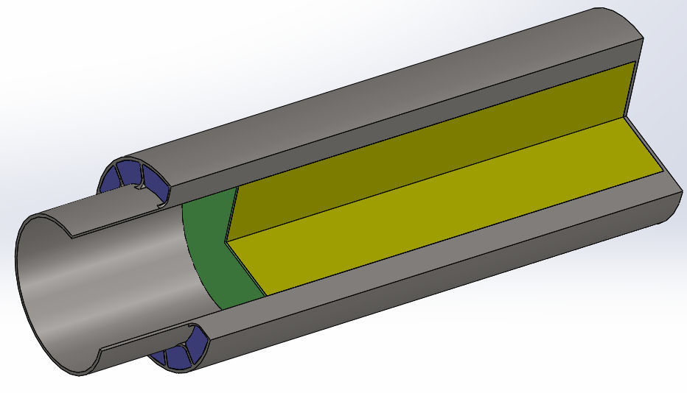

Figure 5.1. Gallium Loaded Target (Green is W, Yellow is Ga, Blue is H2O)

The accelerator beam tube is 75mm diameter. A closed cylinder will be constructed with supply & return lines for cooling water. There will be 12 stainless steel ‘fins’ (0.065” thick) welded to the outside of the inner tube, these act as guides for the water and do not need to be attached to the outer cylinder. There are six water supply lines and six return lines, each of these straddle two channels. The Gallium is fed into the lower fitting on the bottom of the rear plate and the top fitting allows the target chamber to vent while filling (figure 2). There will be a small volume of inert gas to allow for the thermal expansion. The fill and drain valves will be fitted with remotely controlled electric/pneumatic ball valves. The volume of the Gallium is 875.5 cm3, with a mass of 5.35kg, while the thermal expansion will be 0.3 cm3. The surface area (heat transfer area) is 481 cm2. Please note that the enclosure is all welded stainless steel and there are no exposed copper gaskets.

The LERF has an isolated water cooling system located the accelerator vault that has sufficient cooling capacity; it is rated for the full recirculated power of 100kW. This “Dump Water Skid” has its own recirculation pump, monitoring system, resin bed, and a parallel plate heat exchanger to the normal LCW system.

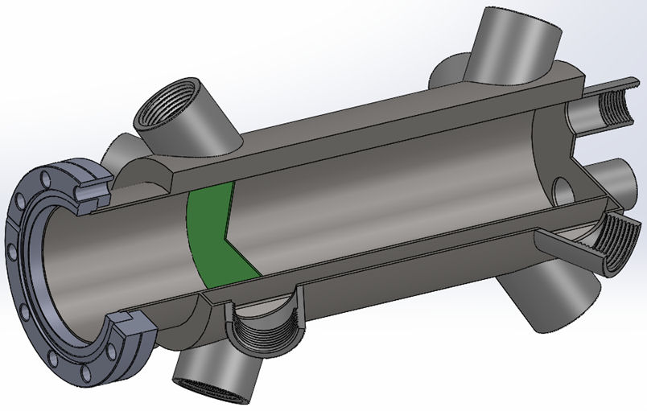

Figure 5.2. Cut-a-way view of Ga target chamber

Thermal modeling was done using Comsol Ver. 4.3b. The inputs to the model were to give a worst case; assume 50 kilowatt dissipated power, no raster on the electron beam with a top-hat spot 16mm, and no convection currents in the Gallium. The water flow was set to a total flow of 23 liters/minute. The maximum temperature was found to be 62C.

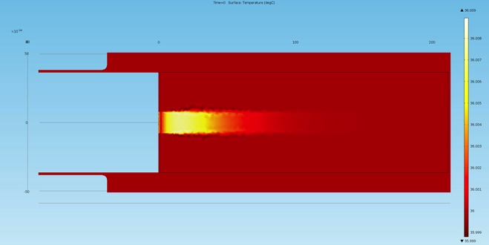 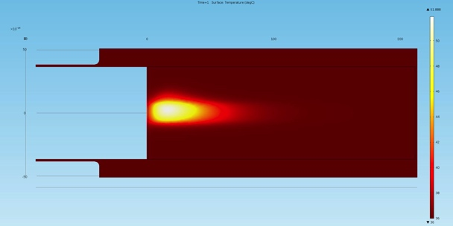

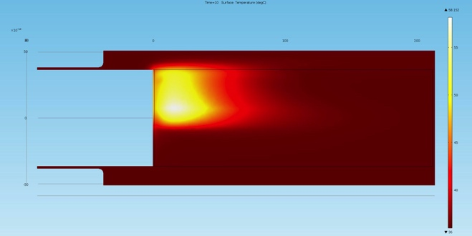 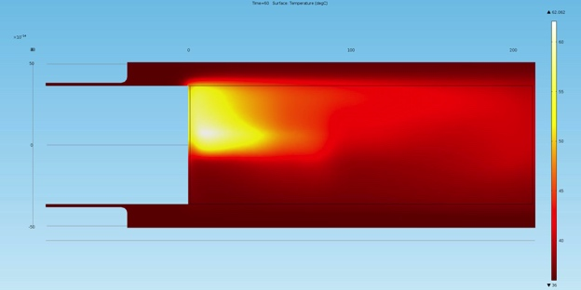

Figure 5.3, Thermal modeling showing heat transfer resulting in a temperature rise of only 6.2C

Once the exposure is complete, the load of Gallium will be gravity fed to a container located inside of a shielded “pig”. There will be remote monitoring via video camera. As the Gallium is drained out, the chamber will be back-filled with inert gas. Once the draining is complete the “pig” with the load of Gallium will be remotely lowered and a cover placed on top. A small rail system, which terminates on a removable dolly, is envisioned to enable ease of retrieval of the shielded pig & Gallium to minimize the radiation exposure to personnel and simplify exiting the vault.

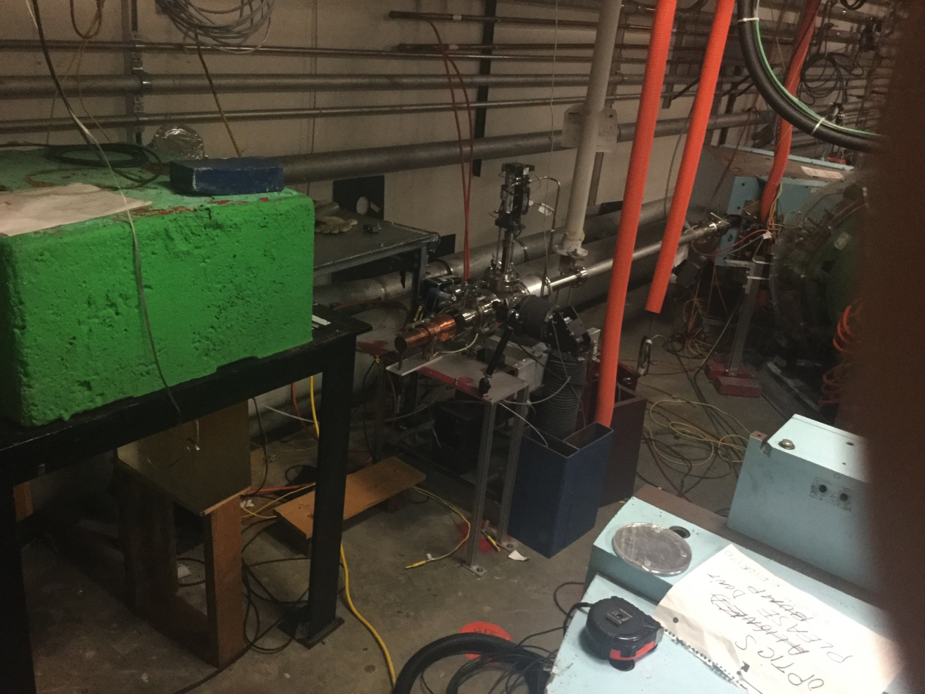

Figure 5.4. The target assembly will be located under the green shield block

Figure 5.5 shows the clear area that the Pig trolley will be located. There is 20” clearance between the bottom of the magnet & the floor. Once the trolley is clear of the magnet and affixed to the dolly, the Pig is now outside of the accelerator “loop”. The pig can now be wheeled out of the accelerator vault, without any other obstructions, to the elevator and to the LERF loading dock.

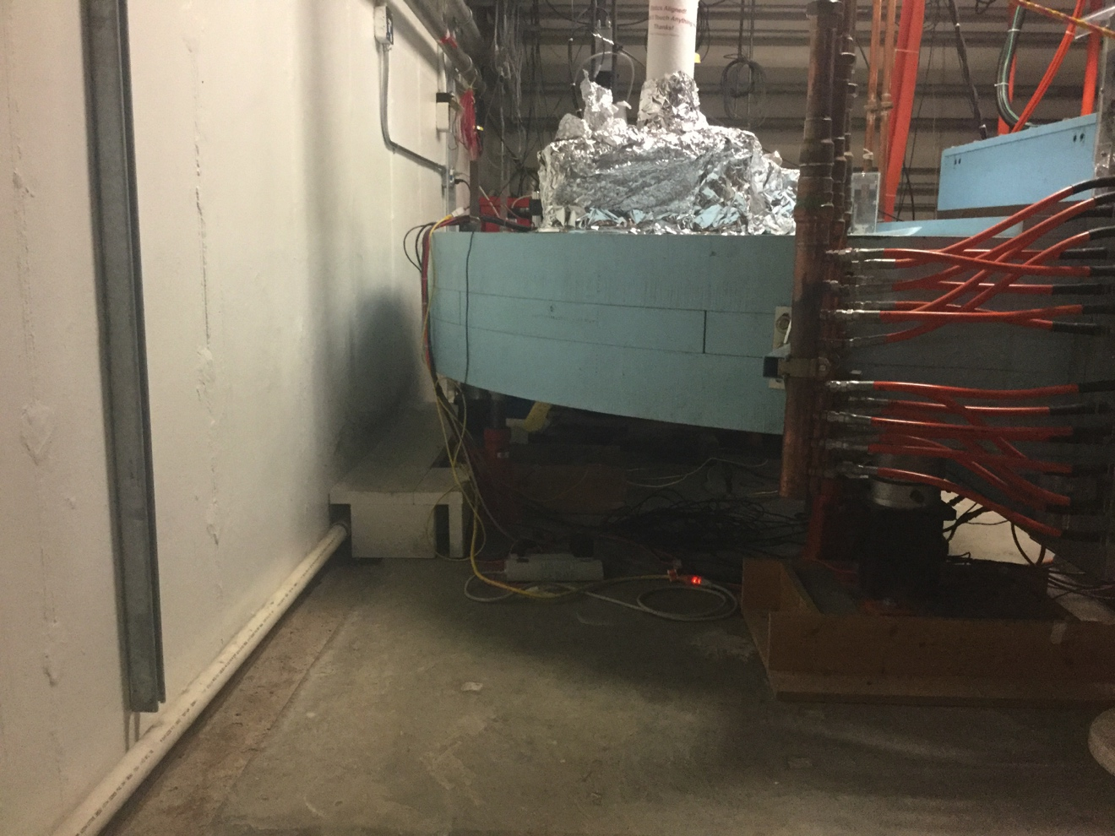

Figure 5.5. The trolley assembly will be located under the blue dipole

**6. Production Economics**

The production of 67Cu from a liquid Ga target using a high average power 20 MeV electron beam from the JLab LERF machine appears to be technically feasible. At 20 MeV the LERF facility can provide substantially over 100 kW of beam power if desired. We have chosen 20 MeV for the operating point because it minimizes the production of undesirable 64Cu. Utilizing a thin tungsten radiator before a pot of liquid gallium produces an efficient photon conversion of the Ga to 67Cu. Since Ga has a very low vapor pressure even at temperatures above 2000C we envision a windowless target system where the target becomes the beam dump. Heat deposited in the Ga will be transferred to a closed radioactive water cooling loop. Power on the target exceeding 50 kW appears feasible leading to production of 13 mCi of 67Cu measured one day after a one hour irradiation. The Ga-Cu liquid will be transferred to a shipping container and sent to VCU for chemical separation.

Economics of the process are shown in Table 6.1 The costs are based on an assumption of 10 production runs per year to amortize fixed costs. These are recurring costs based on FY15 DOE-approved rates for JLab and standard VCU rates but do not include one-time set-up or equipment costs. A fully burdened cost of $37.6k per run is estimated to produce 8 mCi of 67Cu resulting in a cost per mCi of $4702.



**Table 6.1 Recurring 67Cu isotope production costs based on 10 runs per year**

1. **Summary and Conclusion**

We have determined that production of 67Cu is technically feasible at the JLab LERF. Beam operating parameters are easily achievable and high production rates of the desired isotope are possible without producing large fractions of undesirable 64Cu isotope. This is achievable in a relatively short beam running time of 4 hours while operating at only 40% power capability. We have a conceptual design of a beam target which is easily capable of dissipating the desired 50 kW of beam power at 20 MeV

We have estimated the cost of production on the basis of 10 production runs per year with each run producing on the order of 8 mCi of product for a cost of $4.7k/mCi.

While these results appear sufficiently attractive to carry the effort forward to commercialization, there are a few open potential issues to resolve in a set of test runs.

1. The efficiency of the mass separation process is an estimate at the present time. We must chemically separate 10s of nanograms of copper from 5 kG of gallium.
2. Trace copper impurities in the gallium. Altough ultrapure gallium is available or can be produced the price is significantly higher for each “9” of purity. We would hope to be able to use bulk 99.99%pure material for the cost advantage but will need to determine the residual concentration of copper in this product.
3. The extent to which the copper will attach to the chamber walls is unknown. While other construction materials are possible we would prefer the ease with which a stainless steel chamber could be fabricated.

We propose carrying this effort forward with a set of demonstration runs to qualify our process and validate the economics. Appendix D gives a detailed description of the proposed effort including one-time engineering and fabrication costs as well as continuing per run production charges.

**Appendix A. Thomas Jefferson National Accelerator Facility (JLab)**

JLab has pioneered superconducting radiofrequency (SRF) technology for the lab’s CEBAF electron linear accelerator (linac) and has built up extensive experience of over more than a quarter century in the design, fabrication and operation of SRF electron linacs. It also pioneered SRF energy-recovery linac (ERL) technology for the lab’s high-average-power free-electron laser (FEL) [1]. In energy recovery, more than 90% of the beam power is recycled, which means that less than 10% of beam energy is deposited in a beam dump. The energy of the waste beam is therefore lower than the threshold for neutron production and the activation of shield components, thereby reducing both complexity and cost. This is inherently a greener technology.

ERLs offer superior beam characteristics well suited to isotope production. An Electron linac combined with ERL technology has a number of advantages:

* Electron linacs are reasonably simple devices to operate and maintain. A production facility could be run by a relatively small group of technicians.
* An electron linac is an inherently modular system. Upgrading the beam energy is simply a matter of adding more acceleration components as needed
* Electron beam energies can be ‘tuned’ to optimize production of a certain isotope.
* End of life decommissioning is simpler, cleaner and less costly than other technologies.
* Unlike a reactor, the machine could be powered down (instantly).
* Energy recovery means greater overall (wall plug) efficiency.
* Energy recovery allows a reduction in beam energies lost to beam dumps, to below the threshold of neutron production.
* Smaller machine footprint allows flexibility in the placement and location of production facilities

The first practical demonstration of high-power energy recovery in an SRF linac was in JLab’s IR Demo Free-Electron Laser (FEL) facility in 1999 . Since then, that FEL has undergone upgrades and expansions and is regularly run with energy recovery at a nominal beam energy of 150 MeV and 10 mA. For this proposal, we will limit our beam energy and current to 50 MeV and 5 mA respectively (and 100 kW maximum power though the plan is to run 50 kW of beam at 20 MeV).

Figure A.1 shows an ERL’s main components at JLab’s FEL. It begins with an injector, which provides the electron beam bunches, typically from a laser-driven photocathode. This beam is then accelerated by one or more SRF cavities. Typical accelerating gradients are 10–15 MV/m. The cavities are submerged in a helium bath within a cryomodule. The beam is steered and focused with magnets and beamline components until it is delivered to the target apparatus. In our case, the e-beam would pass through a converter, with around 99% of the beam passing straight through. Instead of sending this beam to a dump (and wasting its energy and causing activation), the spent beam is steered back through the cavities, 180o out of phase, so that it is decelerated and the energy returned to the RF structure, ready to accelerate the next bunch that passes through.

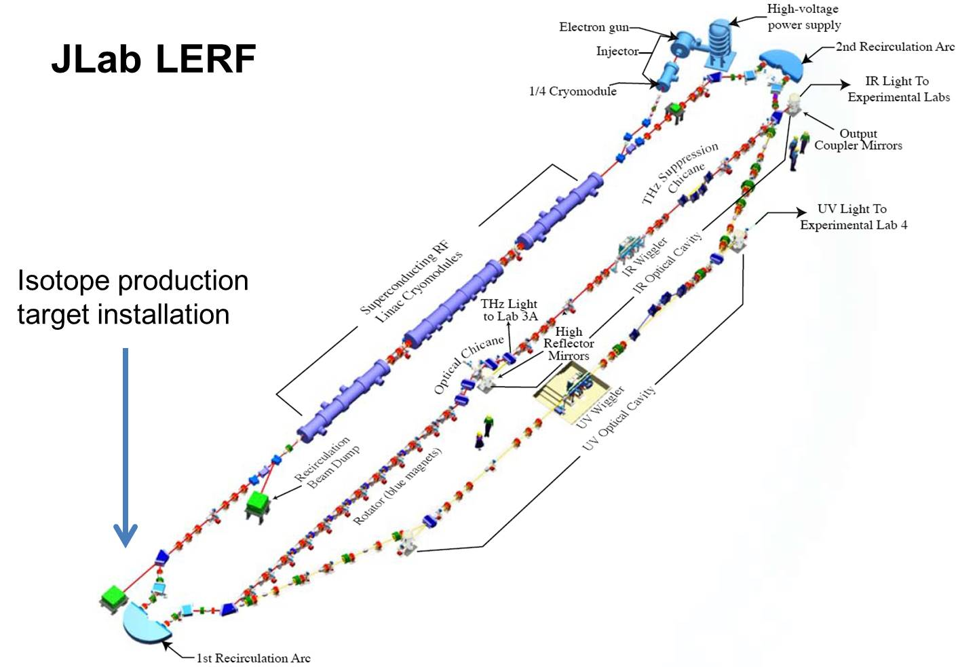

**Figure A.1. The LERF layout at JLab. Dimensions of the recirculation loop are 65 m × 6 m. For isotope production, the beam will not be recirculated and will use the straight line dump in the location indicated. Such installation will not interfere with other uses of the machine such as installation of the DarkLight NSF experimental search for dark matter.**

The heart of the ERL is the linac used for both acceleration and energy recovery of the electron beam. For energy recovery to be efficient the cavities need to a) have a high accelerating gradient to give maximum acceleration per unit length of linac, and b) have low inherent losses in the accelerating structure. This naturally leads to the use of SRF over normal conducting copper structures, as both maximum accelerating gradient and cavity losses are lower. There is of course the added cost of the associated cryogenic systems that are required, but many studies suggest that during operation lifetime of similar facilities the accumulated cost is significantly less. An srf system working in a CW mode is often the optimum solution for high average power electron beam production.

In the isotope production effort we will utilize a straight ahead beam dump in the location indicated in Figure A.1. Such a location is convenient for shielding and has the added advantage of non-interference with other projected uses of the machine. The dump area will require additional new shielding to deal with the 50 kW of beam incident at 20 MeV producing neutrons. (the existing energy recovery dump is designed for 100 kW of beam but at energies less than 10 MeV so no neutrons are produced).

JLab will utilize services of the Accelerator Operations Group to run the accelerator (this is the same group that runs CEBAF) for the isotope production. All accelerator operations will be directed from the CEBAF Machine Control Center. Handling of the radioactive materials will be through the Jefferson Lab Radiation Control Group who will review and monitor all manipulations of the radioactive target. They will also bear responsibility for packaging and shipping of the target material to VCU for chemical separation. A summary of the VCU facilities and capabilities is in Appendix B below.

**Appendix B. Virginia Commonwealth University**

**B.1 Description of facilities and capabilities**

Virginia Commonwealth University (VCU), located in downtown Richmond, Virginia is garnering an impressive status as a top urban research university and has an excellent intellectual environment that is ideally suitable for this proposal. Virginia Commonwealth University is a major, urban public research university with national and international rankings in sponsored research. The Virginia Commonwealth University Medical Center campus occupies approximately six square blocks in downtown Richmond, Virginia. VCU is a state-supported, Carnegie Extensive research institution and, as such, has a number of resources and research-based centers to support research endeavors. Building on a heritage of established strengths in clinical and translational research, VCU has established the Center for Clinical and Translational Research to enhance research infrastructure and promote collaboration. Within the university, the CCTR provides the necessary longitudinal and cross-disciplinary networking, culture, and infrastructure for identifying promising discoveries made in the laboratory, testing them in animals and developing trials and studies for humans. VCU has subscriptions to numerous journals in electronic and hard copy versions and also has a very good collection of books in its libraries.

**B.1.1 Hospital, Clinical Teaching and Research**: The Medical College of Virginia Hospital of the VCU Health System, the Fairfax Inova Hospital, and the McGuire Veterans Administration Hospital together with their associated outpatient clinics provide the clinical teaching sites for medical students and, together with the General Clinical Research Center and the Massey Cancer Center, the sites for clinical research studies.

1. **MCV Hospitals.** The MCV Hospitals are the teaching hospital component of the VCU Medical Center, which also includes a number of outpatient clinics and MCV Physicians, a 600-physician faculty group practice. The VCU Medical Center is a regional referral center for the state and has a Level 1 Trauma Center.
2. **Inova Fairfax**. Consistently ranking in the top 100 hospitals in the United States, the 753-bed Inova Fairfax Hospital has Northern Virginia’s only Level I Trauma Center for treating the most critically injured patients. The VCU School of Medicine has established an educational relationship with the Inova Fairfax Hospital to create the VCU School of Medicine Inova Branch Campus.
3. **McGuire Veterans Administration Medical Center**. The Hunter Holmes McGuire VAMC in Richmond, Virginia provides diagnostic and therapeutic services in medicine, surgery, neurology, rehabilitation medicine, spinal cord injury, psychiatry, and skilled nursing home care. This 703-bed tertiary care facility also serves as a major referral center for subspecialty treatment, open-heart surgery, heart transplant, vascular disease, oncology, and traumatic brain injury. Its ambulatory care activities provide a full range of outpatient services, including women’s health care. The VAMC maintains an intensive research program and provides administrative support, internal review and monitoring, and human studies oversight for all clinical trials.

**B.1.2 Massey Cancer Center.** VCU is the home of Massey Cancer Center (MCC), one of only 65 NCI designated cancer centers, striving to bring their discoveries from the laboratories to the bedside as quickly and safely as possible. MCC is central Virginia's most important resource for cancer research, clinical trials, and treatment, with an annual census of more than 1400 patients. In addition to its research activities, VCU Massey Cancer Center provides comprehensive, nationally recognized clinical oncology care, including a full range of medical and support services. More than 175 full, associate, and affiliate members from 28 academic departments, five schools and one college, come together at VCU Massey Cancer Center to conduct basic, translational, clinical and population sciences research to discover better ways to prevent, diagnose, and treat cancer. Research programs include developmental therapeutics, radiation biology and ontology, cancer cell biology, immune mechanisms, and cancer control. Moreover, the School of Medicine has a large vibrant group of investigators. This intellectual environment informs and inspires, and will contribute greatly to probability of success.

**B.1.3 Center for Molecular Imaging.** The Center for Molecular Imaging (CMI) is one of the VCU School of Medicine’s Research Centers. CMI was established in 2008 to foster and facilitate multidisciplinary molecular imaging and nanotechnology research using advanced non-invasive imaging technologies. The emphasis is on multi-modality imaging approaches to study, biology, biochemistry and pharmacology *in vivo*. Through these efforts, CMI provides a hub for translational research with basic and clinical scientists at VCU and beyond. The VCU Massey Cancer Center (MCC) is one of the centers that have imaging support provided by the CMI. VCU Massey Cancer Center is undergoing a major expansion of its cancer clinical research program. Through a focus on investigator-initiated therapeutic trials and the development of a clinical research affiliations network, the Center is extending its clinical trial offerings to patients across Virginia, helping to bring new drug discoveries to the state’s residents. Along with a dedicated wet laboratory and chemistry space, the CMI investigators have direct access, from within its radiochemistry laboratory, to a 16 Mev Proton GE PETtrace self-shielded Cyclotron (GE Healthcare) operated through partnership with IBA Molecular Inc, USA. The CMI investigators of this proposal have access to a preclinical work area with hot cells, radiochemical and chemical hoods, as well as mini-cells and associated work areas, all adjacent to the preclinical nuclear imaging facility (see below) located conveniently adjacent to the cyclotron and the radiochemistry laboratory in the Gateway Building. In addition, all investigators have access to the other shared resources and facilities maintained and professionally staffed by VCU.

**B.1.3.a 1Facilities and other Resources at the Center for Molecular Imaging in VCU**

1. **Radio-Chemistry, Nano Chemistry, Cell Culture and Molecular Biology Laboratories:** The CMI has three laboratories (362, & 430 SqFt) for molecular, cellular biology and biochemical studies in the Sanger Building and two laboratories (483 & 480 SqFt) for radiochemistry in Sanger and Gateway buildings. Two imaging suites are located one in the Gateway building will state-of-the-art PET/SPECT/CT and optical fluorescence imaging equipment and another in the Sanger Hall Building with 7 Tesla/30 cm horizontal bore Magnetic Resonance Imaging system, Multispectral Optoacoustic Tomography (MSOT) and a R4 microPET. Adjacent to the nano-chemistry laboratories in Sanger is an equipment room (255 SqFt) and a cell culture and fluorescent microscope room (139 SqFt). There is a walk-in 4C° room (200 SqFt), ice-maker, autoclave, photocopier, and a dark room with an automated X-ray film developer down the hall from the laboratory. The radiochemistry laboratory in Gateway building (480 SqFt) has seven hot-cells, three auto synthesizers and three HPLC systems in addition to basic equipment for SPECT (and PET) radiochemistry.
2. **Cyclotron Facility:** CMI has access to a **16 Mev Proton PET Trace Cyclotron** operated through partnership with IBA Molecular. Targetry for the production of O-15, N-13, C-11, F-18, Zr-89, as well as solid targets for the production of I-124, Mn-52, and other inorganic PET radionuclides, are available on this machine.

**(c) Radiochemistry Laboratory:** The radiochemistry laboratory has seven hot-cells, four auto synthesizers; three HPLC systems and HPGe gamma spectroscopy system in addition to basic equipment for SPECT and PET radiochemistry such as radio TLC etc. There is also a gas chromatography system that will be used for organic solvent analysis.

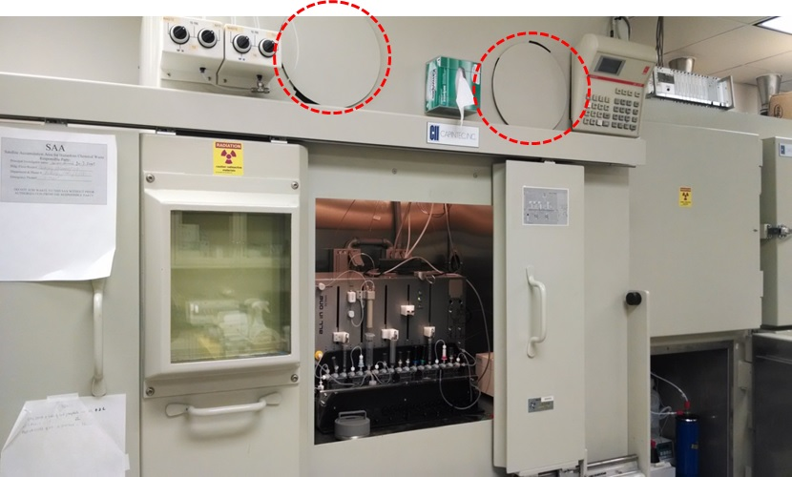

**Figure B.1:** The hot cell that will be used for isotope separation. The remote manipulator will be fitted through the access ports at the top.

**B.1.3.b Other Equipment at the Center for Molecular Imaging**

The laboratories house an automated Forma CryoPlus 1 liquid nitrogen freezer, one -80°C freezer, two upright -20°C freezers, five 4°C refrigerators, and an Eppendorf thermocycler. Two (large centrifuges with temperature control), four micro centrifuges, one with temperature control, electrophoresis systems for running DNA/RNA and protein gels. A gel documentation system is available as a shared resource adjacent to the laboratories. An Olympus fluorescent microscope with `Nuance system’ for multi-spectral imaging (Cri Inc, USA) and a Beckman Coulter multimode plate reader are also available within the PI’s laboratories. A phase-contrast microscope is also available for cell culture. The laboratory also has Mettler analytical and standard balances, a 37°C shaking incubator, one water purifiers, a sonicator, 2 BioRad western transfer apparatus, pH meters, microwave oven, a UV/Visible spectrophotometer, fluorescence spectrophotometer, and a variety of water baths, orbital shakers, vortex mixers, stir plates, pipettors, and vacuum pumps. The cell culture and microscope rooms house A2/B3 Biosafety cabinet, two CO2 water-jacketed incubators, a refrigerator for cell culture reagents.

**B.1.3.c Other Relevant Research Resources and Facilities at the CMI**

1. **Preclinical small animal imaging facilities:** The imaging suites of the Center for Molecular Imaging (CMI) are located in two adjacent buildings the Medical College of Virginia campus of Virginia Commonwealth University. The imaging equipment available with CMI can support multimodality molecular imaging of small rodents such as mice and rats.
2. **Animal Holding Rooms:** The CMI have separate animal holding rooms available next to the imaging facilities, which are approved to house animals injected with radioactive substances. Sufficient space for housing mice is available and includes cages with filter tops, laminar flow racks and biosafety cabinets to prevent the spread of infectious disease. Staffs provide animal care 365 days a year. Veterinary consultation services are readily available, as well as training and technical services regarding surgery and blood sampling.
3. **Computers:** The laboratory currently has 5 PCs with DVD/CD drives, and Ethernet connections to the VCU computer network for backup for storage and transfer of large image data files. These connections provide easy access to internet resources (database searches, e-mail, etc.). The laboratory has networked HP Laser Jet 4000 and 5200 black and white printers and also a HP laser color printer. The imaging facility has five PCs and necessary software to acquire, reconstruct and analyze the *in vivo* images.

**Offices:** Office spaces are available for the PI and other personnel adjacent to all laboratories. The CMI has secretarial support for administrative and fiscal management. Two meeting rooms (~400 SqFt each) adjoin the offices. All laboratory personnel are provided with their individual computers and access to internet at all times. Additionally, the laboratories currently have 8 PCs with DVD/CD drives, and ethernet connections to the VCU computer network for backup for storage and transfer of large data files. These connections provide easy access to internet resources (database searches, e-mail, etc.). The laboratories also have networked HP Laser Jet 4000, HP 5200 black and white printers and also a HP laser color printer. The imaging facility has five PCs and necessary software to acquire, reconstruct and analyze the *in vivo* images.

**Appendix C. South Dakota School of Mines and Technology**

SDSM&T’s relevant expertise and facilities lies nculear physics (especially photo-nuclear physics), and chemical and metallurgical engineering. The latter two departments and programs have extensive interests and capabilities in ultra-pure materials and the associated separations processes to enable such purity. Each of these areas of strength have associated faculty and facilities:

**Nuclear Physics**: SDSM&T 6 nuclear and particle physics faculty, of which 2 specialize in nuclear physics. Among the relevant nuclear facilities for radio-isotope production, purification and measurement are three facilities supportedled by SDSM&T in partnership with the nearby Sanford Underground Research Facility ( http://sanfordlab.org/science ) and several partnering universities. These include:

1) CASPAR (Compact Accelerator System for Performing Astrophysical Research): a low-energy particle accelerator housed a mile below the surface that will allow researchers to mimic nuclear fusion reactions in stars. It is called a compact system because it is a very small accelerator.

2) The MAJORANA DEMONSTRATOR: A complex, ultra-pure and ultra-low-background germanium detectors & shielding at the Sanford Underground Laboratory a mile below the surface in what we call a “Demonstrator Module.” The first half of the detectors will be fabricated from natural germanium, which is 7.44% 76Ge. Sheilding materials, including ultra-pure copper, are purified and manufactured at SURF to enable extreme purity and, therefore, extremely low background spectroscopy.

3) The Berkeley Low Background Counting Facility, recently re-located to a location a mile beneath the surface at Sanford Underground Research Facility, will enable extremely precise and low-rate radioactivity levels in materials from photo-production experiments. This low-background facilty is supported and complemented by surface HPGe gamma spectroscopy measurement capability.

**Chemical Engineering**: SDSM&T offers degrees up to the doctoral level in chemical or chemical & biological engineering. Research support facilities include:

1) Analytical Laboratory

a. FT-IR spectrometer with microscope

b. FT-IR spectrometer with Attenuated Total Reflection (ATR)system

c. Laser-Raman spectrometer

d. HP 6890 gas chromatograph

2) High Performance Computing Cluster (shared with the Physics Department)

a. 49 Nodes/568 CPUs Total

b. 2100-2600 MHz Processor Speeds

c. Software includes Accelrys Materials Studio, VASP, Gaussian, LAMMPS, Towhee, Etomica, CHEMKIN, and Comsol

3) Microscopy Laboratory

a. Scanning electron microscope with energy dispersive X-ray and image analyzer (SEM/EDX)

b. Transmission electron microscope (TEM)

c. Atomic force microscope (AFM)

d. Interfacial force microscope (IFM, one of a half dozen in the world)

4) Process Design and System Analysis Computer Laboratory

a. IBM RISC / 6000 workstations

b. AspenPlus model manager (steady state process simulator)

c. AspenPlus speedup (dynamic simulator)

d. HYSYS process (steady state and dynamic process simulator)

e. Personal computer laboratory (Gateway 2000 Multimedia Pentium computers)

f. HSC software

5) Process Control Laboratory

a. Camile 3000 controller and data acquisition system

b. Reaction and Separation Engineering Laboratory

c. Combustion synthesis reactor

d. Centrifugal combustion synthesis reactor

e. SHS reactor

f. Supercritical extractor

g. Supercritical equilibrium, and variable volume view cell

h. Supercritical reactor

**Materials and Metallurgical Engineering**: SDSM&T offers degrees up to the doctoral level in Materials Engineering and Science. Research support facilities include the Security Printing and Anti-Counterfeiting Technology (SPACT) Center for Security, a center that includes two other universities (University of South Dakota and South Dakota State University):

**South Dakota School of Mines and Technology**:

Direct Write Laboratory (DWL)

The DWL houses state-of-the-art digital fabrication equipment. Also listed are other major pieces of supporting equipment.

• Optomec Aerosol Jet Deposition System (DWL)

• Dimatix Ink Jet Printer (DWL)

• Sonotec, ExactaCoat Printer (DWL)

• PixDro/Trident Ink Jet Printer (DWL)

• HP Research Thermal Ink Jet Printer (DWL)

• Foster-Freeman Forensic Trace Evidence Analysis System

• MTS Nano XP Nanoindenter

• TA Instruments, Q100 DSC, Q800 DMA, Q400EM TMA

• Rame-Hart Contact Angle Goniometer

• BET Surface Area Analyzer

• Zeta Meter-surface charge analyzer

• Microtrack Laser Diffraction Particle Size Analyzer

• Kruss Surface Tensiometer and Viscometer

• Nima, Langmuir Blodgett Film Balance

Applied Electromagnetics and Communications Lab (AECL)

The AECL is used to simulate, construct, and measure electromagnetic devices, materials and antennas.

• Anechoic Chamber 0.7-67 GHz with DAMS-7000 Antenna Positioner

• Agilent E8361C PNA to 67 GHz

• Agilent 85071E Materials Characterization software; Workstation PC (96GB RAM, 4 NVIDIA GPU)

• 12 PCs with commercial simulation software (ADS, IE3D, CST MWS, MWO). LPKF C100 milling machine

• LPKF Multipress S to stack and laminate boards

• LPKF RS via electroplating system

Engineering and Mining Experimentation Station (EMES)

EMES is the largest campus support/multi-user facility, and contains a wide variety of characterization equipment.

• SEM – Zeiss Supra40 variable pressure field-emission SEM with an Oxford AZtec EDS and EBSD; Peltier-cooled (-30C to+50C) and heating stages (+1200C)

• TEM – JEOL JEM-2100 LaB6 transmission electron microscope with Oxford Inca EDS

• XRD – Rigaku Ultima-Plus X-Ray Diffractometer;

• MicroXCT – Xradia MicroXCT-400 high-res 3D X-ray microscope with tensile/compression stage (maximum load 500N

• Bruker MultiMode 8 AFM and STM

• Sonotec, ExactaCoat Printer

• Optomec Aerosol Jet Deposition System

• PixDro/Trident Ink Jet Printer

Also supporting SPACT is the South Dakota State University Department of Chemistry and Biochemistry has 21 full-time faculty 42 PhD and 3 MS students. Available equipment includes two Agilent HPLC instruments, two Agilent GCMS systems (one containing a robotic sampling system), a Gamry 600 potentiostat, multiple ion chromatographs and a Raman spectrophotometer.Instrumentation facilities maintained by the department include: a high-resolution mass spectrometry facility with two LCMSMS systems, pyrolysis, EI, CI or FAB sample ionization capabilities, ESI FTMS, and MALDI-TOF capabilities; high-resolution solution (400 MHz and 200 MHz) NMR spectrometers and two solid-sate NMR spectrometers (200 and 400 MHz) with variable-temperature CRAMPS probe constructed of fluorine-free materials (low 19F background); a spectroscopy lab with near-, mid- and far-IR capabilities including DRIFT and CIR, fluorescence and time-resolved fluorescence spectrometers, a UV-Vis spectrophotometer, and a variety of atomic absorption and ICP spectrometers. The Department of Electrical Engineering and Computer Science (EE&CS) has 22 faculty members, 35 MS, and 15 EE PhD students and 25 CS MS students. The department has two large cleanrooms, thin film deposition capability (ion beam assisted deposition, E-beam evaporation, thermal evaporation, sputter deposition, thermal evaporation, thermal oxidation, plasma enhanced chemical vapor deposition), thin film processing (rapid thermal processing, optical and electron beam lithography), surface profiler, steady state and lifetime fluorescence spectrometers, and nanofabrication and characterization capabilities. The Department of Sociology and Rural Studies currently has 10 faculty members, 20 PhD and 20 MA students, a computer lab with relevant quantitative and qualitative analysis software, houses the Rural Life and Census Bureau Center which provides access to relevant local and/or national demographic and census data, and sampling and surveying tools to assist research studies.

In addition the University of South Dakota (USD) faculty integral to SPACT occupy six separate laboratories: a complete laser laboratory with UV to NIR excitation and detection capabilities (625ft2 ); two laboratories devoted to materials synthesis, one with clean-room capabilities (500 ft2); a laboratory for controlled-atmosphere work and high-temperature crystal growth (300 ft2); a microscopy laboratory (150 ft2); and a dedicated computer lab (200 ft2). There are five dedicated fume hoods in the synthesis and crystal growth laboratories, each equipped with Schlenk lines and inert gas supplies.

Computing Facilities: USD operates a high performance computing (HPC) cluster comprising 744 processing cores and 70TB of shared network storage connected via gigabit Ethernet.

Major Research Equipment / Facilities include:

• Confocal Raman Microscope with Vis, NIR excitation (Horiba, Aramis)

• TEM (FEI Technai Spirit / 120 kV) and FE-SEM with EDX (Zeiss / Oxford)

• 400MHz NMR with High-Resolution Magic Angle Spinning (Bruker)

• Particle-size, zeta-potential analyzer (Zetasizer Nano ZS)

• Hyperspectral VIS-NIR microscope (Cytoviva)

• Atomic Force Microscope (Pacific Nanotechology)

• Single-crystal (Bruker axs – SMART APEX II) x-ray diffractometer

• Powder x-ray diffractometer with thin-film capability (Rigaku Ultima IV Powder XRD)

• Elemental analysis (Exeter – CE-440)

• Zeiss Scanning Electron Micrograph (SEM) with elemental analysis capability. Used for morphology and composition analysis of nanomaterials and structures related to security applications.

• Cytoviva Hyperspectral Microscope used to collected pixel-by-pixel spectral images for transmission, reflectance, or fluorescence. Used for spectral analysis of security print features or taggants.