# Appendix A: Preliminary Study – 225Ac production

LERF is a very configurable accelerator both in energy and current which makes it a suitable machine for Photoproduction of many isotopes. One of the isotopes of interest is 225Ac which may be produced via either 226Ra(γ,n)225Ra or 230Th(γ,n)229Th at energies lower than threshold of two-neutron production (E<~12 MeV). This is attractive because of low production of accompanying radioactivity, in both reactions. Our investigation of this isotope was cursory for two reasons, one, we wanted to focus on 67Cu and two, we were unable to locate a source of target material.

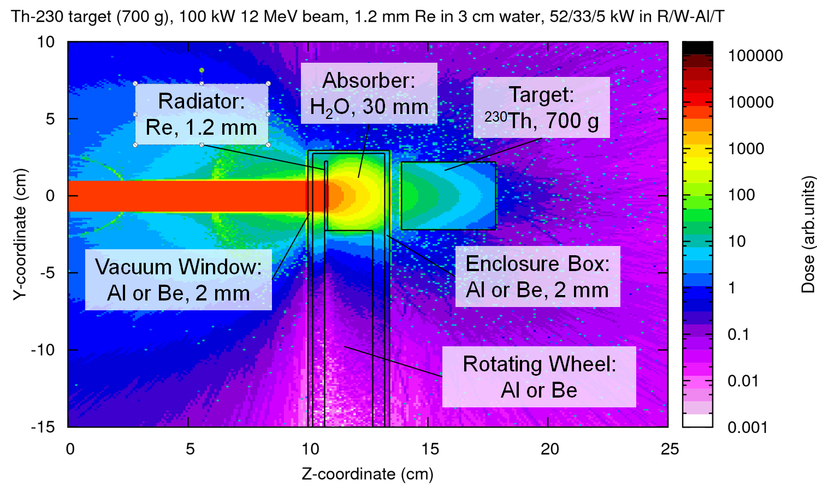

**Figure A.1 – Conceptual set up for 225Ac production**

We will briefly describe a likely path for 225Ac production using a beam power of 100 kW. One of the investigators (P.D) has a patent (US Pat.#8,334,523 B1) “Moving Core Beam Energy Absorber and Converter”. The concept is as follows: a ~1 mm thick radiator in shape a flat ring mounted on the internal rotating wheel, which is suspended in the flow of coolant (water). The radiator will be placed close to the beam entrance. The coolant will be of sufficient thickness to prevent most of the electrons from reaching the target, thus limiting the power on the target (Figure A.1). 230Th is attractive due to the large 230Th(γ,n)229Th cross-section, and low intrinsic radioactivity. According to FLUKA calculations, it would take about 500 hours of electron beam irradiation at 12 MeV, 100 kW, to produce approximately 1 mCi of 229Th in the target. After that the target becomes the sustained source of 225Ra (229Th half-life is 7880 years). It takes about 18 days to regenerate 1 mCi of 225Ac from 1 mCi of 229Th in equilibrium with 225Ra. The separation of 225Ac would follow fairly well established techniques. If the separation technique preserves both Thorium and Radium in the target, then such target may become a long-term operational factory producing 1 mCi of 225Ac every 2-3 weeks.