# Appendix A: Preliminary Study – 225Ac production

LERF is a very configurable accelerator both in energy and current which makes it a suitable machine for Photoproduction of many isotopes. One of the isotopes of interest is 225Ac which may be produced via either 226Ra(γ,n)225Ra or 230Th(γ,n)229Th at energies lower than threshold of two-neutron production (E<~12 MeV). This is attractive because of low production of accompanying radioactivity, both in both reactions. Our investigation of this isotope was cursory for two reasons, one, we wanted to focus on 67Cu and two, we were unable to locate a source of target material.

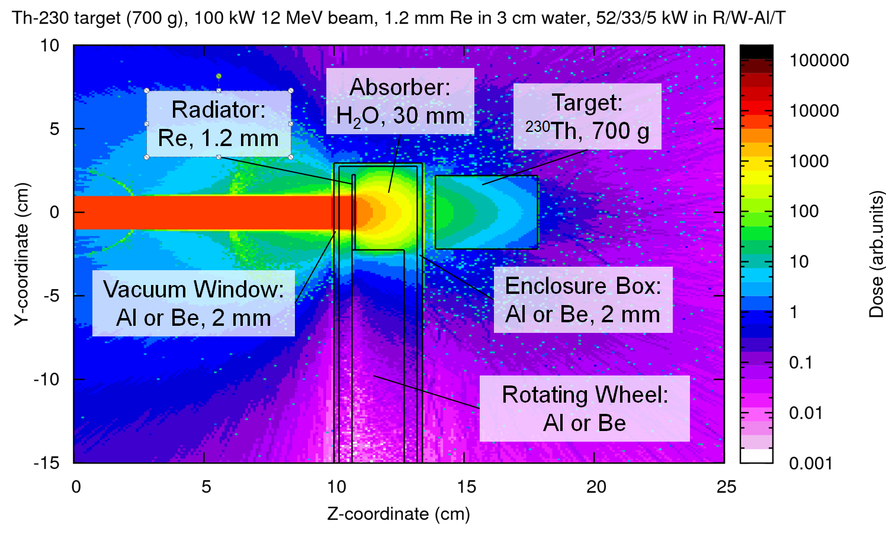

**Figure A.1 – Conceptual set up for 225Ac production**

We will briefly describe a likely path for 225Ac production using a beam power is 100 kW. One of the investigators (P.D) has a patent (US Pat.#8,334,523 B1) “Moving Core Beam Energy Absorber and Converter”. The concept is as follows: a ~1 mm thick radiator in shape a flat ring mounted on the internal rotating whee is suspended in the flow of coolant (water). The radiator will be placed close to the beam entrance. The coolant will be of sufficient thickness to prevent most of the electrons from reaching the target, thus limiting the power on the target. (figure A.1). 230Th is attractive due to the large 230Th(γ,n)229Th cross-section and has low intrinsic radioactivity. 229Th decays to 225Ra. It takes ~18 days to regenerate 1 mCi 225Ac from 1 mCi of 229Th in equilibrium with 225Ra. The separation of 225Ac follows fairly well established techniques.