Jefferson Lab Isotope Production at LERF

Andrew Hutton (Principal Investigator)

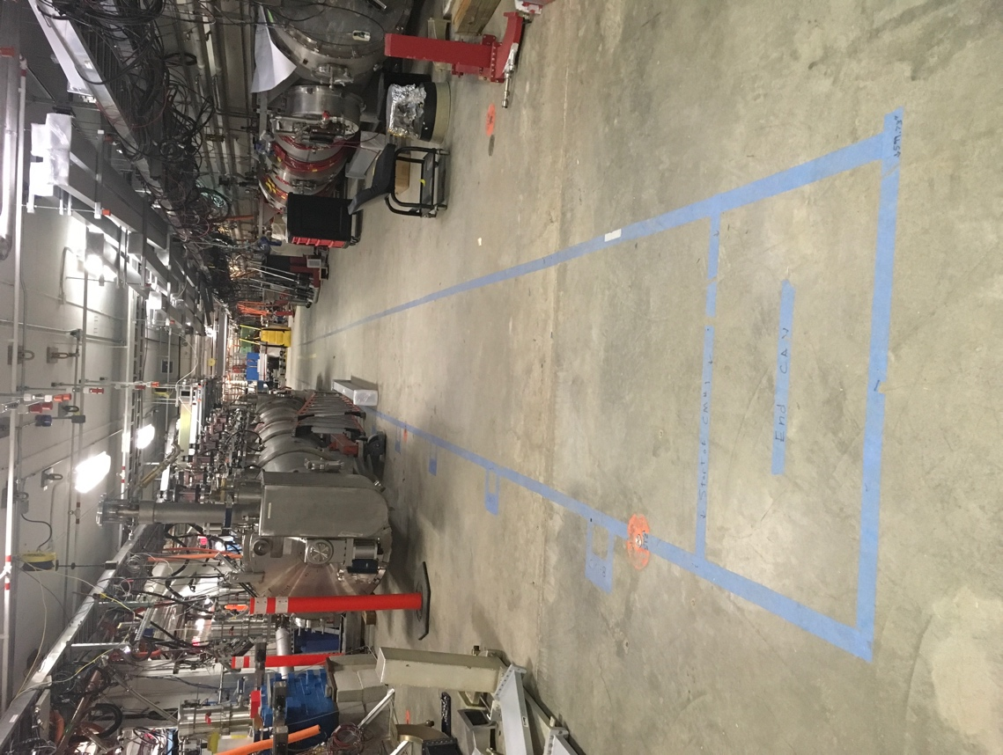Jefferson Lab remains committed to pursuing isotope production at LERF. LCLS II cryomodule testing can proceed in parallel and does not impact our ability to produce isotopes.

LCLS II Cryomodule Testing

The LCLS II cryomodules will be brought into the LERF vault for testing, a maximum of two at a time. They will be brought into the center of the existing accelerator, which has necessitated removing some of the girders in the return loop. This makes energy recovery at the LERF incompatible with the LCLS II testing. The photo shows the LERF cryomodule on the right. On the left is a cryomodule in the position where the LCLS II module will be tested.

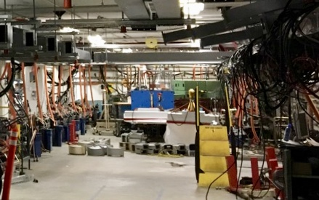The LCLS II cryomodules operate at 1300 MHz and are powered by new solid-state amplifiers (15 of 16 have already been delivered and installed). They are connected to the cryomodules using new waveguide (all of which has now been delivered). The new waveguide is currently being installed. The existing power supplies for the remaining LERF modules remain in place, as do the existing waveguides. The photo shows the waveguide being installed for the LCLS II cryomodule. The isotope radiator and target will be installed behind the green shielding at the back of the photo.

The cryogenic connections for the two LCLS II cryomodules use the existing cryo-connections for the second and third linac cryomodules but the cryo-connections for the injector and first linac module, shared by both isotope production and LERF testing, are still available.

The vault will be locked up during LCLS II cryomodule testing and beam can be run in this state. However, there are long periods when the LCLS II cryomodules are either cooling down or warming up, and this would be the optimum time to carry out the isotope program.

Status of LERF

LERF operated with three cryomodules. At present, two of these cryomodules have been removed and are being kept as hot spares for CEBAF. The remaining module has been relocated to the upstream position and is being used for performance testing (magnetic and vibration studies) which will inform the CEBAF cryomodule refurbishment program.

Since the LCLS II cryomodules are installed in parallel with the LERF cryomodules, there is no interference between them. The ability to send beam along the back wall of the LERF vault has been maintained, and this would enable isotope production in a shielded area of the vault, far 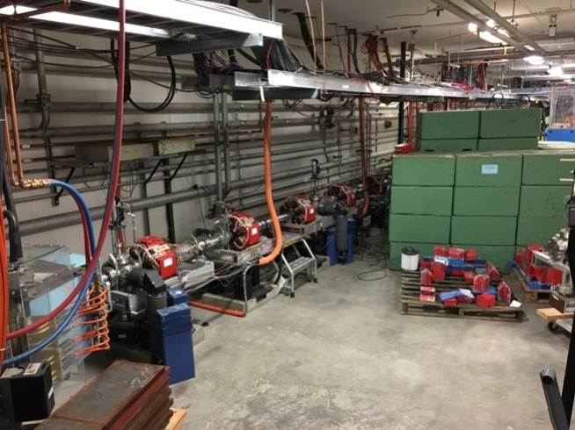from the LCLS II cryomodule testing.

Isotope production

Beam from the existing LERF Injector would be accelerated in the remaining LERF cryomodule to 20-40 MeV with a current up to 1 mA. This would be more than sufficient for initial isotope R&D as well as the first stages of production. The radiator and target would be placed so that access is relatively straight forward; in particular there is a clear pathway to remove the radiated target in a lead container from the vault.

Remove 2 Girders

What is needed

Jefferson Lab has funded the initial isotope production evaluation and tests out of operating funds. One outcome has been the submission of a patent covering the Cu-67 isotope production process from Gallium. Further tests should be funded separately and be fully integrated with the DOE Isotope program. Jefferson Lab retains a small group of people who have been, and are still, enthusiastic about isotope production and could make this unique facility an integral part of the DOE Isotope program.

Radiochemistry at VCU

Target processing and isotope separation will be carried out at the radiochemistry laboratory of the Center for Molecular Imaging (CMI) at VCU. This laboratory is equipped with hot cells and fume hoods for low and large radioactivity handling. The laboratory also houses analytical equipment for chemical and radiochemical analysis.

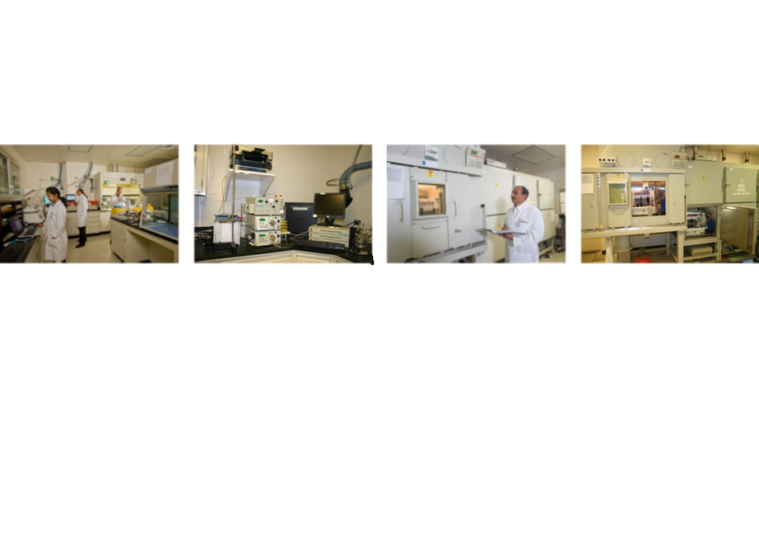

Gallium target processing will be carried out inside a dedicated hot cell with remote manipulators. A combination of solvent extraction and ion exchange chromatography will be employed for the separation of 67Cu from the target and from other impurities. VCU already tested this separation strategy using 67Cu obtained from BNL.

Our Team

The team – Jefferson Lab with its established expertise in accelerators, radiation physics and mechanical engineering and VCU with its comprehensive proficiency in radiochemistry – brings a complete set of skills for isotope production and has been collaborating since April 2014. This collaboration has continued despite a lack of external funding, demonstrating our commitment to this important application of accelerators for society.