Dear Marc,

This is a follow up to our conference call on the 21st of this month. In our proposal the planned tests were to take place at both CEBAF and LERF. As Andrew pointed out during our conversation, all the proposed tests now will be done at LERF due to CEBAF heavily subscribed for nuclear physics experiments. The following is a list of variations from the proposal. The pages in the proposal where the variations occur are in the parentheses.

1. (Page 9) – The sentence “Our strategy is to use LERF’s capability of very high current (≤6 mA) at low energy (≤ 10 MeV) for high power tests of components and to use CEBAF for high energy (≥18.5 MeV), low current (~few microAmps) for isotope irradiation tests.”

Instead, we will use LERF with Beam energies (≥18.5 MeV), and low current (~few microAmps)

1. (Page 14) Figure 7a shows where at LERF injector the (≤ 10 MeV) for high power tests are planned (Green block). The figure below shows where the (≥18.5 MeV), low current test will take place (Green arrow)

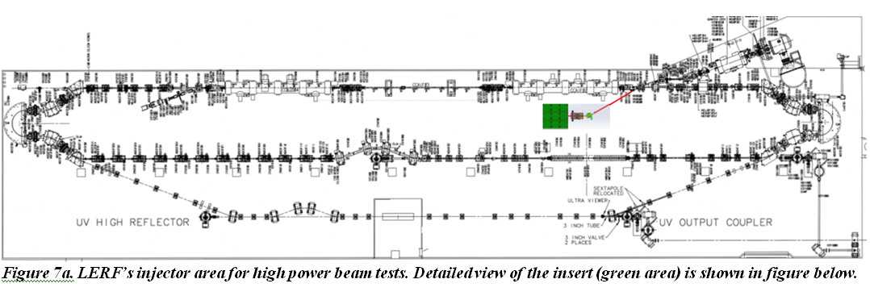

1. (Page 15 ) “At ≥ 18.5 MeV, low current (~5 µA), gallium and zinc targets (CEBAF injector).”

– These tests will take place at LERF as mentioned in item 2 above.

1. (Page 23) Time Table of Activities, Under *Year 2* “During quarters 6 and 7, low power isotope production at beam energies at one or more of energies 18,5, 40 or 100 MeV will be carried out at Jefferson Lab’s CEBAF injector, This will be done at LERF
2. (Page 24) Under Legend Details

“Low current Irradiations of Ga and Zn targets at CEBAF injector at 18.5, 40 and 100 MeV (not all at the same time), followed by radiochemical separation and radionuclide & chemical analysis” –These will be done at LERF

1. (Page 25) Project Goals/Objectives item 5 – “Determination of currents for high energy runs for isotope production at CEBAF injector” - This will be done at LERF
2. (page 26) “Additionally, we will use the guidance of simulations to determine the best beam current at CEBAF injector at 18.5, 40 and 100 MeV that will produce 67Cu which could be separated and which will lead to measurable yields. Additionally, this will determine the shielding necessary at CEBAF injector.” - This will be done at LERF