Dear Marc,

This is a follow up to our conference call on the 21st of this month. In our proposal the planned tests were to take place at both CEBAF and LERF. As Andrew pointed out during our conversation, all the proposed tests will now be performed at the LERF due to CEBAF being heavily subscribed for nuclear physics experiments. The following is a list of variations from the proposal (page numbers identifying the variations are in parentheses):

1. (Page 15) – “40 MeV appears to produce the fewer contaminants at a reasonable 67Cu production and 100 MeV has a higher 67Cu yield albeit with higher degree of contamination (Table 2)”

We will not conduct 100 MeV tests but will go as high as LERF energy permits which is a little over 40 MeV. Our simulations show that 45 MeV may be near optimal energy for production rates and lower contamination.

1. (Page 9) – “Our strategy is to use LERF’s capability of very high current (≤6 mA) at low energy (≤ 10 MeV) for high power tests of components and to use CEBAF for high energy (≥18.5 MeV), low current (~few microAmps) for isotope irradiation tests.”

Instead of CEBAF, we will use LERF with beam energies (≥18.5 MeV), and low current (~few microAmps).

1. (Page 14) – Figure 7a shows where at LERF the proposed tests will take place.

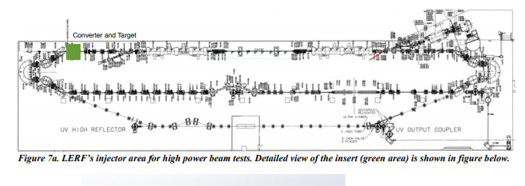

1. (Page 15) – “At ≥ 18.5 MeV, low current (~5 µA), gallium and zinc targets (CEBAF injector).”

These tests will take place at LERF as mentioned in item 2 above.

1. (Page 23) – Time Table of Activities, Under *Year 2* “During quarters 6 and 7, low power isotope production at beam energies at one or more of energies 18.5, 40 or 100 MeV will be carried out at Jefferson Lab’s CEBAF injector.

This will be done at LERF. No 100 MeV tests will be done.

1. (Page 24) – Under Legend Details “Low current Irradiations of Ga and Zn targets at CEBAF injector at 18.5, 40 and 100 MeV (not all at the same time), followed by radiochemical separation and radionuclide & chemical analysis.”

The irradiation will be done at LERF. Chemical separation will be done at VCU. No 100 MeV tests will be done.

1. (Page 25) – Project Goals/Objectives item 5 “Determination of currents for high energy runs for isotope production at CEBAF injector.”

This will be done at LERF.

1. (page 26) – “Additionally, we will use the guidance of simulations to determine the best beam current at CEBAF injector at 18.5, 40 and 100 MeV that will produce 67Cu which could be separated and which will lead to measurable yields. Additionally, this will determine the shielding necessary at CEBAF injector.”

This will be done at LERF. No 100 MeV tests will be done.

Personnel Changes since the time of proposal submission:

1. Andrew Hutton, (Jefferson Lab’s PI) has stepped down as the Associate Director for Accelerators. He is now a full time scientist at Jefferson lab.
2. Douglas Wells of SDSMT is now the Vice President of Academic Affairs at New Mexico Institute of Mines and Technology. He will continue participating in the collaboration.
3. George Kharashvili has left the lab. In conjunction with a graduate student from NMT, we will use existing Jefferson Lab resources to fill in for him.

We are looking forward to your upcoming visit.

Sincerely,

Andrew Hutton