JLab Isotope Production
Procedures & Practices Manual

Kevin Jordan with inputs from entire Isotope Team
11/22/2019
jordan@jlab.org 757-876-1742

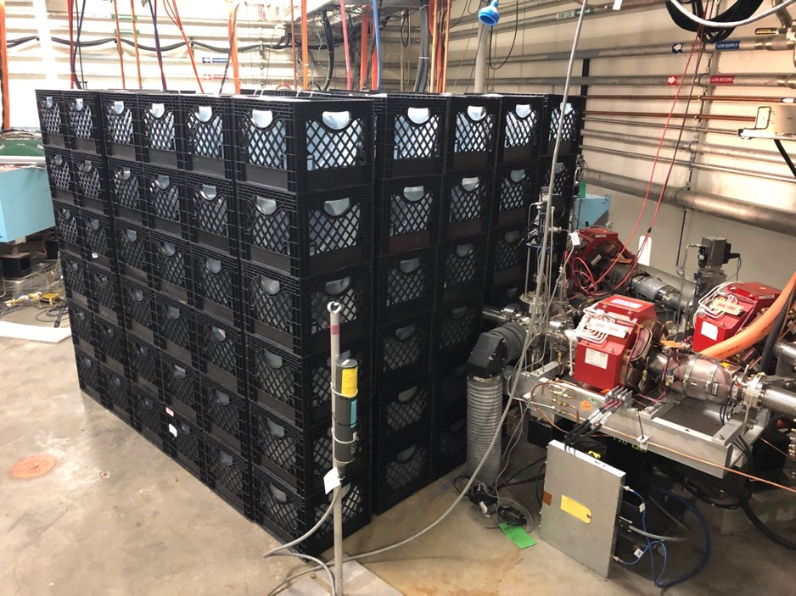

Index

Chapter 1 - Overview
1.1 Overview

Chapter 2 – Boron Nitride Crucible
2.1 Procedure for filling Boron Nitride Crucible

Chapter 3 – Instrumentation
  - Thermocouples
  - Resistance Temperature Detectors
  - ADC Settings
  - Ozone Monitors

Chapter 4 – Interlocks
4.1 Machine Protection System

Chapter 5
  - Procedure for Draining LCW Prior to opening water lines

Appendix A Technical Reference
- P & I Diagram
- Interfaces system print
- Machine Protection System Interface
- Ozone Monitor

Chapter 1

Overview of Isotope Experiment

The Isotope Program at JLab partially addresses the national need for research radioisotopes, especially ⁶⁷Cu, by investigating photo-production using photo-nuclear reactions induced by bremsstrahlung photons from a high-power electron linac. Initially, we propose to investigate the production of useful quantities of ⁶⁷Cu.
We used FLUKA [3] to calculate ⁶⁷Cu yields in gallium. For the eventual production runs, we have settled on 50 KW beam power for reasons of target heating and heat removal. Calculated yields of ⁶⁷Cu for 40 MeV and 100 MeV electron beams at this power in thick ⁷¹Ga and 20 MeV, 40 MeV, and 100 MeV in natural gallium (⁶⁹Ga – 60.1%, ⁷¹Ga – 39.9%) targets are presented in Table 1. Total induced radioactivity in the targets is also considered. Calculations were for 10 radiation length targets.

Target | ⁶⁷Cu Production (mCi/h/50kW)  E_{e} = 20 MeV | ⁶⁷Cu Production (mCi/h/50kW)  E_{e} = 40 MeV | ⁶⁷Cu Production (mCi/h/50kW)  E_{e} = 100 MeV
⁷¹Ga | 10 | 43 | 53
Natural Ga | 4 | 17 | 22
Table 1. Yields of ⁶⁷Cu per 50 kW beam in thick ⁷¹Ga and natural gallium targets calculated using FLUKA

For the R&D program, we narrowed the choice of energy to 40 MeV with up to 5kW of beam power. A run at 20 MeV produces much less undesirable spurious radioactivity in the target but the yield of ⁶⁷Cu is much lower. We chose 99.9999% chemically pure gallium for reasons of its low initial copper content at a reasonable cost.
The irradiation plan calls for a run at 35-40 MeV and 1 kW beam power to confirm the radiation shielding calculations before carrying out several runs at 35-40 MeV and 5kW beam power.
The gallium will be contained in a boron nitride crucible which will be removed from the irradiation area using long-handled tongs and placed in a lead pig. The pig will then be placed in a Class A shipping container and sent to VCU for radiochemical separation of the ⁶⁷Cu.

Chapter 2

Procedure for Filling Gallium in Isotope Crucible

- Don PPE; Lab coat, safety goggles & Nitrile (11 mil minimum thickness) Gloves
- Lay down protective barrier in the fume hood in lab 1, ensure fume hood is on, and lower the sash as much as practical for splash protection.
- Heat the Gallium in a water bath (glass beaker) on a hot plate to 30 to 40 C, set crucible on hot plate as well to raise temperature to >30C (if exceed 44C, then use tongs to handle beaker.) (Fig. 1)
- Set crucible on a scale & zero scale
- Place 50 grams of Gallium in crucible
- Screw Graphite plug into the end of the crucible. Place a label on the copper plate that holds the crucible to indicate that the crucible contains gallium.
- Store filled crucible on the LCW stabilized copper plate until ready for use
- Properly dispose of gloves in trash
- If gallium is spilled, cleanup with spill pads and return used pads to ESH for disposal
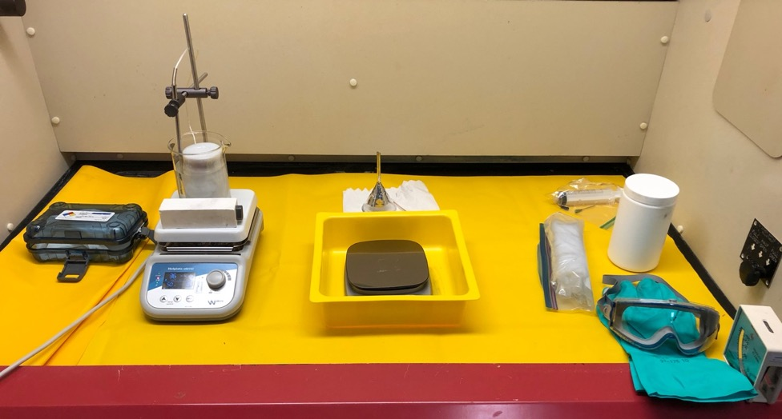
Figure 1; Crucible and Gallium on hot plate

Chapter 3

Instrumentation

Thermocouples & Resistance Temperature Detectors
The isotope experiment is instrumented with both thermocouples (TCs) and resistance temperature detectors (RTDs). Two different technologies are used to minimize any effect from the high radiation area. These are attached to the LCW supply and to each of the return water lines from the window frame cooling, the Tungsten radiator and the base plate cooling. Additional thermometers are located at the Beryllium vacuum window frame, the Tungsten radiator, the base plate and the rear support plug. (Fig. 2) There is a total of 12 thermometers instrumenting the entire isotope assembly.
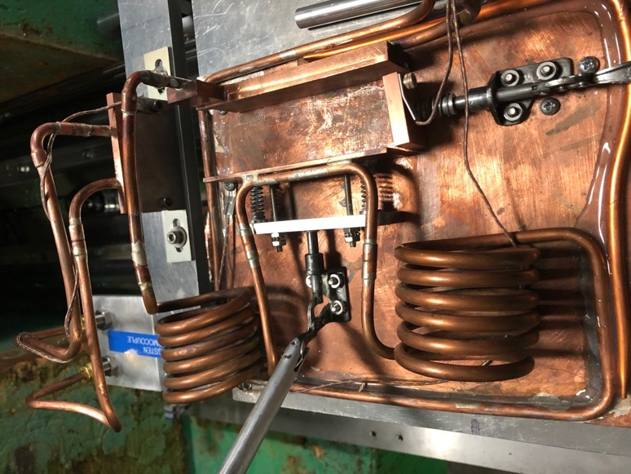

Figure 2; Additional TCs on the Isotope assembly

The TCs & TRDs are readout using the Omega CNi3253 controllers. (Fig. 3). These have been repurposed from the FEL High Reflector instrumentation. The advantage is that all of these channels exist in the EPICS control system. The cables have been extended to the rear of the LERF vault, the controllers are placed behind the concrete support column for additional radiation shielding.

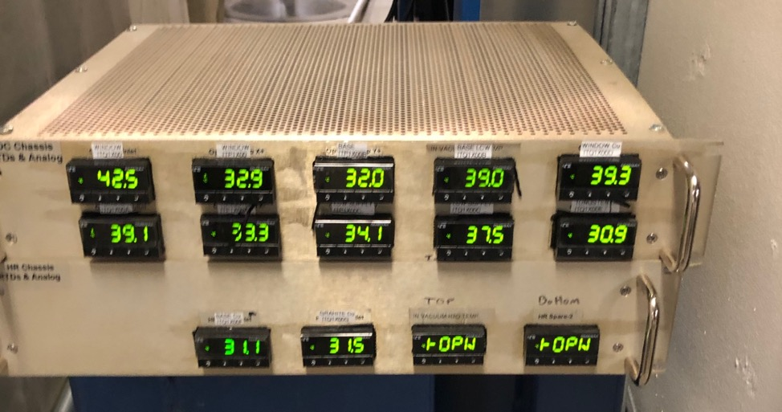
Figure 3; Omega controllers for reading out thermocouples and RTDs, 12 channels

Anticipated Temperature Rise
POWER DISSAPATED IN ISOTOPE RIG kj 10/9/2019
Minimum Flow Rate |  |  |  |  | Alarm at 10 C rise of 3x
Piece | Nomenclature | Power (W) | Factor | GPM | Delta C | Resulting T
Window | 1X00 | 5 | 265 | 0.1 | 0.1887 | 35.1887
Tungsten | 1X00A | 103 | 265 | 0.1 | 3.8868 | 38.8868
hBN/Gallium | 1X00B | 892 | 265 | 0.1 | 33.6604 | 68.6604
Total |  | 1000
Desired Flow Rate
Piece |  | Power (W) | Factor | GPM | Delta C | Resulting T
Window | 1X00 | 5 | 265 | 0.3 | 0.0629 | 35.0629
Tungsten | 1X00A | 103 | 265 | 0.3 | 1.2956 | 36.2956
hBN/Gallium | 1X00B | 892 | 265 | 0.3 | 11.2201 | 46.2201
Total |  | 1000

ADC Settings
The ADC is a differential input 64 channel VMIC MVME 3122,

Ozone Monitors
There are two ozone monitors in the vault, one near the concrete support post & the other in the GTS air plenum. (Fig 4 & 5). There is a nitrogen purge line fixed to the region where the electron beam passes through the air between the Beryllium window & the Tungsten target. This line is remotely controlled and interlocked to the Machine Protection System.
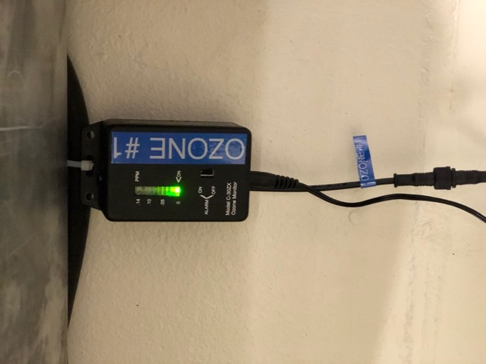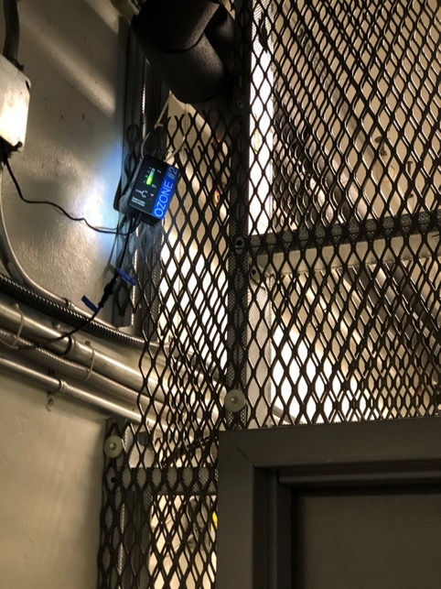
Figure 4; Ozone Monitor # 1 Figure 5; Ozone monitor # 2

Chapter 4

Machine Protection System (MPS) Interlocks

Each of the three water cooling loops and the Nitrogen gas has a flow interlock switch that is connected to the LERF MPS. The MPS is designed around Beam Modes (allowable total beam power) and Machine Modes (beam destination), Twelve spare channels have been assigned for use with the isotope experiment. (Fig. 6) All of these channels must be green or the Beam Mode will drop from CW to Pulsed – low duty cycle.

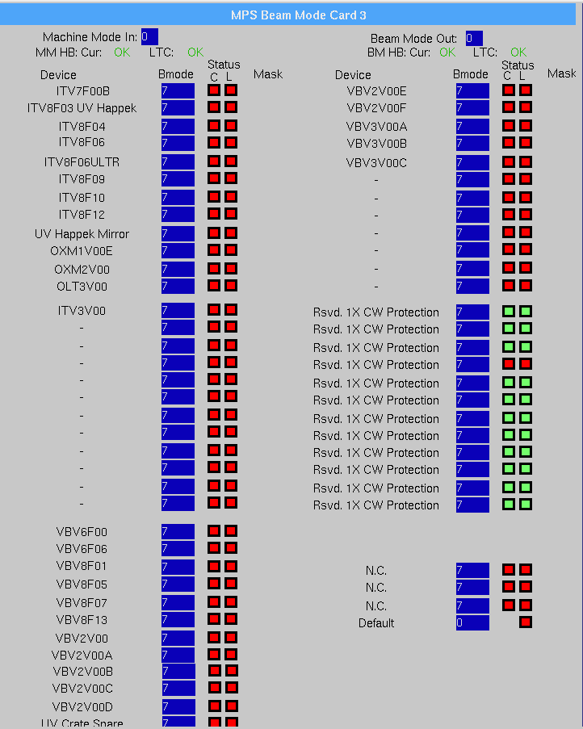
Figure 6; MPS EPICS Screen with 1X interlocks
There is an interface box in the tunnel near the isotope 1X beamline. The interface has 12, 2-pin connectors that tie into the flow switches, the spare channels have a jumper (short) on each of those cables. (Fig. 7)
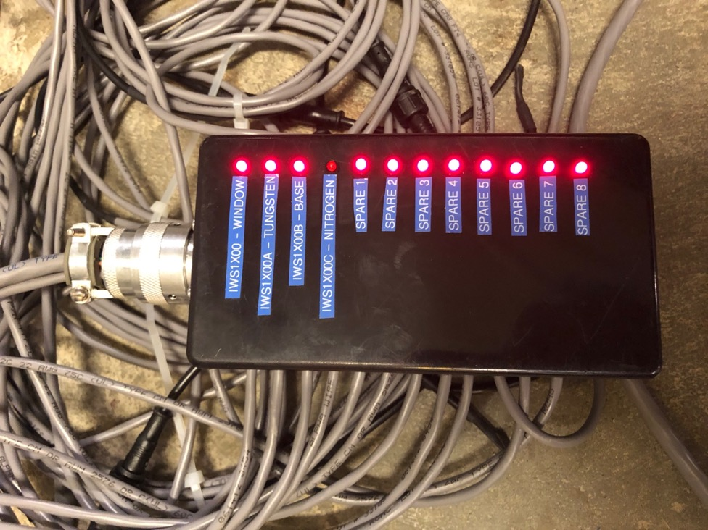
Figure 7; MPS Interface box

Chapter 5

Procedure for Draining LCW from Isotope Rig

- Close IMV1X00C Supply, then IMV1X00C Return. These are the DUMP LCW cooling connections to the isotope rig (Fig. 8)
- Close the supply first then return for the following valves: IMV1X00, IMV1X00A, IMV1X00B. These are the three cooling circuits for the window, tungsten, and base plate. (Fig. 9)
- Place the ¼” drain line connected to IMV1X00D securely in a bucket. Open this valve slowly to avoid any splashing of the LCW. (Fig. 10)
- Open both the Supply & Return ball valves of the LCW circuit you wish to drain, then slowly open IMV1X00D Nitrogen Supply valve to push the LCW out of this circuit, repeat as needed. Be careful not to splash or spill the Dump LCW water. (Fig. 11)

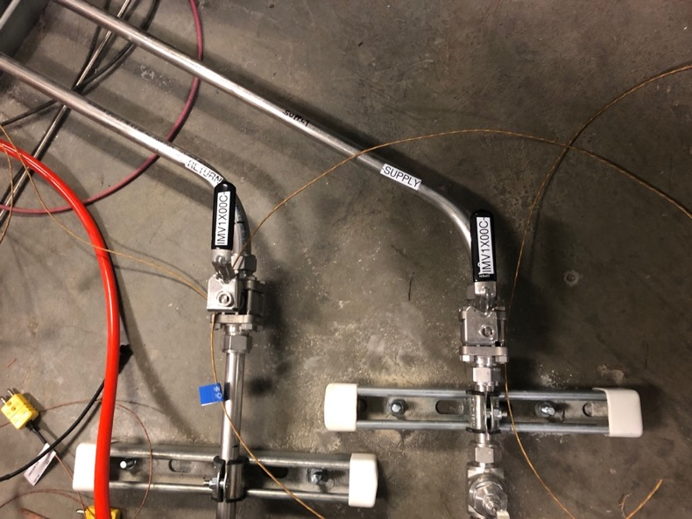
Figure 8; Dump LCW Supply & Return Valves
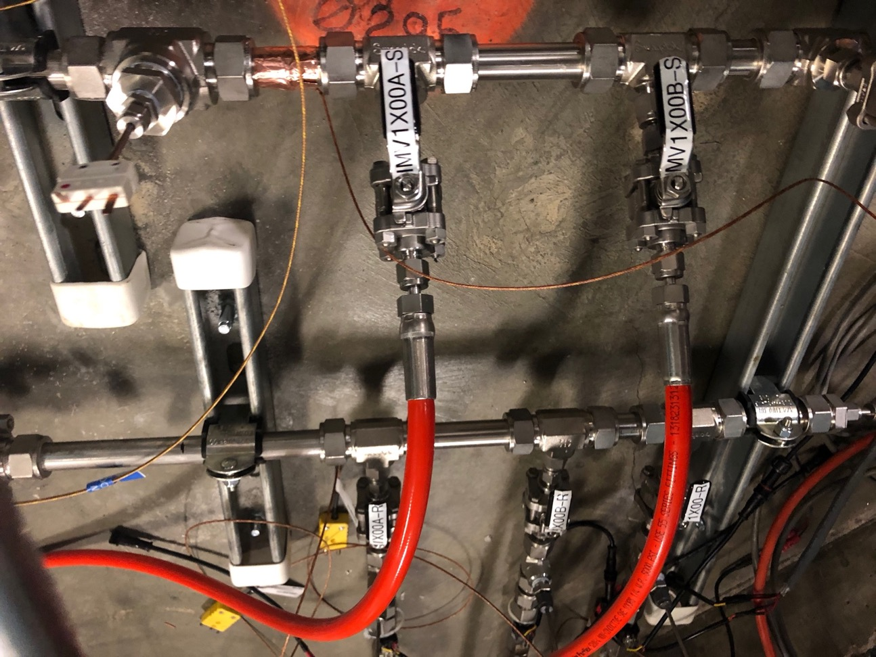
Figure 9; Three branch cooling circuits
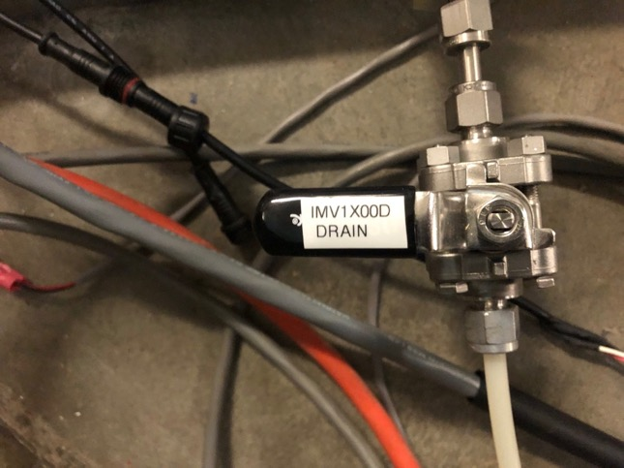
Figure 10; ¼” Nylon drain line
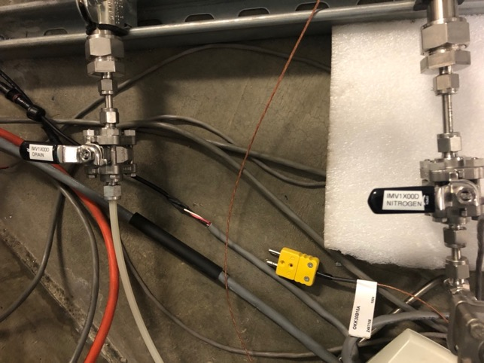
Figure 11; Nitrogen supply to blow circuits dry

Appendix A Technical Reference
- P & I Diagram
- TC/RTD Routing to ADC
- MPS Interface
- Ozone Monitor Manual

- P & I Diagram

