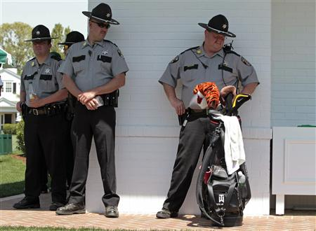

A group of police officers stand next to Tiger Woods' golf bag while Woods was on the putting green following his practice round for the 2010 Masters - Wednesday April 7, 12:41 AM golf tournament at the Augusta National Golf Club in Augusta

