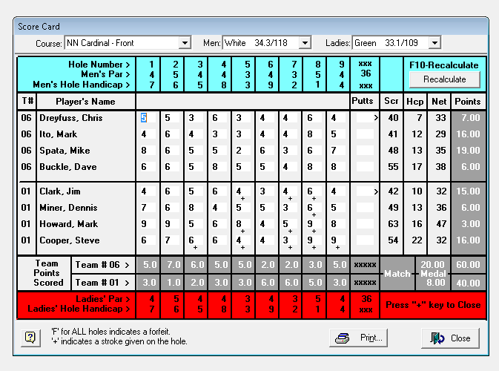

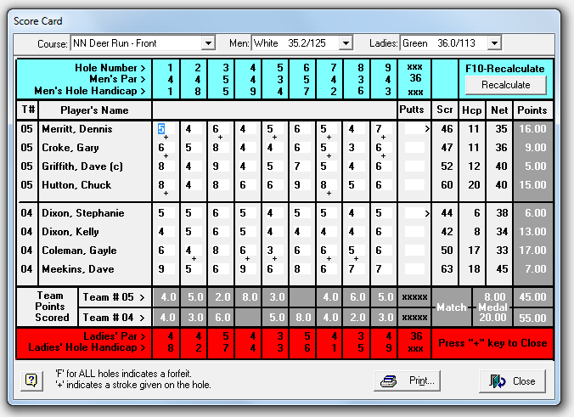

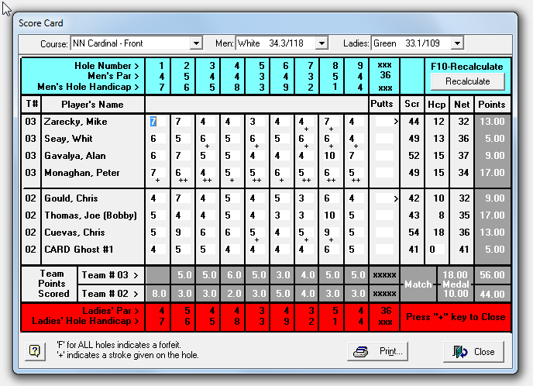

**Notes:**

Software notes - the software used for the scoring does not allow the 'Card' player to have zero points. Actual score is team #3 56 - team #2 is 39.  
Since the Card can win no points, Team #2 loses, and receives a total of 39 points. Team #2 wins, receives 54 points, the 44 match points plus 10 points for team low net for 3 matched players.