**Santa Holiday Golf Tournament - Saturday, November 10, 2018 Woodlands Golf Club**

**9 Woodland Road, Hampton, Va 757-727-1705**

Benefit: Toys for Tots, bring a new toy (optional), enjoy breakfast at $ 3.00, play golf $50 player, arrive between 7:00 -7:50 AM. Start time 8:00 AM. Pictures with Santa Claus in the clubhouse from 8:00-10:00 AM. Hole Sponsor: $100 Fee. Prizes for 1st, 2nd, and 3rd place; Longest drive, Closest to the pin, and Shortest drive. Captain's choice. Bring your camera or phones for pictures with Santa. Make a difference for a child this Christmas. Santa is watching and needs your help!



Send registration and checks made out to: **Art Wolz, Santa Tournament Director, 1750 Gloucester Road, Gloucester Point, 23062, arthur.wolz@cox.net 804-824-4978. You may also register at the Golf Course.**

**Santa Golf Tournament**

**Name:____________________________________Address______________________________**

**City_________________________________________State____________Zip ______________**

**Telephone#_______­­­­­_____________________Email___________________________________**

**(Please copy for additional players)**

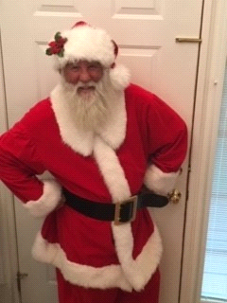

**Thank you for your support!**