BRIC SEMINAR
John Vennekate
Accelerators for Environmental Applications
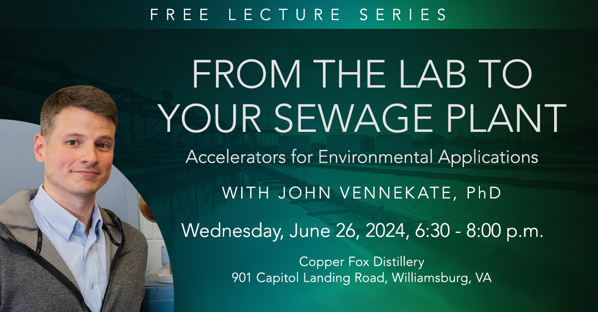
The history of environmental applications of ionizing irradiation dates back to the 80s and 90s of the last century. Electron beam has proven to be a useful tool for the treatment of industrial waste water and flue gases and is already in use in multiple pilot plants in East Europe and Asia. It also offers a new alternative for tackling rising challenges for the wastewater treatment industry of the future in form of newly discovered harmful contaminants.
The talk presents developments that enable a technology transfer of well-established superconducting accelerator technology from science to this field of environmental applications with a focus on water treatment. Recent achievements and future concepts are summarized with an emphasis on the pioneering work done at Jefferson Lab.
Wednesday, 09 April 2025
4:00 pm
Auditorium
Zoom (Meeting ID: 161 376 6098 Passcode: 206846)

