Weekly Reporting

WBS 1.01.07 JLAB Management

Week of October 23-29, 2015

**Issues:** Need to get BCRs processed for cavity flanges and Warm Compressors.

**Accomplishments this week:**

We have added the Warm Compressors contract details to the BCR file. We have for a cobra run to support the BCR submission. This BCR will ask for no overall funding increase but will ask for a significant increase in FY16 funding.

We have received the September EV and Variance reports. We are working on the single variance report required.

APPs have been updated and are being reviewed for sign off this week.

Preparing for Cost and OPA reviews

**Upcoming Activities:**

* Cavity & CM Testing Workshop at FNAL 29-30 October

Weekly Reporting

WBS 1.04.6 JLAB Cryomodules

Week of October 23-29, 2015

**Issues:** pCM component schedules; JLab pCM schedule is driven by the availability of parts, in particular cu-plated cavity string bellows.

**Accomplishments this week:**

Preparing back up documentation for the ICER review in Nov 2015 including justifications for pre-2014 estimates.

Participated in Director’s Review.

Planning to attend the Cavity and CM Testing workshop at the end of the month.

Progress on testing end cap fabrication continues. MLI for shields was fabricated and piping sub-assemblies are being welded.

Submitted PRs for production cavities (phase II & III) and gate valves. Worked with procurement on updated APPs.

Inspection report completed for the 300 mm pipe needed for the GHRP sub-assembly. Non-compliances are being reviewed with FNAL SOTR.

Recovery plan for copper-plated bellows is being implemented. Flanges have been recovered from four bellows and sent to the bellows manufacturer to expedite a small shipment. Four long bellows arrive on 6-NOV at JLab; balance of 14 expected 12-NOV. Long spools will be returned to vendor for rework. Four short bellows ordered. Plating vendor process will be reviewed by SLAC plating expert prior to continuing. Next round of plating at vendor scheduled for week beginning 16-NOV.

AES036 is being re-tested opportunistically – had exhibited some field emission during previous vertical tests.

SC Magnet SOTR visited FNAL to witness magnet testing.

**QUALITY**

Provide QA support with the plating issue on the cavity string bellows and spool pieces. Inspect and review the defective areas of the various non-conformances. Participate in vendor conference call and planning a trip to visit Epner the plating vendor in two weeks to conduct an onsite audit.

Work continues with the ACS documents. The ACS development continues for the bellows and spool pieces, pending processing of the new batch of parts. The draft ACS for the all metal gate valve will likely change pending a decision on test and inspection of the gate valves while inside the cleanroom. The draft ACS for the HOMFTs awaits a response from Fermilab. The ACSs for the Tuner and HOM Absorbers are under development at JLab.

**Upcoming Activities:**

* Cavity & CM Testing Workshop at FNAL 29-30 October
* ICER at SLAC, 17-19 November

Weekly Reporting

WBS 1.04.08 JLAB Cryoplant System

Week of October 23-29, 2015

**Issues:** None

**Accomplishments this week:**

Continued to address the recommendations of the Cryogenic System Final Design Review

The procurement specification for the cryogenic plant warm helium gas storage vessels was completed and is being circulated for approval.

A design coordination meeting was held with the 4.5K cold box vendor (Air Liquide). Topics included the design of the turbine variable brake design, evaluation report of 50% load effect on the 4.5K cold box, and tasks leading to the PDR. The performance of the 4.5K cold box at 50% load was found satisfactory when combined with the turbine variable brake control system.

Worked to develop the backup material for the warm helium compressor BCR.

Preparations continued for the DOE APM Cost Review to be held at SLAC, Nov 17-19th at SLAC.

Design work continued for the compressor room warm helium gas piping installation design. Design completion remains set for December 2015.

**QUALITY**

ACR development for the major cryoplant subsystems is planned to be completed.

**Upcoming Activities:**

ICE Review at SLAC November 17-19, 2015

Warm Helium Compressor Vendor CDR, week of Jan 7th

Weekly Reporting

WBS 1.02.03.05.12 LLRF

Week of October 23-29, 2015

**Issues:** None

**Accomplishments this week:**

* LLRF Coordination/Documentation:
  + Worked on FAC and Directors review presentations.
  + Discussed cryomodule cabling with Matt Boyes
* Stepper Motor Board: The stepper board is in (picture below). It is presently being assembled.

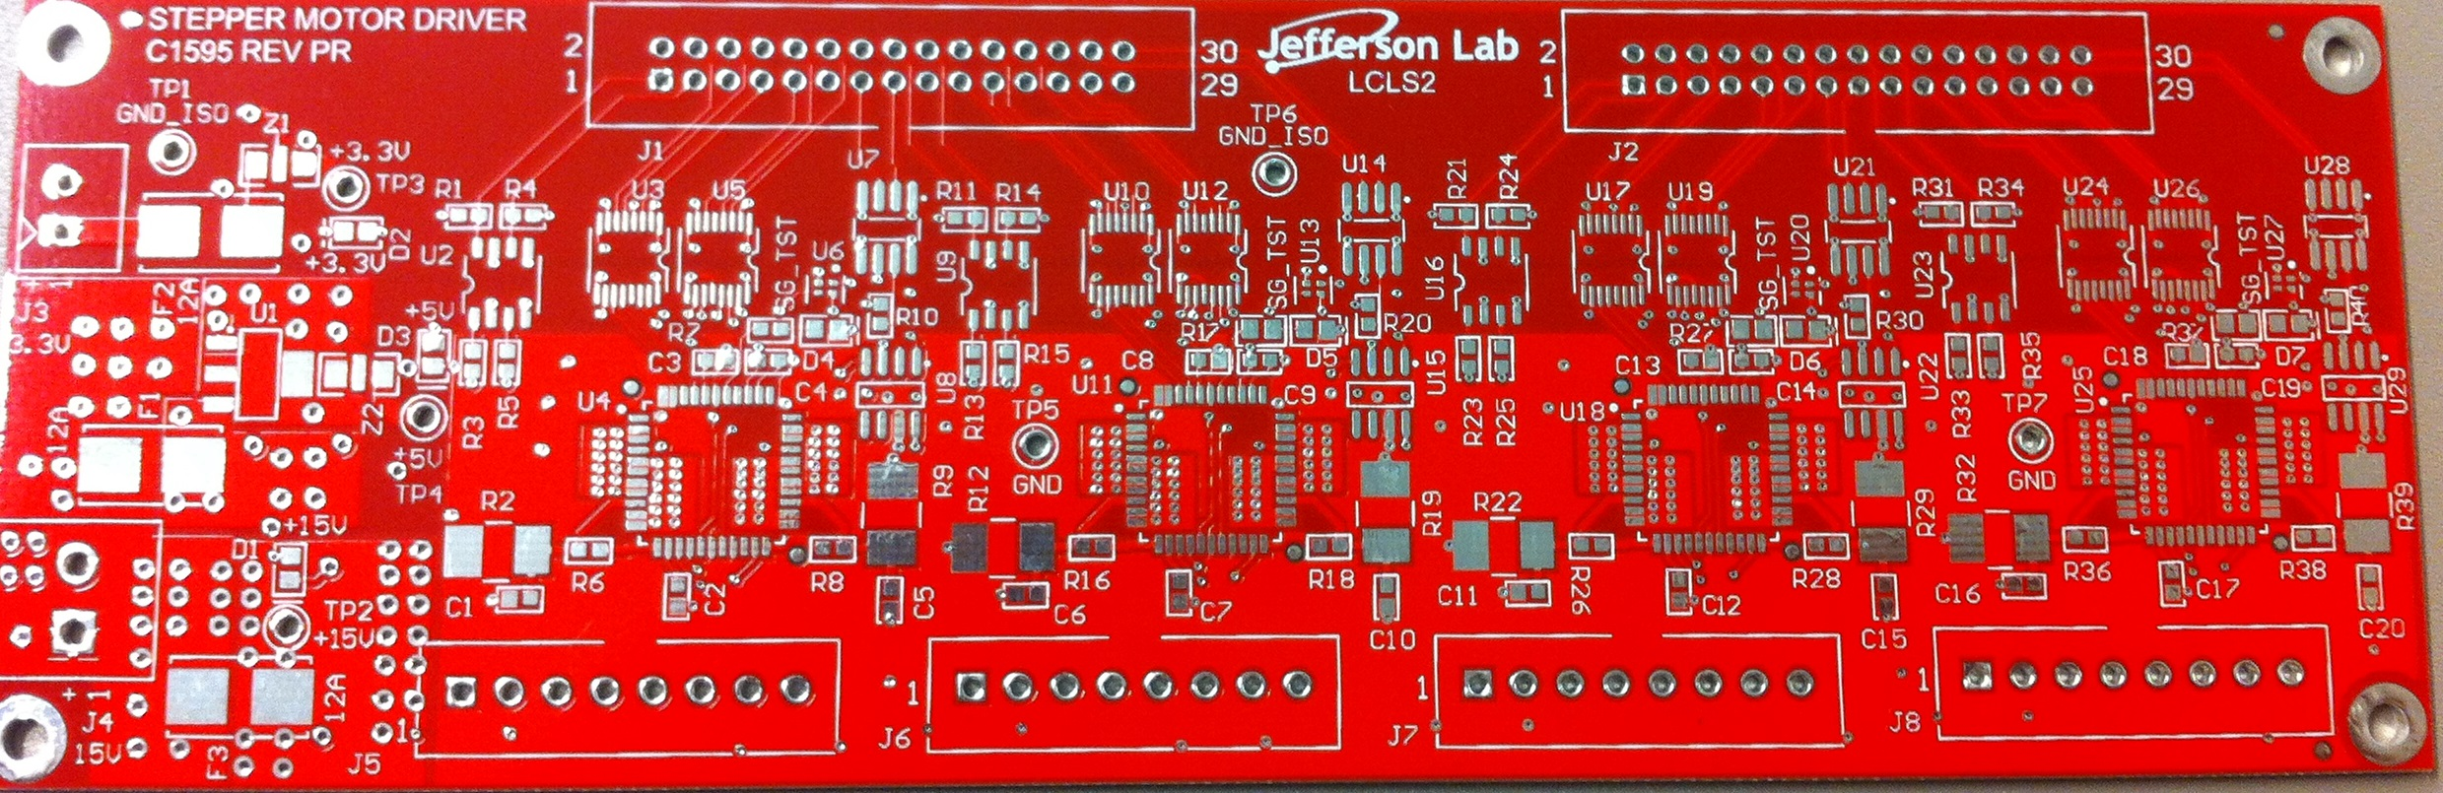

Stepper board.

* Interlock Board: ARC/IR boards are being manufactured. Electrometer and Vac are in CAD.
* Common Power Supply: Break out backplane is in and being assembled.

**Upcoming Activities:**

* + Continue with LLRF coordination
  + Test stepper board.
  + Continue working on the interlock boards.
  + Coordinating prototype cryomodule test facility modifications