Weekly Reporting

WBS 1.01.07 JLAB Management

Week of April 22-28, 2016

**Issues:** Some material remains to be delivered to the cavity vendors; sheet material from DESY, non-sheet material from FNAL.

**Accomplishments this week:**

Finalized schedule reviews and updates in preparation for the baseline.

Started VARs for March.

Started updating the schedule with April progress.

2K Cold Compressors – RFP is out. Proposal due date extended by 2 weeks at the request of vendor. New due date 0600 (6:00 am) 31 May 2016.

Production Bellows (Fabrication and Plating) Plating: RFP issued last Thursday (21 Apr). Proposals due 06 May.

Cavity Tuners - Tuner Frames – Proposals are in – we had 9 submissions. We will be able to award by 15 May the scheduled date. Need updated drawings from FNAL NLT than 15 May.

**Upcoming Activities:**

Weekly Reporting

WBS 1.04.6 JLAB Cryomodules

Week of April 22-28, 2016

Week of April 22-28, 2016

**Issues:** Project schedule driven by production cavity delivery schedule – best schedule from vendors is available. Project needs to investigate other ways to recover float beyond CM production. Lack of resources (subject matter experts) for CTM refurbishment activities may delay cavity production.

**Accomplishments this week:**

The following list of BCRs has been discussed with the SM and are in progress: Production CM Cancellation Coils (in preparation), HX for Testing Production CMs (in preparation).

We are developing a cost estimate for a heat exchanger dedicated for use during production CM testing. MSU/FRIB needs the existing one returned after prototype CM testing.

Key dates for pCM:

Cavity string assembly complete – 29-Apr-2016.

CM assembly complete – 21-Sep-2016.

Cavity Procurement

Actively working cavity production schedule issues in order to recover schedule float by accelerating vendor delivery rates. Current P6 forecast schedule reflects JLab’s best estimate and shows some negative float for the early cavity deliveries.

RI and ZANON have first article production is underway. Both vendors are making good progress on single parts fabrications.

See FNAL weekly report for status of material shipments.

Fabrication of four single cell cavities has started. Cells have been formed, sent through chemistry and are at EB welding now. Material drops have been sent to FNAL (Posen) for analysis.

Proposed visit to FNAL for CTM technical discussions and training (Marhauser, Timergali) is planned for after vendor visit.

DESY colleagues visited ZANON and completed CTM and HAZEMEMA refurbishment. Next visit will be during commissioning steps with first article cavities. JLab has provided contract modification to ZANON for signature.

Cavity vendor visit planning is on-going – dates are 10-19 May. Agenda has been finalized.

Collecting parts and preparing to ship first sets of PICs to RI for first article cavities. Restraint brackets from FNAL have been requested.

Cavity string assembly: All cavities with couplers were placed on the assembly rail. The string was pumped down and leak checked. The string rolled out onto the assembly rail at work station 2 on Tuesday 4/26.

JLab alignment team visited FNAL to witness cavity string alignment. JLab alignment team is currently surveying the string.

Modification of parts and assembly of UCM (GHRP) are ongoing. A request for center support post has been made to FNAL to replace unit that was damaged during machining/handling. Final super insulation of bayonet boxes in progress. Repair weldment of vacuum vessel end caps in progress. Completed QC of mag shields and identified some minor dimensional issues. Added spacer mount holes and enlarged the G-10 spacer center hole for fluxgate sensors and other leads in order to prepare the shields for installation. Modified four-poster tooling to provide clearance for center post.

CM vacuum vessel and testing end caps assembled and installed in CMTF for measurements on cryogenic and RF connections.

Tuner SOTR will visit FNAL to witness tuner installation starting Thursday 4/28.

CM Assembly Lead (J. Fischer) will visit FNAL next week to witness tuner installation and for technical discussions.

Cavity production lead for clean room assembly (D. Forehand) will visit FNAL next week for technical discussions in advance of JLab lessons learned report.

Preparing to receive five SSAs on 4/29 and planning for subsequent on-site tests by R&K. Date TBC.

JLab staff (Cheng, Leung, Lenzer, Macha) are participating in vendor visit to vacuum vessel supplier.

Evaluating tuner frame proposals from vendors.

SOTR and Certified Welding Inspector visited shipping fixture vendor on 4/26 for site evaluation.

We are preparing to make an award for production cavity string bellows and spools. We received confirmation from LCLS-II to specify 316LN materials for bellows flanges and approval of $80K cost increase.

**QUALITY** – No Report.

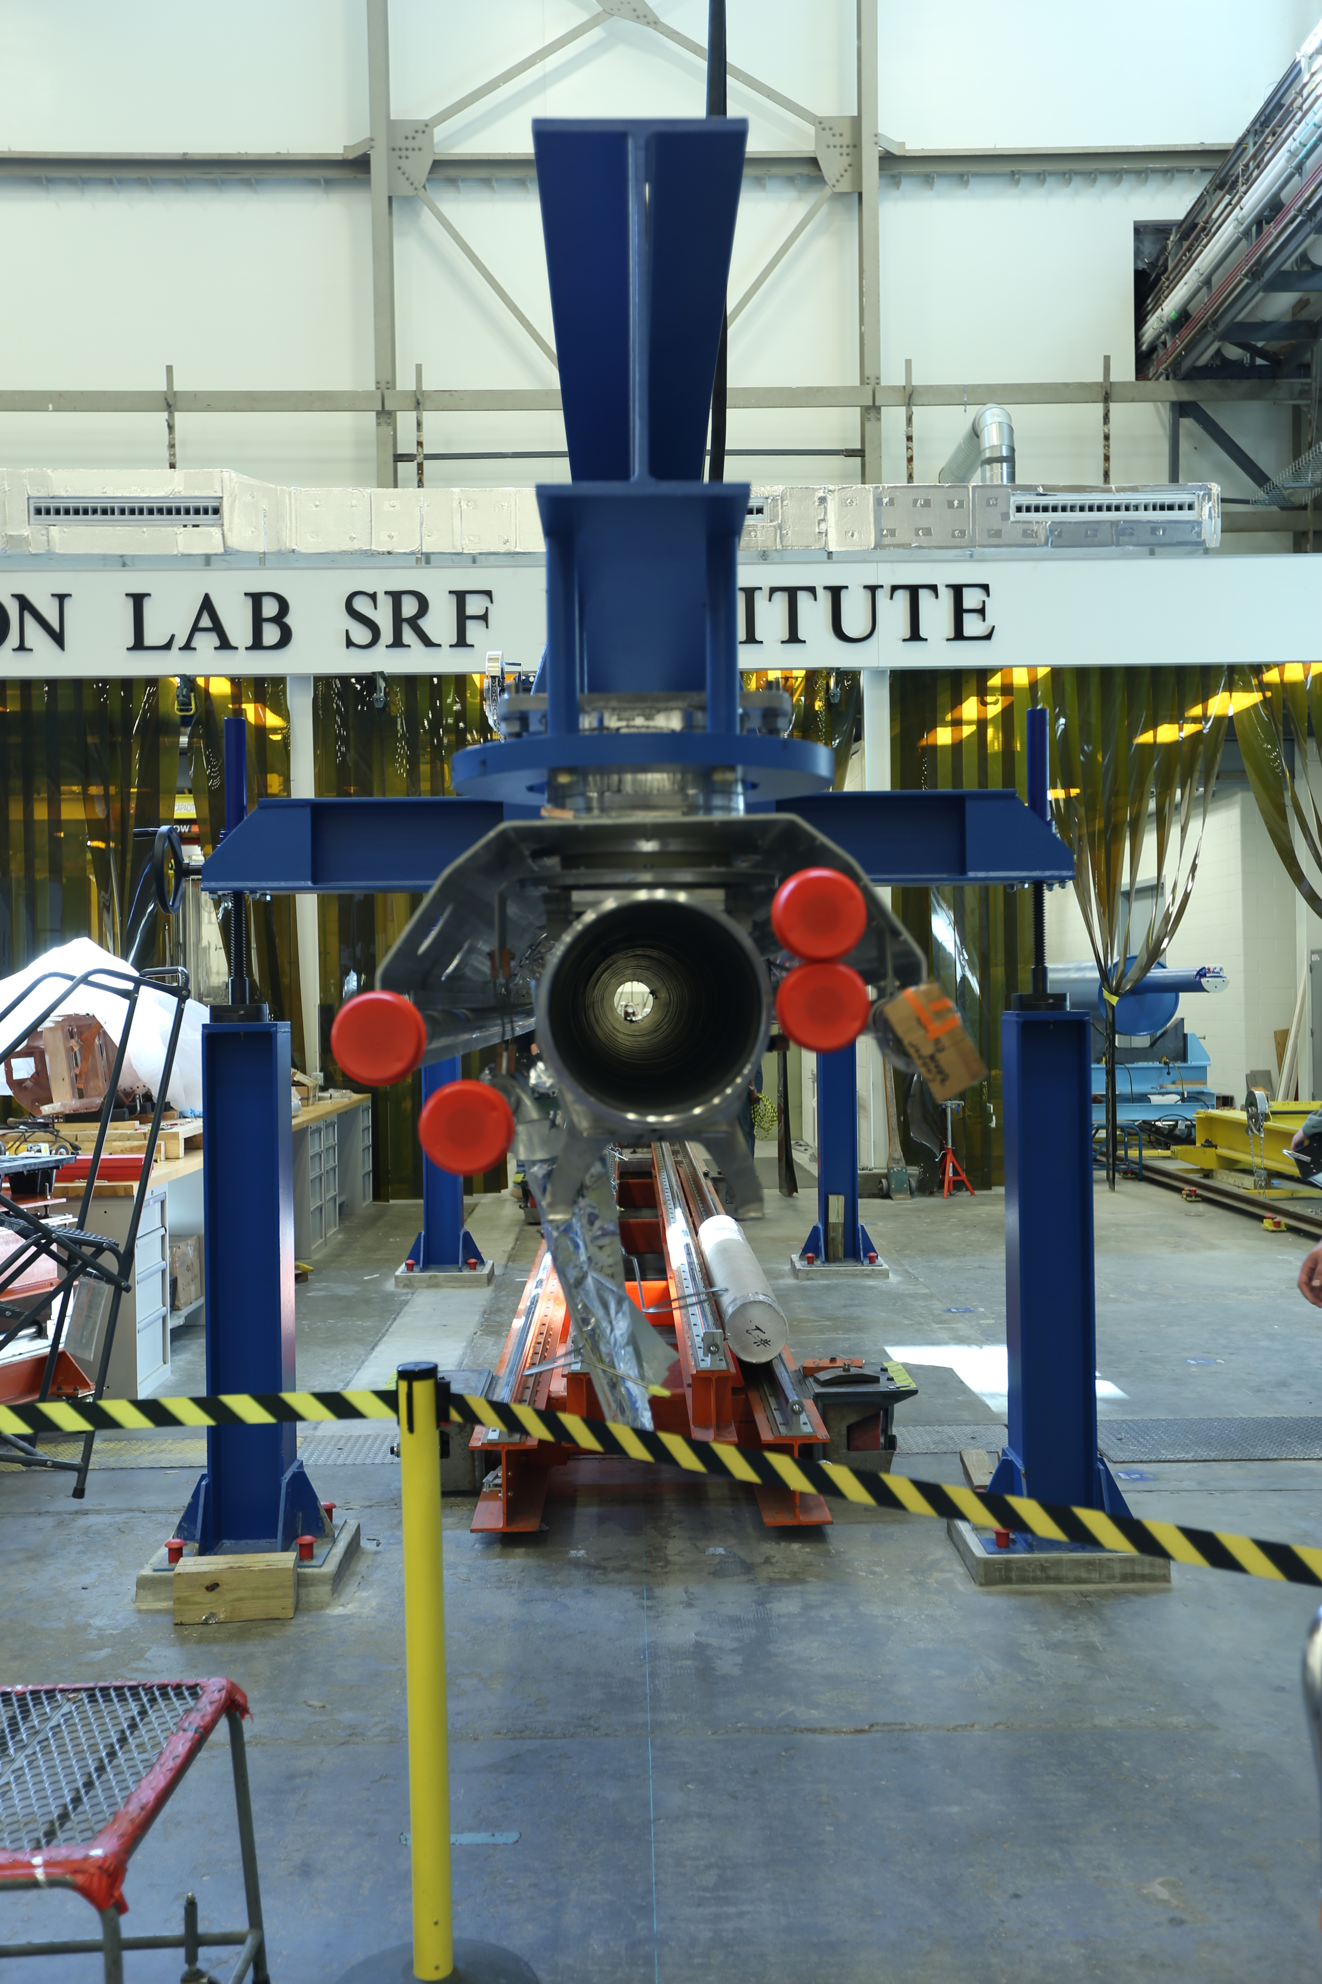

Cryomodule Assembly Rail.

**Upcoming Activities:**

* Visit FNAL to observe tuner installation Apr 28-May 3, 2016
* Cavity Vendor Visit to Germany & Italy May 10-19, 2016
* Coupler Vendor Visit to France & Germany May 19-26, 2016
* SSA Vendor visit to JLab for Acceptance Testing May 2016

Weekly Reporting

WBS 1.04.08 JLAB Cryoplant System

Week of April 22-28, 2016

**Issues:** 4.5K Cold Box PDR Action Items, Warm Helium Compressor CDR Readiness

**Accomplishments this week:**

Request for Proposals has been released for the procurement of 2K cold compressors for both CP1 and CP2 cryogenic plants. Responses will be received in May 2016 (four weeks).

The 4.5K cold box vendor PDR action items with the vendor on 13 April indicate completion by 4 May as scheduled . Pre-review documentation continues to be received from the vendor. These items include valve sizing, heat exchanger pressure drop for all operating modes, adsorber vessel design details, and QC/QA plant.

Warm helium compressor skid frame weldments continue to be fabricated at the vendor shop for 4 of the 12 compressor skids. This includes both HP and LP compressor skids.

Peter Knudsen (JLab ME) and Damon Rath (lead designer) have been assigned to the 2K cold assembly design. Peter continued to develop the engineering design basis for the designer who is schedule to start next week.

Procurement specifications for the MCCs, oil removal vessels, and gas storage vessels are being released to procurement.

P&IDs have been updated for CP2 and are under final review for release.

**QUALITY**

No report

**Upcoming Activities:**

* Warm Helium Compressor CDR, 25 May 2016
* Completion of the 4.5K PDR follow up action items, 4 May 2016
* Cryoplant BIO Review 9 Aug 2016

Weekly Reporting

WBS 1.02.03.05.12 LLRF

Week of April 22-28, 2016

**Issues:** None

**Accomplishments this week:**

JLAB

* LLRF Coordination/Documentation:
  + CMTF SSA control. A network switch is being installed to control all 8 SSAs
* Resonance/Stepper Motor Board:
  + Stepper board is being assembled.
  + Chassis distribution power board: Is at manufacture.
  + FMC breakout board: Schematic is done. It is being laid out by another design group at JLAB.
  + Resonance chassis front and rear panel quotes are in. The grill cutouts are expensive. They should be back at JLAB mid-May.
* Interlock Board/Chassis:
  + FEM: First test results show the board works as expected. It was tested using a nA current source. See pictures below.
  + Temp board is being assembled
  + ARC/IR boards waiting for designer (small change to connector). This board will be delayed 2 weeks. We expect to have one assembled by late May.
  + Interlock chassis design to begin next week.
* Common Power Supply/Chassis:
  + Power supply chassis is being tested.

**Upcoming Activities:**

* JLAB:
  + Continue prototype tests and assembly (resonance, interlocks, power supply)
  + CMTF: Continue working on documentation, installation and instrumentation.
  + **Resonance chassis tests with FNAL Late May.**
  + June 13-17 Rack assembly, test and shake down (JLAB).

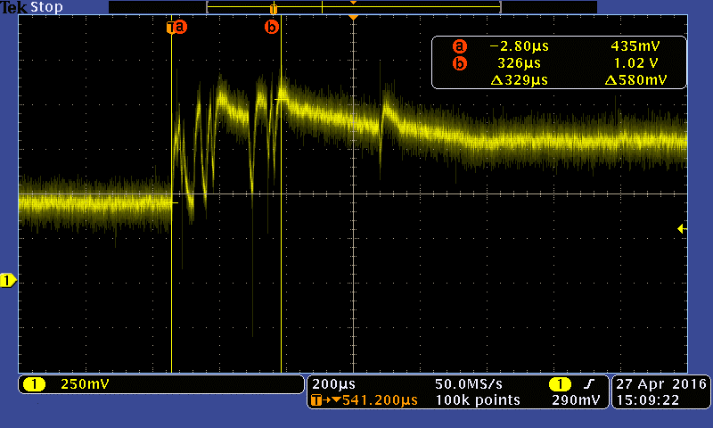

FEM board capturing a current pulse.