Weekly Reporting
WBS 1.01.07 JLAB Management
Week of April 29 – May 5, 2016
Issues: Some material remains to be delivered to the cavity vendors; sheet material from DESY, non-sheet material from FNAL.
Accomplishments this week:
Finalized schedule reviews and updates in preparation for the baseline.
Submitted VARs for March.
Updated the schedule with April progress.
Upcoming Activities:

Weekly Reporting
WBS 1.04.6 JLAB Cryomodules
Week of April 29 – May 5, 2016
Issues: Project schedule currently contains best production cavity delivery from vendors. Project needs to investigate other ways to recover float beyond CM production. Lack of resources (subject matter experts) for CTM refurbishment activities may delay cavity production.
Accomplishments this week:

The following list of BCRs has been discussed with the SM and are in progress: Production CM Cancellation Coils (in preparation), HX for Testing Production CMs (in preparation) and Reduction of Number of Shipping Frames (in preparation).

We have developed a cost estimate for a heat exchanger dedicated for use during production CM testing. MSU/FRIB needs the existing one returned after prototype CM testing.

Key dates for pCM (in P6):
Cavity string assembly complete – 31-May-2016.
CM assembly complete – 20-Oct-2016.

Cavity Procurement
Actively working cavity production schedule issues in order to recover schedule float by accelerating vendor delivery rates. Current P6 forecast schedule reflects JLab’s best estimate and shows some negative float for only the first set of cavity deliveries at each PL.

RI and ZANON are making good progress on single parts fabrications. RI expects to have first article assembled at first hold point in time for next week’s visit.

Prepared draft of Production Cavity Support Team roles and responsibilities and circulated for internal review. Plan to discuss with FNAL and SLAC colleagues next week.

See FNAL weekly report for status of material shipments.

Fabrication of four single cell cavities is complete. Cells have received post-weld chemistry, cleaning and are being assembled for cold testing. Tests are scheduled for week beginning 16-May.

Proposed visit to FNAL for CTM technical discussions and training (Marhauser, Timergali) is planned for after vendor visit.

Collecting parts and preparing to ship first sets of PICs to RI for first article cavities. Restraint brackets from FNAL have been requested.

Cavity string assembly: The string is currently onto the assembly rail at work station 2. Three leaks on beamline flanges are being repaired by increasing torque values on fasteners based on guidance from FNAL and XFEL colleagues.

JLab alignment team completed surveying the string, measured as-built cavity positions and set BPM spool position. CM assembly team moved the upper cold mass assembly from cantilever system to 4-Poster system. CM assembly team installed magnet tooling under BPM assembly and subsequently removed it to rework the cavity string flange pairs. Final super insulation of bayonet boxes is complete. Repair weldment of vacuum vessel end caps in progress

CM vacuum vessel and testing end caps assembled and installed in CMTF for measurements on cryogenic and RF connections. Measurements have been completed.

Tuner SOTR visited FNAL to witness tuner installation from 4/28 to 5/3.

CM Assembly Lead (J. Fischer) visited FNAL to witness tuner installation and for technical discussions.

Cavity production lead for clean room assembly (D. Forehand) visited FNAL for technical discussions in advance of JLab lessons learned report on pCM cavity string assembly.

We positioned five SSAs and continued planning for subsequent on-site tests by R&K, scheduled for 5/16 to 5/19.

JLab staff (Cheng, Leung, Lenzer, Macha) participated in vendor visits to vacuum vessel supplier.

SOTR evaluating tuner frame proposals from vendors. Expect to award next week.

Procurement Clearance Request was prepared for shipping fixture and being review internally prior to sending to SLAC for approval. Expect to award early next week.

We awarded production cavity string bellows and spools to Kurt J. Lesker. Kick-off planned for next week and plan to follow up with vendor visit to Pittsburgh PA later in May.

QUALITY – JLab staff supported Fermilab colleagues during the vendor visit to WXCX in Wuxi City, China. We were also joined by two IHEP representatives in the visit. The team members were well represented with different functions from the partner labs. The team conducted technical discussions in the design of the vacuum vessel and upper cold mass assembly. We reviewed the QA and manufacturing plans for the production of these assemblies. Vendor manufacturing ‘Hold-Points’ were established for the upper cold mass. The team witnessed the leak test of the first production vacuum vessel and also conducted size checks of the various welds. We also discussed shipping package design, delivery schedules, and follow-up visits. The quality system at WXCX looks good. WXCX was very responsive and open to suggestions and requests.

Upcoming Activities:
- Cavity Vendor Visit to Germany & Italy May 10-19, 2016
- Coupler Vendor Visit to France & Germany May 19-26, 2016
- SSA Vendor visit to JLab for Acceptance Testing May 16-19 2016
- Cavity string bellows and spools vendor visit May 2016, dates TBD

Weekly Reporting
WBS 1.04.08 JLAB Cryoplant System
Week of April 29 – May 5, 2016
Issues: 4.5K Cold Box PDR Action Items, Warm Helium Compressor CDR Readiness
Accomplishments this week:
Request for Proposals has been released for the procurement of 2K cold compressors for both CP1 and CP2 cryogenic plants. Responses will be received in May 2016 (three weeks).
JLab has received 4.5K cold box vendor PDR action item documentation as planned on May 4th. These documents include valve sizing, absorber vessel design details, equipment weights/size, mounting details, MTTR, MTBF, and QC/QA plan. The documentation is being made available to the PDR reviewers with comments due no later than COB EST Wednesday, May 11th.
Warm helium compressor skid frame weldments continue to be fabricated at the vendor shop for 4 of the 12 compressor skids. This includes both HP and LP compressor skids. Minor design items based on the completed seismic analysis are being incorporated into the skids. Skid weldments under current construction are not affected.
Peter Knudsen (JLab ME) and Damon Rath (LCLSII designer) have been assigned to the 2K cold assembly design. Peter continued to develop the engineering design basis for the designer who started this past week. LCLSII engineering has looked at the preliminary cold box concept envelope and it complies with the needs of LCLSII.
Procurement specifications for the MCCs, oil removal vessels, and gas storage vessels are being released to procurement.
P&IDs have been updated for CP2 and are under final review for release.
QUALITY
4.5K Cold Box QA/QC plan is being distributed to JLab QA/QC members for review and compliance.

Upcoming Activities:
- Warm Helium Compressor CDR, 25 May 2016
- Cryoplant BIO Review 9 Aug 2016

Weekly Reporting
WBS 1.02.03.05.12 LLRF
Week of April 29 – May 5, 2016
Issues: None
Accomplishments this week:
JLAB
- LLRF Coordination/Documentation:
  - CMTF SSA control. Switch location has been decided.
  - CMTF LLRF Network: Finalized network with JLAB people
  - Exchanged emails with Larry et al concerning chassis design issues.
  - Rama is waiting on BMB7 documentation.
- Resonance/Stepper Motor Board:
  - Stepper board is ready for test (this was a connector mod, not expecting difficulty with it)
  - Chassis distribution power board: Should be in Friday and fabricated next week.
  - FMC breakout board: Lay out needs to be checked by Rama, it should go out for manufacture Monday.
  - Resonance chassis: Front and rear panel quotes should be back May 15.
- Interlock Board/Chassis:
  - FEM: Testing continues. A heating issues on the one the HV op-amps will be resolved using the high power package version of the chip.
  - Temp board is being assembled
  - ARC/IR boards: Still waiting for designer (small change to connector). This board will be delayed 2 weeks. We expect to have one assembled by late May.
  - Interlock chassis design on hold.
- Common Power Supply/Chassis:
  - Power supply chassis has been tested. Line harmonics were less than -55 dBV under load. Pictures are below.
Upcoming Activities:
- JLAB:
  - Continue prototype tests and assembly (resonance, interlocks, power supply)
  - CMTF: Continue working on documentation, installation and instrumentation.
  - Resonance chassis tests with FNAL Late May.
  - June 13-17 Rack assembly, test and shake down (JLAB).

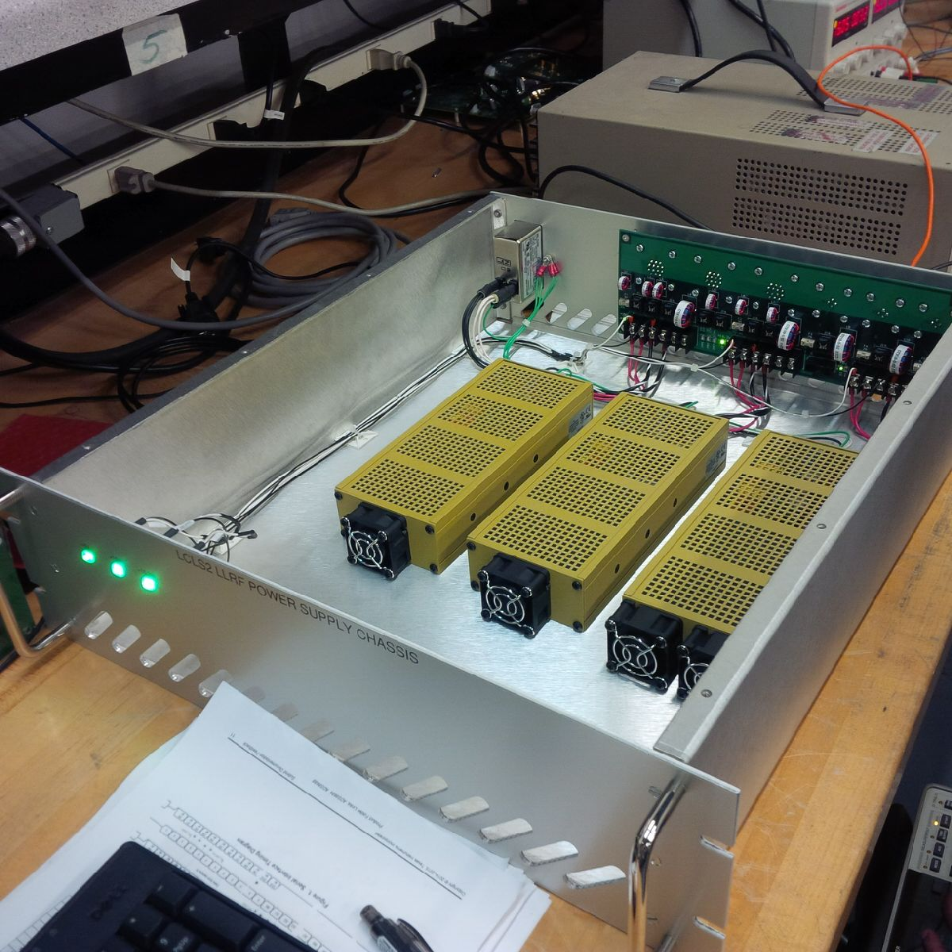
Power Supply Chassis being tested.
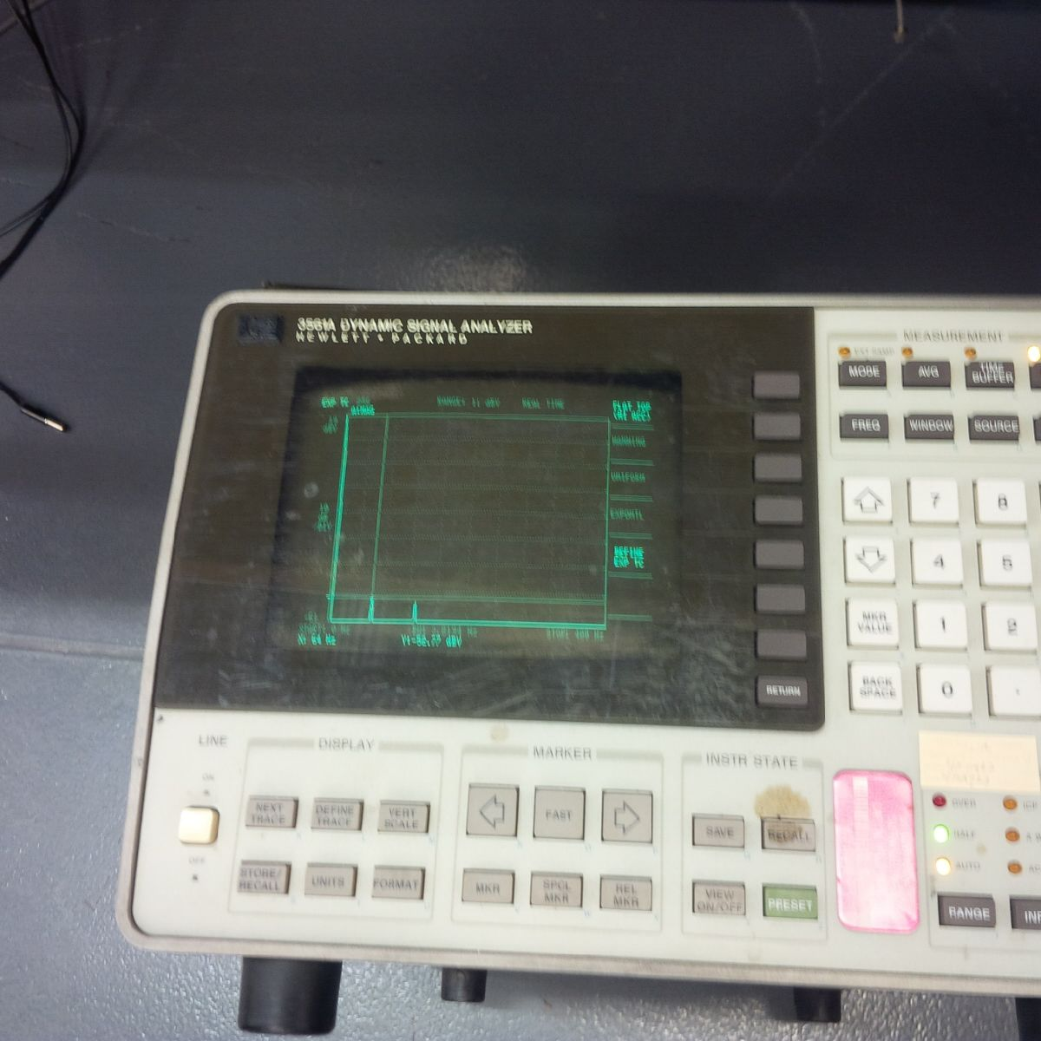
Dynamic signal analyzer showing the line harmonics
of the power supply.

