Weekly Reporting

WBS 1.01.07 JLAB Management

Week of Jun 10-16, 2016

**Issues:** Some material remains to be delivered to the cavity vendors; sheet material from DESY, non-sheet material from FNAL. Material is on the critical path for the cavity production. Need a schedule from SLAC for the copper plating of the first sets of bellows and spool pieces.

**Accomplishments this week:**

Completed SOTR traing including 5 SLAC personnel.

Updating/developing APPs as required.

Monthly PM report submitted.

Working with SLAC/LCLS II to understand how to document the cavity vendor acceleration incentives.

**Upcoming Activities:**

Weekly Reporting

WBS 1.04.6 JLAB Cryomodules

**Issues:** Niobium tubes are on the critical path for RI and Zanon cavity production. Lack of resources (subject matter experts) for CTM refurbishment activities planned in June could delay cavity production. Efficient transfer of lessons learned from FNAL pCM assembly in order to reduce JLab pCM assembly duration.

**Accomplishments this week:**

What-if schedule files have been completed for Cu-Plated Bellows/Spools, and End Lever Tuners Frames. The two BCRs have been combined to one. Next step is the test Cobra run. Plan to complete by 23-June.

Discussions on-going with SLAC PMO regarding best method to incorporate cavity incentives into project plan.

Cavity Procurement

Visited DESY on June 10 and discussed CTM contract technical scope and responsibilities currently in place between cavity vendors and DESY.

RI – sixteen cavities have been released from the first hold point. Three cavities have been released from hold point two – these cavities have been doped.

See FNAL weekly report for status of material shipments. Currently connection tube materials are critical path for cavity vendors. Customs official at DESY is will be out of the office for the next three weeks.

Zanon QA plan was reviewed by JLab QA lead. Awaiting responses from FNAL SMEs.

DESY experts refurbished the CTM at Zanon. Next step is a commissioning test in late July with a completed cavity.

Flux expulsion tests are in progress on Tokyo Denkai single cell cavities.

Zanon has received some of the first sets of PICs – hardware sufficient for 16 cavities expected by 25-JUN.

C. Grimm and S. Chandrasekaran (FNAL SOTRs) arrived Wednesday to witness pCM assembly steps as part of the effort to provide efficient transfer of lessons learned from FNAL pCM assembly. Discussions on piping and magnetic shielding are on-going.

AES018 arrived from FNAL on 15-June. This cavity/HV assembly will be used to develop tuner installation techniques.

Impact of cost due to changes in revised tuner drawings from FNAL is being evaluated.

CM assembly activities:

Insulation is installed on all cavities. First layer of magnetic shields installed on all cavities. Magnetic shielding end cap modifications are in progress. UCM has been reassembled, hung on 4-poster and aligned. UCM and transfer rails aligned

Vacuum vessel QC started, preparing for degauss, OSP drafted, materials on order. Magnet heat stations test fit. Magnet thermal intercept installed. HOM clamps have been modified per latest dwg revision. JT Kit welded and leak checked.

JLab staff (Fischer, Stirbet and Wilcox) traveled to FNAL June 13-15 to witness warm coupler installation.

CM Assembly completion in P6 – 20 OCT; CM Testing start in P6 – 7-NOV.

Continuing to update Bill of Materials in order to highlight missing items. Working with FNAL staff to identify and procure missing items so as not to delay pCM assembly.

CMTF: Coax to waveguide transitions are installed for the first four channels. Transitions for 5-8 are in the process of being installed. Waveguide sections for the verticals (coax transitions down to the FPC locations) are being assembled and installed. Heat stationing straps added to bayonet boxes. Bayonet box positioned in cave for u-tube fabrication to make in-situ measurements.

**QUALITY** – No report – on travel.

Planned Travel:

* Copper Plating Vendor Visits 14-22 JUN
* Coupler Vendor Visit 19-21 JUN
* RI Vendor Visit w/Galayda 24-JUN, Zanon Vendor Visit w/Galayda TBD
* WXCX Vendor Visit 1-5 AUG

Weekly Reporting

WBS 1.04.08 JLAB Cryoplant System

Week of Jun 10-16, 2016

**Issues:**

**Accomplishments this week:**

Vendor proposals for the procurement of 2K cold compressors for both CP1 and CP2 cryogenic plants were received by May 31, 2016. Technical review of the offers were conducted and questions/clarifications have been presented to the vendors. Currently waiting for comment response.

A 4.5K cold box HazOp coordination meeting was held at JLab on June 1-2. The topics included the safety shutdowns, pressure relief value, and control loops associated with the operation of the cold box and integration with the interconnecting subsystems. The HazOp analysis results was part of the upcoming FDR for the cold box. Preparation for the FDR continued for 25 July with the list of requirements per the procurement specification. A preliminary list of presentations and documentation for the FDR has been developed.

SLAC engineers attended the SLAC safety training at SLAC.

Warm helium compressor skid control panel assemblies have been delivered to PHPK for the upcoming compressor skid assembly. Bulk oil separators are under fabrication.

**QUALITY**

No Report

**Upcoming Activities:**

Cryoplant BIO Review 9 Aug 2016

4.5K Cold Box FDR, July 25th (tentative)

Weekly Reporting

WBS 1.02.03.05.12 LLRF

Week of Jun 10-16, 2016

**Issues:** None

**Accomplishments this week:**

**JLAB**

* LLRF Coordination/Documentation:
  + Working on next week’s team meeting agenda
  + Manpower availability due to competing lab priorities continues to delay completion of chassis and hardware.
* Resonance/Stepper Motor Board/Chassis:
  + Chassis power distribution power board: Additional boards are in assembly for RF Station and PRC.
  + Resonance chassis: Chassis is assembled (picture below). Testing has begun with the power supply chassis.
* Interlock Board/Chassis:
  + FEM: Board tests are complete. It is ready for modification and then re-spin.
  + ARC/IR boards: It will go out for manufacture June 17. 5-7 day turn around for board manufacture.
  + FMC connector board (interlocks): Waiting for designer to start layout.
  + Interlock chassis front panels are due in end of the month.
* Common Power Supply/Chassis:
  + Additional chassis is in construction (for LBNL). More to follow.

**Upcoming Activities:**

* JLAB:
  + Continue prototype tests and assembly (resonance, interlocks, power supply)
  + June 22/23: Team meeting at JLAB

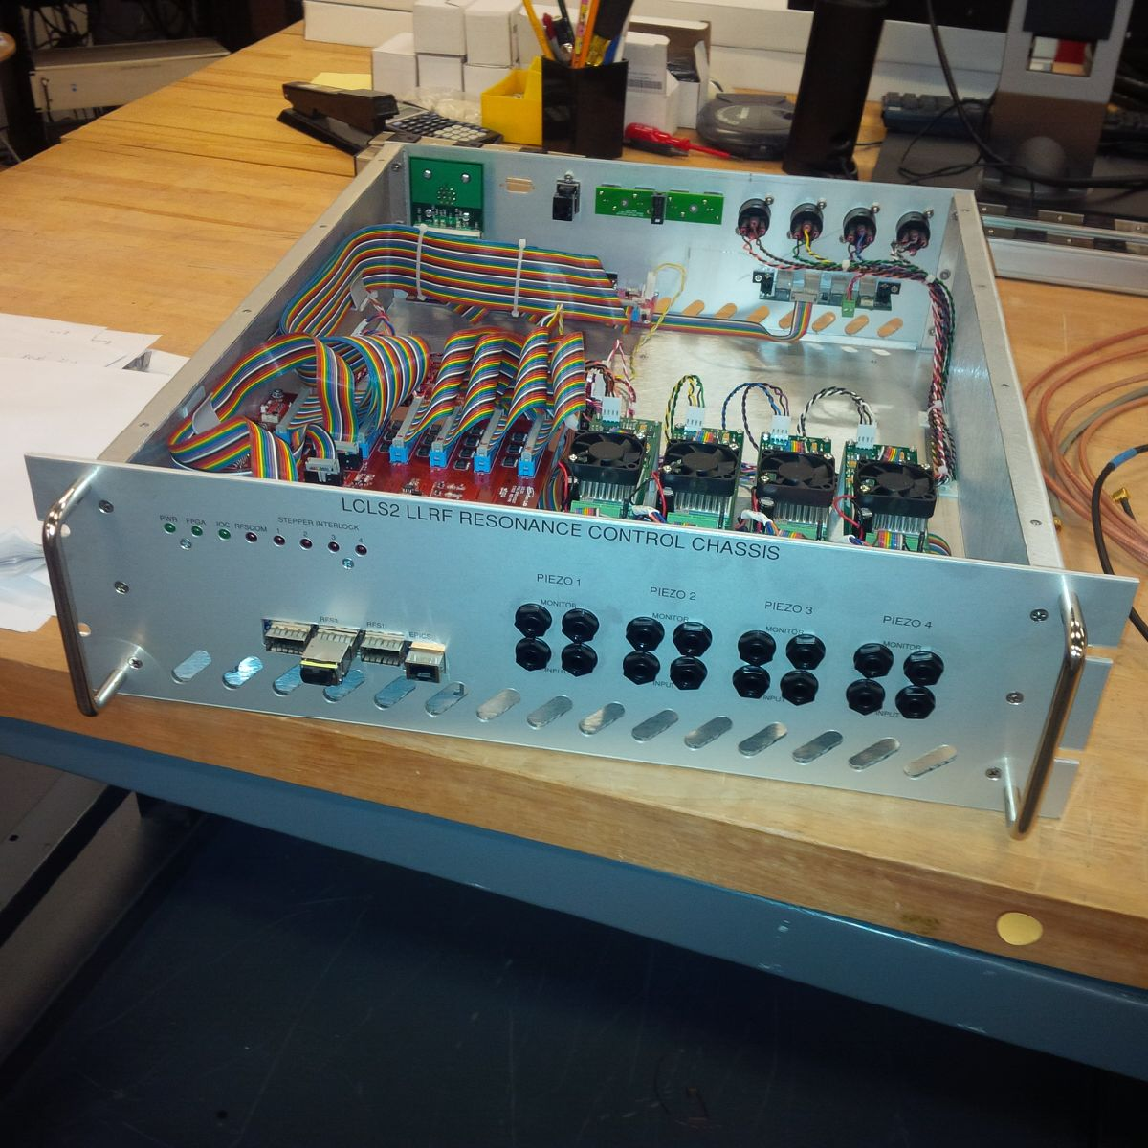

Resonance Chassis for stepper and piezo control.