Weekly Reporting

WBS 1.01.07 JLAB Management

Week of Nov 4-10, 2016

**Issues:**

**Accomplishments this week:**

Attended BES meeting in Germantown, presented cryoplant and cryomodule status.

Preparing for a cryoplant schedule review, distributed a draft agenda.

Working on BCRs - cryoplant installation scope transfer, bellows plating, beamline absorbers, additional shipping fixture and caps.

Conducted a procurement readiness review for the Beam Line Absorbers.

Conducted SOTR training at FNAL.

**Upcoming Activities:**

Director’s Review 4.5 K Cold Box System 16 November

Weekly Reporting

WBS 1.04.6 JLAB Cryomodules

Week of Nov 4-10, 2016

**Issues:** Efficient transfer of lessons learned from FNAL pCM assembly in order to reduce JLab pCM assembly duration – currently at last assembly work station. Cost and schedule impacts due to cavity recipe development effort at vendor.

**Accomplishments this week:**

BCR is under development for beamline bellows plating schedule adjustment. Plan to discuss at next BCR facilitation meeting.

Developing cost and schedule input for BCR for another shipping frame for on-site transport at FNAL. No additional caps for leak-checking needed.

Preparing BCR to request additional funds for BLA procurement. BLA PRR was held on 10-November. Ready to discuss at next BCR facilitation meeting.

Cavity Procurement

Attended PCC meeting and reported on vendor meetings from previous week including hold point updates and expected cavity deliveries. Conducted weekly vendor call with Zanon. Eight cavities shipped from Zanon on 2-NOV – four destined for each lab. Four cavities shipped from RI – destined for JLab. Awaiting resolution of design revision to split ring assemblies from FNAL.

Zanon vendor visit scheduled for 14-15 December. Cavities 200 through 215 should be tested prior to this visit in order to provide feedback on first articles.

Continuing discussion on routing of cavities from RI and Zanon to partner labs and plans for use in CMs. Received vendor projected delivery schedules for next 10 shipments. Lack of deliveries to JLab within November combined with potential CTF down (3-4 months) could impact long term CM delivery schedule.

pCM assembly activities at Work Station 5:

Installation of warm couplers continues – all eight closure flanges are installed. Instrumentation tees and flanges are being installed. Installed downstream warm-cold beampipe. Pressure tested heat exchanger. Completed pressure test on line A. Main coupler pumping lines have been cleaned and are ready for installation. Bayonet box 01 instrumentation has been completed. Second bayonet box guard vacuum being welded.

Current CM completion date is 22-NOV in P6.

Production CM Activities

PRR scheduled for 10-January at JLab to review test results from JLab pCM. Currently discussing agenda for workshop planned for 11-12 January at JLab.

Continuing to inspect bellows and spools and production tuner frames. Continued to receive FPCs from CPI and RI.

The CM02 string assembly was completed and confirmed leak tight on 09-NOV. The string will roll-out on or before 11-NOV.

Vertical Testing for Zanon Cavities made from NX material:

202 – Plan to perform optical inspection on 11-NOV.

201 – Qo = 2.4 x 10^10, quench limited at 14.5 MV/m. FE onset at 8 MV/m. Plan to disassemble, re-rinse and re-test on 15-NOV.

UCM004 incoming inspection is on-going including dimensional inspection. Magnetic hygiene control (survey & demag if necessary) will follow and leak check of cryo pipes will also be performed.

Preparing the demag coils for VV004.

JLab staff are visiting WXCX this week for QC of VVs and UCMs in fabrication.

JLab staff is planning to visit DESY to review shipping cap installation on XFEL CMs.

Cryomodule Test Facility

Safety systems group is conducting the CMTF Personnel Safety System (PSS) certification. PSS certification will allow SSA testing into shorts that have been installed on WG's in Cave. Coax cables have been run between SSAs and CMTF control room.

**QUALITY**

* In our regular QA Coordination meeting with Fermilab we discussed topics on WXCX UCMs and VVs, CM shipping frame fit test results, Lessons-learned on pCMs, cavity-vendor transfer of Hold-Point data, and the various current and upcoming vendor visits. The results from the SLAC QA assessment of JLab welding practices were also discussed.
* Participated in the HOM Beam Line Absorber PRR on Thursday Nov 10th.

**Upcoming Travel:**

* Vacuum Vessel Visit (Gary Cheng, Kurt Macha) to China 7-11 Nov 2016
* Ed Daly, Ari Palczewski to visit Cornell 10 Nov 2016 to discuss possible cavity testing
* Shipping Cap Installation Visit at DESY - Naeem Huque, 13- 16 Nov 2016
* Visit Zanon to provide feedback on first articles, 14-15 Dec 2016

Weekly Reporting

WBS 1.04.08 JLAB Cryoplant System

Week of Nov 4-10, 2016

**Issues:**

**Accomplishments this week:**

The 4.5K Cold Box vendor reported a 12-week delay in the delivery during the FDR. A Director’s review is planned for a vendor presentation of schedule recovery at JLab on Nov 16th. Work during the past week included preparation of the agenda material.

A 2K cold compressor FDR Part 1 was successfully held Nov 8th at JLab. JLab has received all pre-review documentation from the vendor (Air Liquide) in advance of the review. Presentations were complete and include physical dimensions, performance curves, electrical and control requirements, and schedule.

Work continued addressing the 10 Cryoplant PDR recommendations.

The design of the transfer line interface boxes and related transfer line continued through the week. A review of the interface box design and connected transfer line remains set for January 2017.

Technical bid evaluations continued for the oil removal vessels and helium storage vessels.

A BIO visit to JLab to discuss the cryogenic plant documentation, standards, ES&H coupled with a tour of the CHL is planned for November 15th.

**QUALITY**

* Participated in the 2K Cold Compressor FDR #1.
* Reviewed the Diesel Generator Stand-by Power Spec for LCLSII.
* Approved the Technical Spec for the Fabrication of Enclosed Industrial Control Panels.

**Upcoming Activities:**

* BIO Visit to JLab, November 15th
* Controls Integration Meeting, at SLAC, Dec 5th
* 4.5K Cold Box System Presentation to Directors @ JLab, Nov 16
* 2K Cold Compressor Design Review Part 2, Jan 11, 2017
* Interface Box/Transfer Line PDR January 2017

Cryoplant Manufacturing Status Pictures

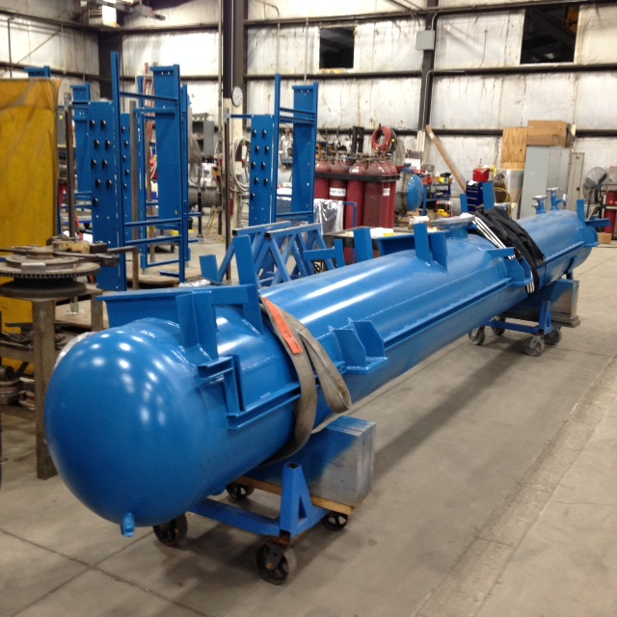

Warm Helium Compressor Bulk Oil Separator

Typical of 12 Units @ PHPK

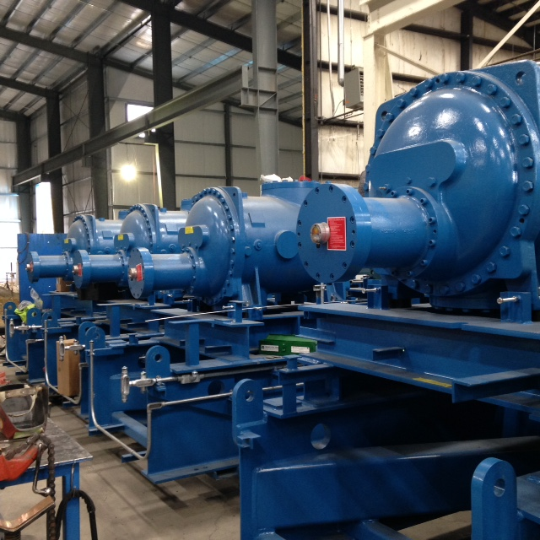

LCLSII Cryoplant Warm Helium Compressor Skids

Cryoplant #1, 6 Skids at PHPK

Weekly Reporting

WBS 1.02.03.05.12 LLRF

Week of Nov 4-10, 2016

**Issues:** None

**Accomplishments this week at JLAB:**

LLRF Coordination/Documentation:

* + Heater: Review should be done next week and released for board fabrication.
  + Production cost estimate: Met this week and discussed test benches and production tests. Dave received quotes back from vendors for chassis fabrication. Sending BOMs out to companies for kitting quotes.

Resonance/Stepper Motor Board/Chassis:

* + Chassis waiting for installation into CMTF.
  + Garth/Rama/George: Soft IOC is working and boots off JLAB network.
  + Firmware still being developed.

Interlock Board/Chassis:

* + Interlock Chassis: Bench Testing is complete on first chassis.
  + FEP Board: Rest of the boards are in assembly.
  + ARC/IR boards: Two boards are assembled.
  + Temp Boards: Two boards ready for testing.
  + Power supply board: Two more are in assembly.
  + The last two chassis are partially assembled. Three chassis are assembled.
  + Garth and George are working on the soft IOC.

Common Power Supply/Chassis:

* + Testing power supply chassis with electronic load.
  + Developing test procedure and discussing how to test for production.
  + Production PS: Discussing modifications needed for the production unit.

CMTF

* + LCLS2 Server: On site waiting for installation.
  + RF Cables and instrumentation: SSA drive cables have been installed.
  + Chassis (Resonance and Interlock) connector list sent to Larry King for connector and cable fabrication.
  + Clyde and George are working on EPICS screens and data bases.

**Upcoming Activities:**

* + Continue prototype tests and assembly (resonance, interlocks, power supply)
  + Team Meeting planned for December??
  + JLAB pCM Installation and tests