Weekly Reporting
WBS 1.01.07 JLAB Management
Week of Mar 10-16, 2017

Issues:
Accomplishments this week:
Met with Cryo SM and Project Managers at JLab for the CP replan and CM EAC effort
Prepared and submitted BCR for 8 cavities and 300 sheets of niobium material
Prepared and submit VARs
STL and Project Director meeting at E. Zannon

Upcoming Activities:
Director’s Review at SLAC 3-5 May 2017
International Particle Accelerator Conference 14-19 May
DOE Status Review at SLAC 13-15 June 2017
SRF 2017 in China July 2017
FAC at SLAC Late Summer 2017

Weekly Reporting
WBS 1.04.6 JLAB Cryomodules
Week of Mar 10-16, 2017

Issues: Cost and schedule impacts due to cavity recipe development effort at vendors. Lack of parts in circulation returned to RI may limit future cavity delivery rates.
Accomplishments this week:
CTF down is in progress and currently on schedule to complete work on 7-April.

Discussing path forward including schedule and priority for 32 cavities and additional niobium.

Prepared and presented BCR for 8 optional cavities and cell material (300 sheets). BCR was approved. Awards for both of these items are in progress.

Preparing BCR for additional 25% of PICs to continue cavity shipments uninterrupted.

Cavity Status
Zanon is continuing production with JLab cavity fabrication experts onsite and supervising procedure development and on-going work.

PCCM was held this past week with a focus on testing results.

First batch of four RI cavities were removed from the test stand. Four more cavities are being loaded onto a test stand. Testing is planned for next week. A third batch of four cavities is planned for shipment from RI to DESY in late March. Two batches of four cavities are being prepared for shipment to FNAL.

JLab expert reviewed RI cleanroom assembly techniques, noted some inappropriate techniques and provided a list of procedure improvements.

Cavity 024 (scratched iris) was EP’ed, and is being reassembled this week for vertical test when CTF is back up in April.

pCM Status
Participated in shipping tests meeting to review plans and preliminary results from shipping tests. Beam pipes parts have been cleaned, pre-assembled and bagged in the cleanroom. Started welding modifications to Bayonet box tomorrow. Expecting new JT stems for pCM from FNAL for test.

Production Status
CM-04:
Awaiting two more qualified cavities from DESY testing.

VV006 has been inspected, An NCR has been generated regarding missing welds.

CM-03 currently at WS1:
String has been re-assembled and began pumpdown on Sunday. Leak check is being completed today. The string is planned for rollout by Friday, 17 March.

Vacuum vessel VV004 – An NCR has been generated regarding missing welds.

CM-02 currently at WS3:
Magnet lead soldering is done and heat stations have been torqued. Lollipops have been removed. Alignment of string is in progress. Tuner installation is planned for next week.

Continuing inspections on beamline bellows and spools prior to shipment to plating vendor.

Procurement staff are traveling to witness pressure test of new HX at Eden end of this week. Unit will be shipped to JLab next week.

QUALITY
Reviewed the process and requirements of the new SLAC QA procedure on Equipment Transfer & Verification. Discussions are taking place internally, with SLAC and with Fermilab.

Continue with the fact-finding and draft Lessons-Learned report on the issue of the compressed CM3 cavity string assembly.

Upcoming Travel:
RI Vendor Oversight Visit to discuss FE Mar 13 – 15 (A. Palczewski)
Vendor visit to EDEN to witness HX testing Mar 15-16 (J. Tenbusch, K. Macha)
E. Zanon Vendor Oversight Mar 16-31 (A. Palczewski)
E. Zanon Meeting March 17 (J. Galayda, J. Preble)
E. Zanon Vendor Oversight Mar 26-31 (C. Reece)
Vendor Visit to Wuxi March 20-24 (Cheng, Fischer)

Weekly Reporting
WBS 1.04.08 JLAB Cryoplant System
Week of Mar 10-16, 2017
Issues:
Accomplishments this week:
Prepared and presented the 2K cold box assembly design review on 9 March. The agenda, charge, and supportive materials was provided to three reviewers from three different laboratories. Final report pending.
Preparation for delivery and storage of the compressor skids are underway at SLAC. A pre-shipment meeting took place at PHPK on March 14th. Mike Bevins and Dirk Pfluekhaln (SLAC) attended the planning meeting. Antonio DeLira (SLAC EE) inspected compressor skids C1, C2, C3,C5,C6 electrical and control wiring and panels prior to shipment.
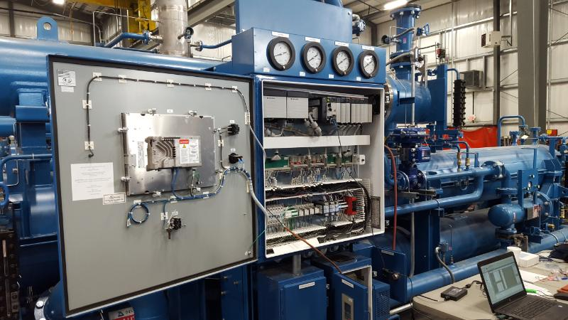
Warm Helium Compressor Electrical Control Panel
Assembly work continued on the fabrication of the CP1 Upper Cold Box assembly. The top head has been placed on a support stand. Multiple piping spools have been fabricated for installation between the top head and heat exchangers/vessels.
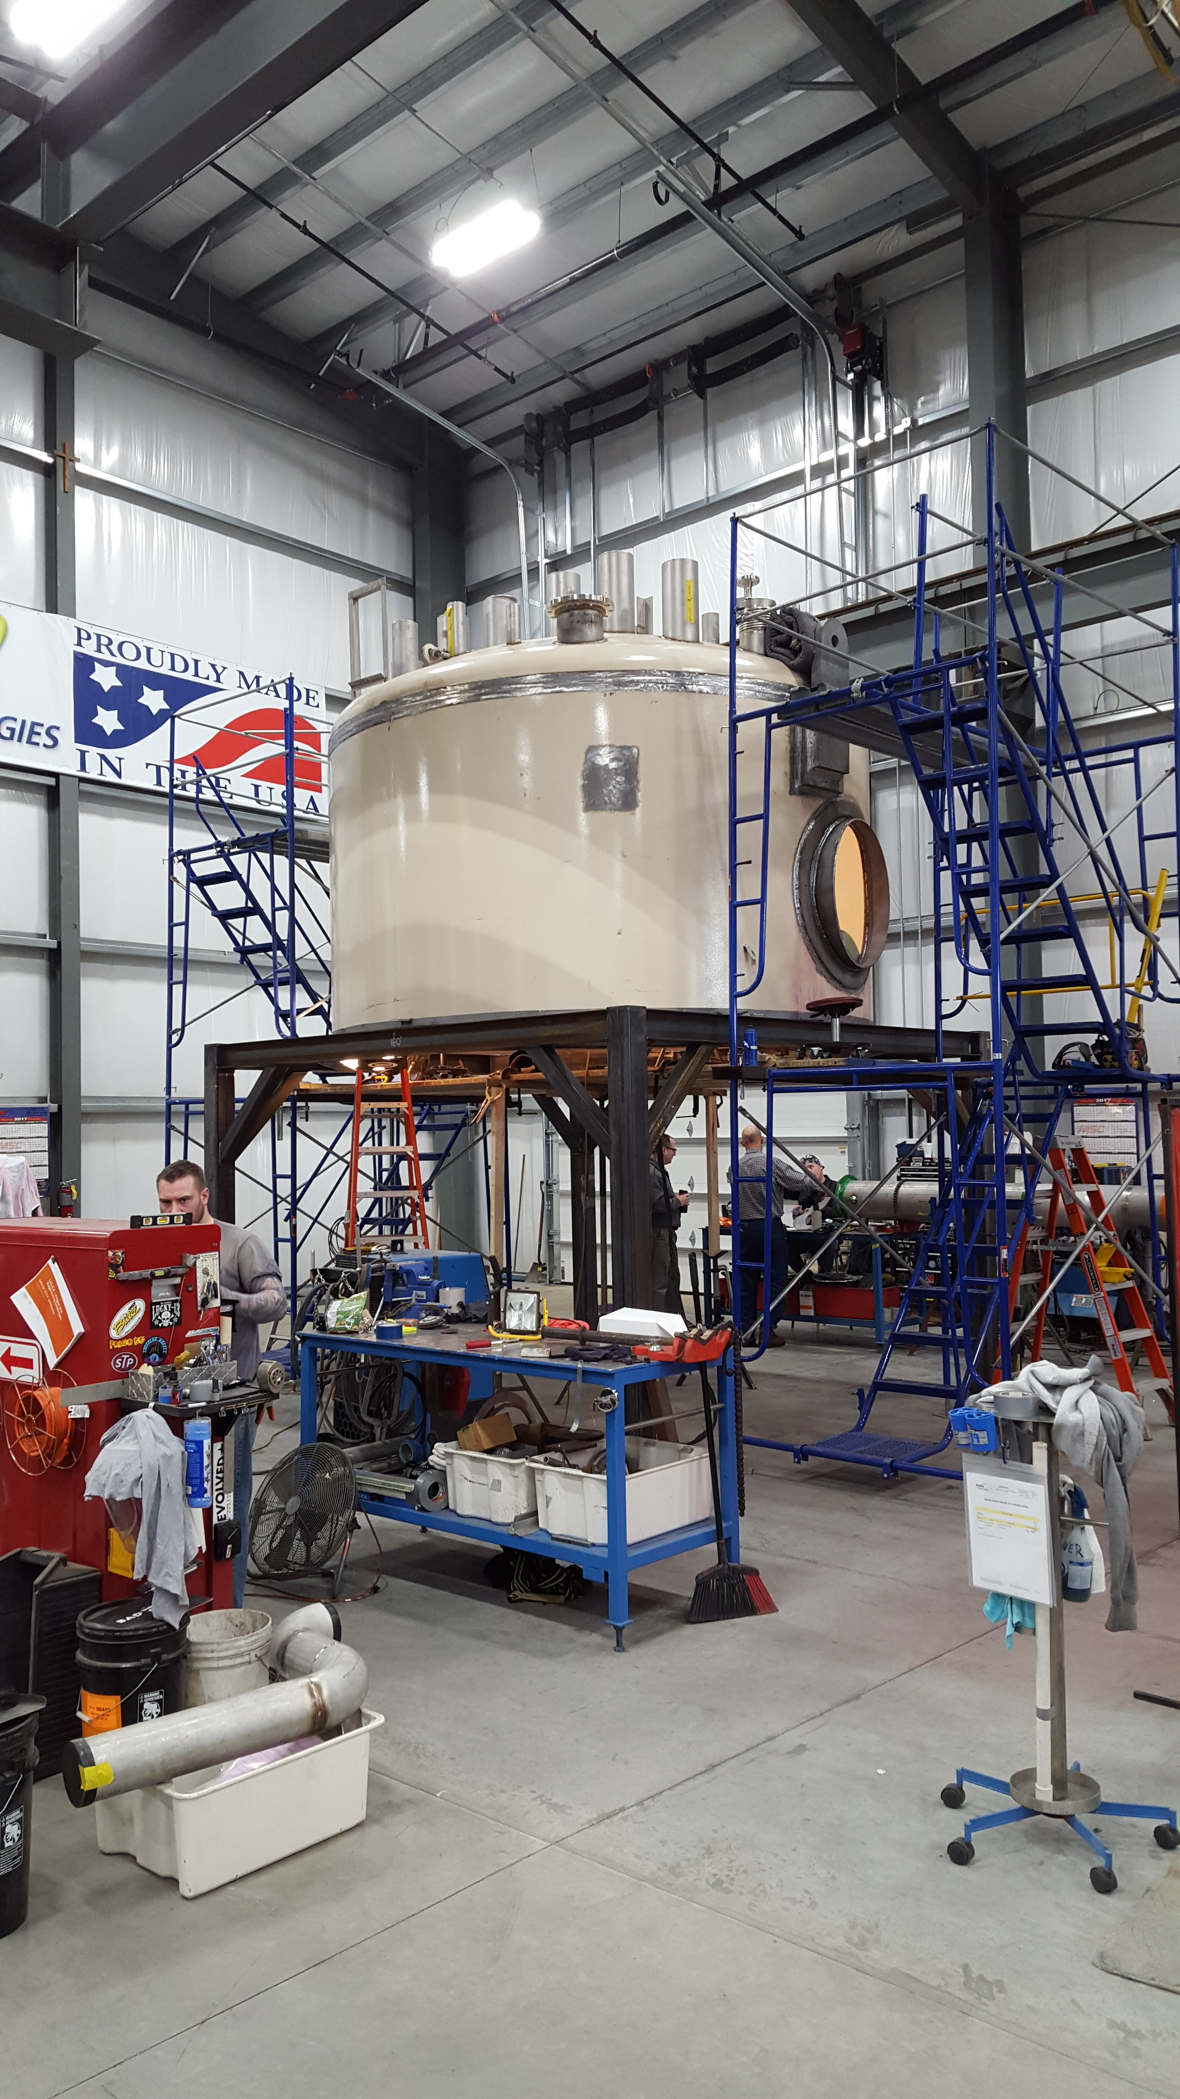
Figure 1 CP1 UCB Top Head.
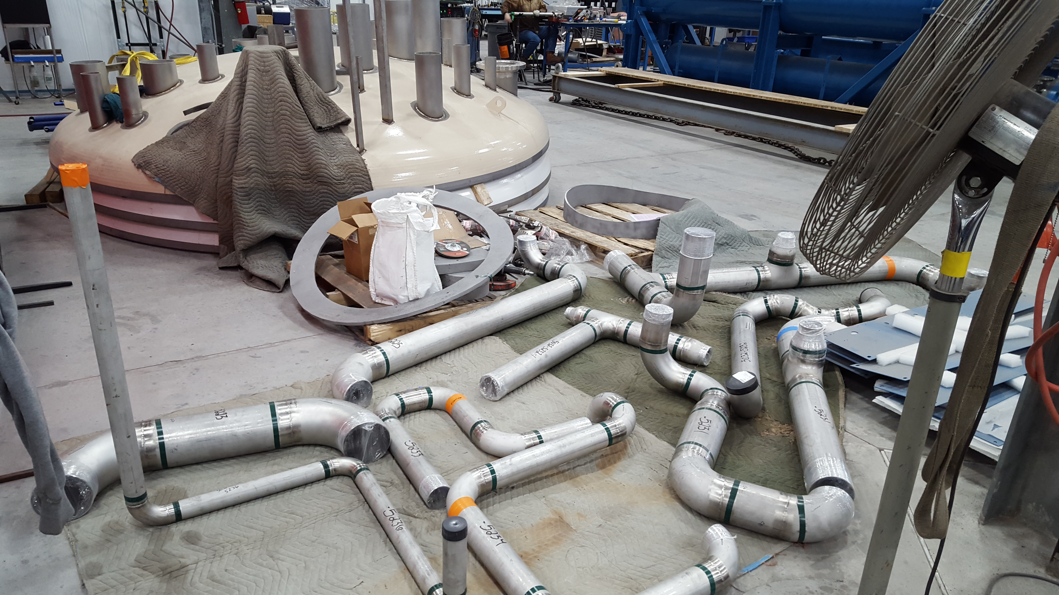
CP1 UCB Piping Spools
A BCR was presented to cover unexpected custom charges for 4.5K cold box heat exchangers and turbines on 23 February. The request was rejected by SLAC management until SLAC/DOE discussion was completed. Custom charges are in process of mitigation and final determination by procurement.
A cryoplant replan was developed for remaining work with presentation to SLAC management scheduled for today, March 16.
QUALITY
JLab QA/QC plans to participate in 2K cold box assembly FDR.
Reviewed the draft 2K Cold Box Specification with the JLab CryoPlant SOTR. Recommended additions and modifications were provided.
Upcoming Travel/Reviews:
Cryoplant Commissioning Review, 20 March
Shipping Safety Plan Review, 24 March
75% CP Installation Design Review, SLAC, March 28-29
Directors Review, SLAC, May 3-5th 2017
DOE Review, SLAC, June 13-15th 2017
FAC Review, SLAC, late summer 2017

Weekly Reporting
WBS 1.02.03.05.12 LLRF
Week of Mar 10-16, 2017

Issues: None
Accomplishments this week at JLAB:
- LLRF Coordination/Documentation:
  - Heater: The FPGA board is still in CAD.
  - Presented at the RF/Cryomodule commissioning review.
  - Active Compensation: Participated in discussions for the LLRF proposal.
  - JLAB Controls group taking over ownership of the EPICS LLRF in the CMTF.
- Resonance/Stepper Motor Board/Chassis:
  - Testing software in the CMTF next couple weeks.
  - Reviewed test bench block diagram. We are moving forward with the design.
- Interlock Board/Chassis:
  - Reviewed test bench block diagram and moving forward with design.
- Common Power Supply/Chassis/Boards:
  - Gun PS Chassis/Board: This has been delayed due to CEBAF priorities. A schematic will be finished next week and then given to CAD.
  - Power Distribution Investigation: We have modified a PS chassis for two conductor distribution. Looking at removing chassis connector pcb and going with a panel mount connector (eliminates one more connection). Then straight to the chassis PS distribution board.
  - Getting quotes on electronic loads or the PS test bench.
- CMTF
  - Improving the CMTF LLRF for the next pCM tests.
Upcoming Activities:
- Prepare for SLAC controls review in April
- Prepare for FDR in May

