Weekly Reporting

WBS 1.01.07 JLAB Management

Week of April 7-13, 2017

**Issues:**

**Accomplishments this week:**

Finalized the path forward for additional cavities and cavity material procurements.

Cryoplant re-plan iterations.

Submitted the monthly report.

CMTF helium refrigerator came on line on schedule.

**Upcoming Activities:**

Director’s Review at SLAC 3-5 May 2017

International Particle Accelerator Conference 14-19 May

DOE Status Review at SLAC 13-15 June 2017

SRF 2017 in China July 2017

FAC at SLAC Late Summer 2017

Weekly Reporting

WBS 1.04.6 JLAB Cryomodules

Week of April 7-13, 2017

**Issues:** Impact on cryomodule assembly schedule due to design changes and parts availability associated with microphonics.

**Accomplishments this week:**

CTF down completed scheduled work on 7-April. VTA resumed testing on 10-April.

Continuing to develop proposal for possible additional CM design verification and acceptance testing at JLab. Plan to present to JLab management by end of next week.

Developing revised cavity shipment schedule that includes additional cavities, additional materials and considerations for re-processing and recovery.

Finalized BCR presentation for additional Parts in Circulation in advance of CCB on 13-April.

Cavity Status

Submitted change requests to Zanon including modified processing and movement of excess material. Developing plans for evaluation of bare cavity recovery steps at FNAL.

The movement of material was delayed by Zanon. There are developing the packing list in preparation for movement of material. Date for shipment has not been specified but expected very soon.

Continuing on-site support at Zanon to monitor processes and procedures. Zanon has completed Hold point 1 for 260 to 266, and Hold Point 2 for 256 to 259. Five cavities (216 to 219 & 224) were sent from JLab to FNAL for development of recovery methods. Four cavities (229, 234, 238 & 244) are being sent to JLab for remediation process development. Three cavities (227, 228, 231 - fully dressed/completed) are being sent from Zanon to FNAL for development of recovery methods.

RI has completed Hold Point 1 thru 104 (except 103), Hold Point 2 thru 093 except 084, 087, 092 and Hold Point 3 thru 083 except 058, 063 and 081. Four cavities (074, 076, 077, 078) arrived at FNAL. Four cavities (079, 080, 082, 083) are en route to JLab. Four cavities (081, 084, 085, 086) are planned for shipment to FNAL. The next JLab shipment (087, 088, 089, 090) has been redirected to DESY for testing. Next FNAL shipment (091, 092, 093, 094) is planned to ship at the end of April.

pCM Status

pCM was moved into CMTF and positioned. Heat exchanger in place and ready for use.

Production Status

Jlab and FNAL are working through kit lists for workstations to ensure identical parts used and to identify any shortfalls in components.

CM-02 (currently at WS4):

The lower 50K shields have been installed. Clearances were added at the liquid level stand pipes to avoid thermal shorts. Cold mass assembly was moved to WS4, the cantilevered tooling, and then MLI was installed. The cold mass was inserted into the

vacuum vessel, and then the vacuum vessel was aligned.

CM-03 (currently at WS3):

The two-phase piping leak checking was completed. Installation of helium vessel MLI and magnetic shields is in progress. Instrumentation was added to helium vessels

and cold couplers. Checklist was reviewed prior to moving to WS3.

CM-04:

Six cavities are in the clean room in preparation for string assembly.

Cavity 024 did not qualify. It had an attempted repair that was unsuccessful. The cavity will be returned to the vendor. Cavity 049 qualified with Qo > 3.5 x 10^10 and Emax = 24 MV/m (admin limit). Cavity 070 is cold and planned for test on Thursday evening. Cavity 048 is planned for testing on Friday.

CM-05

Three cavities (057, 061, 062) have been tested and qualified at DESY. Three cavities (072, 073, 075) have been inspected at JLab and are awaiting testing.

**QUALITY**

Compiling a new significant NCR after the latest VTA testing for the RI cavity # 024. This cavity had failed VTA testing previously due to field emissions. An internal inspection uncovered a scratched iris that had originated at the vendor. Following a light EP, the cavity showed similar performance and was unable to pass the VTA test.

Participated in the internal reviews of the Technical Change Requests from RI.

**Upcoming Travel:**

E. Zanon Vendor Oversight Apr 7-15 (H. Park)

E. Zanon Vendor Oversight Apr 24 – May 2 (K. Macha)

E. Zanon Vendor Oversight May 6-19 (A. Palczewski)

HOM BLA Vendor Kick-Off Mtg – May 14-18 (H. Park, E. Daly, T. Peshehonoff)

E. Zanon Vendor Oversight May 16-26 (C. Reece)

WXCX Vendor Visit July 24-28 (Cheng, Fischer)

Weekly Reporting

WBS 1.04.08 JLAB Cryoplant System

Week of April 7-13, 2017

**Issues:**

**Accomplishments this week:**

* 2K Cold Box FDR final report has been received this week. Continued work plan for completion of the design. Preparing to close out FDR recommendations.
* Assembly work continued on the fabrication of the CP1 Upper Cold Box in preparation of installing HXs and piping spool pieces.
* Work continued on the two recovery compressor skid assemblies, Compressor skid #1 is nearly completion, skid #2 is approximately 30% complete.

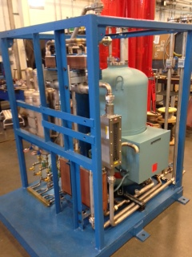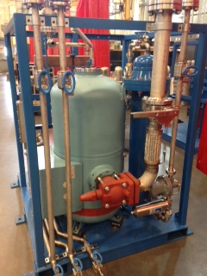

Recovery Compressor Skid #1

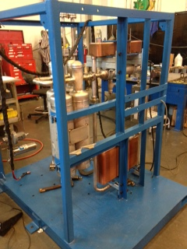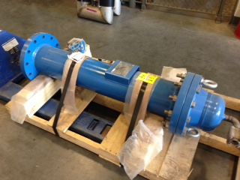

Recovery Compressor #2 and Final Filter

* A 75% mechanical, electrical, and installation construction review was held at SLAC on March 30. The installation documentation package was reviewed. Comments were received this week.
* The last shipment of cold box heat exchangers (shipment #4) for both plants have been received at PHPK. Viswanath Ravindranath (SLAC) witnessed heat exchanger leak check and partial cold box valve leak checking.
* A cryoplant Strategy and Procurement Modification BCR was developed for remaining work for presentation to SLAC management. A presentation was made on April 4th. Additional questions were raised during the BCR and tentative responses to the questions were reviewed on April 11th.
* PHPK has received the final seismic design report from Hopper. Air Liquide will review the final report for 5 days prior to submittal to JLab. JLab should receive the report early Week of April 17th.

**QUALITY**

Plans are in place for JLab QA/QC to be present during warm helium compressor shipment.

**Upcoming Travel/Reviews:**

Directors Review, SLAC, May 3-5th 2017

DOE Review, SLAC, June 13-15th 2017

FAC Review, SLAC, late summer 2017

Weekly Reporting

WBS 1.02.03.05.12 LLRF

Week of April 7-13, 2017

**Issues: None**

**Accomplishments this week:** On travel, no report.