Weekly Reporting
WBS 1.01.07 JLAB Management
Week of April 14-20, 2017

Issues:

Accomplishments this week:
Helium Dewars awarded
Submitted cavity and material procurement package
Completing HOM BLA award BCR

Upcoming Activities:
Director’s Review at SLAC 3-5 May 2017
International Particle Accelerator Conference 14-19 May
Collaboration Meeting 12 June 2017
DOE Status Review at SLAC 13-15 June 2017
SRF 2017 in China July 17-21, 2017
FAC at SLAC July 25-27, 2017 (Tentative)

Weekly Reporting
WBS 1.04.6 JLAB Cryomodules
Week of April 14-20, 2017
Issues: Impact on cryomodule assembly schedule due to design changes and parts availability associated with microphonics. Insufficient quantities of PICs may lead to delays in shipments from cavity vendors.
Accomplishments this week:
VTA testing has resumed in the past week after completion of CTF planned work. Next planned interruption for commissioning of CTF new cold box is 22-May.

Presented proposal for possible additional CM design verification and acceptance testing at JLab. Working on issues identified – cost recovery model and potential impacts on CHL operations.

Developing revised cavity shipment schedule that includes additional cavities, additional materials and considerations for re-processing and recovery. Current schedule in P6 reflects the best understanding of planned deliveries to date.

BCR for additional Parts in Circulation was presented at CCB on 13-April but not approved.

Preparing BCR for HOM BLA award and contract milestones.

Received request from SM to develop cost estimate for additional cryomodules in advance of upcoming reviews.

Cavity Status
PCC meeting on Monday with topics including cavity shipments. Plan for processing and rework of cavities at FNAL remains undefined.

No call with Zanon on Tuesday due to conflicts at vendor. Zanon materials are packed and ready for pick-up by RI. Planned for pick-up next Wednesday.

Zanon shipped first four bare restart cavities (256 – 259) to FNAL on Tuesday.

Continuing on-site support at Zanon to monitor processes and procedures.

RI production continues – up to cavity 109 at HP #1, up to 93 at HP #2 and up to 86 at HP #3.

pCM Status
Waveguides are connected. Modified U tube and vaporizer are installed. Cooldown planned after cavities for J1.3-5 are qualified in the VTA – 19-APR.

Production Status
CM-02 (currently at WS5):
J1.3-2 was moved to cantilever fixture, MLI was applied, cold mass was inserted into vacuum vessel and aligned. CM was moved to WS5 on 19-APR.

CM-03 (currently at WS3):
Needle bearings installed. Four inch two-phase pipes being welded. Instrumentation is in progress. Magnet lead installation is in progress. VV006 has been set up for demagnetization.

CM-04 (currently at WS1):
String assembly started. Six of eight cavities are on the lollipops. Expect to roll out to WS2 on 28-APR. SC magnet is here and ready for installation. UCM008 is being surveyed on four poster.

CM-05
Four cavities are qualified for the string. Three tested qualified cavities (057, 061, 062) will ship from RI on 25-APR. Cavity 048 qualified with Qo (16 MV/m) > 3.0 x 10^10, Emax of 24 MV/m admin limited and no FE. Cavity 072 is being tested today. Plan to start assembly on 8-May.

QUALITY

Submitted the significant NCR to SLAC for the RI cavity # 024. This cavity had failed VTA testing previously due to field emissions. An internal inspection uncovered a scratched iris that had originated at the vendor. Following a light EP, the cavity showed similar performance and was unable to pass the VTA test. The cavity will be dispositioned as return to vendor (RTV).

Awaiting from SLAC on changes to the new Equipment Transfer Verification process.

Reviewing the QC documents from WXCX for UCM#014 and VV#014.

Upcoming Travel:
E. Zanon Vendor Oversight Apr 24 – May 2 (K. Macha)
E. Zanon Vendor Oversight May 6-19 (A. Palczewski)
HOM BLA Vendor Kick-Off Mtg – May 14-18 (H. Park, E. Daly, T. Peshehonoff)
E. Zanon Vendor Oversight May 16-26 (C. Reece)
E. Zanon Vendor Oversight May 30-Jun 10 (A. Palczewski)
SRF 2017 Lanzhou, China July 17-22 (A. Palczewski, C. Reece, N. Huque, K. Davis, L. Zhao, V. Bookwalter)
WXCX Vendor Visit July 24-28 (Cheng, Fischer)

Weekly Reporting
WBS 1.04.08 JLAB Cryoplant System
Week of April 14-20, 2017
Issues:
Accomplishments this week:
- 2K Cold Box FDR final report has been received last week. Continued work plan for completion of the design. Preparing continued to close out FDR recommendations.
- Assembly work continued on the fabrication of the CP1 Upper Cold Box in preparation of installing HXs and piping spool pieces.
- Work continued on the two recovery compressor skid assemblies, Compressor skid #1 is nearly completion, skid #2 is approximately 30% complete.
- Shipment of Warm Helium Compressors began for SLAC. JLab’s Bruce Lenzer at vendors for truck loading oversight, Ted Peshehonoff will travel to SLAC for arrival. Compressor skid pressurized to 13 psi.

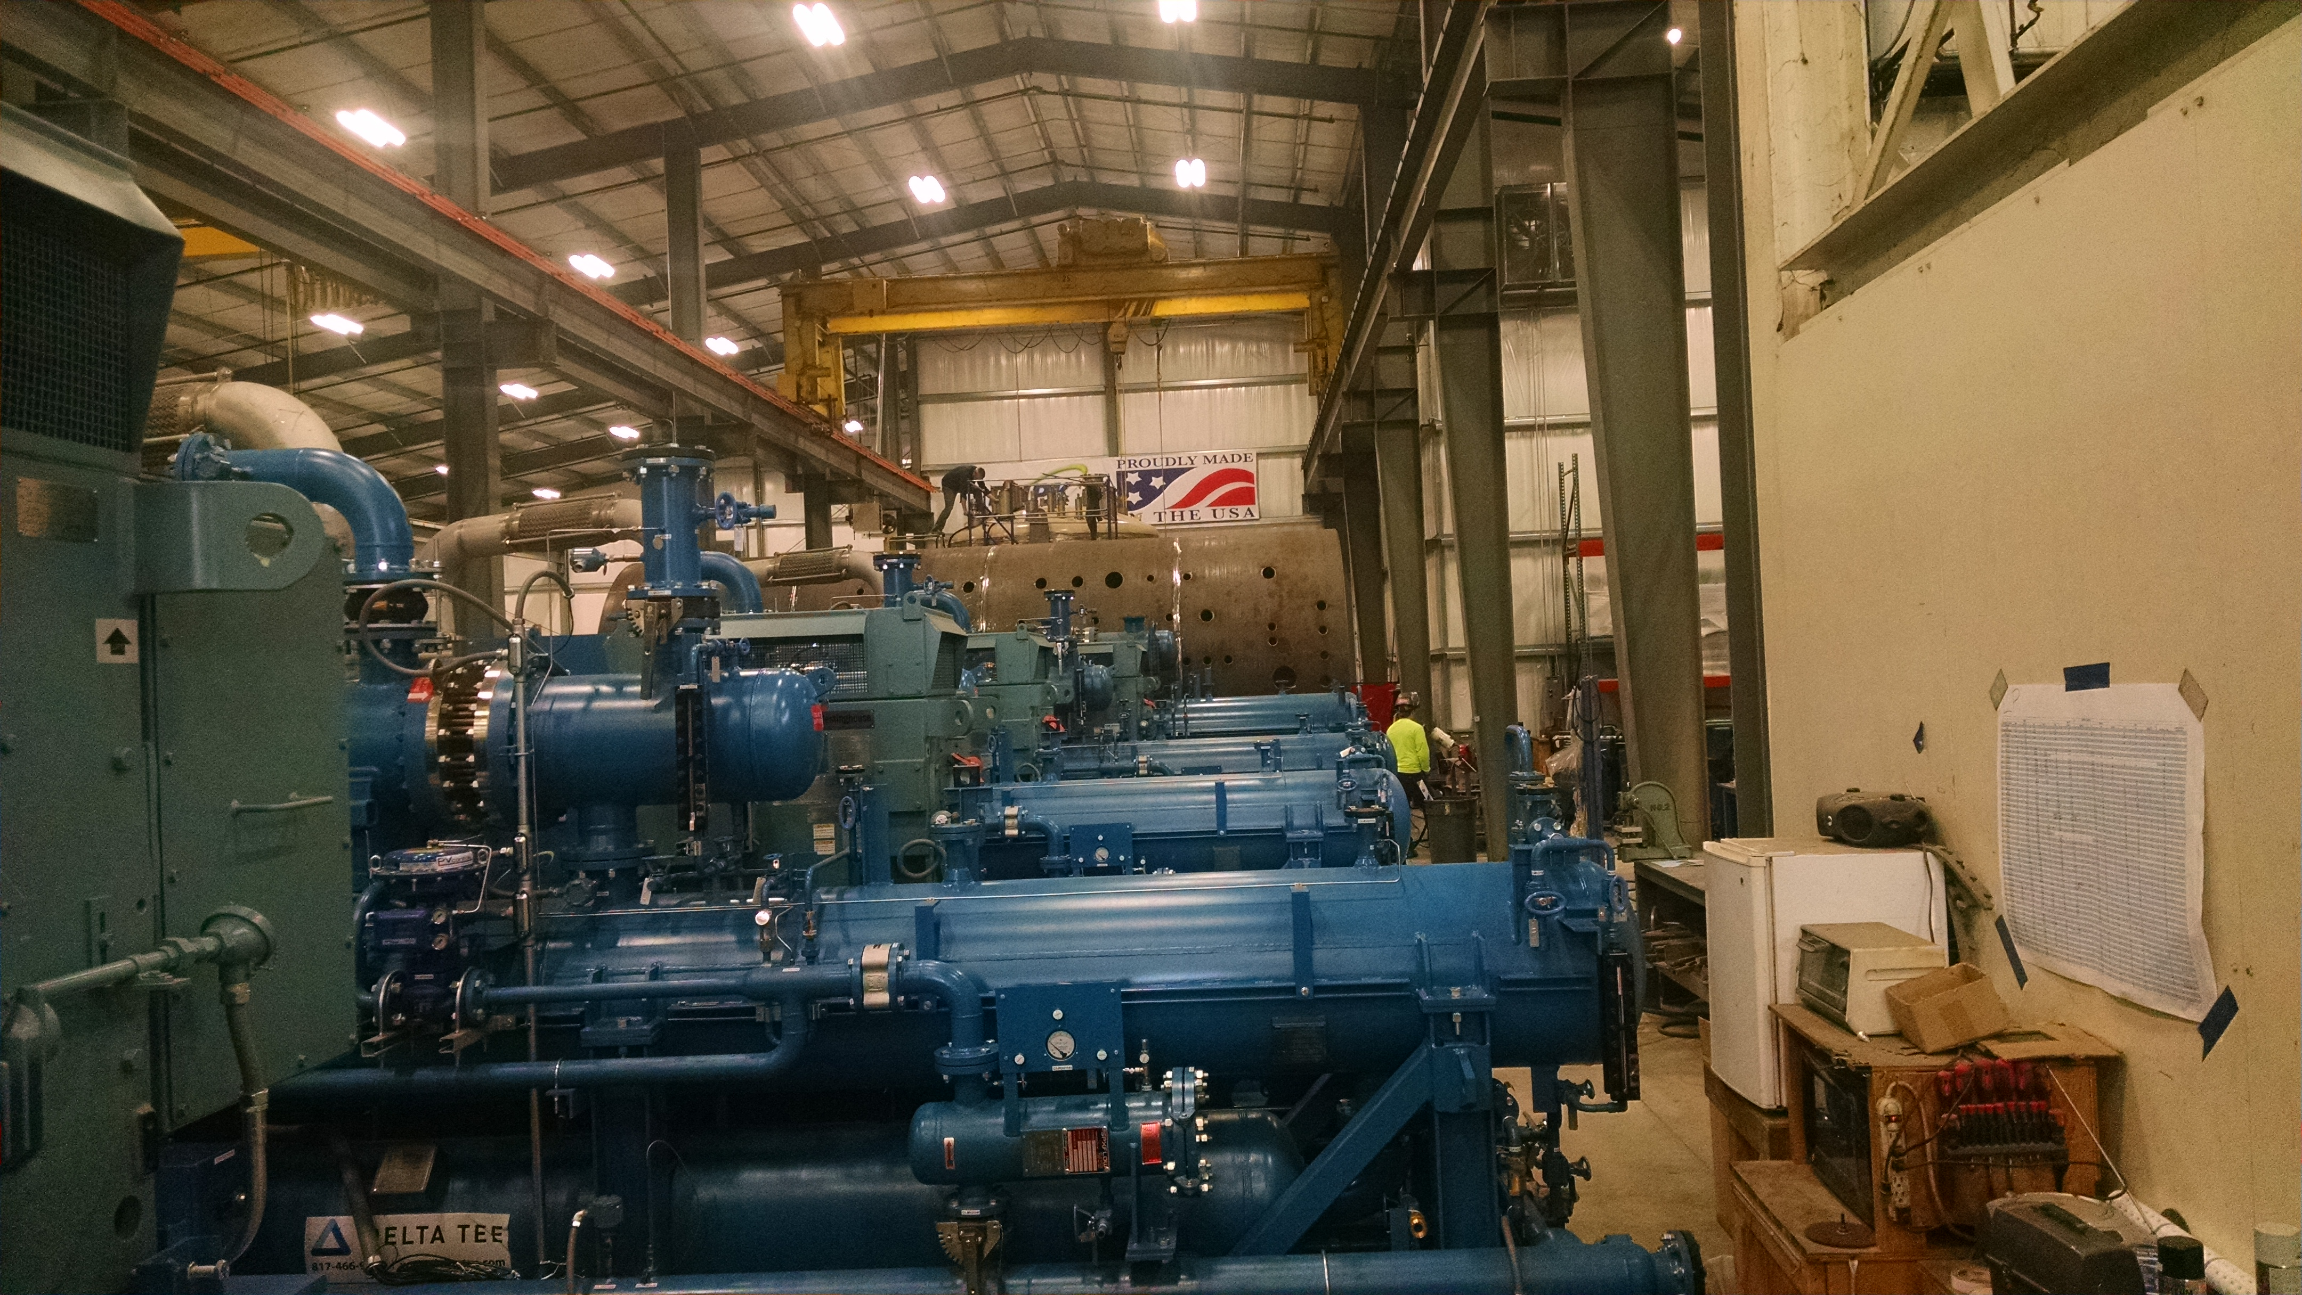
Line Up of CP1 Warm Helium Compressors for Shipment
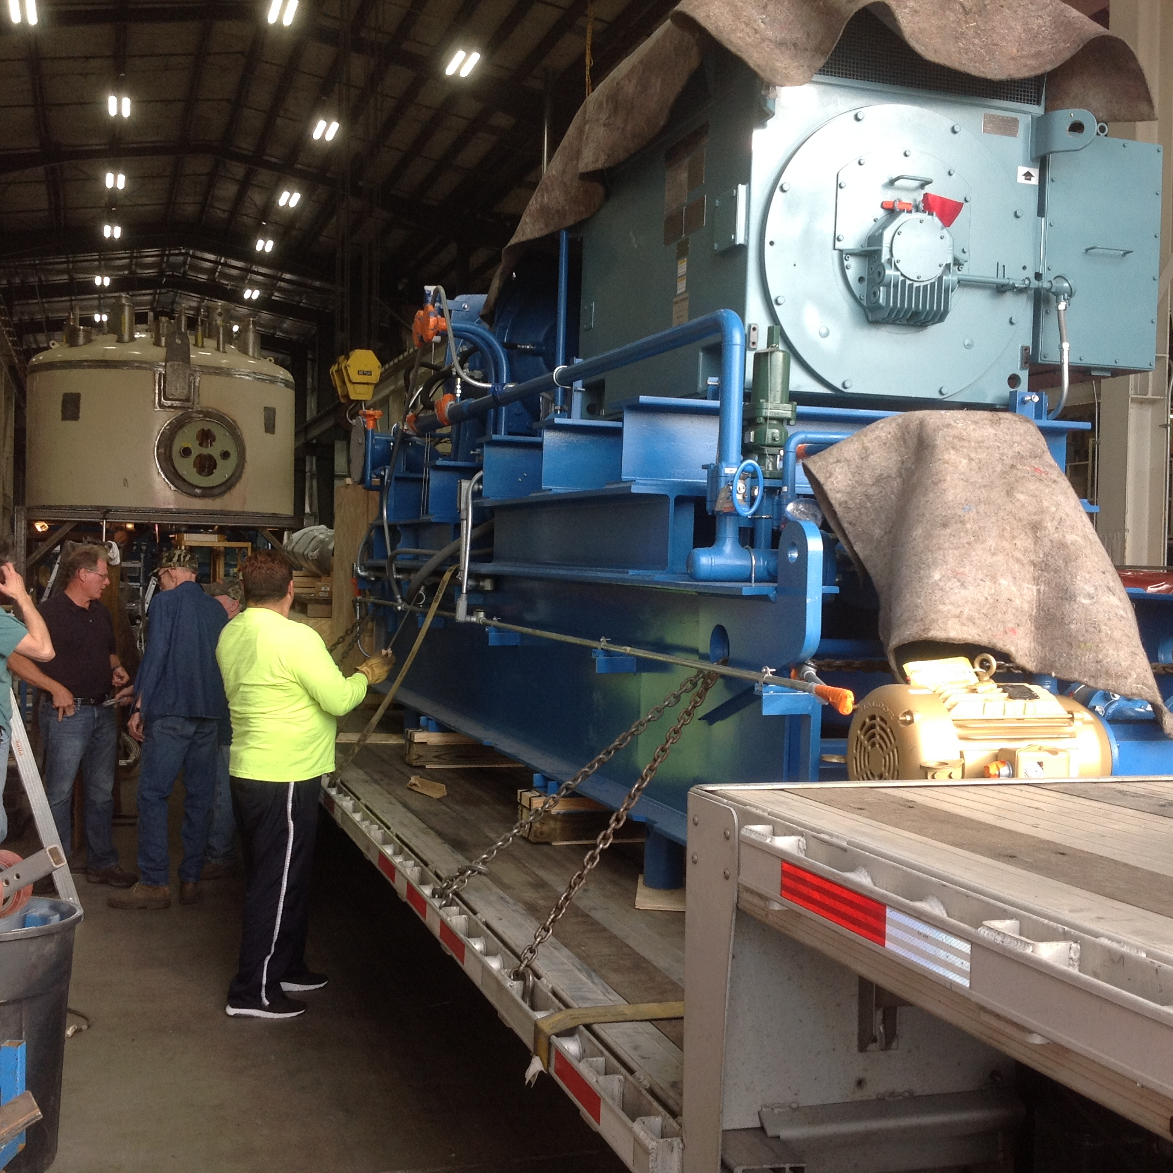
CP1 Warm Helium Compressor Skid Loaded on Tractor/Trailer
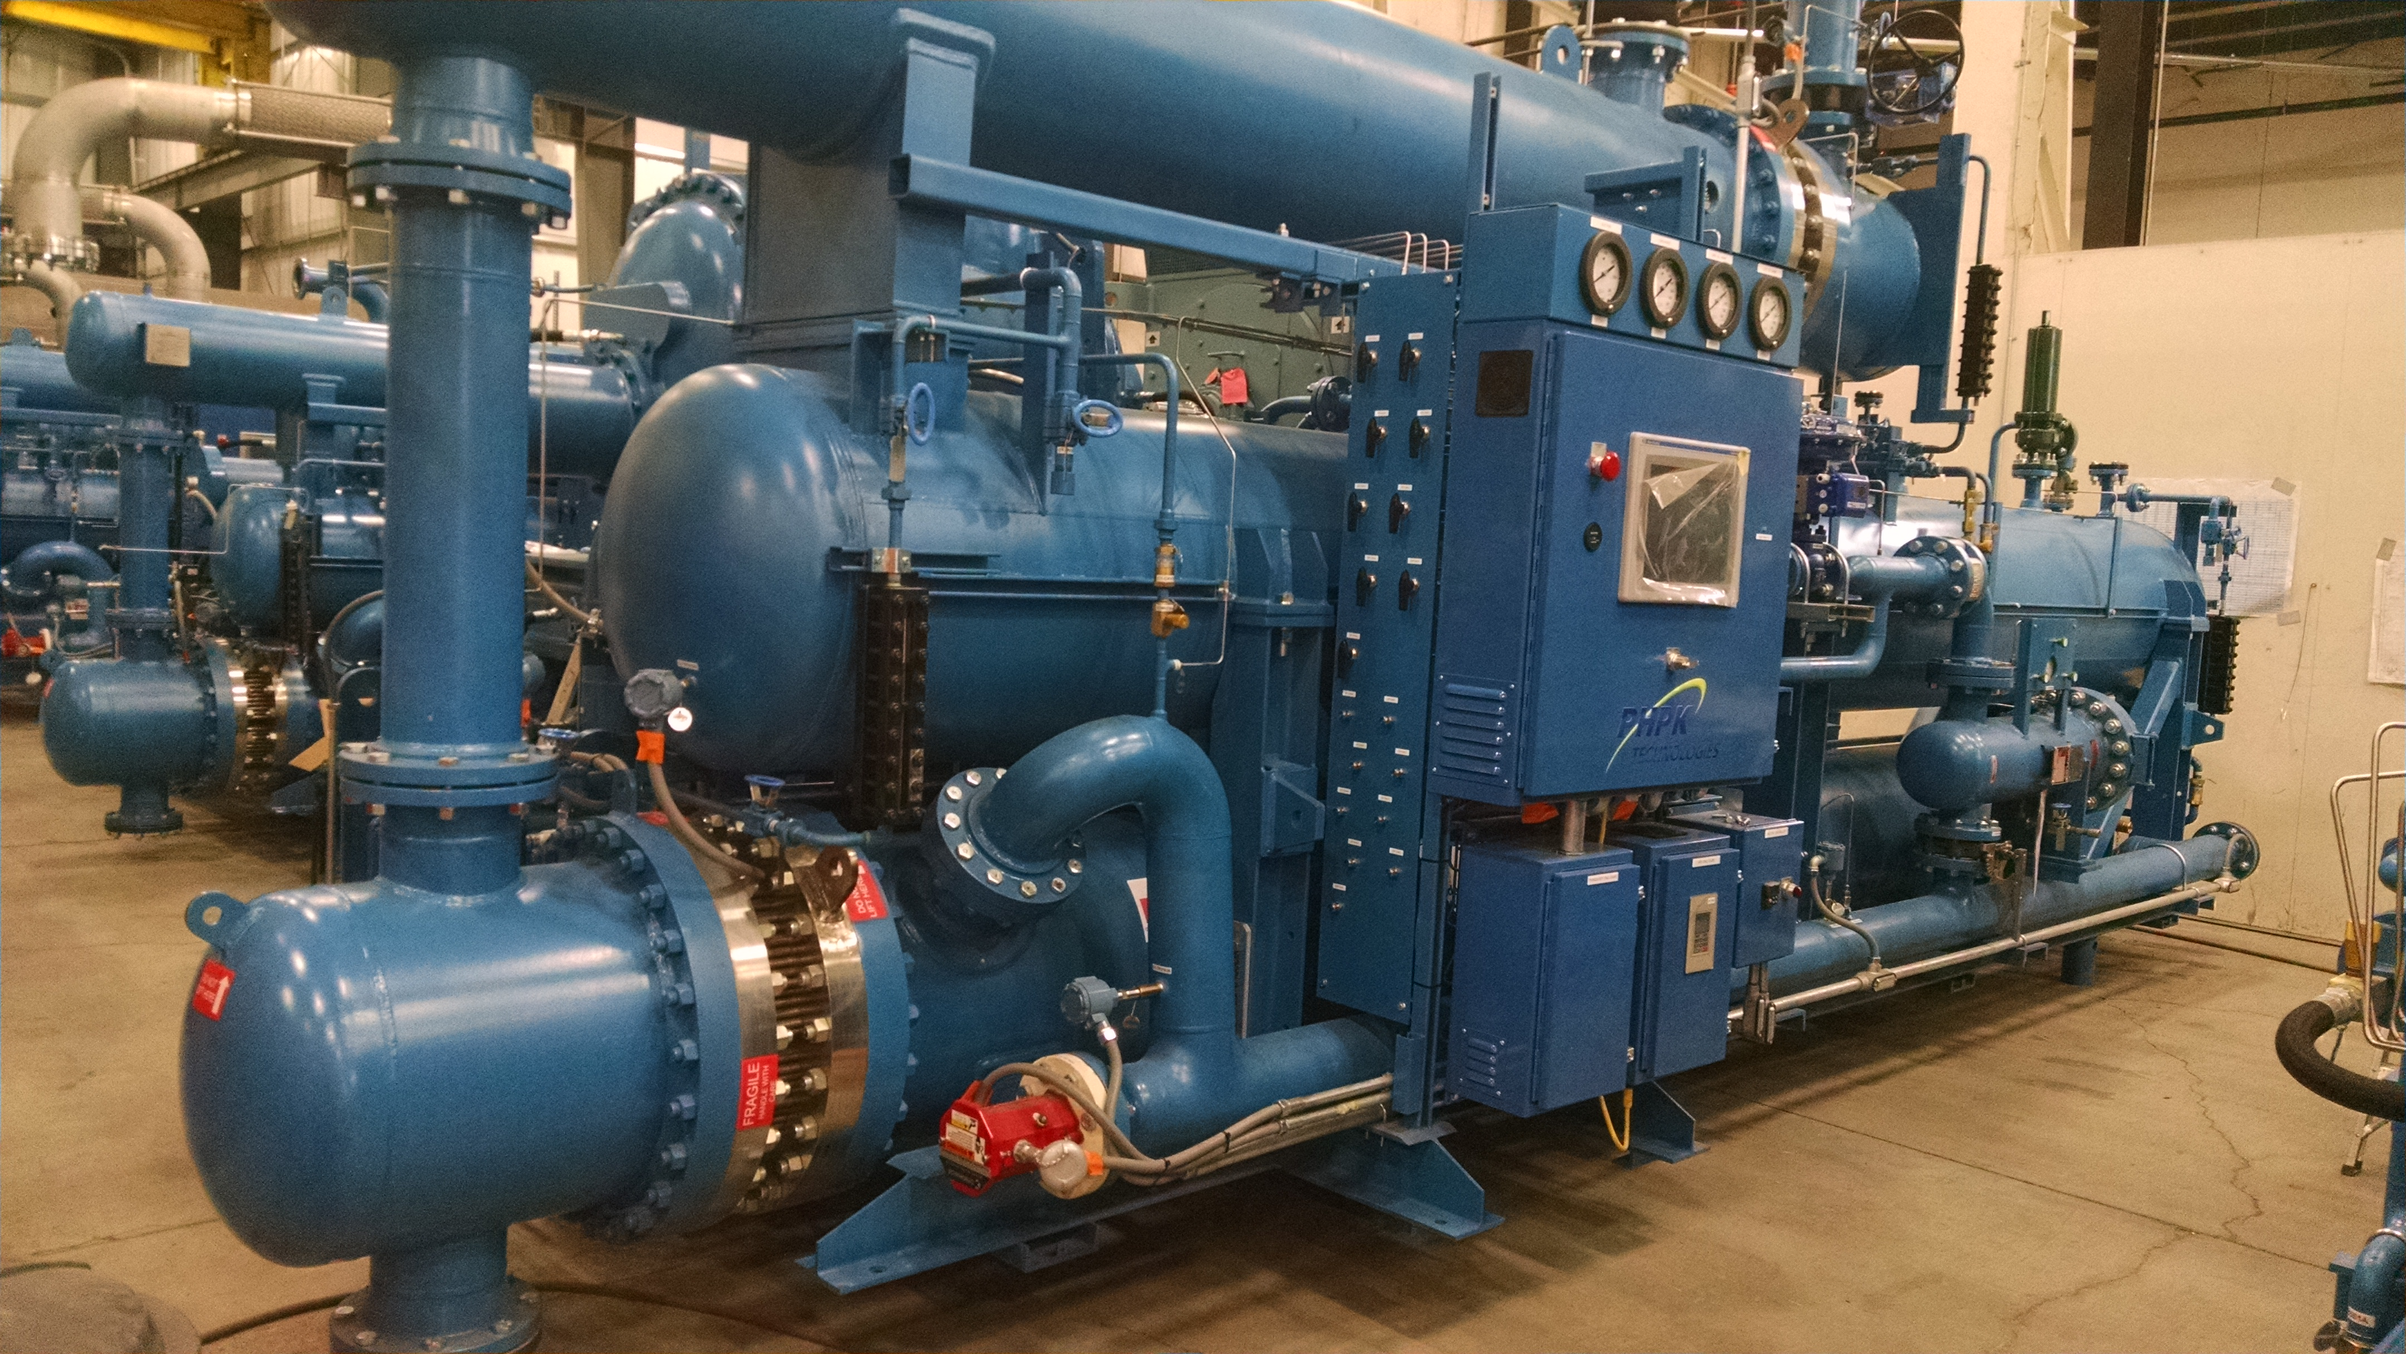
LCLSII Compressor Skid Ready for Shipment
- A 75% mechanical, electrical, and installation construction review was held at SLAC on March 30. The installation documentation package was reviewed. Comments were received last week for consideration.
- The last shipment of cold box heat exchangers (shipment #4) for both plants have been received at PHPK. Viswanath Ravindranath (SLAC) witnessed heat exchanger leak check and partial cold box valve leak checking. Leak on previously delivered heat exchanger found to be in aluminum piping, not stainless to aluminum joint. Heat exchanger manufacturer and PHPK discussing repair.
- A cryoplant Strategy and Procurement Modification BCR was developed for remaining work for presentation to SLAC management. A presentation was made on April 4th. Additional questions were raised during the BCR and tentative responses to the questions were reviewed on April 11th.with cryogenic SM. L4 milestone list developed, milestone descriptions are being generated.
- PHPK has received the final seismic design report from Hopper. Air Liquide will review the final report for 5 days prior to submittal to JLab. JLab should receive the report Week of April 17th.
QUALITY
Bruce Lenzer is visiting PHPK (4/20 – 4/21) to witness the loading of the first warm helium compressor skid for delivery to SLAC.
Upcoming Travel/Reviews:
Directors Review, SLAC, May 3-5th 2017
DOE Review, SLAC, June 13-15th 2017
FAC Review, SLAC, late summer 2017

Weekly Reporting
WBS 1.02.03.05.12 LLRF
Week of April 14-20, 2017

Issues: None
Accomplishments this week:
- LLRF Coordination/Documentation:
  - Heater: The FPGA board rout is being reviewed …slower than expected. Chassis design has started.
  - Active Compensation: Continued discussions with the LCLSII LLRF and SRF community. Sent Matt a revised estimate of JLAB participation.
  - CMTF EPICS software, Interlocks and Resonance are ready for pCM tests
  - Participated in production discussion with VADAtech.
  - Continued discussions with JLAB management on the full LLRF production. They have requested a more thorough estimate.
  - Front Panels are being sent to JLAB for resonance, interlocks and ps.
- Resonance/Stepper Motor Board/Chassis:
  - Piezo control: JLAB is planning on adding PI controls to the resonance chassis for operation with the JLAB LLRF system.
  - Josh and Larry are working on the communications from the RFS chassis to the Resonance chassis …this continues.
  - Procuring of parts for the test bench is ongoing. Looking at encoders for stepper motor.
  - Making production modifications to the pc boards, including SLAC ID.
- Interlock Board/Chassis:
  - Test bench block diagram is now in Altium. Investigating using existing ADCs or looking for a commercial solution continues …slowly
  - Making production modifications to the pc boards … 8 channels FEP
- Common Power Supply/Chassis/Boards:
  - Gun Power Distribution Board: Board sent out for manufacture. It has been made a little smaller.
  - Gun/Buncher PS Chassis: Ordered individual power supplies.
  - Power Distribution Investigation: Done.
  - Have sent the connector and cable modifications to the partner labs.
- CMTF
  - Continue prepping for the pCM re-test in April ongoing. pCM will be cold on May 1.

Upcoming Activities:
- Garth will visit JLAB the week of May 1
- Prepare for CMTF tests
- Prepare for Directors/DOE Review
- Internal design freeze meetings for JLAB designs May 15.

